CHEMICAL ENGINEERING TRANSACTIONS  VOL. , 2023 | A publication of
The Italian Association
of Chemical Engineering
Online at www.cetjournal.it

Guest Editors:
Copyright © 2023, AIDIC Servizi S.r.l.
ISBN 979-12-81206-XX-X; ISSN 2283-9216

Investigation of vegetable oil-based nonionic surfactants for the petroleum industry
Máté Hartyányi^{a,}*, Roland Nagyª, László Barthaª, Sándor Puskás^{b}
ªDepartment of MOL Hydrocarbon and Coal Processing, University of Pannonia, H-8200 Veszprém, Hungary
^{b}Oilfield Chemicals and Technologies, MOL Plc, H-6701 Szeged, Hungary
*hartyanyi.mate@mk.uni-pannon.hu
Nowadays, surfactants find extensive use across various industries owing to their versatile and beneficial characteristics, serving as detergents, wetting agents, emulsifiers, foaming or dispersing agents, spanning from the food and cosmetics industries to heavy industry. Non-ionic surfactants constitute one of the most diverse groups within this domain. Within the realm of surfactants, factors such as application efficiency, environmental friendliness, and sustainability are increasingly significant. To enhance these properties, utilizing natural and recycled raw materials presents a viable solution, particularly surfactants derived from vegetable and animal oils and fats or their derivatives, which constitute a significant portion of the market.
The primary objective was to synthesize non-ionic surfactants using natural vegetable oil and recycled vegetable oil. The physicochemical properties of the produced nonionic surfactants were determined through analytical testing, along with assessing their applicability using impact assessment methods. The study compared results and drew conclusions regarding the correlation between the properties of the raw materials and those of the final products.
  - Introduction
Surfactants, also known as surface-active agents, are substances added to liquids to enhance their dispersal properties by lowering the liquid's surface tension. Their capacity to reduce tension arises from their amphipathic molecular structure, characterized by a hydrophilic group and a hydrophobic group (Aryanti et al., 2021). Surfactants create stable emulsions and are found in formulations for food, pharmaceuticals, petroleum compounds, cosmetics, water and soil remediation, textiles, and various other processes (Secato et al., 2016).
These molecules are classified based on the nature of the hydrophilic head group, including anionic (negative charge), cationic (positive charge), non-ionic (no charge), and zwitterionics (both negative and positive charge) (Belhaj et al., 2020).
Ethanolamides of fatty acids (FA) represent a significant category of nitrogen-containing non-ionic surfactants. They find extensive use in detergents, cosmetics, wetting agents, dispersants, and more (Mäki-Arvela et al., 2016). Additionally, ethanolamides serve as raw materials for other surfactant classes, such as oxyethylated ethanolamides (Ahmad, 2017).
There is growing interest in ethanolamides of FA containing 16–22 carbon atoms. These products are soluble in oil, possess low Hydrophilic-Lipophilic Balance (HLB) values (2–3 units), and are effective emulsifiers for water-in-oil emulsions, widely used in oil and gas production (Ibragimov et al., 2017). The primary methods for preparing ethanolamides involve aminolysis of FA esters and direct amidation of FA with ethanolamines.
The direct amidation of fatty acids (FA) with ethanolamines is a crucial industrial method for producing ethanolamides. The process involves cyclic heating of a mixture of FA with the corresponding ethanolamine at temperatures ranging from 150 to 180°C. Continuous water removal is essential, achieved through evaporation or by lowering pressure with inert gas bubbling or an azeotropic agent (Yanovsky et al., 2013).
Synthesis time selection often lacks rigorous theoretical justification, commonly assessed by residual acid value or water released, particularly for diethanolamides. The reaction of FA and monoethanolamine results in an equilibrium mixture of amide, ester, and amido ester. Compared to monoethanolamines, diethanolamine amidation (DEA) is a more complex process, involving secondary and tertiary reactions. Certain side reactions are irreversible (Yanovsky et al., 2018). The main reactions of fatty acids with diethanolamie shown in Figure 1.
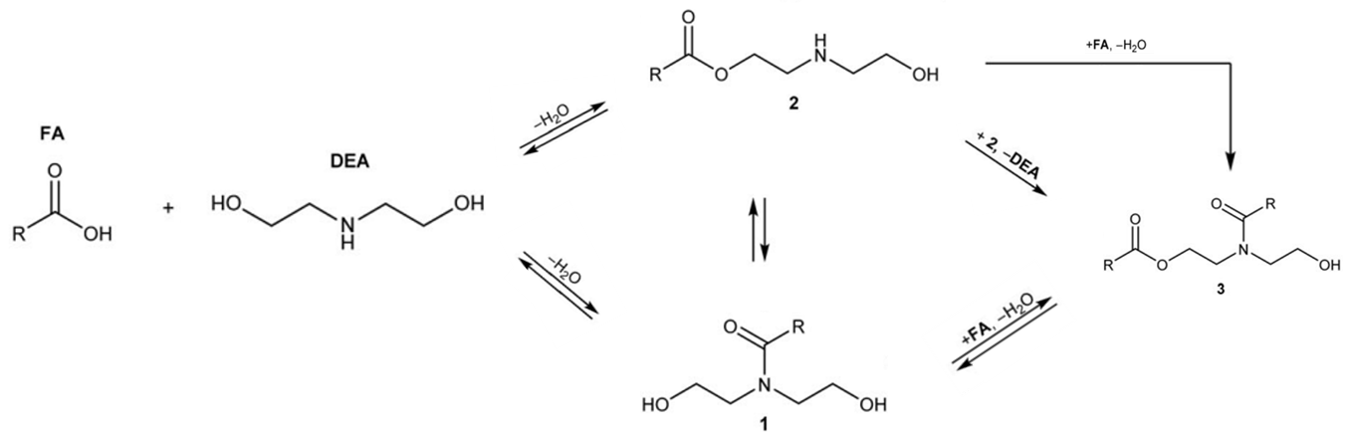
Figure 1: Main reactions of fatty acids with diethanolamie (Yanovsky et al. 2018)
In our work, the aim was to synthesize surfactants using five different fatty acids and diethanolamine under identical reaction conditions. Another goal was to investigate the physical and physicochemical properties of the synthesized reaction products. Additionally, we aimed to examine the relationship between specific properties and chemical structure.
  - Materials
Various unique fatty acids were used for the synthesis of surfactants to create the hydrophobic tail, while for the ensure of water-soluble properties, dietanolamine was used, providing the hydrophilic head. The individual fatty acids used in the synthesis had carbon chains ranging from C₁₄ to C₁₈, all of which were saturated. Additionally, in one instance, oleic acid was utilized, with a chain length of 18 carbon atoms, yet it was an unsaturated fatty acid containing a double bond in the carbon chain. The main properties of used fatty acids are summarised in Table 1.
Table 1: The main properties of used fatty acids
Name of fatty acid | Average molecular weight, g/mol | Producer | Melting point, °C | Appearance | Density, g/cm³ | Solubility in water at 20°C, mg/l | CAS Number | Carbon chain | Purity, %
Lauric acid | 200,32 | Sigma-Aldrich | 43-45 | White, solid | 0,883 (at 50 °C) | 58 | 143-07-7 | C_{12:0} | >99
Myristic acid | 228,38 | Sigma-Aldrich | 57-59 | White, solid | 0,862 (at 63 °C) | <0,05 | 544-63-8 | C_{14:0} | >99
Palmitic acid | 256,38 | Sigma-Aldrich | 59-63 | White, solid | 0853 (at 62 °C) | <0,05 | 57-10-3 | C_{16:0} | >98
Oleic acid | 282,46 | Thermo Scientific | 13-17 | yellowish/ brownish liquid | 0,890 (at 20 °C) | <0,05 | 112-80-1 | C_{18:1} | >96
Stearic acid | 284,48 | Sigma-Aldrich | 68-70 | White, solid | 0,845 (at 73 °C) | <0,05 | 57-11-4 | C_{18:0} | >97

Apart from the unique fatty acids, diethanolamine was utilized as a reagent in the synthesis, along with potassium hydroxide serving as a catalyst. Main properties of these materials are summarized in Table 2.

Table 2: The main properties of used diethanolamine and catalyst
Name of material | Short name | Average molecular weight, g/mol | Producer | Melting point, °C | Appearance | CAS Number | Purity, %
Diethanolamine | DEA | 105,14 | Thermo Scientific | 26-30 | Colourless, solid | 111-42-2 | >98,5
Potassium hydroxide | KOH | 56,11 | VWR Chemicals | 360 | White, solid | 1310-58-3 | >85

The fatty acids and diethanolamine were used in liquid form. The solid materials were heated 5 °C above the melting point before using, except the potassium hydroxide.
  - Methods
    - Synthesis
The reaction required for surfactant production was carried out in four-necked flasks. The synthesis of surfactants was conducted under same manufacturing parameters in each case. The synthesis parameters of the reaction are summarized in Table 3.
Table 3: Main parameters of synthesis
Parameter | Value
Temperature, °C | 160
Pressure, bar | 1
Reaction time, h | 4
Ratio of reagents (DEA:FA), mol/mol | 2,25
Catalyst ratio, m/m% | 1

The catalyst was added to the reaction mixture after reaching the reaction temperature.
    - Appearance investigation
The examination of the appearance of reaction mixtures produced during the syntheses was done visually. The color of the products and their tendency to separate were assessed after 24 hours of storage at room temperature.
    - Water number
One gram of the substance under examination is weighed on an analytical balance, and then it is dissolved in 30 cm³ of a previously prepared cyclohexene-dioxane mixture (4% cyclohexene content). Following this, the prepared sample is titrated with distilled water until a persistent turbidity is observed. The water number of the substance under examination is derived from the number of cubic centimetres of distilled water required to reach the turbidity indicating the endpoint of titration.
    - Solubility in water
The samples were assessed for their water solubility by utilizing a 1 m/m% solution prepared from the synthesized surfactant in distilled water. Solubility of surfactants was measured by WTW TURB 400IR turbidity meter. The turbidity determination based on nephelometric measurements.
    - Solubility in oil
The samples were assessed for their oil solubility by utilizing a 1 m/m% solution prepared from the synthesized surfactant in SN-150 base oil. A prepared surfactant solution was transferred into cuvettes, and the intensity of transmitted light at a wavelength of 500 nm was examined using a spectrophotometer. The turbidity of the sample under examination was compared to that of pure oil (0%) and the light scattering of a reference opal (100%). A measured turbidity values are expressed in percentage.
    - pH value of surfactant solution
For the pH measurements surfactant solutions were prepared by using the surfactants in 1 m/m% concentration. The measurements were carried out at 25 °C.
    - Measurement of IFT value
The interfacial tension between the aqueous phase of the surfactant solution and the SN-150 base oil was measured using the spinning drop method. The measurement was carried out in a Krüss SDT tensiometer. While the rotation of the cylinder exerts a centrifugal force on its wall, the drops of the lower density fluid are deformed in an elongated form. The interfacial tension between the two fluids can be calculated from the form of the drops using the Young–Laplace-fit method. The measurements were carried out at 25 °C temperature using the surfactants solution in 1 m/m% concentration.
    - Viscosity and density measurements
For the viscosity and density measurements an automatic viscometer (SVM 3000 Stabinger Viscometer) was used. The device performs the tests at a constant shear rate of 100 1/s and determines the viscosity and density. The measurements were carried out at 100 °C temperature.
  - Results
The results of the measurements of the appearance and stability of the surfactants synthesized from fatty acids are summarized in Table 4.
Table 4: Appearance and stability of reaction products
Mark of surfactants | Used fatty acid | Appearance of surfactants | Stability of surfactants
S-1 | Lauric acid | Pale yellowish/ brownish, liquid | Stable, phase separation was not observed
S-2 | Myristic acid | Pale yellowish/ brownish, paste | Stable, phase separation was not observed
S-3 | Palmitic acid | Pale yellowish/ brownish, solid | Stable, phase separation was not observed
S-4 | Oleic acid | Dark brown, liquid | Stable, phase separation was not observed
S-5 | Stearic acid | Pale yellowish/ brownish, solid | Stable, phase separation was not observed

The products of the reactions were stable in all cases, and phase separation was not observed. Among the produced surfactants, two were liquid, two were solid, and one was pasty. The surfactant synthesized from the smallest molecular weight, the shortest-chain fatty acid (S-1), was liquid, as well as the one synthesized from the fatty acid containing a double bond. With the increase in carbon chain length, the flow properties of the surfactants decreased. An exception to this trend was observed for the surfactant synthesized from the fatty acid containing a double bond. The properties of the surfactants are summarized in Table 5.
Table 5: Properties of reaction products
Mark of surfactants | Water number, cm³/g | Dynamic viscosity at 100 °C, mPas | Kinematic viscosity at 100 °C, mm²/s | Density at 100 °C, g/cm³
S-1 | 14,10 | 18,9 | 19,4 | 0,9730
S-2 | 13,15 | 20,7 | 21,1 | 0,9805
S-3 | 13,05 | 30,1 | 30,6 | 0,9877
S-4 | 13,25 | 25,3 | 26,1 | 0,9671
S-5 | 12,40 | 25,9 | 26,8 | 0,9675

The properties of the synthesized surfactants were examined, revealing that an increase in the carbon chain length led to a decrease in the water number of the surfactants. Based on this, it can be inferred that surfactants synthesized from longer-chain fatty acids have increased oil solubility and decreased water solubility. The surfactant containing the unsaturated carbon chain exhibited a different trend; its water number was higher than that of the surfactant with the same length but containing a saturated carbon chain. Significant differences or trends was not observed between the density and viscosity results measured at 100 °C for the synthesized surfactants. The results of the studies carried out with the surfactant solutions are summarized in Table 6.
Table 6: Properties of solutions prepared by using the reaction products
Mark of surfactants | Turbidity in water, NTU | Transmittance in SN-150 base oil, % | pH in water | IFT, mN/m
S-1 | 1,39 | 65 | 10,0 | 0,4082
S-2 | 4,52 | 68 | 10,0 | 0,5715
S-3 | 267 | 70 | 10,2 | 3,3214
S-4 | 175 | 22 | 10,2 | 0,3182
S-5 | 373 | 82 | 9,9 | 4,1403

In the case of turbidity examination of the surfactant's aqueous solution, an increase in carbon chain length resulted in decreased water solubility, as expected from the water number values. However, this trend was not uniform; when increasing the chain from C_{14:0} to C_{16:0}, the turbidity of the solutions increased by two orders of magnitude. For the surfactant containing a double bond better solubility was observed than the saturated carbon chain of the same length, and the difference in turbidity between the solutions was approximately twofold. Similar trends were observed between the surfactants containing C_{14:0} and C_{16:0} carbon chains in the interfacial tension measurements. Here, a change of one order of magnitude was detectable between the two surfactants. Increasing the carbon chain length resulted in higher interfacial tension values for the surfactants with saturated carbon chains. The lowest IFT value was determined compared to the other surfactants in case of surfactant synthesized from the fatty acid containing a double bond. In the oil solubility test, for saturated fatty acids, the turbidity of the solutions decreased with increasing carbon chain length, as expected from the water number values. For the surfactant containing the unsaturated carbon chain, it had the lowest solution transmittance, i.e., the highest turbidity. The solution of this surfactant allowed 43 % less light to pass than the least oil-soluble saturated carbon chain surfactant (S-1) and 60 % less than the surfactant made from the same chain length but with a saturated carbon chain (S-5). The transmittance of surfactants solutions in SN-150 base oil shown in Figure 2.
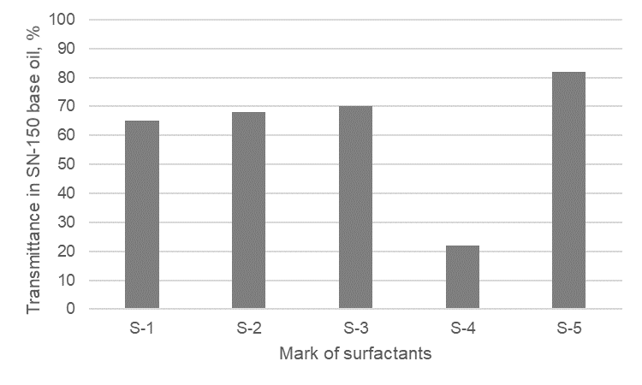
Figure 2: Transmittance of surfactants solutions in SN-150 base oil
For the surfactant synthesized from the fatty acid containing a double bond, a significant leap was consistently found compared to saturated fatty acids based ones.
  - Conclusion
Surfactants using five different fatty acids and diethanolamine under same reaction conditions were synthesized. The utilized fatty acids had saturated chains ranging from C_{12:0} to C_{18:0} and one with an unsaturated C_{18:1} chain.
Initially, the stability and appearance of the synthesized surfactants were examined. All reaction products remained stable without phase separation; among them, two were liquid, two solid, and one pasty. The surfactant derived from the smallest molecular weight (S-1) and the one from the fatty acid with a double bond were both liquid, contrary to the general trend of decreasing flow properties with increasing carbon chain length, except for the surfactant synthesized from the fatty acid containing a double bond.
The examination of synthesized surfactants showed that longer carbon chain lengths correlated with decreased water numbers, suggesting higher oil solubility and lower water solubility. However, the surfactant with an unsaturated carbon chain exhibited a different trend, with a higher water number compared to its saturated counterpart of the same length. No significant differences or trends were observed in density and viscosity results measured at 100 °C for the synthesized surfactants.
Longer carbon chain lengths generally resulted in decreased water solubility of surfactant solutions, consistent with water number values. However, this trend varied; increasing the chain from C_{14:0} to C_{16:0} notably increased solution turbidity by two orders of magnitude. Surfactants with unsaturated carbon chains exhibited better solubility compared to their saturated counterparts of the same length, with approximately twofold differences in turbidity between the solutions. Interfacial tension measurements reflected similar trends between surfactants with C_{14:0} and C_{16:0} carbon chains, showing a one order of magnitude change, with longer chain lengths leading to higher interfacial tension values, except for the surfactant synthesized from fatty acids containing a double bond, which showed the lowest interfacial tension.

Nomenclature
DEA – Diethanolamine

FA – Fatty acid
HLB – Hydrophilic-Lipophilic Balance
IFT – Interfacial tension, mN/m
SN – Solvent Neutral

Acknowledgments
Prepared with the professional support of the Doctoral Student Scholarship Program of the Co-operative Doctoral Program of Ministry of Innovation and Technology financed from the National Research, Development and Innovation Fund. Founding number: KDP-11-3/PALY-2021
Expressing gratitude to MOL Plc for their generous support of the research and providing the opportunity for publication.
References
Ahmad M. U. (2017) Fatty acids: Chemistry, synthesis, and applications, AOCS Press, London, England.
Aryanti N., Khoiriyah L., Heny D.R., Nafiunisa A., Wardhani D.H., 2021, Synthesis Cocamide DEA as Green Surfactant from Virgin Coconut Oil, IOP Conf. Series: Materials Science and Engineering, 1053(1), 012066
Belhaj A.F., Elraies K.A., Mahmood S.M., Zulkifli N.N., Akbari S., Hussien O.S., 2020, The effect of surfactant concentration, salinity, temperature, and pH on surfactant adsorption for chemical enhanced oil recovery, Journal of Petroleum Exploration and Production Technology, 10(1), 125-137.
Ibragimov N. G., Musabirov M. K., Dmitrieva A. Y., 2017, Development of formulation of hydrophobic emulsion for selective acidizing of fractured-cavernous carbonate reservoirs, Neftyanoe Khozyaystvo = Oil Industry, 11, 129–131.
Mäki-Arvela P., Tkacheva A., Dosmagambetova I., Chapelliere Y., Hachemi I., Kumar N., Aho A., Murzin D. Y., 2016, Thermal and catalytic Amidation of stearic acid with ethanolamine for production of pharmaceuticals and surfactants, Topics in Catalysis, 59, 1151–1164.
Secato J. F. F., Coelho D. F., Rosa N. G. J.,Costa L. D. L., Tambourgi E.B., 2016, Biosurfactant Production Using Bacillus Subtilis and Industrial Waste as Substrate, Chemical Engineering Transactions, 49, 103-108.
Yanovsky V. A., Andropov M.O., Fakhrislamova R.S., Churkin R.A., Minaev K.M., Yanovskaya E.A., 2018, The Effect of Duration of Amidation of Fatty Acids with Diethanolamine on the Surfactant Properties, Journal of Surfactants and Detergents, 22(3), 641-654.
Yanovsky V. A., Churkin R. A., Andropov M. O., Kosova N. I., 2013, Synthesis and study of properties of emulsifiers for reverse emulsions based on derivatives of acids of tall oil distillate and ethanolamines, Bulletin of the Tomsk State University, 370, 194–199.

