|  |  |
| --- | --- |
| cetlogo ***CHEMICAL ENGINEERING TRANSACTIONS***  ***VOL. , 2024*** | A publication of  aidiclogo_grande |
| The Italian Association  of Chemical Engineering  Online at www.cetjournal.it |
| Guest Editors: Leonardo Tognotti, Rubens Maciel Filho, Viatcheslav Kafarov  Copyright © 2024, AIDIC Servizi S.r.l. **ISBN** 979-12-81206-09-0; **ISSN** 2283-9216 | |

Evaluation of lignocellulosic material composting accelerator bacteria

Arley A. Reales, Jorge A. Castellón, Edison A. Zuluaga, Laura S. Ramírez\*

Faculty of Engineering, University of San Buenaventura, Cartagena de Indias, Colombia

laura.ramirez@usbctg.edu.co

Composting is a biotechnological process that decomposes plant waste into soil-enriching products through microbial activity. Control of parameters such as temperature, humidity and aeration is crucial for an optimal process, which typically takes months. To optimize this, beneficial microorganisms are employed (bioaugmentation). Two compost setups were conducted using lignocellulosic material: one open to the outdoors and the other closed. Both comprised of dry leaves (58 %), fruit peels (12 % banana and papaya), and water (30 %). Parameters were monitored every 2 days for 2 months, and samples were analyzed after seven months. Microorganisms were characterized in Gram-positive and Gram-negative strains. Subsequently, API tests were employed for identification. Four different microorganisms were inoculated individually in other previous described open setups. Physiochemical analysis revealed a final C/N ratio of 45 for uninoculated compost. Inoculated compost, particularly with *Chromobacterium violaceum* and *Pseudomonas luteola*, showed a reduced C/N due to their growth, while *Paenibacillus alvei* and *Lactobacillus collinoide*s improved phosphorus solubilization and reduced soluble organic carbon, respectively. Additionally, *C. violaceum* showed the highest growth rate and substrate consumption. Inoculants decreased the C/N ratio by up to 60 % in 45 days, compared to 170 without. This shows the acceleration of lignocellulosic-based compost by the tested bacteria.

* 1. Introduction

Each year, 14 % of the world's food production is wasted, either post-harvest or before reaching the market (FAO, 2022). Improper disposal of these wastes, mainly composed of lignocellulosic plant matter, leads to environmental pollution through phenomena such as pollution, eutrophication, and even health issues (Liu et al., 2022; Ávila Avelar, 2019; Sharma et al., 2019; Xu et al., 2018). These organic wastes can be treated through composting to stabilize them and minimize their environmental impact (Azim et al., 2018). Composting is a technique for producing organic fertilizers or compost, involving the degradation of organic waste by various bacteria and fungi. Although generally is simple and economically accessible, this process typically takes several months to complete (Campitelli et al., 2014).

Physiochemically, the composting process consists of four stages necessary for obtaining compost: First, during the mesophilic phase, soluble compounds are degraded at 40 °C, lowering the pH due to acid generation. Then, in the thermophilic phase, temperatures peak at 80 °C, degrading resistant compounds such as hemicellulose, and pH increases due to ammonia production. In the final cooling and maturation phases, temperature and pH stabilize as substrate reduction occurs, initiating humus formation through polymerization and condensation reactions, respectively (Campitelli et al., 2014; Bohórquez Santana, 2018; Saldarriaga et al, 2019).

The microorganisms involved in the process typically consist of bacteria and fungi that carry out their feeding, growth, and reproduction processes using the waste materials (Amigos de la tierra, 2004). The role of these microscopic beings is indispensable in compost elaboration, as their metabolism beneficially converts lipids, carbohydrates, and proteins into a nutritious amendment for soils and plants. The types of microorganisms participating in the process largely depend on the aerobic or anaerobic atmosphere in which degradation occurs, commonly found are *Psudomonas, Bacillus*, and *Streptomyces* in the former, and *Clostridium aceticum* and Acetobacter woodii in the latter (Mheta and Sirari, 2018). Generally, in aerobic compost, oxidation reactions predominate, while in anaerobic compost, typical reactions include hydrolysis, acidgenesis, acetogenesis, and methanogenesis (Meegoda, Patel and Wang, 2018).

The composting process typically takes 6 months in an aerobic environment, and despite it can be carried out in the absence of oxygen, this is not usually done as it can take twice as long. Additionally, the lack of oxygen prevents reaching high temperatures during the thermophilic phase, which mitigates the safety of the final product (Mheta and Sirari, 2018). This latter aspect is especially important cause the addition of immature compost to the soil can lead to plant death due to the high microbial load depleting the available oxygen for them (FAO, 2013). Furthermore, compost in an aerobic atmosphere mainly releases carbon dioxide (CO2), while in an anaerobic atmosphere, it mainly releases methane (CH4) (Mheta and Sirari, 2018).

The speed at which the complete process occurs depends on the total initial carbon/nitrogen (C/N) ratio of all materials, as well as the control of independent parameters such as moisture and aeration. The ideal value for C/N is 25; if it is much lower, excessive ammonia will be released, and if it is much higher, microorganisms will require more time to degrade the matter (Azim et al., 2018). Additionally, compost tends to stabilize near this ideal C/N value (Campitelli et al., 2014), with some independence of its initial value, making this parameter useful for determining the level of maturation. On the other hand, the microorganisms involved are essential in the process kinetics, and therefore, inducing a direct relationship between the concentration of these populations and the maturation time is a valid premise that has already been successfully tested in various studies (Méndez-Matías et al., 2018; García-Ramos et al., 2019; Carlos Raffo, 2021; Constante Ibarra, 2021).

This article aims to evaluate the impact of potential endogenous catalytic microorganisms on the final physiochemical properties of compost that influence in the quality and maturation time.

* 1. Materials and methods

Figure 1 shows the methodology scheme. Initially, the setups were prepared using lignocellulosic material and fruit peels. The composition of all composts consisted of 1,000 g of dried leaves, 200 g of banana and papaya peels in a 5:1 ratio, and 500 mL of initial potable water, mixed in a clean bucket and stored in a closed place at room temperature. One open setup and one closed setup were prepared. Every 2 days, for 2 months, temperature (measured with a Punzon model TP101), pH (measured with an H&Co model PHMETRO PH-009), and moisture (10 g of sample dried for 15 minutes in an oven heated to 100 ºC) of the compost were measured, ensuring proper control of the leachate and discarding it at appropriate times. Samples for analysis were taken after a total time of 7 months.

For the identification of microorganisms was employed the technique of serial dilutions up to 10-5. Once cultured on nutrient agar plates, they were visually sorted and isolated based on their color and appearance. After Gram staining, samples with mixed populations were inoculated in selective EMB and Mannitol agars, and the most persistent ones were isolated using a loop with a pointed tip. For the identification of Gram-negative bacteria, the API 20 E test was used, and for Gram-positive bacteria, the API STAPH test, supported by API CHB 50 for Bacillus and API CHL 50 for Lactobacillus was used.

From the identified microorganisms, 2 Gram-negative and 2 Gram-positive strains were used individually as catalysts, in duplicated open setups with the same ratio and type of materials used previously. For inoculation, these strains were individually incubated in BHI broth for 24 to 48 hours, and then each was diluted in the 500 mL of water initially added to each compost. Sampling and data collection were performed identically, and samples for testing were taken after 2 months. Physicochemical analyses were carried out following NTC 5176 and its respective subdivisions for each parameter, as well as other studies. For all methods, the sample was dried at 70 °C for 24 hours and sieved to a size of 2 mm or less (ICONTEC, 2011). The physicochemical parameters and the respective method employed or adapted are as follows: Total Nitrogen (TN) using the Kjeldahl method (Puentes Contreras and Coronado Rojas, 2014; ICONTEC, 2011; UPV, 2017), Total Carbon (TC) by calcination (Bautista and Hernández, 2021), Water-soluble Carbon (WSC) through wet digestion and spectrophotometry (UPV, 2016), and Total Phosphorus (P2O5) by vanado-molybdate and spectrophotometry (Puentes Contreras and Coronado Rojas, 2014; ICONTEC, 1996).



Figure 1: Scheme of the methodology.

* 1. Results and discussion

The identified Gram-negative microorganisms were as follows: *Pseudomonas aeruginosa*, *Pseudomonas luteola*, and *Chromobacterium violaceum*. In the same order, the codes generated by the API 20 E kit and the matching percentages provided by APIWEB were 2202002 with 56.8 %, 2206002 with 74.2 %, and 2206000 with 60.1 %, respectively. Regarding Gram-positive microorganisms, the following were identified: *Bacillus mycoides*, *Brevibacillus laterosporus*, *Lactobacillus collinoides*, *Paenibacillus alvei*, and *Bacillus firmus*. The four randomly selected strains and their respective labels are as follows: *C. violaceum*, *P. luteola*, *L. collinoides*, and *P. alvei.*

In Figure 2, the temperature and pH data taken from the composts can be observed. It is noted that the open compost without inoculum functions as a blank. Primarily, it’s highlighted that the temperature peak of the inoculated composts occurs 2 days earlier than the control, indicating process optimization. However, this curve does not reach the high values normally expected (Campitelli et al., 2014). Additionally, the average temperatures of Gram-positive microorganisms (30.96 °C) are slightly higher than those of Gram-negative ones (30.73 °C). *P. alvei* stands out from all other setups with a peak of 34.4 °C.

On the other hand, it is observed that the values of the non-inoculated setups are much lower than the others, mainly due to the temperature of the medium in which they are located cause the relatively small volume of material for each setup leads to a greater dependence on the effects of the surrounding environment. This, in addition to the high initial C/N ratios of the composts (shown later), also justifies the fact that the temperature peaks reported in the literature were not reached. Despite studies with similar temperature values in the thermophilic phase have been reported (Sánchez-Bernal et al., 2019), it is necessary to determine the impact of this parameter on the safety of the final product.

Regarding the pH, it is noted that it slightly increases from an initial acidic value to a basic value, ranging between 7 and 8, which corresponds to what is suggested in the literature (Azim et al., 2018; Mehta and Sirari, 2018), and reported by another study (Méndez-Matías et al, 2018). It is highlighted that *L. collinoides* is slightly above the other setups, with an average value of 7.1. As for the discrepancies with the control, which is notably higher, it is inferred that this is essentially due to microbial action. Finally, the humidity data directly depend on the amount of added water, aeration, and the frequency of leachate extraction. This parameter ranged between 60 and 80 %, which is higher than the normal range established of 40 to 60% (Azim et al., 2018; Campitelli et al., 2014; Mehta and Sirari, 2018). It is inferred that this is mainly due to the lignocellulosic material having good properties for retaining moisture.

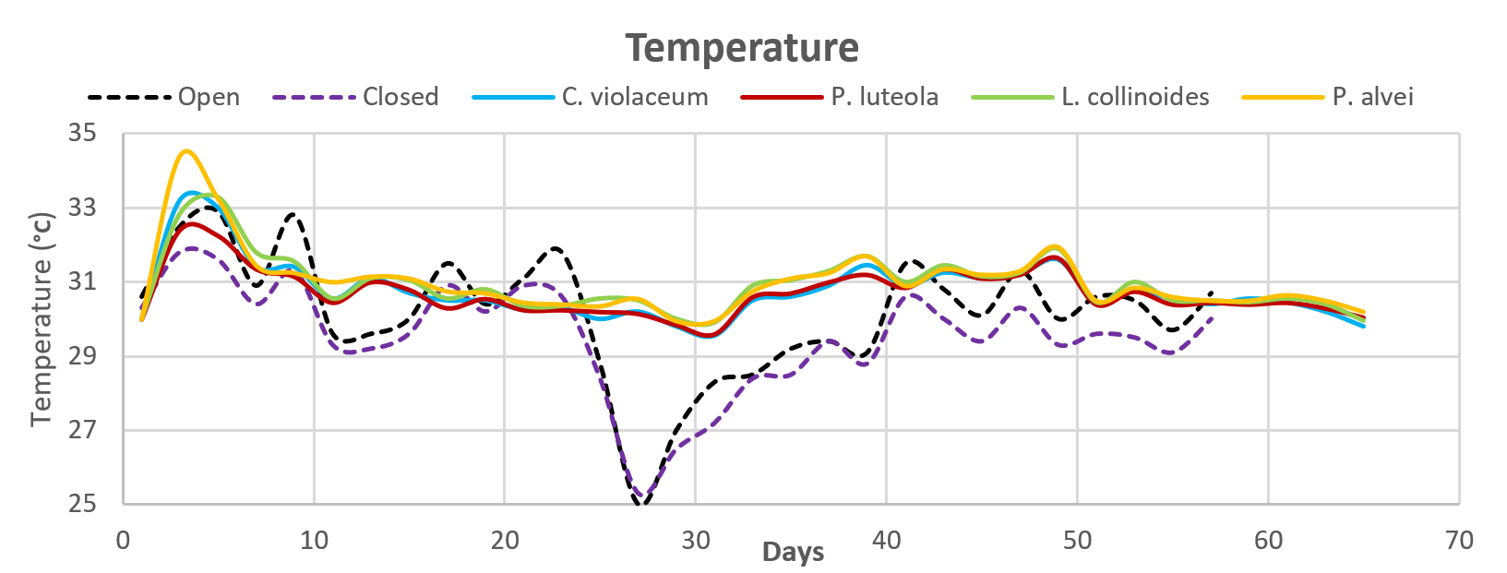 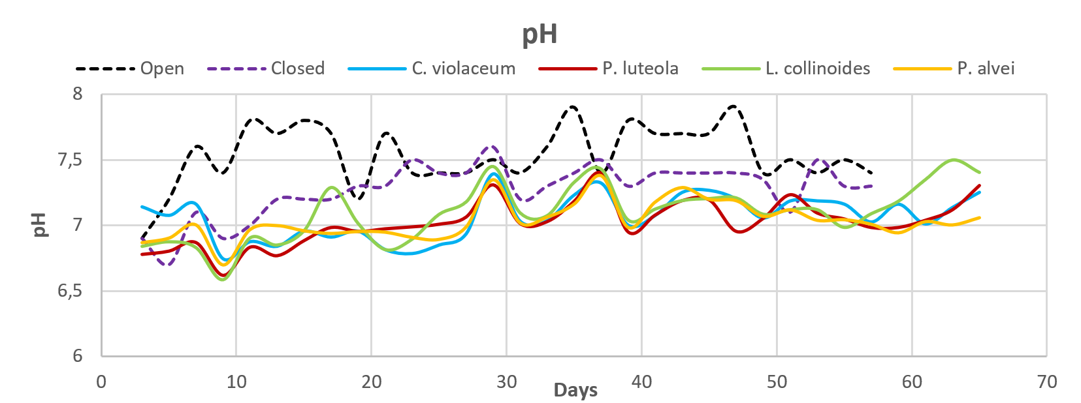

Figure 2. a. Temperature Curve. b. pH curve.

In Table 1, the types of samples chosen for chemical assays are presented, while Table 2 displays the results. As expected, the C/N ratio decreased over the maturation period, consistent with literature reports (Azim et al., 2018; Campitelli et al., 2014; Amigos de la tierra, 2004; Mehta and Sirari, 2018; Méndez-Matías et al, 2018; Montoya, Ospina and Sánchez, 2020). The blank sample taken at 7 months has the lowest C/N value, which is higher than the closed setup without inoculum. Additionally, the sample from the *C. violaceum* inoculated compost taken at 1.5 months has the best C/N value compared to all strains used. Knowing that the initial C/N of all setups corresponds to 137, this strain reduced it by 60.74 % in just 1.5 months, followed by *P. luteola* with 54.65 %. Since the C/N of the *C. violaceum* inoculated compost is very close to the blank, and considering the significant difference in maturation times (1.5 months and 7 months), a good understanding of the catalytic impact of this microorganism can be established.

Regarding the Water-Soluble Carbon (WSC), it represents the organic matter available for degradation, so it is reasonable to think that this is inversely proportional to the degradation time, except for the value obtained for the blank at 7 months, which does not follow this pattern. The bacterium that most reduced this parameter was *L. collinodies*. As for the phosphorus content, it is higher at the beginning of composting and is eliminated through leachate due to its high solubility in water (Meegoda et al., 2018), so it is logical that composts with longer maturation times have lost the most phosphorus. Additionally, phosphorus solubilization also depends on microbial action, with *P. alvei* achieving the highest yield, which is 50 % higher than the other strains. In general, the inoculated setups obtained greater phosphorus solubilization, although it has been reported that some of the microorganisms used have a greater ability to perform this action, such as *P. aeruginosa* and *P. luteola* (Montoya, Ospina and Sánchez, 2020; Ahmad et al., 2022; Setiyo, Harsojuwono and Gunam; 2020), in this case, different results were observed.

Table 1: Physiochemical parameters of the compost samples

|  |  |  |  |  |  |
| --- | --- | --- | --- | --- | --- |
| Compost Sample | TN | TC | WSC | P2O5 | C/N |
| Open Compost (7 months) | 0.99 % | 42.51 % | 1.75 % | 0.12 % | 42.77 |
| Closed Compost (7 months) | 0.90 % | 43.89 % | 0.37 % | 0.11 % | 48.98 |
| Closed Compost (5 months) | 0.91 % | 39.17 % | 0.94 % | 0.12 % | 43.05 |
| *C. violaceum* (1.5 months) | 0.70 % | 37.54 % | 0.56 % | 0.18 % | 53.63 |
| *P. luteola* (1.5 months) | 0.74 % | 45.97 % | 0.43 % | 0.21 % | 61.95 |
| *L. collinoides* (1.5 months) | 0.67 % | 45.78 % | 0.38 % | 0.21 % | 68.12 |
| *P. alvei* (1.5 months) | 0.55 % | 46.35 % | 0.50 % | 0.29 % | 84.90 |
| Dry leaves without degradation | 0.38 % | 48.65 % | 2.55 % | 0.32 % | 128.71 |
| Dry papaya peels | 0.25 % | 50.25 % | 5.16 % | 0.10 % | 199.42 |
| Dry banana peels | 0.31 % | 52.52 % | 7.39 % | 0.36 % | 170.52 |

TN: Total Nitrogen, TC: Total Carbon, WSC: Water-Soluble Carbon, P2O5: Total Phosphorus and C/N calculated as TC/TN.

Since Water-Soluble Carbon (WSC) also indicates substrate in the form of microbial organic matter, it can be used as an indicator of microbial growth. In Table 2, the kinetic reaction balances are shown for the control at 5 months and for the inoculated setups at 1.5 months, and in Figure 3, the corresponding graph of substrate consumption for each strain is shown. It is observed that *C. violaceum* exhibits the highest carbon degradation (26.73 %) and the highest growth rate (0.034). Despite *P. alvei* has a similar growth rate (0.032), its carbon degradation is much lower (9.11 %), and therefore, its yield as well.

Table 2: Reaction kinetic balances.

|  |  |  |  |  |  |  |  |  |
| --- | --- | --- | --- | --- | --- | --- | --- | --- |
| Sample | S0 | Sf | %S | X0 | Xf | YX/S | t | μm |
| Open Compost | 0.505 | 0.382 | 24.26 % | 0.00015 | 0.0094 | 0.077 | 150 | 0.027 |
| *C. violaceum* Compost | 0.505 | 0.370 | 26.73 % | 0.0012 | 0.0056 | 0.042 | 45 | 0.034 |
| *P. luteola* Compost | 0.505 | 0.455 | 9.90 % | 0.0012 | 0.0043 | 0.087 | 45 | 0.028 |
| *L. collinoides* Compost | 0.505 | 0.454 | 10.10 % | 0.0012 | 0.0038 | 0.075 | 45 | 0.026 |
| *P.alvei* Compost | 0.505 | 0.459 | 9.11 % | 0.0012 | 0.0050 | 0.108 | 45 | 0.032 |

S: Carbon mass / Substrate mass, %S = (S0 – Sf) / S0, X: Biomass (kg), YX/S: Biomass production / Substrate consumption, t: Time (days), μm: Growth rate (kg of biomass / Day) (Díaz Fernández, 2021; Doran, 1998).

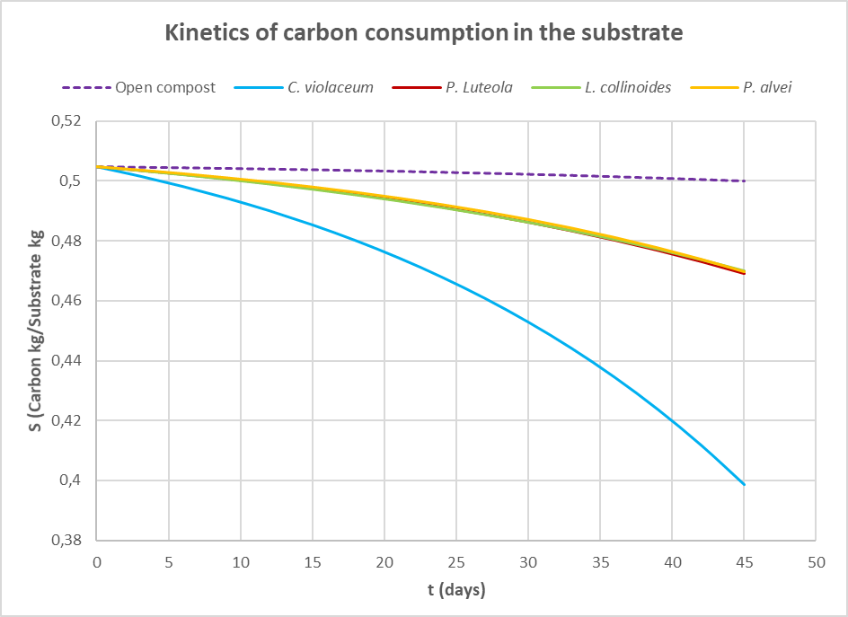

Figure 3. Carbon degradation curve in composts.

* 1. Conclusion

The use of catalytic bacteria in compost composed of lignocellulosic material and fruit peels can expedite the maturation process and enhance the final physiochemical properties. Among these, *C. violaceum* is the most effective strain, reducing the initial C/N ratio by 60.74 %, as well as the substrate carbon content by 26.73 %, followed in performance by *P. luteola*, which decreased the C/N ratio by 54.65 %. Regarding *P. alvei*, its high growth rate, contrasted with its deficiency in carbon degradation (9.11 %), diminishes its catalytic efficiency. Nevertheless, it showed the best results in improving the thermophilic phase of the compost by reaching the highest temperature peak. Finally, *L. collinoides* exhibited the highest average pH value and the highest degradation of Water-Soluble Carbon. According to these results, the employment of bacteria found out in lignocellulosic-based compost can optimize the time maturation of the composting process and the final values of some physiochemical parameters such as C/N, Water-Soluble Carbon and Total Phosphorus. Thus, the use of these microorganisms in a catalyst product for the composting process becomes interesting as a topic for future development due to the potential they have.

References

Ahmad A., Zafar U., Khan A., Haq T., Mujahid T., Wali M., 2022, Effectiveness of compost inoculated with phosphate solubilizing bacteria, Journal of Applied Microbiology, 133(2), 1115-1129.

Amigos de La Tierra, 2004, Basic Manual for making compost: Home composting pilot project (In Spanish).

Ávila Avelar J., 2019, (In Spanish) Efficient Use of Organic and Inorganic Fertilizers in Wheat Production: Towards Environmental Sustainability (In Spanish), Undergraduate Thesis, Universidad Autónoma de Baja California, Mexicali Baja California, México).

Azim K., Soudi B., Boukhari S., Périssol C., Roussos S., Alami I. T., 2018, Composting parameters and compost quality: a literature review, Organic Agriculture, 8(2), 141-158.

Bautista J. I., Hernández J. J. A., 2021, Determination of organic carbon by the chemical method and by calcination, Engineering and Region (In Spanish), 26, 20-28.

Bohórquez Santana W., 2019, The composting process (In Spanish), 1st ed, Ediciones Unisalle, Colombia.

Campitelli P., Ceppi S., Velasco M., Rubenacker A., 2014, Obtaining quality fertilizers for plants (In Spanish), 1st ed, Editorial Brujas, Argentina.

Carlos Raffo F., 2021, Improvement of composting of organic waste from poultry farming through the use of effective microorganisms (In Spanish), Master Thesis, Universidad Tecnológica Nacional, Concepción del Uruguay, Argentina.

Constante Ibarra T. G., 2021, Inoculation of microorganisms in the composting process (In Spanish), Undergraduate Thesis, Universidad Técnica de Ambato, Cevallos, Ecuador.

Díaz Fernández M., 2021, Process Engineering, 3rd edition, Ediciones Paraninfo, S.A., Madrid.

Doran P. M., 1998, Bioprocess Engineering Principles.

FAO, 2013, farmer's composting manual (In Spanish).

FAO, 2022, Addressing Food Loss and Waste: A Triple-Win Opportunity (In Spanish), <www.fao.org/newsroom/detail/FAO-UNEP-agriculture-environment-food-loss-waste-day-2022/es>.

García-Ramos C., Arozarena-Daza N. J., Martínez-Rodríguez F., Hernández-Guillén M., Pascual-Amaro J. Á., Santana-Gato D., 2019, Obtaining compost through the biotransformation of waste from agricultural markets, Cultivos Tropicales, 40(2).

ICONTEC, 1996, NTC 234 – Fertilizers or fertilizers. Test method for the quantitative determination of phosphorus (In Spanish).

ICONTEC, 2011, NTC 370 – Fertilizers or fertilizers. Determination of total nitrogen (In Spanish).

ICONTEC, 2011, NTC 5167 - Products for the agricultural industry. Organic products used as compost or fertilizers and soil amendments or conditioners (In Spanish).

Liu Q., He X., Luo G., Wang K., Li D., 2022, Deciphering the dominant components and functions of bacterial communities for lignocellulose degradation at the composting thermophilic phase, Bioresource Technology, 348, 126808.

Meegoda J. N., Li B., Patel K., Wang L. B., 2018, A review of the processes, parameters, and optimization of anaerobic digestion, International Journal of Environmental Research and Public Health, 15(10), 2224.

Mehta C. M., Sirari K., 2018, Comparative study of aerobic and anaerobic composting for better understanding of organic waste management: A mini review, Plant Archives, 18(1), 44-48.

Méndez-Matías A., Robles C., Ruiz-Vega J., Castañeda-Hidalgo E., 2018, Composting of agroindustrial waste inoculated with lignocellulosic fungi and modification of the C/N ratio, Revista Mexicana de Ciencias Agrícolas, 9(2), 271-280.

Montoya S., Ospina D. A., Sánchez Ó. J., 2020, Evaluation of the Physical–Chemical and Microbiological Characteristics of the Phospho-Compost Produced Under Forced Aeration System at the Industrial Scale, Waste and Biomass Valorization, 11, 5977-5990.

Puentes Contreras P. A., Coronado Rojas A. J., 2014, Determination of Nitrogen, Phosphorus and Potassium present in the pruning of the Proteas Leucadendron crop, for future reuse in the production of compost (In Spanish), Degree Work for Technologist, Corporación Tecnológica de Bogotá, Bogotá D. C., Colombia.

Saldarriaga J. F., Gallego J. L., López J. E., Aguado R., Olazar M., 2019, Selecting monitoring variables in the manual composting of municipal solid waste based on principal component analysis, Waste and Biomass Valorization, 10, 1811-1819

Sánchez-Bernal R., Pita-Castañeda D. J., González-Velandia K. D., Hormaza-Verdugo J. A., 2019, Analysis of mixtures of organic solid waste used in the manufacture of non-structural ecological bricks (In Spanish), Revista de Ciencias Ambientales, 53(1), 23-44.

Setiyo Y., Harsojuwono B. A., Gunam I. B. W., 2020, The concentration of heavy metals in the potato tubers of the basic seed groups examined by the variation of fertilizers, pesticides and the period of cultivation, AIMS Agriculture and Food, 5(4), 882-895.

Sharma B., Vaish B., Monika, Singh U., Singh P., Singh, R., 2019, Recycling of Organic Wastes in Agriculture: An Environmental Perspective, International Journal of Environmental Research, 13(2), 409-429.

UPV, 2016, Determination of soil water-soluble organic carbon | | UPV (In Spanish), 2016, <www.youtube.com/watch?v=0Wh2eBUOSpo>.

UPV, 2017, Determination of total nitrogen in soils by Kjeldahl | | UPV (In Spanish), <www.youtube.com/watch?v=uhnOjvFJDN0>.

Xu X., Nie S., Ding H., Hou F. F., 2018, Environmental pollution and kidney diseases, Nature Reviews Nephrology, 14(5), 313-324.