CHEMICAL ENGINEERING TRANSACTIONS  VOL. , 2024 | A publication of
The Italian Association
of Chemical Engineering
Online at www.cetjournal.it

Guest Editors: Leonardo Tognotti, Rubens Maciel Filho, Viatcheslav Kafarov
Copyright © 2024, AIDIC Servizi S.r.l.
ISBN 979-12-81206-09-0; ISSN 2283-9216

A Circular Economy Challenge: Turning Wastes into Sustainable Asphalt Binders by Pyrolysis
Michela Alfeª, Valentina Gargiulo^{a,}*, Giovanna Ruoppoloª, Luciana Ciminoª, Paolino Caputo^{b}, Valeria Loise^{b}, Pietro Calandra^{c} and Cesare Oliviero Rossi^{b}
ª CNR – STEMS, National Research Council, Institute of Sciences and Technologies for Sustainable Energy and Mobility, P.le V. Tecchio, 80 80125 Napoli, Italy
^{b}University of Calabria, Department of Chemistry and Chemical Technologies, 87036 Arcavacata di Rende (CS), Italy
^{c}CNR-ISMN, National Research Council, Institute of Nanostructured Materials, Via Salaria km 29.300, 00015, Monterotondo, Italy
valentina.gargiulo@stems.cnr.it
The present study aims to investigate the potential of waste pyrolysis products to act as alternative binders or additives in asphalt preparation with the ultimate goals of effective resource use, recovery and recycling, conservation of non-renewable resources, reduction of production costs and achievement of a regenerative circular economy. Char and oil deriving from the pyrolysis of civil and agricultural wastes have been considered as new-concept alternative additives for asphalt preparation. Following an in-depth chemical and structural characterization, oil and char samples have been tested as additives in asphalt binder preparation. After the standard rheological characterization, to test the possible anti-ageing effect exerted by char and oil samples used as additives, the bituminous preparations were subjected to a short-term simulated ageing (RTFOT method) and the resulting mechanical properties evaluated. The results indicate that all the biochar samples were able to strength the overall chemical structure of bitumens and are therefore suitable to be used as bitumen modifier. It is noteworthy that two char samples (char from tires and char from lemon peels) exhibited also anti-ageing properties. As concerns bio-oil samples, in one case (oil from tires pyrolysis) a rejuvenating action is highlighted.
  - Introduction
Much research is currently focused on improving bitumen’s properties due to its use as a binder in road paving processes. The most common method to improve bitumen’s mechanical properties is the use of additives. Polymeric materials are the most used additives to make bituminous hot mixtures more flexible at low temperatures and more rigid at high temperatures; SBS (Styrene-Butadiene-Styrene) is the most used additive (Alnadish et al., 2023). Anyway, due to the high cost and the fossil fuel nature of polymeric additives, the research into new sustainable bitumen additives is becoming a hot topic. In this framework, several studies have investigated the use of carbon-based substances such as bio-oils, biochar, activated carbons, natural waxes, gum, polysaccharides, and natural rubber. Among these emerging materials, biochar is the most investigated and promising bitumen modifier (Rondón-Quintana et al. 2022). Biochar and bio-oil are the two main products deriving from the thermal degradation (pyrolysis) of a biomass. Biochar is a carbon rich material characterized by a high specific surface area, small particle size, porous structure, low thermal conductivity, abundant functional groups on the surface, high chemical and biological stability, and low flammability. Biochar can be obtained at lower costs than activated carbon and generates fewer negative environmental impacts (Rondón-Quintana et al. 2022). In bitumen, biochar is added as powder at 2 to 20 wt.% (percentage by mass of asphalt binder) and optimal contents were found below 10 wt.% (Rondón-Quintana et al. 2022). Biochar’s nano-sized particles even when added in small percentages can effectively modify bitumen’s rheological properties (viscosity, failure temperature, ageing resistance, stiffness, resistance to permanent deformation (rutting)) due to their high surface to volume ratio and tuneable surface characteristics (Rondón-Quintana et al. 2022). Several studies have investigated the physicochemical improvements of bitumen modified with biochar. The pioneeristic study of Zhao et al. demonstrated that the use of biochar as a bitumen modifier at 5–10 wt.% increased the viscosity of the asphalt binder at high service temperatures, while little effects at low service temperatures (≤ 10 °C) were found (Rondón-Quintana et al. 2022). Besides the searching of new bitumen additives, there is a growing the demand for alternative binders or additives acting as rejuvenators for aged asphalt to mitigate the negative effects of conventional bitumen and to meet the future needs of the road industry, such as sustainability and circular economy. Bio-oil can be a candidate of choice for this because its composition can be adapted to the purpose by properly selecting the starting feedstock and pyrolysis conditions. Many studies have already demonstrated that bio-oil can be used as bio-binder or as rejuvenation agent (Zhang et al., 2020).
The potential of using biochar and bio-oil samples deriving from civil and agricultural wastes pyrolysis as a modifier in bitumen for road applications was investigated in this work. The properties of modified bitumen mixtures produced before and after short-term ageing were evaluated in terms of conventional test and rheological properties.
  - Experimental section
    - Materials
The feedstocks used to produce bitumen additives by pyrolysis process were two civil wastes (refuse derived fuel (RDF) and scraped waste tires (WT)), and three agricultural/aquaculture wastes (lemon peels (LP), rice husk (RH) and shrimp-derived chitosan (SC)). RDF, whose composition was reported elsewhere (Caputo et al. 2022; Alfè et al., 2022) after a drying process (one week, 30°C), was homogenized by a blade milling up to the micrometric size. WT powder was characterized by a size of 0.8 mm and it was used as received. Lemon peels were wastes recovered from Limoncello liqueur production process. Before use, lemon peels underwent a drying process (105°C, 24 h) to remove residual alcohol and water traces and then blade milled up to the micrometric size. SC was purchased form Merck and used without any further purification. RH is sourced from a deposit located in Kazakhstan, and it was used as received. The composition and the characteristics of all the feedstocks are reported in Table 1.
Table 1: Feedstocks properties (n.d., not determined)
 | C (wt.%) | H (wt.%) | N (wt.%) | S (wt.%) | Other elements (wt.%) | Moisture (wt.%) | Volatiles (wt.%) | Ashes (wt.%) | Fixed carbon (wt.%)
RDF | 48.39 | 6.85 | 0.39 | 0.30 | 44.07 | 1.61 | 80.7 | 9.05 | 8.70
WT | 82.3 | 6.10 | 0.10 | 2.30 | 9.2 | 0.49 | 64.58 | 6.7 | 28.23
LP | 39.2 | 5.20 | 1.10 | n.d. | 54.5 | 1.75 | 76.2 | 5.65 | 16.4
SC | 38.0 | 6.32 | 5.08 | n.d. | 50.6 | 1.79 | 71.8 | 0.41 | 26.0
RH | 34.9 | 5.10 | - | n.d. | 60.0 | 7.69 | 57.84 | 18.57 | 15.90
    - Bitumen additives production
WT and RDF were pyrolyzed in a prototype macro-thermobalance by using the experimental set-up previously described (Gargiulo et al. 2023). During each run, the feedstock was placed in a stainless-steel cylindrical vessel (r = 0.045 m, h = 0.3 m, V = 2.13 L) and pyrolyzed at 550°C and 1 bar under a constant flow rate of pure nitrogen (0.07 L/min). WT and RDF pyrolysis oils were collected at the exhaust by an ice-cooled trap. RH was carbonized under an inert atmosphere (Ar) in an auger furnace in the 500–800°C temperature range for 3 hours. LP, and SC were thermally treated in a LECO 701 thermobalance at 550°C under a nitrogen atmosphere (flux 8.5 L/min). The temperature was raised from 25°C up to 100 °C applying a heating rate (HR) of 15°C/min and then held for 10 minutes to remove moisture, then the temperature was raised up to 550°C applying a HR of 37°C/min and held for 1.5 hours. At the end of the thermal treatment, the system was cooled down under nitrogen flux.
    - Structural characterization methods
Proximate analysis was performed on a LECO 701 thermobalance according to the standard ASTM D7582-15. C, H, N, S contents were determined by ultimate analysis in accordance with ASTM D3176-15 and ASTM D4239 standards. C, H, N contents were determined by using a LECO 628 analyser after EDTA calibration. Sulphur content was determined by using a LECO CS 144 analyser calibrated with vanadyl sulphate pentahydrate and a low sulphur coal (Leco 502-681). The thermal behaviour of the feedstocks and of pyrolysis products (both pyrolysis oil and char) was investigated by thermogravimetry on a Perkin-Elmer STA6000. Each feedstock (5-20 mg) was heated from 30 °C up to 700 °C under an inert atmosphere (N₂, 0.040 L/min) applying a HR of 5°C/min. Char and oil samples (5-20 mg) were heated from 30 °C up to 800 °C under an oxidizing atmosphere (air, 0.040 L/min) applying a HR of 10°C/min. The surface chemistry of the char samples was investigated by infrared spectroscopy in the 450–4000 cm⁻¹ range on a Perkin–Elmer Frontier MIR spectrophotometer operated in transmittance mode with KBr pellets (2 wt.%). The crystallinity of char samples was investigated by X-ray powder diffraction (XRD) analysis in the 2θ range 3–90° using a Rigaku Miniflex 600 diffractometer equipped with a CuKα radiation source.
    - Rheological tests
Bituminous samples were prepared by adding an amount of char between 3 and 6 wt.% to a neat 50/70 penetration grade (according to ASTM D946) kindly supplied by Loprete Costruzioni Stradali (Terranova Sappo Minulio, Calabria, Italy). Mechanical properties of the bituminous samples were evaluated by Rheology Time Cure tests, performed in a temperature ramp at a constant heating rate of 1°C/min. Tan δ (loss factor) was measured in the regime of small amplitude oscillatory shear at a frequency of 1Hz by dynamic stress-controlled rheometer (SR5, Rheometric Scientific, USA) equipped with a parallel plate geometry (gap 2 mm, diameter 25 mm, temperature controlled by a Peltier element, uncertainty ±0.1°C). To evaluate the effect of additives with the ageing process, artificial bitumen ageing was performed by the Rolling Thin-Film Oven Test (RTFOT) procedure, according to ASTM D2872-04. To simulate the natural ageing occurring in a period of about 10-12 years under operating conditions, RTFOT was also extended to 225 min (Caputo et al. 2022).
  - Results and discussion
Figure 1 shows the thermal profiles of the feedstocks under an inert atmosphere (N₂).
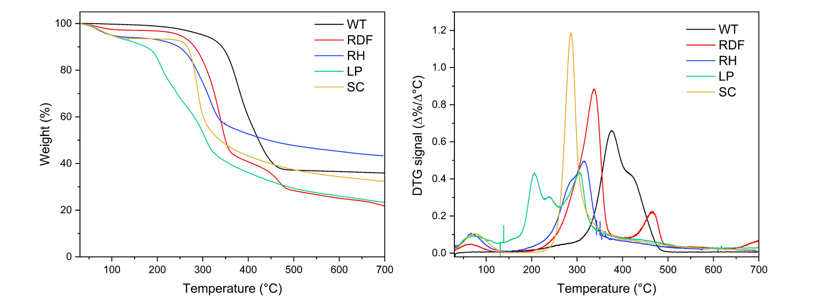
Figure 1: TG (left) and DTG (right) curves of the feedstocks (N₂, 40 mL/min, HR=5°C/min)
In all the cases the thermal decomposition of the feedstock’s components ends at 550°C leading to the production of a thermal stable solid residue (char). As expected, the final amount of char reflects the feedstock’s composition (Table 1). From RH the highest amount of solid residue (48 wt.%) is produced, while the lowest is obtained by LP and RDF (around 20 wt.%).
Table 2 reports the compositions of all the char samples and pyrolysis oils derived from WT and RDF. RDF-char is characterized by the lowest carbon content (30.89 wt.%) and by a low thermal stability as testified by the TG profile under an oxidative atmosphere (Figure 2) exhibiting three main weight losses peaked at 410°C, 500°C and 680°C, respectively. The prominent weight losses below 500°C for RDF-char indicates both a structure easily oxidizable and the occurrence of catalytic phenomena driven by the high ash content, as testified by the unburned residue (above 45 wt.%). WT-char exhibits a quite high carbon content (88.8 wt.%), a very low hydrogen content (0.03 wt.%) and a not negligible sulphur content (3.2 wt.%). WT-char is also characterized by a high thermal stability in air, suggesting a good degree of graphitization. As a matter of facts, looking at the TG profile in Figure 2, the burn-off of WT-char occurs at a temperature above 600°C, typical of well-structured carbonaceous materials with a good degree of graphitization like combustion derived products (Gargiulo et al. 2023). Even though LP-char contains 55.9 wt.% of carbon and low contents of hydrogen and nitrogen (0.65 wt.% and 0.35 wt.%, respectively), it is the least thermally stable of all the char samples tested (burn-off before 500°C). This behaviour suggests a poorly structured carbon network and catalytic effects promoted by the high ash content (above 20 wt.%). SC-char contains a quite high carbon content (70.8 wt.%) and a very high nitrogen content (8.5 wt.%) in accordance with the composition of the starting feedstock (Table 1). SC-char exhibits a thermal profile characterized by only one main event peaked around 550°C testifying a quite good degree of graphitization.
Table 2: Pyrolysis products composition (n.d., not determined)
 | C (wt.%) | H (wt.%) | N (wt.%) | S (wt.%) | Other elements (wt.%)
RDF-char | 30.9 | 0.28 | 0.29 | 0.53 | 67.9
RDF-oil | 61.4 | 10.3 | 0.70 | n.d. | 21.6
WT-char | 88.8 | 0.03 | 0.10 | 3.20 | 7.87
WT-oil | 75.2 | 9.40 | 0.20 | n.d. | 15.2
LP-char | 55.9 | 0.65 | 0.35 | n.d. | 43.1
SC-char | 70.8 | 1.50 | 8.50 | n.d. | 19.2
RH-char | 44.5 | 1.10 | - | n.d. | 54.4
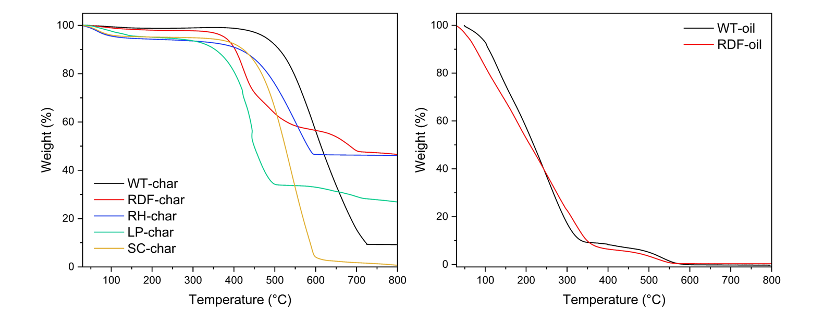
Figure 2: TG curves (air, 40 mL/min, HR=10°C/min) of char samples (left) and oil samples (right).
RH-char is characterized by a quite low carbon content (44.5 wt.%) and a not negligible amount of hydrogen (1.10 wt.%). RH-char exhibits also a quite high thermal stability, indeed, its TG profile is characterized by only one thermal event above 550°C. RH-char, like LP-char and RDF-char, is very rich in ash (50 wt.%).
The compositions of the two oils are quite different: WT-oil exhibits the highest carbon content while RDF-oil the highest hydrogen content. Such a difference can be explained considering that the pyrolytic decomposition of rubber in WT leads to aromatic species (Ye et al. 2022), while the presence of polymer-based materials in RDF leads to the formation of waxes and aliphatic hydrocarbons (Alfè et al. 2022). At convers, the thermal behaviour is almost comparable (Figure 2, right panel): a massive devolatilization/decomposition of both samples occurred before 350°C, and the decomposition of the heavier residue is completed after 550°C.
The crystallinity of the char samples was probed by X-ray diffraction and the resulting patterns are reported in Figure 3 (left). Looking at the XRD patterns of RDF-char and LP-char, it is worth of note that the diffraction peaks ascribable to the inorganic components prevail on the broad peak expected for the amorphous carbon fraction. In both cases calcite (CaCO₃) is the main inorganic component identified. The WT-char can be considered a mixture of amorphous and crystalline materials: the broad band peaked around 25 2θ° is ascribable to the amorphous carbon fraction and the broad peaks between 25-60 2θ° mainly to ZnS and ZnO (Gargiulo et al. 2023). SC-char exhibits a XRD pattern typical of an amorphous carbon with a main broad peak around 25 2θ°. CR-char XRD pattern is also characterized by a main broad peak but shifted toward lower 2θ° (the maximum is around 21 2θ°) due to the very high concentration of SiO₂.
The surface chemistry of the different char samples was investigated by infrared spectroscopy (Figure 3, right panel). RDF-char and LP-char FTIR spectra are characterized by a broad band between 3000–3700 cm⁻¹ due to O-H stretching vibrations (and possible adsorbed H₂O), a band peaked around 1580 cm⁻¹ ascribable to the skeletal vibration of C=C and/or C=O bonds, an intense band peaked around 1480 cm⁻¹ and less intense bands below 1000 cm⁻¹ ascribable to vibrational modes of inorganic components. The FTIR spectra of WT-char and SC-char are characterized by a broad band in the 3000–3700 cm⁻¹ range related to O-H stretching vibrations (possible adsorbed H₂O), overlapping bands at 1100–1600 cm⁻¹ due to the skeletal vibration of C-C, C=C and C=O bonds of the carbonaceous network and low intense bands between 700-1000 cm⁻¹ ascribable to the bending of aromatic out of plane C-H bonds. In SC-char spectrum of note is the presence of a small peak around 2200 cm⁻¹ ascribable to N-containing groups.
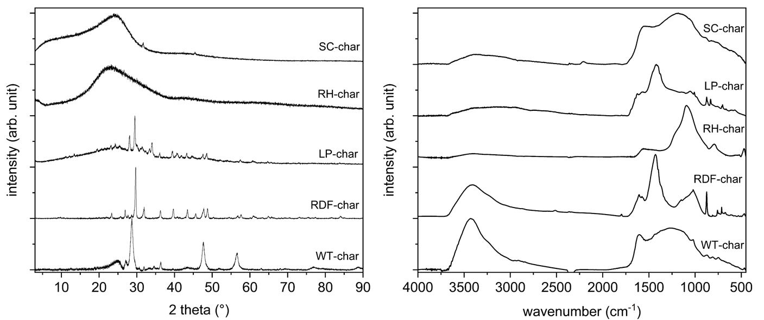
Figure 3: (left) XRD pattern of char samples. (right) FTIR spectra of char samples
RH-char FTIR spectrum contains broad peaks between 1600 and 1000 cm⁻¹ belonging to skeletal vibration of C-C, C=C and C=O bonds in complex carbon network and an intense peak at 1100 cm⁻¹ due to Si-O-Si stretching mode signal (Gargiulo et al. 2019).
The time cure tests results of the char addition to a low penetration grade bitumen are shown in Figure 4.
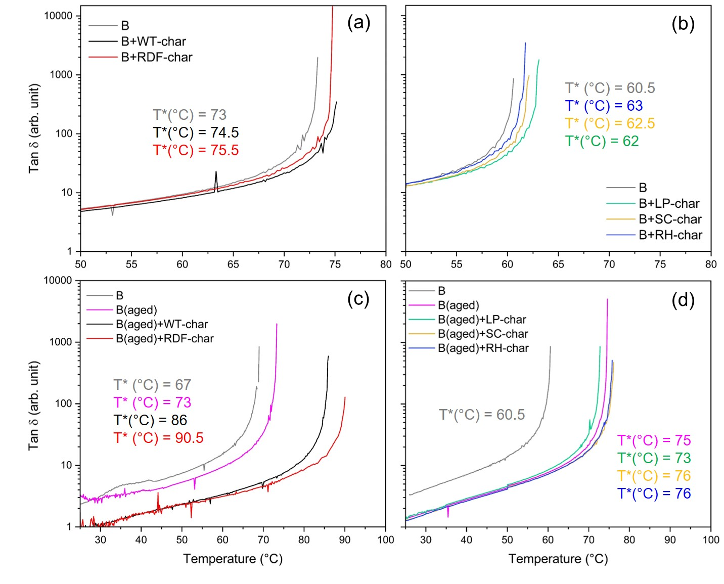
Figure 4: Tan δ as a function of temperature for the neat bitumen (B) when modified by char samples from civil wastes (a) and agricultural/aquaculture wastes (b). Tan δ as a function of temperature for the aged bitumen (B(aged)) when modified by char samples from civil wastes (c) and agricultural/aquaculture wastes (d)
Tan δ diverges at higher temperatures in bitumens modified with char samples, demonstrating their role as bitumen modifiers (Figure 4, panels a and b). The increase of the temperature transition (T*, namely the temperature at which gel-to-sol transition takes place) indicates a higher temperature resistance and a strengthening of the overall chemical structure of the bitumens modified with char. A slightly higher reinforcement effect in the case of WT and LP derived char samples is evidenced. Based on the results reported in Figure 4 (panels a and b), it can be concluded that all the char samples can be used bitumen modifier, but those deriving from WT and LP lead leading to a larger increase of T*. In the case of WT-char, reasonably, this result is ascribable to the higher carbon content (88.8 wt.%) allowing for a better dispersion inside binder mixture. The ability of char to act as bitumen modifier was tested also in the case of aged bitumen. To this aim, neat bitumen underwent an artificial ageing process, and then it was modified with char. Also, in the case of aged bitumen, the addition of char leads to an increase of T*, but surprisingly the effects are quite different from those detected in the case of neat bitumen. Indeed, the addition of WT-char and LP-char to the aged bitumen corresponds to a lower increase of transition temperature. This result is opposite to the effect occurring as consequence of the addition of char to the neat bitumen and can be interpreted taking into consideration that the aged bitumen is reached in oxygen functional groups and different interactions with char structure can take place. This opens the door to possible use of such char samples as anti-ageing agent. The effect of WT-char as anti-ageing agent has been already probed (Gargiulo et al. 2023), while experiments to probe anti-ageing effects exerted by LP-char are ongoing.
Regarding the use of bio-oil as an additive, in this work, the ability of WT-oil to act as a rejuvenating agent was also investigated. Studies on RDF oil are ongoing. Bitumen was subjected to RTFOT procedure extended up to 225 minutes and then modified with 6 wt.% of WT-oil. The addition of WT-oil causes a shift of T* to a lower temperature (T* of neat bitumen ~65°C, T* of aged bitumen ~80°C, T* of aged bitumen with WT-oil ~68°C) due to the partial restoring of the initial mechanical properties. The aged bitumen tends, after oil addition, to recover the pristine viscosity and plasticity reaching values quite close to those of the neat bitumen.
  - Conclusions
This study showed how residues from the pyrolysis of wastes can be used to improve bitumens. The addition of char from the pyrolysis of tires (WT) or lemon peels (LP) to a benchmark bitumen results in a higher transition temperature. This effect is mainly related to the high carbon content of the char, especially WT-char, and its chemical compatibility with the bitumen, allowing its homogeneous dispersion within the bituminous molecular matrix through effective interactions. It was also demonstrated a very promising use of pyrolysis oil as rejuvenating agent to recover the bitumen pristine viscosity and plasticity after prolonged ageing.
Acknowledgments
This research was funded by @CNR Project ReScA “Recupero degli scarti da pirolisi di rifiuti urbani per potenziare e ripristinare asfalti”, decision of Administration Council dated 21 December 2021 and “ECCSELLENT - Development of ECCSEL R. I. ItaLian facilities: usEr access, services and loNg-Term sustainability” Code: IR0000020 – CUP F53C22000560006.
References
Alfè, M., Gargiulo, V., Porto, M., Migliaccio, R., Le Pera, A., Sellaro, M., et al., 2022, Pyrolysis and Gasification of a Real Refuse-Derived Fuel (RDF): The Potential Use of the Products under a Circular Economy Vision, Molecules, 27, 8114.
Alnadish, A.M., Katman, H.Y.B., Ibrahim, M.R., Gamil, Y., Mashaan, N.S., 2023, A bibliometric analysis and review on the performance of polymer modified bitumen, Frontiers in Materials 10, 1225830.
Caputo, P., Calandra, P., Loise, V., Le Pera, A., Putz, A.-M., Abe, et al., 2022, When Physical Chemistry Meets Circular Economy to Solve Environmental Issues: How the ReScA Project Aims at Using Waste Pyrolysis Products to Improve and Rejuvenate Bitumens. Sustainability, 14, 5790.
Gargiulo, V., Alfe, M., Ruoppolo, G., Cammarota, F., Oliviero Rossi, C., Loise, V., et al., 2023, How char from waste pyrolysis can improve bitumen characteristics and induce anti-aging effects, Colloids and Surfaces A: Physicochemical and Engineering Aspects, 676, 132199
Rondón-Quintana, H.A., Reyes-Lizcano, F.A., Chaves-Pabón, S.B., Bastidas-Martínez, J.G., Zafra-Mejía, C.A., 2022, Use of Biochar in Asphalts: Review, Sustainability, 14, 4745.
Ye, W., Xu, X., Zhan, M., Huang, Q., Li, X., Jiao, W., Yin Y., 2022, Formation behavior of PAHs during pyrolysis of waste tires, Journal of Hazardous Materials, 435, 128997.
Zhang, X., Zhang, K., Wu, C., Liu, K., Jiang, K., 2020, Preparation of bio-oil and its application in asphalt modification and rejuvenation: A review of the properties, practical application and life cycle assessment, Construction and Building Materials, 262, 120528.

