CHEMICAL ENGINEERING TRANSACTIONS  VOL. , 2024 | A publication of
The Italian Association
of Chemical Engineering
Online at www.cetjournal.it

Guest Editors: Leonardo Tognotti, Rubens Maciel Filho, Viatcheslav Kafarov
Copyright © 2024, AIDIC Servizi S.r.l.
ISBN 979-12-81206-09-0; ISSN 2283-9216

Effectiveness and Quality of Coating Different Polymeric Coupons with Cellulose Hydrogels
Bianca R. Estevam^{a,}*, Gabriel A. Azevedo^{b}, Aldemir A. Cavallini Junior^{c}, Rubens Maciel Filhoª, Ângela M. Moraes^{b}, Leonardo V. Fregolente^{a,}*.

ªLaboratory of Optimization, Design and Advanced Control - School of Chemical Engineering, University of Campinas (UNICAMP), 13083-852 Campinas-SP, Brazil.
^{b}Laboratory of Engineering of Products and Processes in Bioresources - School of Chemical Engineering, University of Campinas (UNICAMP), 13083-852 Campinas-SP, Brazil.
^{c}Structural Mechanics Laboratory - School of Mechanical Engineering, Federal University of Uberlândia (UFU), 38408-100, Uberlândia-MG, Brazil

corresponding authors e-mail: b262792@dac.unicamp.br and leovf@unicamp.br
This study aimed to analyse and compare the effects of dip-coating with cellulose hydrogel coupons of Acrylonitrile Styrene Acrylate (ASA), polyamide (Nylon®), and Tritan® to produce hydrophilic structures for water uptake from fuels. In this process, the polymeric substrates were immersed in a cellulose solution after adding the crosslinking agent (epichlorohydrin). The samples were kept in the solution at 30 ºC for 1 h and then removed at a withdrawn speed of 98 or 410 mm.min⁻¹. The coated and uncoated materials were characterized regarding contact angle, mass of hydrogel adhered and surface morphology. In addition, the roughness of the uncoated substrates was measured. The samples underwent sequential swelling and drying cycles to evaluate water retention and the possibility of reusing the material. Tukey test, at a 95 % confidence level, was used to assess differences in roughness, the mass of adhered hydrogel, contact angle, and swelling degree for each polymeric substrate and condition analysed. The coated coupons exhibited increased hydrophilicity when compared to the uncoated control group, reaching a water contact angle of around 50 º. ASA displayed the greatest incorporation of hydrogel; however, it was mainly retained in the grooves of the material, limiting its ability to interact with water. Meanwhile, the hydrogel film formed on Nylon® coupons achieved a higher degree of swelling (3.5-3.9 g.g⁻¹). Thus, this study demonstrated that the material used in the coating process strongly influenced the characteristics of the hydrogel film formation and its performance regarding water retention.
  - Introduction
The use of hydrogels as oil desiccants represents a novel technique that has been recognized for its promising results both with synthetic and natural polymers (Arthus et al., 2023). Notably, among natural hydrogels, those derived from cellulose stand out due to their cost-effectiveness, good mechanical properties, and suitable water retention capacity (Estevam et al., 2023). When designing continuous-flow systems for oil dehydration, incorporating structured packings is advantageous as they enhance mass transfer with low pressure drop. However, the geometric complexity of structured packings hampers the production of hydrogel particles with these configurations. An alternative approach is to produce structured packing using traditional polymers through additive manufacturing and coating them with hydrogels to form a hydrophilic film over the structure surface (Gonçalves et al., 2021).
Hydrogel-coated structures have numerous applications in fields that require high mass transfer areas. Examples of applications include membranes for oil-water separation; removal of dyes, salt, and metal ions from wastewater; surfaces with controlled corrosion and self-cleaning properties; and medical devices such as cardiovascular stents, orthopaedic implants, flexible electronics, and encapsulation of structures for the production of bioactive composites (Tang and Yan, 2017).
Among coating techniques, the dip-coating method stands out for its simplicity and cost-effectiveness (Jebali et al., 2024). This technique involves three major steps: immersing the substrate in the precursor solution for a required time to promote the desired interaction, removing the substrate for drainage, and evaporating excess solvent by heating in a dry environment (Jeong et al., 2023). Despite being simple, the dip-coating process involves complex multivariable chemical and physical parameters, including immersion time, withdrawal speed, number of immersion cycles, fluid density and viscosity, surface tension, substrate surface area, and evaporation conditions (Tang and Yan, 2017). In case of coating the surfaces with hydrogels, the density and surface tension vary throughout the process, making the dynamics more complex (Jebali et al., 2024). Furthermore, the success of the process depends on the adequate interaction between the substrate surface (material to be coated) and the hydrogel that will form the film (Jeong et al., 2023). Thus, before producing the structured packed bed, it is essential to conduct a preliminary study to select the most suitable material for substrate synthesis and determine the most viable coating conditions.
In this work, coating of different polymeric coupons with cellulose hydrogel was evaluated. Three materials, Acrylonitrile Styrene Acrylate (ASA), polyamide (Nylon®), and Tritan® were selected as substrates due to their strong mechanical properties and high chemical stability. Furthermore, these types of materials are commercially available as polymeric filaments to be used in additive manufacturing of products with complex geometries. The primary objective of this investigation was to form a uniform hydrogel film on specimens made from these polymers to enhance hydrophilicity and improve water retention. The characteristics and conditions for hydrogel film deposition were investigated to select the polymeric substrate for further evaluation in the manufacturing of structured packing beds for oil treatment systems.
  - Methodology
    - Production of the coupons by additive manufacturing
Polymeric coupons of ASA, Nylon®, and Tritan® were made by additive manufacturing technique (3D printing) by Fusion and Deposition Modeling (FDM). The samples were 30x30 mm² in size and 3.0 mm thick. The specimens were printed with 100 % infill, using a printing speed of 30 mm.s⁻¹ and a printing table temperature of 235 °C. The extrusion temperature was maintained at 240 ºC for ASA, 235 ºC for Nylon®, and 265 ºC for Tritan®. These conditions are in accordance with recommendations of the equipment and filaments supplier for each type of polymer. Prior to coating, the coupons were washed with water and ethanol and dried in an oven at 60 ºC until constant mass. The roughness of the pieces was measured in triplicate at the center region of the samples using a Mitutoyo SJ-201 rugosimeter.
  - Coating procedure
Microcrystalline cellulose (4 % in weight) was dissolved in NaOH:urea:H₂O solution (7.5:11.5:81 by weight) at a temperature below 5 °C under constant stirring (750 rpm) for 2 h. After complete solubilization, the solution was maintained for 30 min at -18±2 ºC and stored at 2.5±0.8 °C. Then, it was heated to 30 °C and mixed with 10 % (in volume) of epichlorohydrin (Estevam et al., 2023). Immediately after adding the crosslinker, the coupons were dipped into the hydrogel solution and remained immersed in it for 1 h at 30 °C and 750 rpm stirring speed, to facilitate hydrogel formation over the specimens (Tang and Yan, 2017). Afterward, the coupons were raised, drained by dripping for approximately 1 min, and were cured in an oven at 60 ºC for 4 h. The effect of the speed at which the substrates are removed from the hydrogel solution (withdrawal speed) was evaluated at 410 or 98 mm.min⁻¹. Eventual residues and excess reagents were removed by washing the coupons by immersion in distilled water for 24 h with periodic changes of the water. Then, the samples were dried in an oven for 24 h at 60 ºC. The curing, washing and drying processes were performed with the coupons suspended to avoid compromising the coating quality. After the coating process, the coupons were stored in Petri dishes and kept in a silica desiccator at room temperature.
  - Assessment of coating effectivity and quality
The mass of hydrogel incorporated on the polymeric coupons was determined gravimetrically by calculating the difference in mass between the uncoated and coated samples subjected to withdrawal speeds of 410 or 98 mm.min⁻¹. Measurements were performed in triplicate.
The hydrophilicity of the structures was estimated through the contact angle. For this, a drop of deionized water was deposited on the coupons and its angle with the surface was measured using a OCA20 equipment, Dataphysics. The measurements were taken in 5 different regions of each of the samples prepared in triplicate to assess the homogeneity of the structure’s hydrophilicity. The analysis was performed with coated (using 410 mm.min⁻¹ withdrawal) and uncoated samples to evaluate the increase in hydrophilicity.
The Tukey’s test was used to evaluate the differences in the mass of hydrogel incorporated on the different polymeric substrates and withdrawal speed, and to assess the difference in the hydrophilicity between the uncovered polymeric substrates and covered samples. The analysis was performed using the Statistica7® Software with a confidence level of 95 % (Witte and Witte, 2017).
The quality of the coating and the modifications imposed on the structure of the polymeric coupons were evaluated using a High-Resolution Scanning Electron Microscope (ThermoFisher Scientific, model Quattro S equipment). Surface and cross-section regions of coated (at 410 mm.min⁻¹ withdrawal) and uncoated samples were evaluated. The equipment was operated at a voltage of 10 kV with a current of 23 pA and a spot size of 2.5 nm. The surface of the coupons was analyzed at 50 x magnifications, while the cross-section region was analyzed using magnifications of 500 x and 1,000 x. To allow the visualization of the cross-sections, the coupons were previously immersed in liquid nitrogen for approximately 30 seconds and fractured with pliers.
  - Swelling degree in water
The swelling of the coupons coated with the hydrogel at a withdrawal speed of 98 mm.min⁻¹ was measured by immersing the samples in 200 mL of distilled water at 45 °C for 24 h. The mass difference between dried and swollen samples was used to calculate the swelling degree (Fregolente et al., 2018). The stability of the coating was analyzed by submitting the samples to 3 cycles of swelling (at 45 ºC for 24 h) and drying (at 60 ºC for 24 h). In each cycle, the mass of samples and swelling degree were determined after removing the excess of water by gently blotting the material with a paper towel. Analysis was performed in triplicate and the Tukey test, at 95 % confidence, was used to evaluate the differences in swelling degree and mass of hydrogel adhered in each cycle (Witte and Witte, 2017). Thus, it was possible to identify the feasibility of using the coated coupons in several cycles of water uptake and drying regeneration. For comparison purposes, three replicates of uncoated polymeric coupons and particles of cellulose hydrogel were submitted to the same swelling-drying conditions.
  - Results and discussion
The results of the roughness and mass of hydrogel deposited on the coupons are described in Table 1. It is observed that the polymer used to produce the coupons significantly influenced the amount of hydrogel incorporated. Notably, ASA and Tritan® coupons exhibited roughness significantly greater than those made from Nylon® (Table 1). However, Tritan® coupons demonstrated lower levels of hydrogel incorporation than ASA coupons. In the case of ASA substrates, the roughness may have favored the incorporation of hydrogel on the surface, which is significantly higher than that observed for Nylon® (coated at 98 or 410 mm.min⁻¹ withdrawal speed) and Tritan® coupons (coated at 410 mm.min⁻¹ withdrawal speed) at 95 % confidence. The analysis of the effect of withdrawal speed for coupons made from the same polymers indicates that this factor was significantly different for Nylon® substrates. The literature indicates that at low withdrawal speed, the coating process follows a capillary regime, allowing for a greater amount of hydrogel to be incorporated into the substrate. Meanwhile, at higher withdrawal speeds, the reduced time for the solution to traverse the substrate hinders the incorporation of hydrogel into the polymeric coupon (Jeong et al., 2023). However, the long period that the samples remained immersed in the hydrogel solution (1 h) may have led to a reduction in the effect of the withdrawal for the ASA and Tritan® samples (Tang and Yan, 2017).
The variance in the amount of hydrogel incorporated on the different polymeric substrates may be attributed to the surface characteristics of the coupons, such as roughness, and adhesiveness to other polymers. Sanatgar et al. (2017) explained that the filaments and printing conditions highly impact the adhesiveness of the materials. Substrates composed of Nylon® and ASA typically exhibit strong interfacial adhesion to other polymers, whereas materials made from Tritan® are less prone to interact with other polymers (Sanatgar et al., 2017; Zhang et al., 2021). Besides, under identical printing conditions, the use of different filaments can result in surfaces with distinct roughness due to the different resolutions achieved by each filament during the printing process (Osman and Lu, 2023). The obtained results suggest that the effectiveness of the coating process is not solely dependent on the roughness of the material. Instead, it arises from a complex interaction between the substrate and the hydrogel to achieve proper adhesion. This adhesion may be influenced by the surface characteristics of the substrates, printing conditions, use of pre-treatments prior to coating, type of hydrogel used, and also the coating conditions.

Table 1: Roughness of the substrates and mass of hydrogel incorporated on them for each withdrawal speed.
Polymeric substrate | Roughness of  uncoated coupon (μm) |  | Mass of hydrogel adhered (g) at different withdrawal speed
 |  |  |  | 410 mm.min⁻¹ | 98 mm.min⁻¹
ASA | 19.12±1.79ª |  |  | 0.149±0.087^{a/A} | 0.214±0.027^{a/A}
Tritan® | 18.60±3.58ª |  |  | 0.077±0.001^{a,b/A} | 0.071±0.015^{b/A}
Nylon® | 2.84±0.46^{b} |  |  | 0.027±0.005^{b/A} | 0.094±0.015^{b/B}
Lowercase letters indicate differences resulting from coupon polymer composition and capital letters indicate differences concerning coating condition, at 95 % confidence determined using the Tukey’s test.

The water contact angle of the uncovered surfaces was determined as 80.4±7.3 º for ASA, 63.6±3.6 ° for Tritan® and 62.6±5.6 º for Nylon®, indicating that all polymeric substrates exhibit a certain degree of hydrophilicity since their contact angles were lower than 90 º. This characteristic can benefit the incorporation of the hydrogel into the substrate by intermolecular interaction or by diffusion of similar molecules, resulting in the formation of a robust bond between the adhesive and the adherent material (Sanatgar et al., 2017). The Tukey test showed that the uncoated ASA coupons had a significantly greater contact angle than those made of Tritan® and Nylon®. This result may reinforce that, for ASA, the incorporation of the hydrogel was more related to surface roughness, while for Tritan® and Nylon®, the adhesion of the hydrogel was more dependent on the interactions between the substrate and hydrogel polymers. After the formation of the hydrogel film, the contact angle of the polymeric coupons significantly reduced in all the samples analyzed, reaching 48.6±7.7 º in ASA, 49.7±4.5 º in Tritan® and 55.4±5.5 º in Nylon® coupons. The contact angle of the coated surfaces was considered significantly equal at 95 % confidence, indicating that this parameter reflects the characteristic of the cellulose hydrogel formed on the surfaces. Furthermore, considering that the analyses included measurements in five distinct regions for each of the three replicates assessed per material, the low standard deviation obtained implies that the hydrogel film coverage pattern did not significantly vary among the different regions analyzed.
The quality of the coating was evaluated using high-resolution SEM on both the surface (Figure 1) and cross-section (Figure 2) regions. SEMs of the surface regions were generated at 50 x magnification. For the cross-section region, an increase of 500 x was used for the ASA and Tritan® coupons and 1,000 x for Nylon®. This difference was necessary to allow visualization of the presence of hydrogel in the substrate grooves, which are smaller and shallower in Nylon® coupons. In ASA coupons, the hydrogel exhibited an apparently thicker layer, making it challenging to visualize the original coupon topography. However, the formation of the film appeared more discontinuous, with discernible divisions between regions of hydrogel deposition (Figure 1d). Tritan® coupons displayed a thinner layer of hydrogel, with deposition spatially concentrated in groove regions (Figure 1e). In the case of Nylon® coupons, a thin film was identified, covering both the surface and the granules initially present on the substrate (Figure 1f). The polymeric substrate exhibited grooves as a result of the deposition of filaments lines during the printing. Upon analyzing the cross-sectional regions (Figure 2), it becomes evident that in Tritan® and Nylon® substrates, the hydrogel formed only a thin film layer over these grooves. In contrast, in ASA coupons, the grooves were completely filled by the hydrogel, which may result in a greater mass of hydrogel accumulated on the surface of the substrate. However, the hydrogel fraction retained within the grooves will have a less efficient interaction with the medium, which may impair their effectiveness of water uptake and can present some retraction force contrary to swelling. It is important to note that some irregularities and distortions observed in the cross-sectional images of the coated coupons may have resulted from the cutting process with torsion by clamps. Although this process was necessary to access the cross-sectional region of the samples, it could have caused wear and deformation of a part of the structures due to hydrogel drag. To minimize this effect and enable clear visualization of the cross-sectional region of the coupons, further tests should be carried out using a microtome.

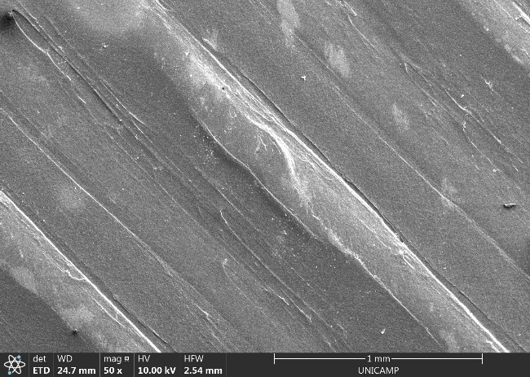  a | 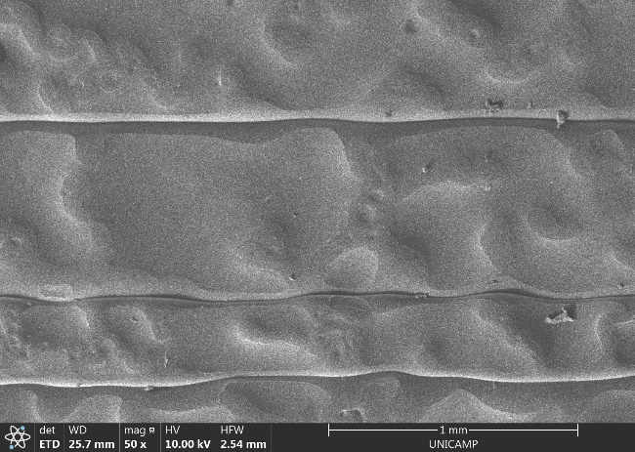  b | 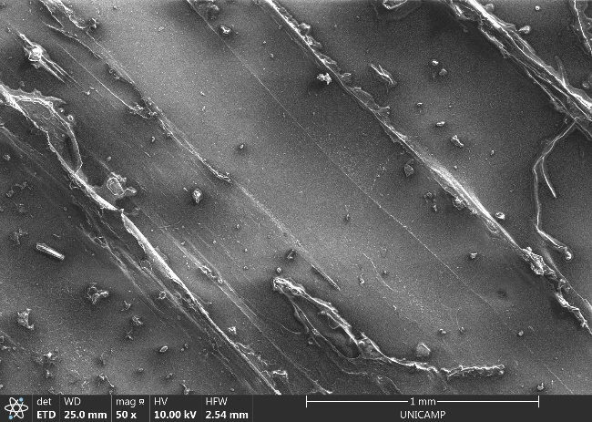  c
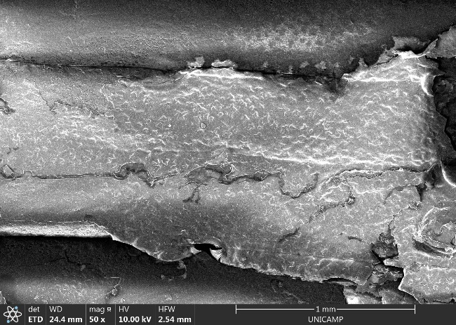  d | 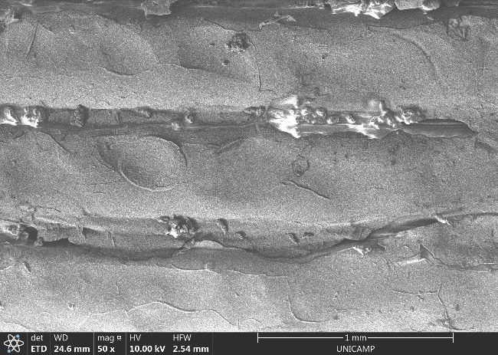  e | 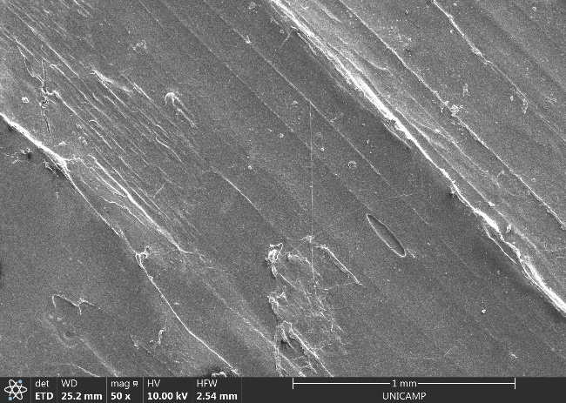  f
Figure 1: SEM of the surface of the coupons of ASA (a - uncoated and d - coated samples), Tritan® (b - uncoated and e - coated samples),and Nylon® (c - uncoated and f - coated samples).
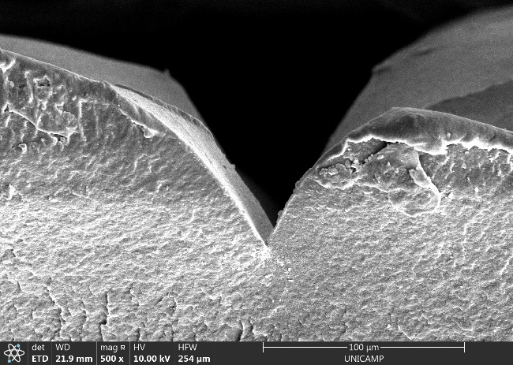  a | 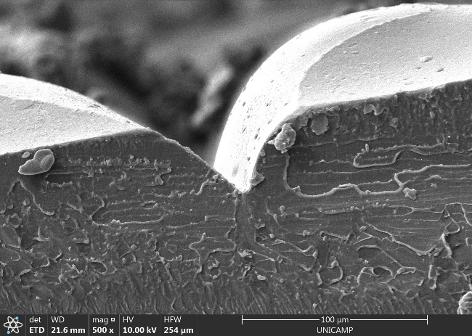  b | 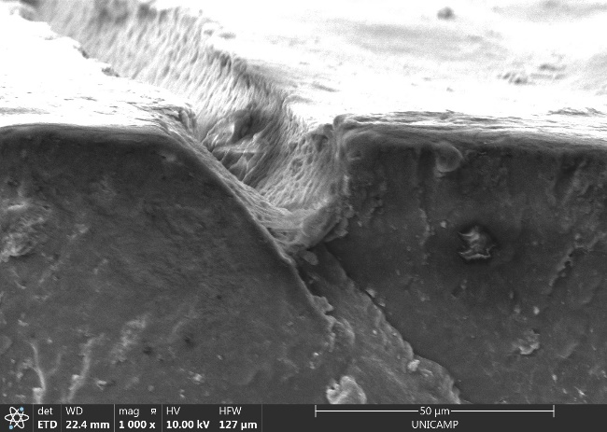  c
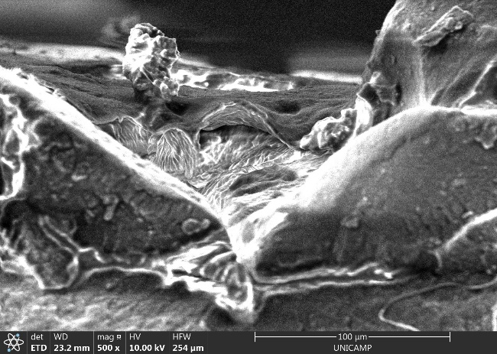  d | 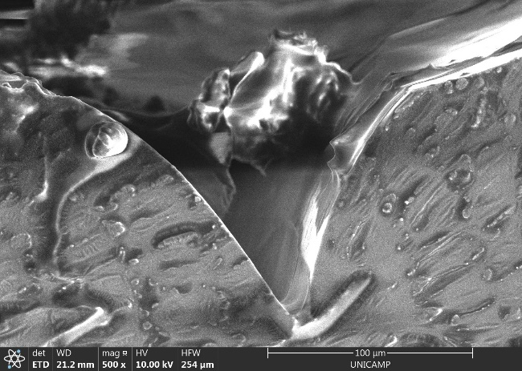  e | 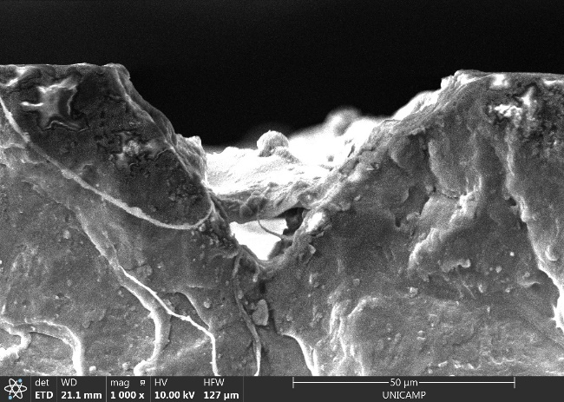  f
Figure 2: SEM of the cross-section of coupons of ASA (a - uncoated and d - coated samples), Tritan® (b - uncoated and e - coated samples),and Nylon® (c - uncoated and f - coated samples).

The swelling degree of the hydrogel film in distilled water varied significantly among the used polymeric substrates (Figure 3a). Notably, the lowest swelling was observed in ASA coupon, despite it showed the greater mass of incorporated hydrogel. In this case, a substantial portion of the hydrogel was trapped within the pores and grooves of the coupon (as observed in Figure 2d), hindering its interaction with water. Meanwhile, the hydrogel film on Nylon® and Tritan® samples reached a higher swelling degree, with Nylon® samples standing out by retaining up to 3.9 g of water per gram of adhered hydrogel. In these samples, the hydrogel film was formed on the outermost surface of the substrate, enhancing its ability to interact with water. The materials analyzed showed variations in the swelling degree (Figure 3a) and in the mass of incorporated hydrogel (Figure 3b) throughout the three swelling and drying cycles evaluated. This may be related to the gravimetric analysis method, which requires removal of the excess water by slightly pressuring the samples with a paper towel. This procedure could cause detachment of hydrogel. In addition, a fraction of the free water on the surface can remain trapped in the grooves, affecting the swelling degree value. However, at 95 % confidence, this variations were not significant. Consequently, it can be inferred that, within the analyzed conditions, the swelling capacity remains consistent across the three swelling cycles.

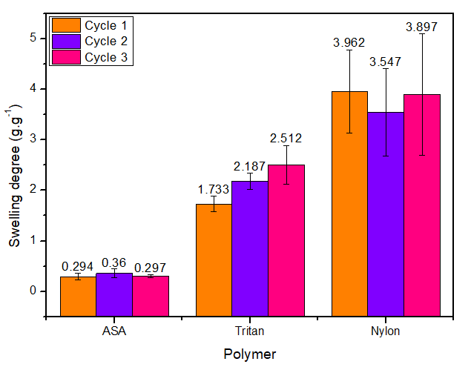  a | 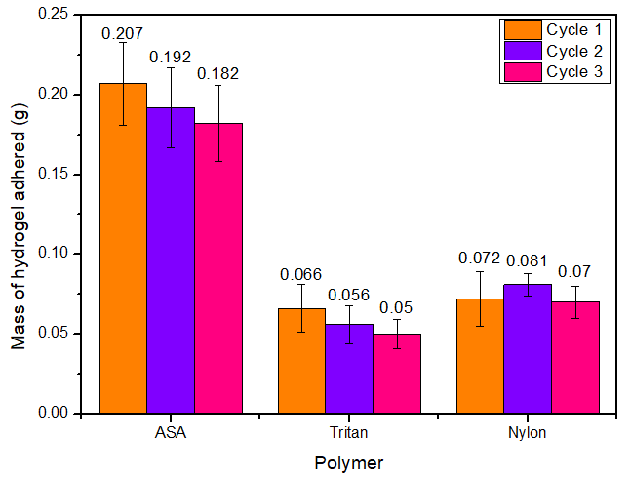  b
Figure 3: Swelling degree (a) and mass of incorporated hydrogel (b) of the evaluated polymeric coupons during the cycles of swelling and drying.

The analysis of the uncoated substrates showed that they presented a low swelling degree (0.011±0.001 g.g⁻¹ for ASA, 0.093±0.008 g.g⁻¹ for Tritan®, and 0.112±0.003 g.g⁻¹ for Nylon®). Therefore, the fraction of water retained by the polymers used to produce the coupons can be considered negligible. The swelling degree of cellulose hydrogel particles subjected to the same swelling conditions was 17.942±0.823 g.g⁻¹, which is almost 5 times higher than the value reached by the covered Nylon® substrates. In this context, Seidi et al. (2020) explain that the swelling of surface-attached hydrogels differs from free-standing hydrogels, as free-standing hydrogels can swell in three dimensions, whereas in surface-attached hydrogels the polymer chains have less mobility, with the swelling occurring linearly and mainly limited to the dimension perpendicular to the substrate. Therefore, it must be considered that systems utilizing materials coated with hydrogel films exhibit different performance characteristics compared to those using hydrogel particles.
  - Conclusion
The effectiveness of coating polymer coupons produced through 3D printing with cellulose hydrogels is strongly influenced by the substrate material, especially its roughness and interfacial adhesion. The withdrawal speed impacts the coat of Nylon® substrates by reducing the surface tension of the hydrogel solution and enabling a greater accumulation of hydrogel on their surface. Successful coating also relies on a positive interaction between the substrate polymer and the hydrogel. Among the materials examined, ASA coupons accumulated a greater amount of hydrogel (up to 0.2 g), but its entrapment in the substrate's grooves diminished the water retention capacity of the hydrogel, reaching a swelling degree of only 0.3 g.g⁻¹. On the Nylon® coupons, it was possible to form a thin hydrogel film in the outmost surface of the substrates, allowing greater water retention (3.9 g.g⁻¹) even with a reduced mass of hydrogel adhered (0.09 g). The coated material presented swelling degree and mass of hydrogel adhered significantly equal (at 95 % confidence) during consecutive cycles of swelling and drying. This suggests that the material can be used in at least three cycles of water uptake and drying regeneration. Further studies should encompass the measurement of hydrogel thickness film and adhesiveness. Furthermore, it is essential to assess coating conditions, such as immersion time and coating cycles, to identify optimal parameters that enhance the formation of the hydrophilic hydrogel film.
Acknowledgments
The authors acknowledge the funding provided by Petrobras S.A. with the University of Campinas Support Foundation, grant #2022/00024-6; the São Paulo Research Foundation (FAPESP), grant #2021/03472-7; the National Council for Scientific and Technological Development (CNPq), grant #314724/2021-4; and the Coordination for the Improvement of Higher Education Personnel (CAPES), finance code 001, through Institutional Internationalization Program (CAPES- PrInt) grant #18p52383/2023; and the Program of Academic Excellence (PROEX), grant #33003017034p8.
References
Arthus L, Fregolente PBL, Maciel MRW, Fregolente LV. Hydrogels for the Removal of Water Content from Liquid Fuels. Hydrogels. 1st ed., Taylor & Francis; 2023, p. 24.
Estevam BR, Vieira FF dos S, Gonçalves LH, Moraes ÂM, Fregolente LV. Cellulose hydrogels for water removal from diesel and biodiesel: Production, characterization, and efficacy testing. Fuel 2023;347:128449. https://doi.org/10.1016/J.FUEL.2023.128449.
Fregolente P, Gonçalves H, Wolf Maciel MR, Fregolente L. Swelling Degree and Diffusion Parameters of Poly (Sodium Acrylate-Co-Acrylamide) Hydrogel for Removal of Water Content From Biodiesel. Chem Eng Trans 2018;65:445–50. https://doi.org/https://doi.org/10.3303/CET1865075.
Gonçalves HL, Fregolente PB, de Andrade GM, Wolf Maciel MR, Fregolente L. Development of a Hydrogel Column for Water Removal from Fuels. Chem Eng Trans 2021;86:1117–22.
Jebali S, Vayer M, Belal K, Mahut F, Sinturel C. Dip-coating deposition of nanocomposite thin films based on water-soluble polymer and silica nanoparticles. Colloids Surfaces A Physicochem Eng Asp 2024;680:132688. https://doi.org/10.1016/j.colsurfa.2023.132688.
Jeong D-H, Xing L, Lee MKH, Vani N, Sauret A. Deposition and alignment of fiber suspensions by dip coating. J Colloid Interface Sci 2023;650:407–15. https://doi.org/10.1016/j.jcis.2023.06.180.
Osman A, Lu J. 3D printing of polymer composites to fabricate wearable sensors: A comprehensive review. Mater Sci Eng R Reports 2023;154:100734. https://doi.org/10.1016/j.mser.2023.100734.
Sanatgar RH, Campagne C, Nierstrasz V. Investigation of the adhesion properties of direct 3D printing of polymers and nanocomposites on textiles: Effect of FDM printing process parameters. Appl Surf Sci 2017;403:551–63. https://doi.org/10.1016/j.apsusc.2017.01.112.
Seidi F, Zhao W, Xiao H, Jin Y, Saeb MR, Zhao C. Radical polymerization as a versatile tool for surface grafting of thin hydrogel films. Polym Chem 2020;11:4355–81. https://doi.org/10.1039/D0PY00787K.
Tang X, Yan X. Dip-coating for fibrous materials: mechanism, methods and applications. J Sol-Gel Sci Technol 2017;81:378–404. https://doi.org/10.1007/s10971-016-4197-7.
Witte RS, Witte JS. Statistics. 11th ed. Wiley; 2017.
Zhang Y, Zhang X, Cao Y, Feng J, Yang W. Acrylonitrile-Styrene-Acrylate Particles with Different Microstructure for Improving the Toughness of Poly(styrene-co-acrylonitrile) Resin. Adv Polym Technol 2021;2021:1–13. https://doi.org/10.1155/2021/3004824.

