CHEMICAL ENGINEERING TRANSACTIONS  VOL. , 2024 | A publication of
The Italian Association
of Chemical Engineering
Online at www.cetjournal.it

Guest Editors: Leonardo Tognotti, Rubens Maciel Filho, Viatcheslav Kafarov
Copyright © 2024, AIDIC Servizi S.r.l.
ISBN 979-12-81206-09-0; ISSN 2283-9216

Novel Cellulose-Sodium Polyacrylate IPN Hydrogel for Biodiesel Dehydration
Giovana Almenara, Bianca R. Estevam*, Maria Regina W. Maciel, Leonardo V. Fregolente*.
Laboratory of Optimization, Design and Advanced Control – Department of Process and Products Design- School of Chemical Engineering, University of Campinas (UNICAMP), 13083-852 Campinas-SP, Brazil]
*corresponding authors e-mail: b262792@dac.unicamp.br and leovf@unicamp.br
This research proposes the use of a novel hydrogel made from cellulose and sodium acrylate using the Interpenetrating Polymeric Network (IPN) approach for biodiesel dehydration process. In this work, some experimental conditions of the hydrogel production were investigated. Firstly, the immersion time of the cellulose hydrogel into the solution with the compost of the second network were evalueted. Then, the initiation mechanism (thermal or photoinitiation) and the use of a catalyst was analyzed. The concentration of monomer (sodium acrylate) and crosslinking (methylene bis-acrylamide) on the second network was evalueted in a tow-level factorial design. The swelling degree was used as the response at 95 % confidence. The best performance was achieved by the IPN hydrogel prepared by immersing the cellulose hydrogel in a solution with 1 mol.L⁻¹ of AS and 0.03 mol.L⁻¹ of MBA for 48 h and using a photoinitiation process in the absence of a catalyzer. In this condition, the IPN reached a swelling degree of 19 g.g⁻¹, which is almost twice the value reached by the single-network cellulose hydrogel. In addition, the IPN hydrogel reduced about 42 % of the water concentration in the saturated biodiesel, achieving an efficiency value between those reached by the single-network hydrogel synthesized with cellulose (35 %) and sodium polyacrylate (56 %). Furthermore, the IPN may have improved mechanical resistance. Thus, this research demonstrates the potential to apply cellulose-sodium acrylate IPN hydrogel in biodiesel dewatering process, addressing the key point in the synthesis of this novel material.

  - Introduction
Polymeric hydrogels are three-dimensional networks made of hydrophilic macromolecules. These materials have various applications, including fuel dehydration (Bashir et al., 2020; Gonçalves et al., 2021). Cellulose is an advantageous polymer for hydrogel synthesis due to its widespread availability and low production cost (Kundu et al., 2022). However, cellulose hydrogels have limitations such as reduced hydrophilicity and moderate swelling capacity compared to synthetic polymeric hydrogels (Qureshi et al., 2020). These limitations can be overcome by adding hydrophilic polymers to cellulose. One of the most used approaches for this is the synthesis of hydrogels grafted onto cellulose (Bayramgil, 2018). This manuscript suggests an innovative alternative to improve the hydrophilicity of cellulose hydrogels: the addition of a second network using sodium acrylate to create an Interpenetration Polymeric Network (IPN). The literature points that this strategy can improve the hydrophilicity and impart greater mechanical properties (Niu et al., 2020) to make the material suitable to be applied for water uptake from biodiesel.
There are different methods for synthesizing IPN hydrogels, either through simultaneous or sequential steps. Simultaneous synthesis occurs when monomers and crosslinkers are mixed, and both the primary and secondary networks are synthesized at the same time through independent routes. Meanwhile, the sequential method involves the synthesis of a single-network hydrogel, which is then swollen into a solution containing the precursors for the second network, followed by the synthesis of the second network into the primary one (Zoratto and Matricardi, 2018). The synthesis of cellulose-based IPN typically utilizes the sequential approach due to better control of synthesis conditions and the superior performance of the resulting materials (Naseri et al., 2016). Parameters influencing the properties of IPN hydrogels include the swelling time of the hydrogel in the solution containing the compounds of the second network, the type and concentration of these compounds, and the synthesis method of the second network (Niu et al., 2020). The second network can be synthesized through the free radical polymerization method. In this process, an active species (radical) undergoes division into two equal parts, each possessing unpaired electrons. This initiates a chain reaction as these radicals bind with other monomers, ultimately leading to the formation of the polymer (Santos et al., 2022). Radical formation can occur through thermal or photochemical decompositions. Although both processes allow for the formation of cellulose based IPN hydrogels, the literature suggests that IPN synthesized by photopolymerization exhibits greater homogeneity (Zoratto and Matricardi, 2018).
This research aims to investigate the synthesis of cellulose-sodium polyacrylate IPN hydrogels and determine, for the first time, its effectiveness in removing water from biodiesel. It was evaluated the time required for the proper entrance of the precursors of the second network inside the cellulose hydrogel, the initiation method, and the concentration of monomers and crosslinker of the second network, evaluating the swelling degree and the water removal from biodiesel. Thus, it assessed the benefits of introducing the second network for the intended application, comparing water removal efficiency in biodiesel using IPN and single-network hydrogels. Therefore, a novel hydrogel for biodiesel treatment is proposed.
  - Methodology
    - Synthesis of the single network cellulose hydrogel
The single network cellulose hydrogel was synthetized according the methodology described by Estevam et al. (2023) using microcrystalline cellulose. Initially, a solution of NaOH/urea/water was prepared following a mass proportion of 7.5/11.5/81. The solution was placed in an ice bath until it reached a temperature of 5 °C and then 4 % (in weight) of cellulose was added to the mixture and stirred at 750 rpm for 2 hours to ensure complete dissolution. Subsequently, the solution was cooled to -18 °C for 30 minutes and then stored at 2.5 °C for 24 h. After this period, the volume was measured, and the solution was gradually warmed until it reached 30 °C. Then, 10 % (in volume) of epichlorohydrin was added and stirred for 1 h. The mixture was transferred to Petri dishes and placed in an oven for 4 hours at 60 °C to complete the hydrogel formation. Then, the hydrogel samples were cut into discs with a diameter of 1.0 mm and washed by immersion in distilled water for 24 h, with periodic changes of water, to remove impurities and excess reactants. Finally, the hydrogel was dried in an oven at 60 °C for 24 hours and stored in silica desiccator until use.
    - Synthesis of the single network sodium polyacrylate hydrogel
The sodium polyacrylate hydrogel was synthetized following the methodology developed by Fregolente et al. (2023). For this process a solution was prepared with 9.2 % (in weight) of sodium acrylate (SA), 0.015 mol of N,N’-methylene-bis-acrylamide (MBA) per mol of AS and 0.011 mol.L⁻¹ of N,N,N,N’-tetramethylethylenediamine (TEMED) as catalyzer. The solution was bubbled with N₂ during 10 minutes at room temperature. Then, 0.4 g.L⁻¹ of potassium persulfate was added as initiator. The solution was maintained with N₂ bubbling until gel formation. The hydrogel was left to rest for 24 h to assure high monomer conversion, than cut and dried in an oven at 60 ºC for 24 h.
    - Optimization of the synthesis of the cellulose-sodium acrylate IPN hydrogel
The IPN hydrogel was synthesized by sequential method, in which the cellulose hydrogel (prepared as described in section 2.1) was immersed in a solution containing SA, MBA and the initiator. Primarily, it was evaluated the time required for the proper entrance of the precursors of the second network into the cellulose hydrogel. In this set of experiments, 0.2 g of cellulose hydrogel was immersed in 10 mL of solution with 3 M SA, 0.09 M of MBA, and 0.4 g.L⁻¹ of photoinitiator (Irgacure-2959). The samples were kept at a refrigeration (around 2.5 ºC) and in absence of light. The mass of the hydrogels was measured after 24, 48 and 72 h to identify the equilibrium time of swelling into the monomeric solution. This methodology were based on the studies of Niu et al. (2020).
Once the swelling time was determined, the synthesis of the IPN hydrogel was evaluated regarding the initiation method, either thermal or photoinitiation, following the literature recommendations (Lin et al., 2019; Santos, 2020; Song et al., 2021). For these experiments, a 10 mL solution with the precursors of the second network was prepared maintaining the concentration of SA e MBA at 3 M and 0.09 M, respectively. In the case of thermal initiation, it was added potassium persulfate; and for photoinitiation Irgacure-2959 was used; both in the concentration of 0.4 g.L⁻¹. In the case of photoinitiation it was also verified the use of TEMED (0.011 mol.L⁻¹) as catalyzer, as proposed by Santos (2020). Both solutions were prepared with a total volume of 10 mL, mixed with 0.2 g of cellulose hydrogel and kept at a refrigerator for 48 h. Then, the samples with thermal initiator were placed in an oven at 60 °C for 6 h. Meanwhile, the samples with photoinitiator were kept in a photoreactor at 365 nm ultraviolet light intensity under nitrogen atmosphere. The nitrogen atmosphere was created by gas injection for 30 minutes before starting the process and maintained for another 1 hour after the beginning of light irradiation. The samples were kept at rest for 72 h under light, then washed by immersion in distilled water during 24 h, to remove any excess reactants, and dried in an oven at 60 ºC for 24 h. The IPN hydrogels prepared using both methods were evaluated regarding the mass of the IPN hydrogel and the swelling degree in water at room temperature (25 ºC) during 72 h. With this, the initiation method was selected.
The concentration of the monomer and crosslinker used in the synthesis of the second network was assessed using a 2² full factorial design, with the levels detailed in Table 1. The other synthesis conditions, such as swelling time and initiation method, were maintained as previously described and selected. The swelling degree was used as a response, which was evaluated in duplicate and analyzed in the Statistica® 10.0 software using 95 % confidence and pure error. For swelling, 0.1 g of hydrogel was immersed in 200 mL of distilled water and kept in a thermostatic bath at 37 ºC for 72 hours. The results obtained were also compared with those reached by the single network cellulose and sodium polyacrylate hydrogels.

Table 1: 2² factorial design used to investigate the concentration of monomer and crosslinker in the synthesis of the IPN hydrogel
Factors |  | Levels
 |  | -1 | 1
AS concentration (mol/L) |  | 1 | 3
MBA concentration (mol per mol of AS) |  | 0.03 | 0.05
    - Water removal from saturated biodiesel
The IPN hydrogel that reached greater swelling degree, according to the evaluation detailed in section 2.3, was investigated regarding water removal from biodiesel. For this, the commercial biodiesel was mixture with 5 % (in volume) of distilled water by magnetic stirring at 750 rpm for 30 minutes. Afterward, the mixture was transferred to a decantation funnel and left for 72 h at room temperature to remove the free water. Then, 25 mL of saturated biodiesel was mixture with 0.1 g of hydrogel and stirred at 150 rpm for 72 h at 30±5 ºC. With comparative propose, the single network cellulose and sodium polyacrylate hydrogels were also submitted to the same experimental conditions. Control samples (saturated biodiesel without hydrogel) was used to identify any water losses by other mechanism than hydrogel sorption. The water content in the oil prior and after the hydrogel treatment was determined by Coulometric Karl Fischer method (D6304-20 ASTM, 2021).
  - Results and discussion
    - Optimization of the synthesis of the cellulose-sodium polyacrylate IPN hydrogel
The analysis of the mass gain over time of the cellulose hydrogel immersed in the solution with the precursors of the second network revealed that the equilibrium was reached after 24 h. In this condition, the hydrogels with initial mass of 0.2 g presented a swollen mass of 2.20 g. This value remained similar after 48 h and 72 h, indicating that the 24 h time is sufficient to ensure the entrance of the precursors of the second polymeric network into the cellulose hydrogel. Similar results were obtained by Niu et al. (2020), who report that that after 24 h of immersion of cellulose hydrogels in a solution with acrylamide and bis-acrilamida, there was no mass gain and the resulting hydrogels presented equal mechanical resistance. To ensure that all the compounds necessary for the second network entered the cellulose hydrogel, a swelling time above the equilibrium (48 h) was applied in subsequent tests, according to the recommendations of Lin et al. (2019).
Regarding the initiation method, it was observed that all hydrogels had a similar increase in the dry mass, from 0.2 g in single network, to around 0.3 g in the IPN hydrogels prepared for both by thermal and photoinitiation. However, there were differences in the swelling degree reached by the prepared hydrogels. The IPN hydrogels synthesized by thermo initiation showed similar swelling degree (at 25 ºC) to the single network cellulose hydrogel, remained around 7.4±0.7 g.g⁻¹. Meanwhile, the hydrogels synthesized by photoinitiation presented a higher swelling degree, reaching 9.1±0.4 g.g⁻¹ in the absence of TEMED catalyst and 8.6±1.1 g.g⁻¹ with the use of the catalyst. Santos (2020) evaluated the synthesis of poly(acrylamide-co-sodium acrylate) hydrogels using thermal and photochemical initiation methods. Their results showed that the hydrogels synthesized by photoinitiation exhibited 1.6 times greater efficiency in removing water from biodiesel than those synthesized by thermal initiation. According to the author, this difference could be attributed to variation in the three-dimensional configuration generated by each initiation mechanisms, resulting in the exposure of hydrophilic groups in different regions of the hydrogels. Additionally, with the methods used, the photoinitiation technique allowed for greater control of the nitrogen atmosphere, which reduced the occurrence of parallel reactions between monomers and oxygen. Regarding the addition of the catalyzer, the addition of a TEMED can result in the immediate formation of free radicals, leading to a more compact entanglement (Huang et al., 2017). However, in the case of photoinitiation, the use of this catalyst did not have a significant impact on the synthesis of the IPN hydrogel. In this condition, the time required for the light to permeate within the hydrogel seems to have a greater effect on the synthesis process than the instantaneous generation of free radicals. Therefore, further research should focus on determining the optimal photopolymerization time for synthesizing cellulose-sodium polyacrylate IPN hydrogels. Based on the results obtained, the photoinitiation method without adding a catalyst was applied for synthesizing IPN hydrogels in subsequent experiments.
Based on the Pareto chart (Figure 1A), both the concentration of AS and MBA have a significant impact on the swelling degree of the IPN hydrogel at 95 % confidence. The negative effect of both factors indicates that the response (swelling degree) is more favorable at lower levels of both factors. This result is also supported by the graph of marginal means (Figure 1B), which shows that the best condition was achieved when using the concentration of AS and MBA at level -1. However, it is worth noting that the standard deviation bars overlap for different MBA levels, indicating that the responses may be similar, with a less relevant effect. The addition of monomers in the second network can increase the amount of hydrophilic groups of the hydrogel. Nevertheless, it creates a denser network, which can hamper the mobility of the hydrogels chains, reducing its expansion and the amount of water that the material it can retain (Singh et al., 2023). Despite this, the swelling degree obtained by the IPN hydrogel (synthesized with 1 mol.L⁻¹ of AS and 0.03 mol L⁻¹ of MBA) was 19.5±0.8 g.g⁻¹, which is approximately twice that of the single-network cellulose hydrogel subjected to the same conditions (10.5±0.1 g.g⁻¹), but still much lower the value reached by the sodium polyacrylate hydrogel (161.2±13.7 g.g⁻¹).

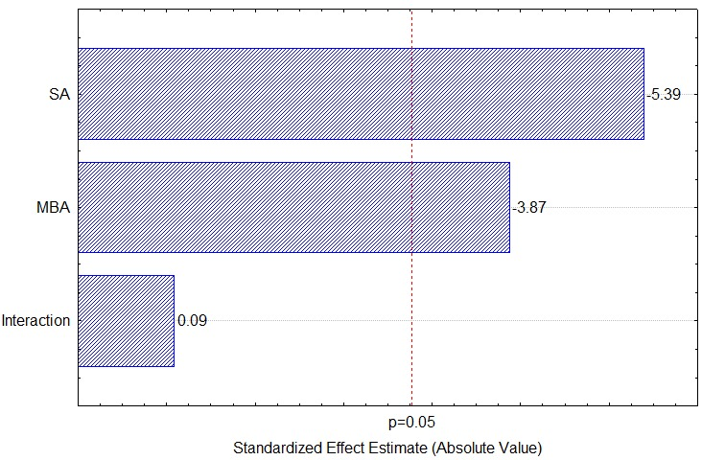  A | 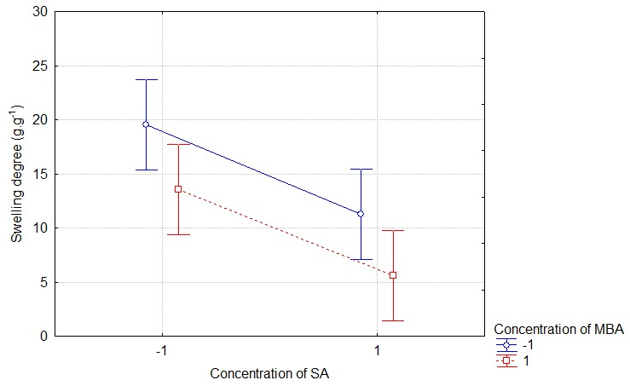  B
Figure 1: Pareto chart (A) and graph of marginal means (B) indicating the effects of the parameters evaluated in the 2² full factorial design using the maximum swelling degree as a response.

The reduction in the swelling degree with the increase in the concentration of composts of the second network was also reported by Lin et al. (2019) using cellulose-polyacrylamide IPN hydrogels. They observed that as the concentration of acrylamide increased from 1 to 5 mol.L⁻¹, the swelling degree was reduced from 24 to 7 g.g⁻¹. Chang et al. (2011) also varied the weight ratio of the compounds used in the second network (N-isopropyl acrylamide and bis-acrylamide) incorporated in cellulose hydrogel and reported that doubling the ratio of the compost of the second network, the swelling degree decrease from 60 g.g⁻¹ to 17 g.g⁻¹. Therefore, the obtained results agree with the literature and emphasize the significance of assessing the concentration of compost of the second network in IPN hydrogels. Despite this study focused on the analysis of the swelling degree as a response parameter to evaluate the IPN hydrogels, it is worth highlighting that this parameter may not imply a direct correlation with the removal of water from oils (especially for non-free water) as swelling can be influenced by chain mobility, regardless of its intrinsic hydrophilicity. Therefore, the relationship between the degree of swelling and effectiveness in water removal under specific conditions requires a thorough analysis, considering factors such as molecular mobility, for a more comprehensive understanding of the phenomena involved.
    - Water removal from saturated biodiesel
The creation of the second network into the cellulose hydrogel benefited the removal of water from the biodiesel (Figure 2). While the cellulose hydrogel presented the water removal efficiency of 31.32±5.27 %, the IPN hydrogel synthesized with 1 mol.L⁻¹ of AS and 0.03 mol.L⁻¹ of MBA using a photoinitiator process achieved a water removal efficiency of 41.94±0.98 %. In this condition, the water concentration in biodiesel reduced from 1,934±21 ppm to 1,114±18 ppm. The efficiencies reached with the IPN hydrogel is between the value achieved by the single-network hydrogel synthesized with cellulose (31.32±5.27 %) and sodium polyacrylate (56.26±3.33 %). This evidence that the addition of dissociated ionic charges from the sodium acrylate to the cellulose hydrogel structure can improve its water uptake from fuels. As far as we know, this is the first study that use IPN hydrogels to remove water from biodiesel. However, the advantages of adding sodium acrylate to hydrogels for water removal was also explored by Gonçalves et al. (2021), who achieved an efficacy of around 53 % in removing water from saturated biodiesel using poly(sodium acrylamide-co-acrylate) hydrogels. These results suggest that the cellulose-sodium acrylate IPN hydrogel performs comparably to single-network synthetic hydrogels. In addition, the development of a second network may provide other advantages, such as enhanced mechanical strength, warranting further investigations. Furthermore, economic analyses should be applied to assess the feasibility of the process.
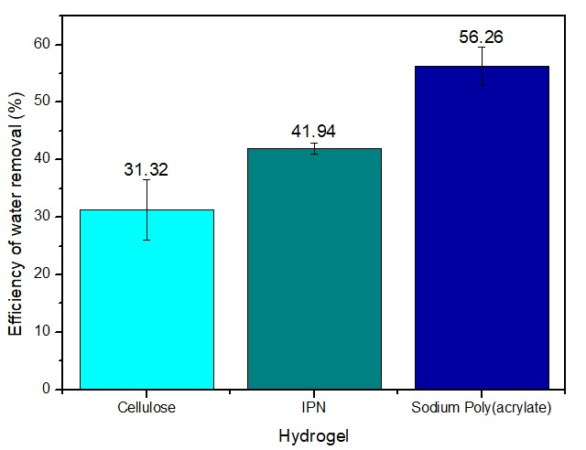
Figure 2: Efficiency of water removal from saturated biodiesel using different types of hydrogels.
  - Conclusions
This research demonstrates that incorporating an additional polymeric network of sodium polyacrylate into the cellulose hydrogel can enhance the hydrophilicity of the material, leading to increased swelling degree and water removal from biodiesel. The investigation of the synthesis conditions reveals that the cellulose hydrogel should remain in the solution with the precursors of the second network for at least 24 h, and the photoinitiation process allows for better material performance. A higher swelling degree was achieved by using 1 mol.L⁻¹ of AS and 0.03 mol.L⁻¹ of MBA in the synthesis of the second network. Under these conditions, the IPN hydrogel reached a swelling degree of around 19 g.g⁻¹ and removed 42 % of the water diluted in the biodiesel. Thus, this research demonstrated for the first time that the cellulose-sodium polyacrylate IPN hydrogel performs comparably to other synthetic polymeric hydrogels used for water removal from fuels and can be potentially applied as fuel desiccant after further technical and economic assessment.
Acknowledgments
The authors acknowledge the funding provided by the ANP'S Human Resources Program for the Oil and Gas Sector (PRH-23/ANP-finep) grand number 043919; the São Paulo Research Foundation (FAPESP), grant number 2021/03472-7; the Coordination for the Improvement of Higher Education Personnel (CAPES), Financing Code 001, through Institutional Internationalization Program (CAPES- PrInt) grant number 18p52383/2023; and the Program of Academic Excellence (PROEX), grant number 33003017034p8.
References
Bashir, S., Hina, M., Iqbal, J., Rajpar, A.H., Mujtaba, M.A., Alghamdi, N.A., Wageh, S., Ramesh, K., Ramesh, S., 2020. polymers Fundamental Concepts of Hydrogels: Synthesis, Properties, and Their Applications. Polymers (Basel). 12, 60. https://doi.org/10.3390/polym12112702
Bayramgil, N.P., 2018. Grafting of hydrophilic monomers onto cellulosic polymers for medical applications, in: Biopolymer Grafting: Applications. Elsevier Inc., pp. 81–114. https://doi.org/10.1016/B978-0-12-810462-0.00003-X
Chang, C., Han, K., Zhang, L., 2011. Structure and properties of cellulose/poly( N -isopropylacrylamide) hydrogels prepared by IPN strategy. Polym. Adv. Technol. 22, 1329–1334. https://doi.org/10.1002/pat.1616
D6304-20 ASTM, A. standard, 2021. Standard Test Method for Determination of Water in Petroleum Products, Lubricating Oils, and Additives by Coulometric Karl Fischer Titration. https://doi.org/10.1520/D6304-20
Estevam, B.R., Vieira, F.F. dos S., Gonçalves, L.H., Moraes, Â.M., Fregolente, L.V., 2023. Cellulose hydrogels for water removal from diesel and biodiesel: Production, characterization, and efficacy testing. Fuel 347, 128449. https://doi.org/10.1016/J.FUEL.2023.128449
Fregolente, L.V., Gonçalves, H.L., Fregolente, P.B.L., Maciel, M.R.W., Soares, J.B.P., 2023. Sodium polyacrylate hydrogel fixed bed to treat Water-Contaminated cloudy diesel. Fuel 332, 125953. https://doi.org/10.1016/j.fuel.2022.125953
Gonçalves, H.L., Bogalhos Lucente Fregolente, P., Wolf Maciel, M.R., Fregolente, L.V., 2021. Formulation of hydrogels for water removal from diesel and biodiesel. Sep. Sci. Technol. 56, 374–388. https://doi.org/10.1080/01496395.2019.1709506
Huang, C., Li, Y., Duan, L., Wang, L., Ren, X., Gao, G., 2017. Enhancing the self-recovery and mechanical property of hydrogels by macromolecular microspheres with thermal and redox initiation systems. RSC Adv. 7, 16015–16021. https://doi.org/10.1039/C7RA00317J
Kundu, R., Mahada, P., Chhirang, B., Das, B., 2022. Cellulose hydrogels: Green and sustainable soft biomaterials. Curr. Res. Green Sustain. Chem. 5, 100252. https://doi.org/10.1016/j.crgsc.2021.100252
Lin, F., Lu, X., Wang, Z., Lu, Q., Lin, G., Huang, B., Lu, B., 2019. In situ polymerization approach to cellulose–polyacrylamide interpenetrating network hydrogel with high strength and pH-responsive properties. Cellulose 26, 1825–1839. https://doi.org/10.1007/s10570-018-2171-y
Naseri, N., Deepa, B., Mathew, A.P., Oksman, K., Girandon, L., 2016. Nanocellulose-Based Interpenetrating Polymer Network (IPN) Hydrogels for Cartilage Applications. Biomacromolecules 17, 3714–3723. https://doi.org/10.1021/acs.biomac.6b01243
Niu, L., Zhang, D., Liu, Y., Zhou, X., Wang, J., Wang, C., Chu, F., 2020. Combination of acid treatment and dual network fabrication to stretchable cellulose based hydrogels with tunable properties. Int. J. Biol. Macromol. 147, 1–9. https://doi.org/10.1016/j.ijbiomac.2020.01.034
Qureshi, M.A., Nishat, N., Jadoun, S., Ansari, M.Z., 2020. Polysaccharide based superabsorbent hydrogels and their methods of synthesis: A review. Carbohydr. Polym. Technol. Appl. 1, 100014. https://doi.org/10.1016/J.CARPTA.2020.100014
Santos, F.B., 2020. Desenvolvimento de leitos de hidrogel de alto desempenho para remoção de água de combustíveis líquidos. Universidade Estadual de Campinas.
Singh, A.K., Itkor, P., Lee, Y.S., 2023. State-of-the-Art Insights and Potential Applications of Cellulose-Based Hydrogels in Food Packaging: Advances towards Sustainable Trends. Gels 9, 433. https://doi.org/10.3390/gels9060433
Song, F., Gong, J., Tao, Y., Cheng, Y., Lu, J., Wang, H., 2021. A robust regenerated cellulose-based dual stimuli-responsive hydrogel as an intelligent switch for controlled drug delivery. Int. J. Biol. Macromol. 176, 448–458. https://doi.org/10.1016/j.ijbiomac.2021.02.104
Zoratto, N., Matricardi, P., 2018. Semi-IPNs and IPN-based hydrogels, in: Polymeric Gels. Elsevier, pp. 91–124. https://doi.org/10.1016/B978-0-08-102179-8.00004-1

