CHEMICAL ENGINEERING TRANSACTIONS  VOL. , 2024 | A publication of
The Italian Association
of Chemical Engineering
Online at www.cetjournal.it

Guest Editors: Leonardo Tognotti, Rubens Maciel Filho, Viatcheslav Kafarov
Copyright © 2024, AIDIC Servizi S.r.l.
ISBN 979-12-81206-09-0; ISSN 2283-9216

Molecular Simulation of Hydrothermal Gasification of Digestate Sludge with Copper Catalyst Addition
Do Tuong Haª, Hien Duy Tong^{b}, Khanh-Quang Tran^{c,*}, Thuat T. Trinh^{d,*}
ªFaculty of Applied Sciences, Ton Duc Thang University, Ho Chi Minh city, Vietnam
^{b}Faculty of Engineering, Vietnamese-German University (VGU), Thu Dau Mot City, Binh Duong Province, Vietnam
^{c}Department of Energy and Process Engineering, Norwegian University of Science and Technology - NTNU, Norway
^{d}Porelab, Department of Chemistry, Norwegian University of Science and Technology - NTNU, Norway
* khanh-quang.tran@ntnu.no; thuat.trinh@ntnu.no
Hydrothermal gasification (HTG) has emerged as a promising technology for converting wet and low cost biomass and organic waste resources to valuable fuel gases including hydrogen and methane. In this study, hydrothermal gasification of digestate sludge, a promising approach for waste management and energy recovery from biogas plants, is investigated through molecular simulations. Copper catalyst addition is explored to enhance the process conversion efficiency. The results reveal significant improvements in gas yield and conversion rates upon copper nanoparticle catalyst addition. This work also sheds light on the catalyst aging mechanisms and offers valuable insights into optimizing hydrothermal gasification conditions for digestate sludge treatment, contributing to sustainable waste management practices and renewable energy generation.

  - Introduction

Digestate sludge originates from anaerobic digestion (AD) processes in wastewater treatment plants, where microorganisms break down organic materials without oxygen to produce combustible gas mixtures containing primarily methane and carbon dioxide (Li et al., 2011). The resulting digestate contains non-digestible matter and valuable nutrients such as nitrogen and phosphorus, making it suitable for agricultural use (Mata-Alvarez et al., 2014). However, challenges associated with digestate sludge include its variability in composition due to factors like feedstock type and pre-treatment methods used during anaerobic digestion (Nkoa, 2013), as well as potential risks linked to contaminants such as heavy metals and pathogens (Verstraete et al. 2011). Consequently, researchers are exploring alternative ways to effectively utilize digestate sludge, including HTG. Optimization of biomass conversion, like HTG of digestate sludge, is crucial for sustainable waste-to-energy technologies (Verstraete et al., 2011; Zhang et al., 2010; Tran et al., 2020; Mahmoodinia et al., 2017).

HTG is a process that occurs in supercritical water, typically at temperatures ranging between 500-700°C and corresponding pressures. The use of water as the reaction medium renders HTG highly compatible with the valorization of wet feedstock such as digestate sludge (Promdej & Matsumura, 2011). Due to its potential for generating hydrogen-rich syngas with reduced environmental impact compared to conventional gasification methods, HTG has significant potential. Using catalysts plays a crucial role in optimizing HTG reaction conditions, lowering the gasification temperature and pressure, as well as modulating product selectivity (Arregi et al., 2018; Guo et al., 2010 ). Copper-based catalysts have been widely studied for their effectiveness in improving the conversion of biomass to syngas during HTG (Guo et al., 2010). Another important aspect of using catalysts in HTG is their potential impact on the overall economics of the process. It is because, by lowering the temperature and pressure required for gasification, catalysts can contribute to cost savings and reduced energy consumption. This is particularly relevant when considering large-scale implementation of HTG technologies for waste management or renewable energy production (Nkoa, 2013).

In this paper, Reactive force field (ReaxFF) is utilized for investigating the HTG of digestate sludge. By employing ReaxFF simulations, researchers can analyze the molecular-level interactions between the digestate sludge components and the copper nanoparticle catalyst, as well as explore the impact of catalyst on gas yield and composition products. This computational approach allows for a deeper understanding of the underlying reaction mechanisms and provides valuable guidance for optimizing HTG conditions, ultimately contributing to more efficient waste management practices and renewable energy generation.

  - Models and methods
In this study, we investigated the HTG of digestate sludge using molecular simulations. Three simple model compounds were chosen for investigation: aspirin (acetylsalicylic acid), xylylenediamine, and sacrylamide. These representative model compounds were selected as they are present in digestate sludge solutions (He et al., 2022). Figure 1 shows the initial system containing Cu nanoparticle (Cu-NP) of a size of 4 nm and the three model components.

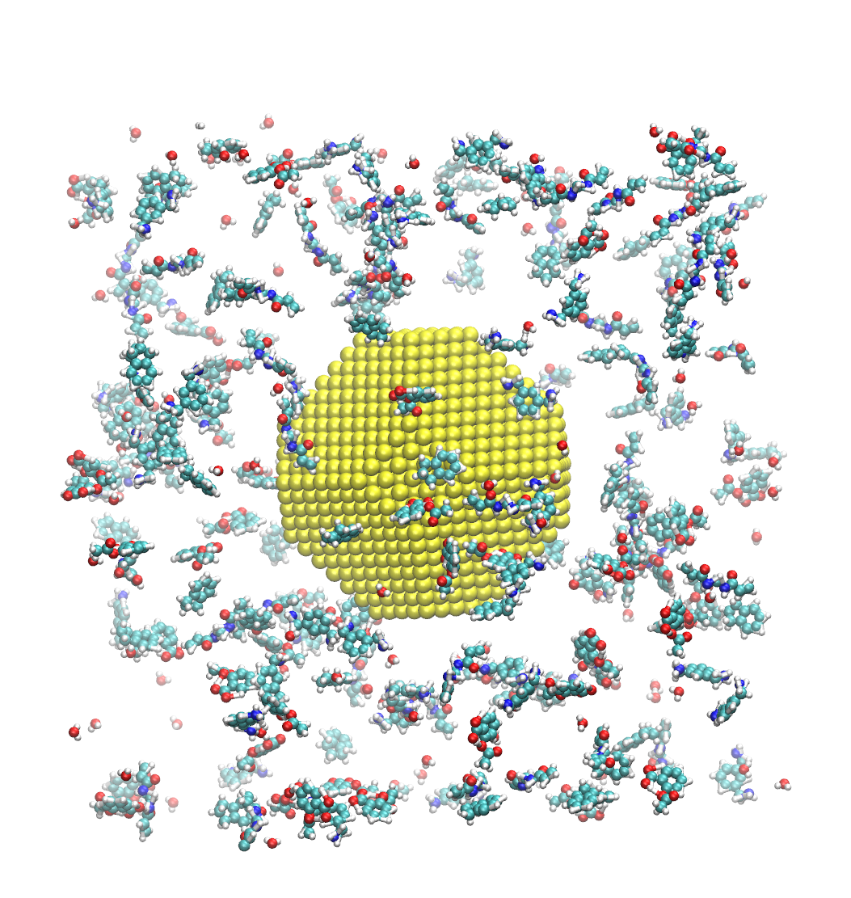
Figure 1: A model of digestate sludge with copper nanoparticle (Cu-NP) catalyst used in ReaxFF MD simulation of HTG process. The color yellow, green, blue, red and white represent Cu, C, N, O, and H, respectively.
ReaxFF (Reactive Force Field) is a bond-order based force field method used for molecular dynamics simulations of chemical reactions processes. It was developed to overcome the limitations of traditional force fields, which often fail to accurately describe the dynamic behavior of reactive systems due to their fixed bonding topology and limited parameter sets (van Duin et al., 2001). ReaxFF uses a reactive potential energy function that allows for the formation and breaking of chemical bonds in real-time during the simulation. The method is based on the bond order concept, where the strength of a chemical bond is determined by its overlap with adjacent atoms. This approach enables ReaxFF to accurately model complex reactions involving multiple bond-forming and breaking events, as well as changes in molecular structure and composition. For a more detailed description of the ReaxFF force field and its underlying methodology, interested readers should be referred to the original paper introducing ReaxFF (van Duin et al., 2001).

In this study, we employed the ReaxFF parameters proposed by Monti et al. (2013) to investigate the HTG process. To accelerate the reaction kinetics and overcome the time and length scale limitations inherent in molecular dynamics (MD) simulations, we conducted the simulations at elevated temperatures beyond those reported in the literature for experimental conditions (Reddy et al., 2014; Ha et al., 2024). The temperature range used for the HTG simulations in this work was between 3,000 K and 4,000 K, which is consistent with the temperature range employed in a previous study by Liu et al. (2020). It was common practice to speed up the chemical reaction in nanoscale simulations by simulating the HTG process at a temperature higher than the experimental settings (Liu et al. 2020). The total simulation time was set to 250 ps with a time step of 0.25 fs allowing for an accurate and efficient exploration of the HTG process.

  - Results and discussions
    - Formation of product phase

In this section, we present the gas product composition for both cases: with and without the catalyst addition. By comparing these compositions, we can observe the impact of the addition of Cu-NP catalyst on enhancing HTG efficiency and improving overall process performance.

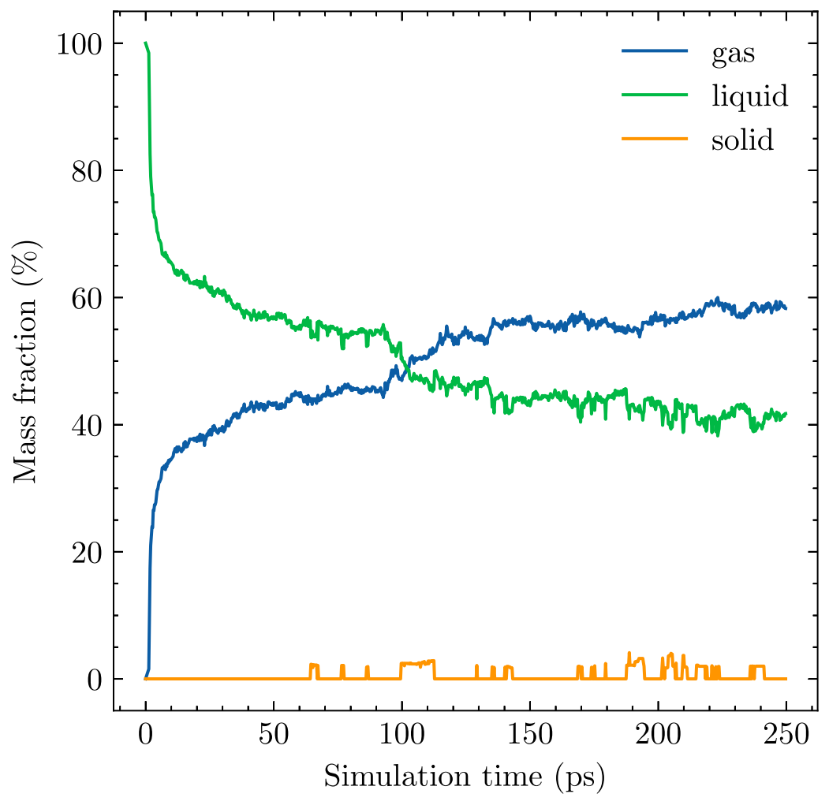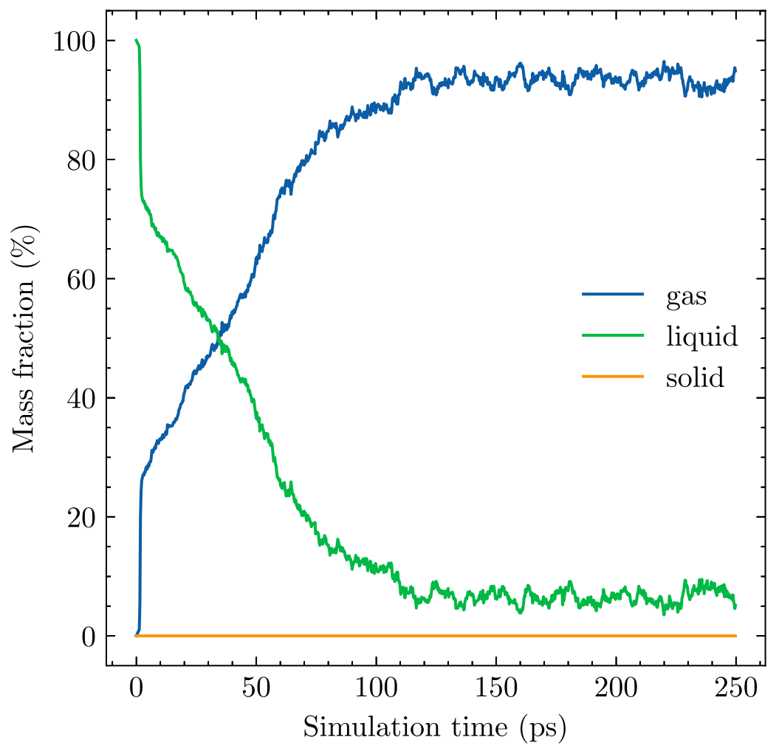
- (b)
Figure 2: Mass fraction (%) of different phases during HTG simulation time at temperature T=3200K in the case without catalyst (a) and with Cu-NP catalyst (b).

Figure 2 presents the mass fraction (%) of different phases during HTG simulation time at a temperature of 3,200 K, highlighting the significant impact of the Cu-NP catalyst on the conversion process. In Figure 2(a), which illustrates the case without a catalyst, it is evident that the gas yield remains relatively low throughout the simulation, remaining around 60%. In contrast, Figure 2(b) displays the mass fraction distribution for the case with the Cu-NP catalyst. As demonstrated in this figure, the introduction of the catalyst leads to a substantial improvement in the gas yield, which increases to approximately 95% during the simulation period. This marked increase in gas yield underlines the crucial role that the Cu-NP catalyst plays in facilitating the conversion of digestate sludge components into valuable gaseous products.

It is interesting to observe that in the case without a catalyst, there is a very small amount of solid phase (less than 3%) present throughout the HTG process. However, when employing the Cu-NP catalyst, no solid phase is observed in the entire HTG simulation, highlighting the superior performance of the catalyst in promoting the conversion of digestate sludge components into gaseous products. This observation emphasizes the importance of employing an appropriate catalyst to enhance the efficiency and effectiveness of the HTG process.

    - Composition of gaseous product

This section focuses on the composition of gaseous products generated during the HTG process, both with and without a Cu-NP catalyst. Figure 3 illustrates the evolution of the number of different gas molecules against simulation time at a temperature of 3200 K, highlighting the distinct gaseous product compositions in the absence and presence of the Cu-NP catalyst.

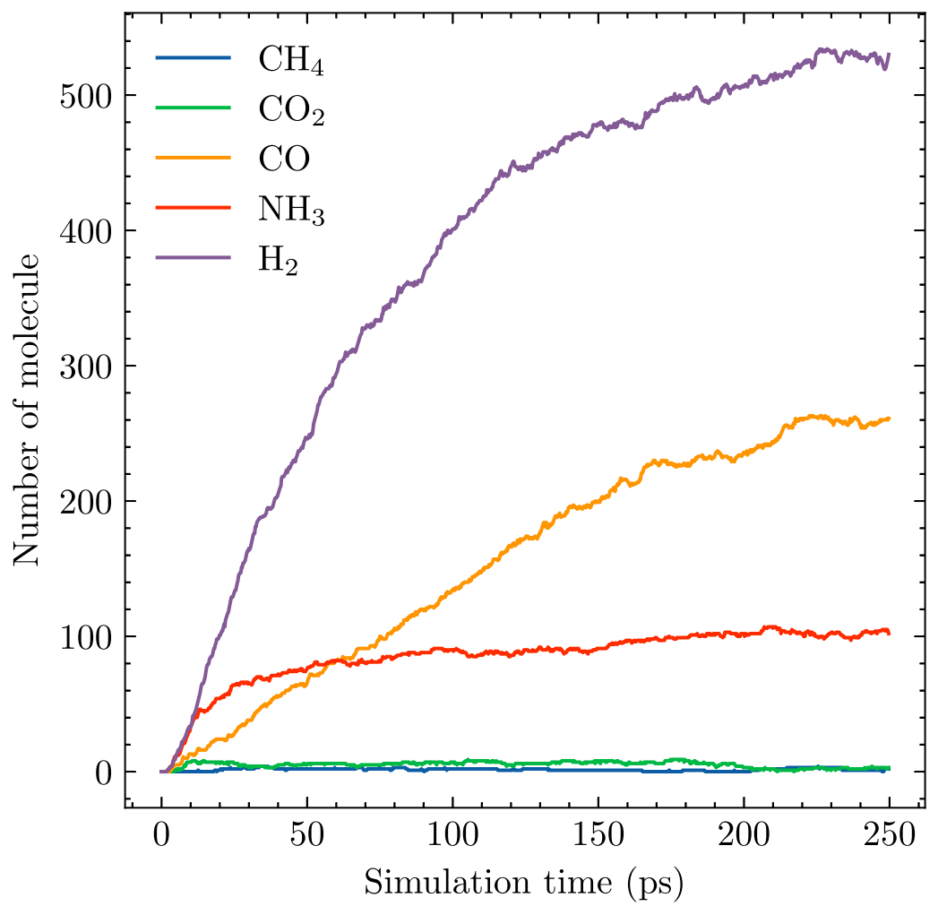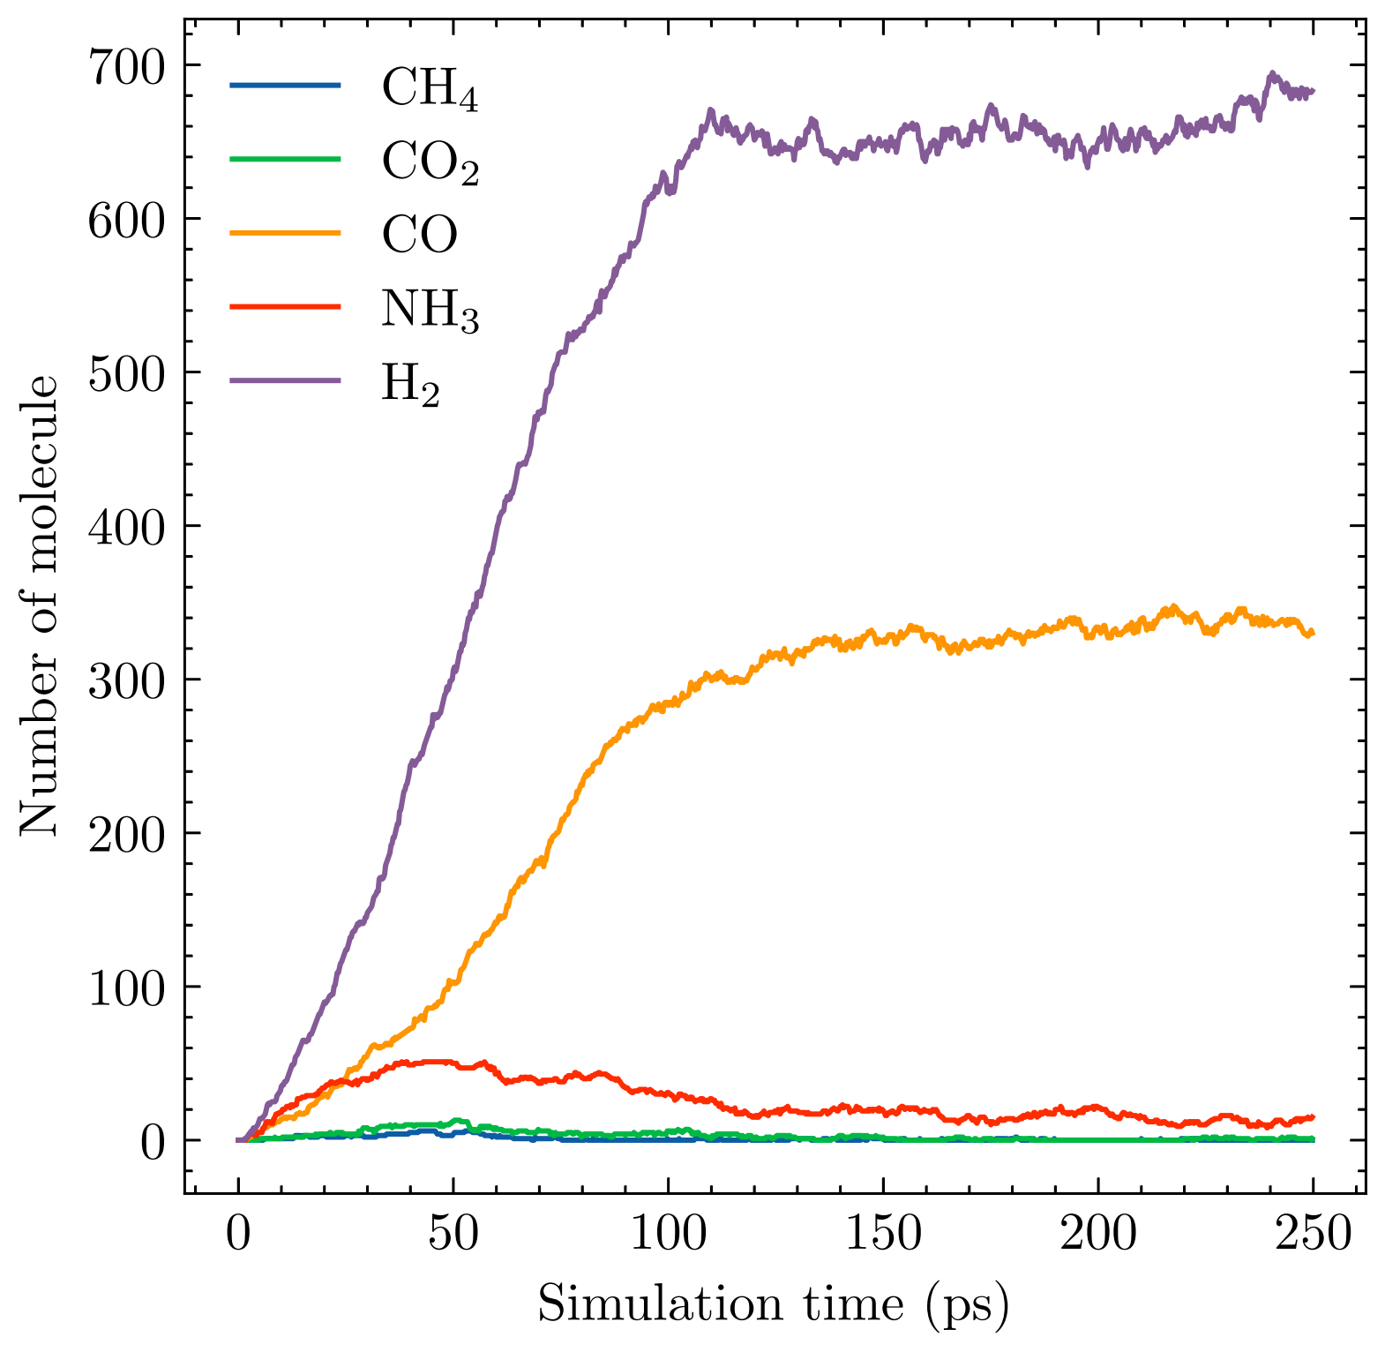
- (b)
Figure 3: Evolution of number of different gas molecules against the simulation time of HTG process at temperature T=3200K in the case without catalyst (a) and with Cu-NP catalyst (b).
As demonstrated by Figure 3(a), which shows the case without a catalyst, H₂ was found to be the most abundant gaseous product, followed by a lower concentration of carbon dioxide (CO) and other less significant gas molecules. However, no methane (CH₄) was observed in this context. In Figure 3(b), which depicts the case with the Cu-NP catalyst, hydrogen was the most abundant gaseous product. Nonetheless, a higher concentration of hydrogen product was observed for the case with in the presence of the Cu-NP catalyst compared to the case without it.

Table 1: Mass fraction of main gaseous product from HTG process obtained from ReaxFF MD
System | Simulation temperature | H₂ | CO | NH₃ | CH₄ | CO₂
Without catalyst | 3,200 K | 36% | 17% | 6% | 0% | 0%
With Cu-NP catalyst | 3,200 K | 62% | 27% | 1% | 0% | 0%

The mass factions of main gaseous products from the simulation of HTG with and without the catalyst are numerically tabulated in Table 1. Clearly, the addition of Cu-NP catalyst significantly enhances the HTG process, leading to a considerable increase in hydrogen gas yield. In the case without a catalyst, H₂ gas yield was found to be approximately 36%, while in the presence of the Cu-NP catalyst, this value increased to around 62% (Table 1). This substantial improvement in H₂ gas yield can be attributed to the catalytic effects of copper nanoparticles, which facilitate the conversion of digestate sludge components into hydrogen.

Interestingly, the presence of the Cu-NP catalyst also led to a reduction in the formation of ammonia (NH₃) from 6% without the catalyst to just 1% when using the catalyst. This observation can be explained by the fact that copper catalysts are known to promote the conversion of NH₃ to nitrogen (N₂) and hydrogen (H₂). By accelerating this reaction, the Cu-NP catalyst effectively reduces the formation of ammonia during the HTG process.

    - Catalyst aging mechanism

The long-term stability and performance of Cu-NP catalysts in practical applications is crucial, as well as for optimizing their design to enhance their durability and effectiveness. The aging mechanism of Cu-NP catalysts during HTG processes involves the incorporation of oxygen atoms into the nanoparticles, which can lead to the formation of copper oxide (Cu_{x}O_{y}). This process is primarily driven by the reaction: 2Cu + 1/2O₂ -> Cu₂O. However, at high temperatures and under HTG conditions, a multitude of radicals are present, leading us to observe that the primary oxidation reaction of Cu involves its reaction with hydroxyl radicals (•OH).
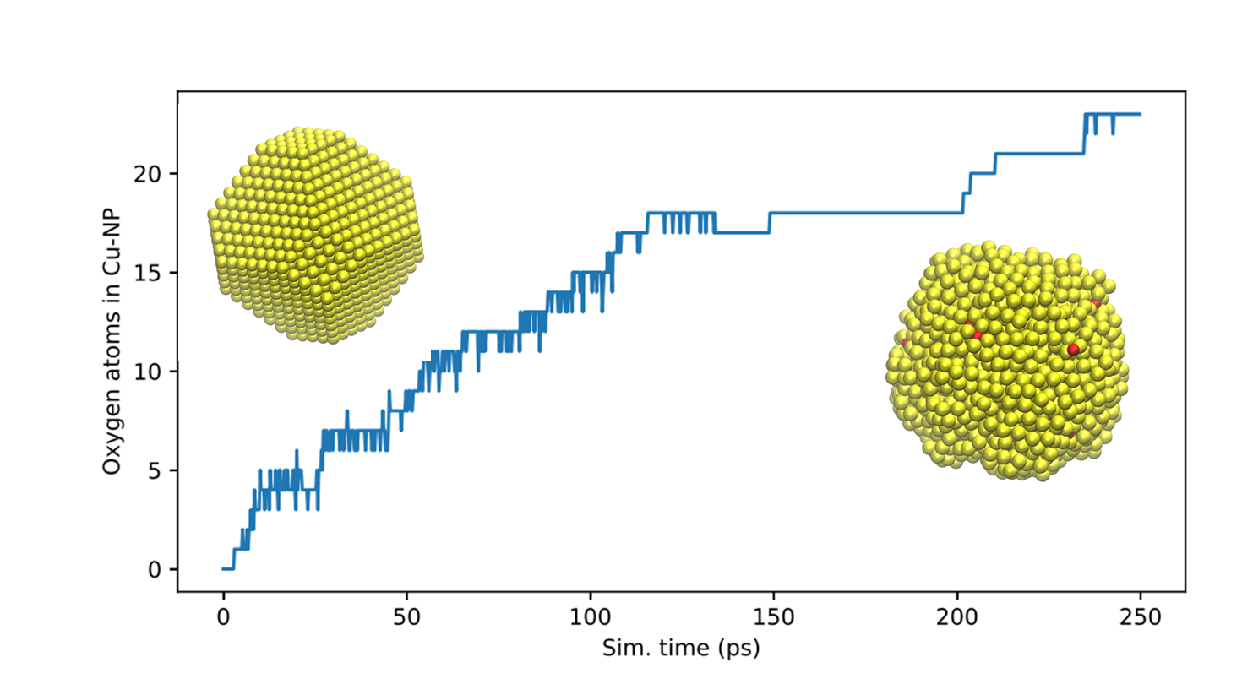
Figure 4: Number of Oxygen atom incorporated into Cu-NP during HTG process at temperature T=3,200 K.
As illustrated in Figure 4, which presents the number of oxygen atoms incorporated into Cu-NP during the HTG process at a temperature of 3200 K over time, it becomes evident that the aging mechanism follows a specific evolution pattern. Initially, most of the oxide forms after approximately 100 ps, indicating a rapid onset of the aging process. As the simulation progresses, the number of oxygen atoms incorporated into Cu-NP gradually increases, reaching around 25 atoms after 250 ps.

By analyzing these findings, it can be concluded that approximately 25 oxygen atoms have been incorporated into the Cu-NP catalyst, leading to an oxygen content of 1% of the total atomic composition of the catalyst. We can estimate that complete deactivation of the Cu-NP catalyst takes place after approximately 100 catalytic cycles. However, it is crucial to emphasize that this estimation requires further simulations to confirm its accuracy and to gain a more comprehensive understanding of the aging mechanism and its implications on the catalyst's performance over extended periods. Another intriguing question is at which level of oxygen incorporation could influence the catalytic properties and performance of the Cu-NP catalyst in the HTG process.
  - Conclusions
In conclusion, this study has demonstrated the significant impact of the Cu-NP catalyst addition on enhancing the hydrothermal gasification process, leading to a notable increase in hydrogen gas yield and reduced formation of ammonia. By simulating the aging mechanism of Cu-NP catalysts during HTG processes, we have gained valuable insights into the incorporation of oxygen atoms into the nanoparticles, which can lead to the formation of copper oxide and potentially affect the catalytic properties and performance of the Cu-NP catalyst. Further research is required to validate our estimation of complete deactivation of Cu-NP catalysts after approximately 100 catalytic cycles, as well as to explore the impact of varying temperature conditions and different digestate sludge feedstocks on the long-term stability and effectiveness of these materials. By gaining a more comprehensive understanding of the aging mechanism and optimizing the design of Cu-NP catalysts, we can contribute to the development of more durable and efficient catalysts for practical applications in waste management and renewable energy production processes.
Acknowledgments
The research leading to these results has been co-funded by the Norway Grants 2014-2021 via the National Center for Research and Development, within the frame of the project: “Negative CO2 emission gas power plant” - NOR/POLNORCCS/NEGATIVE -CO2-PP/0009/2019-00 which is co-financed by program “Applied research” under the Norwegian Financial Mechanisms 2014-2021 POLNOR CCS 2019 - Development of CO2 capture solutions integrated in power and industry processes. TTT acknowledge funding from the Research Council of Norway (RCN), the Center of Excellence Funding Scheme, Project No. 262644, PoreLab. Co-financing and support from Ton Duc Thang University, Vietnamese-German University, and Norwegian University of Science and Technology are gratefully acknowledged.
References

Van Duin, A. C., Dasgupta, S., Lorant, F., & Goddard, W. A. (2001). ReaxFF: a reactive force field for hydrocarbons. The Journal of Physical Chemistry A, 105(41), 9396-9409.
Arregi A., Amutio M., Lopez G., Bilbao J., Olazar M. (2018). Evaluation of thermochemical routes for hydrogen production from biomass: A review. Energy Convers. Manage., 165, 696-719.
Guo Y., Wang S., Xu D., Gong Y., Ma H., Tang X. (2010). Review of catalytic supercritical water gasification for hydrogen production from biomass. Renewable Sustainable Energy Rev., 14, 334-343.
Ha D T., Tran K-Q., Trinh T T. (2024). New insights into the hydrothermal carbonization process of sewage sludge: A reactive molecular dynamics study. Fuel, 361, 130692.
He P., Huang Y., Qiu J., Zhang H., Shao L., Lü F. (2022). Molecular diversity of liquid digestate from anaerobic digestion plants for biogenic waste. Bioresour. Technol., 347, 126373.
Hosseini S E., Wahid M A. (2016). Hydrogen production from renewable and sustainable energy resources: Promising green energy carrier for clean development. Renewable Sustainable Energy Rev., 57, 850-866.
Huelsman C M., Savage P E. (2012). Intermediates and kinetics for phenol gasification in supercritical water. Phys. Chem. Chem. Phys., 14, 2900.
Kaledin A L., van Duin A C., Hill C L., Musaev D G. (2013). Parameterization of Reactive Force Field: Dynamics of the Nb6O19H8 Lindqvist Polyoxoanion in Bulk Water. J. Phys. Chem. A, 117, 6967-6974.
Kalinci Y., Hepbasli A., Dincer I. (2009). Biomass-based hydrogen production: A review and analysis. Int. J. Hydrogen Energy, 34, 8799-8817.
Kruse A. (2008). Supercritical water gasification. Biofuels Bioprod Bioref, 2, 415-437.
Li Y., Park S Y., Zhu J. (2011). Solid-state anaerobic digestion for methane production from organic waste. Renewable Sustainable Energy Rev., 15, 821-826.
Liu X., Wang T., Chu J., He M., Li Q., Zhang Y. (2020). Understanding lignin gasification in supercritical water using reactive molecular dynamics simulations. Renewable Energy, 161, 858-866.
Mahmoodinia M., Trinh T T., Åstrand P., Tran K. (2017). Geometrical flexibility of platinum nanoclusters: Impacts on catalytic decomposition of ethylene glycol. Phys. Chem. Chem. Phys., 19, 28596-28603.
Mata-Alvarez J., Dosta J., Romero-Güiza M., Fonoll X., Peces M., Astals S. (2014). A critical review on anaerobic co-digestion achievements between 2010 and 2013. Renewable Sustainable Energy Rev., 36, 412-427.
Matsumura Y., Minowa T., Potic B., Kersten S., Prins W., Vanswaaij W., Vandebeld B., Elliott D., Neuenschwander G., Kruse A. (2005). Biomass gasification in near- and super-critical water: Status and prospects. Biomass Bioenergy, 29, 269-292.
Monti S., Corozzi A., Fristrup P., Joshi K L., Shin Y K., Oelschlaeger P., van Duin A C., Barone V. (2013). Exploring the conformational and reactive dynamics of biomolecules in solution using an extended version of the glycine reactive force field. Phys. Chem. Chem. Phys., 15, 15062.
Nkoa R. (2013). Agricultural benefits and environmental risks of soil fertilization with anaerobic digestates: A review. Agron. Sustain. Dev., 34, 473-492.
Promdej C., Matsumura Y. (2011). Temperature Effect on Hydrothermal Decomposition of Glucose in Sub- And Supercritical Water. Ind. Eng. Chem. Res., 50, 8492-8497.
Reddy S N., Nanda S., Dalai A K., Kozinski J A. (2014). Supercritical water gasification of biomass for hydrogen production. Int. J. Hydrogen Energy, 39, 6912-6926.
Tran K-Q., Werle S., Trinh T T., Magdziarz A., Sobek S., Pogrzeba M. (2020). Fuel characterization and thermal degradation kinetics of biomass from phytoremediation plants. Biomass Bioenergy, 134, 105469.
Verstraete W., Vlaeminck S E. (2011). ZeroWasteWater: Short-cycling of wastewater resources for sustainable cities of the future. International Journal of Sustainable Development &amp; World Ecology, 18, 253-264.
Zhang L., Xu C, Champagne P. (2010). Overview of recent advances in thermo-chemical conversion of biomass. Energy Convers. Manage., 51, 969-982.

