CHEMICAL ENGINEERING TRANSACTIONS  VOL. , 2024 | A publication of
The Italian Association
of Chemical Engineering
Online at www.cetjournal.it

Guest Editors: Leonardo Tognotti, Rubens Maciel Filho, Viatcheslav Kafarov
Copyright © 2024, AIDIC Servizi S.r.l.
ISBN 979-12-81206-09-0; ISSN 2283-9216

Synthetic Natural Gas Obtained from Biomass Derived Syngas: a Study on Different Technological Approaches
Roberto Ruggieroª*, Antonio Coppola^{b}, Massimo Urciuolo^{b}, Fabrizio Scala^{a,b}
ªDICMaPI, University of Naples Federico II, P.le Tecchio 80, 80125, Napoli, Italy
^{b}STEMS, CNR, P.le Tecchio 80, 80125, Napoli, Italy
roberto.ruggiero4@unina.it
Biomass gasification is a thermochemical process that produces a gaseous end product known as syngas, the main components of which are CO, CO₂, and H₂. Starting from syngas it is possible to upgrade this mixture into Synthetic Natural Gas (SNG) through a catalytic methanation process. In this work, a thermodynamic study was conducted to see how operative parameters such as the temperature of the methanation reactor, the quality of the syngas (related to different gasification technologies), and the presence of a conditioning stage based on water gas shift reaction, can influence the output variables as the conversion degree of the reactants, the mass yield and the low heating value of the final products.
  - Introduction
The burning of fossil fuels has been found to contribute significantly to global warming and climate change, as stated in (IPCC report, 2023). As a result, it has become necessary to develop new strategies that can help us to sustain the energy demand of our society, and renewable energies are recognized as the most promising choice thanks to the low emissions involved in their exploitation. The use of residual biomass looks promising, thanks to the capacity of being carbon neutral. Numerous thermochemical and biochemical processes exist to convert biomass into chemical products or energy, such as combustion, pyrolysis, gasification, anaerobic digestion, etc. Catalytic methanation is a process that can be used to convert the syngas obtained from gasification into Synthetic Natural Gas (SNG), with the following reactions:

𝐶𝑂 + 3𝐻2 ↔ 𝐶𝐻4 + 𝐻2𝑂 | 𝛥𝐻 = - 206𝐾𝐽 𝑚𝑜𝑙 𝑎𝑡 298 𝐾 | (1)
𝐶𝑂2 + 4𝐻2 ↔ 𝐶𝐻4 + 2𝐻2𝑂 | 𝛥𝐻 = - 164𝐾𝐽 𝑚𝑜𝑙 𝑎𝑡 298 𝐾 | (2)
Both reactions are extremely exothermic and involve a reduction of volume. So better conversions can be achieved at high pressures and low temperatures. In addition, the occurrence of other reactions, such as water gas shift, Boudouard reaction, dry reforming, methane cracking, etc. (Gao et al., 2012) should be considered. In this work, the simulation of different technologies for the gasification process as air gasification, air-steam gasification, and steam-gasification, have been investigated by the utilization of Aspen Plus software to individuate the best gasification conditions to have a syngas suitable for the methanation process, and to obtain a product suitable in terms of quality (LHV and composition) for the possible injection in the gas grid.
  - Materials and method
All the simulations were conducted on Aspen Plus using a model biomass based on wood chips taken from (Cirillo et al., 2021), whose characteristics are reported in Table 1.
Table 1: Wood chips proximate and ultimate analyses
Proximate analysis (%), as received |  | Ultimate analysis (%), dry basis
Moisture | 9.80 | Carbon | 43.6
Fixed Carbon | 18.3 | Hydrogen | 5.2
Volatile Matter | 71.7 | Nitrogen | 0.2
Ash | 0.2 | Oxygen | 0.8

The flowsheet of the simulated process is characterized as follows:
- The first section where the biomass is decomposed into its elements (C, H, N, O).
- A gasification stage where the biomass elements are converted into syngas using air, steam, or a mixture of air + steam.
- A Water-Gas-Shift stage where the H₂/CO ratio of the syngas is improved, through the addition of steam. Considered only in the cases with air gasification.
- A methanation stage where the syngas obtained in the previous step is converted into SNG.
- A water separation stage where the water produced during the methanation stage is removed.
- Intermediate heat exchangers are present to reach the desired temperature for the gasification, methanation, and cleaning stages.
- A cleaning stage to remove the excess moisture contained in the biomass, remove char (ash + solid carbon) obtained during gasification, and remove solid carbon formed during the methanation stage.
The main assumptions made for the simulation of the process are the following:
- Gasification, methanation, and water gas shift are considered as equilibrium stages.
- Tars are not considered in syngas, the main components of which are H₂, CO, CO₂, methane (CH₄), and water vapor (H₂O).

Table 2: Units used on Aspen Plus

Key component | Aspen Unit | Operative parameters
Decomp reactor | Ryield | T=110ºC, P=1 atm
Gasifier | RGibbs | T=850ºC, P=1 atm
WGS reactor | Requil | T=320ºC, P=1 atm
Methanation reactor | RGibbs | T=300,350,400ºC, P=1 atm
Water separation system | Flash | T=40ºC, P=1 atm

The different blocks used in Aspen Plus and their operating conditions are listed in Table 2. To model the gasification stage, it was chosen to use a fixed value of parameters such as the equivalence ratio and the Steam/Biomass ratio (S/B) at the gasifier. The first one is described as the ratio between the oxygen used and the oxygen required for the complete combustion of the fuel, the latter one is the ratio between the mass flow rate of biomass and that of the steam added in the gasification stage.

For the methanation reactor three scenarios were considered for all the configurations studied:
- Best Case (BC) where the formation of solid carbon is neglected.
- Worst Case (WC) where the formation of solid carbon is considered.
- External Hydrogen (H) where the formation of solid carbon during the methanation is considered, but a minimum amount of external hydrogen is added to the syngas to prevent carbon formation.

In Table 3 all the process configurations simulated in this work are reported. The first configuration considered is air gasification + methanation (AG+M). Here a low-cost gasification agent is used to convert the biomass in syngas which is characterized by a small amount of hydrogen and a huge presence of inert gas (nitrogen), which will bring some undesired effects such as a lower heating value of the final product and limitations on syngas conversion in the methanation reactor. To improve the hydrogen content, steam can be added in the gasification stage obtaining the second configuration studied in this work, air + steam gasification + methanation (AS+M); here nitrogen is still present but with a lower concentration. To obtain a syngas where the amount of hydrogen is significantly larger only steam can be used as a gasification agent to obtain the two configurations called steam gasification + methanation (SG+M) and (SG+M*), characterized by values of S/B=0.3 and S/B=0.5, respectively. For all these cases the three scenarios described above were studied. The configuration called triple feeding (TRI-FEED+H+M) is based on the idea of providing the amount of oxygen required to obtain gasification at a fixed value of the equivalence ratio by feeding 2 streams: air for 25% of the required oxygen, and a pure O₂ stream for the 75% left. Such a system could be interesting when the required hydrogen is obtained through the electrolysis of water with the oxygen being a subproduct of electrolysis. In this way, some of the typical problems associated with the syngas obtained through air gasification are avoided. Then the influence of conditioning stages has been preliminary studied through a Water Gas Shift section for improving the hydrogen content of low quality syngas like the one obtained through air-gasification.
Table 3: Systems of Interest

Different configurations | Characteristics values
Air gasification + methanation (AG+M) | Equivalence ratio=0.2
Air gasification + hydrogen + methanation (AG+H+M) | Equivalence ratio=0.2
Air + steam gasification + methanation (AS+M) | Equivalence ratio=0.2, Steam/Biomass=0.2
Air + steam gasification + hydrogen + methanation (AG+H+M) | Equivalence ratio=0.2, Steam/Biomass=0.2
Steam gasification + methanation (SG+M) | Steam/Biomass=0.3
Steam gasification + hydrogen + methanation (SG+H+M) | Steam/Biomass=0.3
Steam gasification + methanation* (SG*+M) | Steam/Biomass=0.5
Steam gasification + hydrogen + methanation* (SG*+H+M) | Steam/Biomass=0.5
Triple feeding + hydrogen + methanation (TRI-FEED+H+M) | Equivalence ratio=0.2, 75% by pure O₂ stream

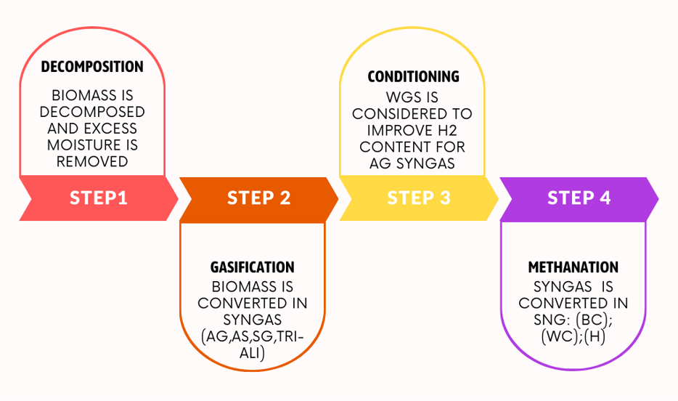
In Figure 1 the block diagram of the operations performed for the different configurations is reported. The water gas shift stage was only conducted for the syngas obtained from air gasification, and the influence of this stage will be discussed in section 3.3.
Figure 1: Block diagram of the operations conducted to obtain synthetic natural gas
  - Results
    - Influence of the methanation temperature
To verify the influence of the temperature of the methanation reactor, three different values were chosen: T=300ºC, 350ºC, and 400ºC. Figure 2 reports the degree of conversion of hydrogen for the configurations based on syngas obtained through air gasification at such three temperatures. The worst case is represented by the lower value of the range, and the best case is the highest value. The case with external hydrogen feeding to avoid carbon formation is represented by an intermediate value. Looking at the results we can see that different range widths are present for the different temperatures and that better performances are always associated with T=300ºC. The worst-case scenario for T=300ºC shows better performance compared to all the cases at T=350ºC and 400ºC for both scenarios, where solid carbon is considered and when it is neglected. This means that better conditions, with or without an external source of hydrogen, are associated with temperatures lower than 400ºC, where the desired reactions are thermodynamically favored, like CO and CO₂ hydrogenation. In Table 4 the molar composition of the SNG obtained in the scenario with the addition of external hydrogen at the three temperatures is reported. Here it is clear how the CH₄ content is influenced by temperature, resulting in a decrease from 34.45 to 28.10%.

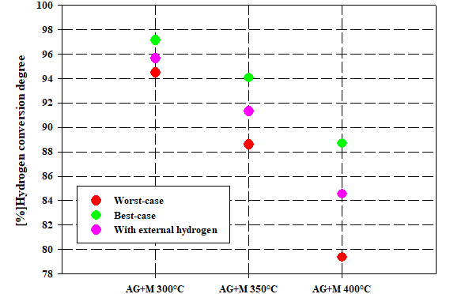

Figure 2: Effect of the temperature on hydrogen conversion degree for AG+M configuration

Table 4: Molar composition of the SNG obtained

Different configurations | H₂  mol(%) | N₂ mol(%) | O₂ mol(%) | H₂O  mol(%) | CO mol(%) | CO₂ mol(%) | CH₄  mol(%)
Air-gasification+external hydrogen+methanation (AG+H+M) T=300ºC | 4,91 | 46,89 | 0 | 6.47 | 0.02 | 7.26 | 34.45
Air-gasification+external hydrogen+methanation (AG+H+M) T=350ºC | 9.28 | 44.58 | 0 | 6.47 | 0.08 | 8.01 | 31.58
Air-gasification+external hydrogen+methanation (AG+H+M) T=400ºC | 15.70 | 41.18 | 0 | 6.47 | 0.28 | 8.26 | 28.10

    - Influence of the different configurations
Starting from syngas obtained through different technologies will lead to different ratios between the amounts of hydrogen and CO and CO₂. In fact, for both the cases of steam gasification (S/B=0.3 and S/B =0.5) the molar fraction of hydrogen is much higher compared to the values obtained for air gasification and air + steam gasification since there is no nitrogen in the syngas. However, also in these cases to obtain a relevant improvement of the quality of the syngas and to completely avoid the formation of carbon during the fuel synthesis step, an extra amount of hydrogen is required. In Figures 3a and 3b (relative to a methanation temperature of 350ºC), it is possible to observe the difference in the lower heating value of the obtained SNG, and in the mass yield of produced methane, defined as:

$$mass yield of methane=kgCH_{4}/(kg Biomass+kg External Hydrogen)$$ | (3)
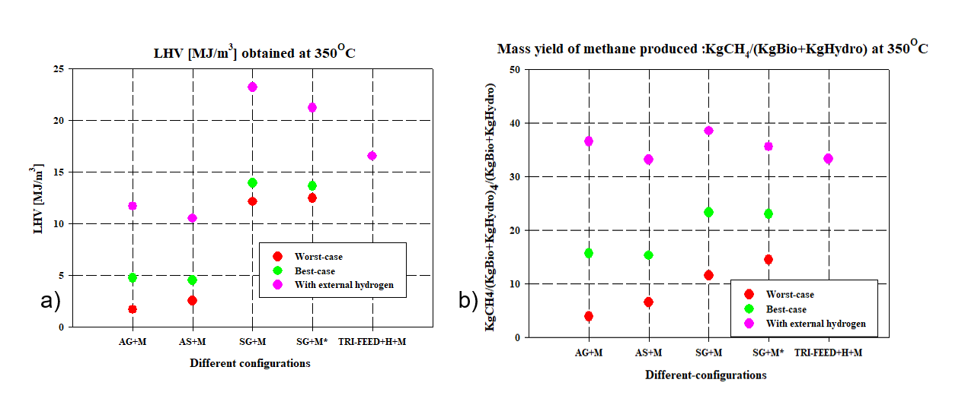Figure 3: Lower Heating Value of the Synthetic Natural Gas obtained (a) and mass yield of methane produced for the different process configurations (b)
In Figure 3a it can be observed that there are some differences between the cases involving air gasification syngas and air + steam gasification syngas, with the latter showing better performance in the worst-case scenario thanks to the better H₂/CO ratio, but worst performance in the external hydrogen addition scenario. This is probably due to the higher amount of carbon dioxide contained in air + steam gasification syngas which will diminish the influence of undesired reactions such as the Boudouard one. Conversion of steam gasification syngas into SNG shows better performance compared to the two previous technologies, also in the worst-case scenario. For this technology, a better LHV is obtained in the external hydrogen addition scenario when S/B=0.3. This is because for higher S/B ratios reactions such as water gas shift are enhanced during gasification and when we are considering the amount of hydrogen required to avoid solid carbon formation the final fuel will be richer in carbon dioxide. But as seen in Figures 3a and 3b when we are not considering a hydrogen external stream, the case with S/B=0.5 will lead to improved performances for the worst-case scenario for both variables considered. Triple-feeding system + external hydrogen and methanation shows encouraging results for both the variables compared to air gasification + methanation and air + steam gasification + methanation systems, but this application is limited as described before for cases involving water electrolysis.
3.3 Influence of the WGS stage
To obtain better performance for the methanation stage, it is typically required a further conditioning stage to improve the ratio between H₂/CO before the considered fuel-synthesis stage. In this work, this was obtained through the addition of a water gas shift unit, with extra steam feeding. For T=300ºC as the working temperature of the methanation reactor and for the cases involving air gasification syngas, three different outlet H₂/CO ratios have been considered (2.08, 2.6, 3.0), to study the influence of this stage on the variables of interest, such as the mass yield of methane defined in this case as:

$$mass yield of methane=kgCH_{4}/(kg Biomass+kg External Hydrogen+kgH_{2}O_WGS)$$ | (4)

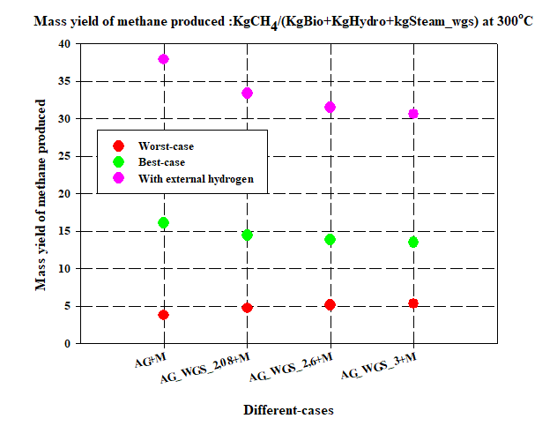
Figure 4: Mass yield of methane produced for the cases with WGS conditioning stage for three different H₂/CO outlet ratios = [2.08, 2.6, 3.0], for syngas obtained through air-gasification

In Figure 4 is possible to observe that for all three different ratios, the width of the interval between the worst-case and best-case scenarios is smaller compared to the case without the WGS stage. This is due to a better performance in the worst-case scenario due to the extra amount of hydrogen obtained in the conditioning stage which allows to limit carbon species formation. The higher amount of carbon dioxide is responsible for the lower performance in the best-case scenario, where still a large amount of CO₂ is not converted. This is because WGS conditioning helps the system to avoid undesired reactions which will create solid carbon as a by-product, but in the same way, the yield of the desired product will be slightly lower.
  - Conclusions
Methanation temperature can significantly influence the conversion of hydrogen and the final composition of the SNG. For this reason, it is suggested from a thermodynamic point of view to work at temperatures below 400°C. Starting from the syngas obtained through different gasification technologies will lead to different synthetic natural gas qualities. The steam gasification + methanation stage obtained for S/B=0.3 seems to be the most interesting configuration to produce high-quality SNG. To significantly improve the quality of the final stream for all the cases studied it is necessary to use an external source of hydrogen. Working with low-quality syngas (the one obtained from air gasification), requires a further conditioning step like a water gas shift reactor to improve the H₂/CO ratio, to minimize the use of an external source of hydrogen to avoid carbon formation, while obtaining slightly lower yields.
Acknowledgments
We wish to acknowledge CMD S.P.A. for financing the PhD fellowship of Roberto Ruggiero.
References
IPCC, 2023. Climate Change 2023: Synthesis Report. Contribution of Working Groups I, II and III to the Sixth Assessment Report of the Intergovernmental Panel on Climate Change. IPCC, Geneva, Switzerland, pp. 35-115.
Cirillo D, Di Palma M, La Villetta M, Macaluso A, Mauro A, Vanoli L, 2021. A novel biomass gasification micro-cogeneration plant: Experimental and numerical analysis. Energy Conversion and Management, 243, 114349.
Gao J, Wang Y, Ping Y, Hu D, Xu G, Gu F, 2012. A thermodynamic analysis of methanation reactions of carbon oxides for the production of synthetic natural gas. RSC Advances, 2, 2358 – 2368.

