CHEMICAL ENGINEERING TRANSACTIONS  VOL. , 2024 | A publication of
The Italian Association
of Chemical Engineering
Online at www.cetjournal.it

Guest Editors: Leonardo Tognotti, Rubens Maciel Filho, Viatcheslav Kafarov
Copyright © 2024, AIDIC Servizi S.r.l.
ISBN 979-12-81206-09-0; ISSN 2283-9216

Xylose, Glucose and Fructose Extraction from Different Herbaceous Crops in a Green Biorefinery Demonstration Platform: A Comparative Study
Damian E. Lopez Fetzer*, Thalles A. Andrade, Morten Ambye-Jensen
Aarhus University, Department of Biological and Chemical Engineering, 8200 Aarhus N, Denmark
CBIO, Aarhus University Centre for Circular Bioeconomy, 8830 Tjele, Denmark
*Damianf@bce.au.dk
The extraction of xylose, glucose, fructose, and other sugars in different brown juice (BJ) biomasses in a green biorefinery may be used on a large scale for fermentation and biobased production. A comparative study of different BJ obtained in a biorefinery demonstration platform was conducted employing white clover, red clover, grass-clover mixture, alfalfa, festulolium, and ryegrass as feedstock. In the green biorefinery, the biomass was submitted to mechanica wetl fractionation in which a green juice (GJ) and a fiber cake fraction were separated. The protein was extracted from the GJ by using heat precipitation at 85 ˚C and, sent to a decanter centrifugation, where a leaf protein concentrate was separated from the BJ. Total sugar content varied between 29.10 g/L to 10.82 g/L, in BJ from the different feedstocks. Glucose constitutes the carbohydrate with the highest concentration in BJ of festulolium, ryegrass, red clover, and grass-clover feedstock. Among all the remaining carbohydrates in the BJ, xylose is the major sugar in BJ from alfalfa and white clover. However, the highest xylose concentration was in red clover with 7.04 g/L. Ryegrass showed a higher concentration of fructose with 9.17 g/L. In general, fructose was extracted in all the BJ biomasses with quantities up to 4.73 g/L, except alfalfa with 1.81 g/L. Ryegrass and festulolium exhibited a majority concentration with 5.19 and 8.43 g/L of sucrose. Maltose and galactose presented low sugar concentrations and arabinose had the lower concentrations in BJ biomasses.

  - Introduction

The high demand for protein for animal and human consumption is estimated to almost double worldwide by 2050 due to the increasing human population (United Nations, 2022). The global market requests alternative diets richer in protein such as plant-based protein sources. Soy protein has taken center stage in the market, but it is essential to find more sustainable substitutes and to minimize soybean import dependence. (Henchion et al., 2017). A sustainable crop with high protein yield is green leaf biomass such as legumes and grasses that represent novel protein sources. To employ leaf protein for feed and food purposes, the protein needs to be extracted from the complex leaf matrix. In the protein extraction process, the biomass is initially submitted to wet fractionation, and the fiber cake fraction is separated from the protein-rich green juice. Then, the green juice is submitted to subsequent precipitation to separate the protein from the residual juice, which has been labeled brown juice. Finally, the leaf protein concentrate is dried. The process where the leaf protein concentrate is extracted from the biomass, and two side streams of fiber cake and BJ with potential for multiple applications, is defined as green biorefinery. Green biorefinery is a concept that utilizes diverse types of natural wet biomass feedstocks, including grasses and leguminous, to produce different and valuable products and by-products sustainably (Møller et al., 2021). Many studies describe the advantages of green biorefinery implementation and the generation of byproducts during the process on a laboratory scale. However, when it comes to large-scale production, green biorefinery byproducts such as BJ, which represent a large amount in the process, have not been explored in depth, so studying the process on a larger scale is also compulsory to evaluate their potential applications.

The brown juice has a dry matter content ~ 4.7 % (Andrade et al., 2022), and sometimes BJ reaches up to 15% (Zanin, 1998). BJ constitutes a source of sugars (glucose, xylose, fructose, sucrose among others), oligopeptides, minerals, secondary metabolites, and other nutrients extracted from the leaf protein. Multiple monosaccharides and disaccharides have been found in brown juice. In addition, studies have shown the potential of BJ as fertilizer and presented high antioxidant capacity with flavonoids and phenolic compounds. The analysis reported that the BJ contains B vitamins, riboflavin, nicotinic acid, nicotinamide, biotin, and other components (Barna et al., 2022). BJ can be used in multiple applications, such as methane production using anaerobic digestion (Feng et al., 2021), fermentation medium for microorganisms, including L-lysine production (Thomsen et al., 2004), lactic acid to produce bioplastics, single-celled organisms, and other biotechnology applications (Sakarika et al. 2022). Khoshnevisan has shown that BJ alfalfa could also be used in plant nutrition as fertilizer (Khoshnevisan et al., 2023). In the food industry, d-fructose is considered a sweetener, and it is perceived earlier than sucrose or glucose. The sweetness of fructose blended with sucrose, aspartame, or saccharin is detected to be greater than the sweetness calculated by the individual (Hallfrisch, 1990).

The present study demonstrates the possibility of valorizing brown juice from herbaceous biomasses rich in sugars like glucose, xylose, and fructose as part of a green biorefining on a large scale, which could be used for different applications such as fermentation of single-celled organisms, sweetener for diabetics in food and beverage, as pharmaceuticals additive, in green chemistry and so on.

  - Material and Methods
    - Green biorefinery processes
The biomasses used were grasses and legumes including white clover (Trifolium repens), red clover (Trifolium pratense), alfalfa (Medicago sativa), festulolium, ryegrass (Lolium perenne), and a grass-clover mixture (ForageMax 55) consisted of ryegrass, red fescue, and white clover with a seed content of 65, 25 and 10 %, respectively.
Figure 1 describes the green biorefinery process at the demonstration platform for research and development located at Aarhus University, Foulum, Denmark. After being harvested in the field, the biomass is transported directly to the biorefinery and processes at a capacity of up to 10 tonnes per hour. The processing at the demo platform involves 1) eliminating foreign physical materials and subsequently maceration of 4-5 cm of particle size, 2) mechanical separation of the biomass by a twin screw press into a green juice and a fiber pulp fraction, 3) heat treatment of the green juice to 85 °C in two heat exchangers with heat recovery to precipitate soluble protein, 4) and separation of the leaf protein concentrate and brown juice using a decanter centrifuge. The gathered demonstration scale experiments during 2022 were all part of multiple projects pursuing multiple goals of producing LPC, fiber or brown juice for different tests and applications. However samples of the BJ were taken consistently, treated and analyzed in the same way.

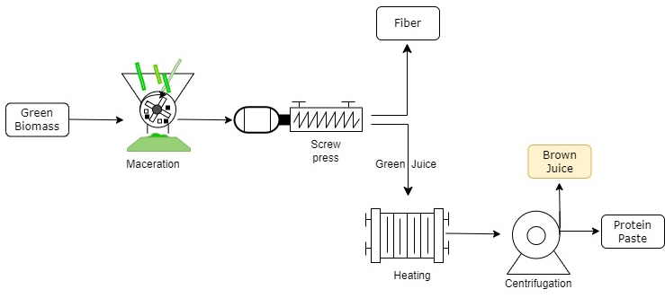
Figure 1: Schematic representation of the production of green biorefining in the Demo platform at Aarhus University.
    - Carbohydrate content
Brown juice samples were taken in plastic tubes with 12 mL of capacity. The BJ samples were homogenized and centrifuged for 10 min and filtered using a filter of 0.45 μm of pore size. The samples were kept in plastic vials of 2 mL at -20 °C.

The carbohydrate contents from brown juices were estimated in the HPLC equipment using an Agilent system (Agilent Technologies, 1260 Infinity) with an RI detector at 50 °C. As a stationary phase, an Agilent MetaCarb 87P Carbohydrate Column Pb+2 Form (7.8 x 300 mm) was utilized and MilliQ water was used as the mobile phase. A flow rate of 0.4 mL min-1 was maintained throughout the analysis. The column temperature was set at 80 °C. The standard used for the HPLC system included the following sugars such as C6 monosaccharides: glucose, fructose, and galactose; C5 monosaccharides: xylose and arabinose; and disaccharides: sucrose and maltose. A calibration curve was calculated using a mixture of standards using the seven carbohydrates described (curve of 5 points), with a coefficient of determination of 0.998.

  - Results and Discussion
    - Sugar concentration of brown juice
Throughout the 2021 season, from May to August, brown juice samples of seventeen batches of festulolium, ryegrass, alfalfa, red clover, white clover, and grass-clover mixture were processed and evaluated. Table 1 specifies the number of experiments for each biomass.
Table 1: Batches of brown juice biomasses used in season 2021
Biomasses | Festulolium | Ryegrass | Alfalfa | Red clover | White clover | Grass-clover
No. Batches | 1 | 1 | 1 | 2 | 3 | 9*
Harvest date | 16/05/2022 | 16/05/2022 | 26/09/2022 | 09/08/2022  19/09/0022 | 23/06/2022 09/08/2002 22/09/2022

*See Figure 4.

In Figure 2, the concentration of the seven more abundant sugars and total sugars of the six BJ biomasses is shown. The total sugar content from ryegrass BJ reported a higher total sugar concentration of 29.10 g/L and alfalfa BJ had a lower total sugar content of 10.82 g/L. According to Santamaría-Fernández et al. (2018), BJ from red clover, alfalfa, and grass-clover biomasses at laboratory scale resulted in similar amounts (between 6.8 g/L to 27.8 g/L) of total sugar (glucose, xylose-fructose, cellobiose, and arabinose) than this work. If compared with different plants, like oilseed radish (3.3 g/L of total sugar), it is interesting to notice that in general, the experiments in the present study extracted higher total sugar concentrate using grasses and legumes as raw material. In another research, a mixture of red clover and grass-clover exhibited 27.45 g/kg of total sugar (Martinez et al., 2018); finding similarities with the present work while pointing out that these works were developed on a laboratory scale.

Glucose was found in all the BJ samples and constitutes the carbohydrate with the highest concentration in festulolium, ryegrass, red clover, and grass-clover with similar percentages, as seen in Figure 3. In terms of concentration, BJ from ryegrass obtained up to 11.01 g/L of glucose, being the most extracted compound, as seen in Figure 2.

Among all the remaining carbohydrates in the BJ coming from different biomasses, xylose is the major sugar in BJ from the legumes of alfalfa and white clover. The highest amount of xylose was found in red clover with 7.04 g/L. In addition, alfalfa showed the highest xylose percentage with 35 % of the total sugar content. No significant differences were observed between white and red clover, with around 30 % and only about 5 % of the total sugar content of the grass-clover mixture corresponding to xylose. Xylose was not detected in the two grasses of festulolium and ryegrass.

Figure 2: The concentration of mono and disaccharides found in six BJ biomasses.
Fructose was extracted in all the BJ samples with quantities above 4.73 g/L, except for alfalfa with 1.81 g/L. Ryegrass showed a higher concentration of fructose with 9.17 g/L.

Festulolium and ryegrass exhibited higher amounts of sucrose with 5.19 and 8.43 g/L, respectively. In terms of percentage, both have a similar composition profile, as seen in Figure 3. Besides, maltose and galactose presented low concentrations in BJ biomasses. It is interesting to notice that a similar concentration of both carbohydrates was found in festulolium, ryegrass, and grass-clover. Red and white clover extracted higher maltose (2.64 g/L) and galactose (0.57 g/L) concentrations, respectively.

Finally, BJ from- the different biomasses contained a lower concentration of arabinose, from 0.02 to 0.06 g/L, in which red clover presented the highest concentrations. Arabinose was not detected in festulolium and ryegrass. It is positive to find low arabinose values because it could be converted into a microbial inhibitor reducing the fermentation capacity. According to Bákonyi et al. (2020), xylose reported a high value compared to fructose, and arabinose exhibited the lowest concentration in BJ alfalfa, showing a similar tendency in this work.

Figure 3: The Percentages of mono and disaccharides found in six BJ biomasses.
    - Seasonal behavior of sugar
Figure 4 shows the same grass-clover mixture processed in nine batches from 17 May to 17 August 2022. Total sugar content was reduced from 21.77 to 4.67 g/L throughout the season. It is interesting to notice that from the first to the last month, the sugar concentration decreased more than 4 times. The tendency might be related to the increase in temperature and lower availability of water, according to Jensen K. B., et al. (2014) during spring the sugar content was better than in summer. In the same months, BJ´s carbohydrate content decreased but then increased again when fall began. This demonstrates that the amount of water, clime, and number of harvests have a major influence on the final sugar and should be investigated in depth.
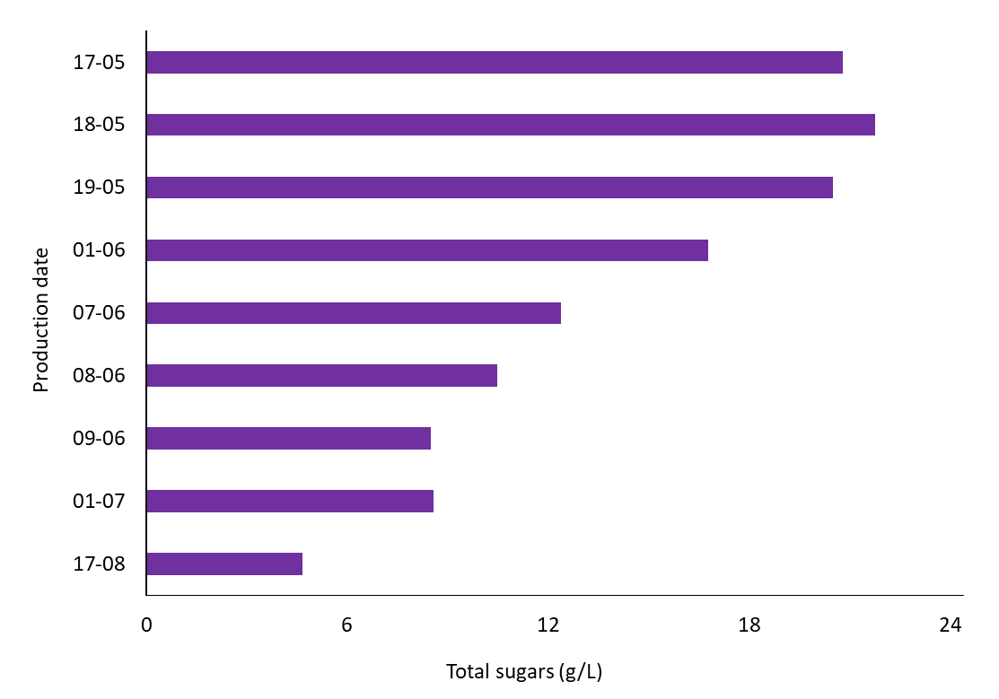
Figure 4: Total sugar concentration in clover-grass mixes during the season 2022.

  - Conclusions
In this study, multiple brown juice leaf biomasses were extracted and analyzed on a large scale, during the season 2021 at the demonstration platform located at Aarhus University, Denmark. It was demonstrated that the total sugar of grass-clover brown juice decreased almost four times the sugar concentration, in a total time of 4 months, from May to August. Total sugar content between 29.10 g/L to 10.82 g/L was found, representing an important sugar source for future applications of this sidestream. The major concentrations of glucose, xylose, fructose, and sucrose of BJ from ryegrass, red clover, and festulolium were 11.01 g/L, 7.04 g/L, 9.17 g/L, and 8.43 g/L, respectively. However, it is possible to affirm that glucose, xylose, and fructose are the most important sugar compounds in BJ from green leaf biomasses. Maltose and galactose presented low concentrations in BJ biomasses. Arabinose exhibited lower concentration values, and it was not detected in BJ from festulolium and ryegrass. Due to the similarities in the sugar percentage, it is possible to divide into 3 groups’ sugar profiles:1) alfalfa, red clover, and white clover (legumes), 2) ryegrass and festulolium (grasses), and 3) grass-clover mixture. The use of sugars from brown juice from leaf processing in a green biorefinery represents a real possibility on a large scale for food, biotechnology, pharmaceutical, chemical, and other applications.

Acknowledgments
This work has been conducted within the Aarhus University Centre for Circular Bioeconomy, and department of Biological Chemical Engineering at Aarhus University, Denmark. The authors acknowledge the financial support from- the GUDP project GRØNBIORAF, H2020 GO-GRASS project (European Union’s Horizon 2020 Research and Innovation program, grant agreement No 862674), and the EU Interreg ØKS project Green Valleys.

References
Andrade T. A., Ambey-Jensen M. 2022. Process Integration and Techno-Economic Assessment of a Green Biorefinery Demonstration Scale Platform for Leaf Protein Production, Computer Aided Chemical Engineering 51, 877-882.
Bákonyi N., Kisvarga S., Barna D., Tóth I. O., El-Ramady H., Abdalla N., Kovács S., Rozbach M., Fehér C., Elhawa N., Alshaal T., Fári G. M., 2020. Chemical Traits of Fermented Alfalfa Brown Juice: Its Implications on Physiological, Biochemical, Anatomical, and Growth Parameters of Celosia. Agronomy 10, 247.
Barna D., Alshaal T., Toth I. O., Cziaky Z., Gabor F. G., Domokos-Szabolcsy E., Bakonyi N., 2022, Bioactive metabolite profile and antioxidant properties of brown juice, a processed alfalfa (Medicago sativa) by-product, Heliyon 8, e11655.
Feng L., Ward A. J., Ambye-Jensen M., Moller H. B., 2021, Pilot-scale anaerobic digestion of by-product liquid (brown juice) from grass protein extraction using an un-heated anaerobic filter, Process Safety and Environmental Protection 146, 886-892.
Hallfrisch J., 1990, Metabolic effects of dietary fructose, FASEB journal 4, 9, 2652-2660.
Henchion M., Hayes M., Mullen A.M., Fenelon M., Tiwari B., 2017, Future Protein Supply and Demand: Strategies and Factors Influencing a Sustainable Equilibrium, Foods 6, 53.
Jensen K. B., Harrison P., Chatterton J. N., Bushman S. B., and Creech J. E., 2014, Seasonal Trends in Nonstructural Carbohydrates in Cool- and Warm-season Grasses, Crop Science Society of America 54, 2328–2340
Khoshnevisan B., Fog E., Baladi S., Chan S. W. S., 2023, Birkved M., Using the product environment footprint to strengthen the green market for sustainable feed ingredients; Lessons from a green biomass biorefinery in Denmark, Science of The Total Environment 877, 162858.
Martinez E. J., Micolucci F., Gomez X., Molinuevo-Salces B., Uellendahl H., 2018, Bioactive metabolite profile and antioxidant properties of brown juice, a processed alfalfa (Medicago sativa) by-productInternational Journal of Environmental Science and Technology 15, 2615–2624.
Møller, A. H., Hammershøj, M., Hachow N. M., Tanambell, H., Stødkilde, L., Ambye-Jensen M., Danielsen, M., Jensen, S. K., Dalsgaard T. K., 2021. Biorefinery of Green Biomass How to Extract and Evaluate High Quality Leaf Protein for Food?. Journal of Agricultural and Food Chemistry 69, 14341−14357.
Sakarika M., Delmoitié B., Ntagia E., Chatzigiannidou I., Gabet X., Ganigué R., Rabaey K., 2022. Production of microbial protein from fermented grass. Chemical Engineering Journal 433, 133631.
Santamaría-Fernández M., Molinuevo-Salces B., Lübeck M., Uellendahl H., 2018. Biogas potential of green biomass after protein extraction in an organic biorefinery concept for feed, fuel and fertilizer production. Renewable Energy 129, Part B, 769-775.
Thomsen M. H., Bech D., Kiel P., 2004. Manufacturing of Stabilised Brown Juice for L-lysine production –
from University Lab Scale over Pilot Scale to Industrial Production, Chemical and Biochemical Engineering Quarterly 18 (1), 37–46.
United Nations, 2022, Revision of World Population Prospects, United Nations <https://esa.un.org/unpd/wpp/publications/files/keyfindingswpp2015.pdf> accessed 02.01.2024
Zanin, V. A., 1998 New Nutritional Idea for Man: Lucerne Leaf Concentrate. APEF, Association Pour la Promotion des Extraits Foliaires en Nutrition. France.

