|  |  |
| --- | --- |
| cetlogo CHEMICAL ENGINEERING TRANSACTIONS  ***VOL. 108, 2024*** | A publication of  aidiclogo_grande |
| The Italian Association  of Chemical Engineering  Online at www.cetjournal.it |
| Guest Editors: Leonardo Tognotti, Rubens Maciel Filho, Viatcheslav Kafarov  Copyright © 2024, AIDIC Servizi S.r.l. **ISBN** 979-12-81206-09-0; **ISSN** 2283-9216 | |

Sewage Sludge Energy Potential Assessment: Characterization Approach

Ellen Cristina Abrahão Cezarinia,\*, Zudivan Peterlia, b, York Castillo Santiagoc, d, Osvaldo José Venturinia

a Excellence Group in Thermal Power and Distributed Generation (NEST), Federal University of Itajubá (UNIFEI), Av. BPS 1303, Itajubá-MG, 37500-903- Brazil

b Federal University of Espírito Santo (UFES), Campus Goiabeiras, Vitória-ES, 29075-910, Brazil.

c Laboratory of Optimization, Design, and Advanced Control (LOPCA), School of Chemical Engineering, University of Campinas (UNICAMP), Av. Albert Einstein 500, Campinas-SP, 13083-852 – Brazil

d Brazilian Biorenewables National Laboratory (LNBR), Brazilian Center for Research in Energy and Materials (CNPEM), 13083-970 Campinas, São Paulo, Brazil.

ellencezarini@unifei.edu.br

The sludge generated in sanitary sewage treatment, mainly during all stages of sewage treatment, is a waste that can be used for energy purposes. The sewage sludge can contain many toxic substances, such as pathogens, metals, and organic contaminants, which can cause severe environmental pollution. Therefore, the adequate treatment and possible energy recovery (generation of electricity and/or heat), in addition to representing a noble destination for sanitary sludge, is aligned with the concept of circular economy. To assess the potential for using sewage sludge as an energy source, various analyses were carried out for its characterization, such as proximate and ultimate analysis, calorific value determination, granulometric analysis, and surface adhesion tension. Among the results obtained, the lower heating value (LHV) stands out, with an average value of about 17 MJ/kg, which is a close result to the LHV of conventional biomass. Furthermore, the tests and sludge characterization results show that the drying method proposed in this study is more interesting than the convective method, given that it produces a smaller particle size in the material, for example.

* 1. Introduction

According to Pereira Junior (2020), biomass and waste can provide various opportunities in the energy market through waste-to-energy technologies (*i.e*., technologies for energy recovery from waste) while also providing environmental benefits by aiding in the proper disposal of waste. To employ a specific biomass as an energy source, it is necessary to consider the available conversion technologies, focusing on those associated with thermochemical or biological processes. Examples of such technologies include gasification and anaerobic digestion, respectively (Batlle et al., 2022).

Sewage sludge stands out among the waste materials that can be energetically utilized. According to Menezes (2022), sewage sludge is an unavoidably generated residue during various stages of sewage treatment, including the preliminary stage (removal of some solid by-products from sewage), primary stage (removal of sedimentable and floating solids through physical processes), secondary stage (removal of organic matter and some nutrients through biological processes), and tertiary stage (removal of specific contaminants through physicochemical processes).

The sludge can contain numerous toxic substances, such as pathogens, metals, and organic contaminants, which, in turn, can cause severe environmental pollution (Gomes, 2019). Proper disposal of these and other residues generated during sewage treatment is crucial, posing a challenge in managing Wastewater Treatment Plants (WWTP), especially in developing countries (Buonocore et al., 2018). Various treatments and procedures are employed for the proper disposal or energy utilization of sludge, including anaerobic digestion, dewatering, thermal drying, incineration, and landfill disposal (Ding et al., 2021). Additionally, other technologies allowing the production of fuels with lower environmental impact, such as pyrolysis and gasification, are considered (Capodaglio, 2023).

Furthermore, for fuel thermochemical conversion, in the case of sanitary sludge, drying is an essential pretreatment to reduce moisture content; this aims to decrease the energy requirements of the dryer, increase calorific value, and minimize the content and volume pathogen (Di Fraia et al., 2018). The thermal drying process involves removing moisture and certain volatile substances from a material, with the reduction of sludge moisture occurring through water loss by evaporation and the removal of microorganisms (Almeida Júnior, 2017). According to Schnell et al. (2020), thermal sludge drying can be categorized into conductive, convective, radiative, and mixed drying.

Conducting a complete characterization of biomass is essential to selecting the most suitable technology for energetically harnessing biomass. Among the critical analyses performed on biomass, notable ones, according to Zinza Junior (2022), include determining its elemental chemical composition, immediate chemical composition, and calorific value. In the case of sanitary sludge, characterization should also encompass morphology, surface adhesion tension, residual, and equilibrium moisture, among other factors (Peterli, 2019).

In this work, a physical-chemical characterization of sanitary sludge was carried out to determine the energy potential of this waste. For this purpose, the samples were studied through particle size analysis, surface tension, and ultimate and proximate analysis. The results indicated that sanitary sludge has properties that allow its use as fuel in thermochemical conversion processes. Therefore, adequate characterization and pretreatment allow the sludge to be used, mitigating environmental impacts.

* 1. Materials and methods

The present study analyzed samples of sanitary sludge from the centrifugation stage of the Mulembá I Wastewater Treatment Plant (WWTP), located in Vitória, ES, Brazil. Thus, it is possible to characterize the sludge through the preparation and analysis of samples. The process began with the collection of centrifuged sludge, treatment of the collected sludge on a heated plate and in an oven, breaking down the treated sludge on a heated plate, and finally, mixing the crumbled sludge with centrifuged sludge to form mixtures (dry sludge and centrifuged sludge) with varying Total Solids (TS) content ranging from 20 to 90%.

Subsequently, morphological and property characterization of the sludge was conducted, highlighting the determination of elemental and immediate chemical composition, calorific value, granulometric analysis, and surface adhesion tension (SAT).

All tests for sludge characterization were conducted in laboratories located at UNIFEI and are detailed in the following subsections.

* + 1. Chemical composition and calorific value

The data for centrifuged sludge consists of information collected during technical visits to the Mulembá I WWTP. Based on the data provided by the company, a proximate and elemental analysis of the sludge samples is conducted, followed by the determination of their calorific value.

Five replicates were carried out in a PerkinElmer CHNS/O 2400 Series II elementary analyzer for the elemental analysis. Carbon, hydrogen, nitrogen, and sulfur concentrations were determined, while oxygen concentration was calculated by difference. Regarding the proximate analysis, a TGA701 Thermogravimetric Analyzer was used with three different heating ramps (5, 10, and 20 °C/min), while the calorific value was determined through three replicates by using a C2000 Calorimeter.

* + 1. Granulometric analysis

Particle size distribution analyses are necessary to understand the influence of the mixture of treated and centrifuged sludge, as well as the drying method used on the final particle diameter of the sludge. The test followed the procedure described below, which was based on the Brazilian Standard (NBR) 7217 (Associação Brasileira de Normas Técnicas, 1987) and can be observed in Figure 1:

* Sludges with initial TS content ranging from 20% to 90% undergo thermal drying in the experimental dryer (granular bed method);
* Centrifuged sludge undergoes thermal drying in the experimental dryer (granular bed method) and an oven (convective method);
* Centrifuged sludge (non-crumbled and crumbled) undergoes drying on a heated plate.



Figure 1: 1) Sludge treated with 40% TS; 2) Centrifuged sludge with drying in an oven (A) and an experimental dryer (B); 3) Sludge centrifuged and dry on a heated plate

* + 1. Surface adhesion tension

In order to characterize the adhesive forces present in the sludge and define the physical boundaries between its fluid, plastic, and solid states, the surface adhesion test was conducted using the universal testing machine from EMIC, model DL, with a load cell of 50 N. Throughout the test, a force between 0 and 1 N was applied to the sludge surface with a flat plate, followed by the tensile test and recording of the maximum stress. The Surface adhesion tension (SAT) was calculated using Equation 1.

|  |  |
| --- | --- |
|  | (1) |

In this test, 14 distinct samples were used, including sludges with TS content ranging from 15% to 90%, as well as samples with 3.5% (thickened sludge) and 7.5% TS (mixture of thickened sludge and treated dry sludge), potable water, and crumbled sludge.

* 1. Results

This section shows the results of the characterization of sanitary sludge and compares the convective drying method with the granular bed method.

* + 1. Chemical composition and calorific value

The chemical composition (ultimate and proximate) and the calorific value of the sludge samples collected at the Mulembá I WWTP are presented in Table 1.

Table 1: Chemical composition of sanitary sludge

|  |  |  |  |
| --- | --- | --- | --- |
| Ultimate analysis | % | Proximate analysis | % |
| C | 40.0 | Moisture | 8.58 |
| H | 5.8 | Volatile | 62.03 |
| O | NA | Ash | 17.48 |
| N | 7.0 | Fixed carbon | 11.91 |
| S | NA |

The heating value is crucial when considering biomass conversion into energy, especially for biomass with a high organic material content (Moura et al., 2020). The heating value is classified as either higher or lower. The Higher Heating Value (HHV) does not consider the heat associated with the condensation of water formed in reaction with the hydrogen contained in the biomass. On the other hand, the Lower Heating Value (LHV) is obtained by subtracting from the HHV the heat associated with the condensation of water vapor formed by the reaction of hydrogen in the biomass, meaning it refers to the energy content on a wet basis. (Neiva, 2018).

According to Ramos et al. (2018), LHV and HHV are parameters used to describe heat production of a unit quantity of fuel during complete combustion, defining the energy chemically bound in the fuel. The results of the tests carried out using the C2000 calorimeter and the sludge samples collected indicated an HHV and LHV of 18.6 MJ/kg and an LHV of 17.4 MJ/kg, respectively. Thus, it is possible to infer sanitary sludge samples exhibit HHV and LHV values superior to some biomasses, such as sugarcane bagasse, which has an LHV of approximately 17 MJ/kg (Correia et al. 2020). Therefore, sludge is a viable feedstock for fuel use and can be used in power generation.

* + 1. Granulometric analysis

In order to perform the granulometric characterization of the centrifuged sludge, it was necessary to process the samples using convective drying methods (with sludge treated in an oven on a heated plate, both non-crumbled and crumbled) and the granular bed method (sludge treated in the experimental dryer).

Therefore, to determine the granulometric difference in the sludge treated by the two different thermal drying methods, data from the particle size distribution of the centrifuged sludge treated with varying TS content at 80°C were used, as shown in Figure 2.

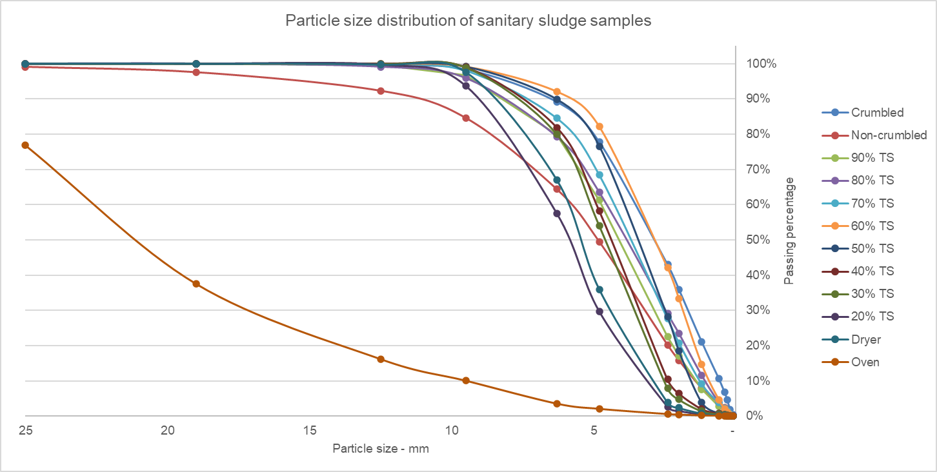

Figure 2: Particle size distribution of sanitary sludge samples

It is observed that the difference between the sludge treated in the oven and the one treated in the experimental dryer is because the former was processed through the convective drying method, where air surrounds the bulk mass of the sludge. In contrast, the latter, determined by the granular bed method, involves air flowing through the sludge bed, passing through the pores formed by the material's particles (granules) (Ling et al., 2022).

The treatment using the granular bed method is more favorable than the convective method, resulting in smaller particle sizes. In the first method, the average diameter is around 19 mm, while exciding 25 mm in the second method. Additionally, the results show a tendency for sludges with high and low TS contents to form grains with larger diameters. In contrast, sludges treated with 50 to 70% TS generate particles with smaller diameters (12 mm).

It is emphasized that obtaining particles with smaller diameters is interesting, depending on their use. For example, in quality pellet production, one of the criteria is the geometry and dimensions of the particles (Rodrigues, 2021). Moreover, increasing the particle diameter in fluidized gasification tends to increase the minimum fluidization velocity; however, granular particles reduce the risk of bed blockage (Michelotto, 2018). Another characteristic is that granular sludge is distinguished by its rapid sedimentation rate and methane generation capacity, enabling it to function as an essential element in degrading organic pollutants in wastewater (Zainudin et al., 2023).

* + 1. Surface adhesion tension

In this test, 14 distinct samples were prepared and analyzed. The results are presented in Figure 3, along with the identification of their physical states.

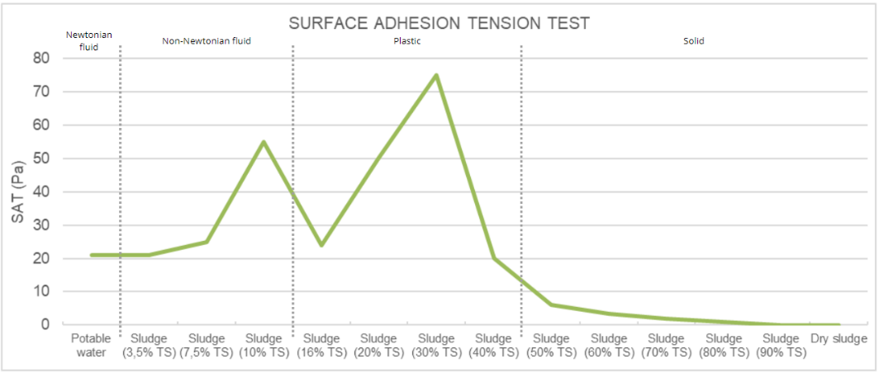

Figure 3: Surface Adhesion Tension results

It is observed that the highest values of sludge adhesion tension are obtained with 10% (liquid sludge) and 30% (plastic sludge) TS content, which are approximately 51 Pa and 71 Pa, respectively. Thus, it is understood that the range between 7.5-40% TS should be avoided for thermal drying processes, as it may lead to operational issues such as passage blockages, jamming of moving parts, and undesired fouling (Deng et al., 2017). Furthermore, a higher percentage of solids requires a smaller area for the drying bed (Santos et al., 2016).

Therefore, the results presented in this section indicate that wet sludge with 50% TS content is the most suitable for the thermal drying process defended in this study since it exhibits low plasticity and falls outside the range of high adhesion for sludges in the solid state.

* 1. Conclusions

From the obtained results, it is observed that the mixture of treated sludge with centrifuged sludge can modify the morphological and rheological characteristics of the sludge, proving to be an essential technique for controlling properties derived from these characteristics. Therefore, it is concluded that this mixture reduces the final particle size of the thermally treated sludge, making it less coarse than the drying of centrifuged sludge alone. Furthermore, sanitary sludge is a waste product characterized by a high organic material content and a lower heating value of 17.4 MJ/kg, rendering its utilization in energy generation feasible.

Another aspect observed throughout this study is that the granular bed method has an advantage over the convective method in producing treated sludge with a particle size classification with a smaller diameter. Regarding the choice of low-temperature drying, it was observed that this condition did not hinder the process from achieving high TS content at the end of drying, indicating that it is possible to produce a dry, granular biosolid, possibly sanitized and suitable for use in various productive processes.

Nomenclature

SAT – surface adhesion test, Pa

Tmax – maximum tension registered, N

A – surface area of the flat plate, m²

Acknowledgments

The authors wish to express their thanks to the Research Support Foundation of the state of Minas Gerais - FAPEMIG (grant APQ-02413-17, the National Council for Scientific and Technological Development - CNPq (grant 317527/2021-5), and the Coordination for the Improvement of Higher Level Personnel - CAPES.

References

Almeida Júnior, A. (2017). *Evaluation of the thermal drying process of sewage sludge*. <tede.bc.uepb.edu.br/jspui/handle/tede/3291> accessed 24.08.2023.

Associação Brasileira de Normas Técnicas. (1987). Determining the particle size composition -NBR 7217. *ABNT-Assoc. Bras. Normas Tec*, 3.

Batlle, E. A. O., Julio, A. A. V., Santiago, Y. C., Palácio, J. C. E., Bortoni, E. D. C., Nogueira, L. A. H., Dias, M. V. X., & González, A. M (2022). Brazilian integrated oilpalm-sugarcane biorefinery: An energetic, exergetic, economic, and environmental (4E) assessment. *Energy Conversion and Management*, *268*. <https://www.sciencedirect.com/science/article/pii/S0196890422008536?via%3Dihub> accessed 08.08.2023

Buonocore, E., Mellino, S., De Angelis, G., Liu, G., & Ulgiati, S. (2018). Life cycle assessment indicators of urban wastewater and sewage sludge treatment. *Ecological Indicators*, *94*, 13–23. <doi.org/10.1016/j.ecolind.2016.04.047> accessed 10.09.2023.

Capodaglio, A. G. (2023). Biorefinery of sewage sludge: overview of possible value-added products and applicable process technologies. *Water*, *15*(6), 1195. <www.mdpi.com/2073-4441/15/6/1195> accessed 04.08.2023.

Correia, M. A. C., Seye, O., da Silva, A. M. P., & da Silva, R. L. (2020). Characteristics and energy potential of sugarcane bagasse stored uncovered for a prolonged period of time. *Revista Em Agronegócio e Meio Ambiente*, *13*(1), 173–187.

Deng, W.-Y., Yuan, M.-H., Mei, J., Liu, Y.-J., & Su, Y.-X. (2017). Effect of calcium oxide (CaO) and sawdust on adhesion and cohesion characteristics of sewage sludge under agitated and non-agitated drying conditions. *Water Research*, *110*, 150–160. <www.sciencedirect.com/science/article/pii/S0043135416309320> accessed 30.08.2023.

Di Fraia, S., Figaj, R. D., Massarotti, N., & Vanoli, L. (2018). An integrated system for sewage sludge drying through solar energy and a combined heat and power unit fuelled by biogas. *Energy Conversion and Management*, *171*, 587–603. <www.sciencedirect.com/science/article/abs/pii/S0196890418306289> accessed 05.09.2023.

Ding, A., Zhang, R., Ngo, H. H., He, X., Ma, J., Nan, J., & Li, G. (2021). Life cycle assessment of sewage sludge treatment and disposal based on nutrient and energy recovery: A review. *Science of the Total Environment*, *769*, 144451. <www.sciencedirect.com/science/article/pii/S0048969720379821?casa\_token=lN\_ERY18R4wAAAAA:ExW1e2G6sa4YkkaoHV4JUEpH39Dec2rVgaMtvrrilQAEVdTHRi-GtQdAPUEyEI8yMuZK6rCr\_RI5> accessed 24.08.2023.

Gomes, L. (2019). *Making use of the sludge generated in sewage treatment plants and its relationship with the environment*. <repositorio.ufmg.br/handle/1843/32595> accessed 11.12.2023.

Ling, W., Xing, Y., Hong, C., Zhang, B., Hu, J., Zhao, C., Wang, Y., & Feng, L. (2022). Methods, mechanisms, models and tail gas emissions of convective drying in sludge: A review. *Science of the Total Environment*, *845*, 157376. <www.sciencedirect.com/science/article/pii/S0048969722044746> accessed 30.08.2023.

Menezes, L. N. B. (2022). *Proposal for managing sewage sludge using a thermochemical process*. <www.realp.unb.br/jspui/handle/10482/44825> accessed 11.12.2023.

Michelotto, D. de A. (2018). *Fluid dynamic analysis of the variation in aspect ratio of cylindrical particles in a fluidized bed*. <repositorio.jesuita.org.br/handle/UNISINOS/7647> accessed 23.12.2023.

Moura, A. F. F., de Oliveira Siqueira, A. M., Leite, I. C., Martins, M. C., Castro, F. D., & da Silva, J. L. (2020). Energy reuse of sewage treatment plant sludge - a review. *The Journal of Engineering and Exact Sciences*, *6*(5), 740–747. <periodicos.ufv.br/jcec/article/view/11734> accessed 11.08.2023.

NEIVA, P. S. (2018). *Thermal capacity and calorific value of biomass*. <dspace.uniube.br/handle/123456789/1091> accessed 12.01.2024.

Pereira Junior, A. O. (2020). *Energy recovery from waste: a market that can't be ignored*. <repositorio.ipea.gov.br/bitstream/11058/10697/1/brua\_24\_opinicao.pdf> accessed 05.11.2023.

PETERLI, Z. (2019). *Energetic and experimental evaluation of low-temperature drying of sanitary sludge using heliothermal energy*. <repositorio.unifei.edu.br/jspui/handle/123456789/3864> accessed 24.07.2023.

Ramos, A., Monteiro, E., Silva, V., & Rouboa, A. (2018). Co-gasification and recent developments on waste-to-energy conversion: A review. *Renewable and Sustainable Energy Reviews*, *81*, 380–398. <www.sciencedirect.com/science/article/pii/S1364032117310936> accessed 30.07.2023.

Rodrigues, B. V. C. (2021). *Production of pellets using primary sludge generated in the kraft pulp industry.* <www.locus.ufv.br/handle/123456789/28652> accessed 11.10.2023.

Santos, D. S., Teshima, E., Dias, S. M. F., Araújo, R. A., & Silva, C. M. R. da. (2016). Effect of bed drying on the physicochemical and microbiological characteristics of upflow anaerobic reactor sludge used in sewage treatment. *Engenharia Sanitaria e Ambiental*, *22*, 341–349. <www.scielo.br/j/esa/a/hRMrGbQcycmWLVhWDJZTcXn/> accessed 23.12.2023.

Schnell, M., Horst, T., & Quicker, P. (2020). Thermal treatment of sewage sludge in Germany: A review. *Journal of Environmental Management*, *263*, 110367. <www.sciencedirect.com/science/article/pii/S0301479720303029?casa\_token=IUP6zCyG2SkAAAAA:E6SD9zdmNarJ5xgglf96SfpWHriZE60tPUBrm5xxqWqSqBv5UxJ26CnAzqZJ1o3l-IGG0otkoYUD> accessed 01.08.2023.

Zainudin, S. F., Anuar, A. N., Yuzir, A. M., Sharani, N. A., Aris, A. M., & Khor, B. C. (2023). The Granular Sludge Properties and Performance Evaluation of Upflow Anaerobic Sludge Blanket Reactor as a Pretreatment for Domestic Wastewater. Chemical Engineering Transactions, 106, 1189–1194. <https://www.cetjournal.it/index.php/cet/article/view/CET23106199> acessed 21.03.2024

Zinza Junior, E. (2022). *Comparison of the use of raw biomass to generate energy in a 66 MW thermoelectric plant*. <repositorio.unesp.br/items/0c11da57-4f99-466e-b42a-a3a4ecb3212c> accessed 24.08.2023.