CHEMICAL ENGINEERING TRANSACTIONS  VOL. , 2024 | A publication of
The Italian Association
of Chemical Engineering
Online at www.cetjournal.it

Guest Editors: Leonardo Tognotti, Rubens Maciel Filho, Viatcheslav Kafarov
Copyright © 2024, AIDIC Servizi S.r.l.
ISBN 979-12-81206-09-0; ISSN 2283-9216

Biomass Gasification: An Advanced Conceptual Model for Downdraft Reactor
Marco Vaccari*, Mariangela Guastaferro, Leonardo Tognotti
University of Pisa, Department of Civil and Industrial Engineering, Largo Lucio Lazzarino 2, 56126 Pisa (Italy)
*marco.vaccari@unipi.it
There is an urgent need for research efforts aimed at developing technologies capable of efficiently gasifying sustainable biomasses composed of organic waste from various industrial processes. This work constitutes a crucial contribution to the field by addressing the pressing need for sustainable biofuels production. It introduces an innovative open-source mathematical model, implemented in Python, designed to simulate the complex process of gasifying advanced biomasses within a downdraft gasifier. Termed the “bi-equilibrium with tar cracking” model, it represents a significant advancement in the modelling of biomass gasification, offering a versatile and comprehensive tool for researchers and engineers in the field. The model’s multi-zone framework is particularly noteworthy, as it meticulously divides the downdraft gasifier into four distinct zones: the drying zone, where moisture content is reduced; the pyrolysis zone, where biomass undergoes thermal decomposition; the separation zone, where tar and other pyrolysis products are destined to different treatments; and the gasification zone, where syngas is produced. This granular approach enables a detailed analysis of each stage, facilitating a deeper understanding of the intricate gasification process. Furthermore, the model’s multi-scale nature incorporates parameters within the separation section, allowing for the simulation of molecular-level phenomena, such as the formation of preferential pathways. These pathways play a pivotal role in determining the composition of the resulting syngas, making the model exceptionally valuable for predicting and optimizing syngas quality.
  - Introduction
The European directive aimed at promoting the utilization of renewable energy sources has established specific targets for 2030. Among these objectives, it is stipulated that future fuels must consist of a minimum of 3.5% advanced biofuels and no more than 3.8% first-generation biofuels. This distinction, primarily based on feedstock selection, arises from concerns about the sustainability of conventional biomass derived from dedicated crops, as it competes with food crop cultivation for limited arable land resources (Tezer et al., 2022).
Figure 1 shows the technology readiness levels (TRLs) of the gasification process: first and second generations of biomass in standard configurations have been deeply studied (Sikarwar et al., 2016), while the present challenges open the road to different research investigations. On the other hand, a deep understanding and knowledge of the process along with the alternative approaches to gasification are cost-effectively required for optimization and advancements for full-scale applications. Therefore, modeling can provide valuable assistance.
Different strategies have been proposed relying both on kinetic and equilibrium models (Safarian et al., 2019). Catalanotti et al. (2022) developed a kinetic model for a downdraft gasifier using Aspen Plus validating it with experimental data at different equivalent ratio (ER). Aspen Plus has also been used to evaluate the synergy between a gasification process and a solid oxide electrolysis cell to enhance the syngas production (Detchusananard et al., 2023). Moreover, artificial neural network models have also been exploited to predict the gasification process outcomes, e.g. for palm oil (Azhar et al., 2023).
In this work we focus on a model that combine both kinetic and equilibrium approaches. Taking inspiration from the so called “bi-equilibrium” model proposed by Biagini et al. (2016), we proposed an update that considers also a tar cracking section to evaluate products that are not gasified. Our research endeavors pivot towards the development of an advanced computational tool in Python. This novel framework introduces a tripartite partitioning scheme for pyrolysis products. This enhance the model's predictive capabilities, with the aim of being a general-purpose tool to evaluate different modelling approaches just specifying partition parameters values.
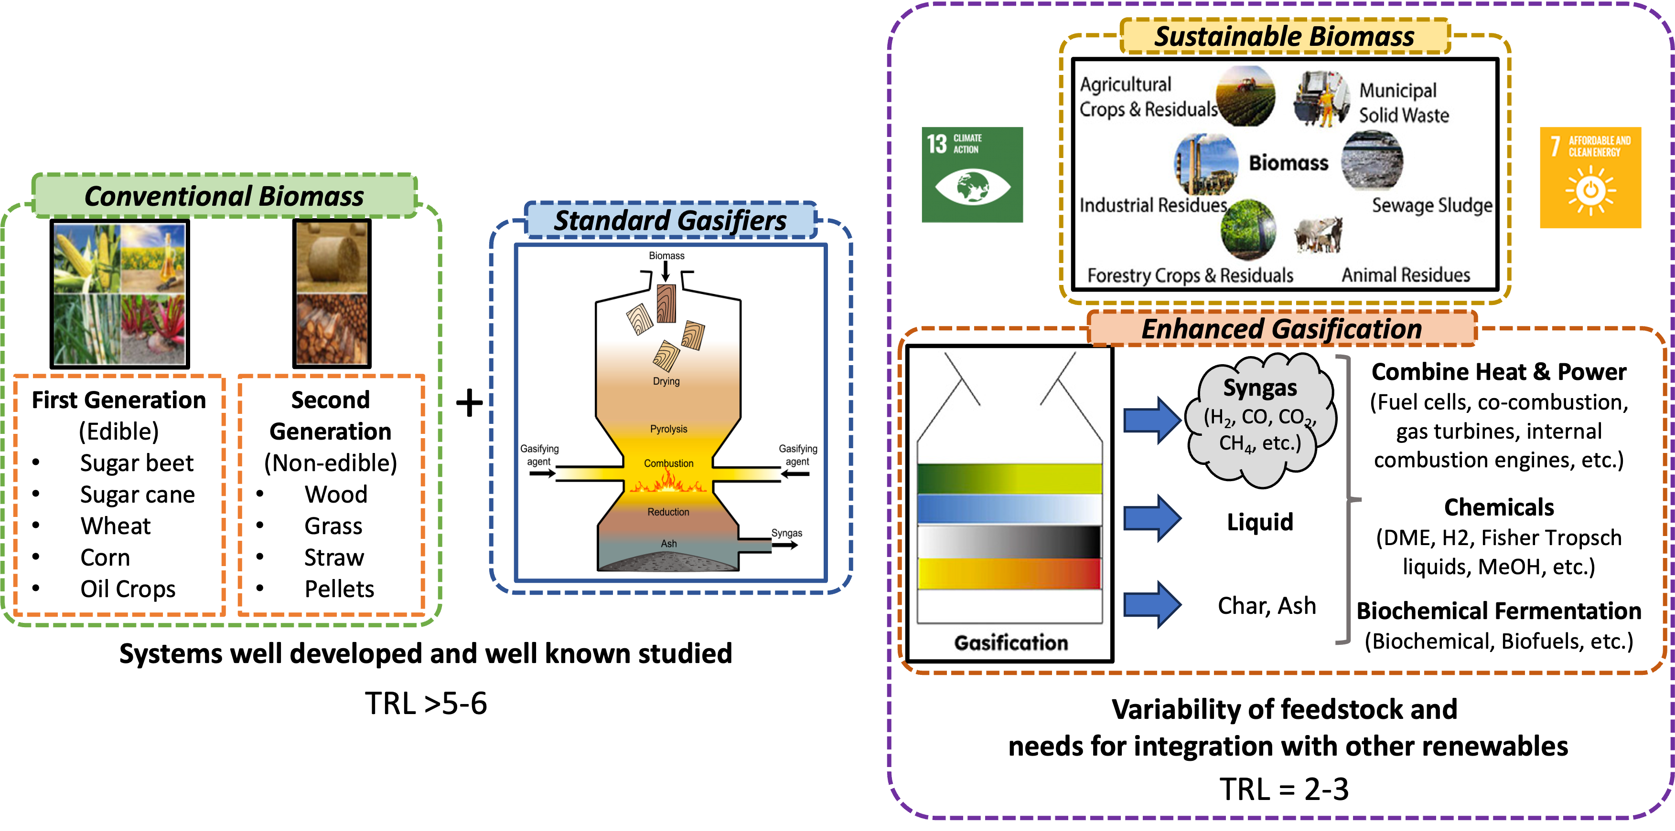
Figure 1: Technology readiness levels (TRLs) for the gasification systems. The conventional one (on the left) in terms of biomass and gasifiers configurations used; on the right, the research stage solution constituted by the use of sustainable biomass and the interaction with renewable energy sources. Adapted from (Tezer et al., 2022).
  - Modeling framework
    - Conceptual model
The general structure of the downdraft gasifier and the proposed conceptual model are reported in Figure 2.
The single-equilibrium model with tar cracking has demonstrated promising outcomes subsequent to fine-tuning the partitioning parameter. Nonetheless, a consistent discrepancy persists between the model's predictions and experimental data, regardless of the chosen parameter setting. Specifically, the model consistently underestimates high-temperature product yields. This recurring deviation arises from the inherent challenge of selecting an optimal temperature for minimizing Gibbs free energy (Biagini et al., 2016).
In the operational context of the downdraft gasifier, a distinct thermal profile emerges within the gasification chamber, spanning from a peak temperature ($T_{peak}$) proximal to the throat, where gasifying agents are introduced, to a notably lower temperature ($T_{out}$) at the gasifier's discharge point (see Figure 3). This temperature gradient underscores the complexity of the situation: equilibrium reactions occur not solely at the peak temperature but also at lower temperatures within the chamber. Regrettably, single-equilibrium models lack the sophistication necessary to encapsulate this complex thermal profile, resulting in a persistent underestimation of product yields that favor formation at lower temperatures.
In pursuit of addressing this limitation, a tripartite partitioning scheme for pyrolysis products is considered (see right of Figure 2). The initial component focuses on tar cracking, accommodating the presence of non-equilibrium products within the syngas composition. Subsequently, a module dedicated to high-temperature equilibrium reactions facilitates precise predictions of gasification products like CO and H₂, prevalent at elevated temperatures. Finally, a distinct segment addresses low-temperature equilibrium reactions, enabling the model to offer more accurate forecasts of gasification products such as CO₂ and CH₄ that are predominant at lower temperatures. By integrating these three distinct facets, our enhanced computational framework aims to bridge the gap between theoretical predictions and experimental observations in the domain of gasification processes.
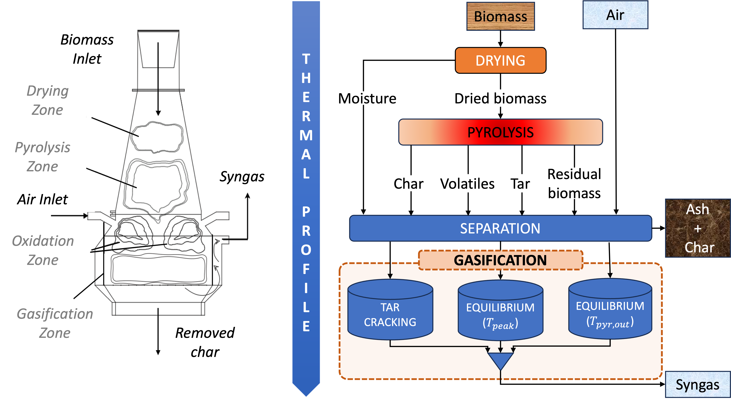
Figure 2: Scheme of the downdraft gasifier (Biagini et al., 2016) (on the left) and detail of the developed conceptual model (on the right) with the main section and stream described.
In general, coherence can be identified between the conceptual framework guiding the implementation of the code and the geometric representation of the downdraft gasifier depicted in Figure 2.
Specifically, the fed biomass encounters an initial drying zone where the moisture within the solid evaporates; thereafter, the dried biomass continues its descent. Approaching the oxidative section, it encounters a gradually increasing temperature. Under conditions of elevated temperature and oxygen absence, the biomass undergoes devolatilization. This reactor section, where devolatilization occurs, is termed the pyrolysis zone, and its products (volatiles, tar, char, and unconverted biomass) continue their descent along the downdraft. The treatment of the pyrolysis submodel is twofold. Firstly, the kinetics description provides a vector of fractions of biomass progressively consumed at the different temperature intervals in which the profile is discretized. Secondly, the speciation model associates the yield of each species at every temperature (Neves et al., 2011), e.g., for CO, $y_{CO} = \left[y_{CO}\left(T_{1}\right); y_{CO}\left(T_{2}\right);…; y_{CO}\left(T_{i}\right);…y_{CO}\left(T_{pyr,out}\right)\right]$, equivalently for CO₂, H₂, H₂O, CH₄, C₂H₄, tar, and char.
Near the throat section of the reactor, the gasifying agent, in our case air, is introduced. In this zone, the oxygen contained in the air oxidizes the carbon with flame generation. The heat generated in the constriction serves to thermally sustain the overlying pyrolysis but also to support the endothermic reactions that will occur in the zone below. Specifically, volatile combustion reactions occur, constituting the oxidative zone. In the conceptual model, this section is not depicted as it is integrated with the gasification section, forming a single equilibrium zone. The separation zone illustrated in Figure 2 is a modeling construct aimed at describing certain phenomena occurring in proximity to the throat section of a downdraft reactor. First, the bypass of the oxidative section is here represented by a separation factor. This phenomenon essentially occurs due to imperfect air mixing near the throat section, thus creating an anaerobic zone where the pyrolysis products cannot oxidize (Biagini et al., 2016). The tar that travels through these preferential paths is therefore not subjected to equilibrium but solely to thermal degradation. Second, the production of species whose formation is favored at low temperatures, that happened in a later phase, when the temperature decreases due to reduction reactions. Hence, a second separation factor is introduced to improve the prediction of gasification products for the equilibrium stage.
The hot products from the oxidative zone eventually reach the equilibrium zone, where oxidation and reduction reactions take place. Model-wise, these two zones are depicted together by two equilibrium reactors and a conversion reactor. The equilibrium section is modeled by minimizing the Gibbs free energy: this approach overcomes the difficulty related to defining a set of reactions because the composition of the outgoing mixture that minimizes the free energy function is calculated. From an implementation perspective, the thermodynamic study required to compute all the necessary quantities has been performed with dedicated Python libraries for numerical optimization. Clearly, this minimization is subject to elementary material balance constraints. The first equilibrium is performed at $T_{peak}$, while the second equilibrium occurs at the temperature at which the pyrolysis ends ($T_{pyr,out}$). The fraction of the non-solid pyrolysis products and the initial moisture present in the biomass do not come into contact with the oxidizing agent and therefore bypass the equilibrium zone, undergoing solely thermal cracking. From a modeling standpoint, the characterization of the tar with two representative compounds is performed. It is noteworthy that representing tar using representative products at different condensation temperatures allows for modeling the physical separation phenomena downstream of the reactor. To describe the tar cracking phenomenon, the model proposed by Rath and Staudinger (2001) has been chosen, which provides both the vapor-phase kinetics of tar disappearance and the distribution of various gaseous products.
The products from all three reactors are combined to constitute the outgoing syngas.
    - Assumptions
In this paragraph, we address the models' assumptions due to the complex nature of reality, which precludes a rigorous treatment of gasification. These assumptions aid analysis and clarify the model's scope.
- The process modeling is conducted under steady-state conditions and feedstocks are introduced under ambient conditions of 298 K and 1 atm.
- Moisture is assumed to completely evaporate in the initial section, aligning with the typical low water content of biomass fed into downdraft gasifiers, as shown in Table 1.
- Despite the gasifier operating under slight vacuum conditions, for simplicity, atmospheric pressure (1 atm) is assumed, and the ideal gas law is applied to the gas phase.
- It is assumed that char is exclusively composed of solid carbon (C).
- The gaseous phase resulting from biomass gasification comprises a mixture of CO, CO₂, H₂, H₂O, CH₄, C₂H₄, and tar. The tar is divided into two fractions: a high-boiling fraction represented by phenol (C₆H₆O) and a low-boiling fraction represented by acetaldehyde (CH₃CHO).
- Thermal gradients within biomass particles are neglected and a linear thermal profile along the reactor is assumed (see Figure 3).
- The sulfur content in biomass and the formation of pollutants due to reactions with air (COS, H₂S, CS₂, NH₃, NO_{x}, and HCN) are disregarded.
By delineating these assumptions, we establish the framework within which the model operates and provide transparency regarding the constraints and simplifications inherent in its formulation. Moreover, Table 1 contains the ultimate and proximate analysis of the feedstock employed as test case in the result section.
Table 1: Ultimate and proximate analyses of corn cobs (Biagini et al., 2016)
Ultimate Analysis | (wt.% dry biomass) |  |  |  | Proximate Analysis | (wt.% dry biomass)
Carbon  Hydrogen  Nitrogen  Oxygen | 47.6  6.10  0.52  45.8 |  |  |  | Fixed carbon  Volatile matter  Ash  Moisture | 17.8  80.1  2.12  10.1

    - Thermal profile
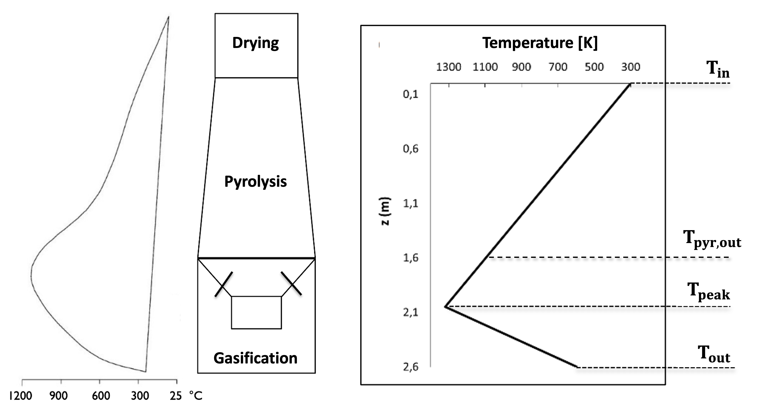
Figure 3: Temperature profile along the gasifier (on the left) and its piecewise linear approximation (on the right)
In an attempt to decouple material balances from thermal ones, a linear thermal profile is assumed within the reactor, characterized by a parameter denoted as heating ratio ($HR$). This parameter represents the slope of the linear thermal profile and is defined as $HR=ΔT/Δt$. Its unit of measurement is K/s, representing the rate at which the temperature increases from the inlet section to the throat section. It is evident that this parameter is substantially dependent on the dimensions of the equipment and the feed rates. This choice is consistent with the study conducted by Dogru et al. (2002), where the thermal profile established in a downdraft gasifier is experimentally measured using a series of thermocouples, with the results depicted on the left of Figure 3. Additionally, a graphical representation of the simplified thermal profile as a function of height is provided on the right of Figure 3. In general, the thermal profiles depicted in the above figures can be defined as spatial since they illustrate the temperature variation with respect to the height of the reactor. However, it is crucial to derive a temporal temperature profile from these spatial profiles by relating the space that biomass traverses inside the gasifier with the time it takes. The key factor that correlates these two quantities is obviously the solid's velocity, which essentially depends on the volumetric flow rate and the passage section. To evaluate the volumetric flow rate of the solid, it is necessary to note that biomass, in situations of rapid heating coupled with volatile release, may undergo swelling phenomena that significantly alter the size distribution and therefore the volume. However, in the case of downdraft gasification, heating is reasonably slow, allowing for a gradual release of volatiles through the pores present in the biomass, without causing swelling or volumetric alterations of the particles. Therefore, this model considers that the char produced from pyrolysis has the same dimensions as the biomass. Given the volume of the reactor and the biomass feed rate, it is possible to calculate, the slope of the line representing the thermal profile up to the constriction zone, which is found to be 0.208 K/s. This value is of fundamental importance for characterizing the thermal profile and consequently the entire pyrolysis phase.
  - Results: model validation
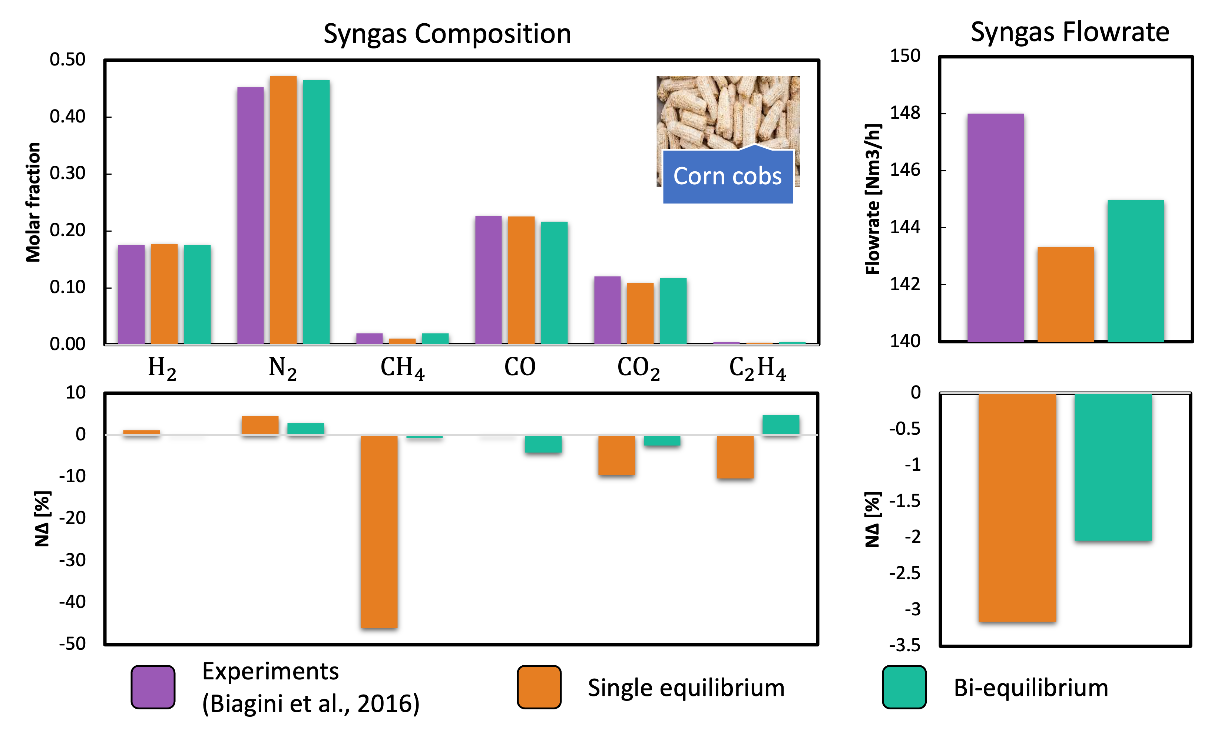
Figure 4: Comparison with experimental data (Biagini et al., 2016) of the single and bi-equilibrium models as developed in this work. Results are compared in term of absolute values (top) and with a normalized error $NΔ$ (bottom), both for the syngas composition (left) that for its flowrate (right).
In this gasification test, 73 kg/h of biomass described by the analysis in Table 1 and 85 kg/h of biomass with an ER = 0.279 were fed. The comparison with results predicted by different models is depicted in Figure 4. The metric of measurement is the relative error $NΔ=\left(y_{exp}-y_{mod}\right)/y_{exp}$ in which $y_{exp}$ is the experimental data taken from Biagini et al. (2016), and $y_{mod}$ is the corresponding modelled result. From Figure 4 some considerations can be drawn; in general, it is evident that the bi-equilibrium model predicts products favored by low temperatures, such as CO₂ and CH₄, much more accurately than the single equilibrium model. In the case of CH₄ the single equilibrium is undervaluing the experimental data of about 40% while with the bi-equilibrium model with tar cracking such a difference is under 1%. The predictive capability extends beyond mass balance alone, allowing for a relatively accurate assessment of the peak temperature (1290 K) established in the throat section, as compared to literature data (Biagini et al., 2016) with $NΔ=2\%$. In light of this, it can be concluded that the introduction of an additional partitioning parameter, enabling the prediction of high-temperature gasification products, confirms to perform an enhancement of the model's predictive capacity. Finally, it is to be underlined that as tuning parameters vary, different production mechanisms are favored: $T_{peak}$ equilibrium predicts high-temperature equilibrium products, $T_{pyr,out}$ equilibrium predicts low-temperature equilibrium products, while tar cracking predicts non-equilibrium products.
  - Conclusions
This scientific study provided an in-depth investigation into biomass gasification, with a particular emphasis on the downdraft configuration. By detailing the sub-model components of the model framework and assessing the limitations of existing prediction tools, we aimed to enhance the predictive accuracy of gasification processes. Introducing a parameter for further partitioning of pyrolysis products proved to be a valuable addition, facilitating better prediction of low-temperature equilibrium products. The developed “Bi-equilibrium model with tar cracking” exhibited superior performance compared to traditional single equilibrium models, particularly after fine-tuning parameters using data from real-world gasification tests. It is worth noting that the presented tool not only enhances the established Bi-equilibrium model (Biagini et al., 2016) by incorporating tar cracking but also offers a general formulation adaptable to various configurations. This versatility holds promise for broader applications in biomass gasification research and industrial practice, offering a robust framework for optimizing processes and advancing sustainable energy production. As we refine and expand upon these findings, future research may explore a wider range of agro-food waste materials, potentially incorporating polymeric substances, and adapt the model to simulate alternative reactor configurations. These efforts will undoubtedly contribute to furthering our understanding and optimization of biomass gasification processes, ultimately driving advancements in renewable energy technologies. As a result, the model holds great promise for advancing the development of sustainable biofuels, aiding in the attainment of the ambitious renewable energy targets set for 2030 and beyond.
Acknowledgments
Project funded under the National Recovery and Resilience Plan (NRRP), Mission 4 Component 2 Investment 1.3 - Call for tender No. 1561 of 11.10.2022 of Ministero dell’Università e della Ricerca (MUR); funded by the European Union – NextGenerationEU: Award Number: Project code PE0000021, Concession Decree No. 1561 of 11.10.2022 adopted by Ministero dell’Università e della Ricerca (MUR), CUP - I53C22001450006, Project title “Network 4 Energy Sustainable Transition – NEST”.
References
Azhar, A. A. N., Manaf, N. A., Yabar, H. F. (2023). Artificial Neural Network Model for Palm Oil Biomass Gasification Process Prediction. Chemical Engineering Transactions, 106, 1237–1242.
Biagini, E., Barontini, F., & Tognotti, L. (2016). Development of a bi-equilibrium model for biomass gasification in a downdraft bed reactor. Bioresource Technology, 201, 156–165.
Catalanotti, E., Porter, R. T. J., Mahgerefteh, H. (2022). An Aspen Plus Kinetic Model for the Gasification of Biomass in a Downdraft Gasifier. Chemical Engineering Transactions, 92, 679–684.
Detchusananard, T., Wiranarongkorn, K., Im-Orb, K. (2023). Process Analysis of Integrated Biomass Gasification and Solid Oxide Electrolysis Cell (SOEC) for Syngas Production. Chemical Engineering Transactions, 99, 691–696.
Dogru, M., Howarth, C. R., Akay, G., Keskinler, B., & Malik, A. A. (2002). Gasification of hazelnut shells in a downdraft gasifier. Energy, 27(5), 415–427.
Neves, D., Thunman, H., Matos, A., Tarelho, L., & Gómez-Barea, A. (2011). Characterization and prediction of biomass pyrolysis products. Progress in energy and combustion Science, 37(5), 611-630.
Rath, J., Staudinger, G. (2001). Cracking reactions of tar from pyrolysis of spruce wood. Fuel, 80(10), 1379–1389.
Safarian, S., Unnþórsson, R., & Richter, C. (2019). A review of biomass gasification modelling. Renewable and Sustainable Energy Reviews, 110, 378–391.
Sikarwar, V. S., Zhao, M., Clough, P., Yao, J., Zhong, X., Memon, M. Z., Shah, N., Anthony, E. J., Fennell, P. S. (2016). An overview of advances in biomass gasification. Energy & Environmental Science, 9(10), 2939–2977.
Tezer, Ö., Karabağ, N., Öngen, A., Çolpan, C. Ö., Ayol, A. (2022). Biomass gasification for sustainable energy production: A review. International Journal of Hydrogen Energy, 47(34), 15419–15433.

