CHEMICAL ENGINEERING TRANSACTIONS  VOL. , 2024 | A publication of
The Italian Association
of Chemical Engineering
Online at www.cetjournal.it

Guest Editors: Leonardo Tognotti, Rubens Maciel Filho, Viatcheslav Kafarov
Copyright © 2024, AIDIC Servizi S.r.l.
ISBN 979-12-81206-09-0; ISSN 2283-9216

Biochar and Hydrochar Impact on the Anaerobic Digestion Process of Sewage Sludge
A. Capone^{a*}, S. Borowski^{b}, E. Sobolewska^{b}, L. Zaccariello^{c}, B. Morroneª
ªDepartment of Engineering, University of Campania “Luigi Vanvitelli”, Aversa (Caserta), Italy
^{b}Department of Environmental Biotechnology, University of Technology Engineering, Lodz, Poland
^{c}Department DiSTABiF, University of Campania “Luigi Vanvitelli”, Caserta, Italy
annalinda.capone@unicampania.it
Many studies have been conducted on the anaerobic digestion of sewage sludge due to its enormous amount to collect and dispose of. Different methods to improve the process of anaerobic digestion of sewage sludge have been investigated, focusing on the increase of biogas production.
In this article, attention is focused on the use of two different carbon-rich products to boost the production of methane in the anaerobic digestion of sewage sludge. The investigation aims to underline the different outcomes that biochar and hydrochar show on methane yield. Both are carbon-rich products but there are differences in their properties and the processes from which they are derived. Biochar is a product of the pyrolysis treatment of biomass. This product can be different in composition and properties depending on the process conditions. Hydrothermal Carbonization (HTC) is an important mid-temperature thermochemical process that converts biomass into hydrochar. The solid HTC by-product seems to be a good accelerator of methane production. The tests are performed in batch reactors, with 0.5, 2, and 5 grams of the two products added to 60 grams of inoculum and 100 grams of sludge, based on the total volatile solids. Mesophilic Anaerobic Digestion was adopted, at a temperature of 35°C, for 34 days, until methane production was stopped. pH is an important parameter for the process, its value being maintained in the 6.8-8 range. The results show a significant increase in methane yield compared to the simple anaerobic digestion process.
  - Introduction
The article highlights the significance of sewage sludge as a substantial portion of waste disposal. It emphasizes the potential drawbacks, including contaminants and pathogens, while noting its organic matter and essential nutrient content. The focus is on anaerobic digestion (AD) for energy recovery and the role of sewage sludge characteristics (Khawer, et al., 2022). The article introduces biochar (BC) as an additive to expedite AD, detailing its benefits in stabilizing the process and promoting methane production. Another approach involves hydrothermal carbonization (HTC) and the production of hydrochar (HY), with the combined AD+HTC process aiming to reduce sludge production and enhance biogas production (Ferrentino, Merzari, Fiori, & Andreottola, 2020). The article explores and compares the impact of BC and HY on sewage sludge anaerobic digestion.
    - Anaerobic Digestion Process
The study explores mesophilic anaerobic digestion at 35°C, a process converting the organic biomass into biogas, mainly methane and carbon dioxide. The transformation involves four phases with different bacterial and archaeal families: hydrolysis, acidogenesis, acetogenesis, and methanogenesis (S. Harirchi, 2022). Maintaining an optimal pH between 7 and 7.5 is crucial, especially for methane production. Methanogens, with slower growth, are a limiting factor, and pH adjustment is essential. The addition of calcium hydroxide aids in alkaline fermentation initiation. The process not only yields gaseous products but also significantly reduces sludge volume, making the resulting digestate suitable for safe agricultural use as fertilizer, having destroyed pathogenic microorganisms.
  - Materials and Methods
In recent years, there has been a concerted effort to scrutinize various processes aimed at improving methane yield in sludge anaerobic digestion. This study specifically investigates the anaerobic digestion of sewage sludge in batch reactors, focusing on the influence of different materials on the process. The primary focus of this research cores on utilizing two distinct carbonaceous products as a boost for the AD process: biochar and hydrochar.
    - Experimental Apparatus
The experimental tests entail the utilization of batch reactors and ovens designed to achieve the specified operating temperatures. In investigating the anaerobic digestion of sewage sludge, a system was implemented, employing glass bottles as reactors with a 500 ml capacity. The bottles were filled to a volume of 200 ml, maintaining a headspace above the substrate to facilitate gas production and diffusion. A variable quantity of bottles was employed, wherein each combination of biomass, inoculum, and either biochar or hydrochar was replicated a minimum of twice. In the initial trial, 14 bottles with 500ml of capacity were utilized, with a redundancy of two bottles for each test. Subsequently, the operational functionality and absence of leaks in the apparatus for conducting anaerobic digestion (AD) experiments were verified. The mesophilic conditions were maintained throughout the process, employing two ovens set at a constant temperature of 35°C, ensuring a stable temperature for the entirety of the experimental duration. A pipe-based connection system interlinks each anaerobic digestion (AD) bottle with an external counterpart containing a 2% NaCl water solution, facilitating the collection of the generated gas. Gas accumulation is monitored through daily assessments of water displacement within bottles positioned outside the ovens. This setup enables the biweekly measurement of gas production, approximately every three days. For monitoring the composition of biogas and the physical parameters of gas mixtures during the methane fermentation process, a portable analyzer, the Nanosense DP-27 BIO, has been specifically designed. This analyzer is utilized to measure gas production by sampling gas from each bottle and evaluating the volume percentages of CH₄, CO₂, O₂, H₂S, and H₂. The Anaerobic Digestion process is concluded when biogas production stabilizes and ceases to increase, typically occurring within an experiment duration ranging from 22 to 34 days. Following the completion of the entire process, a comprehensive analysis of the data collected on a daily and weekly basis is conducted to compile an account of actual methane production. This analysis sheds light on the influence of the two hydrothermal carbonization (HTC) products and biochar on the overall methane production. Moreover, various analyses were conducted on both substrates, sewage sludge, before the process, and the solid product resulting from AD, the digestate. The amounts of compounds such as volatile fatty acids, orthophosphates, and nitrogen ammonium were analyzed on the latter using spectrophotometry with the UV-VIS DR6000 spectrophotometer (Hach Lange, Loveland, CO, USA).
    - Sewage Sludge and Inoculum
The sewage sludge employed as a substrate in the mesophilic anaerobic digestion process was sourced from the wastewater treatment plant in Lodz and meticulously stored at 4°C. The dewatered sludge exhibited total solids (TS) and volatile solids/total solids (VS/TS) values of 60.92 ± 1.05 and 74.82 ± 0.2%, respectively.
The inoculum was an anaerobic sludge derived from Zdunska Wola wastewater treatment plant, (Poland).
Before utilization, moisture and ash measurements were conducted on both the sludge and the inoculum. It was imperative to assess the percentages of Volatile and Total Solids to establish the Biomass/Inoculum ratios for reactor feeding purposes. Table 1 presents these parameters, obtained as the average of three samples per product and the standard deviation.
Table 1: Samples Analysis
Substrate | TS  [g/kg] | Ash  [g/kg] | VS  [g/kg] | VS  [% TS]
Sludge (ave) | 60.92±0.96 | 15.34±0.27 | 45.58±0.27 | 74.82±0.09
Inoculum (ave) | 48.93±0.35 | 22.05±0.10 | 26.88±0.25 | 54.94±0.12
The substrate analysis revealed a Total Solids (TS) value of approximately 60 grams per kg of substrate, comprising 45 g/kg of Volatile Solids (VS) for the sludge and 49 g/kg with 27 g/kg VS for the inoculum.
Choosing a 1:1 ratio between the Volatile Solids of the substrate (VS_{s}) and the inoculum (VS_{I}), a mixture with a total volume of 160 g was formulated. This mixture consisted of 100 g of inoculum and 60 g of sludge purification, representing a balanced blend of primary and secondary sludge.
$$\frac{VS_{I}}{VS_{S}}=\frac{26.88}{45.58}=0.59≃0.60$$ | (1)
The elemental analyses of the sewage sludge and inoculum were meticulously carried out at the Department of Environmental Biotechnology of Lodz using Flash 2000 Series Elemental Analyzers (Thermo Fisher Scientific), providing a comprehensive understanding of its chemical composition and characteristics. The detailed results are presented in Table 2, providing insights into the elemental components and characteristics of the sewage sludge being studied.
Table 2: Sewage Sludge properties
Sample | Unit | C | H | N | P | S | O
Sewage Sludge | %TS | 67.2 | 4.9 | 3.73 | 0.36 | 0.11 | 23.7

    - Biochar and Hydrochar
This study aims to assess the influence of different biochar materials on the anaerobic digestion of sewage sludge in batch reactors. The experiments were carried out using glass reactors with a total volume of 500 ml and a working volume of 200 ml. Initially, a base mixture (blank) comprising sludge and inoculum, covering an approximate volume of 160 ml, was introduced into the reactors. Subsequently, varying doses (0.5g, 2g, 5g, 8g) of both biochar and hydrochar were added to each reactor, with two repetitions for each dose.
Biochar, a solid product resulting from biomass degradation through pyrolysis, is widely recognized for its soil improvement properties. It provides stable, slow-release carbon, enhances nutrient retention, and regulates water characteristics (Anh, et al., 2022). In contaminated soils, biochar's attributes contribute to heavy metal containment and the degradation of organic compounds. Recent studies underscore biochar's crucial features, including high porosity, a substantial specific surface area, good electrical conductivity, and specific surface functional groups, rendering it suitable for diverse roles such as a catalyst or adsorbent. The incorporation of biochar into anaerobic digestion reactors proves advantageous for process stabilization and increased methane production. Its diverse physicochemical properties, controlled during production, make it adaptable for specific applications. The biochar utilized in this study originates from a commercial supplier specializing in the sale of this material as a fertilizer product. Hydrochar, a carbon-rich solid produced through the hydrothermal carbonization of biomass, was investigated using the same starting biomass as the sewage sludge in the anaerobic digestion process. In this study, a hydrochar derived from a HTC process employing sewage sludge as biomass is utilized.
    - Anaerobic digestion with different doses of biochar
The potential impact of biochar (BC) on methanogenesis, a crucial component of the global carbon cycle, has been explored. Previous studies support the use of BC as an additive in AD processes for various substrates, showing improvements in volatile fatty acids (VFAs) degradation rate and methane production yield.
Studies by (X. Wang, 2017) highlighted BC's positive effects on food waste and the organic fraction of municipal solid waste (FORSU) digestion. Additionally, (Y. Shen, 2015) demonstrated BC's ability to increase sludge alkalinity and mitigate ammonia inhibition in anaerobic digestion systems. BC has been shown to enhance nutrient retention and optimize the carbon-nitrogen ratio. The study involved adding different doses of BC to sewage sludge with the anaerobic digestion process conducted in 11 glass flasks of 500 ml. The BC used in this study was a commercially available type obtained as a fertilized product from pyrolysis. It was sourced from a commercial store in Poland. The doses (0.5 g, 2 g, 5 g, 8 g) were added to a substrate of 60 grams of sludge and 100 grams of inoculum, with each dose repeated twice for experimentation.
    - Anaerobic digestion with different doses of hydrochar
The study explored the AD of sewage sludge with varying doses of hydrochar (HC), a carbon-rich solid product derived from the hydrothermal carbonization (HTC) process known for positively impacting methane generation. Previous research, such as that by (X. Wang, 2017), highlighted hydrochar's role in accelerating organic matter solubilization, enhancing hydrolysis, and influencing acidification during anaerobic digestion.
The HTC process was carried out in a lab-scale plant located at the Department of University “L. Vanvitelli” in Caserta (DiSTABiF), Italy. The lab-scale reactor, with a volume of 1.5 l, operated under mild conditions (240°C) and subcritical water conditions with a duration of 4 hours, transforming sewage sludge into HC. Real-time data collection-controlled pressure and temperature, ensuring a controlled process. The resulting HC underwent natural drying and subsequent oven drying at 105°C for 24 hours, with an elemental analysis conducted. Key HC properties are detailed in Table 3. Different HC doses (0.5 g, 2 g, 5 g, 8 g) were added to the substrate during AD to compare methane production with and without the solid product in sewage sludge. The investigation utilized 500 ml flasks as reactors, with each sludge-inoculum-hydrochar combination tested twice, and three flasks used as blanks for reference.
Table 3: Hydrochar properties
Sample | Unit | C | H | N | P | S | O
Hydrochar | %TS | 79.4 | 5.3 | 0.43 | 0.08 | 0.59 | 14.2
    - Analytical procedures
The study involved pre-application characterization of materials, including measurements of moisture, ash, and total volatile and total solids using standard procedures: UNI-EN 14774-1 for the moisture content analysis, UNI-EN 15158 for the Volatile Matter, UNI-EN 14775 for the amount of Ash, UNI-EN 15104 for the C, H, N, and S content. Moisture content was determined by overnight oven drying at 105°C, ash content by maintaining samples at 600°C for two hours, and Total Volatile Solid (TS) by calculating the difference between residues at 105°C and 600°C. Additional analyses on the digestate included measuring Volatile Fatty Acids (VFAs) and Orthophosphates using reagents and a UV-VIS DR6000 spectrophotometer (Hach Lange, Loveland, CO, USA). These analyses contribute to biomass characterization and process parameter identification.
  - Results and Discussion
    - Influence of Biochar and Hydrochar on the Anaerobic Digestion of Sewage Sludge
The acquired results underscore the varied impact of Biochar on biogas production, contingent upon the quantity added. A meticulous analysis of methane production trends across the five tests, encompassing blank and blank with 0.5 g, 2 g, 5 g, and 8 g of Biochar respectively named BC-1, BC-2, BC-3, and BC-4, reveals distinctive outcomes (Figure 1a). Specifically, in certain instances—most notably with 0.5 g and 5 g of Biochar—the addition to the mixture of sewage sludge and inoculum yields an increase in methane production. However, for the remaining quantities, methane production is either reduced or nearly comparable to that observed with the blank, indicating a lack of discernible influence from the carbonaceous product.
A comparable outcome was achieved by incorporating hydrochar derived from hydrothermal carbonization (HTC) as a carbonaceous product added to the sewage sludge. In this scenario as well, the addition of hydrochar has a favorable impact on methane production when introduced in quantities of 0.5 g and 8 g, resulting in an approximate increase of 4% and 9%, respectively, in the final methane production (Figure 1b).
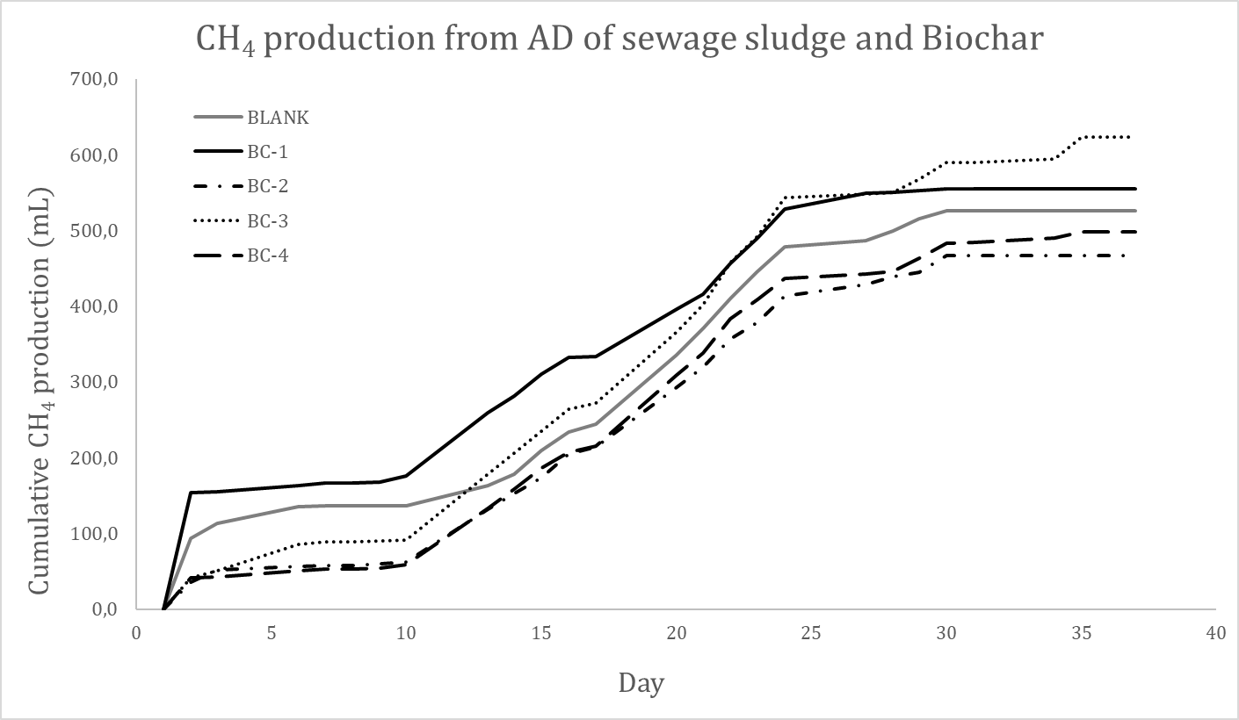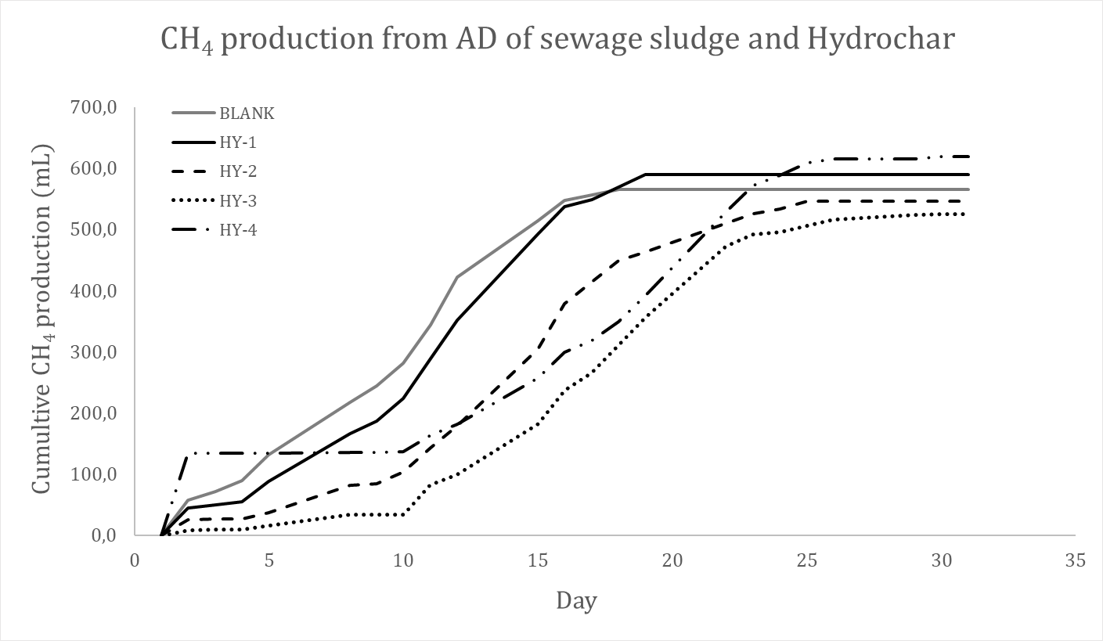
Figure 1: (a) Comparison of CH₄ production with different amounts of Biochar added; (b) comparison of CH4 production with different amounts of Hydrochar added.
The observed trends indicate that the two carbonaceous products involved in the AD process can augment the chemical reactions between the substrates and microorganisms. Conversely, since these products do not have dedicated production methods, they may serve as enhancers or catalysts for the process. Specifically, in the case of hydrochar, its properties, such as conductivity, can influence the disruption of molecular bonds, potentially enhancing the efficiency of the process. The experiments conducted in the two distinct cases involving the use of Biochar and Hydrochar allow for a comparison of the effects resulting from the addition of these two carbon products. The primary difference between the two is the duration of the experiment, with the hydrochar experiment being notably shorter (Figure 2a). The shorter duration of the experiment involving the use of hydrochar can be attributed to the fact that the peak of maximum methane production is reached more quickly, as evident from the graph. Notably, the methane production achieved with hydrochar is also higher than that observed in the case of using Biochar. While the statement holds true in certain instances, it is important to note that the differences between the two cases in terms of methane production quantity vary with the amount of carbonaceous product added.
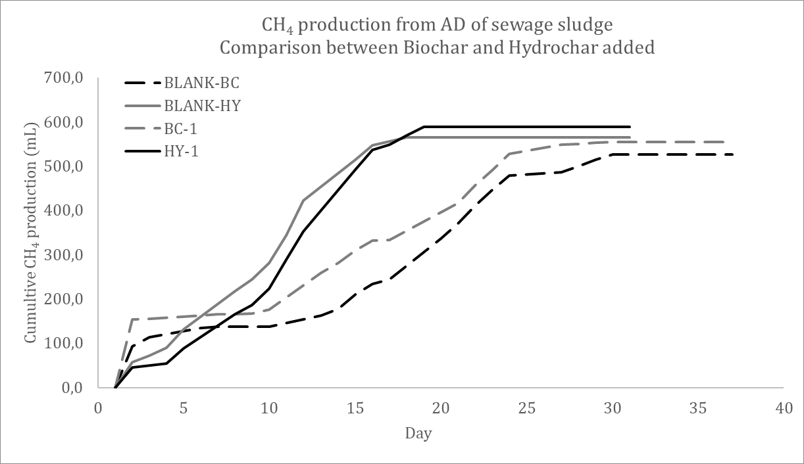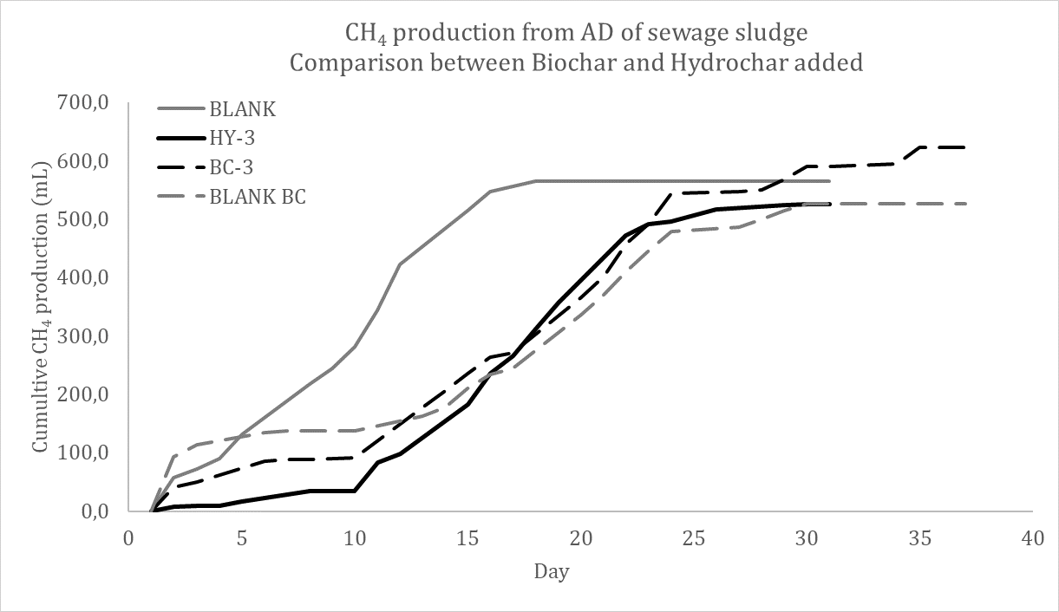
Figure 2: (a) Comparison of CH4 production with 0.5g of different carbonaceous products added; (b) comparison of CH4 production with 5g of different carbonaceous products added.
    - Influence of Biochar and Hydrochar on Volatile Fatty Acid Concentrations in Digestate
After the AD process of sewage sludge enriched with biochar and hydrochar, a comprehensive set of analyses was conducted on the resulting digestate, a byproduct of the AD process alongside biogas. The primary focus was on examining the impact of the two carbonaceous additives on the concentration of volatile fatty acids (VFAs) after the process, given the influential role of VFAs in the anaerobic digestion process. Volatile fatty acids (VFAs) find applications across diverse industries. They play a pivotal role in the anaerobic digestion process, crucial to produce biogas and the generation of renewable energy. Furthermore, VFAs serve in the manufacturing processes of food, beverages, chemicals, pharmaceuticals, and cosmetics.
A preliminary observation derived from the graphical representation of VFA quantities within the digestate unmistakably illustrates a discernible upward trend, correlating with the escalating quantities of the added carbonaceous products. This observed trend provides valuable insights into the distinctive effects of biochar and hydrochar on VFA production, contributing to a deeper understanding of their respective roles in enhancing anaerobic digestion efficiency. Typically, the levels of VFAs generated in each experiment exhibit a notable increase during the anaerobic digestion (AD) of sewage sludge when combined with hydrochar, surpassing the corresponding quantities observed in the AD process involving sewage sludge mixed with biochar. This discernible trend underscores the distinct impact of hydrochar and biochar on VFA production during anaerobic digestion, shedding light on their varying influences within the wastewater treatment framework.
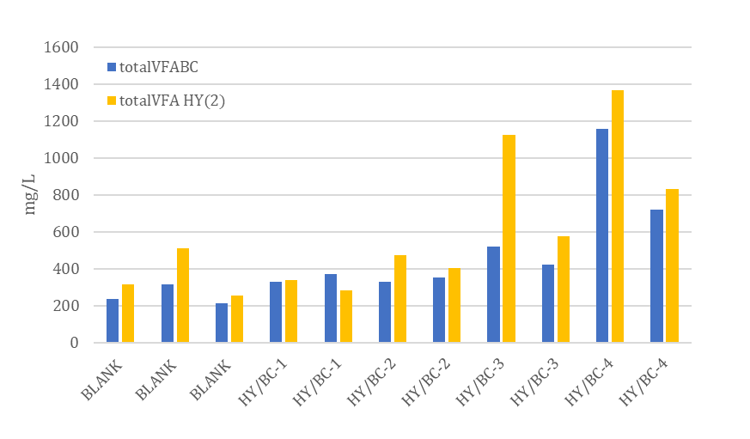
Figure 3: Comparison of VFA production with different carbonaceous products added.
    - Comparative Analysis of Digestate Composition in Sewage Sludge Anaerobic Digestion with Biochar and Hydrochar Addition
Ammonium (NH4+) and orthophosphates (PO43-) found in digestate from sewage sludge anaerobic digestion shed light on nutrient dynamics. Careful digestate management is crucial to avoid environmental impacts such as groundwater pollution from excess nitrogen or phosphorus. Evaluation of these compounds in digestate from anaerobic digestion of sewage sludge mixed with biochar and hydrochar shows no significant difference in production overall. However, biochar use results in higher orthophosphate production compared to hydrochar use. The impact of HY on these components suggests that its porosity and structure may serve as effective traps for pollutants.
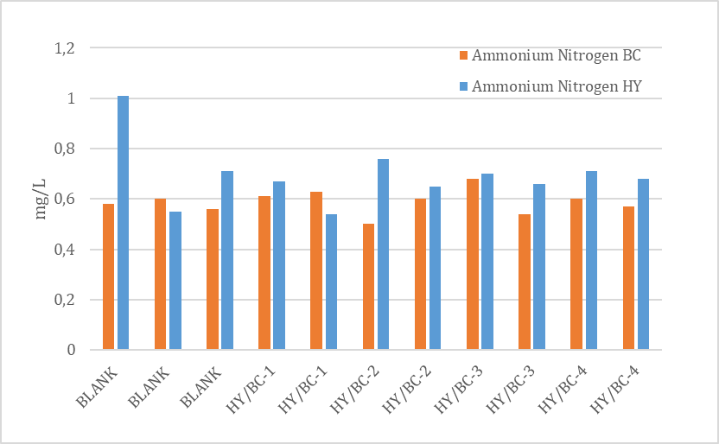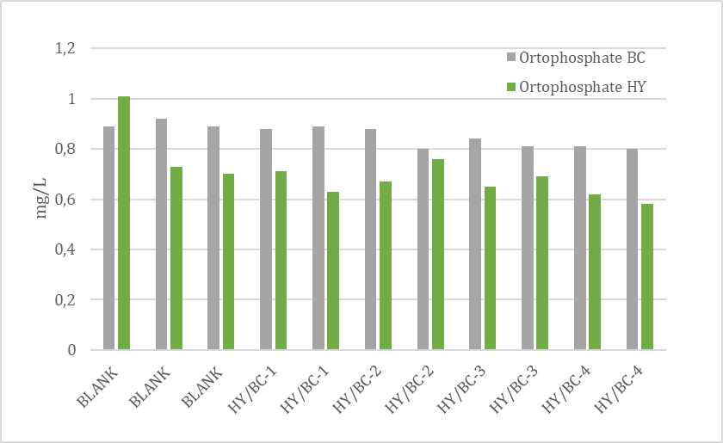
Figure 4: (a) Comparison of Ammonium Nitrogen production with different carbonaceous products added; (b) comparison of Orthophosphate production with different carbonaceous products added.
  - Conclusions
The carbonaceous products, Biochar and Hydrochar, demonstrably enhance methane production efficiency in mesophilic anaerobic digestion when mixed with sewage sludge at varying concentrations. However, their impact on anaerobic digestion efficiency is contingent upon the quantity added. Notably, at an initial concentration of 8 g added to the sludge, Hydrochar significantly bolstered methane production by 9% in anaerobic digestion reactors. Conversely, as the initial concentration of Hydrochar diminishes, the observed increase in methane production in the biogas becomes less pronounced. Furthermore, the addition of Hydrochar emerges as a pivotal factor capable of influencing the microbial community. Significantly, Hydrochar led to an elevation in the quantity of volatile fatty acids (VFAs) produced in the anaerobic digestion system, reaching up to a notable 21% increase in some cases. These findings underscore the nuanced role of Hydrochar in optimizing the efficiency and microbial dynamics of mesophilic anaerobic digestion processes.

Acknowledgments
This work has been partially supported through the grants SOSPIRI project funded by the Italian Ministry of the Environment and Energy Safety CUP: F29J22001310004 and CIBUS project funded by Regione Campania Italy CUP: B27G22000290002.
References
Anh, T. H., Goldfarb, J. L., Foley, A. M., Lichtfouse, E., Kumar, M., Xiao, L., . . . al., e. (2022). Production of biochar from crop residues and its application for anaerobic digestion. Bioresource Technology, 363, pp. 127970.
Ferrentino, R., Merzari, F., Fiori, L., & Andreottola, G. (2020). Coupling Hydrothermal Carbonization with Anaerobic Digestion for Sewage Sludge Treatment: Influence of HTC Liquor and Hydrochar on Biomethane Production. Energies, 13, 6262.
Khawer, M. U., Naqvi, S. R., Ali, I., Arshad, M., Juchelkov, D., Anjum, M. W., & Naqvi, M. (2022). Anaerobic digestion of sewage sludge for biogas & biohydrogen production: State-of-the-art trends and prospects. Fuel.
S. Harirchi, S. W. (2022). Microbiological insights into anaerobic digestion for biogas, hydrogen or volatile fatty acids (VFAs): a review. Bioengineered, 13:3, 6521-6557.
X. Wang, J. Z. (2017). Evaluating the potential impact of hydrochar on the production of short-chain fatty acid from sludge anaerobic digestion. Bioresource Technology, 234-241.
Y. Shen, J. L.-D. (2015). Producing Pipeline-Quality Biomethane via Anaerobic Digestion of Sludge Amended with Corn Stover Biochar with in-Situ CO2 Removal. Appl. Energy, 158, 300-309.

“ave” is for Average

