CHEMICAL ENGINEERING TRANSACTIONS  VOL. , 2024 | A publication of
The Italian Association
of Chemical Engineering
Online at www.cetjournal.it

Guest Editors: Leonardo Tognotti, Rubens Maciel Filho, Viatcheslav Kafarov
Copyright © 2024, AIDIC Servizi S.r.l.
ISBN 979-12-81206-09-0; ISSN 2283-9216

Syngas Cleaning by Chemical Looping Conversion of Tars from Hazelnut Shells Pyrolysis/Gasification
Orlando Paloneª*, Beatrice Vincenti^{b}, Alessandro Amadei^{c}, Martina Damizia^{c}, Luca Cedolaª, Benedetta de Caprariis^{c}, Domenico Borelloª
ªDepartment of Mechanical and Aerospace Engineering, Sapienza University of Rome, Via Eudossiana, 18, Rome, Italy
^{b}Department of Astronautical, Electrical and Energy Engineering, Sapienza University of Rome, Via Eudossiana, 18, Rome, Italy
^{c}Department of Chemical Engineering Materials Environment, Sapienza University of Rome, Via Eudossiana, 18, Rome, Italy
*Corresponding author e-mail: orlando.palone@uniroma1.it
Syngas tars are responsible for clogging and corrosion of pipelines and equipments due to their high condensation temperatures. At the same time, considering their energy content they cause a reduction in the energy efficiency of the conversion process. To overcome these drawbacks, the addition of a downstream reactor to perform hot catalytic gas cleaning has been proposed. However, the occurrence of significant carbon deposition and sulphide formation on the catalytically active surfaces can easily lead to early deactivation of the catalyst. Chemical looping tar reforming is based on a solid material, known as oxygen carrier, that undergoes two reactions steps: (1) reduction by interaction with the gas and tar streams; (2) regeneration by oxidation with ambient air, which also involves the combustion of any deposits on the particle surface. In this work, the first reaction step of the process is investigated in an integrated setup involving the pyrolysis or the gasification of hazelnut shells and the reaction with the oxygen carrier for tar abatement. Two reactor configurations have been considered: (1) single reactor, where the biomass and the oxygen carrier beds are loaded in series into the same reactor; (2) two reactors, where the two beds are loaded into different reactors in series. Blank tests for pyrolysis and gasification are also carried out for comparison. The results indicate that the two beds configuration enables higher tar conversion (89% wt for pyrolysis and 75% wt for steam gasification), though the presence of the oxygen carrier causes a reduction in the energy content of the syngas, especially in terms of H₂ concentration, which is reduced from around 34% to 21% mol for pyrolysis and from 28% to 21% mol for steam gasification.
  - Introduction
The depletion of fossil fuels reservoirs associated with the climate crisis is currently driving scientific research towards new and more sustainable technologies to produce feedstocks for the energy and chemical industries. Biomass gasification and pyrolysis represent promising routes for the production of carbon neutral and high quality syngas (i.e. with high H₂ and CO molar concentration), that can be used in the energy sector, for example in power production or district heating, and in the chemical sector for the production of liquid fuels and chemicals such as methanol, ammonia, dimethyl-ether, formaldehyde etc. However, to date one of the main drawbacks of this technology is represented by tars formation, which account for 5%-15% of the total energy of the products (Z. Huang et al., 2020). Tars are organic pollutants with a molecular weight higher than benzene that condense at high temperatures causing clogging of pipelines and equipment corrosion. Efficient syngas cleaning and upgrading is crucial for the development of this technology and, in this sense, high temperature gas cleaning is an interesting pathway to preserve the enthalpic content of the syngas from gasification/pyrolysis (Arnaiz del Pozo et al., 2021). The catalytic cracking of tars by steam reforming enables syngas cleaning with simultaneous energy upgrading, since additional CO and H₂ are produced, but it is affected by significant carbon deposition on the catalyst surface which inhibits the performance of the process over time. Chemical looping tar reforming has been recently proposed as an alternative technology that can overcome these drawbacks. Chemical looping reforming (CLR) involves an oxygen carrier (OC) that undergoes two successive reaction steps: reforming, in which the oxygen carrier reacts with a gaseous fuel and produces CO, CO₂, H₂O and H₂, by exchange of lattice oxygen with the solid material; oxidation where the reduced oxygen carrier is oxidized by a stream of ambient air. The available literature on this specific application of chemical looping is limited. Catalysts currently employed for tar cracking are natural ores, alkali metals, transition metals, and carbon-based catalysts. In Cuiping et al. (Cuiping et al., 2020) a composite oxygen carrier with Fe₂O₃, Al₂O₃, and CaO has been synthesized by the impregnation method. At 900 °C, oxygen carrier to carbon molar ratio of 3, and steam to carbon molar ratio of 0.5, a tar conversion above 90% has been demonstrated in a lab-scale fluidized bed reactor where tar has been directly injected. However, over 20 cycles a decrease in the conversion performance has been observed due to sintering and carbon accumulation in the oxygen carriers’ pores. In Luo et al. (Luo et al., 2023) three oxygen carriers are tested (NiO, CuO-NiO, Fe₂O₃-NiO) and compared for the removal of toluene, which is used as tar model, given that toluene accounts for around 15-25% of biomass tar composition. The synergistic effect of Ni and Fe has been observed to promote toluene conversion (94.4%) and syngas production (3.3 Nm³/kg) at 900 °C and at a steam to carbon ratio of 2. Stable toluene conversion has been observed during ten cycles. Similarly, in Keller et al. (Keller et al., 2016) the tar reforming performance of La/Sr/Fe-containing mixed oxides supported on ZrO₂ is assessed with benzene and toluene as tar surrogates. Combinations of La and Fe have provided better benzene and ethylene conversion, especially when Sr had been added, while by increasing the temperatures in the 750-850 °C range a 20% tar conversion increase has been observed. Fe-based oxygen carriers represent promising materials due to their high availability, resistance to attrition, thermal stability, and environmental friendliness (Palone et al., 2024). The combination of Fe with alkaline earth metals, such as Ca, has been proved to improve syngas yield during chemical looping gasification processes compared to iron oxides (X. Huang et al., 2020). Moreover, CaO is inexpensive, environmentally friendly, and is a catalyst for tar cracking. Therefore, the aim of this work is to analyse the effect of a Fe and Ca-based oxygen carrier bed on tar removal from a real syngas stream. Differently from the majority of literature works, no tar surrogates have been used but biomass pyrolysis/gasification has been performed with the subsequent tar removal by a dedicated downstream oxygen carrier bed. Comparison with conventional fixed bed biomass pyrolysis or gasification is undertaken to assess the impact of the oxygen carrier presence on tar removal efficiency and insights from the preliminary results are discussed. Minimizing tar formation is crucial to facilitate the subsequent downstream processing of the syngas to other chemicals or fuels and is also a strategy for increasing the system efficiency of its direct use as a carbon neutral energy carrier.
  - Method
    - Oxygen carrier preparation
The calcium ferrite is prepared via the sol-gel method according to the procedure in Abdalazeez et al. (Abdalazeez et al., 2022). First Fe(NO₃)₃.9(H₂O) and Ca(NO₃)₂.4(H₂O) provided by Sigma Aldrich are weighed so that Fe³⁺:Ca²⁺ = 2:1 and dissolved in distilled water. Stirring at 80 °C for 10 min is performed to reach a homogeneous solution, then citric acid is added according to an acid/Ca molar ratio of 1:1 and finally the pH is adjusted to 7 by the addition of aqueous ammonia. Subsequently, water is evaporated for 6 h at 80 °C and a gel is formed. The gel-like substance is put for 24 h in an oven at 100 °C to evaporate residual water and then calcinated in a muffle furnace at 900 °C for 3 h. The resulting powder is then sieved with a sieve of nominal aperture of 710 µm.
    - Experimental setup and procedure
The experiments are carried out with two reactor configurations. In the first configuration a single stainless-steel tubular reactor of 2 cm diameter and 40 cm length is used. The reactor is loaded with two particle beds in series separated by quartz wool and containing 2 g biomass and 0.5 g Ca ferrite (i.e. 0.25 OC/B in mass), respectively. A simplified scheme of the setup is reported in Figure 1-(a). An argon flow rate of 0.25 nl/min is injected into the reactor and then heating by an external tubular resistance is started with a first step at 200 °C for 5 min to release the residual moisture in the biomass (to avoid clogging), and then a second step at 750 °C for 20 min. In the second configuration, an additional quartz reactor (1 cm diameter and 20 cm length) containing the oxygen carrier is added downstream to the first one (where only biomass is loaded). A simplified scheme is provided in Figure 1-(b). The second reactor is heated by an external resistance to 730 °C and then the biomass reactor is heated according to the previous procedure up to 750 °C. This is expected to promote tar cracking by the oxygen carrier, which is more active at higher temperatures. Each reaction step is evaluated for a total of 20 minutes after which the reactor is cooled down by the Ar flow. In the gasification tests, liquid water is mixed with the Ar flow by injection with a syringe pump and electrically heated to 250°C before entering the first reactor. The resulting mixture is composed of 10% vol H₂O and 90% vol Ar. The gaseous products are analyzed by online mass spectrometry (QGA, Quantitative Gas Analyzer), while the liquid products are condensed and collected in a balloon flask immersed in an ice bath. Gas chromatography–mass spectrometry (GC-MS) is also used for qualitative characterization of the collected tars. However, the associated results will not be displayed in this paper.
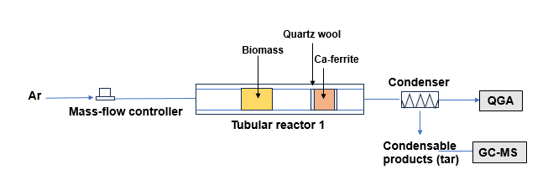
(a)
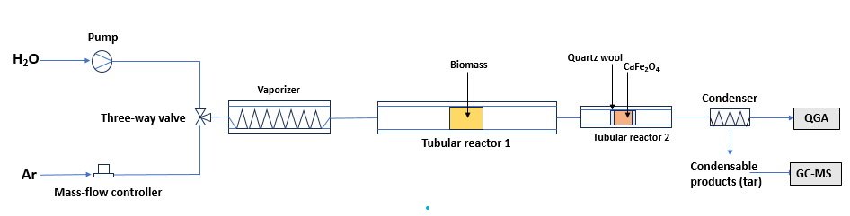(b)
Figure 1. Scheme of the two configurations: (a) one reactor with separate biomass and oxygen carrier beds, (b) two separate reactors with single beds in series
    - Material characterization
Material characterization is carried out by X-Ray Diffraction (XRD) using a Philips Analytical PW1830 diffractometer (Malvern, UK) equipped with a Ni β-filtered Cu Kα (1.5418 A) with applied voltage and current of 40 kV and 30 mA, respectively. A 2$θ$range of 5-90° with a step size of 0.02° and a time step of 3.5 s are enforced. The crystalline phases in the diffractograms are identified by comparison with the Crystallography Open Database (Graulis et al., 2009). The average crystallite size is calculated with the Scherrer’s equation on the most intense hkl plane of each detected phase (Bracciale et al., 2022). As shown in Figure 2, the synthesized material is composed of a mixture of Ca₂Fe₂O₅ and CaFe₂O₄. Peaks of residual Fe₂O₃ are also detected.
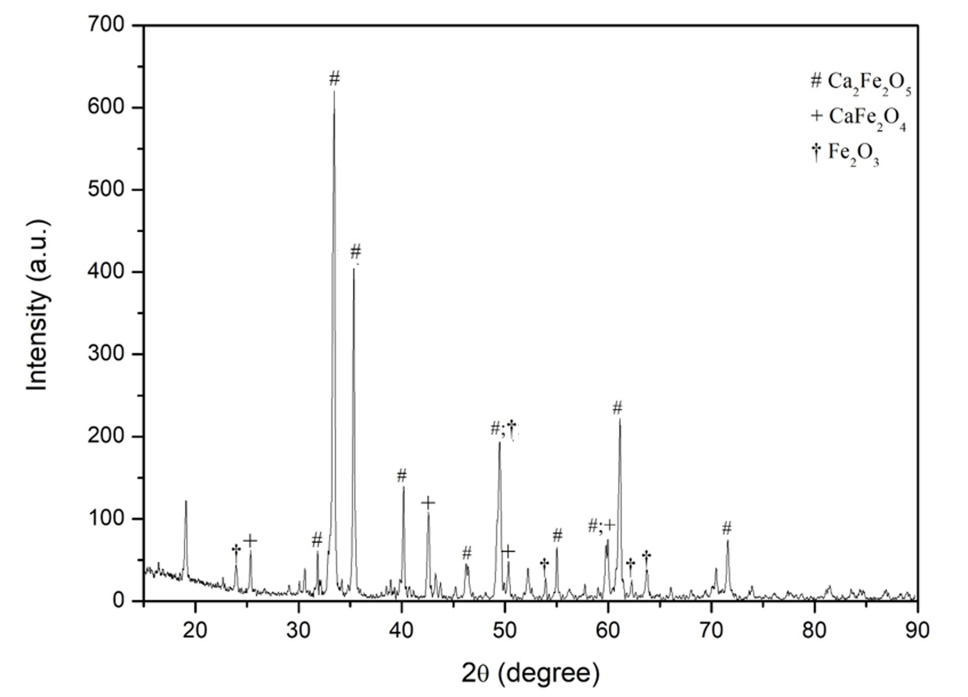
Figure 2. Diffractogram of the synthesized Ca ferrite
The oxygen carrier surface properties are analyzed by the Brunauer-Emmett-Teller (BET) method using a Micromeritics Triflex Analyzer (Micromeritics Instrument Corp., Norcross, Ga, USA) with N₂ adsorption-desorption isotherms at -196 °C in a p/p₀ range from 0.01 to 0.99. Before analysis, the samples are outgassed for 4 h at 300 °C. Isotherm post-processing is performed using the 3Flex Version 4.05 software. The BET and BJH equations are used to determine the specific surface area, the pore volume, and the mean pore diameter, respectively. The results are collected in Table 1. Very low surface area (< 1 m²/g) and pore volumes are detected, as shown in the literature for unsupported iron ores (Luo et al., 2021) or calcium ferrites (Hu et al., 2020).
Table 1. BET analysis of the synthesized Ca ferrite providing specific surface area (m²/g), mean pore width (nm), and total pore volume (cm³/g)
Material | Specific surface area (m²/g) | Mean pore width (nm) | Total pore volume (cm³/g)
Ca ferrite | 0.48 | 7.48 | 0.0011
The selected biomass, hazelnut shells, is characterized with an Eurovector EA3000 elemental analyzer. Three samples have been analyzed to obtain statistically relevant data. The oxygen mass fraction is calculated per difference assuming the absence of any sulfur content in the biomass. The results shown in Table 2 indicate that around 51% wt of carbon and 6% wt of hydrogen are present in the biomass.
Table 2. Elemental analysis of the hazelnut shells
Mass fraction (%) | N | C | H | O (diff.)
Mean | 0.61 | 50.55 | 5.99 | 42.85
Standard deviation | 0.10 | 0.47 | 0.06 | 0.06
  - Results analysis
    - Single reactor configuration
In the first configuration a single reactor is tested with two particle beds in series containing the biomass and the Ca ferrite particles. In this case the objective is to realize a compact configuration where the tars released by the biomass interact with the oxygen carrier bed and are partially oxidized. A comparative analysis is performed with the blank test involving the sole biomass bed. The QGA results on gas compositions are integrated over the whole duration of the tests and collected in Table 3.
Table 3. Average gas compositions (% mol) in the single reactor configuration after blank pyrolysis and with oxygen carrier
 | H₂ | CO₂ | CO | CH₄ | C₂H₄ | Tot
Blank | 28.2% | 27.0% | 28.4% | 14.5% | 1.9% | 100%
Oxygen carrier | 19.1% | 24.4% | 27.9% | 13.5% | 15.2% | 100%
The presence of the oxygen carrier bed causes a decrease in the H₂, CO, and CH₄ concentrations, while the C₂H₄ content rises from 1.9% to 15% mol. This result can be associated with the simultaneous occurrence of material reduction by the fuel gases (H₂, CO, and CH₄) released during pyrolysis and the tar cracking with C₂H₄ production. The mass balance for the three product phases in Table 4 corroborates these findings by reporting a 10% wt decrease in tar production and an increase in the gas phase. The balance is performed by weighing the collected char and tar, while the gases mass yield is derived by mass difference. As expected, the char mass yield remains unaltered. The results are however not satisfactory in terms of tar conversion. This outcome can be attributed to the oxygen carrier bed limited reactivity during tar release, which is expected to occur from around 300 °C during the reactor temperature ramp, as indicated by thermogravimetric analysis results under inert atmosphere shown in Mahmood and Ceylan (Mahmood and Ceylan, 2022).
Table 4. Mass balance for the three product phases (solid, liquid, and gas) in the single reactor configuration after blank pyrolysis and with oxygen carrier
 | Char (g) | Tar (g) | Gas (g) | Tot (g)
Blank | 0.49 | 0.33 | 1.17 | 2.00
Oxygen carrier | 0.49 | 0.30 | 1.20 | 2.00
    - Two reactors configuration: pyrolysis
In the two reactors configuration the tars released by the biomass during the temperature ramp encounter the oxygen carrier bed at high temperature (730 °C). As shown in Table 5, with respect to the blank test the CO concentration increases from 28.4% mol to 39.1% mol, the CH₄ concentration increases to 16.4% mol, and the C₂H₄ increases to 6.4% mol. On the contrary, the CO₂ and H₂ decrease with respect to the blank test and, in particular, the H₂ content is reduced by around 13 percentage points because of the high reactivity with the material. The product phases mass balance in Table 6 corroborates the results, indicating tar conversion by 89% wt, which is mainly converted to syngas.
Table 5. Average gas composition (% mol) in the two reactors configuration after blank pyrolysis and with oxygen carrier
 | H₂ | CO₂ | CO | CH₄ | C₂H₄ | Tot
Blank | 34.3% | 21.0% | 28.4% | 14.1% | 2.3% | 100%
Oxygen carrier | 21.4% | 16.7% | 39.1% | 16.4% | 6.4% | 100%
Table 6. Mass balance for the three product phases (solid, liquid, and gas) in the two reactors configuration after blank pyrolysis and with oxygen carrier
 | Char (g) | Tar (g) | Gas (g) | Tot (g)
Blank | 0.49 | 0.28 | 1.31 | 2.08
Oxygen carrier | 0.51 | 0.03 | 1.55 | 2.09
    - Two reactors configuration: steam gasification
A biomass gasification test with H₂O as enhancer has been carried out in the two reactors configuration. Liquid water is mixed with an Ar flow to reach 10% vol in the final mixture (0.02 ml/min of H₂O) and then heated by a resistance to 250 °C for steam production. Comparison with the blank test results is given in Table 7. Except for a slight increase in CH₄ and C₂H₄ in the oxygen carrier case, which can be ascribed to tar cracking, in general the syngas energy content decreases due to the oxygen carrier reduction. In particular, the H₂ concentration in the final syngas decreases by about 5 percentage points. The combined effect of H₂ reduction and H₂O oxidation of the material can be responsible for this relatively limited drop in the concentration, if compared to the results for pyrolysis. However, tar conversion by 75% wt is achieved, as indicated by the results in Table 8. Compared to the pyrolysis tests of Table 5, in the two reactors configuration with the oxygen carrier the H₂ concentration rises from 21.4% to 33.4% mol while the CO, CH₄, C₂H₄ concentrations are reduced, due to a combination of water gas shift and hydrocarbons steam reforming. Especially the CO concentration decreases substantially, shifting from around 39% mol in the pyrolysis test to about 28% mol in the steam gasification test. Therefore, as expected, the positive effect of the oxygen carrier in terms of tar conversion and hydrogen intensification in the final syngas is more evident in the steam gasification case. On the contrary, the residual tar after gasification and pyrolysis is almost unchanged (0.03 mg), while the char reduction after gasification is also limited (0.02 mg). Compared to literature results on syngas conversion with Ni-Fe based oxygen carrier (Luo et al., 2023), syngas tar conversion is still unsatisfactory. However, from the observed results the following adjustments and implications can be drawn to maximize tar conversion and syngas upgrading: (1) by increasing the second reactor temperature above 800 °C material activity can be improved; (2) by optimizing the steam to carbon ratio hydrogen production can be intensified by the combined effect of water gas shift, hydrocarbons reforming, and oxygen carrier oxidation; (3) by optimizing material synthesis with the addition of a support can provide higher specific surface areas and facilitate tar conversion.
Table 7. Average gas composition (% mol) in the two reactors configuration after blank gasification and with oxygen carrier
 | H₂ | CO₂ | CO | CH₄ | C₂H₄ | Tot
Blank | 38.9% | 14.8% | 30.8% | 12.3% | 3.3% | 100%
Oxygen carrier | 33.4% | 20.9% | 28.3% | 13.7% | 3.7% | 100%
Table 8. Mass balance of the three product phases (solid, liquid, and gas) in the two reactors configuration after blank gasification and with oxygen carrier
 | Char (g) | Tar (g) | Gas (g) | Tot (g)
Blank | 0.47 | 0.12 | 1.47 | 2.05
Oxygen carrier | 0.47 | 0.03 | 1.55 | 2.05
  - Conclusions
Chemical looping tar reforming by a calcium ferrite oxygen carrier is evaluated in an integrated system under hazelnut shells pyrolysis or gasification conditions. Two configurations are compared: (1) single reactor with two particle beds in series; (2) double reactor with one particle bed per reactor. The results for the pyrolysis tests in the first configuration indicate limited tar conversion (10% wt) and a significant reduction in the H₂ concentration in the final syngas, which decreases from around 28% to 19% mol, likely due to the oxygen carrier reduction by H₂. The main limitations in the first configuration lie in the tars being released at low temperatures (from 350 °C according to literature), at which the oxygen carrier is not active. Therefore, a second configuration has been developed where the oxygen carrier is located in a second reactor which is kept at high temperatures (730 °C) during the whole test. With respect to the blank pyrolysis, in the two reactors configuration the CO concentration increases by around 13 percentage points and the tars are significantly reduced (around 89% wt conversion). Given the promising results of the two reactors configuration, steam gasification tests are performed for H₂ intensification in the final syngas with respect to pyrolysis. Compared to the blank gasification test, a general reduction in syngas energy quality is observed except for a slight increase in C₂H₄ and CH₄ concentrations, while tar conversion is promoted and reaches a conversion of around 75% wt. In general, the final tar mass in unchanged between pyrolysis and steam gasification with the oxygen carrier, while as expected the H₂ content is intensified in the latter case by the combined effect of hydrocarbons reforming, water gas shift, and oxygen carrier steam oxidation. Based on these promising results, future optimization of the oxygen carrier composition and of the reaction conditions, such as the steam to biomass ratio and the total temperature in the two reactors, will be crucial to minimize the observed syngas energy downgrading in the presence of the oxygen carrier while maximizing tar conversion.
Nomenclature
Brunauer-Emmett-Teller | BET
Chemical looping reforming | CLR
Gas Chromatography–Mass Spectrometry | GC-MS
Oxygen Carrier | OC
Quantitative Gas Analyzer | QGA
X-Ray Diffraction | XRD
Aknowledgements
Project funded under the National Recovery and Resilience Plan (NRRP), Mission 4 Component 2 Investment 1.3 - Call for tender No. 1561 of 11.10.2022 of Ministero dell’Università e della Ricerca (MUR); funded by the European Union – NextGenerationEU: Award Number: Project code PE0000021, Concession Decree No. 1561 of 11.10.2022 adopted by Ministero dell’Università e della Ricerca (MUR), CUP NEST. The authors would also like to acknowledge the Italian Ministry of University and Research (MUR) as part of the European Union program NextGenerationEU, PNRR - M4C2 - ECS_00000024 “Rome Technopole”
References
Abdalazeez, A., Li, T., Cao, Y., Wang, W., Abuelgasim, S., Liu, C., 2022. Syngas production from chemical looping gasification of rice husk-derived biochar over iron-based oxygen carriers modified by different alkaline earth metals. Int J Hydrogen Energy 47, 40881–40894. https://doi.org/10.1016/j.ijhydene.2022.09.185
Arnaiz del Pozo, C., Cloete, S., Jiménez Álvaro, Á., 2021. Carbon-negative hydrogen: Exploring the techno-economic potential of biomass co-gasification with CO2 capture. Energy Convers Manag 247, 114712. https://doi.org/10.1016/J.ENCONMAN.2021.114712
Bracciale, M.P., Damizia, M., De Filippis, P., de Caprariis, B., 2022. Clean Syngas and Hydrogen Co-Production by Gasification and Chemical Looping Hydrogen Process Using MgO-Doped Fe2O3 as Redox Material. Catalysts 12. https://doi.org/10.3390/catal12101273
Cuiping, W., Hao, Y., Yanbo, Y., Wenzheng, L., Shirui, Y., Weiwei, C., Fengyin, W., Hongcun, B., Xiude, H., 2020. Chemical Looping Reforming of Coal Tar Vapor on the Surface of CaO-Modified Fe-Based Oxygen Carrier. Energy and Fuels 34, 8534–8542. https://doi.org/10.1021/acs.energyfuels.0c00839
Graulis, S., Chateigner, D., Downs, R.T., Yokochi, A.F.T., Quirós, M., Lutterotti, L., Manakova, E., Butkus, J., Moeck, P., Le Bail, A., 2009. Crystallography Open Database – an open-access collection of crystal structures. J Appl Crystallogr 42, 726. https://doi.org/10.1107/S0021889809016690
Hu, Q., Shen, Y., Chew, J.W., Ge, T., Wang, C.H., 2020. Chemical looping gasification of biomass with Fe2O3/CaO as the oxygen carrier for hydrogen-enriched syngas production. Chemical Engineering Journal 379. https://doi.org/10.1016/j.cej.2019.122346
Huang, X., Wu, J., Wang, M., Ma, X., Jiang, E., Hu, Z., 2020. Syngas production by chemical looping gasification of rice husk using Fe-based oxygen carrier. Journal of the Energy Institute 93, 1261–1270. https://doi.org/10.1016/j.joei.2019.11.009
Huang, Z., Zheng, A., Deng, Z., Wei, G., Zhao, K., Chen, D., He, F., Zhao, Z., Li, H., Li, F., 2020. In-situ removal of toluene as a biomass tar model compound using NiFe2O4 for application in chemical looping gasification oxygen carrier. Energy 190. https://doi.org/10.1016/j.energy.2019.116360
Keller, M., Leion, H., Mattisson, T., 2016. Chemical looping tar reforming using La/Sr/Fe-containing mixed oxides supported on ZrO2. Appl Catal B 183, 298–307. https://doi.org/10.1016/j.apcatb.2015.10.047
Luo, H., Zeng, Y., He, D., Pan, X., 2021. Application of iron-based materials in heterogeneous advanced oxidation processes for wastewater treatment: A review. Chemical Engineering Journal 407, 127191. https://doi.org/10.1016/J.CEJ.2020.127191
Luo, M., Shen, R., Qin, Y., Liu, H., He, Y., Wang, Q., Wang, J., 2023. Conversion and syngas production of toluene as a biomass tar model compound in chemical looping reforming. Fuel 345. https://doi.org/10.1016/j.fuel.2023.128203
Mahmood, M.A., Ceylan, S., 2022. Insights into Reaction Modeling and Product Characterization of Hazelnut Shell Pyrolysis. Bioenergy Res 15, 1281–1291. https://doi.org/10.1007/S12155-021-10341-W/FIGURES/5
Palone, O., Ramezani, R., Navarro, C., Di Felice, L., Borello, D., Grasa, G., Gallucci, F., 2024. On the reduction of NiFe/Al2O3 oxygen carrier in high-pressure chemical looping applications. Int J Hydrogen Energy 49, 1304–1317. https://doi.org/10.1016/J.IJHYDENE.2023.09.235

