CHEMICAL ENGINEERING TRANSACTIONS  VOL. , 2024 | A publication of
The Italian Association
of Chemical Engineering
Online at www.cetjournal.it

Guest Editors: Leonardo Tognotti, Rubens Maciel Filho, Viatcheslav Kafarov
Copyright © 2024, AIDIC Servizi S.r.l.
ISBN 979-12-81206-09-0; ISSN 2283-9216

Investigation of Myriophyllum Aquaticum HTC: Reaction Pathways & Compound Identification
Mariangela Guastaferro, Marco Vaccari, Federica Barontini*, Monica Puccini
University of Pisa, Department of Civil and Industrial Engineering, Largo Lucio Lazzarino 2, 56126 Pisa (Italy)
*federica.barontini@unipi.it
Hydrothermal Carbonization (HTC) represents a promising green technology for converting various biomass feedstocks into valuable hydrochar and liquid products. In this study, the HTC process of Myriophyllum aquaticum Verd., highly diffused in Tuscany (Italy), was investigated varying the process temperatures and the holding times. Indeed, it is one of the world's most troublesome invasive aquatic weeds, impacting not only the quality of water but also contributing to habitat deterioration; therefore, several management practices are required to address the problem. This research focused on obtaining preliminary experimental data to be further implemented in a lumped kinetic model to elucidate the reaction pathways leading to the formation of primary hydrochar and liquid compounds responsible for secondary hydrochar production. To figure out the HTC liquid phase composition and the organic compounds responsible for secondary hydrochar formation, the High-Performance Liquid Chromatography (HPLC) analytical technique was employed. This technique allowed to identify and quantify some of key chemical components present in the HTC liquid phase, i.e., sugars and furans. Moreover, the future integration of a lumped kinetic model and advanced analytical techniques not only will enhance the understanding of the Myriophyllum aquaticum HTC process but will also provide valuable insights into the optimization of HTC conditions for biomass conversion and resource recovery.
  - Introduction
Biological invasions are widely recognized as a significant contributor to biodiversity loss. In the context of freshwater ecosystems, Invasive Aquatic Plants (IAP) have become a focal point of concern. The unique characteristics of inland waters, including internal connectivity, high seasonal and spatial variability, and extensive shorelines interfacing with terrestrial ecosystems, render them particularly susceptible to IAP invasions. The challenges posed by IAP extend to conservationists and managers, as these plants inflict considerable damage on freshwater environments. Their impact includes an elevated risk of flooding due to dense plant occupation of riverbeds, physicochemical consequences such as oxygen depletion in densely vegetated areas, and adverse effects on aquatic fauna and native plants through resource competition. Furthermore, IAP create complications for various water-related activities such as drainage, and irrigation. Specifically, species like Ludwigia grandiflora, Myriophyllum aquaticum, and Egeria densa form dense monospecific stands, impeding water movement, trapping sediment, and inducing fluctuations that degrade water quality. In Europe, predominant management techniques involve mechanical harvesting and the introduction of grass carp, that is also employed to control native plants. Herbicide use against IAP is observed in some European countries, although restrictions often apply (Weidlich et al., 2020). North America and Australia have explored biological control programs utilizing both exotic and native organisms. However, attention and resources predominantly focus on specific approaches, namely grass carp (Ctenopharyngodon idella) and introduced insects. Researchers utilize such wastes to reduce or eliminate the above pollutants as a precursor for developing biochar and other by-products with added value. Different from the pyrochar, produced at 300–1200 °C with a pre-drying process of biomass in an inert atmosphere, the hydrochar is the solid product from hydrothermal carbonization (HTC) of biomass at 180–375 °C obtained in an aqueous phase. Compared with pyrochar, hydrochar is characterized by lower cost and higher yield, benefiting the large-scale application (Volpe et al., 2017). The hydrothermal degradation leads to the following products: solid hydrochar, liquid bio-oil, and gases. Hydrochar is the most preferred end-product due to its versatile and adaptive range of applications. Hydrochar exhibits hydrophobic properties, that are better than the starting feedstock in terms of mass and energy density, and combustion performance. The fundamental idea of converting biomass into energy-rich solid fuel is to extract the maximum possible carbon content in the feedstock in its solid form. According to Poomsawat et al. (2021), for the water hyacinth, treated under HTC, the fixed carbon increased upon temperature increase; i.e.: it ranged from 8.88wt% at 180 °C up to 26.06wt% at 220 °C. Gao et al. (2013) treated the water hyacinth for 30 minutes at 240 °C: the % of carbon recovered was equal to 44.26 and its lower heating value (LHV) equal to 16.83 MJ/kg. The dominant form of the product is determined by various process conditions such as temperature, holding times, and heating rate, with reactor pressure typically being autogenic and not specifically set (Huang et al., 2022). Myriophyllum aquaticum, among other important aquatic plants (IAP), falls into the category of lignocellulosic biomass, containing varying proportions of cellulose, hemicellulose, and lignin. Cellulose, organized into fibers and held together by hydrogen bonds, undergoes degradation primarily through hydrolysis reactions at temperatures exceeding 200°C. This process yields oligomers that further decompose into glucose and fructose, undergoing subsequent dehydration, fragmentation, and isomerization, ultimately leading to C–C bond breakage. Furfural and its derivatives are produced, undergoing polymerization and reverse aldol condensation, serving as valuable feedstocks for biodiesel and chemical production. Additionally, the degradation process generates propanoic, lactic, acetic, and formic acids, consequently lowering the medium's pH. Hemicellulose dissolves at 180°C, with shorter residence times resulting in higher solid hydrochar content and vice versa. Prolonged residence times facilitate the polymerization of liquid-phase fragments, yielding secondary hydrochar with a polyaromatic structure. The formation of secondary hydrochar, dependent on residence time, enhances the thermal stability of the produced hydrochar in lignocellulosic biomass. In summary, hydrochar formation occurs through two pathways: the first involves the collapse of cellulose and hemicellulose under subcritical conditions, leading to primary hydrochar formation, while the second pathway results from polymerization of released molecules in the fluid phase (Borrero-López et al., 2018). Therefore, the primary objective of this study is to utilize the HTC process for the treatment of Myriophyllum aquaticum and unravel the reaction pathway leading to hydrochar formation. In pursuit of this goal, two temperature values (200 and 260 °C) and various reaction times (0, 30, 60, and 120 minutes from the set point) will be tested to obtain preliminary data and, consequently, figure out process and analysis feasibility. Employing a direct quenching method using cold water, the reactions will be interrupted at different specified intervals. The resulting aqueous phase will undergo analysis through HPLC to identify soluble intermediates in the aqueous medium responsible for the formation of secondary hydrochar. The results will enable to understand how the HTC process conditions affect the formation of intermediate compounds in the aqueous solution and, consequently, the formation of secondary char.
  - Materials and Methods
Myriophyllum aquaticum
Myriophyllum aquaticum (Figure 1) was provided by Department of Agricultural, Food and Agro-environmental Sciences of University of Pisa, that previously collected the plant from Barra-Barretta Channel. The sample was washed, dried, and then milled using a Retsch SM 100 cutting mill, to reduce the dimensions below 1 mm.
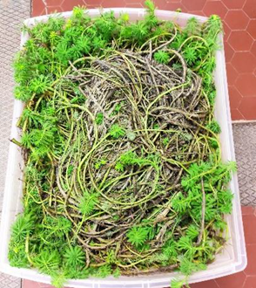
Figure 1: Myriophyllum aquaticum collected from Barra-Barretta channel.
Hydrothermal carbonization experiments
Hydrothermal carbonization experiments were conducted using a 300 mL AISI 316 stainless-steel PARR 4566 reactor, that was outfitted with a mechanical agitator, an electric heating system, a thermocouple, a pressure gauge, and a pressure transducer (refer to Figure 2). Control over reactor temperature was maintained using a Parr 4848 Process Controller. The experiments involved varying reaction temperatures (200 and 260 °C), reaction durations (0-120 minutes), while keeping the solid content constant at 25 wt% for each trial. At specific intervals (0, 30, 60, and 120 minutes from achieving steady state conditions), the reaction was quenched using a cold water bath set at 4 °C. Prior to each experiment, the milled sample was mixed with water to achieve the desired solid content. Upon completion of the HTC test, the mixture of solid and liquid products was recovered from the reactor vessel, and the solid fraction was separated via vacuum filtration. The resulting solid product, referred to as hydrochar, was then dried at 105 °C for 12 hours, weighed, and stored for subsequent characterization.
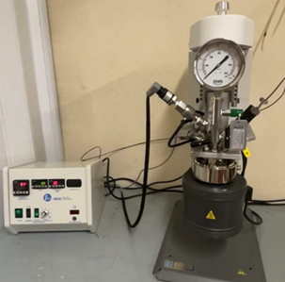
Figure 2: HTC experimental set-up.
HPLC analysis
The filtrated liquid fraction underwent analysis using High Performance Liquid Chromatography (HPLC). The HPLC analysis was performed utilizing an Agilent 1100 Series analyzer comprising a G1329A autosampler, a G1365A multi-wavelength diode detector (DAD), a G1316A column oven set at 30°C, and a Pursuit C-18 column. The mobile phase consisted of a mixture of water and acetonitrile (90:10 %v/v), maintained for 15 minutes. A flow rate of 1 mL/min and an injection volume of 5 μL were employed. Wavelengths of 200 and 275 nm were monitored. Compound identification utilized commercially available pure substances. Retention times for specific compounds were as follows: furfural (5 min), 5-hydroxymethylfurfural (3.6 min), and fructose (1.88 min). External calibration was conducted for each compound to facilitate quantification.
  - Results and Discussion
A closer look at the selected compounds reveals concentrations individually varying with process severity (in terms of temperature and time). Figure 3a, 3b and 3c show, respectively, the contents of fructose, furfural and 5-hydroxy-methylfurfural (HMF), known as key HTC intermediates at the respective process temperatures (200 and 260 °C) after 0, 30, 60 and 120 minutes of process duration.
The obtained concentration trend of these compounds, varying HTC process conditions, shows the formation of fructose, furfural and 5-HMF after hydrolysis of cellulose and hemicellulose and dehydration of the resulting hexoses and pentoses, followed by a decrease, due to the transformation of oligomeric species into carbonaceous compounds as proposed by the literature (Bevan et al., 2023; Borrero-López et al., 2018). In particular, Figure 3a shows the trend of fructose concentration upon the variation of holding time and temperature: at 200 °C the concentration achieves its maximum value after 60 minutes of steady state; at 260 °C it remains almost constant for each tested time. At 200 °C, the furfural concentration follows a trend similar to fructose, whereas, at 260 °C, in the first 30 minutes, the concentration increases before reaching an asymptotic value (Figure 3b). At 260 °C, only 5-HMF concentration shows an increasing trend upon the increase of reaction time.
Concentration measurements, recorded at 200°C, are in accordance with literature data. Initially, intermediate compounds in the solution exhibit an increase with increased holding time, followed by condensation and polymerization processes that result in the formation of hydrochar, consequently reducing their concentration (Reza et al., 2013). However, at higher temperatures, the concentration values demonstrate an upward trend, reaching a constant value. These trends can be elucidated considering that, according to the literature investigation (Lucian et al., 2018), larger quantities of furfurals are extracted from the char at more harsh carbonization conditions (i.e., T=260 °C), suggesting that part of these components may re-condense into the primary solid char as “coal-like” carbon spheres and part of them remain stable in the aqueous solution.
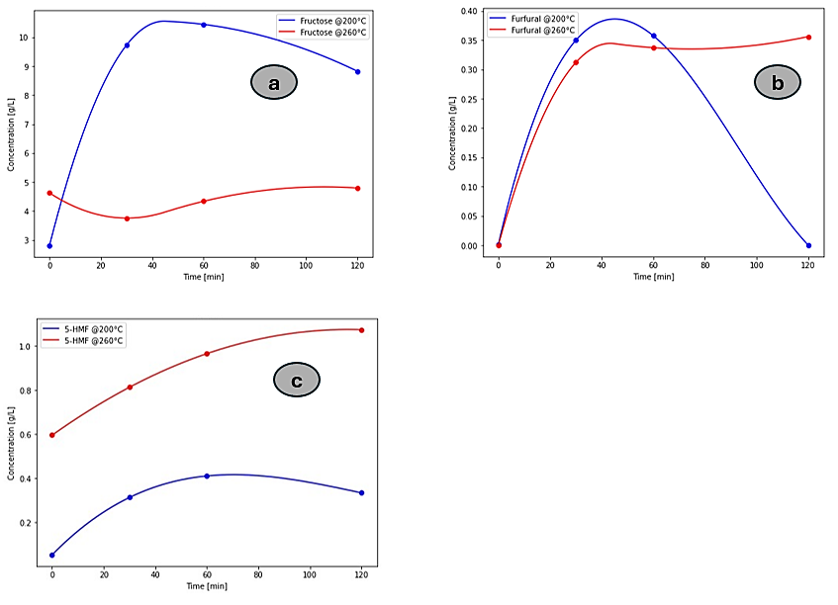
Figure 3: a) Fructose concentration trend at 200 °C (blue line) and 260 °C (red line); b) Furfural concentration trend at 200 °C (blue line) and 260 °C (red line); c) 5-HMF concentration trend at 200 °C (blue line) and 260 °C (red line).
The amounts of solid recovered by the end of the process are reported in Table 1.
Table 1: Hydrochar yields values obtained at different process temperature (T=200 and T=260 °C) and at different holding times (t=0, t=30, t=60 and t=120 min) for each T.
Temperature [°C] | 200 |  |  |  | 260
Time [min] | 0 | 30 | 60 | 120 | 0 | 30 | 60 | 120
Hydrochar yield [%] | 55.7 | 54.9 | 53.7 | 57.3 | 42.1 | 41.8 | 46.5 | 40.4

Based on the findings of Barontini et al. (2023), it is evident that reaction temperature plays a significant role in both solid yield and energy densification. Specifically, higher temperatures in hydrothermal conditions lead to the carbonization of biomass polymers, resulting in their breakdown into the aqueous phase. Consequently, there is an expected loss of mass due to the solubilization of reaction intermediates and inorganic components into the liquid medium. Additionally, a minor decrease in solid mass content occurs due to the release of carbon dioxide through decarboxylation reactions in the gaseous phase. This decline in solid mass content is observed with increasing temperature. Moreover, the results reported in the current study are in line with a previous work carried out on aquatic biomass (Poomsawat et al., 2021): the hydrochar yield ranged from 50 down to 40 % upon temperature increase from 200 up to 220 °C. The pH values are reported in Table 2.

Table 2: pH values obtained at different process temperature (T=200 and T=260 °C) and at different holding times (t=0, t=30, t=60 and t=120 min) for each T.
Temperature [°C] | 200 |  |  |  | 260
Time [min] | 0 | 30 | 60 | 120 | 0 | 30 | 60 | 120
pH | 4.8 | 4.7 | 4.7 | 4.8 | 5.1 | 5.5 | 5.5 | 5.6

The pH remains almost constant, because the holding times are short to appreciate significant changes as reported in (Borrero-López et al., 2018). However, the increase in pH, for higher temperature (260 °C), could be due to the condensation and polymerization of organic acids in the aqueous solution (Reza et al., 2013).
The HPLC analysis allowed to identify the main conversion pathway of cellulose and hemicellulose during HTC process. This pathway is reported in Figure 4, where the black line denotes the reaction pathway of primary hydrochar and the green line shows the reaction pathways of intermediate compound formation.

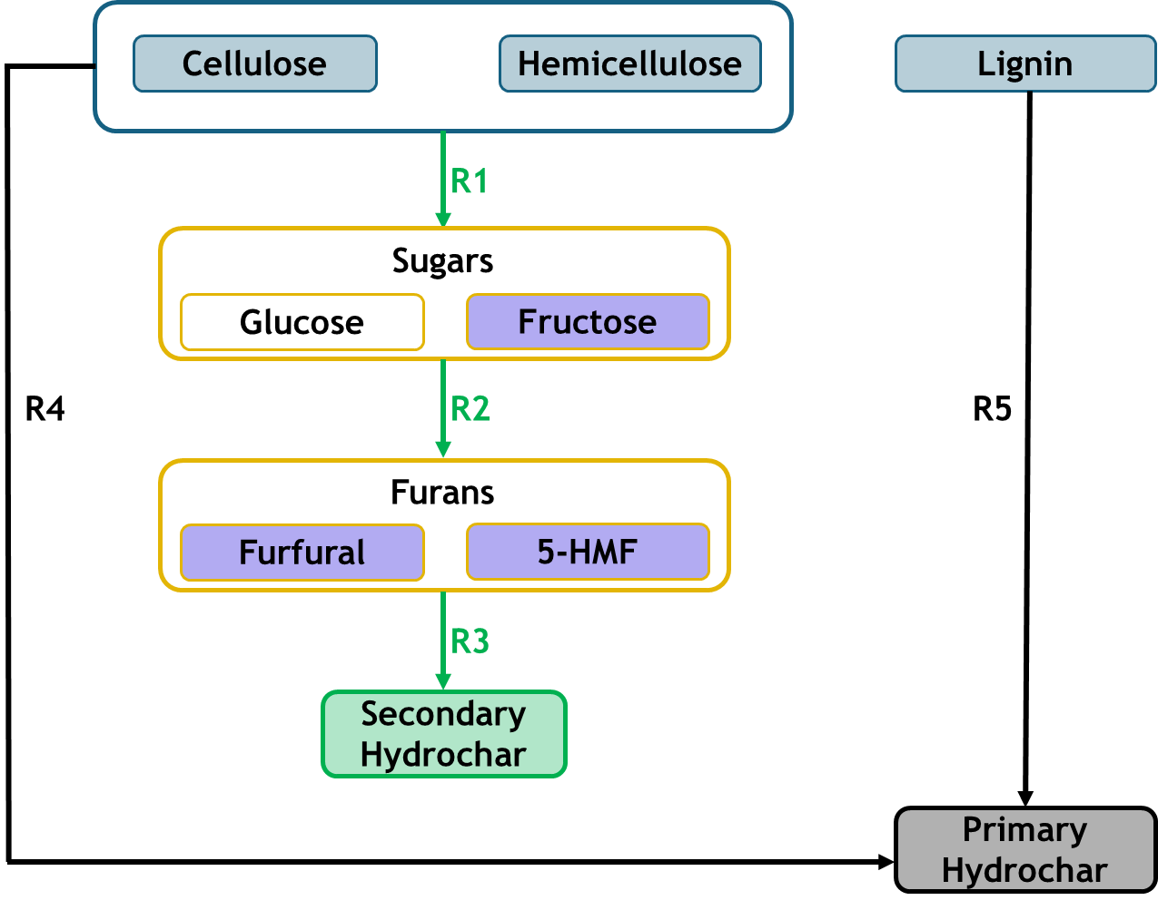
Figure 4: Reaction pathway of HTC process. Black lines (R4-R5) indicate the degradation reactions involving cellulose/hemicellulose and lignin that lead to primary hydrochar formation; green lines (R1-R2-R3) indicate the degradation reactions of cellulose/hemicellulose that lead to intermediate compounds production (those analysed in this study have been underlined in violet) and then to secondary hydrochar formation.
The reaction pathways of the HTC process are schematically described by a global component model (hemicellulose, cellulose, and lignin), in which the initial raw material is converted into intermediates up to the final products in different steps (Figure 4). Consequently, the intermediate products of cellulose and hemicellulose degradation can be grouped to better evaluate each group’s formation kinetics (as reported in Figure 4). Indeed, glucose and fructose can be gathered as total sugar (products of R1); furfural and 5-HMF can be grouped as furans (products of R2). These reaction products have already been evaluated through HPLC analysis. To mathematically evaluate the proposed scheme, the reactions set (i.e., R1-R5) can be described as reported in the Eq. (1-5).

$$\frac{dC_{c-H}}{dt}= -k_{1}{C_{c-H}}^{n1}-k_{4}{C_{C-H}}^{n4}$$ |  | (1)
$$\frac{dC_{sugars}}{dt}= k_{1}{C_{c-H}}^{n1}-k_{2}{C_{sugars}}^{n2}$$ |  | (2)
$$\frac{dC_{furans}}{dt}= k_{2}{C_{sugars}}^{n2}-k_{3}{C_{furans}}^{n3}$$ |  | (3)
$$\frac{dC_{s-HC}}{dt}= k_{3}{C_{furans}}^{n3}$$ |  | (4)
$$\frac{dC_{P-HC}}{dt}= k_{4}{C_{c-H}}^{n4}+k_{5}{C_{lignin}}^{n5}$$ |  | (5)
Where k₁-k₅ of R₁-R₅ indicate the kinetic rate constants, $C_{c-H}, C_{sugars, } C_{furans}, C_{lignin }, C_{s-HC}, C_{P-HC}$show the concentrations of cellulose (C) and hemicellulose (H), sugars, furans, lignin, secondary hydrochar and primary hydrochar, respectively, whereas, $n1-n5$ refer to each kinetic reaction order. This system can be considered as starting point for future modeling approaches, aimed to optimize the future operative conditions.
  - Conclusions and future perspectives
Myriophyllum aquaticum has been successfully processed using HTC process. The aqueous solution obtained after direct quench, for different holding times and temperatures, have been analyzed through HPLC equipment. In particular, HPLC analyses have been pointed out to identify and quantify each intermediate compound concentrations responsible of secondary char formation. We stress that the obtained results are preliminary to a more in-depth experimental analysis in which different operative conditions will be tested for a more thorough assessment of the biomass behavior in the HTC process. Moreover, it has been possible to figure out the reaction pathways and the respective kinetic equations. This will also play a key role in a future modeling approach where the reaction kinetics will be implemented in Python. A further minimization of an error metric with experimental data will provide validation of the model and thus the values for pseudo-intrinsic factors (i.e., pre-exponential factor and activation energy), for each reaction.
Acknowledgments
Project funded under the National Recovery and Resilience Plan (NRRP), Mission 4 Component 2 Investment 1.3 - Call for tender No. 1561 of 11.10.2022 of Ministero dell’Università e della Ricerca (MUR); funded by the European Union – NextGenerationEU: Award Number: Project code PE0000021, Concession Decree No. 1561 of 11.10.2022 adopted by Ministero dell’Università e della Ricerca (MUR), CUP - I53C22001450006, Project title “Network 4 Energy Sustainable Transition – NEST”.
References
Barontini, F., Vitolo, S., Gori, R., Trivelli, L., Puccini, M., 2023. The Hydrothermal Carbonization Process for Waste Valorisation: a Study on the Effect of Process Conditions on the Yield and Properties of Hydrochars from Municipal Solid Waste. Chem Eng Trans 99, 181–186.
Bevan, E., Santori, G., Luberti, M., 2023. Kinetic modelling of the hydrothermal carbonisation of the macromolecular components in lignocellulosic biomass. Bioresour Technol Rep 24, 101643.
Borrero-López, A.M., Masson, E., Celzard, A., Fierro, V., 2018. Modelling the reactions of cellulose, hemicellulose and lignin submitted to hydrothermal treatment. Ind Crops Prod 124, 919–930.
Gao, Y., Wang, X., Wang, J., Li, X., Cheng, J., Yang, H., Chen, H., 2013. Effect of residence time on chemical and structural properties of hydrochar obtained by hydrothermal carbonization of water hyacinth. Energy 58, 376–383.
Huang, C., Yu, C., Wang, G., Zhang, J., Ning, X., Wang, C., 2022. Comparison of structural characteristics and combustibility analysis about hydrochar and pyrochar. J Therm Anal Calorim 147, 10509–10523.
Lucian, M., Volpe, M., Gao, L., Piro, G., Goldfarb, J.L., Fiori, L., 2018. Impact of hydrothermal carbonization conditions on the formation of hydrochars and secondary chars from the organic fraction of municipal solid waste. Fuel 233, 257–268.
Poomsawat, S., Poomsawat, W., 2021. Analysis of hydrochar fuel characterization and combustion behavior derived from aquatic biomass via hydrothermal carbonization process. Case Studies in Thermal Engineering 27, 101255.
Reza, M.T., Yan, W., Uddin, M.H., Lynam, J.G., Hoekman, S.K., Coronella, C.J., Vásquez, V.R., 2013. Reaction kinetics of hydrothermal carbonization of loblolly pine. Bioresour Technol 139, 161–169.
Volpe, M., Fiori, L., 2017. From olive waste to solid biofuel through hydrothermal carbonisation: The role of temperature and solid load on secondary char formation and hydrochar energy properties. J Anal Appl Pyrolysis 124, 63–72.
Weidlich, E.W.A., Flórido, F.G., Sorrini, T.B., Brancalion, P.H.S., 2020. Controlling invasive plant species in ecological restoration: A global review. Journal of Applied Ecology. https://doi.org/10.1111/1365-2664.13656

