CHEMICAL ENGINEERING TRANSACTIONS  VOL. , 2024 | A publication of
The Italian Association
of Chemical Engineering
Online at www.cetjournal.it

Guest Editors: Leonardo Tognotti, Rubens Maciel Filho, Viatcheslav Kafarov
Copyright © 2024, AIDIC Servizi S.r.l.
ISBN 979-12-81206-09-0; ISSN 2283-9216

Unlocking the Potential of Solid-State Fermentation with Insights into Organic Waste Selection and Thermal Dynamics for Sustainable Sophorolipids Production
Teresa Gea, Estefanía Eras-Muñoz, Anna Carrasco-García, Xavier Font, Javier Moral-Vico, Adriana Artola, Antoni Sánchez, Nicolás Oiza, José Bueno-Mancebo, Raquel Barrena.
Composting Research Group (GICOM), Department of Chemical, Biological and Environmental Engineering, Escola d’Enginyeria, Universitat Autònoma de Barcelona, Barcelona, Spain

Solid State Fermentation (SSF) is proposed as an emergent technology in the transformation of organic solid waste into diverse valuable products, playing a key role in creating new value chains for the development of the circular bioeconomy. Sophorolipids are a glycolipid type of biosurfactants, and their production has been proven feasible through SSF. However, the commercialization and scale-up of SSF presents some challenges, among others, the adaptation to a variable feedstock (different types of waste, heterogeneity, seasonality, etc.); or the heat transfer limitations leading to temperature rise over optimal values for the microorganisms’ growth. Understanding the potential of various types of waste and their complementarity is crucial for designing an optimal solid matrix and defining an efficient SSF process with high productivities and potential scalability.
In this work, we assessed the potential of different types of organic solid waste including food and cosmetic industry waste such as oil cakes, agricultural byproducts, or cosmetic-derived sludge. Optimization of C/N ratio resulted in a 30% increase in sophorolipids production. Besides, substrates composition and availability strongly influenced fermentation yields. Fat content strongly affected crude extracts purity.
A model of the fermenting solid matrix has been developed to predict heat generation and temperature dynamics. The influence of organic solid waste chemical composition and their inherent physical parameters (such as thermal conductivity or heat capacity) have been assessed in terms of temperature profiles.
In summary, general recommendations will be outlined for the selection of organic waste for the proper development of the production process of sophorolipids with views to the commercial scaling.

  - Introduction
    - Microbial biosurfactants (BSs) are gaining attention as potential alternatives to chemical surfactants due to their biodegradability, low toxicity, and eco-friendly properties. Recent research suggests their promising applications in biomedical fields for drug delivery and as antimicrobial agent, as well as in agriculture for soil enhancement and crop protection (Dierickx et al., 2022). Economically, the market for BSs is projected to grow significantly, paralleling the growth of chemical surfactants. Sophorolipids (SL), among other BSs, show considerable potential, especially with the wild-type non-pathogenic producer Starmerella bombicola ATCC 22214 and engineered strains. SL production requires of a hydrophilic carbon source (sugars, usually glucose) and a hydrophobic carbon source (long chain fatty acids, oils or fats). Moreover, SL production is influenced by nitrogen availability, with nitrogen limitation favoring production during the stationary growth phase. Optimization efforts have been focused on balancing nutrient concentrations, particularly nitrogen and carbon sources, to maximize SL production.
    - Solid-state fermentation presents a promising approach for BSs production (Ribeaux et al., 2020). The literature indicates several advantages of SSF compared to traditional submerged fermentation, such as the potential to use solid wastes in the circular economy framework, and the absence of foaming during fermentation, the latter particularly important for the case of BSs production. However, SSF systems also present drawbacks and challenges for commercialization. One of the main challenges for the development of SSF and the commercialization of its derived bioproducts is the self-heating of fermenting solids and the existence of temperature and concentration gradients that jeopardize productivity. Thus, a rigorous analysis of the mass and heat transfer phenomena is necessary. Organic solids are poor heat conductors, leading to heat accumulation in the solid matrix and temperature increase during fermentation. Tray reactors limit bed height but require more surface and human resources. Packed-bed bioreactors have been proposed for SSF scale-up, but they can lead to severe temperature gradients and exceed desired process conditions, especially when using fat-enriched substrates like residual oil cakes for SL substrates production. Analyzing temperature dynamics when scaling up SSF systems is crucial to establish their technical viability (Rodríguez et al., 2021a)
    - To enhance SL production via SSF, understanding the influence of nutrient and carbon sources on yeast growth and product composition is essential to define a well-balanced solid matrix. Confirming the feasibility of using waste streams and byproducts for SL production can enhance the commercialization of the technology and development of new value chains to booster circular economy. In parallel, it is crucial to understand how the thermal properties of the solid matrix affect heat retention and temperature evolution, to properly face the process scale-up. The substrates also affect optimal growth rate, and thus the rate of release of metabolic heat, hence affecting thermal dynamics. For instance, the model developed by (Casciatori et al., 2016) is a complete 2-D model that allows for simulating SSF process in packed bed bioreactors. This model has successfully used to simulate fluid dynamics at pilot-scale (Pessoa et al., 2016).
In this work, various waste streams are explored for SL production via SSF. They are used as substrates to provide nitrogen, sugars, and fats, highlighting a novel approach to optimize BSs production using alternative feedstocks. Besides, the effect of specific heat capacity, conductivity, and optimal growth rate are analysed by simulating the SSF process for two different working scales.

  - Materials and Methods
    - Materials
Different organic industrial wastes from local facilities (Barcelona, Spain) were used as feedstock: sweet candy industry wastewater (RSC) as hydrophilic carbon source; nitrogenous sludge (RHP) from the reactors cleaning in cosmetic production (including hair treatments, body cream, etc.) as nitrogen source; winterization oil cake (WOC) coming from sunflower oil refining, and rapeseed cake (RSC) and corn cake (CC) coming from oil extraction facility as hydrophobic carbon sources. Wheat straw provided by the Veterinary Faculty of Universitat Autònoma de Barcelona (Barcelona, Spain) was used as support material.
RSC and RAC were dosed according to previously optimized glucose/nitrogen ratio of 181.7:1.43 (w/w dry basis) (Eras-Muñoz et al., 2023). WOC, RSC and CC were used in the same amount (total wet weight), thus providing different levels of fats.
    - Solid-state Fermentation
Solid-state fermentations were performed in 0.5 L packed bed bioreactors with a working volume capacity of 75%. Each reactor was filled with around 75 g of a solid matrix that included: 14 g of wheat straw; 23 g of solid substrate (WOC, rapeseed cake or corn cake); 26 mL of aqueous solution (glucose, yeast extract, and urea, or substituting sweet wastewater or cosmetic sludge); and 6.4 mL of the S. bombicola inoculum. Replicates were run for each condition and bioreactors were sacrificed for analysis at 48, 96 and 168 h.
Fermentation conditions were set as previously reported by Jiménez-Peñalver et al. (2016). In brief, the temperature was kept constant at 30ºC by submerging the reactors in a water bath. A flow rate of 30 mL min⁻¹ was continuous supplied to the reactors with humidified air regulated by a mass flow controller (Bronkhorst, Spain). Oxygen uptake rate (sOUR) was calculated as indirect measures of biological activity from values recorded of oxygen concentration in the exhaust gases.
    - Sophorolipids extraction
The extraction of Sophorolipids (SL) was carried out using ethyl acetate (1:10, w/v) following the method previously described (Eras-Muñoz et al., 2023). In brief, the mixture was shaken twice in an orbital incubator at 200 rpm and 25°C for 1 hour. The extracts were combined, and anhydrous Na₂SO₄ was added to remove any remaining moisture. Subsequently, the samples were filtered using Whatman paper No.1 and vacuum-dried using a rotary evaporator at 40°C. Following this step, any residual oily residue in the resulting SL crude extract was removed by washing it with n-hexane and allowing it to dry overnight. Finally, the SL crude extract was determined gravimetrically and stored at 4°C until further use in post-fermentation procedures.

    - SSF Model
The study of the substrate-dependent parameters of the model was performed using the SSF model published by (Casciatori et al., (2016). The equations and procedures are thoroughly described in the original work. The model describes fermentation evolution for a packed bed bioreactor in three dimensions: time, and radial and axial axis. It includes: six dependent variables (water content in solids and air, temperature in solids and air, solids and biomass) and six main equations (water balances in solids and air, energy balances in solids and air, solids degradation kinetics and biomass growth). Other secondary equations are used to evaluate different coefficients. In this work, simulations were run to compare the effect of three parameters that depend on solids composition:
- Solid substrate specific heat capacity, Cp. Reference value: 1.7 J g⁻¹ ºC⁻¹
- Solid substrate conductivity, k. Reference value: 0.065 W m⁻¹ ºC⁻¹
- Optimal yeast specific growth rate, μ_{opt}. Reference value: 1.67·10⁻⁵ s⁻¹
Temperature profiles at the central point of the bioreactor were analysed by comparing reference values with those obtained through one-fold increase and decrease. Simulations were conducted for two different bioreactor volumes representing laboratory scale (radius 5 cm) and pilot scale (radius 1 m).
  - Results and discussion
    - Use of wastes as nitrogen, sugars, and fats sources for SL production.
Table 1 presents the results obtained using five different wastes as nitrogen, sugars, or fats sources for sophorolipids production. The different substrates allowed for the yeast growth, as illustrated by the increase in colony forming units between 1.34 and 2.04 (log₁₀). The production of sophorolipids ranged between 0.060 and 0.160 g of crude SL per gram of initial dry mass in the bioreactor. Other authors have reported a production of 0.180 g of crude SL per gram of substrates when using pure substrates (glucose and oleic acid) blended with wheat bran as solid support (Parekh and Pandit, 2012). Therefore, these results are promising as they indicate the possibility of substituting pure substrates with various industrial wastes in SSF systems while achieving comparable yields. Further optimization of the mixtures and combinations of waste materials is expected to lead to improved productivities.

Table 1: Composition of the wastes employed as alternative substrates and obtained outcomes.
Substrate | Glucose  (g kg⁻¹)* | Total Nitrogen  (g kg⁻¹)* | Fat content  (%, d.b.) | CFU increase  Δ log₁₀ CFU | Crude SL production  (g g⁻¹ DM_{i})
Candy industry wastewater | 2.08 | 0.02 | n.d. | 1.340 | 0.117
Cleaning sludge from cosmetic industry | n.d | 3.89 | n.d. | 1.860 | 0.085
Winterization oil cake | n.d. | 0.04 | 47.80 | 1.792 | 0.160
Rapeseed cake | 0.88 | 8.23 | 14.29 | 2.037 | 0.060
Corn cake | 2.68 | 4.58 | 16.60 | 1.995 | 0.072
* Glucose and total nitrogen are expressed in g L⁻¹ for candy industry wastewater.

The production of SL has been extensively documented using crude extract in both submerged and solid-state fermentations. When compared to the extraction of SL from liquid matrices, downstream processing in SSF shows significant differences, mainly due to the distinct characteristics of the solid fermented matrix involved. These differences can lead to a decrease in the efficiency of the hexane extraction process. As a result, impurities may be present in the final crude product, impacting the design of downstream processes and the overall economic performance. The impurities are mainly long chain fatty acids resulting from the hydrolysis of oils or fats that are extracted together with SL(Eras-Muñoz et al., 2023). In this regard, the values presented in Table 1 and those found in the literature should be approached with caution. It is essential to quantify the real SL production since impurities may overestimate SL production.
Finally, the choice of support material has been demonstrated to significantly influence process performance (Rodríguez et al., 2021b), impacting yeast growth, SL production, and downstream costs due to various physical properties such as bulk density, which affects solvent requirements (Rodríguez et al., 2021a).
Given these considerations, it is evident that the combination of substrates and support material, along with the water and fat content, will affect microbial activity and productivity. Furthermore, since these materials also influence the thermal properties of the fermenting solid matrices, the following section provides a closer examination of the effects of these parameters.
    - Temperature dynamics affected by solids properties and operation scale.
The thermal properties of organic materials are influenced by their biochemical composition. For example, various types of wood and lignocellulosic materials exhibit specific heat values (Cp) ranging from 1.3 to 2.4 J g⁻¹ ºC⁻¹, whereas this range extends from 2.17 to 4 for food wastes(Tansel, 2023). Water content will affect these values as it presents a Cp of 4.184 J g⁻¹ ºC ⁻¹.
Moreover, food waste demonstrates higher thermal conductivity ranges (0.37-0.6 W m⁻¹ ºC⁻¹) compared to lignocellulosic materials (0.04-0.17). The presence of fat notably decreases thermal conductivity, as evidenced by the range of 0.56 to 0.23 W m⁻¹ ºC⁻¹ observed in different dairy products with fat contents ranging from 0.19 to 83.59% (w/w, wet basis) (Tavman and Tavman, 1999).
Furthermore, the presence of matrix free-air porosity also influences these parameters due to air's comparatively low specific heat capacity (1 J g⁻¹ ºC⁻¹) and thermal conductivity (0.02 W m⁻¹ ºC⁻¹). Higher free-air porosity leads to lower bulk density and subsequently reduced thermal conductivity, thus playing a crucial role in heat dissipation (Zhang et al., 2023).
Figures 1, 2 and 3 present temperature profiles obtained when simulating the fermentation for different values of heat capacity, conductivity, and optimum growth rate, respectively.
In Figure 1 it can be observed how Cp value had a relative impact on temperature increase at lab scale, with temperature gradients below 5ºC. Surprisingly, there were small differences for Cp of 0.17 and 1.7. (Pessoa et al., (2016) described a significant impact when reducing bed Cp by 20%. When using a high Cp value of 17 J g⁻¹ ºC⁻¹ temperature increase was contained. Although the latest is an unrealistic value for solid matrices, close to H₂ Cp, it illustrates how the properties of the material affect temperature dynamics. This effect is relevant when increasing operation scale. As it can be observed, temperature increased 16-18/ºC for low and medium Cp values, surpassing the thermophilic limit of 45ºC. However, high Cp values kept temperature in the mesophilic range with a moderate increase of 8ºC. This suggests that using support materials with high Cp could be beneficial for scaling up solid-state fermentation, as they can absorb excess metabolic heat and improve temperature control.

A B
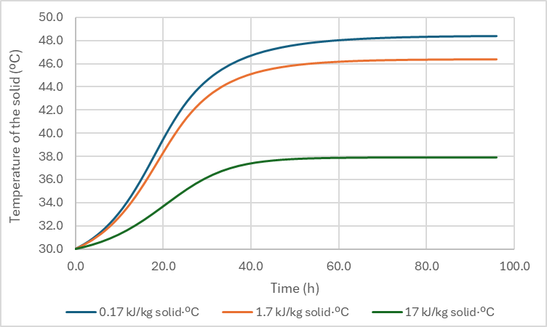
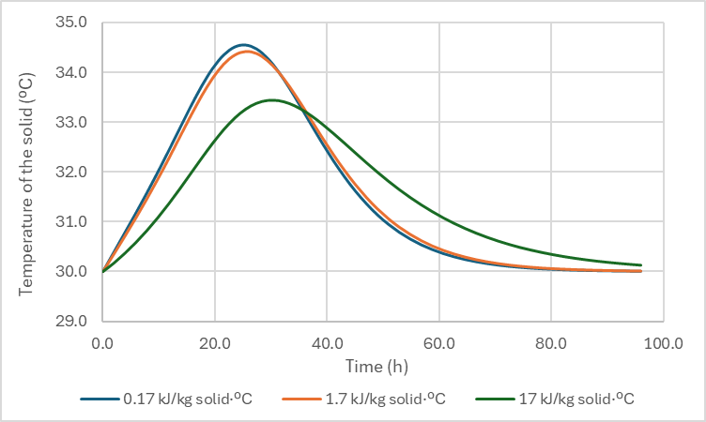

Figure 1. Temperature evolution of the fermenting solid for different values of specific heat capacity for packed bed reactors at A) laboratory scale (radius 5 cm) and B) pilot scale (radius 1 m).

Conductivity (k) significantly affects temperature increase at lab scale (Figure 2). The lower the conductivity, the higher the heat retention and thus the temperature increase. Surprisingly, this effect is not relevant when increasing operation volume, since the same temperature increase is observed for the three values tested. Only for the higher k value, temperature starts decreasing at the end of the fermentation period, illustrating the higher capacity for heat dissipation.

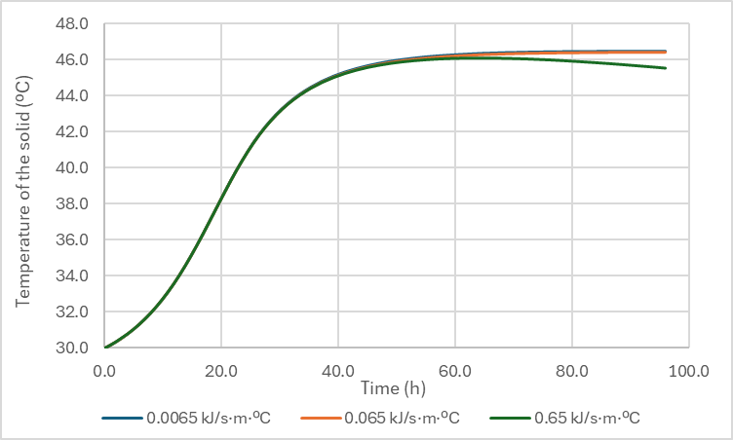
A B
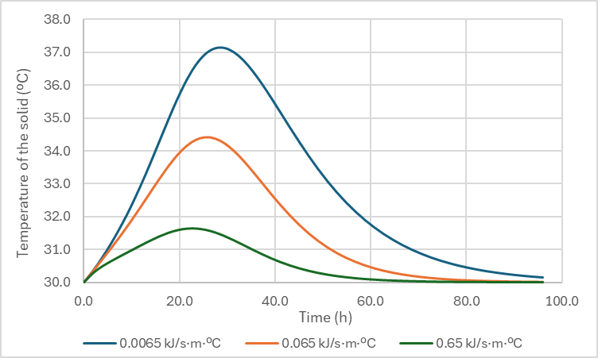

Figure 2. Temperature evolution of the fermenting solid for different values of thermal conductivity for packed bed reactors at A) laboratory scale (radius 5 cm) and B) pilot scale (radius 1 m).

Finally, the effect of the optimum yeast growth rate was also assessed. This parameter, while not directly related to thermal dynamics, serves as a measure of microbial activity and consequently affects potential metabolic heat production. As expected, lower growth rates resulted in decreased heat generation and retention, leading to minimal temperature gradients at the lab scale and a gradual temperature rise at the pilot scale. In contrast, very high growth rates caused rapid temperature increases and accelerated substrate consumption.
When considering operational scale, it becomes evident that smaller volumes can effectively dissipate generated heat and return to initial temperatures over time. In contrast, larger operating volumes require additional mechanisms for heat dissipation due to the inadequate surface area-to-volume ratio (Rodríguez et al., 2021a), resulting in sustained high temperatures throughout the 100-hour simulation period. Extending the simulation duration would be necessary to observe a decrease in temperature.

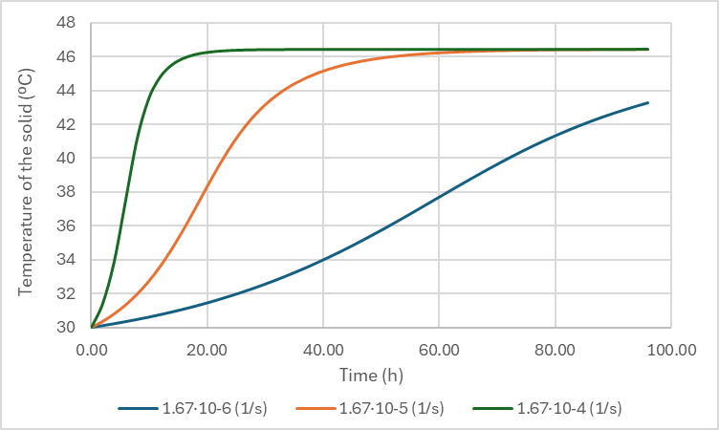
A B
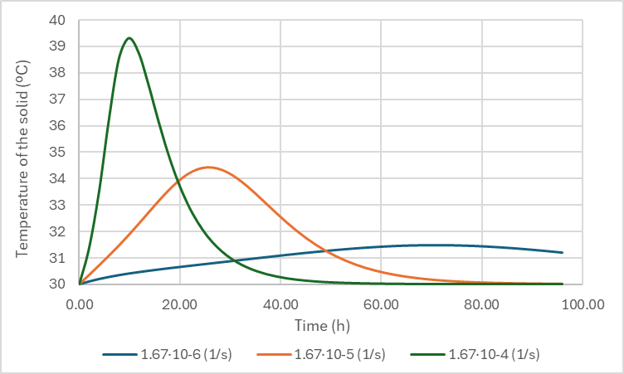

Figure 3. Temperature evolution of the fermenting solid for different values of optimum specific growth for packed bed reactors at A) laboratory scale (radius 5 cm) and B) pilot scale (radius 1 m).

  - Conclusions
This work demonstrates the successful utilization of five different industrial wastes as nitrogen, sugars, or fats sources for sophorolipids production. The production of sophorolipids ranged between 0.085 and 0.200 g of crude SL per gram of initial dry mass in the bioreactor. These results show promise in substituting pure substrates with industrial wastes in SSF systems while achieving comparable yields.
The thermal properties of organic materials, including conductivity and heat capacity, significantly impact temperature dynamics in SSF systems. Lower conductivity results in higher heat retention and temperature increase, while higher heat capacity can contain temperature escalation. Understanding the thermal properties of fermenting solid matrices is essential for effective heat dissipation and temperature control, especially when scaling up operations.
Finally, operational scale influences the ability to dissipate generated heat, with smaller volumes showing more efficient heat dissipation compared to larger volumes. The inadequate surface area-to-volume ratio in larger operating volumes necessitates additional mechanisms for heat dissipation to prevent sustained high temperatures throughout the fermentation period. Thus, additional mechanisms for temperature control are necessary in packed bed reactors. In any case, a well-tuned simulation tool helps in the prediction of process dynamics and supports decision making and design.
In summary, the findings from this study underscore the potential of utilizing industrial wastes in SSF systems for sophorolipids production, while highlighting the importance of considering impurities, optimizing support materials, and understanding thermal dynamics for improved process efficiency and temperature control in SSF operations.
Acknowledgments
The authors wish to express their gratitude for the financial support from the Spanish Ministerio de Ciencia e Innovación (Project PID2020-114087RB-I00). EEM appreciates and thanks Generalitat de Catalunya (AGAUR) for her predoctoral scholarship (FI-SDUR 2020)
References
Casciatori, F.P., Bück, A., Thoméo, J.C., Tsotsas, E., 2016. Two-phase and two-dimensional model describing heat and water transfer during solid-state fermentation within a packed-bed bioreactor. Chemical Engineering Journal 287, 103–116. https://doi.org/10.1016/j.cej.2015.10.108
Dierickx, S., Castelein, M., Remmery, J., De Clercq, V., Lodens, S., Baccile, N., De Maeseneire, S.L., Roelants, S.L.K.W., Soetaert, W.K., 2022. From bumblebee to bioeconomy: Recent developments and perspectives for sophorolipid biosynthesis. Biotechnol Adv. https://doi.org/10.1016/j.biotechadv.2021.107788
Eras-Muñoz, E., Gea, T., Font, X., 2023. Carbon and nitrogen optimization in solid-state fermentation for sustainable sophorolipid production using industrial waste. Front Bioeng Biotechnol 11. https://doi.org/10.3389/fbioe.2023.1252733
Parekh, V.J., Pandit, A.B., 2012. Solid State Fermentation (SSF) for the Production of Sophorolipids from Starmerella bombicola NRRL Y-17069 using glucose, wheat bran and oleic acid. Current Trends Biotechnol Pharm 6, 418–424.
Pessoa, D.R., Finkler, A.T.J., Machado, A.V.L., Luz, L.F.L., Mitchell, D.A., 2016. Fluid dynamics simulation of a pilot-scale solid-state fermentation bioreactor. Chemical Engineering Transactions 49, 49–54. https://doi.org/10.3303/CET1649009
Ribeaux, D.R., Jackes, C. V., Medeiros, A.D.M., Marinho, J., Lins, U., Nascimento, I., Barreto, G., Takaki, G.M.C., 2020. Innovative production of biosurfactant by Candida tropicalis UCP 1613 through solid-state fermentation. Chemical Engineering Transactions 79, 361–366. https://doi.org/10.3303/CET2079061
Rodríguez, A., Gea, T., Font, X., 2021a. Sophorolipids Production from Oil Cake by Solid-State Fermentation. Inventory for Economic and Environmental Assessment. Frontiers in Chemical Engineering 3. https://doi.org/10.3389/fceng.2021.632752
Rodríguez, A., Gea, T., Sánchez, A., Font, X., 2021b. Agro-wastes and Inert Materials as Supports for the Production of Biosurfactants by Solid-state Fermentation. Waste Biomass Valorization 12, 1963–1976. https://doi.org/10.1007/s12649-020-01148-5
Tansel, B., 2023. Thermal properties of municipal solid waste components and their relative significance for heat retention, conduction, and thermal diffusion in landfills. Journal of Environmental Management. https://doi.org/10.1016/j.jenvman.2022.116651
Tavman, I.H., Tavman, S., 1999. Measurement of thermal conductivity of dairy products. Journal of Food Engineering 41, 109–114.
Zhang, L., Gao, X., Li, Y., Li, G., Luo, W., Xu, Z., 2023. Optimization of free air space to regulate bacterial succession and functions for alleviating gaseous emissions during kitchen waste composting. Bioresource Technology 387. https://doi.org/10.1016/j.biortech.2023.129682

