|  |  |
| --- | --- |
| cetlogo ***CHEMICAL ENGINEERING TRANSACTIONS***  ***VOL. , 2024*** | A publication of  aidiclogo_grande |
| The Italian Association  of Chemical Engineering  Online at www.cetjournal.it |
| Guest Editors: Leonardo Tognotti, Rubens Maciel Filho, Viatcheslav Kafarov  Copyright © 2024, AIDIC Servizi S.r.l. **ISBN** 979-12-81206-09-0; **ISSN** 2283-9216 | |

Improvement of biogas production by anaerobic co-digestion of lignocellulose waste using iron oxide nanoparticles

Jhoselyn Castillo Oréa, Jherson Daniel Santosa, Daniel Neciosup Gonzalesa, Eduardo Espinoza Farfána, Edison A. Romero-Cabellob, Rita J. Cabello-Torresa\*

aUniversidad César Vallejo, Grupo de Investigación ICAMB. Campus San Juan de Lurigancho, Lima, Perú

bUniversidad Nacional Agraria la Molina, Av. La Molina,La Molina Lima Peru

[rcabello@ucv.edu.pe](mailto:rcabello@ucv.edu.pe)

Lignocellulosic agricultural waste and manure from livestock are useful for transforming them into energy through anaerobic digestion. When this technique uses alkaline hydrolysis to release carbohydrates or break lignocellulose chains, the digestion process is accelerated, although the application of nanomaterials has also proven to be useful because it catalyzes microbial interaction and optimizes the production of biogas and methane. The objective of the research was to optimize the production of biogas with higher methane content through the anaerobic digestion of coffee and banana waste. To this end, part of the lignocellulose waste was pretreated by alkaline hydrolysis, while digestion was assisted with the application of iron nanoparticles. The experimental design consisted of comparing the production of CH4 in three random blocks, the first, treated the anaerobic digestion of each substrate without any treatment, as well as the digestion of the mixture of both substrates. The second random block applied the substrates pretreated with a NaOH solution to break down the lignocellulose molecules and optimize the proportion of biogas and methane and a third block that also added FeNPS (0.1 g) at the beginning of the digestion process. The results showed that monodigestion developed a lower volume of CH4 (1561.5 -2280.75ml CH4), the anaerobic codigestion of both substrates pretreated with NaOH and assisted with FeNP reached the highest cumulative production of CH4 with 8341ml CH4 in 7 days. However, more research is still required on the doses and combination of FeNPs to improve methane production as an ecological alternative for the valorization of biomass and its conversion into energy.

* 1. ​Introduction

Agricultural waste is not yet used as part of a sustainable economy, its use as biomass and conversion to energy is increasing, however, it is urgent to evaluate the capacity to treat it adequately; achieve the conversion of biomass to renewable bioenergy (Yana et al., 2022) and contribute to the reduction of GHG emissions. The coffee industry produces more than 23 million tons of waste per year, which is why its transformation is important to better guide a circular economy (Durán-Aranguren et al., 2021). The poorly controlled discharge of coffee husks causes serious environmental pollution and is a waste of resources (Du et al., 2021), these are agroindustrial lignocellulosic waste useful for generating biofuels without detriment to food security (Dias et al., 2021). Likewise, one of the most influential crops is banana, whose agricultural waste can be transformed into biofuels (Guerrero et al., 2018). These lignocellulosic wastes require treatment to release carbohydrates. Else, chemical pre-treatment through NaOH improves the quality of the biogas and increases the reaction rate and anaerobic degradability (Jacobo et al., 2023). Finally, livestock farming also generates waste, manure, especially from cattle, increases with livestock farming, causing problems for the environment, especially due to the presence of significant loads of nitrogen, phosphorus and methane emissions that affect the environment (Xin et al., 2018). These wastes can also act as biocatalysts due to the significant microbial load that acts in each of the anaerobic digestion processes (Ahlberg-Eliasson et al., 2021).

Anaerobic digestion is a technology that allows waste to be treated, controlling pollution in exchange for recovering energy (Nie, et al., 2021). This biochemical process takes place in the absence of oxygen and it is the microorganisms that transform and promote the conversion of various organic compounds such as carbohydrates, proteins and lipids into simpler chain products. Under special conditions it can produce methane gas; carbon dioxide; hydrogen sulphur and ammonium; through processes such as: hydrolysis, acidogenesis, acetogenesis and methanogenesis (Torres and Pérez 2010). The use of nanoparticles has even begun, which are opening new fields of action for their very promising application in the production of biogas, methane, etc. because they improve microbial interactions (Singh, et al 2022). Bayisa, et al. (2023) produced methane using iron nanocatalysts by green synthesis and improved the methane yield by 89.5%.

This research aimed to improve biogas production by applying anaerobic digestion using coffee and banana peel waste rich in lignocellulose components using iron oxide nanoparticles. This research was part of an initiative of the ICAMB Research Group of the Cesar Vallejo University.

* 1. Materials and methods

2.1 Collection of precursor material

The coffee husk was collected in the urban area of Alto Penedo (Chanchamayo, Peru), to be used as a substrate, this place has more than 50 hectares of coffee cultivation. Banana peels were also collected at a local market in the area. Likewise, chicken, pig and cow manure was collected from several farms in the area, to test the methanogenic activity and select its use as inoculum. The Minthostachys mollis (muña)-stabilized iron oxide NPs were obtained from the ICAMB Research Group of the César Vallejo University, San Juan de Lurigancho Campus.

2.2 Substrate pre-treatment and FeNPs production

The substrates were air dried for 4 days and then ground (2 mm) for use. These lignocellulosic substrates (coffee peel: 28.9% and banana peel: 13% on a dry basis) were treated with a solution of 1.5 g NaOH/25 g substrate/325 ml water, according to the methodology applied by Li et al. to the. (2020), in a water bath (100° C) for 1 hour. Initially, the banana peel had a pH of 6.52 and the coffee peel a pH of 4.39. After treatment with the NaOH solution, there was an increase in pH to 12 and 10 respectively. Subsequently, the solution was neutralized to pH =7, because it adjusts to the optimal range (6.5 to 7.5), to produce the maximum biogas yield (Syaichurrozi et al. 2020). The ANOVA demonstrated the significant action of NaOH on the residues (p<0.05).

To prepare the FeNPs, ten grams of muña leaf powder were weighed, added to 150 ml of deionized water and mixed at 100oC for one hour. It was then filtered to separate the extract. 3.8 g of FeCl3.6H2O was dissolved in 100 ml of distilled water. Both solutions were mixed in 1:1 ratios for 120 min at 100 °C at 250 rpm, the final suspension was centrifuged at 6000 rpm for 30 min, and the pellet was dried at 100 °C for 24 h. The iron nanoparticles were analyzed in a UV – Visible spectrophotometer (GENESYS 10S UV) using a reading path of 200 -700 nm; to confirm the presence of the nanoparticles.

2.3 Specific methanogenic activity (SMA) test

For the specific methanogenic activity (SMA) test, the procedure of Soto (1992) was followed. 625 ml flasks were used as reactors and 5 g/L acetic acid COD as standard substrate at neutral pH at room temperature (22° to 25°C). The CH4 generated was measured by volume displacement of a NaOH solution (2.5%). The theoretical methane production must be calculated taking into account the temperature and atmospheric pressure conditions under which the experiments are carried out. The SMA was calculated using the slope obtained in the CH4 production curves and was expressed as Kg COD/d.Kg SV. The slope “m” represents the variation of methane production in terms of volume and time expressed as ml CH4/h. It is possible to calculate the daily volume of methane produced, considering the first hours of the process where the highest slope occurs:

|  |  |
| --- | --- |
|  | (1) |

Once the produced volume of CH4 has been calculated, it is possible to apply the universal gas equation to calculate the W (weight) of CH4 (g), considering the position of the laboratory on the coast at 0 meters above sea level (P=1atm), the weight molecular gas (16 g/mol) and ambient temperature (30oC):

|  |  |
| --- | --- |
|  | (2) |
|  | (3) |

Where P = pressure (atm), V is the volume of CH4 (ml), R is the Rydberg constant (8.14472 joule/mol-K) and Mol is the molecular weight of methane. Then considering the following reaction that occurs:

|  |  |
| --- | --- |
|  | (4) |

The amount of oxygen needed in terms of COD can be calculated by stoichiometry:

|  |  |
| --- | --- |
|  | (5) |

The maximum specific activity is expressed as Kg COD/Kg SV.d, based on the mass of inoculum containing 2.5 g of volatile solids applied for the test is:

|  |  |
| --- | --- |
|  | (6) |

The experimental SMA is calculated considering “m” as the slope of the line obtained during the first days that results with the greatest slope (m=slope) and expressed as CH4 ml/h, “I” is the concentration of the inoculum expressed g SSV/ mL; and Vs is the effective volume of sample used = 400 mL.

To calculate SMA the equation was considered:

|  |  |
| --- | --- |
|  | (7) |

2.4 Biochemical Methane Potential (BMP) Test

The Biochemical Potential of Methane (BMP) Test consisted of an experimental design in completely randomized blocks according to the following description: Coffee "untreated, Coffee "treated with NaOH"; Coffee "treated with OH + NP", this same Distribution was applied for banana and then for the coffee + banana mixture, taking as reference the methodology of Naseem (2018) with certain modifications.

2.5 Experimental design

The experiment was conditioned for 7 days at 22°C (batch production), neutral pH and 200 ml of inoculum and a working volume of 400 ml. The experimental design generated 33 experimental units that included controls and blanks, the biogas produced was monitored every day. A portion of 0.1g of NP was applied according to Amo-Duodu et al, (2020). As seen in the figure, one of the highest absorption peaks exposed was present at 290 nm and is located in the range (275-301) reported by Bouafia and Laouini (2020), indicating the formation of iron oxide nanoparticles. Figure 1 shows the flow chart applied in this research.

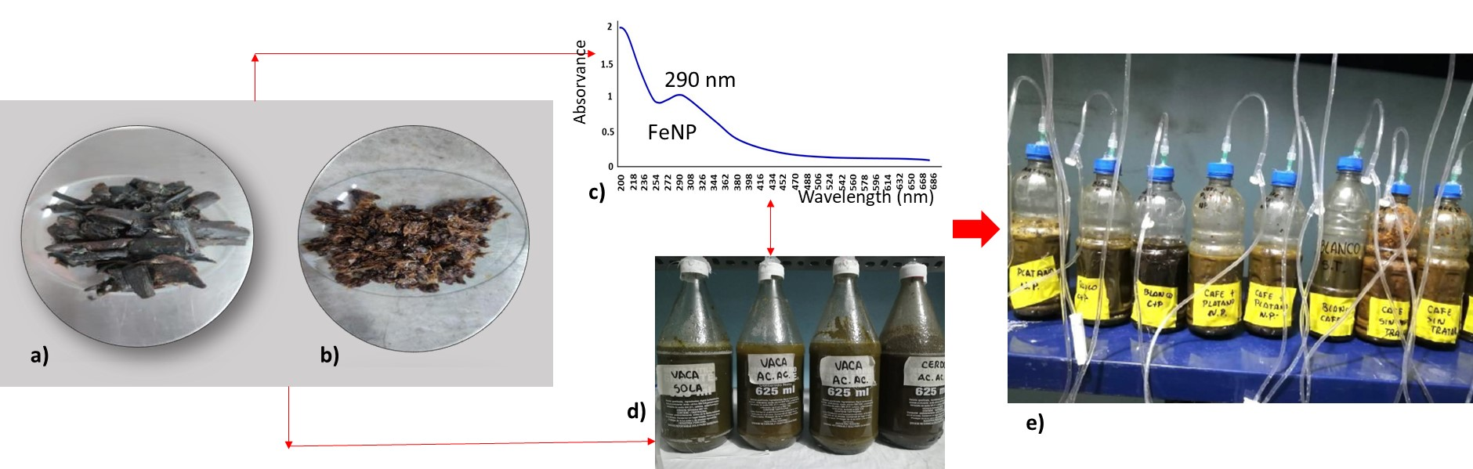

Figure 1. Flow diagram of the developed experiment: a) dried banana peels, b) dried coffee peels; c) Spectrogram of FeNP at 290 nm; d) SMA test; d) BPM.

​2.6 Analysis of data

The data analysis method corresponded to that used by Jacobo et al. (2023). The experiments were performed using the short-term batch experimental setups of 7 days and with a fixed dose of FeNPS.

* 1. Results and discussion

3.1 Specific Methanogenic Activity

Figure 2 shows the results of the methanogenic activity (SMA) test developed for animal manure. To do this, a theoretical slope has been drawn, taken in the section with the greatest initial inclination of the curve, which indicates the potential of the substrate. Accordingly, cow manure produced the highest slope whose line Y = 50.73x +16.218 produced a strong R2 (0.9998).

The methane yield was higher for cow manure, between 1.028 and 1.087 times higher than that of the other inoculums and at a volatile solids content of 11.42 g/L (VS) and total solids content of 12.02 g/L (TS). It shows that cow manure serves as raw material for the production of biogas, according to Malik et al. (2022), a high percentage of VS/TS is an indication that the state of the inoculum corresponds to a biodegradable process, as occurred in this test.

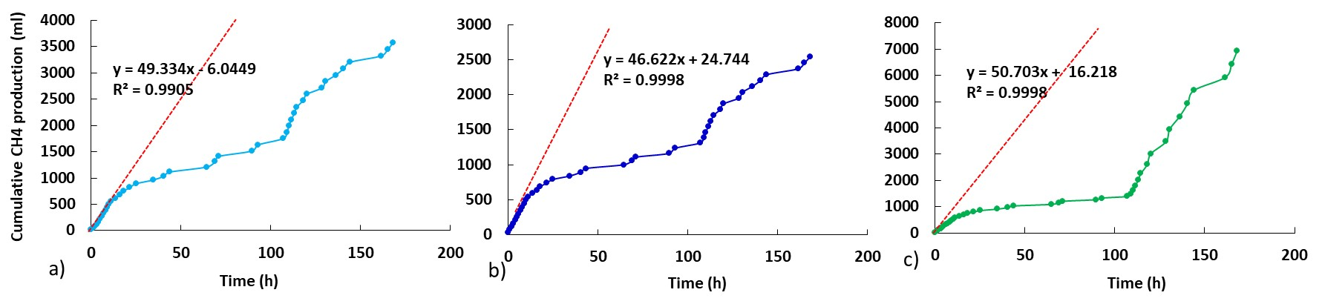*Figure 2. Cumulative distribution of CH4 in the Specific Methanogenic Activity test in a) chicken manure; b) pig manure and c) cattle manure.*

Table 1 shows the results of the methanogenic activity test (SMA) of each of the treated inoculum. SMA tests gave slope results between 46.62 -50.70 expressed in ml/h; the highest value corresponded to cow manure. According to this, the experimental SMA and the theoretical SMA were calculated.

Table 1. Results of the Specific Methanogenic Activity test of manure samples

|  |  |  |  |  |  |  |
| --- | --- | --- | --- | --- | --- | --- |
| Substratum | m  (ml/h) | V CH4  (ml/d) | CH4 (g) | O2 (g/d) | (SMA)  DQO kg/d.kg SV | (SMA)exp  ml CH4/h.g SV |
| Chicken manure | 49.3340 | 1184.0 | 0.7554 | 3.0214 | 1.2086 | 0.0247 |
| Pig manure | 46.6220 | 1118.9 | 0.7138 | 2.8553 | 1.1421 | 0.0233 |
| Cow manure | 50.7030 | 1216.9 | 0.7763 | 3.1053 | 1.2421 | 0.0254 |

3.2 Biochemical Potential of Methane

The biogas production of all the experimental arrangements began from the first day for each analysis unit, however, in the case of coffee (alone) slow beginnings were observed during the first 40 hours, later reaching a production rate of 1 .33 ml CH4/h. stabilizing on the 5th day (205 -209 ml). The tests of coffee treated by alkaline hydrolysis, on the other hand, skyrocketed from the first 45 hours of the process with a production rate of 0.96 mlCH4/h after which it reached gradual stability with lower amounts of CH4 formation ( 161.75 -164 ml CH4). The higher value observed in coffee residues with alkaline treatment would have been due to the release of a higher concentration of simpler chain molecules and the microbial activity in stable mesophilic conditions in the presence of non-inhibitory volatile fatty acids (Batista et al., 2020). However, additional fixation with NP did not show a significant difference (p > 0.05) compared to the untreated sample. This occurred due to limitations presented in the heating batteries of the “treated coffee + NP” arrangement. In the first case (NaOH addition), a rapid conversion to methane occurred through acetogenesis and methanogenesis (Li et al. 2020). Figure 3 shows the results obtained in the biochemical methane potential test. Figure 3a corresponds to the tests carried out on coffee residues. As can be seen, the distribution produced from the accumulated biogas of the coffee waste treated with NaOH solution barely reaches 2890.75 ml (p < 0.05) unlike the other tests. On the other hand, there was no difference (p>0.05) between the digestion without previous treatment of coffee and the digestion of the residue treated with NaOH and NP, due to a destabilization in the uncontrolled system. Figure 3b shows the results for banana, in this case the application of the NaOH and NP solution was effective and there was a significant difference (p<0.05) with the other tests, since a better cumulative distribution was produced. The distribution of NaOH-treated residues showed that alkaline treatment released short-chain carbohydrates especially in the banana peel, optimizing enzymatic hydrolysis (Sun et al., 2022). Figure 3c, belonging to the C+B mixture, shows a distribution similar to that of the banana. Figure 3d shows the summary of each treatment combination, with the combination of C+B subjected to a NaOH +NP solution achieving greater biogas production (8341 ml). In general, the addition of NPs may cause a delay period or a slow process before starting biogas production by anaerobic co-digestion and a higher amount of biogas and CH4 is generated in certain FeNP arrangements (Amen et al. 2017). This indicates that FeNPs require a certain time for their stabilization and induce bacterial growth, due to a bio stimulant effect of methanogenic bacteria that increase biomethanization. The studies carried out by Barua et al. (2019) demonstrated that the co-digestion of banana with other pretreated plant waste had a greater production of biogas and of better quality, because the proportion used exerted a synergistic balancing action in the anaerobic process. Furthermore, banana peels have a lower lignin content, which facilitates their anaerobic conversion into biogas with high methane content (Barua et al. 2019). The banana peel had a higher content of volatile solids of 92.3 g/L and total solids of 100.06 g/L, this gives it a rich presence of carbon and nitrogen-based molecules (Barua et al. 2021). The production of CH4 in treated banana residues (including C+P) exceeded those obtained by Rincón-Catalán et al. (2022) equivalent to a BMP of 373 mLCH4/gVS. According to Amen et al 2017, additional treatment with NP increased its reactivity because anaerobic corrosion of the iron nanoparticles would occur, generating electrons that would be effectively used by methanogenic bacteria to generate methane.

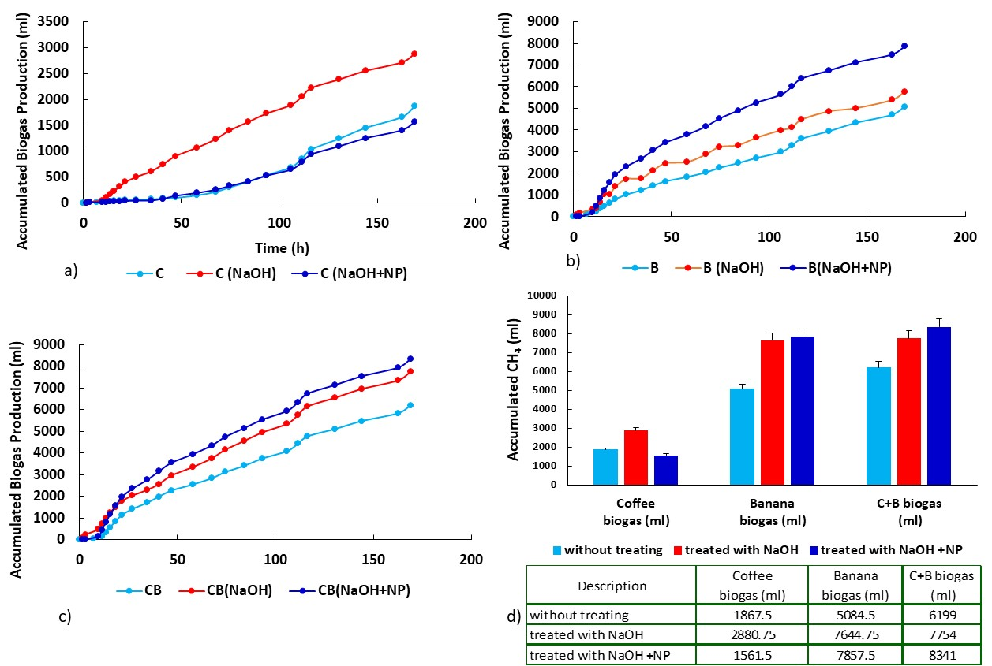​

*Figure 3. Biochemical Potential of CH4 in: a) coffee peels; b) banana peel and c) mixture of coffee and banana peel.*

Table 3 confirms the differences between the treatments for each of the applied arrangements; the p value (< 0.05) indicates the differences found in each case. These results have surpassed other treatments with NaOH applied to rice straw that accumulated a maximum of 1801 ml of biogas in 15 days (Jacobo et al., 2023), indicating the effectiveness of using NaOH and NP especially for banana and the B+C mixture. Although the application of NP improved the biogas yield in general, it is important to continue investigating factors such as the various doses of NP that must be applied and the effects on the microbiota present in mesophilic conditions that imply a lower energy cost.

*Table 3. Analysis of variance for the treatments of a) coffee (C), b) banana (B) and c) mixture of C+B*

|  |  |  |  |  |  |
| --- | --- | --- | --- | --- | --- |
|  | DF | Sum of Squares | Mean Square | F Value | Prob>F |
| Model C (wt-t-NP) | 2 | 39732.3906 | 19866.1953 | 4.34068 | 0.01676 |
| Error | 69 | 315795.727 | 4576.74966 |  |  |
| Total | 71 | 355528.117 |  |  |  |
| Model B (wt-t-NP) | 2 | 198467.661 | 99233.8307 | 9.90848 | 1.65E-04 |
| Error | 69 | 691038.143 | 10015.0456 |  |  |
| Total | 71 | 889505.805 |  |  |  |
| Model C+ B (wt-t-NP) | 2 | 102093.861 | 51046.9306 | 4.34924 | 0.01664 |
| Error | 69 | 809852 | 11736.9855 |  |  |
| Total | 71 | 911945.861 |  |  |  |

Conclusions

Agricultural waste from coffee and banana peels has been used as substrates and cow manure in the anaerobic digestion process for the production of biomethane. Pretreatment of the substrates with alkaline NaOH solution managed to release short-chain carbohydrates from the precursor lignocellulosic material, which favoured the process compared to the control experiments. The addition of muña-stabilized iron NP generated an increase in the production of methane for the mono-digestion of banana peels and in quantities and in the co-digestion of coffee-banana peel efficiently. These results serve as a basis for new research aimed at evaluating dosages in the application of NPs to optimize methane production.

Acknowledgments. The authors would like to thank "Investiga UCV" of the Universidad César Vallejo for financial support for the publication of this research. Thank the ICAMB Research Group of the Cesar Vallejo University for the development of the research project.

References

Ahlberg-Eliasson K., Westerholm M., Isaksson S., Schnürer A., 2021, Anaerobic digestion of animal manure and influence of organic loading rate and temperature on process performance, microbiology, and methane emission from Digestates, Frontiers in Energy Research, 9, 740314.

Amen T.W.M., Eljamal O., Khalil A.M.E., Matsunaga N., 2017, Biochemical methane potential enhancement of domestic sludge digestion by adding pristine iron nanoparticles and iron nanoparticles coated zeolite compositions, Journal of Environmental Chemical Engineering, 5(5), 5002–5013.

Barua V.B., Rathore V., Kalamdhad A.S., 2019, Anaerobic co-digestion of water hyacinth and banana peels with and without thermal pretreatment, Renewable Energy, 134, 103-112.

Battista F., Barampouti E.M., Mai S., Bolzonella D., Malamis D., Moustakas K., Loizidou M., 2020, Added-value molecules recovery and biofuels production from spent coffee grounds, Renewable and Sustainable Energy Reviews, 131, 110007.

Bayisa Y.M., Bullo T.A., Jiru E.B., Ancha V.R., 2023, Sustainable green biogas production from pretreated wheat straw blended with coffee husk using neem leaves-based iron (III) nanocatalyst via response surface methodology, Reaction Kinetics, Mechanisms and Catalysis, 1-21.

Bouafia A., Laouini S.E., 2020, Green synthesis of iron oxide nanoparticles by aqueous leaves extract of Mentha Pulegium L.: Effect of ferric chloride concentration on the type of product, Materials Letters, 265, 127364.

Dias M.E., Oliveira G.H.D., Couto P.T., Dussán K.J., Zaiat M., Ribeiro R., Tommaso G., 2021, Anaerobic digestion of hydrothermal liquefaction wastewater from spent coffee grounds. Biomass and Bioenergy, 148, 106030.

Du N., Li M., Zhang Q., Ulsido M.D., Xu R., Huang W., 2021, Study on the biogas potential of anaerobic digestion of coffee husks wastes in Ethiopia, Waste Management & Research, 39(2), 291-301.

Durán-Aranguren D.D., Robledo S., Gomez-Restrepo E., Arboleda Valencia J.W., Tarazona N. A., 2021, Scientometric overview of coffee by-products and their applications, Molecules, 26(24), 7605.

Garibaldi-Alcívar K.A., Montesdeoca-Pichucho N.B., Baquerizo-Crespo R.J., Oliva-Merencio D., Gómez-Salcedo Y., Pereda-Reyes I., 2022, Anaerobic co-digestion of solid waste from coffee benefit, banana pseudo-stem and pig manure: kinetic, energy and environmental criteria, Revista Centro Azúcar, 49(2), 60-72.

Guerrero A.B., Ballesteros I., Ballesteros M., 2018, The potential of agricultural banana waste for bioethanol production, Fuel, 213, 176-185.

Li Y., Achinas S., Zhao J., Geurkink B., Krooneman J., Euverink G.J.W., 2020, Co-digestion of cow and sheep manure: Performance evaluation and relative microbial activity. Renewable Energy, 153, 553-563.

Malik I. A., Fadzil F., Fadzil F., Seswoya R., 2022, Assessment of Specific Methanogenic Activity from Cow Dung, International Journal of Integrated Engineering, 14(9), 81-87.

Nie E., He P., Zhang H., Hao L., Shao L., Lü F., 2021, How does temperature regulate anaerobic digestion?, Renewable and Sustainable Energy Reviews, 150, 111453.

Rincón-Catalán N.I., Cruz-Salomón A., Sebastian P.J., Pérez-Fabiel S., Hernández-Cruz M.D. C., Sánchez-Albores R.M., Nájera-Aguilar H.A., 2022, Banana Waste-to-Energy Valorization by Microbial Fuel Cell Coupled with Anaerobic Digestion, Processes, 10(8), 1552.

Sarrouh B., de Souza R.O.A., da Silva Florindo R.H., Lofrano R.C.Z., de Oliveira A.M., 2021, Extraction and identification of biomolecules from lignin alkaline hydrolysate from coffee husk, Waste and Biomass Valorization, 12, 787-794.

Singh P.K., Kanungo S., Mishra S., Pattnaik R., 2022, Intrinsic Insights of Nanoparticles via Anaerobic Digestion for Enhanced Biogas Production. In Handbook of Smart Materials, Technologies, and Devices: Applications of Industry 4.0, 2481-2506.

Soto M., Mendez R., Lema J.M., 1992, Characterization and comparison of biomass from mesophilic and thermophilic fixed bed anaerobic digesters, Water science and technology, 25(7), 203-212.

Syaichurrozi I., Basyir M.F., Farraz R.M., Rusdi R., 2020, A preliminary study: Effect of initial pH and Saccharomyces cerevisiae addition on biogas production from acid-pretreated Salvinia molesta and kinetics, Energy, 207, 118226.

Torres L.P., Pérez A., 2010, Actividad metanogénica específica: una herramienta de control y optimización de sistemas de tratamiento anaerobio de aguas residuales, Ingeniería de Recursos Naturales y del Ambiente, Universidad del Valle Cali, Colombia, 9, 5-14

Xin Y., Wang D., Li X. Q., Yuan Q., Cao H., 2018, Influence of moisture content on cattle manure char properties and its potential for hydrogen rich gas production, Journal of analytical and applied pyrolysis, 130, 224-232.

Yana S., Nizar M., Mulyati D., 2022, Biomass waste as a renewable energy in developing bio-based economies in Indonesia: A review, Renewable and Sustainable Energy Reviews, 160, 112268.