CHEMICAL ENGINEERING TRANSACTIONS  VOL. , 2024 | A publication of
The Italian Association
of Chemical Engineering
Online at www.cetjournal.it

Guest Editors: Leonardo Tognotti, Rubens Maciel Filho, Viatcheslav Kafarov
Copyright © 2024, AIDIC Servizi S.r.l.
ISBN 979-12-81206-09-0; ISSN 2283-9216

Eco-Friendly Corrosion Inhibitors from Sugarcane Bagasse for Environments Relevant to CO₂ Transport: A Review
Juan Orozco-Agamez^{a,b*}, Emily Duranª, Nathalia A. Diazª, Darío Peña-Ballesterosª, Anibal Alviz-Meza A^{c}, Sandra Garciaª, Viatcheslav Kafarov ^{c}, Adan Y Leonª
aUniversidad Industrial Santander, Escuela de Ingeniería Metalúrgica y Ciencia de los Materiales, Grupo de Investigaciones en Corrosión – GIC, cra 27 calle 9, Bucaramanga –Santander, Colombia
bBiotech Innovation SAS, San Estanislao de Kostka-Bolívar, Colombia.
cInstitution Universitaria Mayor de Cartagena, Grupo de Investigación GIADI, Facultad de Arquitectura e Ingeniería, Cartagena, Colombia
dUniversidad Industrial Santander, Escuela de Ingeniería Química, Centro de Investigación para el Desarrollo Sostenible en Industria y Energía – CIDES, cra 27 calle 9, Bucaramanga –Santander, Colombia

Environmentally friendly corrosion inhibitors from sugarcane bagasse are a promising alternative to mitigate corrosion problems. These inhibitors are obtained from natural compounds present in the residual biomass of bagasse, such as tannins, phenols, and organic acids. Studies have shown that bagasse extracts exhibit significant corrosion inhibition effects on various metals (steel, zinc, aluminium) in acidic and neutral media, acting through the formation of protective layers on metal surfaces, modifying the chemistry of the medium or inhibiting electrochemical corrosion reactions. This work reviews the state-of-the-art of eco-friendly corrosion inhibitors from sugarcane bagasse in environments relevant to the transport of CO₂, including their composition, mechanisms of action, extraction and purification methods, performance evaluation techniques, and comparisons with conventional inhibitors. Future perspectives are also addressed, such as process optimization, mechanistic understanding, environmental impact assessment and interdisciplinary collaborations to drive the development and successful implementation of these sustainable inhibitors in various industries.
  - Introduction
Corrosion problems are common in various industries such as chemicals, oil, naval, civil construction, transportation, and communication systems (Verma et al., 2021). According to estimates, the direct annual cost of corrosion is close to $3.4 trillion worldwide, equivalent to 3.4% of global GDP (Koch, 2017). These costs include repair and replacement of corroded components, as well as expenses associated with design, manufacturing, installation, and loss of efficiency. Additionally, there are significant indirect costs, such as lost productivity, plant closures, spills, and environmental contamination (Groysman, 2024). From an environmental perspective, the continuous replacement of infrastructure and equipment implies excessive consumption of natural resources, energy, and raw materials, generating additional emissions and waste (Bijapur et al., 2023). Conventional corrosion inhibitors such as chromium, zinc and phosphorus compounds have been widely used to treat this problem, but they present problems of toxicity and environmental impact, driving the search for more ecological and sustainable alternatives (Verma et al., 2021).
Green chemistry or sustainable chemistry is based on a set of principles that seek to design chemical products and processes that reduce or eliminate the use and generation of hazardous substances, thus minimizing the negative impact on the environment and human health. Some of the key principles are using renewable raw materials, avoiding toxic products, maximizing energy efficiency, and promoting product degradability. Natural corrosion inhibitors derived from renewable sources such as sugarcane bagasse align perfectly with these principles by taking advantage of biomass waste, avoiding toxic compounds present in conventional inhibitors, being biodegradable and coming from sustainable sources. Furthermore, their production generally involves lower energy consumption compared to synthetic inhibitors.
In this context, the valorization of agro-industrial waste, such as sugarcane bagasse biomass waste, to obtain eco-friendly corrosion inhibitors has emerged as a promising option (Yaro et al., 2019). Sugarcane bagasse is an abundant byproduct of the sugar industry. According to data from the Food and Agriculture Organization of the United Nations (FAO), global sugarcane production in 2021 was approximately 1.9 billion tons, generating around 354 million tons of bagasse as waste. (FAO, 2022). In the case of Colombia, one of the main panela producers worldwide, it is estimated that for every ton of panela produced, one ton of residual bagasse is generated, reaching a total of 1.2 million tons annually (Fedepanela, 2020). This sugarcane bagasse has a typical composition that includes cellulose (40-50%), hemicellulose (25-35%) and lignin (18-24%), in addition to other minor compounds such as ashes and waxes. The presence of these components, especially lignin and its phenolic derivatives, gives sugarcane bagasse a potential to be used as a source of ecological corrosion inhibitors (Mahmud and Anannya, 2021).
While there are several previous studies that have explored the use of sugarcane bagasse extracts as environmentally friendly corrosion inhibitors, this review aims to provide an updated, comprehensive, and novel perspective on the topic, focusing on evaluating the performance of these inhibitors ecological in environments relevant to the transport of CO₂, using gravimetric and electrochemical techniques. Unlike other works that focus on specific components of sugarcane bagasse, this article comprehensively addresses the latest advances and the state of the art in the field, including the mechanisms of action involved, the most recent methods of extraction and purification of inhibitors, and the most reliable techniques to evaluate their performance and efficiency.
  - Composition of Sugarcane Bagasse
Sugarcane bagasse is an abundant agro-industrial waste, composed mainly of cellulose (40-50%), hemicellulose (25-35%) and lignin (18-24%) (Mahmud and Anannya, 2021). In addition to these structural components, bagasse contains several phenolic compounds, such as tannins, phenolic acids, and flavonoids, as well as organic acids, which exhibit corrosion-inhibiting properties. The presence of these compounds varies depending on factors such as the sugarcane variety, growing conditions, and extraction processes used (Wani et al., 2023). It was decided to focus this section on tannins, phenolic compounds, and organic acids, since they are mainly responsible for the corrosion inhibitory capacity of sugarcane bagasse. These compounds have proven to be efficient corrosion inhibitors by forming complexes with metal ions, modifying the chemistry of the medium and inhibiting electrochemical corrosion reactions.

2.1 Tannins
Tannins are water-soluble polyphenolic compounds present in sugarcane bagasse. Both condensed and hydrolyzable tannins have been identified in bagasse, with condensed tannins being the most abundant. These compounds have proven to be efficient corrosion inhibitors by forming complexes with metal ions and forming protective films on the metal surface (Coniglio et al., 2021). For example, the study carried out by Nardeli et al., (2019), evaluated the corrosion inhibition of an AA1200 aluminum alloy (100 mm × 100 mm × 2 mm) in a 0.05 M NaCl solution using 4.41 x 10⁻³ M of tannin inhibitor solution for 24 h at 25 °C.

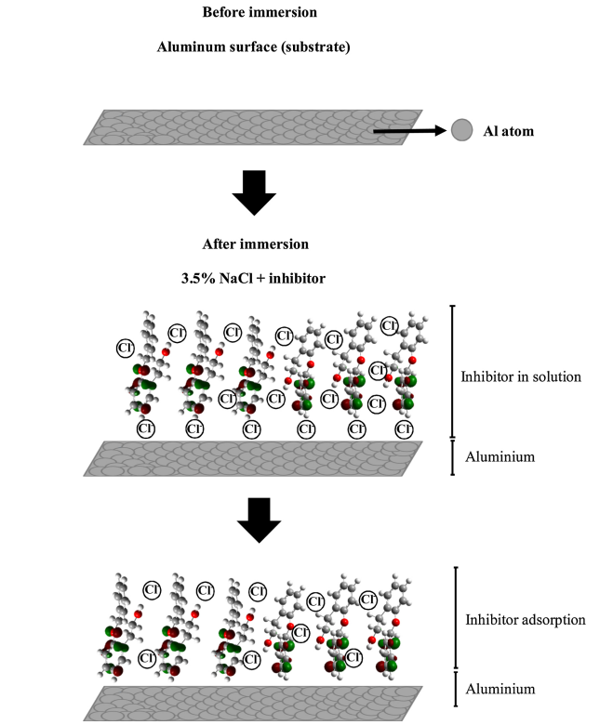

Figure 1: Schematic representation of the proposed adsorption mechanism for the inhibitor.
Figure 1 shows the absorption mechanism of the aluminium alloy after immersion in a 3.5% NaCl solution with the inhibitor. In this model chloride ions are in solution along with the inhibitor and some ions are adsorbed on the metal surface. After some time, the chloride ions are replaced by inhibitory molecules.

2.2 Phenolics
Sugarcane bagasse contains various phenolic compounds, such as phenolic acids, flavonoids, and lignans. These compounds can form protective films on the metal surface and act as corrosion inhibitors through electron donation and complex formation with metal ions (Molina-Cortés et al., 2023). Phenolic compounds or polyphenols are one of the most diverse and widely dispersed groups of substances in the plant kingdom, identified by a phenyl ring as well as several attached hydroxyl groups (-OH). Larif et al., (2013), published a study on the corrosion protection properties of a phenolic extract on carbon steel in a solution of 1M HCl with 0.5 g L⁻¹ of extract. The inhibition of the acid corrosion of steel was attributable to the adsorption of unshared electrons of O atoms producing a protective layer and functioning as a barrier between the steel surface and the corrosive medium (Figure 2).
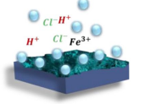

Figure 2: Adsorption inhibition mechanism: surface coating.

2.3 Organic acids
Several organic acids, such as acetic acid, formic acid, and oxalic acid, are present in sugarcane bagasse. As can be seen in Figure 3, these acids can inhibit corrosion by forming insoluble salts with metal ions or by adsorbing on the metal surface, modifying the corrosion mechanism (Guo et al., 2021).
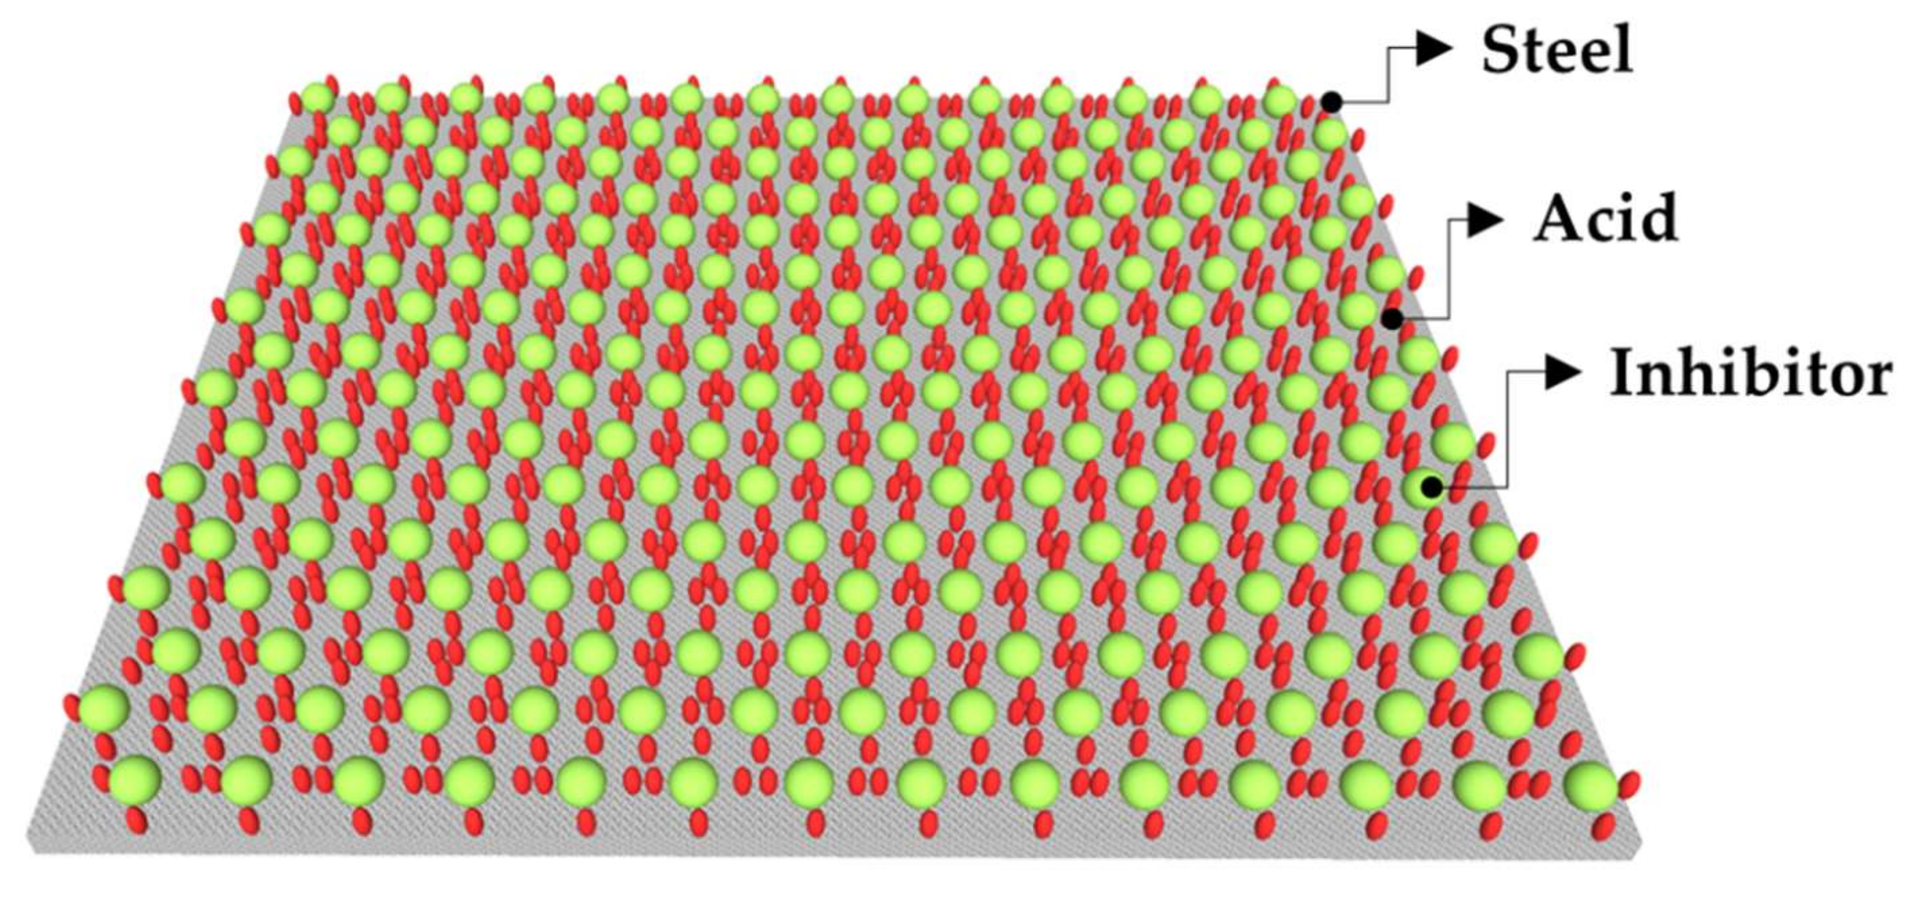
Figure 3: Adsorption action of inhibitor on steel surface.

  - Recent Studies and Advances in the Development of Eco-Friendly Inhibitors
In recent years, numerous studies have focused on the development and characterization of corrosion inhibitors obtained from biomass. These studies have addressed various aspects, such as extraction methods, performance evaluation under different conditions, and formulation optimization (Mesa et., al 2017).

3.1 Extraction and Purification Methods
Several extraction methods have been explored to obtain the bioactive compounds from sugarcane bagasse with corrosion-inhibiting properties. Hartati et al. (2016), evaluated microwave-assisted extraction using 1 M HCl at 80°C. They found that the obtained extracts combined with halogen ions, surfactants, metal nano ions, hexamethylenetetramine, methionine, and other synergists to improve stability and corrosion inhibition performance exhibited a corrosion inhibition efficiency of 91.62% (Huang et al., 2022). On the other hand, in the work of Meng et al. (2021), Soxhlet extraction was employed using anhydrous ethanol at 70°C for 12 hours, obtaining an extract in the form of brown particles (SPRE) with a yield of 39.3%. Additionally, purification methods have been investigated to isolate specific compounds from bagasse, for example, alkaline extraction of bagasse with 10% (w/v) sodium hydroxide solution at 170°C for 1 hour, followed by acid precipitation with hydrochloric acid to pH 2 to isolate lignin, obtaining an efficiency of 96.2% (Rahayu et al., 2018). Table 1 reports other investigations of green inhibitors tested in CO₂-saturated environments, where they also showed efficiencies greater than 80%.

Table 1. Efficiencies reported in the literature of compounds with anticorrosive properties under different conditions in acidic media.

Extract | Corrossive medium and temperature | Extraction method and solvent  (%) | Steel specimen | Inhibition efficiency  (%)
Olive leaf | CO₂-saturated 3.0% NaCl + 0.01% HaHCO₃ + 0.01% CaCO₃ (65 °C) | Soxhelt extraction using methanol | N80 | 94.00
Jatropha curcas leaf | CO₂-saturated 3.5% NaCl (pH 4.7) (25 °C) | Soxhelt extraction using methanol | API 5L - X65 | 82.00
Sida acuta | CO₂-saturated 3.5% NaCl (pH 4.5) | Solvent extraction using methanol | API 5L – X65 | 90.00

3.2 Inhibitor performance evaluation
Numerous studies have evaluated the performance of corrosion inhibitors derived from sugarcane bagasse under different conditions and corrosive media, employing various experimental techniques. One of them is gravimetric and electrochemical techniques. Gravimetric techniques, such as weight loss measurement, have been widely used to determine the inhibition efficiency of sugarcane bagasse extracts. For example, Meng et al. (2021), evaluated purple sugarcane bagasse extracts by weight loss in 1M HCl solutions at 55 °C using 800 mg L⁻¹ of extract with 24 h immersion, obtaining inhibition efficiencies above 90%. Rahayu et al. employed the same technique to evaluate green stem sugarcane bagasse extracts in a 1M HCl solution using 10 gL⁻¹ of extract with an immersion time of 6 h, reporting inhibition efficiencies of up to 80%.
On the other hand, electrochemical techniques, such as potentiodynamic polarization and electrochemical impedance spectroscopy (EIS), provide valuable information about the inhibition mechanisms. Meng et al. (2021) used these techniques to study corrosion inhibition on Q235 steel sheets (50 × 25 × 2 mm³), obtaining inhibition efficiencies above 94%.

3.4 Comparison with conventional Inhibitors
Recent research has made comparisons between the performance of corrosion inhibitors obtained from sugarcane bagasse and conventional inhibitors. In this regard, Njoku et al. (2023) noted that, in acidic solutions, bagasse extracts exhibited similar or even superior inhibition efficiency compared to commonly used commercial inhibitors. These findings suggest that inhibitors derived from sugarcane bagasse could be a viable and more environmentally sustainable alternative compared to conventional inhibitors, especially in acidic corrosive environments.

  - Future Perspectives and Challenges
A key perspective is to comprehensively evaluate the performance of these green inhibitors in environments relevant to CO₂ transport, such as acidic and neutral media at high pressures and temperatures, where the partial pressure of this corrosive gas can be significant. It is necessary to thoroughly understand the specific mechanisms of action, the interaction with different metal substrates and the particular environmental conditions of these environments, which will allow its applicability to expand. Furthermore, it is essential to evaluate the long-term environmental impact, biodegradability and ecotoxicity of these inhibitors to ensure their sustainability, especially rigorously and systematically in applications related to CO₂ transport and storage. Aspects such as the optimization of formulations through the identification of key active ingredients and the study of possible synergies will also be crucial. The successful implementation in the industry of CO₂ transportation will require overcoming the challenges of meeting the strict requirements and regulations of this sector. The development of smart sensors and monitoring systems that evaluate the effectiveness of inhibitors in real time and adjust their dosage optimally could be of great value. In summary, the development of suitable and commercially viable ecological inhibitors for implementation in the CO₂ transport industry constitutes a practically beneficial area of ​​research with great potential for innovation in inhibitor formulations.
  - Evolution of the state of the art in bagasse corrosion inhibitors: A bibliometric view
The interest in the development of eco-friendly corrosion inhibitors derived from sugarcane bagasse has been growing in the scientific community in recent years. Figure 4 shows a network of scientific articles that have addressed this topic, where each node represents a study, and the connections indicate citations between them. This visual representation allows us to appreciate the evolution of the state-of-the-art in this field.

Figure 4: Network of bibliographical references on sugarcane bagasse corrosion inhibitors.

The earliest exploratory works, such as those by Bekkouche (2017) and Kim (2016) (the oldest nodes), laid the initial foundations for investigating the potential of bagasse as a source of eco-friendly inhibitors. From there, numerous subsequent studies have deepened and expanded this approach, as observed in the more recent nodes of Verma et al., (2024), Aliya (2022), and Xu (2023), among others.
The interconnection between the different nodes in the network reflects how the most current research has built upon previous findings, allowing for an accumulation of knowledge and progressive advancement in this field. This growing trend demonstrates the interest and promising prospects that these natural inhibitors represent as a sustainable alternative to conventional inhibitors with toxicity issues.
  - Conclusions
Sugarcane bagasse extracts, rich in natural compounds such as tannins, phenols and organic acids, have proven to be a promising ecological alternative as corrosion inhibitors for various metals in acidic and neutral environments. These inhibitors act by forming protective layers, modifying the chemistry of the medium or inhibiting electrochemical reactions. Unlike conventional inhibitors, they are more respectful of the environment and health, since they come from renewable sources and valorize abundant agro-industrial waste. Given that other ecological corrosion inhibitors have proven to be effective in media saturated with CO₂, it is convenient to study and compare the performance of the inhibitors obtained from sugarcane bagasse in hydrochloric acid and sulfuric acid media, as potential ecological inhibitors for saline environments saturated with CO₂. It is possible that these inhibitors can present equal or even better performance in sweet corrosion conditions, that is, with low sulfur concentration and high CO₂ content. While the results are encouraging, further efforts are required to optimize extraction processes, improve efficiency, understand detailed mechanisms, and evaluate environmental impacts. Interdisciplinary collaboration and exploration of new sources of green inhibitors, such as other agro-industrial wastes, will drive their development and successful implementation in various industries and corrosive environments.

References
Bijapur, K., Molahalli, V., Shetty, A., Toghan, A., De Padova, P., & Hegde, G. (2023). Recent trends and progress in corrosion inhibitors and electrochemical evaluation. Applied Sciences, 13(18), 10107.
Coniglio, R. O., Díaz, G. V., Barua, R. C., Alberto, E., & Zapata, P. D. (2022). Enzyme‐assisted extraction of phenolic compounds and proteins from sugarcane bagasse using a low‐cost cocktail from Auricularia fuscosuccinea. International Journal of Food Science & Technology, 57(2), 1114-1121.
Groysman, A. (2024). Corrosion Risk for Process Safety in the Chemical Industry. Afinidad, 81(601), 10-24.
Hartati, I., Kholisoh, I., Suwardiyono, S., Kurniasari, L., & Riwayati, I. (2016, November). Eco Friendly-Microwave Assisted Extraction of Cellulose from Sugarcane Bagasse. In Proceeding Of The International Seminar and Conference on Global Issues.
Guo, W., Talha, M., Lin, Y., Ma, Y., & Kong, X. (2021). Effect of phosphonate functional group on corrosion inhibition of imidazoline derivatives in acidic environment. Journal of Colloid and Interface Science, 597, 242–259. https://doi.org/10.1016/j.jcis.2021.02.131
Huang, L., Chen, W. Q., Wang, S. S., Zhao, Q., Li, H. J., & Wu, Y. C. (2022). Starch, cellulose and plant extracts as green inhibitors of metal corrosion: a review. Environmental Chemistry Letters, 20(5), 3235-3264.
Koch, G. (2017). Cost of corrosion. Trends in oil and gas corrosion research and technologies, 3-30.
Molina-Cortés, A., Quimbaya, M., Toro-Gomez, A., & Tobar-Tosse, F. (2023). Bioactive compounds as an alternative for the sugarcane industry: Towards an integrative approach. Heliyon, 9(2).
Mahmud, M. A., & Anannya, F. R. (2021). Sugarcane bagasse-A source of cellulosic fiber for diverse applications. Heliyon, 7(8).
Ma IA, Ammar S, Kumar SSA et al (2021) A concise review on corrosion inhibitors: types, mechanisms and electrochemical evaluation studies. J Coatings Technol Res 19:1–28
Marsoul A, Ijjaali M, Elhajjaji F et al (2020) Phytochemical screening, total phenolic and favonoid methanolic extract of pomegranate bark (Punica granatum L): evaluation of the inhibitory efect in acidic medium 1 M HCl. Mater Today Proc 27:3193–3198.
Meng, S., Liu, Z., Zhao, X., Fan, B., Liu, H., Guo, M., & Hao, H. (2021). Efficient corrosion inhibition by sugarcane purple rind extract for carbon steel in HCl solution: mechanism analyses by experimental and in silico insights. RSC advances, 11(50), 31693-31711.
Meriem Z, Hana F, Souad D et al (2021) Experimental and theoretical evaluation of the adsorption process of some polyphenols and their corrosion inhibitory properties on mild steel in acidic media. J Environ Chem Eng 9:106482.
Nardeli, J. V., Fugivara, C. S., Taryba, M., Pinto, E. R., Montemor, M. F., & Benedetti, A. V. (2019). Tannin: A natural corrosion inhibitor for aluminum alloys. Progress in Organic Coatings, 135, 368-381.
Njoku, C. N., Ikeuba, A. I., Anorondu, C. C., Shammah, I. C., Yakubu, E., Elendu, B. N., ... & Uzor, P. C. (2023). A Review of the Extraction and Application of Eco-friendly Biomass for Corrosion Protection of Metals. Results in Chemistry, 101286.
Larif M, Elmidaoui A, Zarrouk A et al (2013) An investigation of carbon steel corrosion inhibition in hydrochloric acid medium by an environmentally friendly green inhibitor. Res Chem Intermed 39:2663–2677
Orozco-Agamez, J., Alviz-Meza, A., Kafarov, V., Colpas, F., Jimenez, M., & Pena-Ballesteros, D. (2023). Natural polymers as green corrosion inhibitors in carbon steels for applications in acid environment. Chemical Engineering Transactions, 100, 109-114.
Qin, Y., Li, Y., Liang, G., Shen, N., Xian, L., & Wang, Q. (2023). Efficient Production of Succinic Acid from Sugarcane Bagasse Hydrolysate by Actinobacillus succinogenes GXAS137. Fermentation, 10(1), 22.
Ratanasumarn, N., & Chitprasert, P. (2020). Cosmetic potential of lignin extracts from alkaline-treated sugarcane bagasse: Optimization of extraction conditions using response surface methodology. International journal of biological macromolecules, 153, 138-145.
Rahayu, P. P., Sundari, C. D. D., & Farida, I. (2018, November). Corrosion inhibition using lignin of sugarcane bagasse. In IOP Conference Series: Materials Science and Engineering (Vol. 434, No. 1, p. 012087). IOP Publishing.
Sanaei Z, Ramezanzadeh M, Bahlakeh G, Ramezanzadeh B (2019) Use of Rosa canina fruit extract as a green corrosion inhibitor for mild steel in 1M HCl solution: a complementary experimental, molecular dynamics and quantum mechanics investigation. J Ind Eng Chem 69:18–31.
Ungureanu, N., Vlăduț, V., & Biriș, S. Ș. (2022). Sustainable valorization of waste and by-products from sugarcane processing. Sustainability, 14(17), 11089.
Verma, C., Ebenso, E. E., Quraishi, M. A., & Hussain, C. M. (2021). Recent developments in sustainable corrosion inhibitors: design, performance and industrial scale applications. Materials Advances, 2(12), 3806-3850.
Wani, A. K., Rahayu, F., Fauziah, L., & Suhara, C. (2023). Advances in safe processing of sugarcane and bagasse for the generation of biofuels and bioactive compounds. Journal of Agriculture and Food Research, 12, 100549.
Yaro, A. S., Ibrahim, M. A., & Khadom, A. A. (2019). Sugarcane wastes as a green additive to control corrosion of steel-reinforced concrete under different treatment conditions. Journal of Bio-and Tribo-Corrosion, 5(4), 89.-

