 CHEMICAL ENGINEERING TRANSACTIONS  VOL. xxx, 2026 | A publication of  
The Italian Association
of Chemical Engineering
Online at www.cetjournal.it

Guest Editors: Flavio Manenti, Botir Usmonov, Alessandro Di Pretoro
Copyright © 2026, AIDIC Servizi S.r.l.
ISBN 979-12-81206-xx-x; ISSN 2283-9216

Advantages of a PTFE-Based Cathode in Sodium–Sulfur Batteries.
Ilyosbek Yusupov*, Saodat Mirsalimova, Khayot Yuldashev, Dilshoda Kadirova, Farrukh Khakimov
Fergana state technical university, Fergana 150100, Uzbekistan
*Corresponding author, e-mail: ilyosbekyusupov872@gmail.com
By utilizing fossil fuels, today we are declining our natural reserves, and in the near future, a dramatic shortage of fossil fuels will be forecasted because these reserves are so limited. Moreover, environmental problems are crucial that effect our lives with negative consequences; especially toxic gases (after using fossil fuels) are detrimental to our nature. As the disadvantages of global warming intensify, finding viable solutions becomes increasingly critical. Using electricity in every-day life is the key solution, and improving efficient energy storage systems is considered to address these mentioned problems. Lithium-ion batteries are widely used across a variety of sectors and play a significant role in reducing greenhouse gas emissions. In particular, battery-powered electric vehicles have gained widespread popularity due to their environmentally friendly operation. However, the limited availability of natural lithium resources raises concerns about the long-term sustainability of lithium-ion battery production. Many experts predict that, by 2030, the global demand for lithium will exceed the available supply, making it difficult for natural lithium reserves to meet future consumption needs. (IEA (2024) Global Critical Minerals Outlook 2024: Lithium. Paris: International Energy Agency). Therefore, many experts now focus on room-temperature sodium–sulfur (RT, Na–S) batteries as a result of the high natural abundance of sodium and sulfur elements. In this research, recent developments in cathode material with PTFE binder for Na–S batteries were summarized, and a new dry-mixed method was used to prepare cathode material. Chemical features of the PTFE based cathode material were tested in three different temperatures (20 °C, 5 °C, -5 °C), and results were compared with former batteries. Moreover, the key factors influencing capacity retention, cycling stability, and rate capability were highlighted with the help of a Neware tester and SEM-EDS analysis. Furthermore, existing limitations and research gaps were identified, and future perspectives focusing on sustainable material development and advanced electrode design were suggested.
Key words: Sodium–sulfur batteries, PTFE Binder, Cathode materials, Energy storage systems, Electrochemical performance, Low temperature performance, SEM Analysis.
Introduction: As global demand for renewable energy increases, the intermittency and instability of sources such as wind and solar energy present significant challenges. As a result, large-scale energy storage systems have become increasingly important, particularly battery energy storage systems. Compared to lithium, sodium is much more abundant in the crustal content (Na: 2.36 % vs. Li: 0.0065 %) and has a lower production cost. Therefore, sodium-ion batteries (SIBs) have become the preferred choice for meeting grid-scale energy storage requirements (Siyang Gan et al., 2025) Rechargeable sodium–sulfur (Na–S) batteries are regarded as a promising energy storage technology due to their high energy density and low cost (Y. Wang et al., 2020). Focusing on renewable energy sources, stationary energy storage systems are crucial for enhancing grid reliability. In the near future, the demand for stationary energy storage devices is expected to rise sharply in order to ensure a stable supply of energy from renewable resources (Bloi, et al., 2020). Moreover, industrial nanoscale waste is very harmful to the environment and, ultimately, to humans and living organisms. Wastewater generated from oil and gas processing, as well as from various plants, often contains numerous sulfur-containing salts, including Na2SO4, Na2S, sodium polysulfides, and NaHS (Khakimov, F.S., et al., 2025). The global CO2 concentration in the atmosphere reached 417.1 ppm in 2022 and increased to 425 ppm in 2025 (Friedlingstein et al., 2022). The primary factor responsible for GHG (greenhouse gases) emissions is the burning of fuels to produce electricity. The increase in these emissions has heightened the necessity for breakthroughs in energy technologies to fulfill the expanding requirements of society beyond the limitations of fossil fuels (Srivastava et al., 2024). Several new policies have been implemented to address rising global temperatures during the November 2023 Conference of the Parties (COP 28). One key strategy is the global renewables and energy efficiency pledge. The USD 5 billion in funding granted to this pledge aims to assist 132 countries in advancing RESs and enhancing their efficiency by 2030 (COP28 UAE, 2024). The rapidly growing demand for lithium-ion batteries, driven by electric vehicles and large-scale energy storage systems, has substantially increased the global consumption of lithium. According to the International Energy Agency (IEA), global lithium demand for clean energy technologies is projected to increase from 92 kt in 2023 to approximately 442 kt by 2030 under the Announced Pledges Scenario (APS), while total lithium demand is expected to exceed 530 kt. This rapid growth raises concerns regarding long-term supply security, mining capacity, and the geographical concentration of lithium production, despite the continued expansion of mining and recycling activities (International Energy Agency (IEA), 2024) Consequently, sodium-ion batteries have emerged as a promising complementary technology because sodium is one of the most abundant elements in the Earth's crust, is widely distributed, and can significantly reduce dependence on critical lithium resources. Both lithium-ion batteries (LIBs) and sodium-ion batteries (SIBs) have their own cathodes that enhance their power (Smith et al., 2021). However, reducing the shuttle effect and improving the number of cycles in batteries are still very important consideration that should be paid attention to. Sodium-sulfur batteries consist of a sulfur-based cathode, an electrolyte containing sodium salts, a sodium metal anode, and a separator in the middle of the battery. Cathode: When it is working, sodium is oxidized at the anode, releasing electrons and forming Na⁺ ions. Then, released Na⁺ ions move through the electrolyte to the cathode, where sulfur undergoes reduction reactions, forming soluble sodium polysulfides (Na₂Sₓ, 2 ≤ x ≤ 8) and finally Na₂S (Wang et al., 2021). Anode: The much richer abundance of sodium in Earth’s crust is the biggest advantage over lithium, and makes it a promising alternative anode material. Sodium metal is one of the ideal anodes for high-performance rechargeable batteries because of its high specific capacity (~ 1166 mAh·g−1), low reduction potential (−2.71 V compared to standard hydrogen electrodes), and low cost (Xu et al., 2024). Binder–cathode interactions were first predicted for sodium–sulfur batteries using theoretical calculations, and then confirmed experimentally using a polyacrylic acid (PAA) binder, in combination with an S-PAN cathode (Eng et al., 2020). One of the effective binders, polytetrafluoroethylene (PTFE), has demonstrated advantages in terms of adhesion strength, ion conductivity, and environmental sustainability (Kareeklin et al., 2026). Polytetrafluoroethylene (PTFE) has found success in energy storage devices, particularly in supercapacitors due to its superior tolerance to alkaline conditions compared with PVDF (Hencz et al., 2019). In this research, PTFE binder was used to prepare the cathode instead of PVDF because better structural stability and chemical resistance can be achieved with PTFE. Unlike PVDF, PTFE forms very strong fibril networks that improve connectivity with the foil sheet and maintain electrode integrity during cycles, and these networks were proven by doing SEM-EDS analysis in this research. In addition, PTFE is more hydrophobic, which helps suppress excessive electrolyte wetting and reduces polysulfide dissolution and shuttle effects.
Key challenges. There are many scientists who have researched ways to increase the efficiency of cathodes. However, several problems are still without a correct answer. First, most anode materials have a low initial coulombic efficiency (ICE) of 30–70 %. Such low ICE means that a large portion of Na⁺ extracted from the cathode during the first charge is consumed by side reactions, which significantly compromises the energy density and cycling stability. Second, their rate capability and cycling stability are inferior to those of LIBs. The sluggish diffusion of the large Na+ leads to poor rate capability. The huge volume changes upon Na insertion and the unsatisfactory surface passivation at the anode/cathode surface provide cycling instability (Qin et al., 2024). Thirdly, reducing the shuttle effect and improve the number of cycles is still a very crucial issue. The main purpose of this research article is to deeply analyze recent developments in PTFE-based cathode material. This paper summarizes a dry mixed method by using a PTFE binder for improving sulfur utilization, suppressing the polysulfide shuttle effect, and enhancing cycling stability. Moreover, the research compares different cathode design approaches in terms of electrochemical performance and structural stability, compares different research studies, and highlights future directions for the development of cost-effective and sustainable sodium-sulfur battery systems.
Methods: PTFE-based cathode material was prepared in the “Chem Tech” laboratory of Fergana State Technical University, and the properties of the ready coin cell battery (charge and discharge curves) were analyzed with the help of a Neware battery tester. In the preparation process of PTFE based cathode, dry-mixed method was used, involving homogenization of the active material, polymer binder, coating, drying, and pressing. The cathode was prepared using wastewater-derived sodium–sulfur (Na–S) salt as the active material, polytetrafluoroethylene (PTFE) as the binder, and carbon nanotubes (CNTs) as the conductive additive. The weight composition of the cathode was 90 wt.% Na–S salt, 3 wt.% PTFE, and 7 wt.% CNTs. Active material (Na-S salt) was purified according to salt purification methods such as freeze-thawing, evaporation, and recrystallization (Khakimov, F.S., et al., 2025). Moreover, an ethylene carbonate (EC) and propylene carbonate (PC)-based electrolyte was employed. A typical electrolyte composition consists of 1 M sodium perchlorate (NaClO₄) dissolved in an EC/PC solvent mixture (1:1, v/v), which has been widely adopted for room-temperature sodium–sulfur batteries owing to its favorable Na⁺ transport properties, good compatibility with sodium metal, and improved cycling stability. In the first stage, Na-S salt was vacuum dried at 180-200 °C for 12 h in the vacuum drier (CJF-2L) before inserting into the glove bag, after vacuum drying, the active material was crushed for about 1 hour until it formed a powder in the glove bag. The whole process was done in an inert glove bag system (H₂O and O₂ < 0.1 ppm) and preserved under oxygen-free and moisture-free conditions for all further processing. Following this, carbon nanotube (CN) and Na-S salt were crushed again for 1 h to make them powder, and their proportions were 7 % and 90 %, respectively. In the next stage of preparing cathode material, PTFE was added to the mixture and crushed again for an hour; during this process, the PTFE binder was mixed with active material and carbon nanotube, resulting in raw cathode material. Then, the mixture was pressed onto an aluminum foil sheet with pressure, and dried for 2 h at 80-90 °C. After that, the dried cathode was left for 3 h in vacuum conditions. In the final stage, circular cathode electrodes with a diameter of 15 mm were produced by punching. Three cathodes were prepared and one of them was inserted into a detachable coin cell using sodium metal as the counter electrode (anode), and a glass fiber separator was placed between the two electrodes. The separator was soaked with an electrolyte to ensure efficient sodium-ion transport. The electrochemical performance of the assembled coin cells was evaluated using a Neware battery testing system (Neware Technology Limited, Shenzhen, China (BTS-8000)). Galvanostatic charge–discharge measurements were carried out within a voltage window of 1-3.6 V and at 0.5, 1, 3 C-rates. For describing the data of battery, Origin software was used to make line graphs, and the electrochemical results presented in this study represent the average values obtained from the three independent cells. In addition, the surface morphology of the PTFE based cathode material was tested by using the scanning electron microscope (SEM), and the elemental composition of the cathode material was determined with Energy Dispersive X-ray Spectroscopy in the laboratory of Tashkent Institute of Chemical Technology. Fourier Transform Infrared (FTIR) spectroscopy was used to analyze the surface of the anode after cycling to identify the presence of polysulfide compounds migrated from the cathode during the electrochemical process.
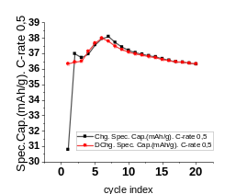  a | 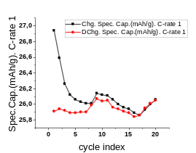  b | 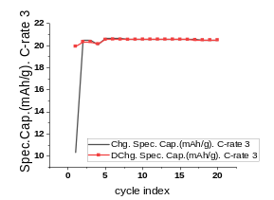  с
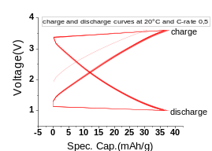 | 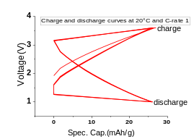 | 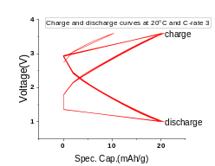
Figure 2. The battery was tested at 20°C in three different 0.5, 1, 3 C-rates and its Spec.Cap.(mAh/g), Voltage(V), and cycle indexes are marked in the figure.
Results and discussion: About 150 cycles could be reached with the highest specific capacity 147 mAh/g, using the 3rd salt fraction as an active material at 0.1 C-rate, and this specific capacity in the third fraction
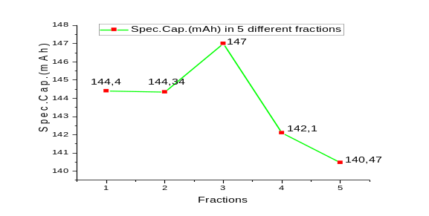
Fraction number | 1 | 2 | 3 | 4 | 5
Spec.Cap.(mAh/g) | 144.4 | 144.3 | 147 | 142.1 | 140.4
Na/S ratio | 0.901 | 0.9 | 0.856 | 0.937 | 0.964
Figure 1. Na/S ratio and the highest Spec.Cap.(mAh/g) with 0.1 C-rate in five different fractions according to previous study [4].
can be explaned by the low Na/S ratio, which leads to more efficient sodium utilization and improved electrochemical performance, while the fifth fraction was lower than others with less than 145 cycles (Figure 1). PTFE-based cathode material that was prepared from the fifth fraction and tested at three different temperatures, and the results were illustrated in Figures 2, and 3. In figure 2 a, the test was carried on 20 cycles at 0.5 C-rate and in the first cycle, the initial charge specific capacity was 30.80 mAh/g but from the second cycle it increased dramatically and reached more than 38 mAh/g in cycle number 7, but then declined slowly from 38 mAh/g to 36.33 mAh/g at the end of the 20th cycle, while the initial discharge specific capacity mAh/g remained unchanged with 36.35 mAh/g. Because the PTFE‐based cathodes experienced only a minor expansion, whereas the others expanded sharply after being tested (Schmidt et al., 2022). The galvanostatic charge and discharge profiles operated in the voltage range of 1-3.6 V. The PTFE-based cathode was also tested at 1 C-rate, and the results are in Figure 2 b. The charge-specific capacity mAh/g was nearly 26 mAh/g in the whole 20 cycles, and the discharge-specific capacity was almost the same. The given lines shows that charge-discharge efficiency was 103.97 % and 100.04 % respectively at 20 °C, indicating good reversibility, due to the increased interaction between the polar polisulfide shuttle and the polar carbon surface, the mobility of the polysulfide shuttle decreases. When C-rate changed from 0.5 to 1, its average charge and discharge specific capacity was declined slowly from 36.33 mAh/g to 26 mAh/g. In the figure 2 c, the battery was tested at 20 °C, C-rate 3. The lines show that charge and discharge specific capacity are the same line with 20 mAh/g at 3 C-rate and demonstrate good cycling stability over prolonged cycles, but its specific capacity is very little in comparison with results taken from C-rates 0.5 and 1. Overall, PTFE based cathode showed the suitability for sodium-sulfur batteries at 20 °C ( room temperature), but when the temperature was 5 °C, specific capacity declined slowly in a voltage range 1 V to 3.6 V (explained in Figure 3). Furthermore, decreasing the specific capacity at higher C-rates indicates that there is limited ion diffusion within the cathode material. In another study, cathodes containing PVDF binders showed a significantly lower initial discharge capacity and failed to recover their initial capacity (Park et al., 2026). It showed difficulty in recovering its initial capacity after cycling, indicating poor reversibility of the electrochemical reactions. This behaviour suggests that structural changes and partial loss of active material occurred during repeated charge-discharge processes, which limited the electrode's ability to restore its original performance. In comparison, when PTFE binder is used, during the cycles its recovery of initial capacity was well performed and continued steadily. These batteries' features demonstrate that when solvent free methode is used, its strong C-F bonding, excellent chemical inertness, and high mechanical stability prevent the surface of the cathode from degradation during cycles. Therefore, when the battery was tested at 20 °C, at 3 C-rate (Figure 2), the specific capacity showed a smooth line in the whole cycles. Figure 3 a show that the charge specific capacity is 20.41 mAh/g with 0.5 C-rate, but this capacity decreased to 18.31 mAh/g in the second cycle. There is a slow decline in the charge specific capacity from 18.31 mAh/g to 16.97 mAh/g between 2-20 cycles. Initial discharge specific capacity started at 17.40 mAh/g and rose to 17.70 mAh/g until the 3rd cycle; however, it declined slowly to 16.87 mAh/g at the end of the cycle. In addition, charge-discharge efficiency is 85.25 % in the first cycle, and from the second it came back to its normal efficiency at an average of 98.5%.
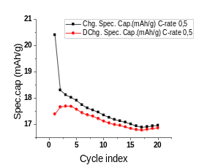  a | 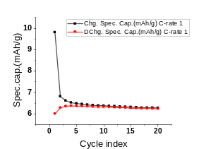  b | 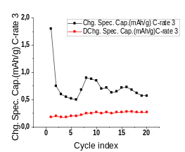  c
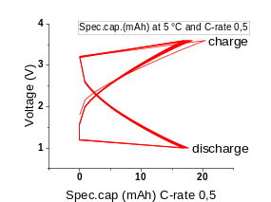 | 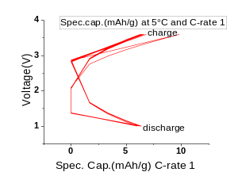 | 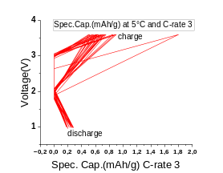
Figure 3. illustrates the electrochemical performance of the PTFE based cathode material by using galvanostatic charge-discharge measurements at 5 °C with 3 different 0.5,1,3 C-rates and 20 cycles.
Figure 3 c demonstrates the test with 3 C-rates at 5 °C; discharge-specific capacity increased slowly from 0.18 mAh/g to 0.27 mAh/g during the 20 cycles, but charge-specific capacity showed a dramatic decline from 1.8 mAh/g to 0.5 mAh/g in the cycles 1-6. In cycle 8, it rose again to 0.9 mAh/g, but decreased to 0.57 mAh/g until the last cycle. In conclusion, the proposed PTFE cathode material demonstrates competitive electrochemical performance at room temperature, but changing the temperature from 20 °C to 5 °C affects its overall working ability. Compared with PVDF-based cathodes, the PTFE-based cathode exhibits a higher density due to its pressure-assisted fabrication process. As a result, the cathode can accommodate a larger amount of active material; however, this also leads to a higher overall electrode mass. Due to its higher density, the PTFE-based cathode has a lower pore volume, which can limit electrolyte penetration and ion transport. Consequently, despite its ability to accommodate a larger amount of active material, the PTFE-based cathode may exhibit lower energy performance than PVDF-based cathode. The experiment conducted at -5 °C failed because of the upper voltage limit drop, polarization effect, and the soft short circuit because of these. The sag of the upper cut-off voltage is due to increased internal resistance. In our previous protocol, the optimal operation window for sodium-sulfur cells was recommended to be between 1.5V and 3.0V. This research also reaffirmed this claim. Especially, low temperatures increase the viscosity of the liquid electrolyte and slow down sodium ion diffusion. Under load at sub-zero temperatures, internal resistance makes it harder for sodium ions to move freely. Interfacial impedance increases at lower thermal limits. Sluggish ion diffusion, higher overpotentials, as well as the room-temperature high-voltage limit, accelerate side reactions and dendrite formation/sodium plating, causing a soft short circuit in the battery; as a consequence, triggers this kind of failure. SEM-EDS analysis. The surface morphology of the PTFE based cathode material was tested on two cathode samples: one pristine cathode before electrochemical cycling and one cathode after cycling, to investigate the swelling and wetting behaviour and evaluate the ability of PTFE binder to be sure the cohesion of the cathode. Figure 4 b (after charge-discharge) the image of PTFE based cathode revealed the formation of fibrillar PTFE networks, which efficiently bonded the active material particles and conductive carbon. After electrochemical cycling, the cathode surface shows noticeable morphological degradation, while the fibrillar structure of PTFE remains clearly visible. Moreover, these networks improved charge transfer and maintained electrode integrity, as a result the battery worked stable during the charge and discharge cycles. EDS analysis indicated that the overall sodium particles declined after being used from 19.37 % to 11.73 %. Due to the reason is that during the last charge at -5 °C (less than 145 cycles), sodium ions moved to the anode surface, resulting the reduction of sodium ions in the cathode. In addition, sulphur ions in the cathode material declined 16.39 % to 5.37 % and it is likely associate with the pre-treatment washing process, because sulphur particles may have been lost during the washing. Figure 5 demonstrate the surface morphology of PVDF based cathode. It can be clear that after many cycles the surface of the cathode was eroded, because of the lower stability of PVDF compared to PTFE. However, despite PTFE-based cathode’s higher density and lower degree of degradation, the cathode exhibited lower energy performance. This may be related to its reduced porosity, which limits electrolyte penetration and ion diffusion within the electrode structure.
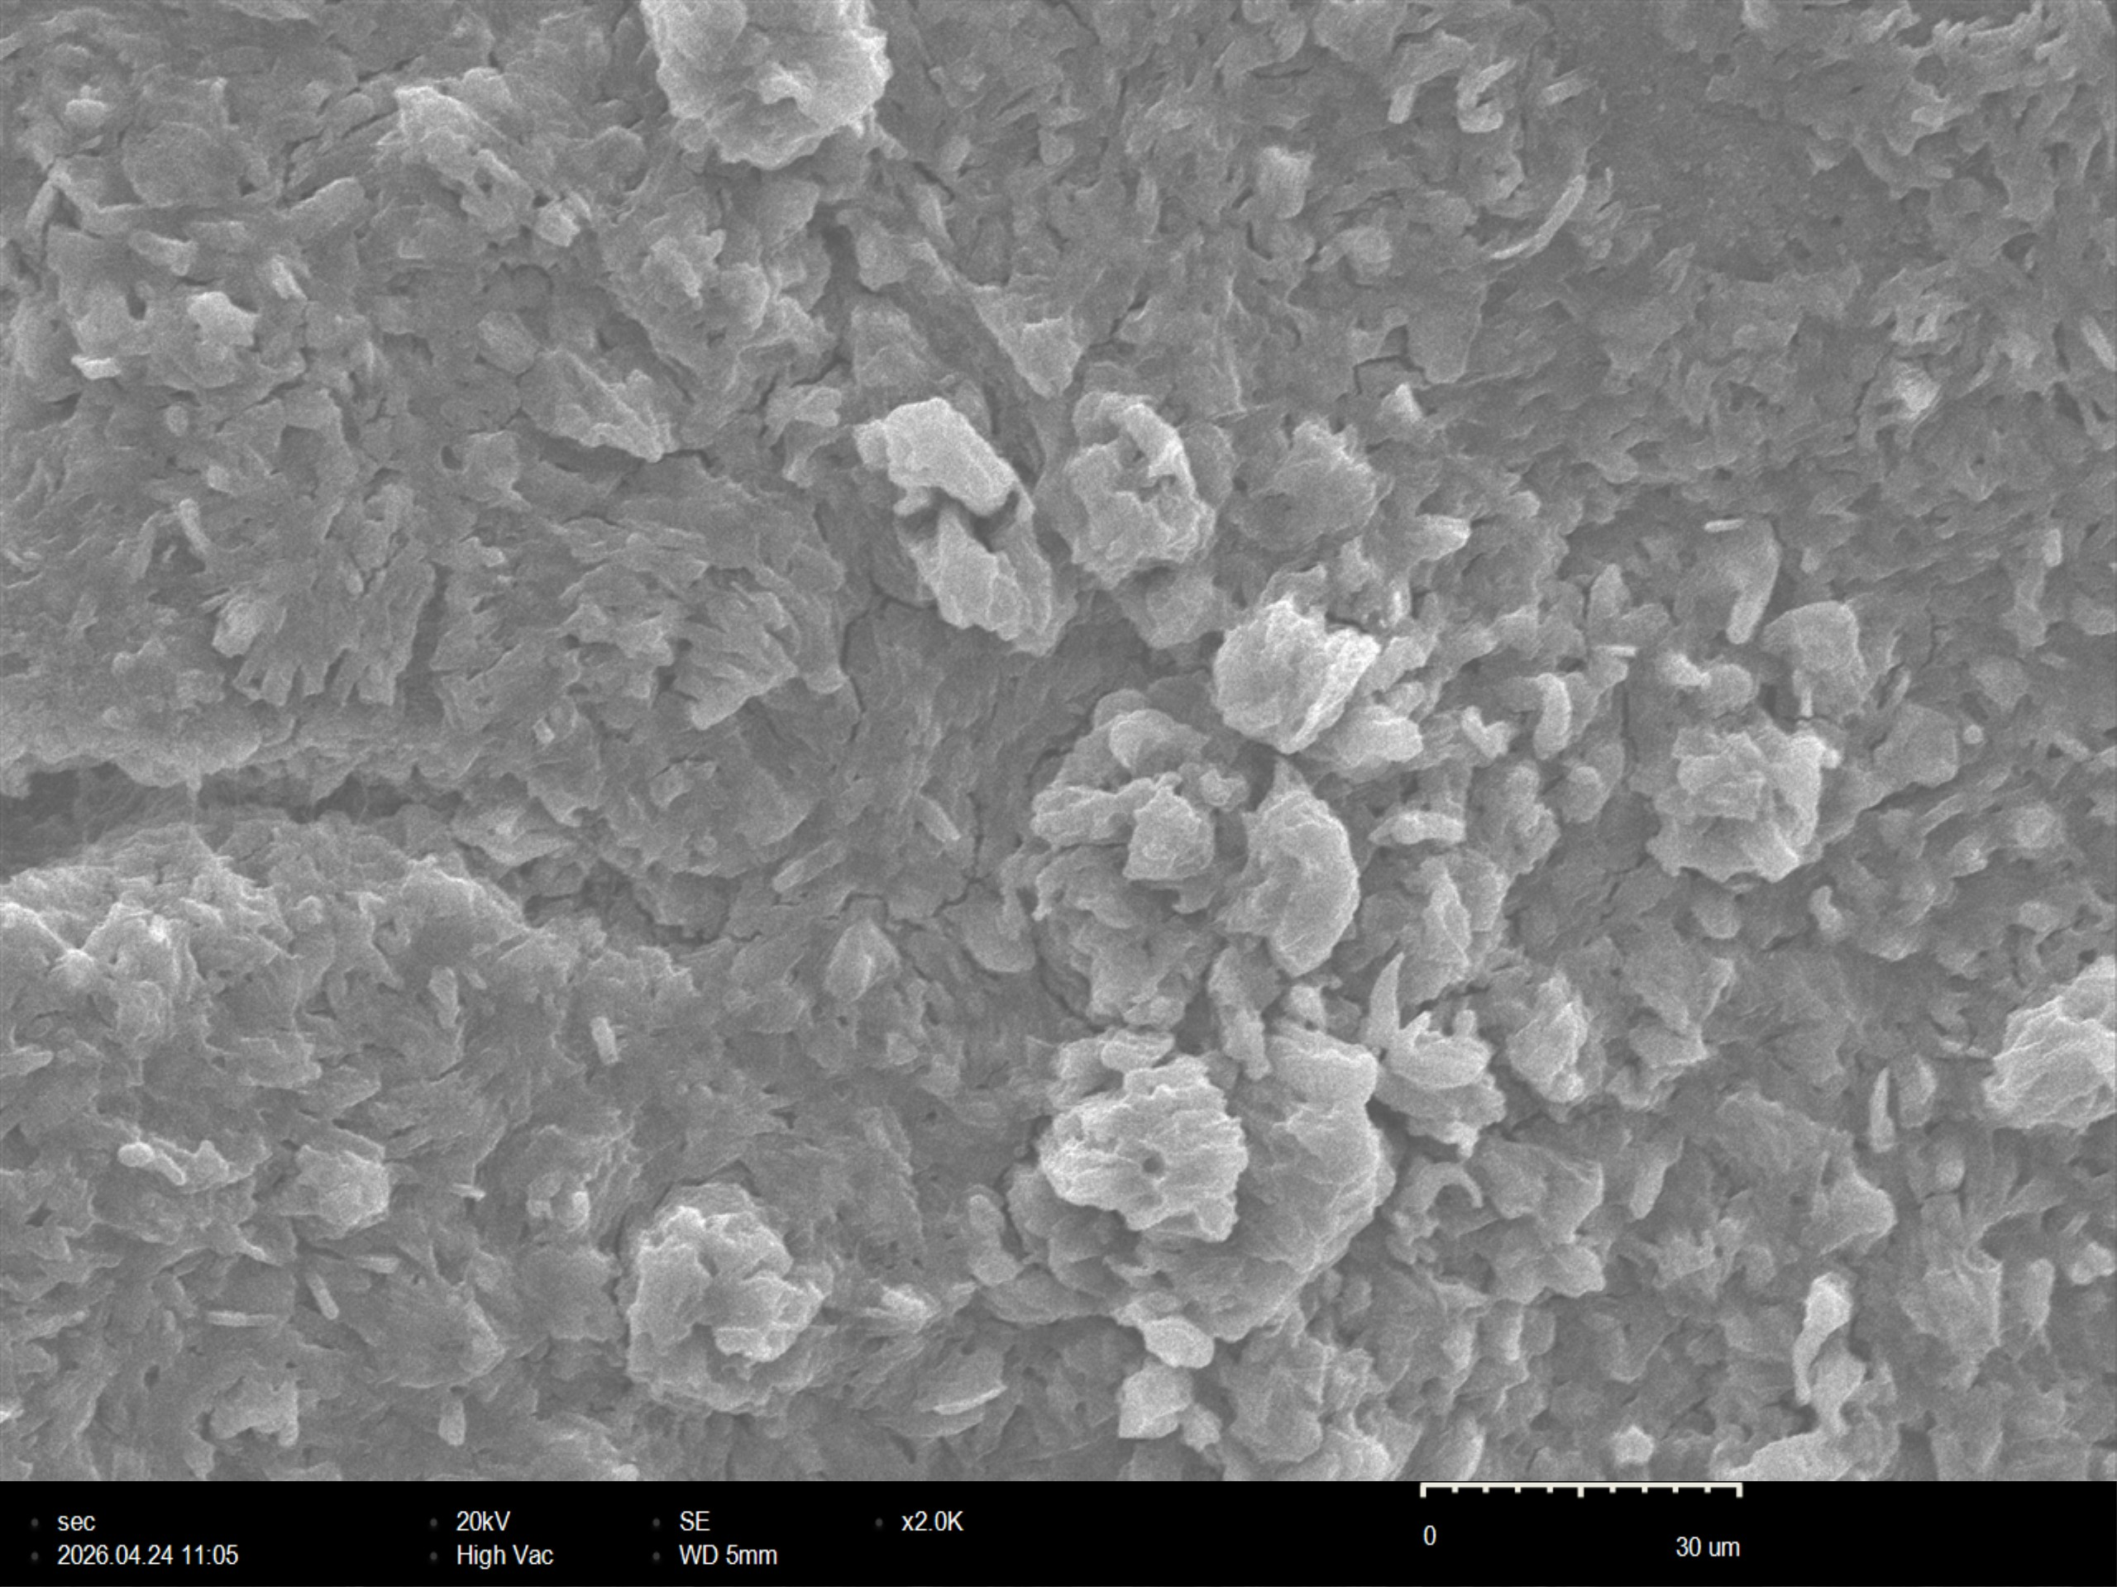  a |  |  |  |  |  |  |  | 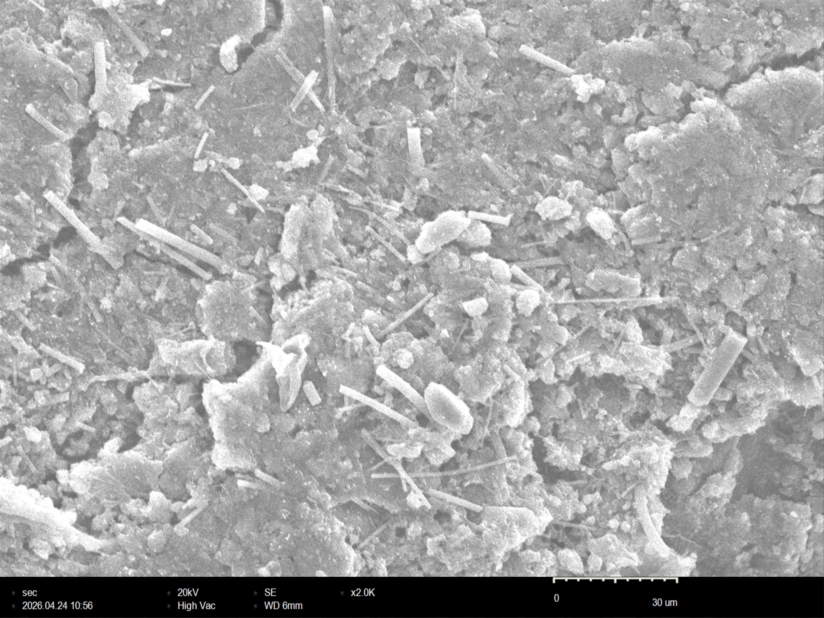  b
Figure 4. SEM-EDS analysis of microstructure of PTFE based cathode material and their elemental analysis before and (left) after (right) charge-discharge

Element | At.n. | Mass | Mass (%) | Mass.norm. (%) | Atom (%) | Abs.er. (%) | Rel.er. (%) | Element | At.n. | Mass | Mass (%) | Mass.norm. (%) | Atom (%) | Abs.er. (%) | Rel.er. (%)
C | 6 | 281 | 20.50 | 38.45 | 51.06 | 1.74 | 8.49 | C | 6 | 201 | 10.71 | 18.40 | 29.94 | 1.04 | 9.70
O | 8 | 366 | 13.26 | 24.88 | 24.80 | 1.04 | 7.88 | O | 8 | 883 | 11.73 | 20.15 | 24.60 | 0.75 | 6.42
F | 9 | 83 | 2.45 | 4.60 | 3.86 | 0.36 | 14.71 | F | 9 | 2 | 0.02 | 0.03 | 0.03 | 0.08 | 498.79
Na | 11 | 1235 | 11.73 | 22.00 | 15.26 | 1.99 | 16.93 | Na | 11 | 5197 | 19.37 | 33.27 | 28.28 | 2.27 | 11.71
S | 16 | 1990 | 5.37 | 10.08 | 5.01 | 0.49 | 9.15 | S | 16 | 16838 | 16.39 | 28.15 | 17.15 | 0.91 | 5.57
 |  | Sum: | 53.31 | 100.00 | 100.00 |  |  |  |  | Sum: | 58.21 | 100.00 | 100.00
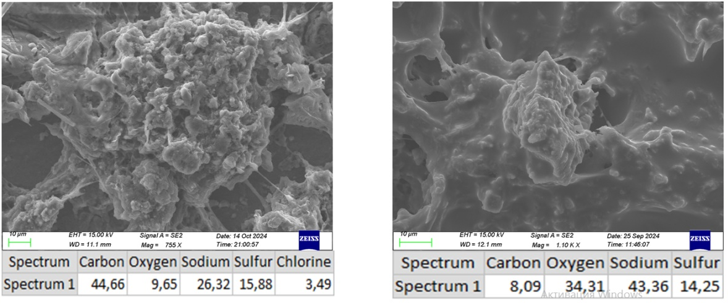
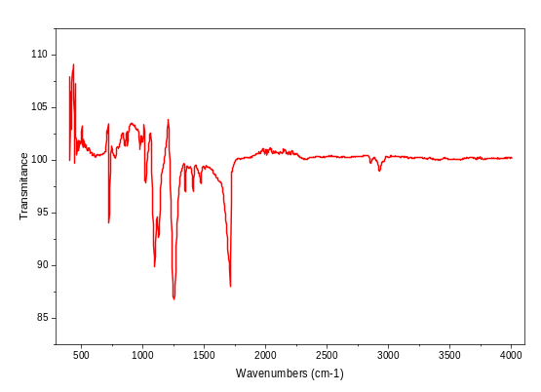In PTFE, the carbon backbone is fully surrounded by fluorine atoms, resulting strong C-F bonds and provide very good chemical resistance, as a result, the surface degradation in the prolonged cycles was significantly reduced. In fact, after being tested, the PTFE based cathode mass showed only a little reduction of about 10%, indication good structural stability. This limited mass loss suggests that active material well attached to the current collector and the density of the surface is high because of the dry-mixed method. In comparison, PVDF contains hydrogen atoms in its polymer chain, declining fluorine shielding, as a result chemical and thermal stability are weak. Moreover, the presence of hydrogen atoms in PVDF promotes electrolyte wetting and swelling, which can negatively affect the specific capacity during cycling. The surface chemical composition of the used anode material was analyzed by FTIR to get data about polysulfides on the anode's surface (Figure 6). After being tested, the anode material was vacuumed in a plastic bag to prevent air exposure before FTIR analysis. The plastic film was recorded separately as a background reference, and then the anode was analyzed. The IR spectra show strong characteristic peaks, primarily the carbonyl (C=O) stretching vibration at approximately 1770 –1800 cm-1, and prove that propylene carbonate exists on the surface of the anode. Moreover, there is a triplet of peaks at about 2970 cm-1, which indicates the presence of ethylene carbonate. It also showed characteristic absorption peaks in the 450-600 cm-1 region, indicating the presence of polysulfides in the sample. It is clear that polysulfides migrated from the cathode to the anode and covered its surface over the course of the last charging process.
Conclusion: Active material Na-S salt was used in the process, and it was derived from the wastewater of the oil-gas industry. The separation methods were explained in a previous study, and the fifth fraction was used to make cathode material (Khakimov, F.S. et al., 2025). It was determined that the PTFE-based cathode material in the 3rd fraction achieved 147 mAh/g at 0.1 C-rate and worked stably during the long 150 cycles. In the 5th fraction, specific capacity reached 140.25 mAh/g at 0.1 C-rate but worked less than 145 cycles. Furthermore, the PTFE-based cathode maintained a relatively stable specific capacity during cycles, demonstrating good structural durability and suppression of rapid capacity fading. This stable cycle performance suggests that the binder system and electrode preparation successfully preserved electrical contact and reduced active material loss during repeated charge-discharge processes. However, reducing the temperature affected its overall working capacity as explained above, and it is proven again that room temperature should be provided to work stably during the cycles. SEM analysis showed a more accurate distribution of active material and conductive binder in the optimized sample, while EDS analysis confirmed the presence of key elements after charge-discharge cycles. Overall, the developed PTFE-based cathode material demonstrated promising electrochemical stability and sustained specific capacity over extended cycles at room temperature. These results highlight the importance of cathode optimization for room temperature (RT) sodium-sulfur batteries and provide important data for future research.
Figure 5. SEM-EDS analysis of microstructure of PVDF based cathode material and their elemental analysis before (right) and after (left) charge-discharge (Khakimov, F.S., et al., 2025).

Figure 6. FTIR specter of used anode material.

References
Bloi, L.M., Pampel, J., Dörfler, S., Althues, H. and Kaskel, S. (2020) ‘Sodium Sulfide Cathodes Superseding Hard Carbon Pre-sodiation for the Production and Operation of Sodium–Sulfur Batteries at Room Temperature’, Advanced Energy Materials, 10(7), 1903245. https://doi.org/10.1002/aenm.201903245
COP28 UAE. Available online: https://www.cop28.com/en/ (accessed on 8 April 2024).
Eng, A.Y.S., Nguyen, D.-T., Kumar, V., Subramanian, G.S., Ng, M.-F. and Seh, Z.W. (2020) ‘Tailoring binder–cathode interactions for long-life room-temperature sodium–sulfur batteries’, Journal of Materials Chemistry A, 8(43), pp. 22983–22997.https://doi.org/10.1039/D0TA07681C
Friedlingstein, P., O'Sullivan, M., Jones, M.W., Andrew, R.M., Gregor, L., Hauck, J., Le Quéré, C., Luijkx, I.T., Olsen, A. and Peters, G.P. et al. (2022) ‘Global Carbon Budget 2022’, Earth System Science Data, 14(11), pp. 4811–4900. https://doi.org/10.5194/essd-14-4811-2022
Siyang Gan, Yujie Huang, Ningyun Hong, Yinghao Zhang, Bo Xiong, Zhi Zheng, Zidong He, ShengruiGao, Wentao Deng, Guoqiang Zou, Hongshuai Hou, Xiaobo Ji (2025) “Comprehensive understanding of closed pores in hard carbon anode for high-energy sodium-ion batteries”, Nano-Micro Letters, Volume 17, https://doi.org/10.1007/s40820-025-01833-x
Hencz, L., Chen, H., Ling, H.Y., Wang, Y., Lai, C., Zhao, H. and Zhang, S. (2019) ‘Housing Sulfur in Polymer Composite Frameworks for Li–S Batteries’, Nano-Micro Letters, 11(1), 17. https://doi.org/10.1007/s40820-019-0249-1
Kareeklin, N., Phukhrongthung, A., Krittayavathananon, A., Wang, B., Luanwuthi, S. and Iamprasertkun, P. (2026) ‘Binder Chemistry of Na₃V₂(PO₄)₂F₃ Cathodes in Aqueous Sodium-Ion Batteries: From “Salt-in-Water” to “Water-in-Salt”’, ACS Applied Polymer Materials, 8(6), pp. 4163–4172. https://doi.org/10.1021/acsapm.5c04664
Khakimov, F.S., Khakimova, S.S.K., Mirsalimova, S.R., Khamrakulov, Z.A., Khamdamova, S.S. and Maksumova, O.S. (2025) ‘Cathode material derived from oil and gas processing wastewater and electrolyte development for use in room temperature sodium-sulfur batteries’, Journal of Energy Storage, 140, 118593. https://doi.org/10.1016/j.est.2025.118593
Park, H., Jeon, C., Kansara, S., Lee, C., Xiong, S., Sun, Z. and Hwang, J.-Y. (2026) ‘Investigating the effect of binder for stabilizing a sulfurized polyacrylonitrile cathode in sodium–sulfur batteries’, Journal of Power Sources, 661, pp. 1–11.https://doi.org/10.1016/j.jpowsour.2025.238587
Qin, Y., Choi, S.-G., Mason, L., Liu, J., Li, Z. and Gao, T. (2024) ‘Carboxylate ester-based electrolytes for Na-ion batteries’, Chemical Science, 15(24), pp. 9224–9239. https://doi.org/10.1039/D4SC02266A
Schmidt, F., Kirchhoff, S., Jägle, K., De, A., Ehrling, S., Härtel, P., Dörfler, S., Abendroth, T., Schumm, B., Althues, H. and Kaskel, S. (2022) ‘Sustainable Protein-Based Binder for Lithium-Sulfur Cathodes Processed by a Solvent-Free Dry-Coating Method’, ChemSusChem, 15(22), e202201320. https://doi.org/10.1002/cssc.202201320
Smith, W.H., Birnbaum, J. and Wolden, C.A. (2021) ‘Production and purification of anhydrous sodium sulfide’, Journal of Sulfur Chemistry, 42(4), pp. 426–442. https://doi.org/10.1080/17415993.2021.1907390
Srivastava, M., Kumar, A.K.M.R. and Zaghib, K. (2024) ‘Binders for Li-Ion Battery Technologies and Beyond: A Comprehensive Review’, Batteries, 10(8), 268. https://doi.org/10.3390/batteries10080268
Wang, Y., Zhang, Y., Cheng, H., Ni, Z., Wang, Y., Xia, G., Li, X. and Zeng, X. (2021) ‘Research Progress toward Room Temperature Sodium Sulfur Batteries: A Review’, Molecules, 26(6), 1535. https://doi.org/10.3390/molecules26061535
Y. Wang, D. Zhou, V. Palomares, D. Shanmukaraj, B. Sun, X. Tang, C. Wang, M. Armand, T. Rojo, G. Wang, Revitalising sodium–sulfur batteries for non-hightemperature operation: A crucial review, Energy Environ. Sci. 13 (2020) 3848–3879, https://doi.org/10.1039/D0EE01699F.
Xu, J., Yang, J., Qiu, Y., Jin, Y., Wang, T., Sun, B. and Wang, G. (2024) ‘Achieving high-performance sodium metal anodes: From structural design to reaction kinetic improvement’, Nano Research, 17(3), pp. 1288–1312. https://doi.org/10.1007/s12274-023-5889-2

