 CHEMICAL ENGINEERING TRANSACTIONS  VOL. xxx, 2026 | A publication of  
The Italian Association
of Chemical Engineering
Online at www.cetjournal.it

Guest Editors: Flavio Manenti, Botir Usmonov, Alessandro Di Pretoro
Copyright © 2026, AIDIC Servizi S.r.l.
ISBN 979-12-81206-xx-x; ISSN 2283-9216

Synthesis of Acrylic Acid and Monoammonium Phosphate Derivatives and Their Application in Modification of Polyolefins
Sunnatilla Erkinovich Abdurazakov^{a,}*, Aytura Sitdikovna Maksumovaª, Erkin Rustamovich Toraev^{b}
ªDepartment of Organic Synthesis Technology, The Tashkent Institute of Chemical Technology, Tashkent, Uzbekistan
^{b}Laboratory of Basic Organic Synthesis Technology, Tashkent Research Institute of Chemical Technology, Tashkent region, Uzbekistan
sunnatillaerkinovich@gmail.com
The demand for environmentally friendly flame retardants is increasing because halogenated flame retardants are harmful to the environment and cause the production of toxic gases. Increasing environmental requirements and fire safety standards necessitate replacing halogenated flame-retardants with halogen-free flame-retardants. Therefore, the development of halogen-free flame-retardant (FR) systems for polyolefin materials such as polypropylene (PP) and polyethylene (PE) is urgent. Improving fire resistance while maintaining mechanical properties is a complex task. Phosphorus compounds, in combination with organic modifiers, are promising in solving this problem. In particular, monoammonium phosphate modified with acrylic acid can improve compatibility with the polymer and increase its mechanical properties. In this study, a new halogen-free flame retardant was synthesized based on acrylic acid and monoammonium phosphate. The synthesis was carried out through condensation and neutralization reactions. The results showed that in the FTIR spectrum of the synthesized product, the absorption line characteristic of the valence vibrations of the -C=C-COOR functional group was observed at 1722,51 cm-1. Overall, the addition of the synthesized flame retardant significantly improved the mechanical performance of the composites, with tensile strength increasing by 5–12% and elongation at break improving by 20–50%.
  - Introduction
Fire safety is of great importance due to the widespread use of polymers in the national economy. The production volume of various types of flame-retardant polymer products in the global market is growing rapidly. In recent years, countries around the world have proposed new legislative measures and strategies to protect human life and property. The scientific and economic aspects of flame resistance, fire safety standards, and new technologies are constantly developing. (Vahabi et al., 2021). These polymer composites are characterized by light weight, high efficiency, and high mechanical properties and are widely used in industries such as aerospace, automotive, marine, and construction. As a result, great attention is being paid to the production of flame-retardant polymer composites (Murad et al., 2025). Depending on the type of flame-retardant chemicals and their working principle, the following flame-retardant fillers are widely used in polymer composites: halogen-based, metal oxide and hydroxide-based, boron and phosphorus-based, synergistic, and intumescent-based (Hasnat et al., 2023). As safety standards are increasingly stringent and the demand for high-performance polymer materials increases, researchers and industry experts are working on high-quality flame-retardant polymer composites (Murad et al., 2025). Studies show that approximately 50 % of electrical fires are caused by burning polymer cables. As a result, halogenated flame retardants are expected to be replaced by halogen-free flame retardants in the near future due to the increasing attention of environmental organizations to environmental issues, and polyvinyl chloride (PVC)-based cables are expected to be gradually replaced by polyolefin (PO)-based cables (Li et al., 2022). Unmodified polymer materials do not have sufficient flame-retardant properties. For example, the limiting oxygen index (LOI) of common plastics such as polyethylene (PE) and polypropylene (PP) is only 17.0–18.0%. Therefore, PP and PE are considered to be easily flammable or combustible materials (Gao et al., 2020). Although some polymer compositions contain flame-retardant elements such as sulfur, nitrogen, fluorine, and silicon, which provide flame-retardant properties, they do not meet fire safety requirements for industrial use. Polymers are widely used in the construction industry due to their corrosion resistance, light weight, and other important properties (Shen et al., 2021). Based on the analysis of the aforementioned studies, it can be concluded that the synthesis of novel reactive compounds—particularly those containing nitrogen and phosphorus with low heat release and smoke generation characteristics—represents one of the most promising directions for the development of effective flame-retardant systems.
  - METHODOLOGY
The experimental part of this study involved the synthesis of the flame-retardant additive, its incorporation into polyolefin composites, and the evaluation of the properties of the resulting materials. Initially, an N–P-containing flame retardant incorporating phosphorus and nitrogen was synthesized. In the subsequent stage, the synthesized N–P flame retardant was used to prepare ethylene-vinyl acetate (EVA)/PE and EVA/PP-based polymer composites in combination with conventional flame-retardant additives, including ammonium polyphosphate (APP), aluminum trihydroxide (ATH), and calcium carbonate (CaCO₃). The flame-retardant properties of the prepared composites were evaluated using UL-94 and LOI tests; their mechanical properties were assessed by tensile strength and elongation at break.
2.1. Synthesis of the N–P flame-retardant additive
The flame-retardant compound was synthesized using the following chemicals: monoammonium phosphate (CAS No. 7722-76-1, melting point 155 °C), acrylic acid (CAS No. 79-10-7, boiling point 141 °C), and technical ethanol, which was purified by distillation at atmospheric pressure (boiling point 76–79 °C). The synthesis was carried out using standard laboratory equipment, including a three-neck round-bottom flask made of borosilicate glass (Boro 3.3), a Dean–Stark apparatus, beakers, a condenser, a receiver, an electric heating plate, and a thermometer (GOST-126464). Initially, analytically pure reagents were accurately weighed using an analytical balance according to the required stoichiometric ratios. Subsequently, the reagents were dissolved in appropriate solvents as follows: 20 g of monoammonium phosphate was dissolved in 54 mL of water, while 12 mL of acrylic acid was dissolved in 21 mL of ethanol. The prepared solutions were then transferred into a 250 mL three-neck round-bottom flask. The Dean–Stark apparatus, condenser, and thermometer were connected to the flask, and the reaction mixture was heated using an electric plate. The reaction was conducted at a temperature range of 100–110 °C. The evolution of reaction water commenced at approximately 100 °C. The total reaction time was 90 minutes. At the completion of the reaction, a white crystalline precipitate was formed. The product was isolated and purified by sequential washing with ethanol followed by acetone. The overall reaction yield was determined to be 88% by equation (1). The reaction pathway can be represented schematically as follows:
CH₂=CH-COOH + NH₄H₂PO₄ CH₂=CH-COOPO₂OHNH₄ + H₂O (1)
To determine the structure, elemental composition, and thermal stability of the synthesized material, the FTIR spectrometer (SHIMADZU IRAffinity-1S), the scanning electron microscope (Jeol JSM-IT210), and the SHIMADZU TRAPEZIUMX testing system were used.
2.2. Preparation and Characterization of Flame-Retardant Polymer Composites
Before preparing the polymer composites, the polymer matrix components, namely EVA, PE, and PP, as well as the flame-retardant components, including the synthesized ammonium acrylate phosphate flame-retardant, APP, ATH, and CaCO₃, were dried at 40–80 °C for 2–4 h. The dried components were weighed according to the predetermined formulations using an analytical balance and subjected to preliminary dry mixing for 5 min. The compositions of the prepared composites are presented in Table 2.
The resulting mixtures were subsequently processed using a laboratory two-roll mill (RT-100D Two Roll Mill). The EVA/PE composites were melt-mixed at 140-165 °C, whereas the EVA/PP composites were processed at 155–185 °C for a total mixing time of 10 min. During the initial mixing stage, the polymer matrix was melted for 3 min. Subsequently, APP, ATH, CaCO₃, and the synthesized ammonium acrylate phosphate flame retardant were gradually incorporated into the molten polymer matrix. Mixing was continued for an additional 7 min to ensure uniform dispersion of the flame-retardant components throughout the polymer matrix. The same mixing procedure was applied to all formulations.
Upon completion of the mixing process, the resulting composite materials were removed from the two-roll mill and cooled to room temperature. The obtained composites were subsequently used to prepare standard specimens for UL-94, limiting oxygen index (LOI), and mechanical testing.
The vertical flammability characteristics of the polymer composites were evaluated using the vertical burning test in accordance with the UL-94 standard. The limiting oxygen index (LOI) of the composites was determined in accordance with ASTM D2863. The mechanical properties of the polymer composites were evaluated using a Universal Testing Machine (UTM) in accordance with ASTM D638. Type V dumbbell-shaped specimens were used for the tensile tests. Before testing, the specimens were conditioned at 23 ± 2 °C and 50 ± 5% relative humidity for 48 h. The tensile tests were then conducted under the same environmental conditions at a crosshead speed of 50 mm/min. The values obtained from the tested specimens are presented in Table 2.
  - Results and discussion
    - Characterization of Ammonium acrylate phosphate flame-retardant
Infrared (IR) spectroscopy
In Figure 1, in the IR spectrum of acrylic acid, an absorption line was observed in the region of 1712.86 cm-1, which corresponds to the valence vibrations of the C=C-COOH bond, the valence vibrations of the -C=C- bond were observed in the region of 1427.39 cm-1, and the valence vibrations of the -OH bond were observed in the region of 978.92 cm-1.
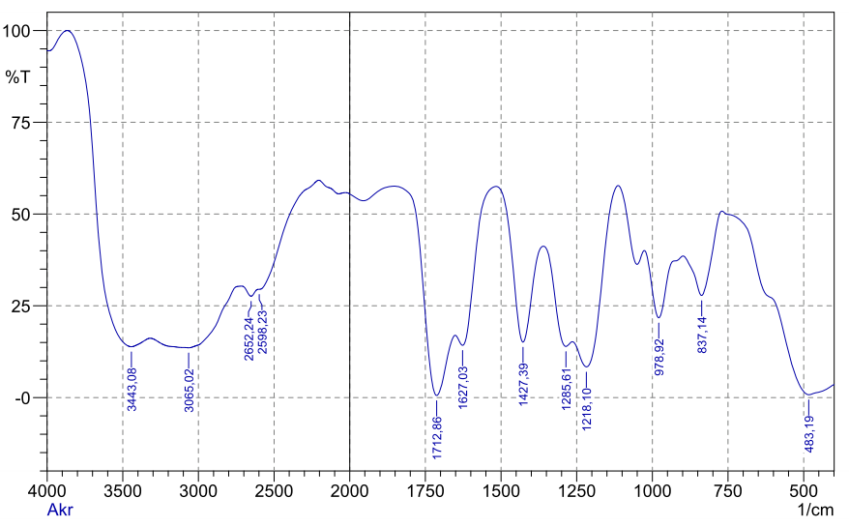
Figure 1: IR spectrum of acrylic acid
In Figure 2, in the IR spectrum of the monoammonium phosphate salt, an absorption line characteristic of the stretching vibrations of the NH4+ group was observed in the region of 3249 cm-1. The stretching vibrations of the H2PO4- group were observed in the region of 1102 cm-1, the stretching vibrations of the P=O bond in the region of 1288 cm-1, and the stretching vibrations of the -OH bond in the region of 918 cm-1.
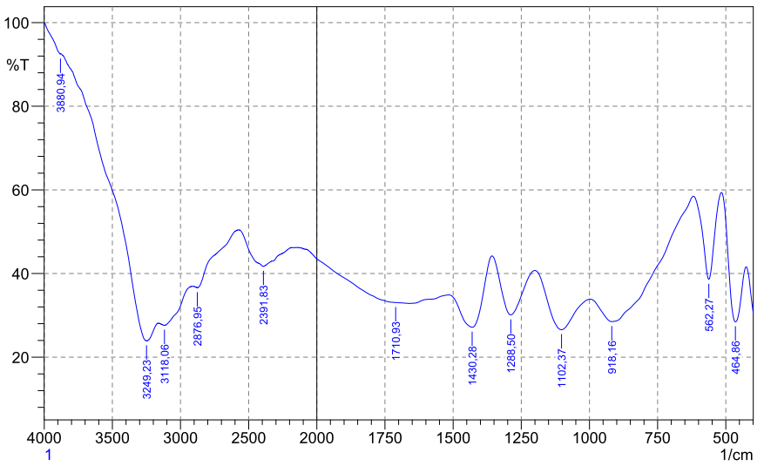
Figure 2: IR spectrum of monoammonium phosphate
In Figure 3, in the IR spectrum of the synthesized ammonium acrylate phosphate flame-retardant, an absorption line characteristic of the stretching vibrations of the NH4+ group was observed in the region of 3118.06 cm-1. The stretching vibrations of the -C=C-COOR bond of the complex ester connected by the double bond were observed in the region of 1722.51 cm-1, the stretching vibrations of the P=O bond in the region of 1282.72 cm-1, the stretching vibrations of the HPO4-2 bond in the region of 1098.51 cm-1, and the stretching vibrations of the -C-O-P- bond in the region of 932.62 cm-1.
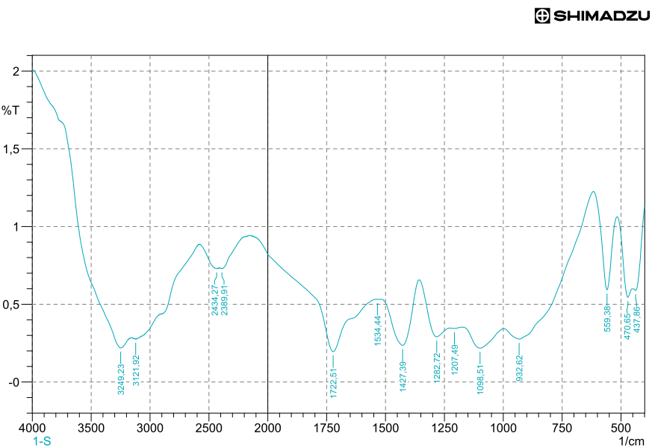
Figure 3: IR spectrum of a product synthesized from acrylic acid and monoammonium phosphate
Thermogravimetric Analysis (TGA)

Figure 4 presents the analysis of the thermogravimetric analysis (TGA) curve of the synthesized ammonium acrylate phosphate flame-retardant. Three intensive decomposition temperature ranges were observed in the TGA curve of the thermogram. The process occurred in three stages: The first mass-loss stage occurred in the temperature range of 31.48–285.45 °C with a weight loss of approximately 1.310 mg (16.639 %). This weight loss is attributed not only to the evaporation of physically adsorbed moisture and residual volatile compounds but also to the initial thermal decomposition of thermally unstable phosphorus-containing structures. The broad temperature interval suggests that partial cleavage of weak chemical bonds and possible decomposition or hydrolysis of phosphate-containing groups may contribute to the observed mass loss. The second decomposition of the sample was in the temperature range of 285.45-506.97 °C, and the decomposition of organic residues or hydroxyl groups occurred. In this case, the sample lost 1.400 mg (17.782 %) of mass. The third decomposition was in the temperature range of 506.97-801.87 °C, and the complete decomposition of the main organic substance occurred. In this case, the sample lost 3.951 mg (50.184 %) of mass. In the DSC thermogram, the liquefaction of the synthesized sample began at a temperature of 195.19 °C and ended at a temperature of 220.22 °C, i.e., a strong exothermic peak was observed. The maximum value of the peak was recorded at T_{peak}=206.03 °C. The magnitude of the heat effect for this process was ΔH= -434.13 J/g, and the signal intensity was -3.85 µV/mg. The wide endothermic-exothermic change observed in the range of 285.45-506.97 °C can be explained by the thermal decomposition of the obtained organic substance and the dissociation of hydroxyl groups in the component. In the range of 506.97-801.78 °C, an increasing exothermic phenomenon was recorded, which corresponds to the combustion of the organic substance and the recrystallization of the residue. DSC analysis confirmed the presence of a three-step thermal process in the sample, and TGA results further substantiated it.

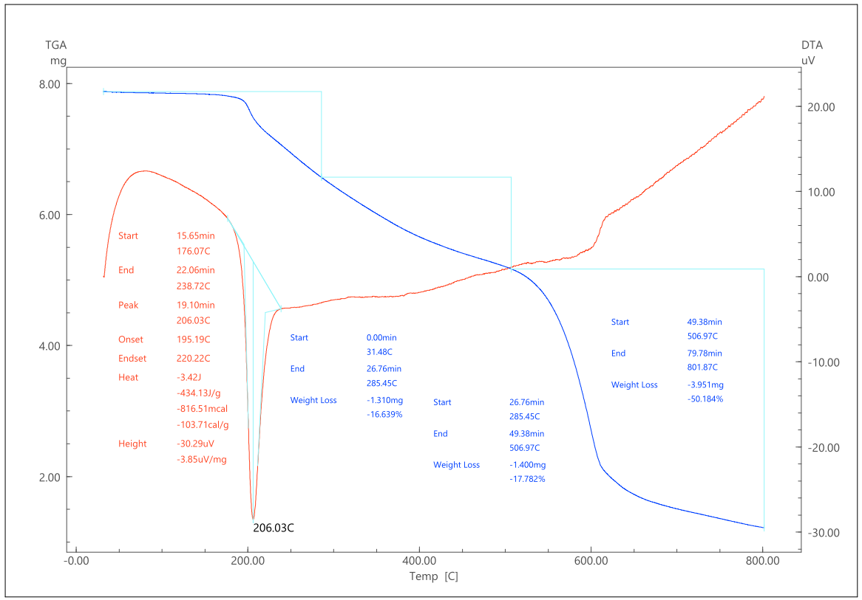
Figure 4: Differential thermogravimetric analysis of N-P flame-retardant synthesized based on acrylic acid and monoammonium phosphate.
In general, within the temperature range of 31.48-801.87 °C, the initial mass of the sample was 7.873 mg, the mass loss of the sample was 6.661 mg (84.605%), and the final residual mass was 1.212 mg (15.395%), which took 79.78 minutes. The analysis of the thermogravimetric analysis curve and the differential thermal analysis curve can be seen in Table 1.
Table 1: Analysis of TGA parameters of the salt obtained as a result of the chemical reaction
№ | Temperature (^{о}C) | Time,  minute | Lost mass (mg) | Lost mass (%) | Average rate of mass loss (mg/min)
1 | 31,48-285,45 | 26,76 | 1,310 | 16,639 | 0,049
2 | 285,45-506,97 | 22,62 | 1,400 | 17,782 | 0,062
3 | 506.97-801,87 | 30,4 | 3,951 | 50,184 | 0,13
Total |  | 79.78 | 6,661 | 84,605 | 0,241

Scanning Electron Microscope

The result of elemental analysis shows that the synthesized substance contained 37.79% carbon, 8.34% nitrogen, 42.87% oxygen, and 11.01% phosphorus. No other trace elements were detected in the synthesized substance.

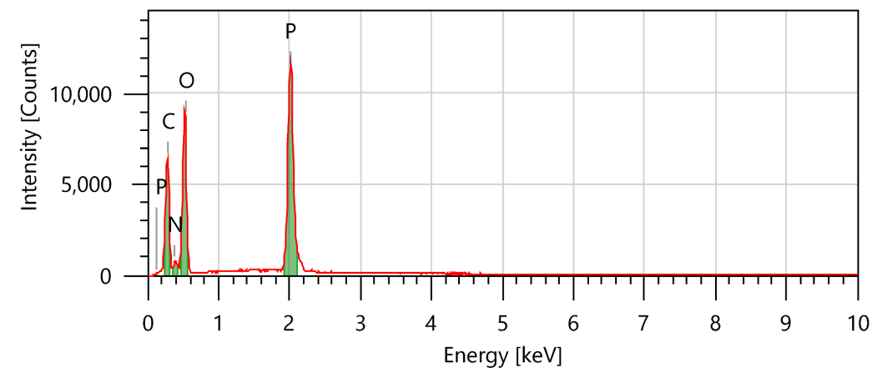

Element | Line | Mass % | Atom %
C | K | 37.79±0.18 | 46.43±0.22
N | K | 8.34±0.23 | 8.78±0.24
O | K | 42.87±0.29 | 39.54±0.27
P | K | 11.01±0.07 | 5.24±0.03
Total |  | 100 | 100
Figure 5: Results of elemental analysis of a product based on acrylic acid and monoammonium phosphate
Polyolefins are blended with various copolymers, including copolymers such as ethylene-vinyl acetate (EVA) and ethylene-vinyl alcohol (EVOH). Such polymer blends are typically used to improve thermal, mechanical, and electrical properties. EVA is typically blended with various grades of polyethylene (PE) and polypropylene (PP). These copolymers are widely used for the sheathing and insulation of electrical cables. The main goal of this study was to reduce the toughness problem in the polymer (Alosime and Basfar, 2023). In this study, blending EVA with isotactic polypropylene (PP) increased the elongation at break of PP by more than 4 times, but in this case, the mechanical properties of the material decreased. When EVA was blended with a polypropylene/ethylene copolymer instead of an i-PP homopolymer, the same amount of EVA gave an even more significant improvement: the elongation at break increased by 4 times. These results show that choosing the right type of polymer can significantly improve the mechanical properties of EVA without increasing its synergistic effect (Castro-Landinez et al., 2021). (Pham, 2021) also found in their study that adding EVA-28 polymer to LDPE/EVA in different proportions increased the elongation at break of the samples. As the amount of EVA-28 increased, the tensile and flexural strength and stiffness also decreased. Sanchez-Olivares et al. (2019), in their study, used melamine triazine and bentonite clay as new flame-retardant additives to the EVA/PE polymer system. When these additives were added, the effectiveness of the protective layer that forms aluminum hydroxide during the combustion process was increased. Samples containing melamine triazine and bentonite clay showed good results in several properties and outperformed commonly used industrial samples. This scientific research used ammonium acrylate phosphate flame-retardant, ammonium polyphosphate (APP), aluminum trihydroxide (ATH), calcium carbonate (CaCO₃), and polyolefin (PO) substances. The results are presented in Table 2.
Table 2: Examples of N-P as adjuvants with conventional flame-retardants in polyolefin composites.
PO matrix | N-P flame retardant (wt. %) | Other flame retardants (wt. %) | Flame retardancy | Mechanical property
EVA/PE  (30/70 %)  (pure plymer) | - | - | UL-94 (1.2 mm): V-2  LOI: 21 % | σ_{t} : 11.2 MPa  ε_{b} : 312.5 %
EVA/PE  (26/24 %)  (control formulation) | - | ATH (37.0)  CaCO₃ (7.0)  APP (6.0) | UL-94 (1.2 mm): V-2  LOI: 23.6 % | σ_{t} : 11.4 MPa  ε_{b} : 72.6 %
EVA/PE  (30/10 %) | 5.0 | ATH (40.0)  CaCO₃ (7.0)  APP (8.0) | UL-94 (1.2 mm): V-2  LOI: 24.6 % | σ_{t} : 5.6 MPa  ε_{b} : 75.3 %
EVA/PE  (20/20 %) | 6.0 | ATH (42.0)  CaCO₃ (7.0)  APP (5.0) | UL-94 (1.2 mm): V-2  LOI: 23.7 % | σ_{t} : 7.2 MPa  ε_{b} : 50.2 %
EVA/PE  (16/24 %) | 4.0 | ATH (51.0)  PE wax (1.0)  APP (4.0) | UL-94 (1.2 mm): V-2  LOI: 21.3 % | σ_{t} : 12.6 MPa  ε_{b} : 80.8 %
EVA/PP  (30/10 %) | 5.0 | ATH (45.0)  CaCO₃ (5.0)  APP (5.0) | UL-94 (1.2 mm): V-2  LOI: 20.5 % | σ_{t} : 10.2 MPa  ε_{b} : 40.3 %
EVA/PP  (25/15 %) | 6.0 | ATH (43.0)  CaCO₃ (3.0)  APP (8.0) | UL-94 (1.2 mm): V-2  LOI: 22.3 % | σ_{t} : 11.2 MPa  ε_{b} : 35.5 %
4. Conclusions
Thus, a method for synthesizing halogen-free flame retardants based on acrylic acid and monoammonium phosphate in a mixed solvent environment at a temperature of 100-110 °C was studied. The structure and elemental composition of the synthesized substance were studied using Infrared (IR) spectroscopy and SEM. Based on the results of elemental analysis, it was determined that the carbon content in it was 37.79 %, the nitrogen content was 8.34 %, the oxygen content was 42.87 %, and the phosphorus content was 11.01 %. When its thermal properties were analyzed using the TGA method, the total mass loss of the sample at a temperature of 801.87 °C for 79.78 minutes was 84.605 %, and the average mass loss rate was 0.241 mg/min. As a result of studying the oxygen index and mechanical properties of the synthesized material, it was determined that the oxygen index was UL-94 V-2, the tensile strength was 12.6 MPa, and the elongation at break was 80.8 %.
Nomenclature
σ_{t} - Tensile strength | ε_{b} - Elongation at break
References
Alosime, E.M., Basfar, A.A., 2023. A Systematic Investigation on the Influence of Intumescent Flame Retardants on the Properties of Ethylene Vinyl Acetate (EVA)/Liner Low Density Polyethylene (LLDPE) Blends. Molecules 28, 1023. https://doi.org/10.3390/molecules28031023
Castro-Landinez, J.F., Salcedo-Galan, F., Medina-Perilla, J.A., 2021. Polypropylene/Ethylene—And Polar—Monomer-Based Copolymers/Montmorillonite Nanocomposites: Morphology, Mechanical Properties, and Oxygen Permeability. Polymers 13, 705. https://doi.org/10.3390/polym13050705
Gao, D., Wen, X., Guan, Y., Czerwonko, W., Li, Y., Gao, Y., Mijowska, E., Tang, T., 2020. Flame retardant effect and mechanism of nanosized NiO as synergist in PLA/APP/CSi-MCA composites. Composites Communications 17, 170–176. https://doi.org/10.1016/j.coco.2019.12.007
Hasnat, M.R., Hassan, M.K., Saha, S., 2023. Flame Retardant Polymer Composite and Recent Inclusion of Magnesium Hydroxide Filler Material: A Bibliometric Analysis towards Further Study Scope. Fire 6, 180. https://doi.org/10.3390/fire6050180
Li, Y., Qi, L., Liu, Y., Qiao, J., Wang, M., Liu, X., Li, S., 2022. Recent Advances in Halogen-Free Flame Retardants for Polyolefin Cable Sheath Materials. Polymers 14, 2876. https://doi.org/10.3390/polym14142876
Murad, M.S., Hamzat, A.K., Asmatulu, E., Asmatulu, R., 2025. Flame-retardant fiber composites: synergistic effects of additives on mechanical, thermal, chemical, and structural properties. Adv Compos Hybrid Mater 8, 31. https://doi.org/10.1007/s42114-024-01111-1
Pham, N.T.-H., 2021. Characterization of Low-Density Polyethylene and LDPE-Based/Ethylene-Vinyl Acetate with Medium Content of Vinyl Acetate. Polymers 13, 2352. https://doi.org/10.3390/polym13142352
Sanchez-Olivares, G., Sanchez-Solis, A., Manero, O., Pérez-Chávez, R., Jaramillo, M., Alongi, J., Carosio, F., 2019. Improving Mechanical Properties and Reaction to Fire of EVA/LLDPE Blends for Cable Applications with Melamine Triazine and Bentonite Clay. Materials 12, 2393. https://doi.org/10.3390/ma12152393
Shen, J., Liang, J., Lin, X., Lin, H., Yu, J., Wang, S., 2021. The Flame-Retardant Mechanisms and Preparation of Polymer Composites and Their Potential Application in Construction Engineering. Polymers 14, 82. https://doi.org/10.3390/polym14010082
Vahabi, H., Laoutid, F., Mehrpouya, M., Saeb, M.R., Dubois, P., 2021. Flame retardant polymer materials: An update and the future for 3D printing developments. Materials Science and Engineering: R: Reports 144, 100604. https://doi.org/10.1016/j.mser.2020.100604

