 CHEMICAL ENGINEERING TRANSACTIONS  VOL. , 2026 | A publication of  
The Italian Association
of Chemical Engineering
Online at www.cetjournal.it

Guest Editors:
Copyright © 2025, AIDIC Servizi S.r.l.
ISBN 979-12-81206-XX-X; ISSN 2283-9216

Comparative Analysis of the Carbohydrate Profile of Dairy Products by HPLC in the Context of Dietary Nutrition
Malika Adilxanova^{a,*}, Khulkar Usmonjonova^{b}, Rano Akramova^{c}, Munisa Abdullayeva^{d}
^{a,b,c,d} Tashkent Institute of Chemical Technology
corresponding.author malikusya2@gmail.com
Milk and dairy products are important sources of high-quality proteins, essential amino acids, vitamins, and minerals. However, lactose intolerance affects a considerable proportion of the world's population, increasing the demand for dairy products with reduced lactose content. Therefore, accurate determination of lactose is essential for product quality control and dietary applications. This study aimed to comparatively evaluate lactose content in raw milk, commercial kefir, and laboratory-prepared cottage cheese using high-performance liquid chromatography (HPLC). Lactose was quantified using an Agilent 1260 Infinity II HPLC system with external standard calibration. The results showed lower lactose concentrations in fermented dairy products than in raw milk. Quantitative analysis demonstrated that lactose content decreased from 3.87% in raw milk to 1.03% in kefir and 0.76% in cottage cheese. The study provides a comparative assessment of lactose content in representative dairy products using a unified HPLC analytical approach. The proposed analytical procedure may be applied for monitoring lactose content in dairy products and may support the development and quality control of products intended for lactose-sensitive consumers.
Keywords: Lactose Intolerance, Fermented Dairy Products, Probiotics, Milk, Kefir, Cottage cheese, HPLC, Hydrolysis.
  - Introduction
Awareness of lactose intolerance has increased significantly among both researchers and consumers of dairy products. This condition is primarily associated with lactose malabsorption caused by a decline in lactase activity, which is naturally high at birth but decreases after weaning. As a result, undigested lactose is fermented by intestinal microbiota, leading to the formation of short-chain fatty acids (such as acetate, propionate, butyrate, lactate, and formate) and gases including hydrogen, methane, and carbon dioxide. These processes are responsible for gastrointestinal symptoms such as bloating, diarrhoea, and abdominal discomfort. Prolonged avoidance of dairy products due to lactose intolerance may contribute to nutritional deficiencies and negatively affect bone health. Epidemiological data indicate that lactose malabsorption affects approximately 70% of the global population, with prevalence reaching up to 95-100% in certain regions of Asia and Europe (Storhaug et al., 2017).
The growing demand for dairy products suitable for lactose-intolerant consumers has stimulated the development of low-lactose and lactose-free milk, yogurt, kefir, cheese, cottage cheese, infant formula, and other dairy products (Mygdalia et al., 2023). The main technological approaches used to reduce lactose include enzymatic hydrolysis, membrane separation, and microbial fermentation (Rao et al., 2021; López Ruiz et al., 2023). Among these, fermentation represents one of the most widely applied and economically feasible methods because lactose is naturally metabolized by lactic acid bacteria. Nevertheless, residual lactose often remains in fermented dairy products, particularly in cottage cheese, making accurate quantitative determination essential for product quality control and nutritional labeling (De Oliveira Neves et al., 2020).
Several analytical techniques have been applied for lactose determination, including polarimetry, enzymatic assays, gravimetric methods, and chromatographic analysis. However, conventional methods may exhibit limited selectivity and sensitivity when determining low concentrations of lactose in complex dairy matrices. High-performance liquid chromatography (HPLC) is considered one of the most reliable analytical techniques because of its high sensitivity, selectivity, and reproducibility, enabling accurate quantification of lactose in dairy products with different compositions (Monti et al., 2017; Mangan et al., 2019; Jakšić et al., 2022).
Although lactose reduction during dairy fermentation has been extensively reported, comparative quantitative data on lactose content in dairy products manufactured using different processing technologies remain limited. In the present study, lactose concentrations in raw milk, commercial kefir, and laboratory-prepared traditional cottage cheese were comparatively evaluated using a unified HPLC analytical procedure. This approach provides a consistent comparison of lactose content in representative dairy products produced using different processing technologies and generates quantitative data that may support the quality control and development of dairy products intended for lactose-sensitive consumers.

  - Materials and Methods
2.1.Materials
Fresh cow's milk obtained from a local dairy farm, commercial kefir (1% fat, Musaffo, Milk House LLC, Uzbekistan), and laboratory-prepared traditional cottage cheese were used in this study. Fresh milk served as the raw material for cottage cheese production, whereas commercial kefir was included as a representative fermented dairy product for comparative analysis. A lactose monohydrate analytical standard (99.3% purity) was used for the preparation of calibration solutions. All chemicals and reagents used during sample preparation and chromatographic analysis were of analytical grade. Dairy samples were stored at 4 ± 1 °C prior to analysis to minimize compositional changes.
2.2.Sample preparation
Sample preparation was performed according to the characteristics of each dairy product prior to HPLC analysis. Fresh cow's milk obtained from a local dairy farm was used without additional treatment. The milk served both as the reference sample for lactose determination and as the raw material for cottage cheese production.
Commercial kefir (1% fat, Musaffo, Milk House LLC, Uzbekistan) was used as a representative fermented dairy product. To obtain a concentrated sample suitable for HPLC analysis, the kefir was frozen at-16 °C for 24 h and subsequently thawed at 8-10 °C. During thawing, partial whey separation occurred, resulting in a concentrated coagulated mass. The sample was filtered through sterile cheesecloth for 12-16 h to remove excess whey. The concentrated kefir sample was then collected and used for chromatographic analysis.
Traditional cottage cheese was prepared under laboratory conditions using a commercial starter culture (Lactoferma, Uzbekistan). According to the manufacturer's specification, the starter culture contained Lactococcus lactis subsp. lactis, Lactococcus lactis subsp. cremoris, Lactococcus lactis biovar diacetylactis, Leuconostoc mesenteroides subsp. cremoris, and Streptococcus salivarius subsp. thermophilus. Fresh milk was heated to approximately 38 °C, inoculated with the starter culture, and incubated at 32-36 °C for 8-12 h until coagulation occurred. The curd was then separated from the whey using sterile cheesecloth, collected, and stored at 4 °C until HPLC analysis.
2.3.HPLC analysis
A lactose monohydrate analytical standard (99.3% purity) was used for the preparation of calibration solutions. Calibration standards were prepared in deionized water at four concentration levels (0.5, 1.0, 2.5, and 5.0%) and used to construct an external calibration curve for quantitative lactose determination.
Sample preparation was performed as described in Section 2.2. Prior to chromatographic analysis, all samples were homogenized to ensure uniformity. Raw milk was analyzed directly, whereas concentrated kefir and cottage cheese samples were homogenized, diluted with deionized water, and filtered through a 0.22 μm nylon membrane syringe filter before injection into the chromatographic system.
Chromatographic analysis was carried out using an Agilent 1260 Infinity II high-performance liquid chromatography system equipped with an Agilent Polaris C18-A column (4.6 × 250 mm, 5 μm).
The chromatographic conditions were as follows:
- mobile phase, 0.1 M KH₂PO₄ solution (pH 2.4);
- flow rate, 1.0 mL min⁻¹;
- column temperature, 30 °C;
- detection wavelength, 210 nm;
- injection volume, 10 μL.
The chromatographic system was operated using the instrument control software under identical analytical conditions for all measurements. Lactose was identified by comparing the retention time of the sample peak with that of the lactose standard. Quantitative determination was performed using the external calibration curve based on peak area measurements. Lactose concentrations were expressed as percentage of lactose content (%). To evaluate the repeatability of the analytical procedure, each sample was analyzed in duplicate, and the average value was used for further calculations.

2.4 Calibration and Method Validation
Calibration of the HPLC method was performed using lactose monohydrate (99.3% purity) as an external standard. Standard solutions covering the working concentration range were prepared and analyzed under the same chromatographic conditions as the dairy samples. Calibration curves were constructed by plotting peak area against lactose concentration.
The analytical method demonstrated excellent linearity for all analyzed dairy matrices, with correlation coefficients (r) ranging from 0.9998 to 0.9999. The limit of detection (LOD) and limit of quantification (LOQ) were determined as 0.06% and 0.19%, respectively.
Method accuracy was evaluated by recovery experiments performed for milk, kefir, and cottage cheese. Recovery values ranged from 99.7% to 100.1%, indicating excellent analytical accuracy. Method precision (repeatability) was assessed by duplicate analyses performed independently by two analysts under identical laboratory conditions. The relative standard deviation (RSD) ranged from 0.09% to 0.15%, demonstrating satisfactory repeatability and precision. The validation parameters confirmed that the proposed HPLC method is suitable for reliable quantitative determination of lactose in dairy products.
Table 1: Validation parameters of the HPLC method for lactose determination.
Parameter | Milk | Kefir | Cottage cheese
Correlation coefficient (r) | 0.9999 | 0.9998 | 0.9999
Recovery (%) | 99.8 | 99.7 | 100.1
Repeatability (RSD, Analyst 1) (%) | 0.11 | 0.15 | 0.09
Repeatability (RSD, Analyst 2) (%) | 0.12 | 0.13 | 0.11
Limit of detection (LOD, %) 0.19
Limit of quantification (LOQ, %) 0.06
  - Results and Discussion
    - Lactose content in dairy products
The results of lactose determination in dairy products using HPLC were presented in Figure 1.

Figure 1. Lactose content (%) in raw milk, kefir, and cottage cheese determined by HPLC. Values represent the mean of duplicate analyses.

The lactose content determined by HPLC in raw milk, kefir, and cottage cheese is presented in Figure 1. As shown in the figure, the highest lactose concentration was observed in raw milk (3.87%), representing the initial composition of the dairy system before processing. A substantial reduction in lactose content was observed after dairy processing. The lactose concentration decreased to 1.03% in kefir and reached the lowest value of 0.76% in cottage cheese.
The reduction in lactose observed in kefir is mainly attributed to the metabolic activity of lactic acid bacteria and yeasts, which utilize lactose as their primary carbohydrate source during fermentation. Lactose is hydrolyzed into glucose and galactose and subsequently converted into lactic acid and other metabolites. Nevertheless, residual lactose remained in kefir, indicating that fermentation alone did not result in complete lactose utilization.
A further decrease in lactose concentration was observed in cottage cheese. In addition to microbial fermentation, lactose was partially removed together with the whey during coagulation because lactose is predominantly distributed in the aqueous phase rather than incorporated into the casein matrix. Consequently, the combined effects of fermentation and whey separation resulted in the lowest lactose concentration among the analyzed dairy products.
The obtained results are consistent with previous studies reporting a progressive decrease in lactose during dairy fermentation and curd production (Monti et al., 2017; De Oliveira Neves et al., 2020; Jakšić et al., 2022). However, the present study provides a comparative evaluation of lactose transformation in raw milk, kefir, and cottage cheese using a unified HPLC analytical procedure under identical chromatographic conditions. This approach enables direct comparison of lactose concentrations throughout successive stages of dairy processing and may be useful for analytical quality control and the development of dairy products with reduced lactose content.
    - Chromatographic analysis of lactose in milk
The chromatographic profile of the milk sample is presented in Figure 2. The analysis was performed using HPLC with ultraviolet (UV) detection at 210 nm.
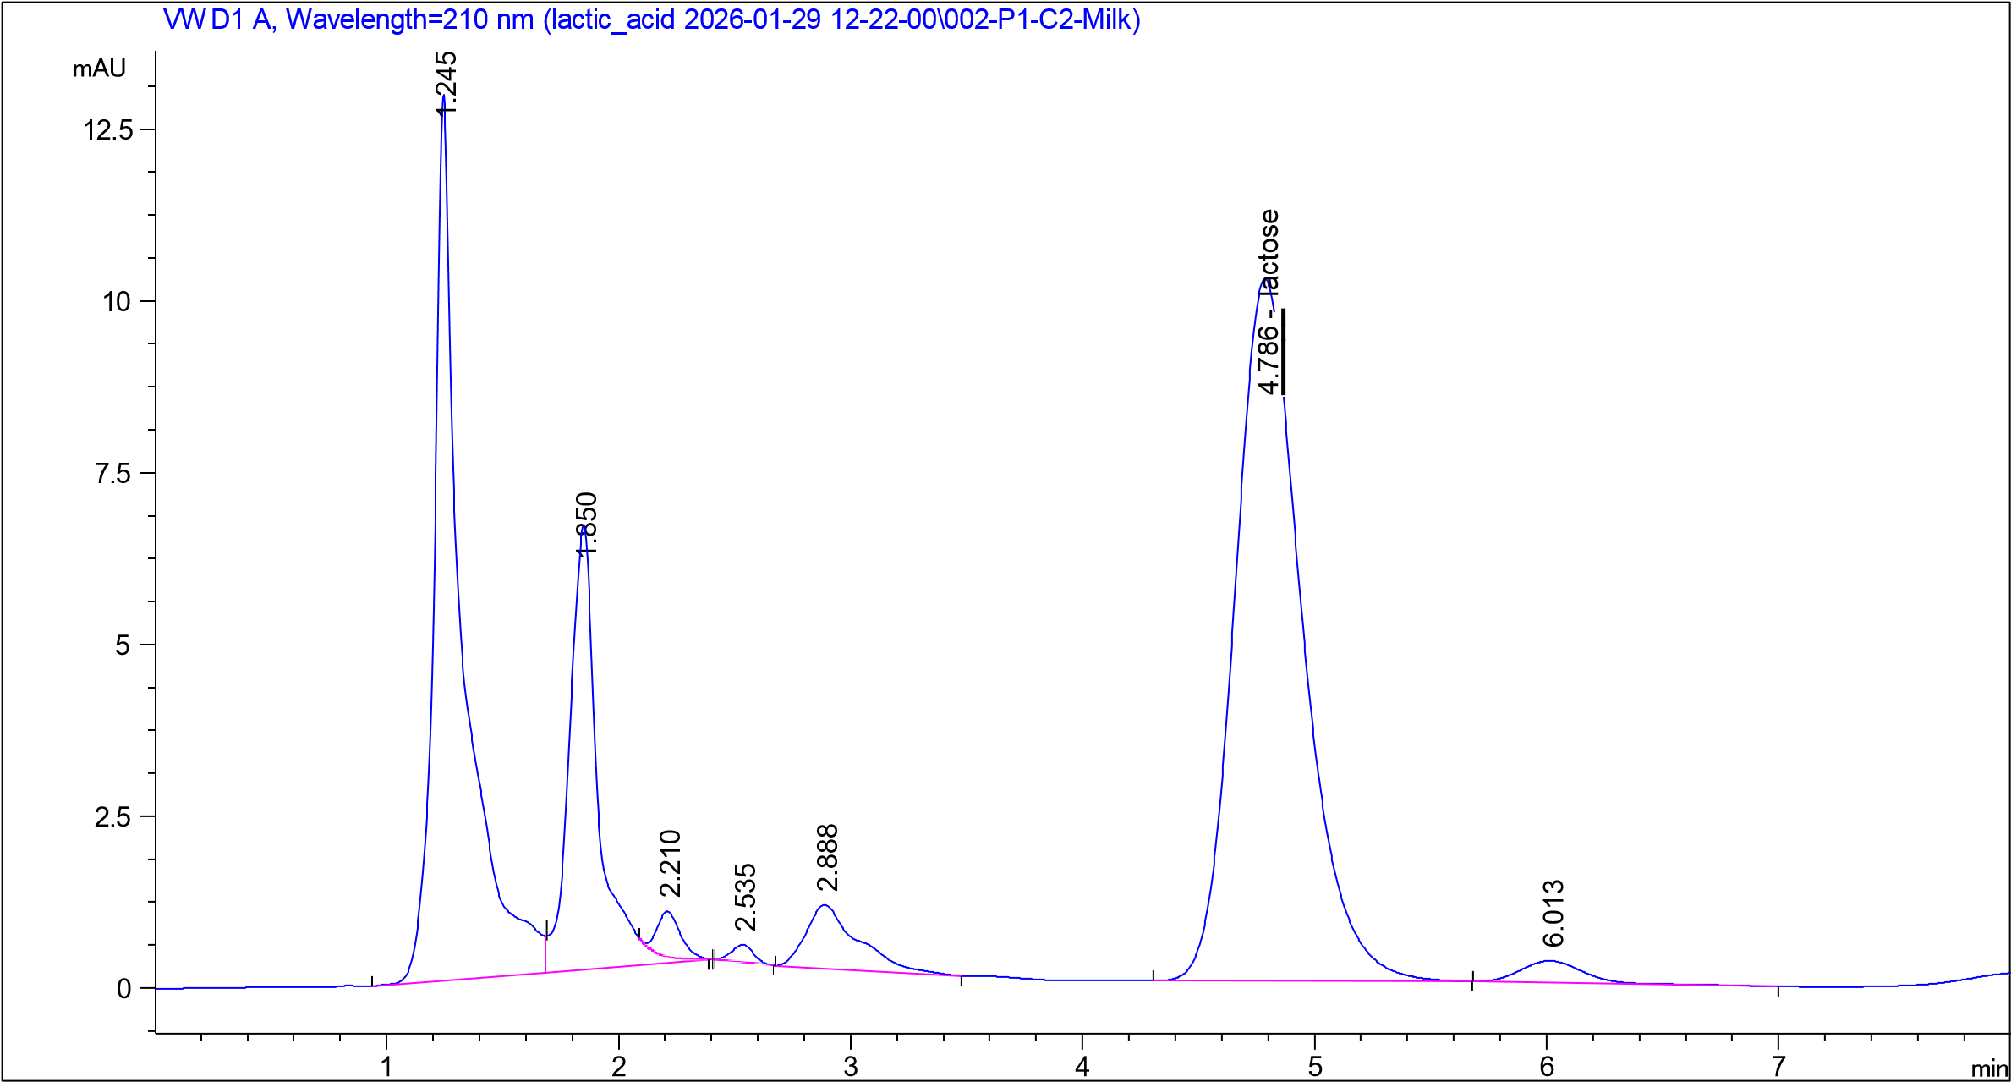
A well-defined peak corresponding to lactose was observed at a retention time of approximately 4.78 minutes. The quantitative analysis showed that the lactose content in the milk sample was 3.87%. In addition to the main lactose peak, several minor peaks were detected at earlier retention times. These peaks may correspond to low-molecular-weight compounds naturally present in milk, including organic acids and intermediate products. The clear separation and symmetry of the lactose peak indicate the reliability of the chromatographic method and confirm the suitability of the selected analytical conditions for the determination of carbohydrates in dairy systems.
Figure 2: HPLC chromatogram of lactose in raw milk
    - Lactose determination in kefir by HPLC
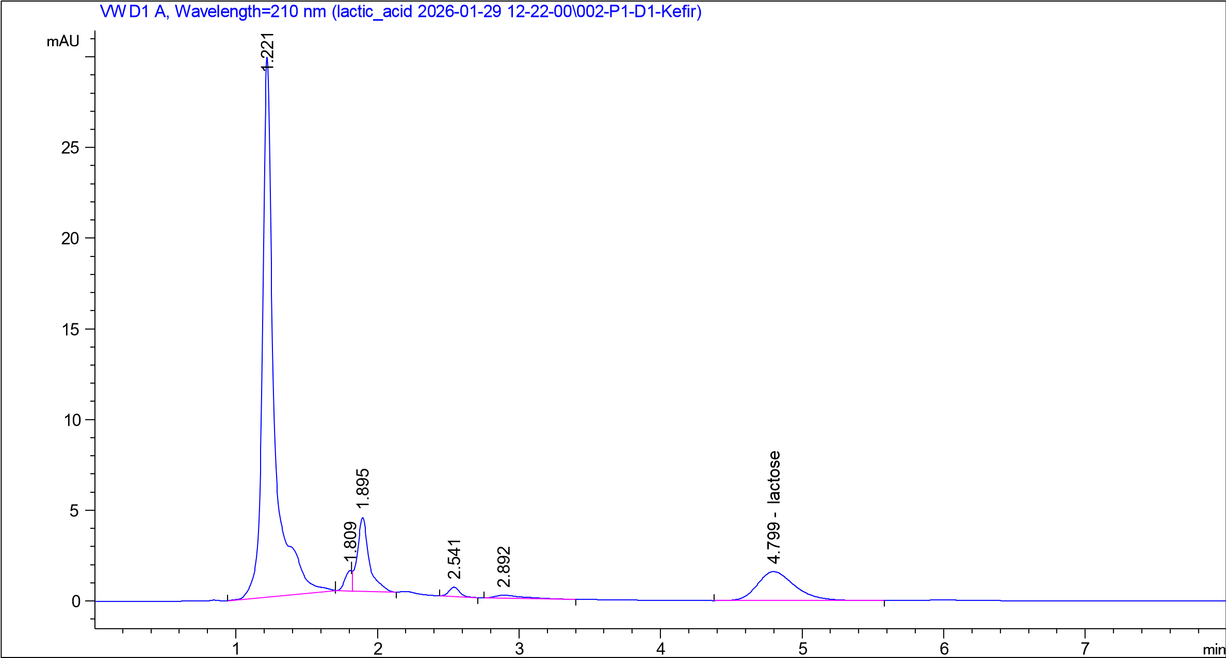
The chromatographic profile of the kefir sample is presented in Figure 3. The analysis was carried out using HPLC with ultraviolet (UV) detection at 210 nm under the same conditions as for the milk sample. A peak corresponding to lactose was observed at a retention time of approximately 4.79 min. However, the intensity of this peak was significantly lower compared to that observed in raw milk. This difference indicates a substantial reduction in lactose content during the fermentation process. The decrease in lactose concentration in kefir can be explained by the metabolic activity of microorganisms present in the starter culture. Lactic acid bacteria and yeast utilize lactose as a substrate, converting it into lactic acid and other fermentation products. As a result, the amount of residual lactose in the final product is reduced.In addition to the main lactose peak, several minor peaks were detected at earlier retention times. These peaks may correspond to low-molecular-weight compounds formed during fermentation, including organic acids and intermediate metabolites. A comparison of chromatographic profiles between milk and kefir clearly demonstrates the transformation of lactose during processing. While raw milk contains a high concentration of lactose, kefir shows a noticeable decrease, confirming the role of fermentation in carbohydrate conversion.The obtained results indicate that lactose is not completely eliminated but partially retained in kefir. This is an important consideration for the development of low-lactose dairy products, as traditional fermentation processes alone may not ensure complete lactose removal.
Figure 3: HPLC chromatogram of lactose in kefir, showing a reduced peak intensity compared to raw milk
    - Lactose determination in cottage cheese by HPLC
The chromatographic profile of the cottage cheese sample is presented in Figure 4. The analysis was performed under the same HPLC conditions as for milk and kefir samples, allowing direct comparison of lactose content across different dairy products.
A peak corresponding to lactose was observed at a retention time of approximately 4.81 min. However, the intensity of this peak was significantly lower compared to both raw milk and kefir samples. This result indicates a substantial reduction in lactose content during cottage cheese production. The decrease can be explained by the combined effect of fermentation and whey separation. In this study, fermentation was carried out using a commercial starter culture (Lactoferma), containing lactic acid bacteria such as Lactococcus lactis and Streptococcus thermophilus, which actively utilize lactose during the fermentation process
During coagulation, a significant portion of lactose is removed together with the whey, while the remaining lactose undergoes partial microbial conversion. Compared to kefir, where lactose reduction is mainly associated with microbial activity, cottage cheese production involves both biochemical and physical mechanisms, resulting in a more pronounced decrease in lactose content. In addition to the lactose peak, minor peaks were detected at earlier retention times, which may correspond to low-molecular-weight compounds and fermentation by-products. The results confirm that cottage cheese contains the lowest residual lactose among the studied samples.
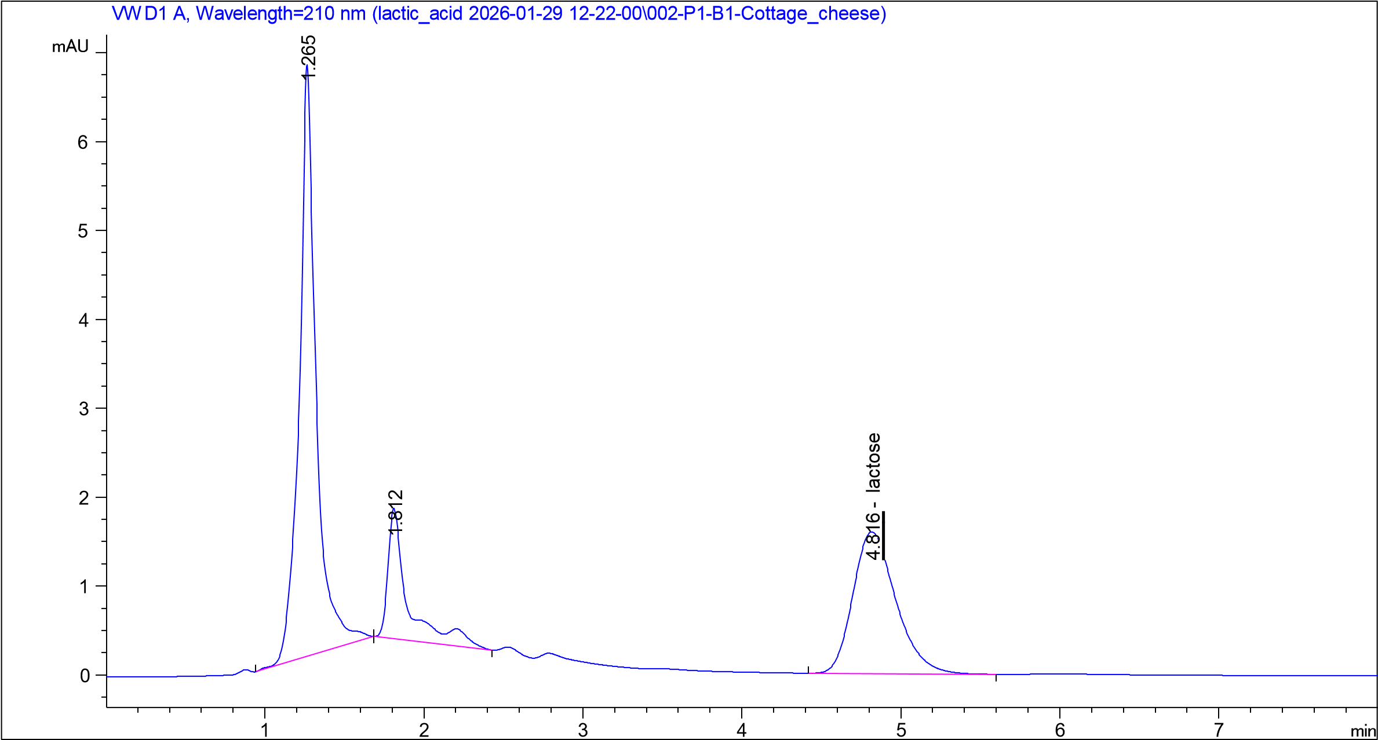
Figure 4: Chromatogram of lactose in cottage cheese, demonstrating the lowest peak intensity among the analysed dairy samples
  - Conclusion
The present study evaluated lactose transformation in dairy products using a validated HPLC method. Quantitative analysis demonstrated a progressive decrease in lactose content from 3.87% in raw milk to 1.03% in kefir and 0.76% in cottage cheese, confirming that dairy fermentation and subsequent curd production substantially reduce lactose concentration. The reduction is associated with microbial lactose metabolism during fermentation and with the partial removal of lactose in the whey during coagulation.
The developed HPLC method demonstrated excellent analytical performance, including high linearity (r = 0.9998-0.9999), recovery values of 99.7-100.1%, and satisfactory repeatability (RSD = 0.09-0.15%), confirming its suitability for reliable lactose determination in dairy products.
The proposed analytical approach provides a consistent tool for monitoring lactose changes during dairy processing and may support quality control as well as the development of dairy products with reduced lactose content for lactose-sensitive consumers.
References
Bartuzi M., Szamocka M., Ukleja-Sokółowska N., 2023, Social and economic difficulties of patients with food intolerances, Advances in Dermatology and Allergology, 40(2), 298–307.
De Oliveira Neves L.N., de Oliveira M.A.L., 2020, Quantification of lactose and lactulose in hydrolysed-lactose UHT milk using capillary zone electrophoresis, International Dairy Journal, 106, 104710.
Jakšić S.M., Popov N.S., Mihaljev Ž.A., Živkov Balo M.M., 2022, Determination of lactose by HPLC method, Journal of Agroalimentary Processes and Technologies.
López Ruiz Á.L., Ruiz Morales F.d.A., Ruiz Pérez-Cacho P., Galán-Soldevilla H., 2023, Effect of lactose reduction in Murciano-Granadina semi-hard goat cheese on physicochemical and sensory characteristics, Foods, 12, 996.
Mangan D., McCleary B.V., Culleton H., Cornaggia C., Ivory R., McKie V.A., Delaney E., Kargelis T., 2019, A novel enzymatic method for the measurement of lactose in lactose-free products, Journal of the Science of Food and Agriculture, 99, 947–956.
Monti L., Negri S., Meucci A., Stroppa A., Galli A., Contarini G., 2017, Lactose, galactose and glucose determination in naturally lactose-free hard cheese: HPAEC-PAD method validation, Food Chemistry, 220, 18–24.
Mygdalia A., Sfetsas T., Dimitropoulou G., Zioupou S., Mitsopoulos T., Lithoxopoulos P., Ioannou C., Katsantonis D., 2023, Recipe for brown rice milk-based vegan ice cream, Asian Food Science Journal, 22, 33–39.
Rao P.S., Singh P., Sharma V., Arora S., 2021, Traditional analytical approaches for lactose residues determination in lactose hydrolysed milks: A review, LWT – Food Science and Technology, 151, 112069.
Storhaug C.L., Fosse S.K., Fadnes L.T., 2017, Country, regional, and global estimates for lactose malabsorption in adults: A systematic review and meta-analysis, The Lancet Gastroenterology and Hepatology, 2(10), 738–746.
Suri S., Kumar V., Prasad R., Tanwar B., Goyal A., Kaur S., Gat Y., Kumar A., Kaur J., Singh D., 2019, Considerations for development of lactose-free food, Journal of Nutritional Intermediary Metabolism, 15, 27–34.

