 CHEMICAL ENGINEERING TRANSACTIONS  VOL. xxx, 2026 | A publication of  
The Italian Association
of Chemical Engineering
Online at www.cetjournal.it

Guest Editors: Flavio Manenti, Botir Usmonov, Alessandro Di Pretoro
Copyright © 2026, AIDIC Servizi S.r.l.
ISBN 979-12-81206-xx-x; ISSN 2283-9216

Synthesis and Corrosion Inhibition Performance of Zn–HEDP and Zn–ATMP-Based Compositions
Madinakhon A. Obidova*, Shoyunus B. Obidov, Khusniddin N. Rakhimov, Hayitjon J. Muxammadjonov, Fotima I. Xolmatova, Eldor E. Mashaev
Tashkent Institute of Chemical Technology, Department of Chemical Technology of Oil and Gas Processing, Tashkent, Uzbekistan
madinakxonobidova1995@gmail.com

The development of efficient and cost-effective corrosion inhibitors based on organophosphonate compounds remains important for water treatment and oilfield applications. This study investigates Zn–HEDP and Zn–ATMP complexes synthesized in glycerol under controlled conditions and characterized by FT-IR and GC-MS. FT-IR bands are consistent with P=O, P–O, C–N, and Zn–O groups. Corrosion tests on carbon steel (St.3) in mineralized water at 50 °C showed substantial inhibition at 4–10 mg/L, with the lowest corrosion rate in Table 1 observed for the 0.33:0.66 Zn–HEDP/Zn–ATMP ratio. Addition of KFS further reduced corrosion rates, indicating a synergistic effect. The results clarify composition–structure–performance relationships in multicomponent phosphonate inhibitor systems.
  - Introduction
Corrosion of carbon steel remains a significant technological and economic problem in water-treatment systems, cooling circuits, oilfield facilities, and other industrial environments where steel is exposed to aqueous electrolytes. The use of corrosion inhibitors is one of the most effective approaches to reducing metal deterioration and extending equipment service life. Depending on their chemical nature, inhibitors may act through adsorption, protective-film formation, modification of anodic and cathodic reactions, or a combination of these mechanisms. Recent research has increasingly focused on developing efficient inhibitors with improved environmental compatibility and applicability under industrial conditions (Ahmed et al., 2024). Among organic inhibitors, phosphonate compounds have attracted considerable attention because of their strong affinity for metal surfaces and their ability to interact with metal ions. In particular, 1-hydroxyethylidene-1,1-diphosphonic acid (HEDP) is widely used in water-treatment applications and has demonstrated significant corrosion-inhibition properties toward carbon steel. The effectiveness of HEDP-based systems depends on inhibitor concentration, solution composition, metal-ion availability, and formulation parameters. Awad (2005) demonstrated that the zinc-to-HEDP molar ratio strongly influences the effectiveness of zinc–HEDP systems for inhibiting carbon-steel corrosion in neutral solutions, emphasizing the importance of optimizing inhibitor composition rather than considering phosphonate concentration alone. The practical relevance of HEDP-based inhibitors has also been demonstrated under industrially relevant cooling-water conditions. Biedunkova et al. (2025) evaluated HEDP for corrosion inhibition of carbon steel in a power-plant cooling-water system and confirmed its potential for application in water-treatment environments. These findings demonstrate that the performance of phosphonate inhibitors should be evaluated not only in simplified laboratory solutions but also with consideration of the composition and operating conditions of real aqueous systems. Another important phosphonate compound is aminotris(methylenephosphonic acid) (ATMP), which contains several phosphonic acid groups capable of interacting with metal surfaces and dissolved species. Ivušić et al. (2020) investigated ATMP in combination with sodium gluconate for carbon-steel corrosion inhibition in 3.5% NaCl solution and demonstrated its applicability in saline environments. Labjar et al. (2010) likewise investigated the corrosion-inhibition performance of ATMP toward carbon steel and reported additional antibacterial properties. These studies indicate that aminophosphonate compounds can provide both corrosion-protection and potentially multifunctional properties in aqueous systems. The corrosion-inhibition behavior of other phosphonate structures has also been investigated. Nakayama (2000) reported inhibitory effects of nitrilotris(methylenephosphonic acid) (NTMP) on cathodic reactions of steel in saturated Ca(OH)₂ solutions. This finding is particularly relevant to understanding the electrochemical action of phosphonate inhibitors because it demonstrates that their influence may involve selective suppression of cathodic processes. Consequently, the chemical structure of the phosphonate and its interaction with the steel–solution interface are important factors determining inhibition performance. Multicomponent inhibitor formulations provide another approach for improving corrosion protection. The combination of different active compounds can modify adsorption, surface coverage, and protective-film formation and may provide complementary effects that are difficult to achieve with a single inhibitor. Rao et al. (2019) investigated the electrochemical behavior of carbon steel in solutions containing three-component inhibitor formulations and demonstrated the importance of interactions between formulation components at the steel–solution interface. In another study, Rao et al. (2022) investigated phosphonate-based inhibitor systems containing lactobionic acid and demonstrated their protective behavior toward carbon steel, further supporting the potential of combined inhibitor formulations. The interaction between zinc ions and HEDP is particularly important for the formation of protective surface films. Wang et al. (2021) investigated zinc-coordinated HEDP self-assembled films on steel using experimental and computational approaches and demonstrated the importance of Zn–HEDP interactions in surface-film formation. Similarly, Yan et al. (2019) studied HEDP–Zn complex thin films for corrosion protection of cold-rolled steel and demonstrated their potential to improve the corrosion resistance of the steel surface. These studies provide a basis for considering zinc–phosphonate coordination as an important mechanism in the development of protective corrosion-inhibiting systems. Despite the progress achieved with individual HEDP- and ATMP-based inhibitors, systems containing both Zn–HEDP and Zn–ATMP remain comparatively less studied. In particular, the influence of the HEDP/ATMP ratio, zinc coordination, inhibitor concentration, and auxiliary formulation components on corrosion performance requires further investigation. The simultaneous presence of two phosphonate ligands may modify the composition and properties of the protective layer and provide different interactions with the steel surface. However, such effects cannot be assumed from the behavior of individual phosphonates and therefore require experimental evaluation. Therefore, the aim of the present study was to synthesize and investigate Zn–HEDP and Zn–ATMP-based inhibitor compositions and evaluate their corrosion-inhibition performance toward carbon steel in mineralized water. Particular attention was given to the effect of the Zn–HEDP/Zn–ATMP ratio and inhibitor concentration on corrosion behavior, as well as to the influence of auxiliary formulation components. FT-IR spectroscopy was used to characterize the functional groups and provide evidence of phosphonate coordination, while GC-MS was applied as a supplementary method for evaluating volatile and semi-volatile components. The obtained results were used to establish relationships between inhibitor composition, structural characteristics, and corrosion-protection performance.
  - Materials and Methods
The study focused on synthesizing zinc–organophosphonate complexes and evaluating their corrosion-inhibition performance. All reagents were analytical grade and used without further purification. KFS (urea–formaldehyde resin) and COMEA (monoethanolamine vacuum-distillation residue) were used as formulation additives.
    - Materials
The main reagents included 1-hydroxyethylidene-1,1-diphosphonic acid (HEDP), nitrilotris(methylenephosphonic acid) (ATMP), zinc oxide (ZnO), sodium hydroxide (NaOH), and glycerol. Distilled water was used as the reaction medium. Carbon steel samples (grade St.3) were applied for corrosion testing in mineralized water.
    - Synthesis of Zn–HEDP and Zn–ATMP complexes
Zn–HEDP and Zn–ATMP complexes were synthesized in a thermostable stirred glass reactor. Distilled water and 1 g glycerol were mixed for 5 min, followed by two-thirds of the required HEDP and ATMP at 30–35 °C. ZnO was added gradually until dissolution, then NaOH was introduced while maintaining 20–25 °C. The remaining one-third of the phosphonates was added after stabilization. The solution was cooled, held for 60–80 min, and dried at 70–80 °C; the final yield was 98.2%.
    - Analytical methods
FT-IR and GC-MS were used as complementary analytical methods. GC-MS was performed on an Agilent 5973N system with a 30 m × 0.25 mm capillary column (5% phenyl methylsiloxane), injector at 280 °C, 1 µL injection, and the DRUGSHORT.M method. FT-IR spectra were recorded from 4000–400 cm⁻¹ in transmission mode; P=O, P–O, C–N, and Zn–O bands were evaluated. Because phosphonate complexes are poorly suited to direct GC analysis, GC-MS is interpreted here only as a supplementary screen of volatile/semi-volatile components, not as direct proof of the intact Zn–HEDP or Zn–ATMP complexes.
    - Corrosion inhibition testing
Corrosion inhibition was evaluated using St.3 carbon steel in Mingbulak mineralized water containing carbonate and sulfate ions at 50 °C. Inhibitor concentrations were 4–10 mg/L, with Zn–HEDP/Zn–ATMP molar ratios of 0.5:0.5, 0.33:0.66, 0.66:0.33, 0.75:0.25, and 0.25:0.75. KFS-containing formulations were also tested. Corrosion rates were determined relative to the blank under identical conditions.
  - Results and Discussion
The synthesized Zn–HEDP and Zn–ATMP complexes were evaluated for structural characteristics and corrosion inhibition performance. Spectroscopic and corrosion data reveal the relationship between composition, structure, and efficiency of the systems. The addition of COMEA did not improve inhibition performance, indicating its limited effectiveness under the studied conditions.
    - Structural characterization of synthesized complexes
The FT-IR spectra of Zn–HEDP and Zn–ATMP (Figure 1) show bands at 1250–1300 cm⁻¹ (P=O), 1180–1240 cm⁻¹ and 2500–2700 cm⁻¹ (P–O(H)/phosphonate vibrations), 1000–1046 cm⁻¹ (C–N), 650–750 cm⁻¹ (C–P), 550–570 cm⁻¹ (Zn–O), and 460–480 cm⁻¹ (O–P–O). These bands are consistent with coordination of phosphonate groups with Zn²⁺ while retaining the P=O functionality.
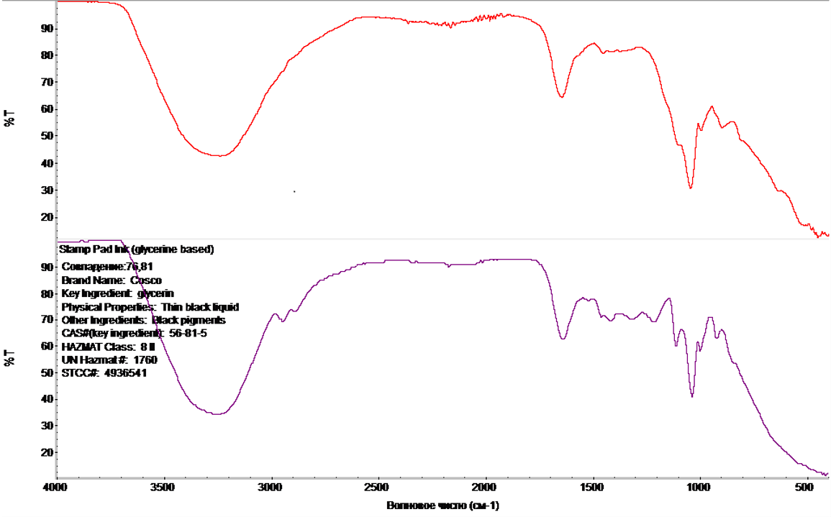
Figure 1: FT-IR spectrum of Zn–HEDP/Zn–ATMP complexes showing characteristic absorption bands
The observed FT-IR bands are consistent with Zn²⁺–phosphonate coordination and support formation of metal–ligand complexes. Such coordination can promote adsorption and protective-film formation on steel surfaces, as reported for Zn–HEDP systems (Wang et al., 2021).
    - Composition analysis by GC-MS
The GC-MS chromatogram (Figure 2) shows two dominant signals at approximately RT 1.27 and 1.61 min, together with minor signals. The available chromatogram does not provide compound names or library-match scores; therefore, definitive molecular assignments are not made here. The GC-MS result is used only as supplementary evidence for the presence of volatile/semi-volatile components and the absence of prominent additional signals.
The limited number of prominent signals is consistent with a relatively controlled formulation, but GC-MS alone cannot establish the purity or intact molecular structure of the non-volatile phosphonate complexes. Structural conclusions are therefore based primarily on FT-IR and the synthesis chemistry.
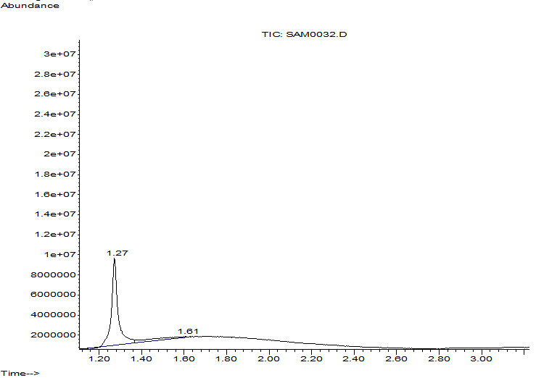
Figure 2: GC-MS chromatogram of synthesized Zn–HEDP/Zn–ATMP compositions
    - Corrosion inhibition performance
Organophosphonate inhibitors can provide effective corrosion protection but may require economical formulations with reduced phosphonate content. Here, Zn–HEDP/Zn–ATMP compositions and their KFS- and COMEA-containing variants were tested in Mingbulak formation water; the results are summarized in Tables 1–2 and Figures 3–6.
Table 1: Influence of Zn–HEDP/Zn–ATMP compositions on corrosion rate of carbon steel (St.3) at 50 °C
Ratio  Zn–HEDP/Zn–ATMP | Corrosion rate, mm/y  at reagent concentrations, mg/L
Ratio  Zn–HEDP/Zn–ATMP | 6 | 10
0.5:0.5 | 0.043±0.002 | 0.024±0.001
0.33:0.66 | 0.014±0.004 | 0.007±0.002
0.66:0.33 | 0.082±0.001 | 0.065±0.003
0.75:0.25 | 0.113±0.003 | 0.106±0.001
0.25:0.75 | 0.110±0.004 | 0.106±0.001

Corrosion performance depended strongly on the Zn–HEDP/Zn–ATMP ratio. In Table 1, the lowest corrosion rate was obtained at 0.33:0.66, reaching 0.007 mm/y at 10 mg/L. The data indicate that an appropriate balance between the two phosphonates favors protective-film formation, whereas less favorable ratios provide weaker protection. COMEA-containing formulations were then compared with the corresponding Zn–HEDP/Zn–ATMP systems.

30,0  40,0  50,0  60,0  70,0  80,0  90,0  100  Molar ratio of Zn-HEDP: Zn-ATMP  0.5:0.5  82  90  94  97  80  53  56  73  66  0.33:0.66  0.66:0.33  0.75:0.25  E, % | 30,0  40,0  50,0  60,0  70,0  80,0  90,0  100  IKSB-KB-1  80  82  45  49  73  66  IKSB-KB-2  COMEA  E, %  8 mg/L  10 mg/L  45
Figure 3: Effect of molar ratio on corrosion inhibition efficiency | Figure 4: Comparison of corrosion inhibition efficiency for different compositions

Figure 4 shows that COMEA did not improve protection under the tested conditions. Its addition was therefore not pursued as the main synergistic route. KFS-containing Zn–HEDP/Zn–ATMP formulations (IKSB-UNI-1 and IKSB-UNI-2) were subsequently evaluated.
Table 2: Effect of composition on corrosion rate of carbon steel (St.3)
Reagent | Corrosion rate, mm/y at reagent dose, mg/L
Reagent | 4 | 6 | 8 | 10
KFS | 0.163±0.002 | 0.137±0.002 | 0.134±0.004 | 0.134±0.002
Zn–HEDP + Zn–ATMP | 0.053±0.002 | 0.038±0.004 | 0.029±0.001 | 0.024±0.001
IKSB-UNI-1 | 0.048±0.003 | 0.031±0.002 | 0.019±0.002 | 0.007±0.002
IKSB-UNI-2 | 0.084±0.001 | 0.062±0.004 | 0.048±0.002 | 0.036±0.001

KFS markedly improved protection when combined with Zn–HEDP/Zn–ATMP. At 10 mg/L, IKSB-UNI-1 showed a corrosion rate of 0.007 mm/y, compared with 0.024 mm/y for Zn–HEDP + Zn–ATMP and 0.134 mm/y for KFS alone. This behavior is consistent with improved surface coverage and formation of a denser protective film by the combined phosphonate–polymeric system.
30,0
40,0
50,0
60,0
70,0
80,0
90,0
100
Inhibitor concentration, g/t
6,0
8,0
10,0
E, %
43
87
74
44
92
80
44
97
85
KFS
IKSB-UNI-1
IKSB-UNI-2

Figure 5: Dependence of the protective effect of inhibiting corrosion of steel St.3 on the concentration and type of reagent

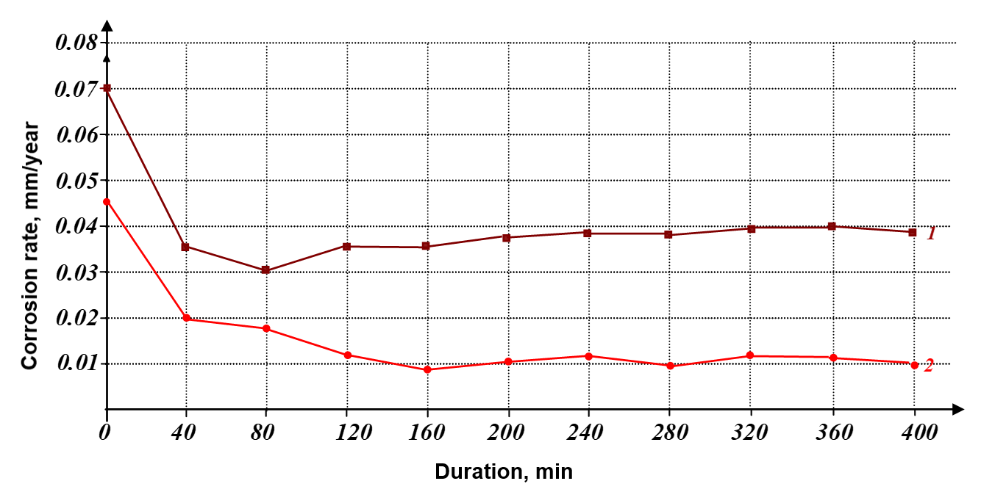
Figure 6: Change in corrosion rate during the experiment using the example of “IKSB-UNI-1”

Figure 6 shows a decrease in corrosion rate followed by stabilization within approximately 2–4 h, consistent with progressive protective-film formation. The second curve, representing the formulation with higher zinc content, shows weaker protection. These results indicate that composition and Zn/HEDP–ATMP balance strongly affect film formation and corrosion control. The data support a mixed inhibition mechanism involving suppression of anodic and cathodic processes, although direct electrochemical confirmation would require polarization or EIS measurements.
  - Conclusions
Zn–HEDP and Zn–ATMP complexes were successfully synthesized, and FT-IR data were consistent with Zn–phosphonate coordination. GC-MS provided supplementary information on volatile/semi-volatile components but was not used to assign the intact phosphonate complexes. Corrosion tests on St.3 steel in mineralized water at 50 °C showed strong dependence on composition; the lowest rate in Table 1 was 0.007 mm/y at 10 mg/L for the 0.33:0.66 Zn–HEDP/Zn–ATMP ratio. Addition of KFS further reduced corrosion, with IKSB-UNI-1 reaching 0.007 mm/y at 10 mg/L. The results support a protective-film mechanism involving Zn–phosphonate interactions and polymeric reinforcement. Further electrochemical and surface analyses are recommended to confirm the mixed-type mechanism and film composition.
References
Ahmed M.A., Amin S., Mohamed A.A., 2024, Current and emerging trends of inorganic, organic and eco-friendly corrosion inhibitors, RSC Advances, 14(43), 31877–31920, doi:10.1039/D4RA05662K.
Awad H.S., 2005, The effect of zinc-to-HEDP molar ratio on the effectiveness of zinc-1-hydroxyethylidene-1,1-diphosphonic acid in inhibiting corrosion of carbon steel in neutral solutions, Anti-Corrosion Methods and Materials, 52(1), 22–28, doi:10.1108/00035590510574880.
Biedunkova O., Kuznietsov P., Martynov S., Kucherova A., Hrytsyna O., 2025, Bench-Scale Performance Evaluation of Phosphonate (HEDP) for Corrosion Inhibition of Carbon Steel in a Power Plant Cooling Water System, Engineering Reports, 7(11), e70473, doi:10.1002/eng2.70473.
Ivušić F., Alar V., Otmačić Ćurković H., 2020, Aminotris(methylenephosphonic acid) and sodium gluconate as inhibitors of carbon steel corrosion in 3.5% NaCl solution, International Journal of Corrosion and Scale Inhibition, 9(4), 1390–1401, doi:10.17675/2305-6894-2020-9-4-12.
Labjar N., Lebrini M., Bentiss F., Chihib N.-E., Hajjaji S.E., Jama C., 2010, Corrosion inhibition of carbon steel and antibacterial properties of aminotris-(methylenephosphonic) acid, Materials Chemistry and Physics, 119(1–2), 330–336, doi:10.1016/j.matchemphys.2009.09.006.
Nakayama N., 2000, Inhibitory effects of nitrilotris(methylenephosphonic acid) on cathodic reactions of steels in saturated Ca(OH)2 solutions, Corrosion Science, 42(11), 1897–1920, doi:10.1016/S0010-938X(00)00034-2.
Rao S.S., Roopas Kiran S., Chaitanya Kumar K., Diwakar B.S., 2019, Electrochemical behaviour of interface of carbon steel/solution containing three-component formulations, Materials Today: Proceedings, 18(6), 2003–2011, doi:10.1016/j.matpr.2019.05.350.
Rao S.S., Chaitanya Kumar K., Roopas Kiran S., Diwakar B.S., 2022, Protective behaviour of two phosphonate-based inhibitor systems containing lactobionic acid in corrosion control of carbon steel, Materials Today: Proceedings, 49(3), 588–592, doi:10.1016/j.matpr.2021.04.509.
Wang D., Yang J., Xue F., Wang J., Hu W., 2021, Experimental and computational study of zinc coordinated 1-hydroxyethylidene-1,1-diphosphonic acid self-assembled film on steel surface, Colloids and Surfaces A: Physicochemical and Engineering Aspects, 612, 126009, doi:10.1016/j.colsurfa.2020.126009.
Yan R., Gao X., He W., Chen T., Ma H., 2019, 1-Hydroxyethylidene-1,1-diphosphonic acid (HEDP)-Zn complex thin films for the corrosion protection of cold-rolled steel (CRS), Corrosion Science, 157, 116–125, doi:10.1016/j.corsci.2019.05.033.

