 CHEMICAL ENGINEERING TRANSACTIONS  VOL. xxx, 2026 | A publication of  
The Italian Association
of Chemical Engineering
Online at www.cetjournal.it

Guest Editors: Flavio Manenti, Botir Usmonov, Alessandro Di Pretoro
Copyright © 2026, AIDIC Servizi S.r.l.
ISBN 979-12-81206-xx-x; ISSN 2283-9216

Modification of Local Bentonite with Gelatin and Physicochemical Properties of the Obtained Composite Films
Makhliyo F. Ganibekova*, Mukaddas T. Aliyeva
Tashkent State Technical University named after Islam Karimov, Tashkent, Uzbekistan
ganibekovamaxliyo0308@gmail.com
Biopolymer-clay composites are promising sustainable alternatives to petroleum-based polymers. In this study, gelatin films were combined with three types of local bentonite (PBG, PBMB and PPD) and cross-linked with glutaraldehyde (GA). Gelatin is biodegradable but limited by low water resistance, whereas bentonite offers a high surface area and cation exchange capacity. The aim of this work was to compare the influence of the three bentonites, which differ in their exchangeable cations, on the structure and water resistance of the cross-linked films. The films were characterised by Fourier transform infrared spectroscopy (FTIR) and scanning electron microscopy with energy-dispersive X-ray analysis (SEM-EDS), and their swelling in water was measured. The FTIR bands were consistent with the formation of Schiff base (C=N) linkages. SEM showed finer clay aggregates in the PPD-based film than in the PBMB-based film. The Ca-rich PPD bentonite gave the lowest equilibrium swelling (44.4 %), whereas the Na-rich PBG bentonite gave the fastest initial water uptake (150 % within 5 min). These differences suggest that the exchangeable cation composition of bentonite affects the water resistance of gelatin films. XRD, replicate swelling measurements and mechanical tests are needed to confirm the proposed interpretations.
Keywords: gelatin, bentonite, glutaraldehyde, composite films, cross-linking, swelling.
  - Introduction
The growing global demand for sustainable and environmentally friendly materials has driven significant research toward the development of biodegradable polymer systems derived from renewable resources. Conventional petroleum-based polymers, while offering excellent performance, pose serious environmental challenges due to their non-biodegradability and long-term ecological impact. In this regard, biopolymer-based composites have emerged as promising alternatives for various industrial applications (Othman, 2014). Among natural polymers, gelatin has gained considerable attention due to its biocompatibility, biodegradability, low cost and film-forming ability (Hosseini et al., 2013). However, its practical applications are limited by poor mechanical strength, high water sensitivity and low thermal stability (Kavoosi et al., 2013). To overcome these drawbacks, the incorporation of inorganic fillers such as clay minerals has proven to be an effective strategy (Zeng et al., 2005). Bentonite, a naturally occurring layered aluminosilicate, is widely used as a reinforcing agent due to its high specific surface area, cation exchange capacity and interlayer expandability (Utracki, 2004). When dispersed within a polymer matrix, bentonite can significantly enhance mechanical, thermal and barrier properties; however, achieving uniform dispersion and strong interfacial interactions between the polymer and clay remains a critical challenge (Pavlidou and Papaspyrides, 2008). Clay-based materials, including bentonite, have also attracted attention as additives in biopolymer films for water treatment, although additive aggregation and the toxicity of cross-linkers such as glutaraldehyde remain concerns (Le et al., 2025).
To further improve the structural integrity of gelatin-based composites, chemical cross-linking is often employed (Bigi et al., 2002). Glutaraldehyde (GA) is a widely used cross-linking agent that reacts with the amino groups of gelatin, forming Schiff base (C=N) linkages and resulting in a more stable three-dimensional network.
Bentonite-based sorbents modified with chitosan have previously been developed for the removal of dyes and metals from textile wastewater (Aliyeva et al., 2024) and of metal ions from industrial wastewater (Aliyeva et al., 2026). Despite extensive research, the combined effect of bentonite mineral composition and glutaraldehyde cross-linking on the structure-property relationships of gelatin-based composites has not been sufficiently explored. Therefore, this study aims to compare the influence of three different bentonite types and GA-induced cross-linking on the structural, chemical and functional properties of gelatin-based composite films.
  - Materials and methods
The materials used and the procedure for preparing the gelatin-bentonite composite films are described below.
    - Materials
Gelatin (pure animal gelatin purchased from a chemical reagent supplier) was used as the biodegradable polymer matrix. Three types of bentonite, denoted as PBG, PBMB and PPD, obtained from local deposits, were used as inorganic fillers. Before use, each bentonite was washed with water, filtered through filter paper and dried in a drying oven at 100–120 °C. Glutaraldehyde (GA, 50 % aqueous solution, analytical reagent grade, Macklin) was used as the cross-linking agent. A ready-for-use biphthalate buffer solution (Metrohm, pH = 4.00 ± 0.02 at 25 °C) was used to control the pH of the reaction medium. Distilled water was used for all solution preparations.
    - Preparation of gelatin-bentonite composite films
Gelatin (5 g) was dissolved in 100 mL of distilled water under heating at 50–60 °C until a homogeneous solution was obtained. Separately, 3 g of each bentonite (PBG, PBMB and PPD) was dispersed in 100 mL of distilled water and stirred on a magnetic stirrer for 2.5–3 h. The bentonite suspensions were then added to the gelatin solution (gelatin/bentonite mass ratio 5:3) under constant stirring, after which 2 mL of the GA solution was introduced as the cross-linking agent. The reaction was carried out in the presence of 10 mL of the buffer solution (pH = 4.00) to maintain a stable acidic environment. The resulting mixtures were cast into Petri dishes and dried at room temperature for 2–4 days to obtain solid films. Three composite samples were prepared according to the bentonite type used and labelled Sample 1 (PBMB), Sample 2 (PBG) and Sample 3 (PPD).
    - Characterisation
The FTIR spectra of gelatin, glutaraldehyde and the composite films were recorded with an FTIR spectrometer. The surface morphology and elemental composition of the films were examined by scanning electron microscopy with energy-dispersive X-ray spectroscopy (SEM-EDS). For the swelling tests, film samples were immersed in distilled water and weighed after 2, 5, 10 and 30 min, 1, 2 and 3 h, and after 24 h. The swelling degree was calculated from the mass gain of the swollen film relative to its dry mass. Each measurement was performed once on a single film sample; therefore, no statistical analysis was carried out.
  - Results and discussion
The FTIR, SEM-EDS and swelling results are presented first, followed by a short discussion of the expected mechanical behaviour.
    - FTIR spectroscopic analysis
In order to elucidate the chemical changes occurring during the formation of the composites, the FTIR spectra of pure gelatin (Figure 1a) and glutaraldehyde (Figure 1b) were first analysed as reference points. The pure gelatin spectrum exhibited characteristic Amide I and Amide II bands at approximately 1630–1650 cm⁻¹ and 1540 cm⁻¹, respectively, corresponding to carbonyl stretching and N-H bending vibrations. The broad absorption at 3300–3400 cm⁻¹ represents the stretching vibrations of the N-H and O-H groups.
a) 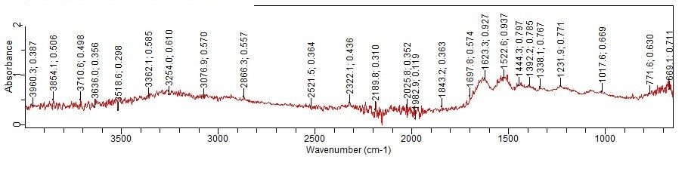 b) 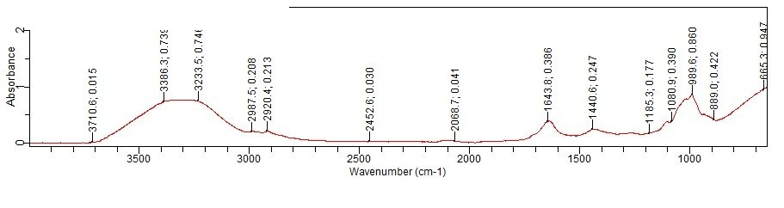
Figure 1: FTIR spectra of a) pure gelatin and b) pure glutaraldehyde, GA
The spectrum of glutaraldehyde showed a prominent carbonyl peak (C=O) and characteristic C-H stretching vibrations. Upon the addition of bentonite and GA-mediated cross-linking, significant changes were observed: the Amide I band shifted and overlapped with the newly formed Schiff base (C=N) vibration, typically appearing around 1648–1651 cm⁻¹ in the PBMB and PPD samples and at 1595 cm⁻¹ in the PBG sample (Table 1). These changes are consistent with a chemical interaction between the organic and inorganic components of the composite.
FTIR spectroscopy was used to investigate the chemical interactions between the gelatin matrix, glutaraldehyde (GA) and the different types of bentonite (PBG, PBMB and PPD). The FTIR spectra of the cross-linked composites are shown in Figures 2a-2c.
a) 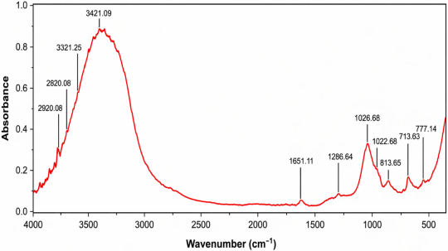 b) 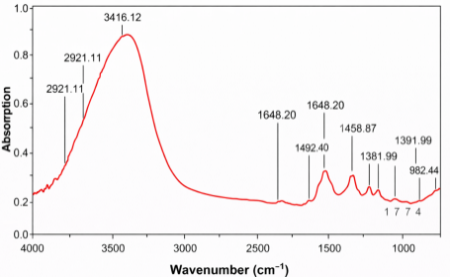 c) 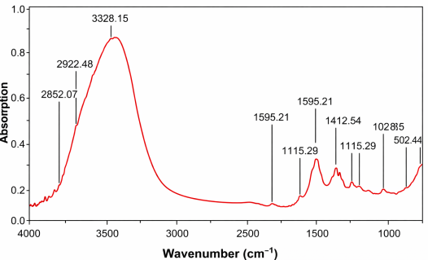
Figure 2: FTIR spectra of the PBMB-, PPD- and PBG-based gelatin composite films
The cross-linking of gelatin by glutaraldehyde is supported by the characteristic absorption bands in all samples. The broad band in the range 3300–3450 cm⁻¹ corresponds to overlapping O-H and N-H stretching vibrations, which is consistent with a hydrogen-bonded network between the gelatin chains and the clay surfaces. The peak observed at 1648–1651 cm⁻¹ in the PBMB and PPD samples (Amide I) is particularly significant: in the cross-linked samples, this peak may represent not only the carbonyl (C=O) vibration but also C=N linkages resulting from the reaction between the ε-amino groups of gelatin and the aldehyde groups of GA. This interaction is expected to contribute to the structural stability and water resistance of the composites. Differences between the three bentonite types were reflected in the spectra, as summarised in Table 1.
The PBMB-based sample exhibited a sharp and intense peak at 1026 cm⁻¹, characteristic of the Si-O-Si stretching vibrations of bentonite, together with several peaks in the lower frequency region (813, 777 and 713 cm⁻¹). In the PPD-based sample, the primary silicate vibration was observed at 982 cm⁻¹, and in the PBG-based sample the Si-O stretching region showed a doublet at 1115 and 1028 cm⁻¹. The peaks in the range 2850–2930 cm⁻¹ correspond to the symmetric and asymmetric stretching of the C-H groups (CH₂ and CH₃) of the aliphatic chains of gelatin and GA; in the PBG sample these peaks were sharper.
Table 1: FTIR band positions of pure gelatin, glutaraldehyde and the gelatin-bentonite composites
Sample | O-H / N-H (cm⁻¹) | Amide I / C=N (cm⁻¹) | Si-O clay (cm⁻¹)
Pure gelatin | 3362 | 1635 | –
Glutaraldehyde | 3386 | 1720 | –
Sample 1 (PBMB) | 3421 | 1651 | 1026
Sample 2 (PBG) | 3328 | 1595 | 1115
Sample 3 (PPD) | 3416 | 1648 | 982
The data in Table 1 show that the Si-O band shifts from 1026 cm⁻¹ (PBMB) to 982 cm⁻¹ (PPD) and appears as a doublet at 1115 and 1028 cm⁻¹ in the PBG sample. Such shifts indicate that the environment of the silicate layers differs among the samples, which may be related to different degrees of interaction between the clay and the gelatin matrix (Wang et al., 2005). However, FTIR alone cannot distinguish intercalated from exfoliated structures, and XRD measurements are needed to confirm this. The Amide I / C=N band at 1648–1651 cm⁻¹ in the PBMB and PPD samples, and its shift to 1595 cm⁻¹ in the PBG sample, is consistent with GA-mediated cross-linking in the presence of bentonite. The lower O-H / N-H stretching wavenumber of the PBG sample (3328 cm⁻¹) than that of the PBMB sample (3421 cm⁻¹) may indicate stronger hydrogen bonding, possibly related to the different cation composition of the clay. Overall, the spectra suggest that both the cross-linking and the bentonite type affect the structure of the films.
    - Scanning electron microscopy (SEM) and energy-dispersive X-ray (EDS) analysis
The surface morphology and elemental composition of the gelatin-based composites containing the different bentonites (PPD, PBMB and PBG) were investigated by SEM-EDS.
The SEM micrographs of the PPD-based sample (Figures 3a and 3b) show relatively fine clay aggregates distributed in the cross-linked gelatin matrix; at higher magnification the particles show a layered morphology. The EDS analysis (Figures 3c and 3d) shows a high content of calcium (5.31 at. %) and magnesium (1.47 at. %), which identifies the PPD bentonite as a Ca-Mg type, together with silicon (18.50 at. %) and aluminium (3.67 at. %). The dense appearance of the matrix may be related to the formation of a network through glutaraldehyde-mediated Schiff base linkages, although SEM alone cannot confirm this.
The PBMB-based sample (Figures 4a and 4b), in contrast, exhibits larger, block-like mineral aggregates. At lower magnification these clusters appear as distinct islands ranging from 100 to 500 μm, and high-resolution images show visible boundaries between the PBMB particles and the gelatin matrix. The EDS profile (Figures 4c and 4d) shows a mixed cation composition with sodium (2.75 at. %), potassium (1.91 at. %) and a lower calcium content (1.48 at. %). The larger aggregates indicate a poorer dispersion of PBMB than of PPD in the film; this may be linked to the layer charge and crystalline nature of the clay, but the present data do not allow this to be established.
The PBG-based sample (Figures 5a and 5b) shows a porous morphology with discrete, rhomboid particles that have a rough, granular surface. The EDS analysis (Figures 5c and 5d) shows a high content of sodium (6.24 at. %) and potassium (3.63 at. %), which identifies the PBG bentonite as a Na-K type. Sodium bentonites generally swell more strongly in water than calcium bentonites, which may influence the dispersion and the interaction with gelatin, but this cannot be concluded from the SEM-EDS data alone.
The comparison of the three bentonites shows that they differ in their exchangeable cations (Ca²⁺, Na⁺, K⁺) and in the size and morphology of their aggregates in the gelatin films. The PPD-based film contained the finest aggregates, the PBMB-based film the largest block-like aggregates, and the PBG-based film porous, rhomboid particles. It is proposed that divalent Ca²⁺ ions may act as bridges between the clay layers and the carboxyl groups of gelatin, whereas the larger PBMB aggregates may act as rigid micro-fillers; these mechanisms are hypotheses and were not verified experimentally. The bentonite type appears to be an important factor for tailoring the properties of biodegradable films for packaging applications (Zubair and Ullah, 2020).
a) 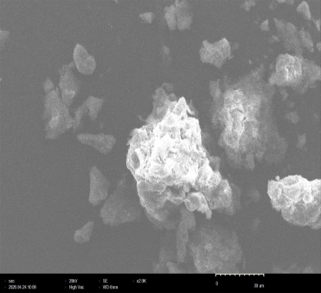 b) 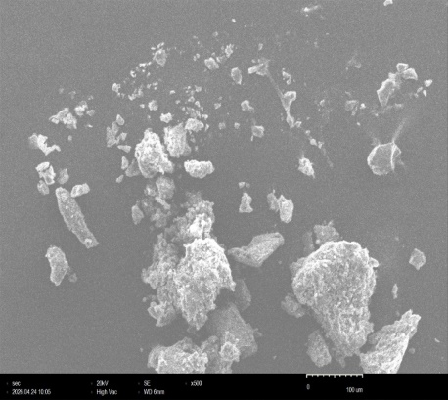
c) 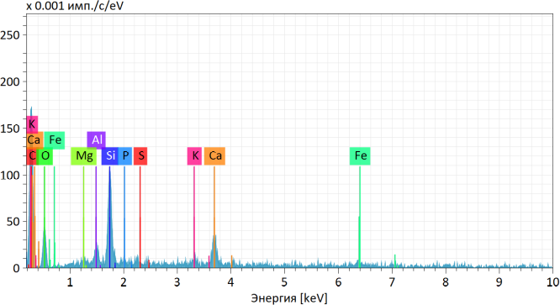 d) 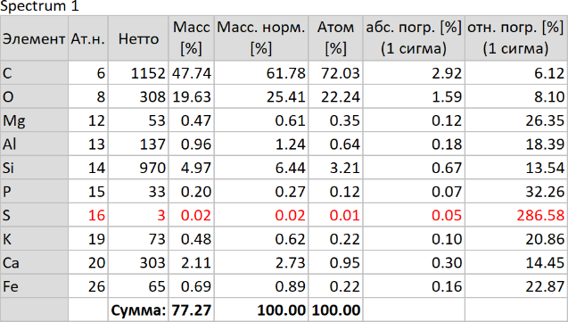
Figure 3: a,b) SEM micrographs and c,d) EDS spectrum and elemental composition of the PPD-based sample
a) 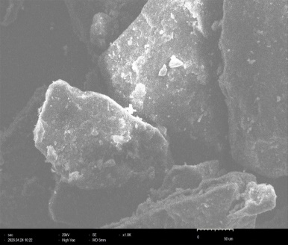 b) 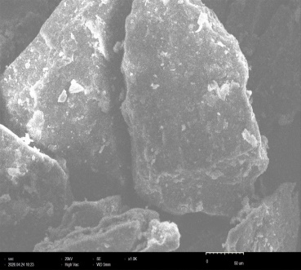
c) 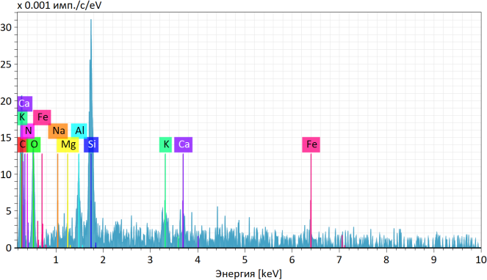 d) 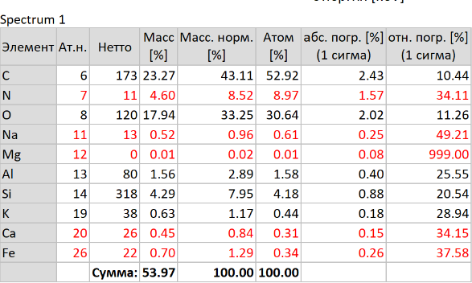
Figure 4: a,b) SEM micrographs and c,d) EDS spectrum and elemental composition of the PBMB-based sample
a) 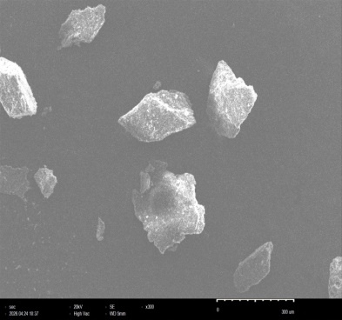 b) 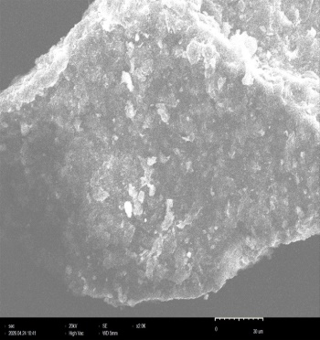
c) 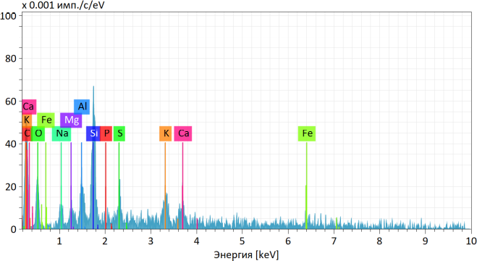 d) 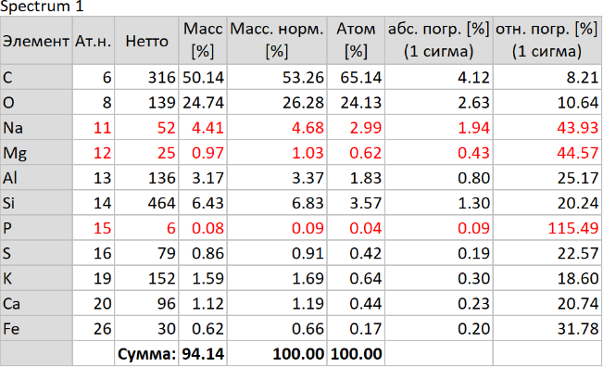
Figure 5: a,b) SEM micrographs and c,d) EDS spectrum and elemental composition of the PBG-based sample
    - Swelling behaviour and structural stability
The water absorption capacity of the composites was evaluated by measuring the swelling degree after 24 h of immersion. The swelling degree depended on the bentonite type: the PBMB-based film showed the highest swelling degree (133.3 %), the PBG-based film a moderate swelling of 75.0 %, and the PPD-based film the lowest swelling degree (44.4 %). The lower swelling of the PPD-based film may be related to its high calcium content, since divalent cations can form ionic bridges between the carboxyl groups of gelatin and the silicate layers, and to the finer clay aggregates observed by SEM. The higher swelling of the PBMB-based film may be related to the larger gaps between the block-like aggregates and the matrix. These explanations are proposed on the basis of the SEM-EDS observations and were not tested directly.
The kinetics of water absorption were followed from 2 min to 3 h. The PBG-based film showed the most rapid hydration, reaching 150 % swelling within the first 5 min, which may be related to its high sodium content and porous structure facilitating water diffusion. The PBMB-based film showed a more gradual increase in water uptake, from 50 % to 100 % over 2 h. The PPD-based film showed the slowest hydration, with swelling values ranging from only 25 % to 45 %. The films did not dissolve during the tests but swelled slightly and turned whitish. Each measurement was performed once, so the values are indicative and some data points deviate from a smooth trend; for the PBG-based film, the swelling at 5 min (150 %) exceeded the value after 24 h (75.0 %). Replicate measurements are needed to confirm these trends. These results indicate that, among the three bentonites studied, PPD gives the films with the highest water resistance.
    - Expected mechanical behaviour
No mechanical tests were performed in this work, and the following statements are hypotheses based on the microstructure. The compact matrix and possible Ca²⁺ bridging in the PPD-based film may increase its stiffness (Podsiadlo et al., 2007), whereas the large PBMB aggregates may act as rigid fillers but also as stress concentrators (Rhim, 2011). The PBG-based film may show intermediate behaviour because of its porous, granular morphology. Tensile tests are needed to check these hypotheses.
  - Conclusions
Gelatin films containing three types of local bentonite (PBG, PBMB and PPD) and cross-linked with glutaraldehyde were prepared and characterised. The FTIR bands were consistent with the formation of Schiff base (C=N) linkages, and the position of the Si-O band (982–1115 cm⁻¹) differed among the bentonites. SEM showed the finest clay aggregates in the PPD-based film and large block-like aggregates in the PBMB-based film, and EDS identified PPD as a Ca-Mg, PBMB as a mixed Na-K-Ca and PBG as a Na-K bentonite. The PPD-based film showed the lowest equilibrium swelling (44.4 %) and the slowest hydration, the PBG-based film hydrated fastest (150 % within 5 min), and the PBMB-based film reached the highest equilibrium swelling (133.3 %). The results suggest that the exchangeable cation composition of bentonite influences the water resistance of gelatin-based films. XRD analysis, replicate swelling measurements and mechanical tests are needed to confirm the proposed interactions and to assess the mechanical behaviour.
References
Aliyeva M.T., Ikhtiyarova G.A., Xolturayeva N.R., Shomurodov D.Q., Geldiyev O.A., 2024, Obtaining an organosorbent based on Apis Mellifera chitosan and bentonite and using it in cleaning textile wastewater from dyes and metals, E3S Web of Conferences, 608, 03051.
Aliyeva M.T., Ganibekova M.F., Negmatova M., Gulboyeva D., Geldiyev O.A., Tursunov Sh., 2026, Removal of metal ions from industrial wastewater with bentonite modified chitosan Apis Mellifera, Advanced Materials for Optics and Photonics: Chemistry and Engineering Perspectives (AMOP 2026), Proceedings of SPIE, 14190, 141902I-1, DOI: 10.1117/12.3116172.
Bigi A., Cojazzi G., Panzavolta S., Roveri N., Rubini K., 2002, Stabilization of gelatin films by crosslinking with genipin, Biomaterials, 23(24), 4827–4832.
Hosseini S.F., Rezaei M., Zandi M., Ghavi F.F., 2013, Preparation and functional properties of fish gelatin-chitosan blend edible films, Food Chemistry, 136(3–4), 1490–1495.
Kavoosi G., Dadfar S.M.M., Purfard A.M., 2013, Mechanical, physical, antioxidant, and antimicrobial properties of gelatin films incorporated with thymol as affected by hydrophobicity and amino acid composition, Journal of Food Science, 78(4), E567-E574.
Le A.K., Nguyen H.T.A., Tran V.T., Do N.H.N., Chu T.Q., Le P.T.K., 2025, From fabrication to application: Electrospun chitosan/PVA nanofiber films for water and wastewater treatment, Chemical Engineering Transactions, 122, 379–384, DOI: 10.3303/CET25122064.
Othman S.H., 2014, Bio-nanocomposite materials for food packaging applications: Trends and challenges, Polymers and Polymer Composites, 22(2), 113–116.
Pavlidou S., Papaspyrides C.D., 2008, A review on polymer-layered silicate nanocomposites, Progress in Polymer Science, 33(12), 1119–1198.
Podsiadlo P., Kaushik A.K., Arruda E.M., Waas A.M., Shim B.S., Xu J., Nandivada H., Pumplin B.G., Lahann J., Ramamoorthy A., Kotov N.A., 2007, Ultrastrong and stiff layered polymer nanocomposites, Science, 318(5847), 80–83.
Rhim J.W., 2011, Effect of clay contents on mechanical and water vapor barrier properties of agar-based nanocomposite films, Carbohydrate Polymers, 86(2), 691–699.
Utracki L.A., 2004, Clay-containing polymeric nanocomposites, Rapra Technology Limited, Shawbury, UK.
Wang S.F., Shen L., Tong Y.J., Chen Z.L., Phang I.Y., Lim P.Q., Liu T.X., 2005, Biopolymer chitosan/montmorillonite nanocomposites: Preparation and characterization, Polymer Degradation and Stability, 90(1), 123–131.
Zeng Q.H., Yu A.B., Lu G.Q., Paul D.R., 2005, Clay-based polymer nanocomposites: Research and commercial development, Journal of Nanoscience and Nanotechnology, 5(10), 1574–1592.
Zubair M., Ullah A., 2020, Recent advances in protein-based bionanocomposites for food packaging applications, Critical Reviews in Food Science and Nutrition, 60(3), 406–434.

