 CHEMICAL ENGINEERING TRANSACTIONS  VOL. xxx, 2026 | A publication of  
The Italian Association
of Chemical Engineering
Online at www.cetjournal.it

Guest Editors: Flavio Manenti, Botir Usmonov, Alessandro Di Pretoro
Copyright © 2026, AIDIC Servizi S.r.l.
ISBN 979-12-81206-xx-x; ISSN 2283-9216

Optimization and Modernization of Vertical Roller Mill Grinding Processes for Portland Cement Production
Mirjalol Sh. Mosidikovª, Zebo A. Babakhanova^{a,c}*, Tonny A. Kurniawan^{b}, Djanon I. Alimdjanovaª, Khayrulla L. Pulatovª, Bobiromon B. Qodirovª
ªTashkent Institute of Chemical Technology, Tashkent, Uzbekistan
^{b}Xiamen University, Xiamen, Fujian, China
^{c}Integral University, Lucknow, India
zebo.babakhanova@gmail.com
This study investigates the crushing zone of a vertical roller mill (VRM) used for grinding processes in a Portland cement production line. Due to particle-size imbalance, raw materials of different fractions are supplied to the mill, contributing to unstable grinding-bed conditions and elevated vibration. Field measurements showed vibration levels of approximately 1.2–1.8 mm/s, i.e. 20–80% above the manufacturer’s recommended limit of 1.0 mm/s. Localized roller-surface defects of approximately 130 × 120 × 150 mm were identified, while the mill drive current under normal operation was approximately 140 A. Based on structural analysis, field inspection, and three-dimensional numerical modelling (ANSYS and Mathcad), roller-surface restoration using EN ISO EC308Mo welding wire was assessed. An 85 mm maximum nominal feed size and a ‘2+2’ auxiliary-roller arrangement are discussed as measures for improving grinding-bed stability. The conducted research suggests that modernization of vertical roller mill grinding processes could enhance energy efficiency, operational reliability, and environmental sustainability; however, further experimental investigations are required to quantitatively confirm these potential benefits.
  - Introduction
The demand for construction materials in Uzbekistan has increased significantly over the past decade, supported by rapid growth in construction activity, urbanization, infrastructure development, and investment in the building sector. According to Uzbekistan’s Construction Materials Industry Association, the sector’s production volume reached 52.6 trillion UZS in 2025, compared with 22 trillion UZS in 2021, more than doubling in four years. In 2025, the industry produced approximately 21.5 million tons of cement, 40 million m² of construction glass, 47 million m² of ceramic tiles, 110 million m² of gypsum board, and 336 thousand tons of dry construction mixtures (Uzsanoatqurilishmateriallari, 2025).
The Tashkent Region of Uzbekistan is home to a number of well-established enterprises specializing in the production of gypsum, cement, reinforced concrete products, mineral wool, and the processing of natural stone. Among these enterprises, Ahangaronsement JSC is one of Uzbekistan’s major cement producers, with wet- and dry-process production capacities of 2.18 and 3 million tons per year, respectively. The dry-process plant is equipped with modern grinding technology. The grinding mill, used for raw material and clinker processing in dry-process plant, is the focus of this study due to its complex operation and the technological and environmental challenges associated with its performance.
A substantial body of technical literature addresses modern grinding technologies aimed at reducing energy consumption and material losses during rock and raw-material processing. Ravipati et al. (2019) demonstrated the use of process simulation and pinch analysis to quantify energy-saving opportunities in cement production, illustrating the importance of measurable energy targets. More recently, Chew et al. (2024) formulated an optimization model for cement-plant to provide intensification of decarbonization processes.
Various grinding systems are employed in cement industry, including ball mills, roller mills, vertical roller mills (VRMs), and horizontal roller mills (HRMs). Vertical roller mills are widely used for grinding relatively soft and medium-hard raw materials such as limestone, clay, and coal. Their advantages include relatively low energy consumption, compact design, and the ability to process materials with varying moisture content. Improvements in roller configuration and the use of high-strength construction materials can further increase energy efficiency up to 30% (Alsop P. et.al., 2007). Although ball mills remain widely used, roller-based technologies offer significant potential for improving energy efficiency in cement production.
  - Materials and Methods
    - Research object
The aim of this study is to improve the operational reliability and service life of a vertical roller mill (VRM) used for grinding cement raw materials and clinker in a dry-process cement plant. Particular attention is given to the degradation of the mill’s metallic housing, including corrosion and crack formation, which can adversely affect structural integrity and operational performance.
The practical significance of the research is associated with the high mechanical loads, complex operating conditions, and maintenance requirements of VRMs. The investigated equipment is a vertical roller mill installed at a cement production facility in 2019, which was selected as the research object for assessing structural degradation and developing methods for its restoration and protection.
    - Materials and Grinding Processes
Vertical roller mills (VRMs) generally offer lower specific energy consumption than conventional grinding systems; however, their performance is highly dependent on the physical characteristics of the feed material, particularly particle-size distribution and moisture content. They also require more sophisticated maintenance, while the relatively high cost of grinding rollers is offset by their high throughput and operational efficiency. One of the principal limitations of VRM operation is the intensive wear of friction and grinding components, which can reduce equipment availability and service life. Therefore, this study focuses on developing technical measures to improve the stress–strain state, structural integrity, and service life of the mill components.
During operation, the VRM reaches its thermal operating regime within approximately 4–8 h. Hot air is introduced into the grinding chamber at temperatures of approximately 110–220 °C and exits at about 85–90 °C. The heated air simultaneously provides the thermal energy required for moisture evaporation and transports the fine ground material upward through the mill. The grinding rollers are positioned approximately 100 mm above the grinding table surface.
The VRM performs grinding, mixing, and drying of the raw material simultaneously. The cement raw meal investigated in this study consists primarily of limestone, clay, iron-bearing rock, and kaolin. The feed material has a bulk density of approximately 1.39 t/m³. The maximum nominal feed size is 85 mm, with oversize particles up to 150 mm constituting no more than 10 % of the feed. The normal particle-size fraction is 0–21 mm, while particles exceeding 105 mm account for no more than 5 %. The mill has a nominal throughput of 500 t/h, with a product fineness of ≤12% residue on a 0.09-mm sieve (R0.09) and a feed moisture content of ≤1%.
These operating and material parameters define the principal boundary conditions for evaluating the mechanical loading, wear behavior, and structural performance of the VRM during grinding operation.
    - Numerical Modeling and Experimental Characterization
Three-dimensional component geometries were prepared in AutoCAD and transferred to ANSYS for finite-element assessment of the roller, bushing and bearing-contact regions. The analysis was intended to identify stress-concentration zones associated with the observed surface defect and to support the restoration geometry. The model domain therefore focused on the mechanically critical roller-support assembly rather than on the complete mill. The field-observed roller mass (approximately 27 t), the measured defect geometry (approximately 130 × 120 × 150 mm), and the operating thermal envelope associated with the hot-gas stream (approximately 110–220 °C at the inlet and 85–90 °C at the outlet) were used as engineering boundary information for interpreting the structural response.
The experimentally observed damage provides the principal validation evidence available in the present study: the largest documented localized roller defect was approximately 130 × 120 × 150 mm, and elevated mill vibration of 1.2–1.8 mm/s was measured against a recommended limit of 1.0 mm/s. These observations identify the roller surface/contact region and associated support components as critical locations for future coupled thermo-mechanical modelling.
The chemical composition of the raw material entering the mill was monitored using an online analyzer installed at the cement plant. Feed particle size was determined by sieve analysis. The maximum nominal feed size was approximately 85 mm, consistent with the mill operating specification. In addition, oversize particles up to 150 mm constituted no more than 10% of the feed, while particles exceeding 105 mm accounted for no more than 5%. Based on the inspection and measurement results, maintenance procedures were developed, including repair of worn rollers and application of protective surface coatings to improve resistance to corrosion and mechanical wear.
The electrical load of the mill drive motor was measured using a Fluke 381 remote current measurement device. Under normal operating conditions, the motor current was approximately 140 A. These measurements were used to characterize the operational load of the mill and to assess changes in its operating condition.
  - Results and Discussion
    - Operating Principle and Structural Characteristics of the Vertical Roller Mill
The operating performance and energy efficiency of a vertical roller mill (VRM) depend on the coordinated operation of its principal mechanical and auxiliary systems. The main components include the grinding rollers and table, hydraulic loading system, material separator, drive unit and transmission system, and associated material-feeding and classification units (Figure 1).

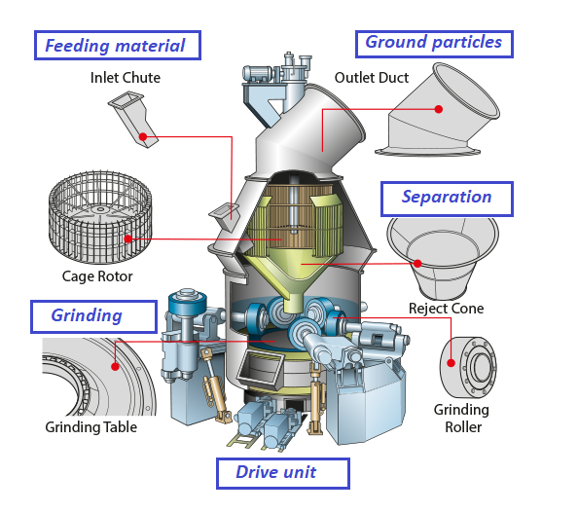
Figure 1. Structural units of VRM. Source: Compiled by the authors.

The hydraulic system provides controlled loading of the grinding rollers against the grinding table and contributes to maintaining a stable grinding bed during operation. Stable grinding-bed conditions are essential for achieving consistent grinding performance and minimizing excessive mechanical loading and wear of the grinding components. Failure or excessive wear of the rollers can result in substantial maintenance costs, extended downtime, and reduced production capacity. Therefore, maintaining the mechanical integrity of the grinding rollers is an important factor in ensuring the reliability of VRM operation.
The separator performs the classification of ground particles according to their aerodynamic and size characteristics.
The grinding assembly consists primarily of the rollers and rotating grinding table. The geometric parameters of the rollers are selected according to the characteristics of the feed material, including its particle-size distribution, hardness, and bulk density. In the present study, the feed particle-size characteristics were considered when evaluating the appropriate roller geometry and operating clearance. Recent industrial-scale studies further emphasize that VRM performance depends on interacting operating variables rather than on a single design parameter. Fatahi et al. (2022a) modelled energy-consumption factors for an industrial cement VRM using explainable machine learning, while Fatahi et al. (2022b) developed and validated a breakage-based model for industrial VRM grinding. Barani et al. (2022) showed that residence-time and active grinding-zone behaviour can be quantified experimentally and through process models. These studies support the need to combine field measurements with transparent model validation when proposing VRM optimization measures.
The drive unit and transmission system represents another critical subsystem of the VRM. Its mechanical characteristics determine the rotational speed, torque transmission, and power available for grinding.
According to the available technical specifications, the grinding components are designed to withstand significant mechanical and abrasive loads during continuous operation. However, field observations indicate that premature surface degradation can occur when foreign metallic particles and coarse contaminants enter the grinding zone.
    - Roller Wear, Corrosion, and Operational Failure of the Vertical Roller Mill
The investigated VRM is equipped with four grinding rollers, each having a mass of approximately 27 t. Under unfavorable operating conditions, the penetration of metallic contaminants into the grinding zone can produce localized surface depressions and impact-related defects. In the investigated case, defects with dimensions of approximately 130 × 120 × 150 mm were observed on the roller surface (Figure 2). These defects represent a significant deterioration of the grinding surface and may alter the contact conditions between the roller and grinding table, thereby increasing vibration, localized stresses, and wear.

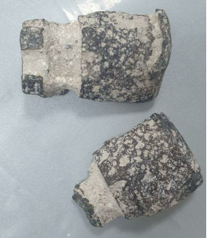 | 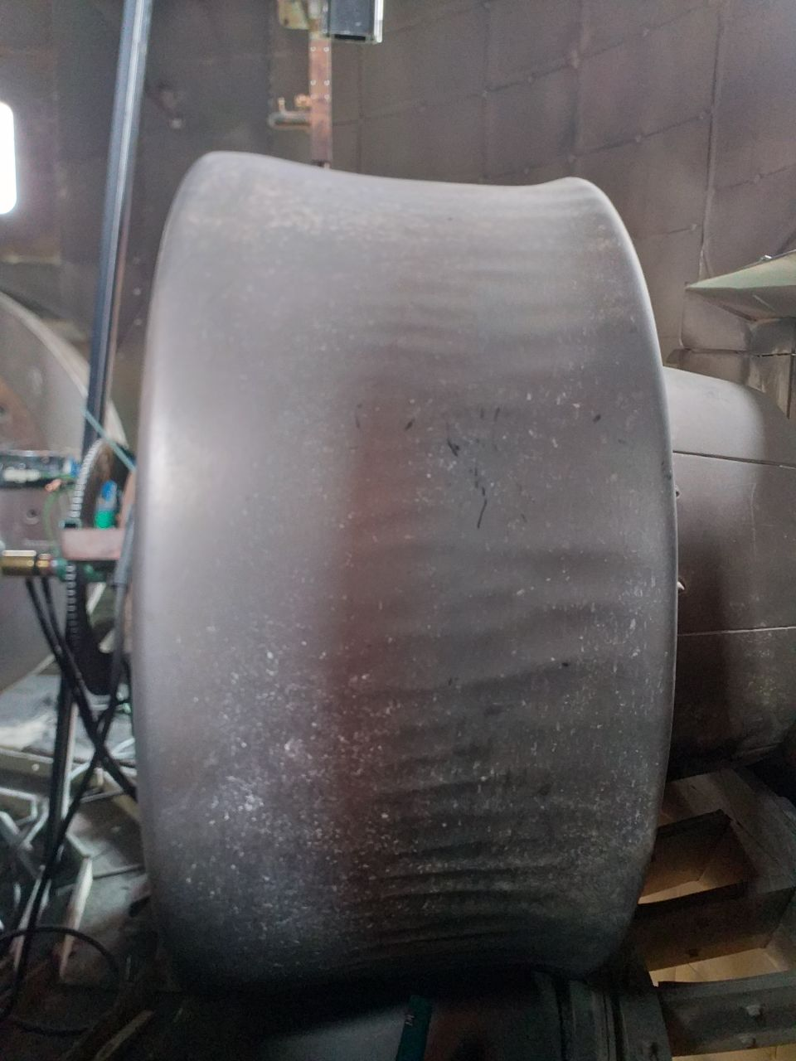 | 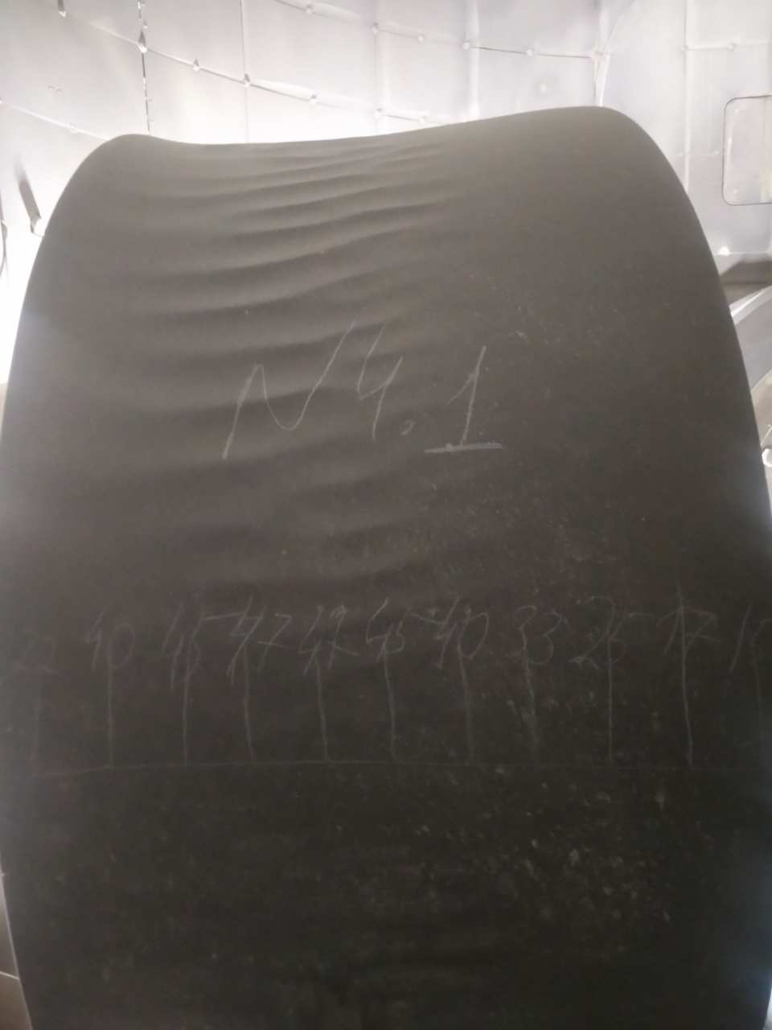
Figure 2. A metal object found inside the mill and corroded grinding surface of the roller. Source: Compiled by the authors.

The observed damage demonstrates that roller-service life is determined not only by the intrinsic wear resistance of the roller material but also by the quality of feed-material preparation and the effectiveness of upstream protection systems. In particular, the reliable removal of metallic contaminants before material enters the grinding zone is an important prerequisite for reducing impact damage and maintaining stable VRM operation.
After several weeks of operation, corrosion and progressive degradation of the metallic components of the grinding table were observed, necessitating periodic repair and restoration. Similar degradation and roller failures have been reported in cement plants in China and other countries (Chen J., 2020). These failures are associated not only with abrasive and impact loading but also with thermal cycling during mill operation and shutdown.
During normal operation, the grinding components are exposed to elevated temperatures generated by the hot gas stream. Repeated heating and cooling cycles produce thermal expansion and contraction of the metallic components. Rapid cooling following an unplanned or prolonged shutdown can generate additional thermal stresses, particularly in regions containing pre-existing defects or residual stresses. Under combined thermal and mechanical loading, these stresses may contribute to crack initiation and propagation and, in severe cases, to roller failure. Therefore, controlled cooling and appropriate shutdown procedures are important for reducing thermally induced damage.
One of the preventive measures investigated in this study is the improvement of the metallic separation system upstream of the grinding mill. Conventional magnetic separators are commonly installed above the conveyor belt. However, their effectiveness can decrease when metallic particles are embedded within a thick layer of transported material or when the conveyor operates at relatively high speed. Under such conditions, metallic contaminants may remain undetected and subsequently enter the grinding zone.
    - Roller Surface Restoration and Structural Assessment
The grinding rollers investigated in the present study are manufactured from a chromium- and manganese-containing alloy. For restoration of damaged roller surfaces, an EN ISO EC308Mo-type welding consumable was selected. The available material certificate/data table reports the chemical composition and tensile properties of the deposited metal.
The surface area requiring restoration and the corresponding quantity of welding material were determined using computer-based geometric calculations. ANSYS models of the roller, bushing and bearing-contact regions were used to visualize likely stress-concentration regions around the damaged/contact zones.

Table 2. Chemical composition and mechanical properties of the welding wire used for roller-surface restoration
Chemical composition |  |  |  |  |  | Mechanical properties
C | Mn | Si | Cr | Ni | Mo | Rm, MPa | Rp, MPa | A, % | KCV, J/cm² | T, ºC
0.050 | 1.50 | 0.80 | 20.5 | 9.70 | 2.90 | 780 | 600 | 35 | 60 | +20

The experimentally documented 130 × 120 × 150 mm surface defect identifies a localized discontinuity capable of disturbing roller-table contact, while the measured vibration of 1.2–1.8 mm/s indicates elevated dynamic excitation. These observations are consistent with prioritizing the defect perimeter, roller contact surface, bushing and bearing-contact regions in subsequent FEM refinement.
3.4. Vibration Analysis and Auxiliary Roller Configuration

The manufacturer's technical requirements specify a vibration level not exceeding approximately 1.0 mm/s for stable mill operation. However, field measurements conducted under the investigated operating conditions showed vibration levels of approximately 1.2–1.8 mm/s. To reduce these dynamic effects, an auxiliary roller configuration based on the “2+2” grinding principle was investigated. The concept was originally developed for roller-mill applications to improve material deaeration and compaction on the grinding table before intensive grinding (Keyssner M., 2007). The auxiliary roller arrangement modifies the material bed and improves the stability of the grinding process, thereby reducing fluctuations in the grinding load. The proposed arrangement is illustrated in Figure 3. Based on the operating conditions identified in the present study, implementation of an auxiliary roller configuration represents a potential engineering measure for improving grinding stability and reducing vibration-induced loads on the mill components.
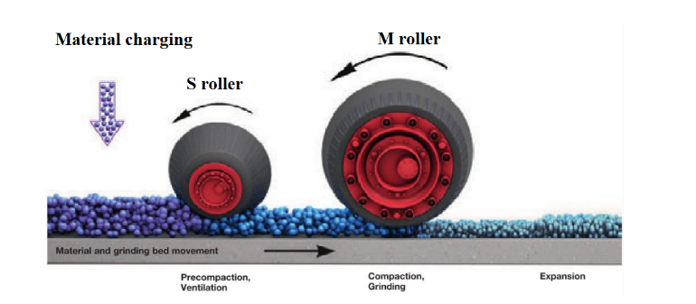
Figure 3. Project view of an efficient grinding system “2+2” in VRM. Source: (Keyssner M., 2007)

The measured data identify a clear operational gap, particularly for vibration: the observed 1.2–1.8 mm/s range is 20–80% above the 1.0 mm/s recommended limit. Premature VRM degradation is associated with interacting factors including metallic contamination, thermal cycling, abrasive wear, feed-material variability, and dynamic loading. The proposed measures—improved upstream metal separation, restoration of damaged roller surfaces, monitoring of critical components, and stabilization of the grinding bed using an auxiliary-roller configuration—therefore address experimentally observed failure mechanisms.

3.5. Quantitative Performance Assessment and Limitations
Table 3 summarizes the quantitative indicators available for the investigated VRM and identifies the performance variables to develops modernization measures.

Table 3. Quantitative performance indicators for the investigated VRM

Performance indicator | Measured/ baseline value | Reference / target | Quantitative assessment | Evidence status
Mill vibration | 1.2–1.8 mm/s | ≤1.0 mm/s (manufacturer requirement) | 20–80% above recommended limit | Measured; demonstrates need for stabilization
Roller-surface damage | Approx. 130 × 120 × 150 mm localized defect | No defect / intact grinding surface | Large localized impact defect documented during inspection | Measured geometrically
Feed particle size | Nominal maximum ≈85 mm; oversize up to 150 mm ≤10%; >105 mm ≤5% | Nominal maximum ≈85 mm | Oversize feed is present and can disturb grinding-bed stability | Measured
Mill drive electrical load | ≈140 A under normal operating conditions | Plant-specific baseline required | Provides an operating-load baseline only | Measured
Throughput | Nominal 500 t/h | 500 t/h nominal capacity | No verified before/after change reported | Design/operating specification; post-modernization production data required
  - Conclusions
The investigation demonstrated that the operational reliability and service life of vertical roller mills (VRMs) are strongly influenced by grinding-component wear, thermal cycling, feed-material characteristics, foreign metallic contaminants, and vibration. The combined effects of these factors can lead to surface degradation, localized defects, and increased mechanical loading of critical mill components.
Field inspection confirmed severe localized roller damage associated with foreign metallic contaminants. A representative surface defect measuring approximately 130 × 120 × 150 mm was identified. These findings indicate the importance of improved upstream metal detection and separation, together with appropriate feed-material control, for reducing the risk of impact-related damage and maintaining stable mill operation.
Roller-surface restoration using chromium- and manganese-containing EN ISO EC308Mo welding material was identified as a technically feasible approach for repairing damaged grinding surfaces. The restoration procedure, combined with periodic condition monitoring, provides a basis for maintaining the structural integrity of critical grinding components and potentially extending their operational service life.
Operational measurements revealed vibration levels of approximately 1.2–1.8 mm/s, compared with the recommended operating level of approximately 1.0 mm/s. The measured vibration was therefore approximately 20–80% above the recommended level. Variations in feed-material characteristics and grinding-bed instability were identified as important factors associated with increased vibration and dynamic loading of the hydraulic cylinders, gearbox, roller assemblies, and bushings.
The analysis indicates that implementation of an auxiliary roller configuration based on the “2+2” principle could improve grinding-bed stability, promote more uniform material distribution, and reduce fluctuations in grinding forces. Improved metallic separation, periodic condition monitoring, roller-surface restoration, feed-size control, and grinding-bed stabilization can therefore be considered as complementary measures for modernization of VRM operation.
Overall, the study identified the principal mechanisms responsible for VRM degradation and established quantitative baseline indicators for the investigated mill. The proposed modernization measures have the potential to improve grinding stability, operational reliability, component service life, and energy and environmental performance. Further experimental investigations and long-term industrial monitoring are required to quantitatively determine their effects on specific energy consumption, throughput, vibration, downtime, component lifetime, maintenance requirements, and environmental performance.
References
Barani K., Azadi M.R., Fatahi R., 2022, An approach to measuring and modelling the residence time distribution of cement clinker in vertical roller mills, Mineral Processing and Extractive Metallurgy, 131(2), 158–165, DOI: 10.1080/25726641.2021.1898266.
Chen J., Jiang H., Fu Y., Qian N., 2020, Heat Transfer Performance of an Axially Rotating Heat Pipe for Cooling of Grinding, Energies, 13(21), 5745, DOI: 10.3390/en13215745.
Chew Y.E., How B.S., Sunarso J., Moser I., Andiappan V., 2024, Optimising Smart Energy System for Decarbonising Cement Production Operations, Chemical Engineering Transactions, 114, 277–282, DOI: 10.3303/CET24114047.
Fatahi R., Nasiri H., Dadfar E., Chehreh Chelgani S., 2022a, Modeling of energy consumption factors for an industrial cement vertical roller mill by SHAP-XGBoost: a “conscious lab” approach, Scientific Reports, 12, 7543, DOI: 10.1038/s41598-022-11429-9.
Fatahi R., Pournazari A., Shah M.P., Barani K., 2022b, A cement Vertical Roller Mill modeling based on the number of breakages, Advanced Powder Technology, 33(10), 103750, DOI: 10.1016/j.apt.2022.103750.
Keyssner M., Gerold C., 2007, Grinding bed stability with Loesche 2+2 and 3+3 systems, Cement International, 5(2), 56–63.
Ravipati D., Singh S., Pandya H., Dalai S., 2019, Energy Savings in Cement Industry: Use of Heat Integration Approach and Simulation Tools, Chemical Engineering Transactions, 76, 421–426, DOI: 10.3303/CET1976071.
Uzsanoatqurilishmateriallari, 2025, 2025 Plans Fully Implemented: Construction Materials Industry Enters a New Stage of Development, <uzsm.uz/en/press_center/news/2025-plans-fully-implemented-construction-materials-industry-enters-a-new-stage-of-development/> accessed 01.08.2026.

