 CHEMICAL ENGINEERING TRANSACTIONS  VOL. xxx, 2026 | A publication of  
The Italian Association
of Chemical Engineering
Online at www.cetjournal.it

Guest Editors: Flavio Manenti, Botir Usmonov, Alessandro Di Pretoro
Copyright © 2026, AIDIC Servizi S.r.l.
ISBN 979-12-81206-xx-x; ISSN 2283-9216

Synthesis of 2,5-Furandicarboxylic Acid Derivatives from Hydroxymethylfurfural of Pd and Transition Metals on Carbon Black Support

Patiparn Boonruamª, Kawin Simawattanaª, Settakorn Upasaenª,
Piyachat Wattanachaiª, Piyasan Paraserthdam^{b}, Soipatta Soisuwan^{a,c,}*

ª Department of Chemical Engineering, Faculty of Engineering, Burapha University, 169 Long-Hard Bangsaen Road, Saensuk Sub-district, Muang District, Chonburi, 20131, Thailand
^{b} Center of Excellence in Catalysis and Catalytic Reaction Engineering, Department of Chemical Engineering, Faculty of Engineering, Chulalongkorn University, Patumwan District, Bangkok,10330, Thailand
^{a, c} Interdisciplinary Center for Decarbonization and Green Energy, Faculty of Engineering, Burapha University, 169 Long-Hard Bangsaen Road, Saensuk Sub-district, Muang District, Chonburi, 20131, Thailand
soipatta@eng.buu.ac.th
The optimum condition of HMF oxidation to FDCA over Palladium coated on black carbon (Pd/BC) was achieved by variation of four parameters, i.e., solvent media (water and acetonitrile), reaction temperature (70 – 150 ºC), oxidizing agent (tert-butyl hydroperoxide (TBHP); molar ratio of TBHP to HMF = 9:1)), and concentration of sodium carbonate solution (0, 0.06, and 0.3 M). Although the reaction time was fixed at 24 h, water and acetonitrile gave different optimal conditions. In case of water media, total yield of HMF oxidation was optimized at a total yield of products 53% under temperature 70 ºC, Na₂CO₃ 0.06 M, and molar ratio of TBHP: HMF (9:1). This condition was green and environmentally friendly, so that Pd incorporated with a second transition metal (i.e., Mn, Ni, and Co) coated on black carbon was tested. The catalysts were prepared via colloidal nanoparticle immobilization. The Pd catalysts incorporating second transition metals were inferior to Pd/BC. The Pd/BC gave selectivity of FFCA >HMFCA>FDCA, whereas the other catalysts did not fully oxidize HMF to FDCA, but these catalysts were only selective to intermediate products, i.e., HMFCA>FFCA.

Keywords: colloidal immobilization, palladium, second transition metal, black carbon, HMF oxidation.
Introduction
Plastic materials are essential for human daily life. The plastic can be used to make consumer products, such as plastic bags, clear plastic bottles, food preservation films, and clear boxes. These clear consumer products are made from polyethylene terephthalate (PET), which has outstanding properties: clarity, flexibility, toughness, and impact resistance, and is long-lasting and not easily degradable, leading to incremental plastic deposition and waste in the ecosystem. Polyethylene terephthalate (PET) is a fossil-based plastic synthesized by esterifying terephthalic acid with ethylene glycol. The depletion of fossil fuels is an environmental and energy issue. Although the world’s proven oil reserves will last for decades, an energy crisis depends on global conditions, and prices rise accordingly. Polyethylene terephthalate is no longer sustainable. Alternatively, bio-based plastic polyethylene furanoate (PEF) has been developed. Polyethylene furanoate has properties comparable to PET, but PET takes more than 200 days to decompose. PEF is derived from 2,5-furandicarboxylic acid (FDCA) and bio-ethylene glycol, both bio-based monomers. 2,5-Furandicarboxylic acid is obtained from the oxidation of 5-hydroxymethylfurfural (HMF), a sugar derivative. HMF decomposes readily as temperature increases, so the reaction requires suitable catalysts. Two types of oxidative catalysts, homogeneous and heterogeneous, are widely applied. Homogeneous cobalt bromide (CoBr), cobalt manganese bromide (CoMnBr), and nickel manganese bromide (NiMnBr) catalysts have been patented and are widely used for the oxidation of para-xylene to terephthalic acid (Sanborn, 2017) (Janka et al., 2016). The homogeneous process requires specialized separation, which is cumbersome. Heterogeneous catalysts have been developed. Noble metal catalysts, such as Au (Megías-Sayago et al., 2018), Ag, Pd, and Pt, were investigated for HMF oxidation. However, they are selective to different products under various conditions, including solvents, oxidizing agents, bases, temperature, and pressure (Antonyraj et al., 2014). Altering the reaction parameters caused one catalyst to show catalytic activity and selectivity toward different products. Palladium, a noble metal, exhibits excellent catalytic activity for HMF oxidation but is scarce and expensive, leading to high production costs (Davis et al., 2011). Transition metals such as Ni, Mn, and Co (Martínez-Vargas et al., 2017), which are active in homogeneous systems, were used to cooperate with palladium. The activities of palladium catalysts combined with a second metal were investigated. Palladium and second-metal nanoparticles loaded on activated carbon were prepared by colloid-chemical reduction and immobilization.
Experiments
Catalyst Preparation
Chemicals for catalyst preparation, i.e., Black carbon supported by Carbokarn factory, Thailand. Palladium Chloride (PdCl₂) and Manganese nitrate tetrahydrate (Mn(NO₃)₂.4H₂O) were purchased from Sigma-Aldrich Corporation. Cobalt nitrate hexahydrate (Co(NO₃)₂.6H₂O) and Nickel nitrate hexahydrate (Ni(NO₃)₂.6H₂O) were purchased from Ajax Finechem Pty Ltd. Hydrochloric acid was purchased from QRëC™, and Sodium borohydride (NaBH₄) was purchased from Fischer Chemical. Chemicals for HMF oxidation, i.e., 5-Hydroxymethylfurfural (5-HMF), were purchased from Sigma-Aldrich Corporation, and tert-butylhydroperoxide was purchased from Ajax Finechem Pty Ltd. Standard and mobile phase chemicals for High-Performance Liquid Chromatography (HPLC): 5-hydroxymethyl-2-furancarboxylic acid (HMFCA), 2,5-Furandicarboxaldehyde (DFF), 5-Formyl-2-furoic acid (FFCA), and 2,5-Furandicarboxylic acid (FDCA) purchased from Sigma-Aldrich Corporation. Tetrahydrofuran was purchased from Ajax Finechem Pty Ltd., and Acetonitrile and Ammonium acetate were purchased from Daejung Chemical & Metal Co., Ltd.

Palladium chloride (PdCl₂) was used as a precursor for palladium metal coated on black carbon (1%Pd/BC). The monometallic palladium nanoparticles were synthesized in a glass cylinder reactor, 500 mL, with an overhead stirrer (Stirrer rotor anchor – type PTFE 600 mm long x 90 mm wide blade). The stirring speed was set at 500 rpm. After 3 minutes, adding 250 mL of deionized water (DI water) to 50 mL of palladium chloride solution (0.285 mmol of PdCl₂) and mixing with 5.83 mL of polyvinyl alcohol (PVA) solution (2% w/v) in the reactor, respectively, resulted in a yellow color. The yellow solution turned brown and colloidal after 7 mL of NaBH4 (0.57 mmol) was added. To immobilize colloidal palladium metal, an aqueous hydrochloric solution was added to adjust the pH to 2, and 3 grams of activated carbon were used as the stationary phase. The mixture was aged for 6 hours, then washed with de-ionized water and centrifuged to separate the immobilized particles. The resultant catalyst was dried at 100 °C for 24 hr. The palladium combined with the second metal was employed in the same method. The palladium chloride solution prepared at the desired concentration (0.75Pd/BC) was mixed with Mn(NO₃)₂.4H₂O or Ni(NO₃)₂.6H₂O or Co(NO₃)₂.6H₂O to meet the final amount of 0.75Pd-025Mn/BC or 0.75Pd-0.25Ni/BC or 0.75Pd-0.25Co/BC. The catalyst names are reported in Table 1.

Table 1: Nomenclature of the catalysts
Precursors |  |  | Catalysts
Starting Precursor #1 | Starting Precursor #2 | Support | Catalysts
PdCl₂ | - | Black Carbon | 0.75Pd/BC
PdCl₂ | Mn(NO₃)₂.4H₂O | Black Carbon | 0.75Pd-0.25Mn/BC
PdCl₂ | Ni(NO₃)₂.4H₂O | Black Carbon | 0.75Pd-0.25Ni/BC
PdCl₂ | Co(NO₃)₂.4H₂O | Black Carbon | 0.75Pd-0.25Co/BC

HMF oxidation
HMF oxidation was carried out in a 50-mL batch-type stainless-steel autoclave (Brave Technologies) reactor, equipped with a thermocouple and pressure gauges. The reactor was charged with a solution (30 mL, water or Acetonitrile) containing the appropriate amount of HMF (3 mmol), base (Na₂CO₃, 0.06 mmol), catalyst (Pd/AC, 300 mg), and TBHP (27 mmol) as the oxidizing agent. The oxidation conditions were set at a temperature of 70°C, a pressure of N₂ (4 bar), and reaction times of 6, 12, 18, and 24 hr. The used catalyst was separated by centrifugation (3000 rpm for 5 min). The catalyst was dried at 100 °C for 24 hr. Reactant (HMF) and products (FDCA and others) were determined by Varian 9012 and Varian 9050 High Performance Liquid Chromatography (HPLC) systems. Products were separated on a reversed-phase C18 column (Cosmosil, 5C18-AR-II, 4.6 ID x 250 mm) and detected with a UV detector at 280 nm. The temperature of the reversed-phase column was maintained at 25 °C. A mixture of acetic acid (1% wt, diluted with water for HPLC) and acetonitrile in a 95:5 volume ratio was used as the mobile phase, with a flow rate of 1 mL/min. The concentrations and types of products were directly determined with calibration curves. The contents of HMF, HMFCA, DFF, FFCA, and FDCA in the samples were calculated by an external standard calibration curve method. The retention times of HMF, HMFCA, DFF, FFCA, and FDCA were 9.409, 5.362, 10.396, 5.950, and 4.742 min, respectively. The HMF conversion and product selectivity were calculated as follows.

$$\text{HMF conversion }\left(\text{\%}\right)\text{ = }\frac{\text{Moles of }{\text{HMF}}_{\text{Initial}}\text{-Moles of }{\text{HMF}}_{\text{Final}}}{\text{Moles of }{\text{HMF}}_{\text{Initial}}}\text{×100\%} (1)$$
$$\text{Product yield of FDCA }\left(\text{\%}\right)\text{ = }\frac{\text{Moles of FDCA}}{\text{Moles of }{\text{HMF}}_{\text{Initial}}}\text{×100\%} (2)$$
$$\text{Product selectivity of FDCA }\left(\text{\%}\right)\text{= }\frac{\text{Product yield (\%)}}{\text{HMF conversion (\%)}}\text{×100\% (3)}$$

Catalyst Characterization
The morphology and particle size distribution of palladium were investigated via Transmission Electron Microscopy (TEM), a Philips Tecnai series 20 with a detector high-angle annular dark field, HAADF. Electron beam at 200 KeV. Scanning Electron Microscope, Hitachi S-3400 N model. A UV-Vis spectrophotometer (Hach DR6000 model) was used to measure from 190 to 1,100 nm. The crystallinity and phase of crystalline structure were identified by X-ray Diffractometer (D8 Advance of Bruker AXS) with CuKα radiation through Ni filter.
Results and Discussion
The product distributions are shown in Figures 1 (Pd/BC and 0.75Pd-0.25Mn/BC catalysts) and Figure 2 (0.75Pd-0.25Ni//BC and 0.75Pd-0.25Co/BC catalysts) in water and acetonitrile systems. Palladium combined with different second metals exhibited product distributions. The Pd/BC is the most oxidizing catalyst in the water system, as it showed the highest production rate at 6 hours, and most of the products were FFCA. The other combined catalysts exhibited product rates comparable to Pd/BC, but their yields favored HMFCA over FFCA. Note that the combined catalyst was inferior to the noble one in accelerating the oxidation, as it could oxidize HMF to HMFCA (the second step) more than FFCA (the third step). In the acetonitrile system, the catalysts were likely less active than in the water system, as they exhibited the highest FFCA yields at 12 and 18 hours. The most noticeable catalyst was the 0.75Pd-0.25Co/BC catalyst, which exhibited the highest FFCA yield at 12 hours.
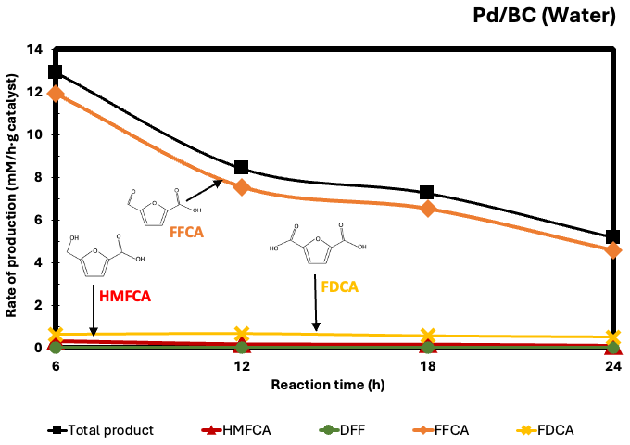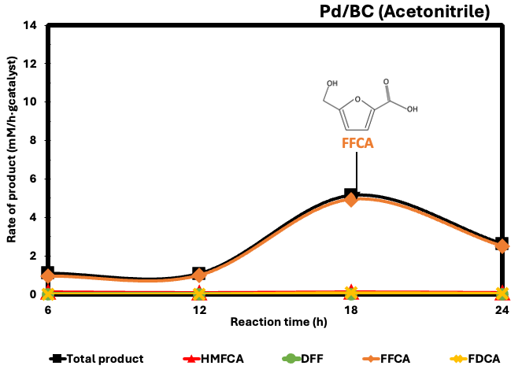

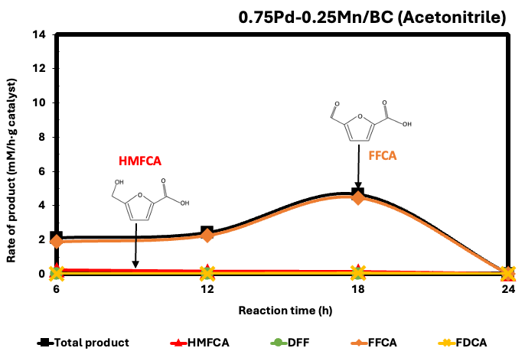

Figure 1. Production distribution of Pd/BC and 0.75Pd-0.25Mn/BC catalysts in water and acetonitrile systems, i.e., HMFCA, FFCA, and FDCA

In a water-based system, transition-metal-doped Palladium catalysts can handle the initial oxidation of HMF to HMFCA but struggle with subsequent oxidation steps (converting HMFCA to FFCA and finally to FDCA), resulting in a slower rate of total product formation. Water molecules and hydroxyl groups can bind strongly to the surfaces of non-noble-metal dopants (oxophilic species), leading to strong competitive adsorption on the catalyst surface and hindering the adsorption of HMF or its intermediate species at active Pd sites (Du et al., 2026). Besides that, transition metals often alter the electronic density of the noble surface, and the electronic interaction can shift the d-band center of Pd metal; it will decrease the adsorption strength of the furan ring aldehyde/alcohol side chains, causing the catalyst to be less active compared to pure Pd (Du et al., 2026)

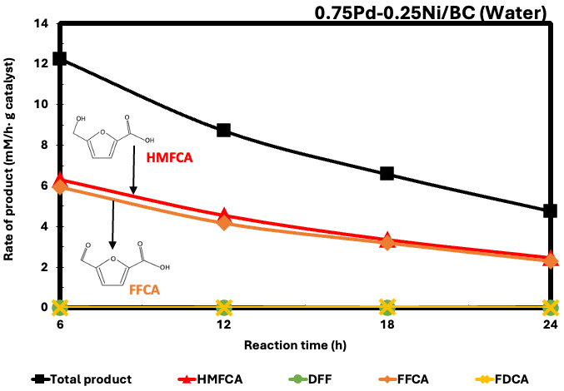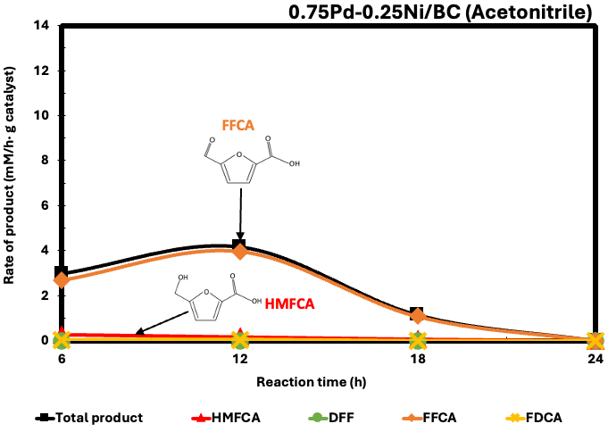

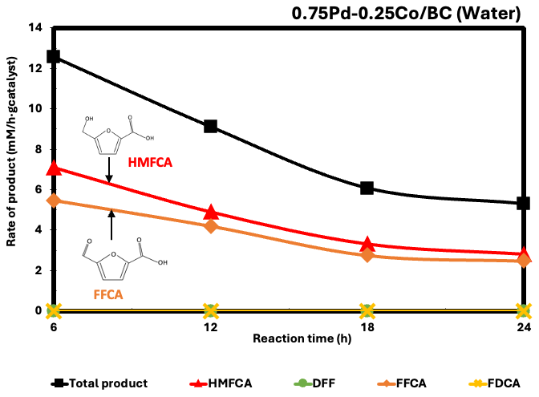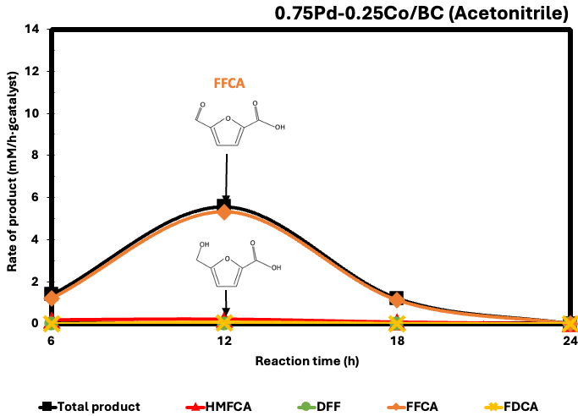

Figure 2 Production distribution of 0.75Pd-0.25Ni//BC and 0.75Pd-0.25Co/BC catalysts in water and acetonitrile systems, i.e., HMFCA, FFCA, and FDCA

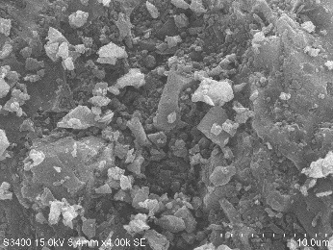
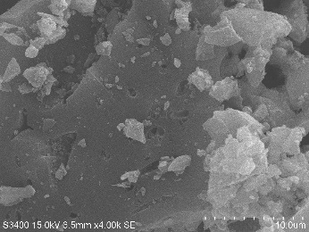
a.)
b.)

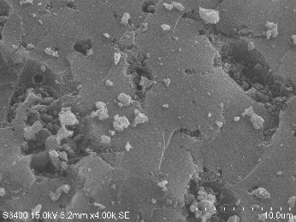
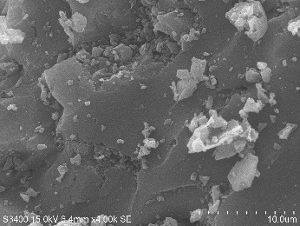
c.)
d.)

Figure 3 TEM images of (a) Pd/BC, (b) 0.75Pd-0.25Mn/BC, (c) 0.75Pd-0.25Ni/BC, and (d) 0.75Pd-0.25Co/BC

The crystallinity of palladium was detected using an X-ray diffractometer, and all patterns showed peaks at (111), (200), and (220), corresponding to palladium metal crystal. The crystal sizes of all catalysts were 17 nm based on the calculation of the main peak (111), corresponding to 2θ = 40º. The TEM images illustrated in Figure 3 and the particle size distributions are exhibited in Figure 4. The particle sizes of palladium metal were 8 nm for Pd/BC and 0.75Pd-0.25Mn/BC. The average particle size increases during preparation using nickel and cobalt precursors. The HMF oxidation is likely to be structurally sensitive. The particle size effect on oxidation selectivity and activity. The addition of Ni and Co increased the average particle sizes to 13 nm and 36 nm, respectively. The larger particles have different crystal facet distributions (fewer low-coordination corner/edge sites and more flat terrace sites), which, in organic acetonitrile, promotes a rapid, localized shift from the second step directly to the third step (FFCA) within 12 hours. The stronger acetonitrile solvent coordinately poisons metal nanoparticles, thereby slowing the step-conversion rate from HMFCA to FFCA for the Pd/BC and 0.75Pd-0.25Mn/BC catalysts (Gou et al., 2025).
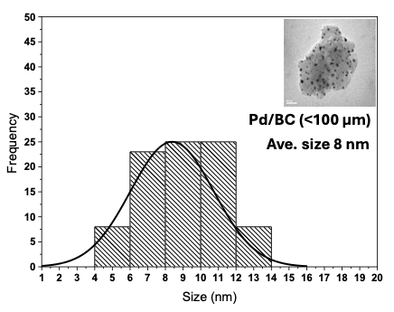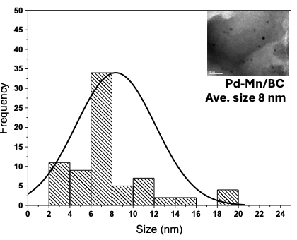
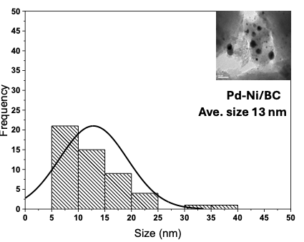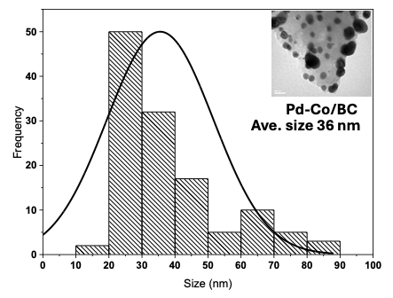
Figure 4 Particle Size distribution of palladium metal catalysts on black carbon

There was no absorption peak at 472 nm of the Pd-O signal in UV-visible spectroscopy, revealing that all 0.75Pd-0.25M/BC catalysts consisted of Pd metal nanoparticles, and they were in good agreement with X-ray diffraction and TEM results.
Conclusion
The combination of the second metal with palladium catalysts resulted in larger particle sizes for the starting Ni and Co precursors. The HMF oxidation appears to be structurally sensitive in acetonitrile, with larger particle sizes likely accelerating it. In the water system, the combination of transition metals suppressed the HMF oxidation because oxophilic properties, such as the ability to absorb water molecules and hydroxy groups, hindered the absorption of HMF reactants due to steric effects.

Acknowledgements

The authors would like to express their gratitude to the senior project students in the Department of Chemical Engineering, Faculty of Engineering, Burapha University, and their financial support by Thailand Science Research and Innovation (TSRI), and National Science Research and Innovation Fund (NSRF) (Fundamental Fund: Grant No. 1.49/2569)

References
Sanborn A.L., 2017, Process for making 2,5-furandicarboxylic acid, Archer Daniels Midland Company. (Decatur, IL, US), United States.
Megías-Sayago C., Lolli A., Ivanova S., Albonetti S., Cavani F., Odriozola J.A., 2018, Au/Al₂O₃ – Efficient catalyst for 5-hydroxymethylfurfural oxidation to 2,5-furandicarboxylic acid, Catalysis Today, 333, 169-175.
Antonyraj C.A., Kim B., Kim Y., Shin S., Lee K.Y., Kim I., Cho J.K., 2014, Heterogeneous selective oxidation of 5-hydroxymethyl-2-furfural (HMF) into 2,5-diformylfuran catalyzed by vanadium supported activated carbon in MIBK, extracting solvent for HMF, Catalysis Communications, 57, 64-68.
Du L., Ku C., Feng M ., Lan J., Park J., Kwon I.S., Kong L., Yang W., 2026, Selective oxidation of high-concentration 5-hydroxymethylfurfural to 2,5-furan dicarboxylic acid at room temperature in water by synergic electronic effect of bimetallic RuCo/NC catalyst, Green Energy & Environment, 11, 1025 – 1036.
Martínez-Vargas D.X., Rivera De La Rosa J., Sandoval-Rangel L., Guzmán-Mar J.L., Garza Navarro M.A., Lucio-Ortiz C.J., De Haro-Del Río D.A., 2017, 5-Hydroxymethylfurfural catalytic oxidation under mild conditions by Co (II), Fe (III) and Cu (II) Salen complexes supported on SBA-15: Synthesis, characterization and activity, Applied Catalysis A: General, 547,132-145.
Guo, Y., Zhao, Y., Gao, S., Lv B., Wu, Z., 2025, Noble Metal-Based Catalysts for Selective Oxidation of HMF to FDCA: Progress in Reaction Mechanism and Active Sites, Chemistry, 7(1), 17.
Janka M.E.K., Randolph P.K., Paula M., Shahanawaz S.A., Reynolds P.L., Russell B.B., Charles M.M., 2016, Oxidation process to produce a purified carboxylic acid product via solvent displacement and post oxidation, Eastman Chemical Company (Kingsport, TN, US), United States.
Davis S.E., Houk L.R., Tamargo E.C., Datye A.K., Davis R.J., 2011, Oxidation of 5-hydroxymethylfurfural over supported Pt, Pd and Au catalysts, Catalysis Today, 160(11), 55-60.

