 CHEMICAL ENGINEERING TRANSACTIONS  VOL. xxx, 2026 | A publication of  
The Italian Association
of Chemical Engineering
Online at www.cetjournal.it

Guest Editors: Flavio Manenti, Botir Usmonov, Alessandro Di Pretoro
Copyright © 2026, AIDIC Servizi S.r.l.
ISBN 979-12-81206-xx-x; ISSN 2283-9216

Comparative Analysis of Protein- and Polysaccharide-Based Microcapsules for Probiotic Delivery
Zilola Ergashovaª , Irene Martín Tornero^{b}, Ana Belén Peromingo^{b} , Shakhnozakhon Salijonovaª, Akbarali Ruzibayevª
ª Tashkent institute of chemical technologies, Department of Food, Perfumery and Cosmetics Technology, Tashkent, Uzbekistan
^{b} University of Extremadura, Faculty of Veterinary, Caceres, Spain
z.ergashova@tkti.uz
  - Abstract
The development of stable delivery systems for lactic acid bacteria (LAB) has gained increasing significance in the functional food and nutraceutical sectors. The present study aimed to investigate the encapsulation efficiency of Lacticaseibacillus casei strain LAB 116 using various microencapsulation matrices, including sodium caseinate, pea protein, maltodextrin, and multilayer systems incorporating chitosan and acetic acid. Particular emphasis was placed on evaluating the physicochemical characteristics, encapsulation yield, and viability of LAB during storage.Microencapsulation was carried out via an emulsification technique followed by a drying process. The resulting microcapsules were characterized in terms of pH, viscosity, water activity, moisture content, color parameters, and solubility. The viability of LAB was assessed using standard plate count methodology on MRS agar across a range of serial dilutions immediately after encapsulation, as well as after 2 weeks and 1 month of storage.
The results demonstrated significant variation in encapsulation performance and bacterial survival depending on the wall material composition. Microcapsules formulated with sodium caseinate yielded approximately 49.5 g of dry powder, exhibited a near-neutral pH (~6.8), and maintained moderate bacterial viability after 1 month (up to 49 CFU at a 10⁻⁷ dilution). In contrast, pea protein-based microcapsules produced a lower powder yield (~22.6 g) but showed superior preservation of bacterial viability, exceeding 300 CFU at a 10⁻⁵ dilution after 1 month of storage.
Maltodextrin-based formulations were characterized by an acidic pH (~3.0–3.5) and relatively high powder yield (~50.2 g); however, they exhibited a rapid decline in LAB viability over time. Multilayer systems composed of maltodextrin, chitosan, and acetic acid demonstrated satisfactory structural integrity but were associated with low initial bacterial viability, which decreased to negligible levels within 2 weeks.
  - Introduction
The increasing demand for functional foods has stimulated significant interest in the incorporation of probiotics, particularly lactic acid bacteria (LAB), due to their well-documented health benefits, including modulation of gut microbiota, enhancement of immune responses, and prevention of gastrointestinal disorders. Among these microorganisms, Lacticaseibacillus casei has attracted considerable attention owing to its high probiotic potential and adaptability to different food matrices.\
espite these advantages, maintaining the viability of probiotic bacteria during food processing, storage, and gastrointestinal transit remains a major technological challenge. Probiotic cells are highly sensitive to environmental stress factors such as oxygen exposure, temperature fluctuations, low pH, and osmotic pressure. As a result, a significant reduction in viable cell counts is often observed before the product reaches the consumer, limiting the functional efficacy of probiotic-enriched foods.
To address these limitations, microencapsulation has emerged as a promising strategy for enhancing probiotic stability. This technique involves entrapping bacterial cells within a protective matrix, thereby shielding them from adverse environmental conditions. Various encapsulation methods have been developed, including spray drying, extrusion, coacervation, and emulsification, each offering distinct advantages and limitations in terms of scalability, cost, and protective efficiency.
Among these approaches, emulsification-based encapsulation is particularly attractive due to its simplicity, scalability, and ability to produce microcapsules with controlled size and morphology. However, the success of this technique largely depends on the selection of appropriate wall materials, which directly influence encapsulation efficiency, mechanical stability, and release behavior of the encapsulated cells.
Encapsulating materials can generally be classified into proteins and polysaccharides. Protein-based materials, such as sodium caseinate and plant-derived proteins, are known for their excellent film-forming properties, emulsifying capacity, and buffering ability. These characteristics enable proteins to create a protective microenvironment around probiotic cells, reducing the impact of acidic and oxidative stress. In particular, plant proteins such as pea protein have recently gained attention as sustainable and allergen-free alternatives to dairy-based encapsulants, aligning with the growing demand for vegan and clean-label products.
In contrast, polysaccharide-based materials such as maltodextrin are widely used in the food industry due to their low cost, high solubility, and good drying performance. Maltodextrin is especially favored in spray-drying applications because it enhances powder yield and improves physical stability. However, its relatively low buffering capacity and susceptibility to acidic conditions may limit its effectiveness in protecting probiotic cells during storage.
To overcome the limitations of single-component systems, multilayer encapsulation approaches have been proposed. These systems typically combine different biopolymers, such as polysaccharides and proteins, to create more complex and potentially more protective structures. Chitosan, for example, is frequently used in multilayer systems due to its film-forming ability and antimicrobial properties. Nevertheless, its interaction with acidic media may negatively affect probiotic viability, highlighting the need for careful optimization of formulation parameters.
Although numerous studies have investigated probiotic encapsulation, direct comparative analyses of protein- and polysaccharide-based systems under identical processing conditions remain limited. In particular, there is a lack of systematic data evaluating the performance of plant-based proteins relative to traditional dairy proteins and carbohydrate matrices in terms of both encapsulation efficiency and long-term bacterial survival.
Therefore, the objective of this study was to perform a comprehensive comparative evaluation of different encapsulation matrices—namely sodium caseinate, pea protein, maltodextrin, and multilayer systems incorporating chitosan—for the delivery of Lacticaseibacillus casei LAB 116. The study focuses on assessing physicochemical properties, encapsulation yield, and probiotic viability over storage time.
By addressing the relationship between wall material composition and probiotic stability, this work aims to contribute to the rational design of effective encapsulation systems for functional food applications, with particular emphasis on sustainable and plant-based alternatives.
Materials and Methods
    - Materials
The probiotic strain Lacticaseibacillus casei LAB 116 was used throughout the study. The culture was maintained under refrigerated conditions prior to use and activated in sterile conditions before encapsulation.
The encapsulating agents included:
- Sodium caseinate (food-grade protein)
- Pea protein isolate
- Maltodextrin
- Chitosan (1.5%, w/w)
- Acetic acid solution (1%, v/v)
All solutions were prepared using distilled water under laboratory conditions.

    - Preparation of Probiotic Suspensions
Bacterial suspensions were prepared by dispersing the LAB culture in distilled water to obtain a homogeneous solution. The suspension was subsequently diluted depending on the formulation requirements.
For emulsification, the bacterial suspension was subjected to ultrasonic homogenization using the following parameters:
Power: 200 W
Cycle: 50%
Amplitude: 75%
Time: 10 minutes
To prevent thermal inactivation of bacteria during sonication, the samples were placed in an ice bath.

    - Preparation of Encapsulation Matrices
Maltodextrin-Based System
Maltodextrin solution was prepared by dissolving 60 g of maltodextrin in 140 g of distilled water under continuous stirring until complete dissolution. The previously homogenized bacterial suspension was gradually added to the solution, followed by additional distilled water to ensure uniform dispersion.
The final mixture was stirred until a stable emulsion was formed.
Multilayer System (Maltodextrin–Chitosan)
Chitosan solution was prepared by dissolving 1.5 g of chitosan in 98.5 g of 1% acetic acid solution. Separately, maltodextrin and bacterial suspensions were prepared as described above.
The encapsulation process involved:
- Mixing the bacterial suspension with distilled water under magnetic stirring (10 min)
- Ultrasonic homogenization under controlled conditions
- Gradual addition of chitosan solution with continuous stirring
- Addition of maltodextrin solution to form a multilayer emulsion

This approach enabled the formation of composite microcapsule structures.

Protein-Based Systems
Sodium Caseinate
Sodium caseinate solution was prepared by dissolving 60 g of protein in 720 g of distilled water at approximately 60°C. The solution was stirred at 200–300 rpm until complete hydration (≈24 h).
After hydration:
The solution was divided into equal portions
LAB culture (≈10 g per portion) was added
Mechanical homogenization was performed using an Omni Mixer at ~5000 rpm for 20 minutes
Ultrasonic homogenization followed under cooling conditions
Pea Protein
The same procedure was applied for pea protein preparation, ensuring complete hydration and uniform dispersion prior to bacterial incorporation.
Both protein systems were designed to create stable emulsions with strong matrix–cell interactions.

    - Microcapsule Formation and Drying
Spray drying was performed using a Mini Spray Dryer S-300. The inlet-air temperature setpoint was 180 °C and the outlet-temperature setpoint was 200 °C. The drying-gas flow rate was 35 m³/h, the atomization-gas flow rate was 850 L/h, and the feed pump rate was 10 mL/min.
The mass of the obtained microcapsules was determined gravimetrically using the following equation:

$M=M_{total}-M_{tare}$ ​

Where:
$M$ is the mass of microcapsules
$M_{total}$ is the weight of container with product
$M_{tare}$ is the weight of empty container
Experimental values ranged between 22.6 g and 50.2 g depending on formulation.

    - Physicochemical Characterization
pH Measurement
The pH of emulsions was measured using a calibrated pH meter. Measurements were performed in triplicate.
Viscosity
Viscosity was estimated using a pycnometer-based density method by measuring mass differences and calculating density indirectly.
Moisture Content
Moisture content was determined by drying samples at 100°C until constant weight was achieved.
Water Activity (a_{w})
Water activity was measured using a water activity analyzer. Values ranged from 0.21 to 0.36 depending on formulation.
Solubility
Solubility was determined by dispersing a known mass of microcapsules in distilled water, followed by centrifugation and drying of the supernatant.
Microbilogical Analysis
The viability of encapsulated LAB was evaluated using the standard plate count method on MRS agar.
Serial dilutions (10⁻³, 10⁻⁵, and 10⁻⁷) were prepared, and colonies were counted after incubation. The available records report plate colony counts rather than fully normalized CFU/g values; accordingly, these counts are presented as recorded and are not treated as absolute viable-cell concentrations.
Measurements were conducted:
Immediately after encapsulation
After 2 weeks
After 1 month of storage
Special attention was given to comparing bacterial survival across different encapsulation matrices.
Statistical Analysis
Physicochemical measurements were performed in triplicate where indicated in the laboratory records. For microbiological analysis, 1 g of each sample was used to prepare the initial suspension, and 0.01 mL (10 µL) of each serial dilution was plated for colony counting.
  - Results and Discussion
    - Physicochemical Properties
Protein-based systems exhibited near-neutral pH values (~6.8–7.2), whereas maltodextrin systems were acidic (~3.0–3.5), which negatively affected bacterial survival .
Water activity values ranged from:
Caseinate: ~0.21
Pea protein: ~0.36
Low water activity in caseinate systems contributed to improved stability.

Formulation / batch | Recovered powder mass (g); recorded pH
Caseinate + LAB I | 49.55; pH 6.90–6.92
Pea protein + LAB I | 23.88; pH 6.89–6.90
Maltodextrin + LAB | 50.19; pH 3.42–3.45
Maltodextrin + chitosan + LAB | 43.25; pH 3.49–3.51

    - Encapsulation Yield
Encapsulation yield varied significantly depending on the wall material:
System | Yield (g)
Caseinate | ~49.5
Pea protein | ~22.6
Maltodextrin | ~50.2
Maltodextrin + chitosan | ~43.3

Maltodextrin-based systems showed the highest yield, while protein-based systems had lower but more functional outputs.

    - Viability of LAB
The initial concentration of the Lacticaseibacillus casei suspension prior to encapsulation was established at 9.0 log CFU/g. The viability of encapsulated LAB was evaluated using the standard plate count method on MRS agar across serial dilutions 10⁻³, 10⁻⁵, and 10⁻⁷. To standardize the evaluation across formulations, survival rates and log reductions were analyzed over a 1-month storage period.
- Pea Protein Systems: Demonstrated exceptional protective efficacy, maintaining high cell counts (exceeding 300 CFU at the 10⁻⁷ dilution, corresponding to a stabilized retention of viable cells close to initial levels) even after 1 month of storage.
- Sodium Caseinate Systems: Exhibited high initial viability, followed by a gradual decrease over 1 month to 4–16 CFU at the 10⁻⁷ dilution.
- Maltodextrin Systems: Showed a sharp decline in viability over time, dropping to ≤15 CFU at high dilutions due to environmental stress.
- Multilayer (Maltodextrin–Chitosan) Systems: Resulted in an almost complete loss of cell viability within the first 2 weeks.
    - Comparative Analysis
The comparative evaluation of encapsulation matrices revealed that wall material composition critically dictates the long-term survival of Lacticaseibacillus casei. Protein-based matrices significantly outperformed polysaccharide and multilayer carbohydrate-chitosan systems.
The superior protective performance of pea protein isolate can be attributed to its unique functional properties, including excellent film-forming capacity, amphiphilic nature, and robust buffering ability. Plant proteins form a compact, viscoelastic network during the drying process that effectively shields probiotic cells from atmospheric oxygen and moisture ingress. Furthermore, pea protein maintains a near-neutral microenvironment pH 6.89–6.90, mitigating acid stress which is a major factor in probiotic inactivation during storage, as supported by previous findings (Burgain et al., 2011; Ding & Shah, 2009).
Although sodium caseinate also provided a near-neutral matrix environment pH 6.79–6.92, it showed a more pronounced reduction in viable counts over 1 month compared to pea protein. This disparity may stem from structural differences in the protein gel networks formed during thermal and mechanical homogenization, as well as distinct interactions between plant versus dairy protein amino acid residues and the bacterial cell membrane.
In contrast, maltodextrin-based formulations, despite yielding high recovery volumes 50.2g, failed to ensure long-term stability. This is primarily linked to the intrinsic acidic reaction of the medium pH 3.0–3.5 and a low buffering capacity, which exposes cells to continuous chemical stress.
The multilayer system incorporating chitosan and acetic acid exhibited the poorest probiotic survival, with viability dropping to negligible levels within two weeks. This adverse effect is directly associated with the mandatory use of acetic acid 1% v/v during chitosan solubilization. Exposure to an acetic environment combined with low pH 3.5 induces severe transmembrane stress and intracellular acidification in L. casei, rapidly compromising membrane integrity and cell viability. These observations align with recent literature highlighting that antimicrobial properties of chitosan matrices can inadvertently compromise probiotic viability if formulation parameters (such as acid concentration and pH) are not strictly optimized (Eratte et al., 2015; Kavitake et al., 2018).

    - Scanning Electron Microscopy
Representative scanning electron micrographs of the prepared microcapsule material are shown in Figure 1. The images reveal irregularly shaped particles with textured surfaces and areas of particle agglomeration.
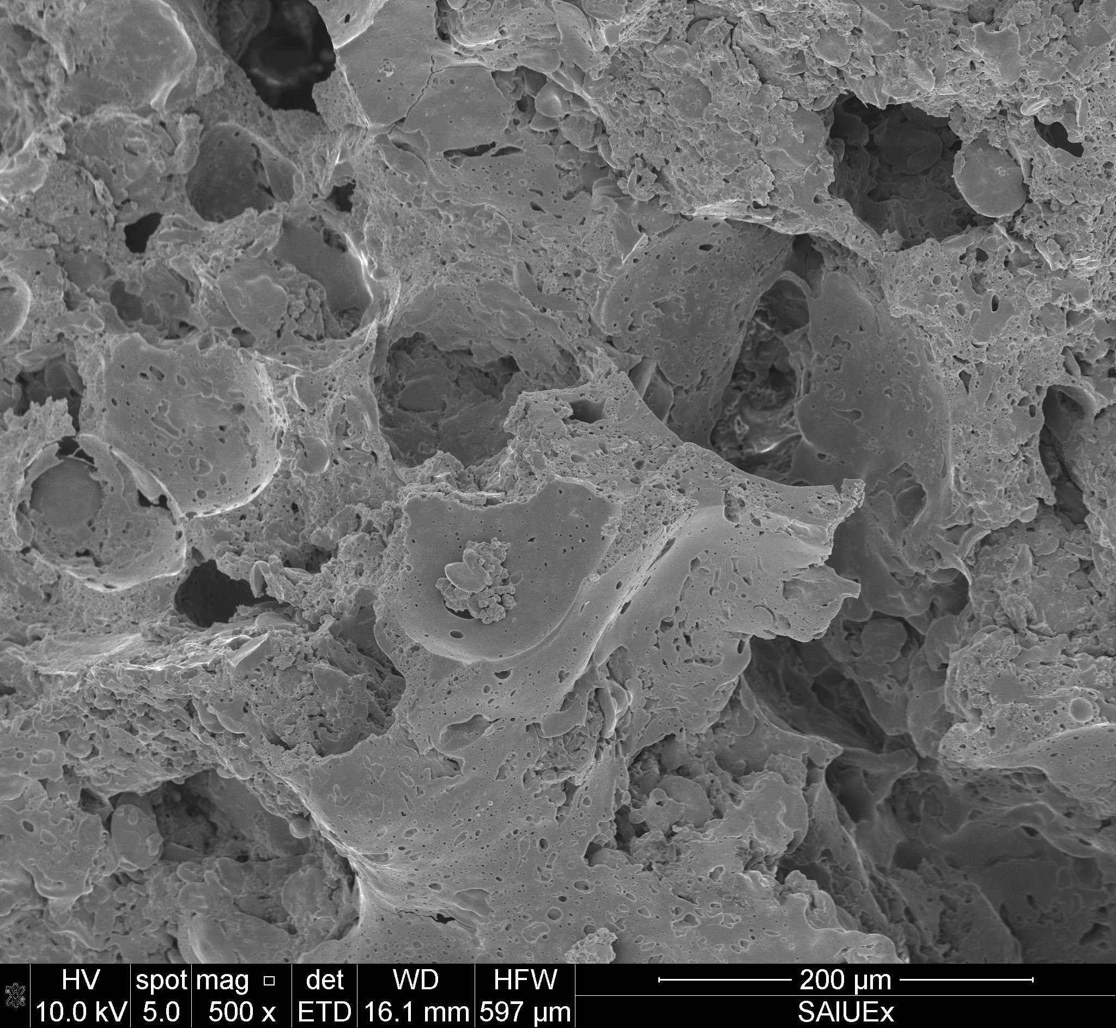
(a)
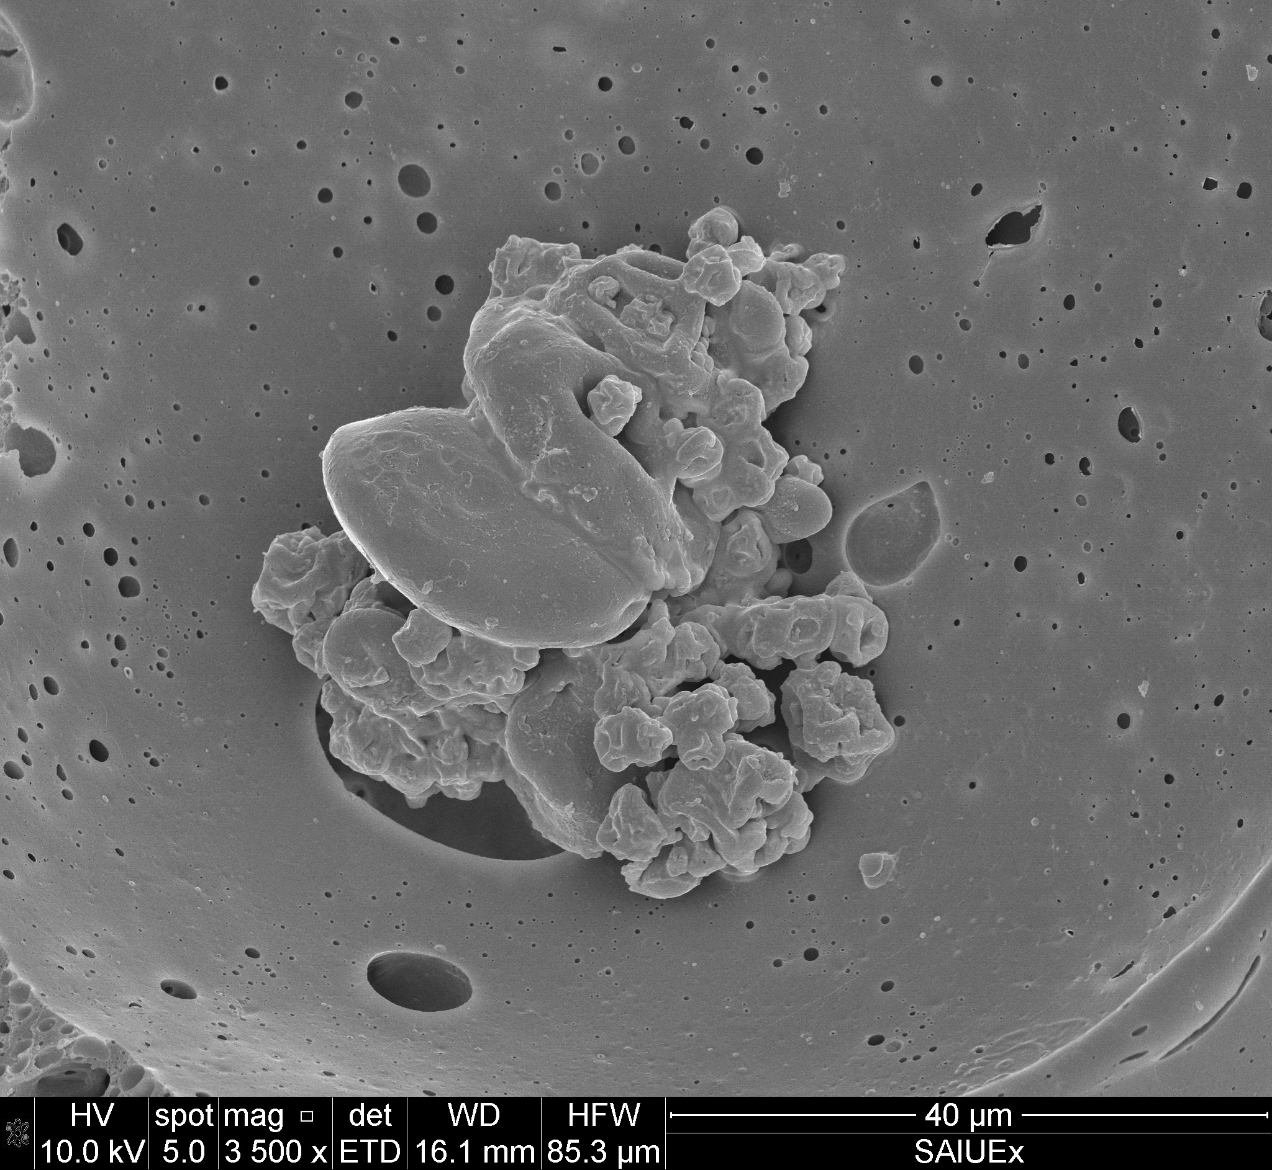
(b)
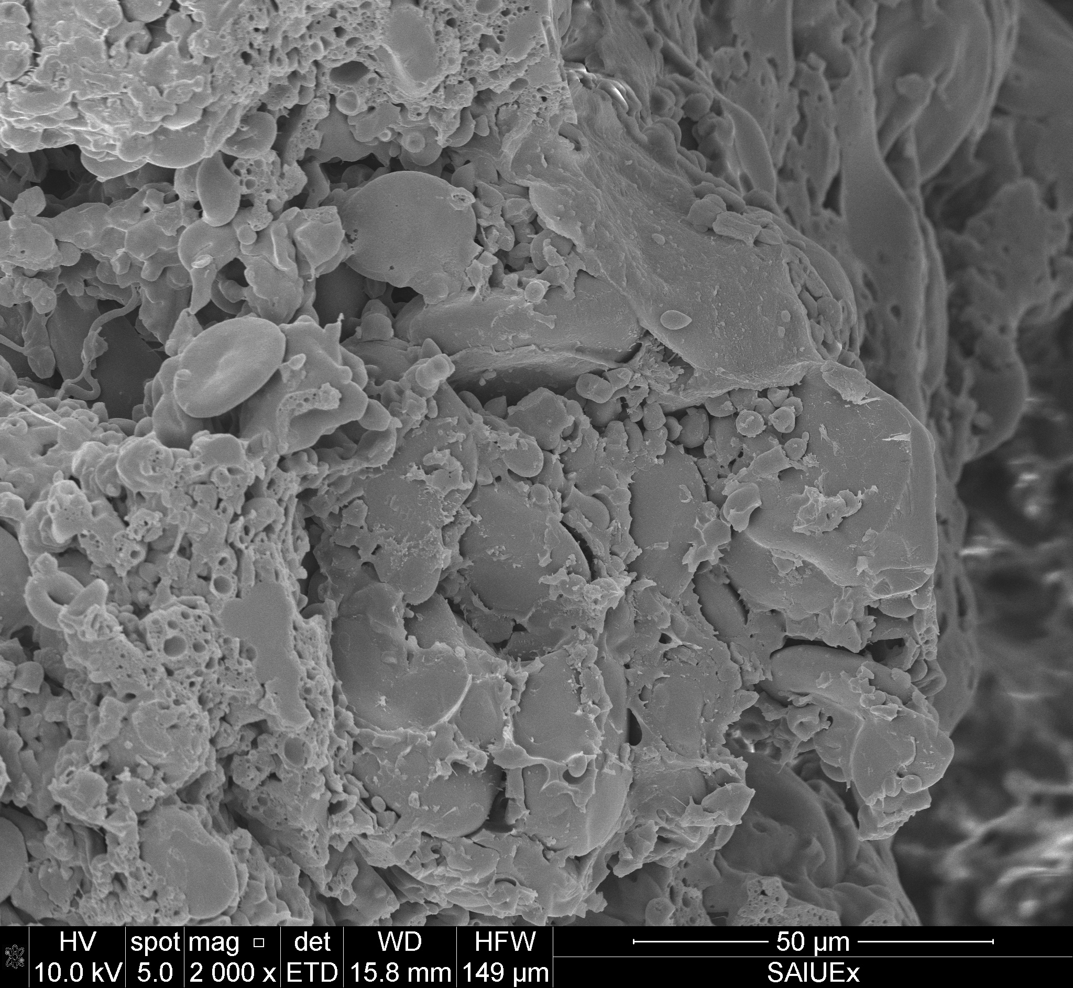
(c)
Figure 1. Scanning electron micrographs of the prepared microcapsule material: SEM conditions visible in the image metadata include 10.0 kV accelerating voltage and 3500× magnification; scale bar = 40 μm.
  - Conclusions
The results of this comparative study indicate that the composition of the encapsulating matrix is an important factor to consider when developing delivery systems for Lacticaseibacillus casei LAB 116. Across the formulations examined, the protein-based systems-particularly pea protein isolate-showed the most encouraging pattern of recoverable viable colonies during storage. In the pea-protein batch, counts remained at or above 300 colonies at the recorded 10⁻⁷ dilution after one month.
Sodium caseinate also provided a near-neutral formulation environment (approximately pH 6.79–6.92), but the first batch showed a decline in plate counts from 131–137 colonies in the initial mixture to 4–16 colonies after one month at the same recorded dilution. This contrast with the pea-protein observations suggests that the performance of protein-based carriers cannot be assumed to be identical and may depend on matrix structure, preparation conditions, and storage behavior. The relatively high recovered powder mass of maltodextrin (50.19 g) did not correspond to consistently high plate counts: counts varied across storage measurements. The maltodextrin–chitosan formulation showed no growth in one assay and sparse growth in another. Its acidic pH, together with the use of acetic acid in the formulation, may have contributed to the observed outcome.
Acknowledgments
The authors acknowledge the collaboration between Tashkent Institute of Chemical Technologies and the University of Extremadura.
References
Anal, A. K., & Singh, H. (2007). Recent advances in microencapsulation of probiotics for industrial applications. Food Science and Technology, 18(5), 240–251.
Cook, M. T., Tzortzis, G., Charalampopoulos, D., & Khutoryanskiy, V. V. (2012). Microencapsulation of probiotics for gastrointestinal delivery. International Journal of Pharmaceutics, 431(1–2), 1–7.
Gbassi, G. K., & Vandamme, T. (2012). Probiotic encapsulation technology: From microencapsulation to release into the gut. Journal of Food Engineering, 112(3), 171–181.
Burgain, J., Gaiani, C., Linder, M., & Scher, J. (2011). Encapsulation of probiotic living cells: From laboratory scale to industrial applications. Journal of Food Engineering, 104(4), 467–483.
Ding, W. K., & Shah, N. P. (2009). Effect of various encapsulating materials on the stability of probiotic bacteria. Journal of Food Science, 74(2), M100–M107.
Heidebach, T., Först, P., & Kulozik, U. (2012). Microencapsulation of probiotic cells for food applications. Critical Reviews in Food Science and Nutrition, 52(4), 291–311.
Krasaekoopt, W., Bhandari, B., & Deeth, H. (2003). Evaluation of encapsulation techniques of probiotics. International Dairy Journal, 13(1), 3–13.
Soccol, C. R., et al. (2010). The potential of probiotics: A review. Food Technology and Biotechnology, 48(4), 413–434.
Martín, M. J., Lara-Villoslada, F., Ruiz, M. A., & Morales, M. E. (2015). Microencapsulation of bacteria: A review of different technologies. Journal of Controlled Release, 219, 509–519.
de Vos, P., Faas, M. M., Spasojevic, M., & Sikkema, J. (2010). Encapsulation for preservation of functionality and targeted delivery of bioactive compounds. International Dairy Journal, 20(4), 292–302.
Chen, M. J., & Chen, K. N. (2007). Applications of probiotic encapsulation in dairy products. Journal of Food Science, 72(4), R39–R44.
Yao, M., et al. (2020). Advances in microencapsulation of probiotics: Technology and applications. Foods, 9(6), 857.
Liu, W., et al. (2017). Microencapsulation of probiotics using biopolymers: A review. Food Hydrocolloids, 63, 378–393.
Peighambardoust, S. H., et al. (2011). Application of spray drying for microencapsulation of probiotics. Drying Technology, 29(6), 643–652.
Gonçalves, A., et al. (2017). Encapsulation of probiotics in food systems. LWT - Food Science and Technology, 85, 378–387.
Shori, A. B. (2017). Microencapsulation of probiotics and its benefits. Journal of Food Science and Technology, 54(8), 2309–2321.
Tripathi, M. K., & Giri, S. K. (2014). Probiotic functional foods: Survival of probiotics during processing and storage. Journal of Functional Foods, 9, 225–241.
Ranadheera, R. D. C. S., et al. (2010). Importance of food in probiotic efficacy. Food Research International, 43(1), 1–7.
Augustin, M. A., et al. (2011). Nano- and micro-encapsulation of probiotics. Food Hydrocolloids, 25(8), 1799–1811.
Etchepare, M. A., et al. (2016). Effect of wall materials on the survival of probiotics. Food Bioscience, 13, 98–104.
Chávarri, M., et al. (2010). Microencapsulation of probiotic bacteria in alginate beads. International Journal of Food Microbiology, 142(1–2), 185–189.
Rajam, R., et al. (2012). Encapsulation of probiotics using spray drying. Journal of Food Engineering, 112(1–2), 67–74.
Kavitake, D., et al. (2018). Recent developments in encapsulation of probiotics. Food Bioscience, 26, 92–102.
Eratte, D., et al. (2015). Encapsulation of probiotics in complex coacervates. Food Chemistry, 192, 198–206.

