 CHEMICAL ENGINEERING TRANSACTIONS  VOL. xxx, 2026 | A publication of  
The Italian Association
of Chemical Engineering
Online at www.cetjournal.it

Guest Editors: Flavio Manenti, Botir Usmonov, Alessandro Di Pretoro
Copyright © 2026, AIDIC Servizi S.r.l.
ISBN 979-12-81206-xx-x; ISSN 2283-9216

Operation of Cooled Fixed-Bed Reactors with Homogeneous Electric Heating
Nicolas Oye, Jens Bremer*
Clausthal University of Technology, Institute of Chemical and Electrochemical Process Engineering, Leibnizstraße 17, 38678 Clausthal-Zellerfeld, Germany
*bremer@icvt.tu-clausthal.de
Temperature control is a central challenge in strongly exothermic catalytic reactions, as insufficient temperatures prevent ignition while excessive temperatures may cause reduced yield, catalyst damage, and safety concerns. Conventional approaches rely mainly on external cooling, feed dilution with recycle concepts, or micro-structured reactors. More recently, electrically heated reactors have been investigated, primarily to supply heat for endothermic processes and, to a limited extent, to support the operation of exothermic systems. In this work, a tubular fixed-bed reactor concept combining external cooling with internal electric heating is investigated through simulations of CO₂ methanation. The additional degree of freedom introduced by internal heating is analyzed with respect to ignition support and hot-spot positioning. A pseudo-homogeneous reactor model is solved using the finite volume method. The results show that internal electric heating can substantially extend the feasible operating window of cooled exothermic reactors. In particular, it enables reactor operation at lower coolant temperatures and allows active adjustment of the hot-spot position. The study demonstrates that combining internal electric heating and external cooling is a promising strategy for improving the flexibility and operability of exothermic fixed-bed reactors.

Keywords: Exothermic reaction, Electric heating, Fixed-bed reactor, Methanation, Hot-spot control
  - Introduction
Strongly exothermic catalytic reactions are of major industrial relevance. Important examples include CO₂ methanation, ammonia synthesis, methanol synthesis, Fischer-Tropsch synthesis, and selective oxidation processes. The design and operation of reactors suitable for these applications are governed by a characteristic thermal conflict: sufficiently high temperatures are required to ignite the reaction and achieve technically relevant rates, while excessive temperatures result in thermal runaway or hot-spot formation that can cause catalyst deactivation, material stress, undesired side reactions, and equilibrium limitations (Froment, 1974). Consequently, temperature control is one of the key challenges in exothermic reactor engineering.
The state of the art for controlling gas-phase exothermic fixed-bed reactions is based primarily on four classes of measures that, while improving temperature control, also introduce trade-offs. First, temperature can be controlled through the inlet conditions (Henda et al., 2008), primarily by adjusting either the inlet temperature, which affects reactor size, hot-spot position, and process integration, or the feed dilution (Jess et al., 1999), which increases recycle effort. Second, external cooling is widely used, for example, in tubular or multi-tubular reactors cooled by water, thermal oil, or molten salt (Sauer et al., 2013). Such reactor concepts are industrially established and provide robust heat removal, but also increase capital costs, and their operating range is constrained by the admissible coolant temperature. Third, reactor and catalyst dimensions and catalyst dilution are selected in order to allow for sufficient heat removal or reduce the heat release rate at the hot-spot (Schlereth and Hinrichsen, 2014). This often implies compromises in space-time yield or increased pressure drop. Finally, microreactors (Tegrotenhuis et al., 2007) and other highly intensified structures have been proposed to improve heat transfer and approach nearly isothermal operation. While these concepts offer superior thermal management, they are associated with disadvantages such as elevated pressure drop, increased fouling sensitivity, and limited direct transfer to industrial-scale configurations (Zhang et al., 2017).
Another route for thermal control is the use of electric heating (Ambrosetti, 2022). Electrification has received considerable attention in recent years, especially as a means of providing process heat for endothermic reactions (Ferri et al., 2025; Wismann et al., 2022). However, electric heating is also relevant for exothermic systems, where it can provide the energy required for ignition or enable local temperature manipulation (Daccache et al., 2024; Watanabe et al., 2025). Depending on the realization, electric heat can be rapidly supplied in situ with high controllability (Zheng et al., 2024). These features are attractive in the context of flexible Power-to-X processes, which increasingly require reactors to follow fluctuating operating conditions imposed by renewable electricity supply.
The combination of internal electric heating and external cooling is particularly interesting because it introduces additional degrees of freedom for reactor operation that would help mitigate some of the previously mentioned trade-offs. The two thermal actions can fulfill different functions: internal heating may support ignition or locally raise the temperature where reaction activity is insufficient, while external cooling removes the released reaction heat and constrains excessive temperatures. Compared to a purely cooled reactor, this decouples temperature increase and temperature limitation to some extent. General advantages may include an enlarged operating window, reduced need for feed dilution, and more direct manipulation of the axial temperature profile.
Despite this potential, the combined use of internal electric heating and external cooling has only been explored to a limited extent. Fache and Marias (2020) discussed a reactor concept with simultaneous cooling and induction-based heating to stabilize product quality during load changes and improve parametric sensitivity (Fache et al., 2020). Based on available literature, a more thorough analysis on utilizing the additional thermal degree of freedom for broader operational objectives in exothermic fixed-bed reactors has not been reported.
The present work addresses this by means of simulation studies on the case of CO₂ methanation. The aim is to investigate how internal electric heating can be used, in combination with external cooling, to improve the controllability of exothermic reactions. Particular emphasis is placed on two aspects: extension of the feasible operating window towards lower coolant temperatures and targeted control of the hot-spot position.
The following sections introduce the reactor model and implementation, and discuss the results obtained from the simulations.
  - Methods
A tubular fixed-bed reactor with external cooling and integrated internal electric heating, as shown in Figure 1, is considered. The basic concept corresponds to an industrially relevant cooled (multi-tubular) packed-bed reactor, supplemented by internal electric heating such as inductive heating of the catalyst particles or resistive heating of a structured packing. In the present study, the heating action is represented as a volumetric heat source distributed uniformly throughout the catalyst bed. This idealized representation captures the principal effect of internal heating and is suitable for qualitatively analyzing its impact on the reactor behavior.

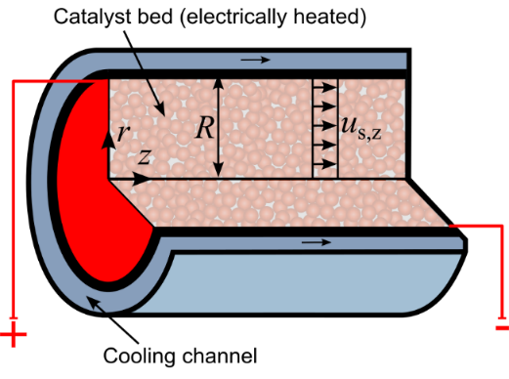
Figure 1: Longitudinal section of the cylindrical electrically assisted cooled fixed-bed reactor, showing the heated catalyst bed, external cooling channel, and axial flow direction
    - Reactor model
The reactor is described by a dynamic pseudo-homogeneous model based on previous work (Gottheil and Bremer, 2025), which is integrated to steady state. The model is applied to CO₂ methanation as a representative strongly exothermic reaction:
$$CO_{2}+4H_{2}⇌CH_{4}+2H_{2}O , Δ_{R}{\tilde{H}}^{0}=-164.9 kJ mol^{-1}$$ | (1)
Dynamic component balances are formulated for all relevant species, together with an energy balance:
$$ερ_{gas}\frac{∂w_{α}}{∂t}=-u_{s,z}ρ_{gas}\frac{∂w_{α}}{∂z}+\left(1-ε\right)η_{cat}{\tilde{M}}_{α}ν_{α}\tilde{r}$$ | (2)

$${\left(ρc_{p}\right)}^{eff}\frac{∂T}{∂t}=-u_{s,z}ρ_{gas}c_{p,gas}\frac{∂T}{∂z}+\left(1-ε\right)η_{cat}\left(-Δ_{R}\tilde{H}\right)\tilde{r}-\frac{2k_{w}}{R}\left(T-T_{cool}\right)+{\dot{q}}_{elec}$$ | (3)
The electric heating term ${\dot{q}}_{elec}$ is at this stage implemented as a homogeneous source term. This is deemed sufficient for the qualitative investigation of electric heating. A more detailed electrification model would require separate heat-transfer relations between the heating structure, gas phase, catalyst phase, and reactor wall. In technically realized systems, the electric heat input may be spatially non-uniform and may therefore influence the precision with which the hot-spot position can be controlled. For example, stronger heat input in colder reactor regions, such as near the wall or upstream of the reaction zone, could shift ignition and the main reaction zone towards the reactor inlet. Therefore, the present homogeneous heat-source representation should be interpreted as a reactor-scale idealization, while spatially resolved heating models are required for a detailed assessment of specific heating concepts.
Pseudo-steady state is assumed for the continuity equation and momentum balance, which results in the expressions for the superficial velocity and the pressure drop:
$$u_{s,z}=u_{s,z,in}\frac{ρ_{gas,in}}{ρ_{gas}}$$ |  |  | (4)
$$\frac{∂p}{∂z}=-u_{s,z}\frac{\left(1-ε\right)}{ε^{3}}\left(150\frac{\left(1-ε\right)μ_{gas}}{d_{p}^{2}}+1.75\frac{ρ_{gas}u_{s,z}}{d_{p}}\right)$$ |  | (5)
The methanation kinetics are described according to Koschany et al. (2016), which has been widely used for nickel-based CO₂ methanation.
    - Numerical implementation
For the numerical solution, the reactor model is discretized by the finite volume method using 300 finite volumes. This results in a system of ordinary differential and algebraic equations.
The operating conditions, reactor geometry and other simulation parameters are taken from the reference case provided by Bremer and Sundmacher (2019).
To allow for better comparison of the electric power introduced to the system, a relative electric power ${\dot{P}}_{elec}^{rel}$is defined as the ratio of the total electric heat to the maximum possible heat of reaction:
$${\dot{P}}_{elec}^{rel}=\frac{{\dot{Q}}_{elec}}{{\dot{Q}}_{reac}^{max}}=\frac{{\dot{q}}_{elec}V_{R}}{-Δ_{R}\tilde{H}{\dot{N}}_{CO_{2},in}}$$ | (6)
A relative electric power of unity thus correlates to an electric-heating power equal to the reaction heat for full conversion. A relative electric power of zero represents the unelectrified base case.
  - Results and discussion
In this section, the following simulation scenarios are analyzed:
- reduction of coolant temperature with and without internal electric heating and
- variation of electric heating power to manipulate the hot-spot position.
    - Reduction of coolant temperature
A first important application of internal electric heating is the extension of the feasible operating window towards lower coolant temperatures. In a purely cooled exothermic reactor, the coolant temperature must often be high enough to ensure ignition and sufficient reaction rates, even though lower coolant temperatures would improve heat removal and ease temperature constraints on the reactor wall and coolant. This leads to a fundamental compromise in the reactor design.

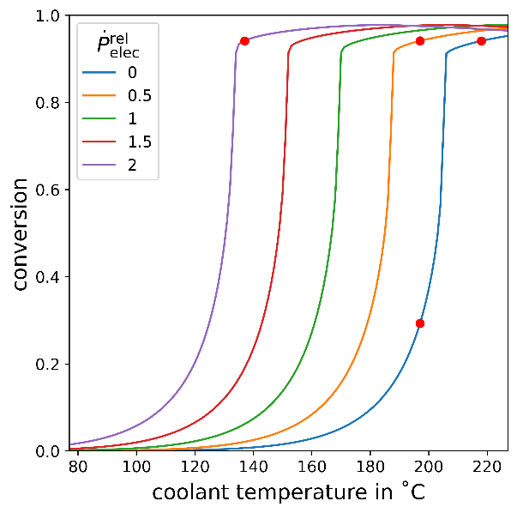  (a) | 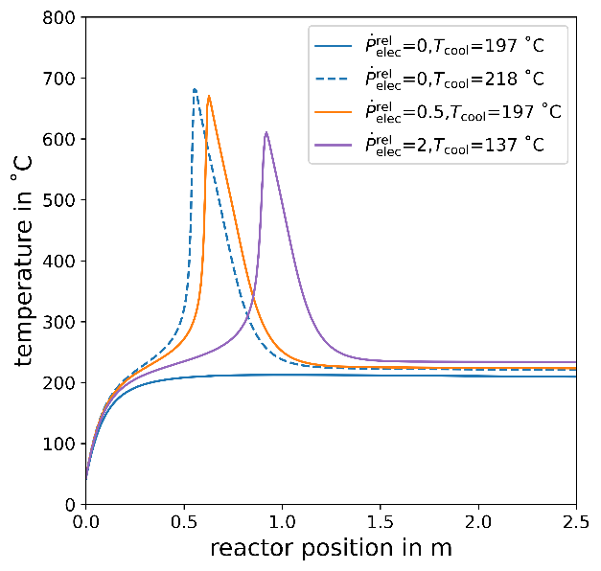  (b)
Figure 2: (a) Ignition curves for different levels of electric heating (red markers denote examples shown in (b)). (b) Corresponding axial temperature profiles
To investigate the effect of electric heating on coolant temperatures, the ignition curve, i.e., the reactor conversion over the coolant temperature, is simulated for several relative electric power values ranging from zero to two. The results, shown in Figure 2a, clearly indicate the characteristic ignition curve of an exothermic reaction, which exhibits the kinetic limitations at lower temperatures and equilibrium limitations at higher temperatures. Comparing the curve of the unelectrified base case to the other curves shows only minor differences in shape, but large differences in position. In other words, introducing electric heat shifts the ignition curve towards lower temperatures and thus reduces the coolant temperature required for ignition. This relaxes the aforementioned compromise and enables an ignited state at significantly lower coolant temperatures compared with the base case. For example, at the high relative electric power of two, the same conversion can be achieved at a coolant temperature of only 137 °C, while the unelectrified base case requires 218 °C. The internal heat input thus effectively compensates for the insufficient thermal activation of the feed, while external cooling still removes the reaction heat effectively once the reaction is established.
This effect is illustrated in Figure 2b, where four axial temperature profiles are compared: an unignited base case, an ignited base case as well as two ignited cases with low and high electric heating respectively. The ignited base case shows the characteristic hot-spot profile of an ignited methanation reactor that indicates high conversions. At reduced coolant temperatures, the base case remains unignited due to insufficient internal temperatures, which results in low conversions. With internal heating at the same reduced coolant temperature, the electrically assisted reactor reaches an ignited state and develops a hot-spot profile similar to that of the ignited base case. A similar conversion is achieved even when further decreasing the coolant temperature by increasing the electric heating. The practical implication is substantial: reactor operation can become less dependent on elevated coolant temperatures and thus less constrained by the thermal limitations of the reactor material and the cooling medium. In particular, this may facilitate the use of simpler cooling concepts or reduce the need for more demanding high-temperature coolants. This also suggests that ignition may be possible under extreme conditions, such as with a room-temperature coolant.
    - Control of hot-spot position
Beyond decoupling coolant temperature from ignition, the additional degree of freedom can be used to influence the axial position of the hot-spot, which can be a critical factor for the reactor design and operation. As reactant concentrations are largest at the inlet, hot-spots in that region will have higher temperatures than in cases with hot-spots closer to the reactor outlet. Additionally, a hot-spot close to the inlet implies underutilization of the remaining reactor length. This is particularly relevant when the operating load range needs to be large, as high loads tend to shift the hot-spot towards the reactor outlet, whereas low loads tend to shift it towards the inlet. In addition to the reactor load and coolant temperature, the hot-spot position is largely determined by the inlet temperature.
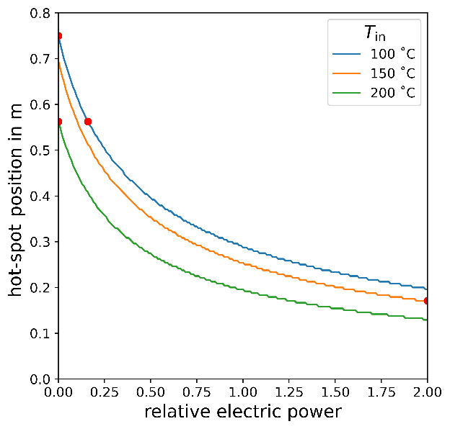  (a) | 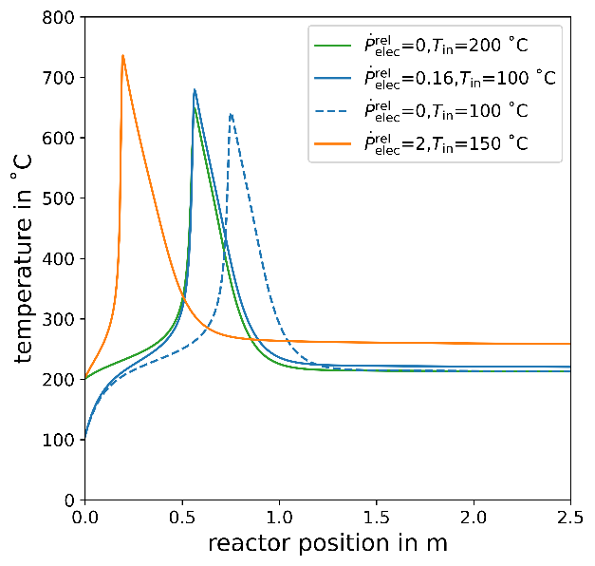 (b)
Figure 3: (a) Hot-spot position versus relative electric power at different inlet temperatures ($T_{cool}=210 °C$, red markers denote examples shown in (b)). (b) Corresponding axial temperature profiles
Subsequently, in this scenario the effect of electric heating on the hot-spot position for different inlet temperatures is investigated. Figure 3a shows that internal electric heating offers a direct means of shifting the hot-spot position for all investigated inlet temperatures. The mechanism is illustrated in Figure 3b. As the heating power is increased, the temperature in the upstream reactor section rises, which promotes earlier reaction onset. This indicates that even with a reduced inlet temperature, electric heating can be used to achieve a hot-spot at the same axial position. For example, at an inlet temperature of 100 °C, increasing the relative electric power from 0 to 0.16 shifts the hot-spot position from 0.75 m to 0.56 m.
Depending on the inlet conditions and the chosen heating power, this can move the main reaction zone upstream or, alternatively, stabilize it in an intermediate region when changing operating conditions would otherwise displace it towards critical locations. A key observation is that the hot-spot location becomes actively adjustable rather than a passive consequence of feed conditions and coolant temperature alone. This increases the accessible operating range, since constraints related to critical inlet- or outlet-near hot-spots can be relaxed. For catalyst systems prone to thermal deactivation, this capability may be especially valuable.
  - Conclusions
A simulation study was conducted to assess the potential of combining internal electric heating and external cooling for exothermic fixed-bed reactors using CO₂ methanation as a case study. The results show that the additional thermal degree of freedom can be exploited in several ways beyond previously reported product-quality stabilization during load changes and improvements in reactor stability.
First, internal electric heating enables ignited reactor operation at lower coolant temperatures and therefore extends the feasible operating window. Second, the hot-spot position can be adjusted, which potentially supports safer operation and improves catalyst utilization.
Overall, the combined concept improves flexibility and operability of exothermic reactors while preserving the advantages of established cooled tubular reactor configurations. These findings indicate substantial potential not only for methanation, but also for other strongly exothermic catalytic reactions such as ammonia synthesis, methanol synthesis, or Fischer-Tropsch synthesis.
The present study focuses on basic applications of the additional degree of freedom. However, the results also suggest further opportunities, for example, accelerated start-up and load changes, or coordinated manipulation of coolant temperature and internal heating power. It should be noted that the improvements come at the cost of increased reactor complexity and additional energy demand. The resulting impact on overall energy efficiency and process economics requires further investigation. A detailed analysis of the impact on dynamic behavior and further operation range extension is beyond the scope of the present paper, but the combined reactor concept provides a promising basis for future work in this direction. Future work should specifically investigate the effect of heating on local catalyst temperatures and the consequent impact on long-term catalyst stability and mechanical integrity.
Nomenclature
$c_{p}$ – specific heat capacity, J/(kg·K)
$d_{p}$ – catalyst particle diameter, m
$k_{w}$ – heat transfer coefficient, W/(m²·K)
$\tilde{M}$ – molecular mass, kg/mol
$\dot{N}$ – molar flow, mol/s
$p$ – pressure, Pa
${\dot{P}}_{elec}^{rel}$ – relative electric power, -
${\dot{q}}_{elec}$ – volumetric electric heat source, W/m³
${\dot{Q}}_{elec}$ – electric heat flow, W
${\dot{Q}}_{reac}^{max}$ – heat release at full conversion, W
$T$ – temperature, K
$\tilde{r}$ – reaction rate, mol/(m³_{cat}·s)
$R$ – reactor radius, m
$t$ – time, s
$u_{s,z}$ – superficial velocity, m/s
$V_{R}$ – reactor volume, m³
$w$ – species mass fraction, -
$z$ – axial reactor position, m
$α$ – species index, -
$Δ_{R}\tilde{H}$ – reaction enthalpy, J/mol
$ε$ – bed void fraction, -
$ρ_{gas}$ – gas density, kg/m³
$μ_{gas}$ – gas viscosity, kg/(m·s)
$ν$ – stoichiometric coefficient, -
$η_{cat}$ – catalyst efficiency factor, -
References
Ambrosetti M., 2022, A perspective on power-to-heat in catalytic processes for decarbonization, Chemical Engineering and Processing - Process Intensification, 182, 109187.
Bremer J., Sundmacher K., 2019, Operation range extension via hot-spot control for catalytic CO₂ methanation reactors, Reaction Chemistry & Engineering, 4, 1019–1037.
Daccache S., Ghosh S., Marias F., Chaudret B., Carrey J., 2024, Iron wool as a heating agent for magnetic catalysis: experiments and analysis of heating properties under a high-frequency magnetic field, Journal of Applied Physics, 136, 133901.
Fache A., Marias F., 2020, Dynamic operation of fixed-bed methanation reactors: yield control by catalyst dilution profile and magnetic induction, Renewable Energy, 151, 865–886.
Fache A., Marias F., Chaudret B., 2020, Catalytic reactors for highly exothermic reactions: steady-state stability enhancement by magnetic induction, Chemical Engineering Journal, 390, 124531.
Ferri G., Ambrosetti M., Beretta A., Groppi G., Tronconi E., Agosti A., 2025, A novel electrified methane steam reformer for intensified H₂ production based on conductive packed foams: experimental and modelling assessment, Chemical Engineering Journal, 523, 168753.
Froment G.F., 1974, Fixed bed catalytic reactors. Technological and fundamental design aspects, Chemie Ingenieur Technik, 46, 374–386.
Gottheil L., Bremer J., 2025, Shifting towards dynamic and load-flexible ammonia synthesis via polytropic fixed-bed reactors, Chemical Engineering Journal, 526, 170927.
Henda R., Machac A., Nilsson B., 2008, Heat and mass transport in a nonlinear fixed-bed catalytic reactor: hot spots and thermal runaway, Chemical Engineering Journal, 143, 195–200.
Jess A., Popp R., Hedden K., 1999, Fischer–Tropsch-synthesis with nitrogen-rich syngas: fundamentals and reactor design aspects, Applied Catalysis A: General, 186, 321–342.
Koschany F., Schlereth D., Hinrichsen O., 2016, On the kinetics of the methanation of carbon dioxide on coprecipitated NiAl(O)_{x}, Applied Catalysis B: Environmental, 181, 504–516.
Sauer J., Dahmen N., Henrich E., 2013, Tubular plug flow reactors, Ullmann’s Encyclopedia of Industrial Chemistry, John Wiley & Sons, Ltd, Weinheim, 1–23.
Schlereth D., Hinrichsen O., 2014, A fixed-bed reactor modeling study on the methanation of CO₂, Chemical Engineering Research and Design, 92, 702–712.
Tegrotenhuis W.E., King D.L., Whyatt G.A., Fischer C.M., Wegeng R.S., Brooks K.P., 2007, Microchannel reactors with temperature control, United States Patent US7297324B2, patents.google.com/patent/US7297324B2/en accessed 10.02.2026.
Watanabe R., Nishide K., Suganuma H., Verma P., Akama H., Fukuhara C., 2025, E-methanation with a spiral catalyst: optimized thermal management and long-term stability, RSC Advances, 15, 7365–7370.
Wismann S.T., Larsen K.-E., Mølgaard Mortensen P., 2022, Electrical reverse shift: sustainable CO₂ valorization for industrial scale, Angewandte Chemie International Edition, 61, e202109696.
Zhang J., Wang K., Teixeira A.R., Jensen K.F., Luo G., 2017, Design and scaling up of microchemical systems: a review, Annual Review of Chemical and Biomolecular Engineering, 8, 285–305.
Zheng L., Ambrosetti M., Tronconi E., 2024, Joule-heated catalytic reactors toward decarbonization and process intensification: a review, ACS Engineering Au, 4, 4–21.

