 CHEMICAL ENGINEERING TRANSACTIONS  VOL. xxx, 2026 | A publication of  
The Italian Association
of Chemical Engineering
Online at www.cetjournal.it

Guest Editors: Flavio Manenti, Botir Usmonov, Alessandro Di Pretoro
Copyright © 2026, AIDIC Servizi S.r.l.
ISBN 979-12-81206-xx-x; ISSN 2283-9216

Durability of Optical Frequency Domain Reflectometry Sensors in Dynamic High-Temperature Fixed-Bed Reactors
Daniel Greiner, Lukas Gottheil, Jens Bremer*
Clausthal University of Technology, Institute of Chemical and Electrochemical Process Engineering, Leibnizstraße 17, 38678 Clausthal-Zellerfeld, Germany
*bremer@icvt.tu-clausthal.de
Dynamic operation of catalytic fixed-bed reactors in Power-to-X processes requires spatially and temporally resolved temperature measurements, because transient hot-spots strongly affect reactor safety, catalyst durability, and model-based process design and control. Conventional thermocouples provide only limited spatial resolution and may disturb the packed bed, whereas optical frequency domain reflectometry (OFDR) enables distributed temperature sensing along minimally invasive fiber-optic probes. In this work, thin-walled stainless-steel-encapsulated OFDR sensors were evaluated for dynamic measurements in high-temperature packed-bed reactors. An external calibration apparatus was constructed to compare ramp-based and stepwise ex situ calibration against K-type thermocouples, while in situ calibration consistency and in operando sensor performance were assessed under realistic reactor conditions using exothermic CO₂ methanation. Sensor-specific calibration was found to be necessary, and fast ramp calibration showed deviations from stepwise calibration due to incomplete thermal equilibration of the calibration assembly. Exposure to approximately 650 °C for 1 h altered the local Rayleigh backscatter pattern after cooling. However, rekeying established a new reference state and restored calibration-consistent behavior below approximately 500 °C. During dynamic reactor operation, the sensor resolved downstream hot-spot migration during an increase in total inlet flow from approximately 21 to 91 NL min⁻¹ over 5 min and the subsequent relaxation toward a new steady state over approximately 8 min, using an axial resolution of 1.3 mm and an acquisition rate of 4 Hz. The results demonstrate that stainless-steel-encapsulated OFDR sensors are suitable for dynamic reactor-model validation and future load-following control applications, provided that sensor-specific calibration, rekeying after thermal excursions, and recalibration after severe high-temperature exposure are considered.
  - Introduction
Fluctuating renewable energy supply and the resulting variability in Power-to-X feedstocks, particularly green hydrogen (H₂), are increasing the need for dynamically operated heterogeneous catalytic reactors. Grenko et al. (2026) have shown that dynamic operation necessitates novel analytical tools to accurately model and simulate dynamic fixed-bed reactors. They propose detailed concentration analysis during dynamic reactor operation to reduce model uncertainty, and also note the large influence of transient temperature fields. In strongly exothermic fixed-bed reactors, the spatial temperature profile, particularly the magnitude and axial position of the hot-spot, can be regarded as a thermal fingerprint of the reactor state. Resolving the evolution of this fingerprint during transient operation therefore provides a direct means of assessing reactor dynamics and validating corresponding reactor models.
Conventional thermocouples are widely used for reactor monitoring, but their relatively large diameters and limited multiplexing capabilities constrain their applicability in highly dynamic, spatially resolved measurements. Multipoint thermocouple assemblies can significantly disturb the packed-bed void fraction and introduce thermal lag due to their thermal mass. These drawbacks motivate the development of minimally invasive, high-resolution alternatives capable of closely following dynamic temperature fields.
Fiber-optic temperature sensors have emerged as promising candidates, owing to their small sensor diameter, simple manufacturing, and ability to host multiple sensing points along a single optical fiber. A review by Ma et al. (2022) identified the main areas of fiber-optic sensor application in the aerospace and metallurgical industries. Stegehake and Gruenewald (2017) proposed the use of minimally invasive fiber-optic sensors as an alternative to traditional thermocouples in chemical reactors. Many applications in chemical reactors have focused on steady-state operation. For instance, Geschke et al. (2024) used this technique to investigate core-shell particles for CO₂ methanation, while Stegehake et al. (2018) used it to evaluate the heat transfer coefficients in fixed beds. Several optical principles can be exploited, including Rayleigh, Brillouin or Raman scattering. Raman-based sensors extend the accessible temperature window but at the cost of reduced signal-to-noise ratios and low spatial resolution. Brillouin-based systems enable long-range distributed measurements, but suffer from low acquisition rates and similarly low spatial resolution (Ma et al., 2022). For highly dynamic catalytic fixed-bed reactors, a technique that combines high spatial resolution with sub-second response time is preferred.
Optical frequency-domain reflectometry (OFDR) can be used to interrogate the intrinsic Rayleigh backscatter pattern of an optical fiber, enabling distributed temperature sensing with sub-millimeter spatial resolution. Nguyen et al. (2013) demonstrated the ability of distributed OFDR to resolve transient spatiotemporal temperature fields in a catalytic monolith reactor during Pt-catalyzed ammonia oxidation. Further reactor applications include Cholewa et al. (2024) for steady-state ammonia synthesis kinetics at temperatures up to 450 °C, Nestler et al. (2021) for steady-state methanol kinetics below 300 °C, and Bremer (2020) for high-temperature dynamic methanation. However, a systematic assessment of calibration stability, thermal durability, and dynamic response under high-temperature reactive fixed-bed conditions remains limited. The main limitation in this case is that silica fibers undergo viscous creep, dopant diffusion, and coating degradation at elevated temperatures. These effects may alter the Rayleigh backscatter pattern or the applicable calibration curve, thereby introducing temperature-measurement errors and potentially compromising mechanical robustness (Ma et al., 2022). To protect the fiber from corrosive media, pressure excursions, and mechanical abrasion during catalyst loading, it is embedded in a thin-walled stainless-steel capillary that may introduce appreciable thermal lag or axial temperature smearing.
The present work investigates stainless-steel-encapsulated OFDR fiber-optic temperature sensors for application in highly dynamic packed-bed reactors. The main hypotheses are that (i) degradation of the fiber-optic sensor due to overheating can be compensated for by re-evaluating the characteristic backscattering behavior, (ii) per-fiber calibration over the entire operating range between approximately 20 °C and 650 °C is necessary to avoid systematic deviations, and (iii) the fiber-optic sensor is suitable for measurement during dynamic reactor operation. To test these hypotheses, an external calibration apparatus is constructed, calibration strategies are developed and assessed, and the sensors are implemented in a packed-bed reactor equipped with both central and wall-mounted fibers. Experiments were conducted to investigate sensor durability with respect to hot-spot burn-in and dynamic hot-spot migration.
  - Methods
    - Fiber-optic temperature sensing principle
In an OFDR system, a narrow-linewidth laser source is swept linearly in optical frequency. Light backscattered from microscopic variations in the refractive index of the sensing fiber is compared to a reference measurement, and the resulting interference pattern is recorded as a function of time. These refractive index variations, arising from intrinsic density fluctuations and small-scale compositional variations within the fiber, act as distributed scattering centers and give rise to Rayleigh backscattering. A Fourier transformation converts this signal into a spatially resolved backscattering profile along the fiber (Rahim et al., 2015). The achievable axial resolution is below one millimeter, enabling the reconstruction of detailed temperature fields along the fiber path (Kreger et al., 2016).
Temperature information is obtained by tracking the temperature-dependent shift of the Rayleigh backscatter pattern relative to a previously recorded reference pattern at a specific sensor temperature (typically ambient temperature). These shifts arise from changes in the refractive index of the fiber, through the thermo-optic coefficient, and its physical length due to thermal expansion. During calibration, the fiber is subjected to a series of well-defined temperatures, and the corresponding local frequency shifts are recorded and mapped to temperature, thereby generating a calibration curve for the fiber spanning the entire temperature range. Subsequent measurements are evaluated by comparing the instantaneous Rayleigh pattern to the reference pattern and converting the measured frequency shifts to absolute changes in temperature after applying the calibration. Mechanical strain also influences the local backscattering behavior of the fiber sensor, as Rayleigh-based distributed sensing is intrinsically sensitive to both strain and temperature (Palmieri et al., 2022). In the present work, the fibers are encapsulated in thin-walled stainless-steel capillaries supplied by Polytec GmbH to reduce strain cross-sensitivity. The LUNA ODiSI 7108 interrogator used in this study has a reported accuracy of ±1 K, a minimum spatial resolution of 0.65 mm, and acquisition rates of up to 20 Hz. The measurements reported here were acquired at an axial resolution of 1.3 mm and an acquisition rate of 4 Hz.
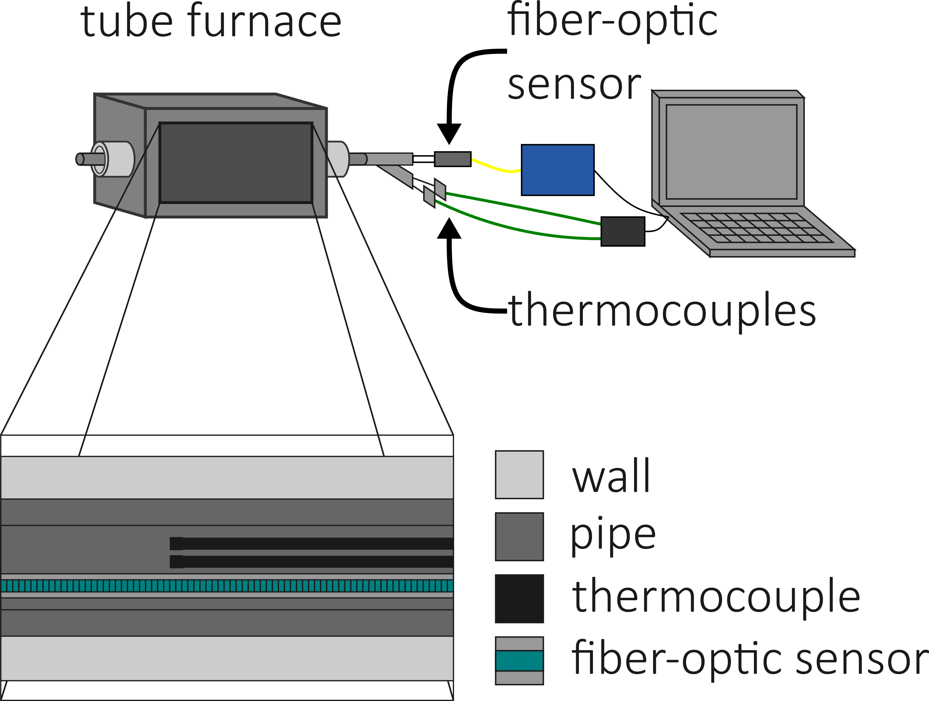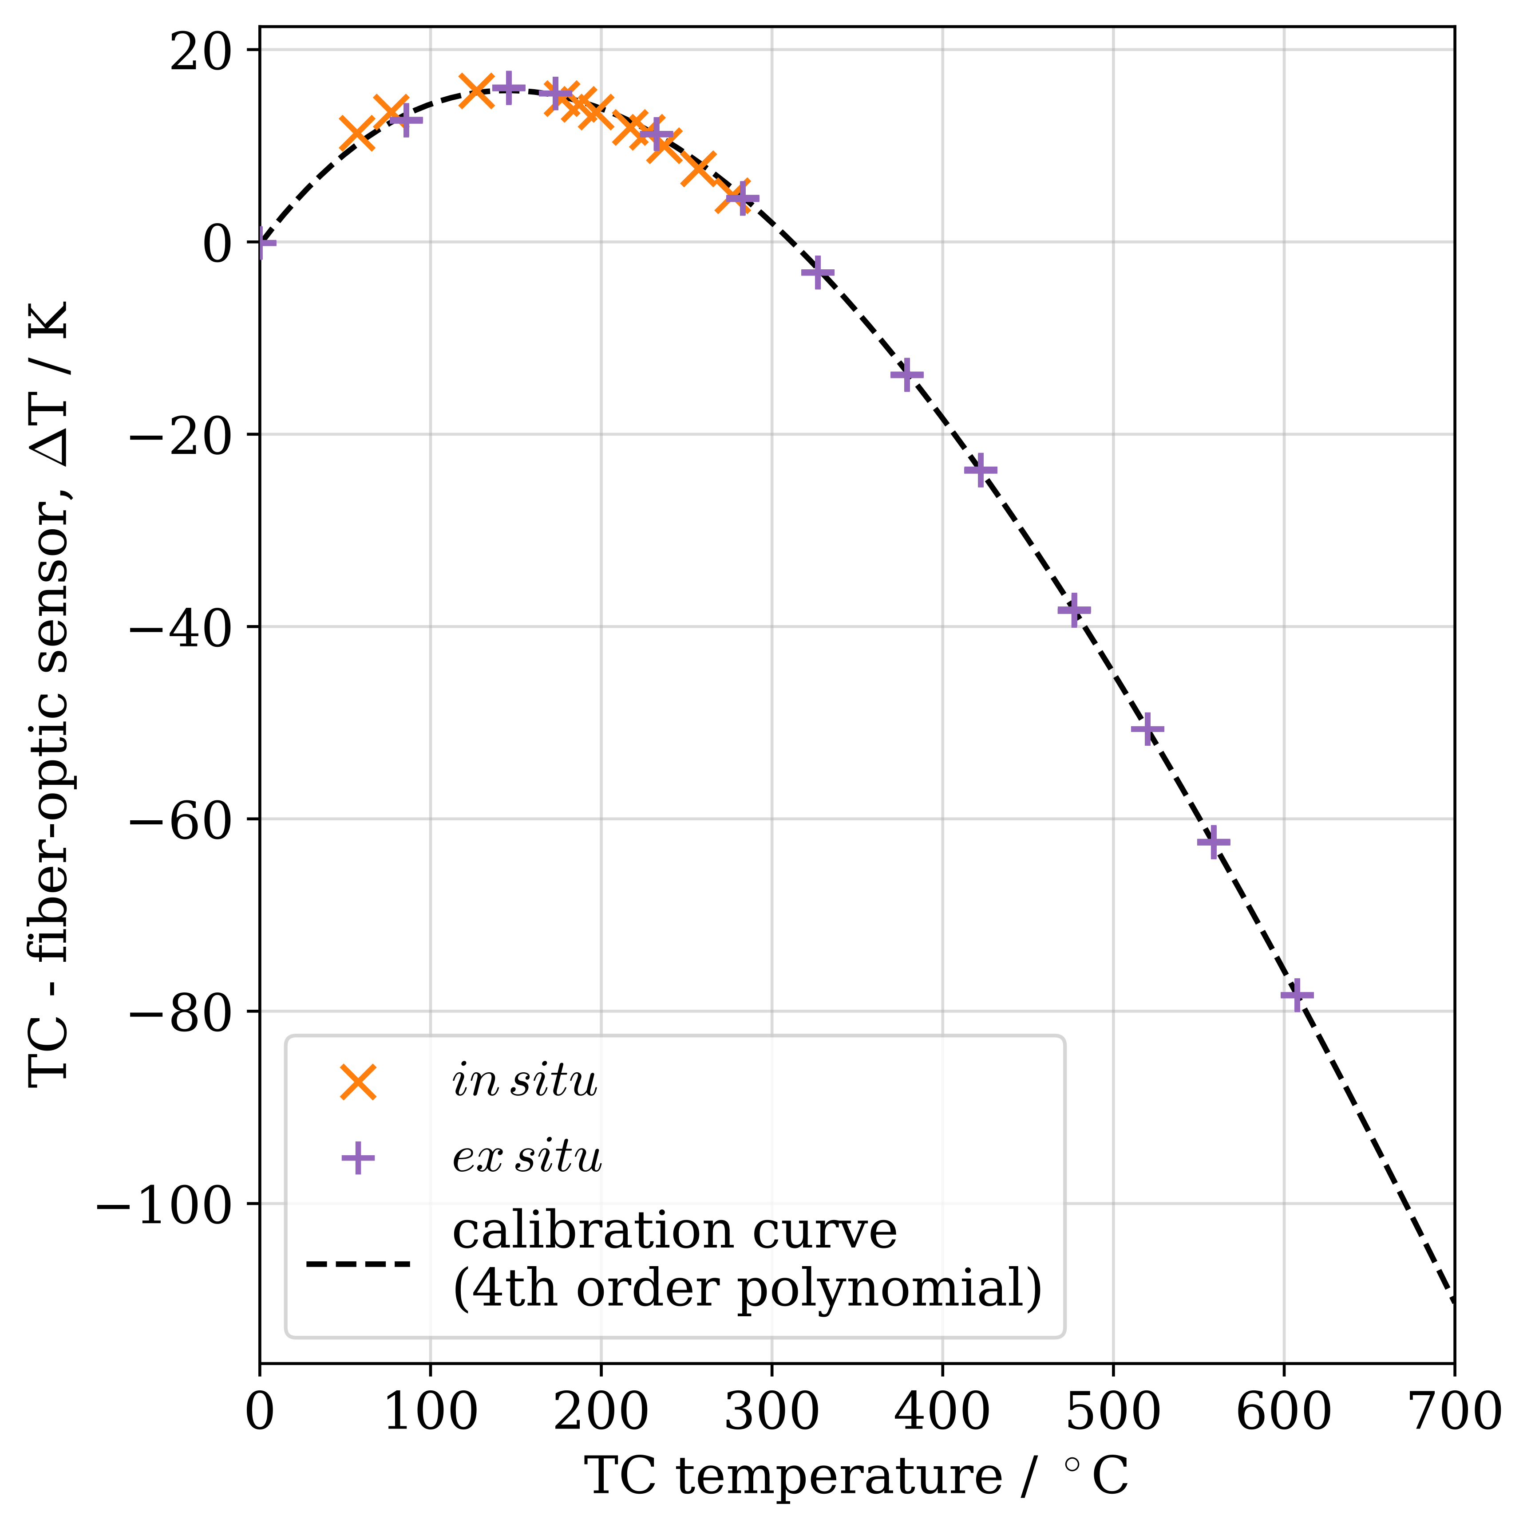
a)
b)
Figure 1: Calibration of the fiber-optic sensor under ex situ and in situ conditions. a) External calibration setup with tube furnace, K-type thermocouples, and fiber-optic sensor. b) Comparison of ex situ and in situ calibration curves.
    - Ex situ calibration
The calibration of the OFDR sensor is performed in an external tube furnace (Carbolite, GHA 12/300) with a heated length of approximately 30 cm. A custom stainless-steel pipe assembly is placed inside the hot zone of the furnace. This pipe contains an inlet and outlet for carrier gas, a stainless-steel feed-through accommodating up to four K-type thermocouples, and a dedicated connector for the fiber-optic sensor. This configuration is illustrated in Figure 1a and enables simultaneous acquisition of reference temperatures and fiber response under controlled conditions.
Two principal calibration strategies are investigated: a continuous linear temperature ramp from 20 to 650 °C with a heating rate of 25 °C min⁻¹ and a sequence of steady-state steps in the same temperature range. In the ramp protocol, the furnace temperature is increased linearly with time, providing a dense set of calibration points across the targeted temperature interval. In the stepwise protocol, the tube furnace is operated at a series of discrete temperature levels. At each level, the system is allowed to reach steady state. If the calibration curves obtained from the ramp and stepwise strategies agree within the sensor accuracy, the thermal response of the encapsulated fiber and reference thermocouples can be considered sufficiently fast relative to the imposed temperature ramp, such that thermal lag and axial temperature smearing do not significantly distort the calibration and subsequent measurements.
The upper calibration temperature of 650 °C exceeds the reported long-term stability limit of approximately 550 °C (Rahim et al., 2015), which can permanently alter the Rayleigh reference pattern and lead to apparent burn-in after cooling, where the recorded temperature may deviate from the actual temperature. A new reference pattern was therefore recorded (rekeying) after cooling. To assess repeatability, the sensor was held at approximately 650 °C for 1 h at the end of each calibration, cooled to ambient temperature, rekeyed, and recalibrated. This procedure was repeated three times.
    - Reactor configuration
The experimental reactor setup is housed within a modular Power-to-X lab pilot plant. The plant’s gas mass flow controllers accommodate the most common reactants for Power-to-X applications, namely hydrogen, nitrogen, and carbon dioxide. An additional supply line for variable input gases, such as ammonia or methane, is present to allow for rapid switching between plant setups and thus reaction conditions. The plant is designed to house multiple reactor geometries and nominal gas throughputs. In this study, an industrial-scale, externally cooled single tube fixed-bed reactor and the highly exothermic CO₂ methanation reaction were chosen to give insight into the performance of the fiber-optic sensors in such extreme conditions. Detailed reactor geometry and catalyst specifications are not disclosed here; however, the investigated configuration corresponds to reactor operation at industrially relevant pressure and flow conditions. Volumetric reactant flow rates of up to 410 NL min⁻¹ and pressures up to 25 bar(g) are possible, allowing the evaluation of industrial operating conditions for a single tube, e.g., as a representative unit of a multi-tubular reactor.
The reactor was designed to accommodate simultaneous axial temperature measurements from two fiber-optic sensors. One sensor is positioned at the radial center of the reactor, while the second sensor is positioned at the inner surface of the reactor wall. The central fiber is housed inside an additional thin-walled stainless-steel pipe. This additional pipe mechanically protects the fiber during catalyst loading and unloading and maintains its position at the reactor centerline. The wall temperature is recorded along the axial direction to quantify heat transfer and validate heat-transfer models during dynamic load changes. The combined central and wall sensor configuration provides radial temperature information over the entire axial bed length. The central sensor provides a bulk temperature profile within the core of the reactor that can be directly compared with the moving thermocouple, whereas the wall sensor supplies the boundary temperature. Together, these measurements support the validation of dynamic reactor models and the extraction of effective heat-transfer coefficients required for advanced model-based analysis and control of industrial-scale processes. For the dynamic demonstration, the total inlet flow was increased from approximately 21 to 91 NL min⁻¹ over 5 min, while the feed composition and remaining operating conditions were kept constant. The final inlet flow was subsequently held constant, and the reactor temperature field continued to evolve for approximately 8 min before a new steady state was reached.
  - Results
    - Calibration strategies
The performance of the OFDR fiber-optic sensor depends strongly on the quality of the calibration that links Rayleigh frequency shifts to temperature. Both ex situ and in situ procedures are therefore examined. As shown in Figure 1b, the ex situ and in situ calibration curves are in close agreement over the overlapping temperature range and are essentially superimposed. This demonstrates that installation of the sensor in the reactor does not introduce a measurable systematic shift in the calibration within the investigated range. The in situ procedure can therefore be used as a practical consistency check of an existing ex situ calibration during reactor start-up. If the full temperature range of interest can be covered under in situ conditions, it can also be used as a complete calibration procedure. The ex situ approach remains preferable when temperatures beyond the accessible reactor operating range must be included in the calibration.
Figure 2a compares the sensor-specific calibration obtained in this study with a previously reported calibration for a similar OFDR sensor (Bremer, 2020). The comparison is restricted to the overlapping temperature range, as the previously reported calibration was established only up to approximately 300 °C. Both calibrations are similar at low temperatures but diverge with increasing temperature, reaching a maximum difference of approximately 5.5 K near 240 °C. This demonstrates that calibration is not necessarily transferable between nominally similar fiber-optic sensors and supports sensor-specific calibration over the entire application-relevant temperature range.
Figure 2b compares the ramp (25 °C min⁻¹) and stepwise calibration approaches. The resulting calibration curves of both methods are substantially different and warrant further investigation into thermal lag. The divergence may be attributed to incomplete thermal equilibration within the calibration assembly, such that radially separated sensor and thermocouple positions may experience different temperatures during heating. Differences in thermal inertia of the fiber-optic sensor and the thermocouples may further contribute to this mismatch. A slower ramp would therefore be expected to reduce this mismatch by allowing for thermal equilibration of the calibration assembly. The presented results should be interpreted as a limitation of the investigated fast ramp calibration procedure rather than as an inherent limitation of the fiber-optic sensor.

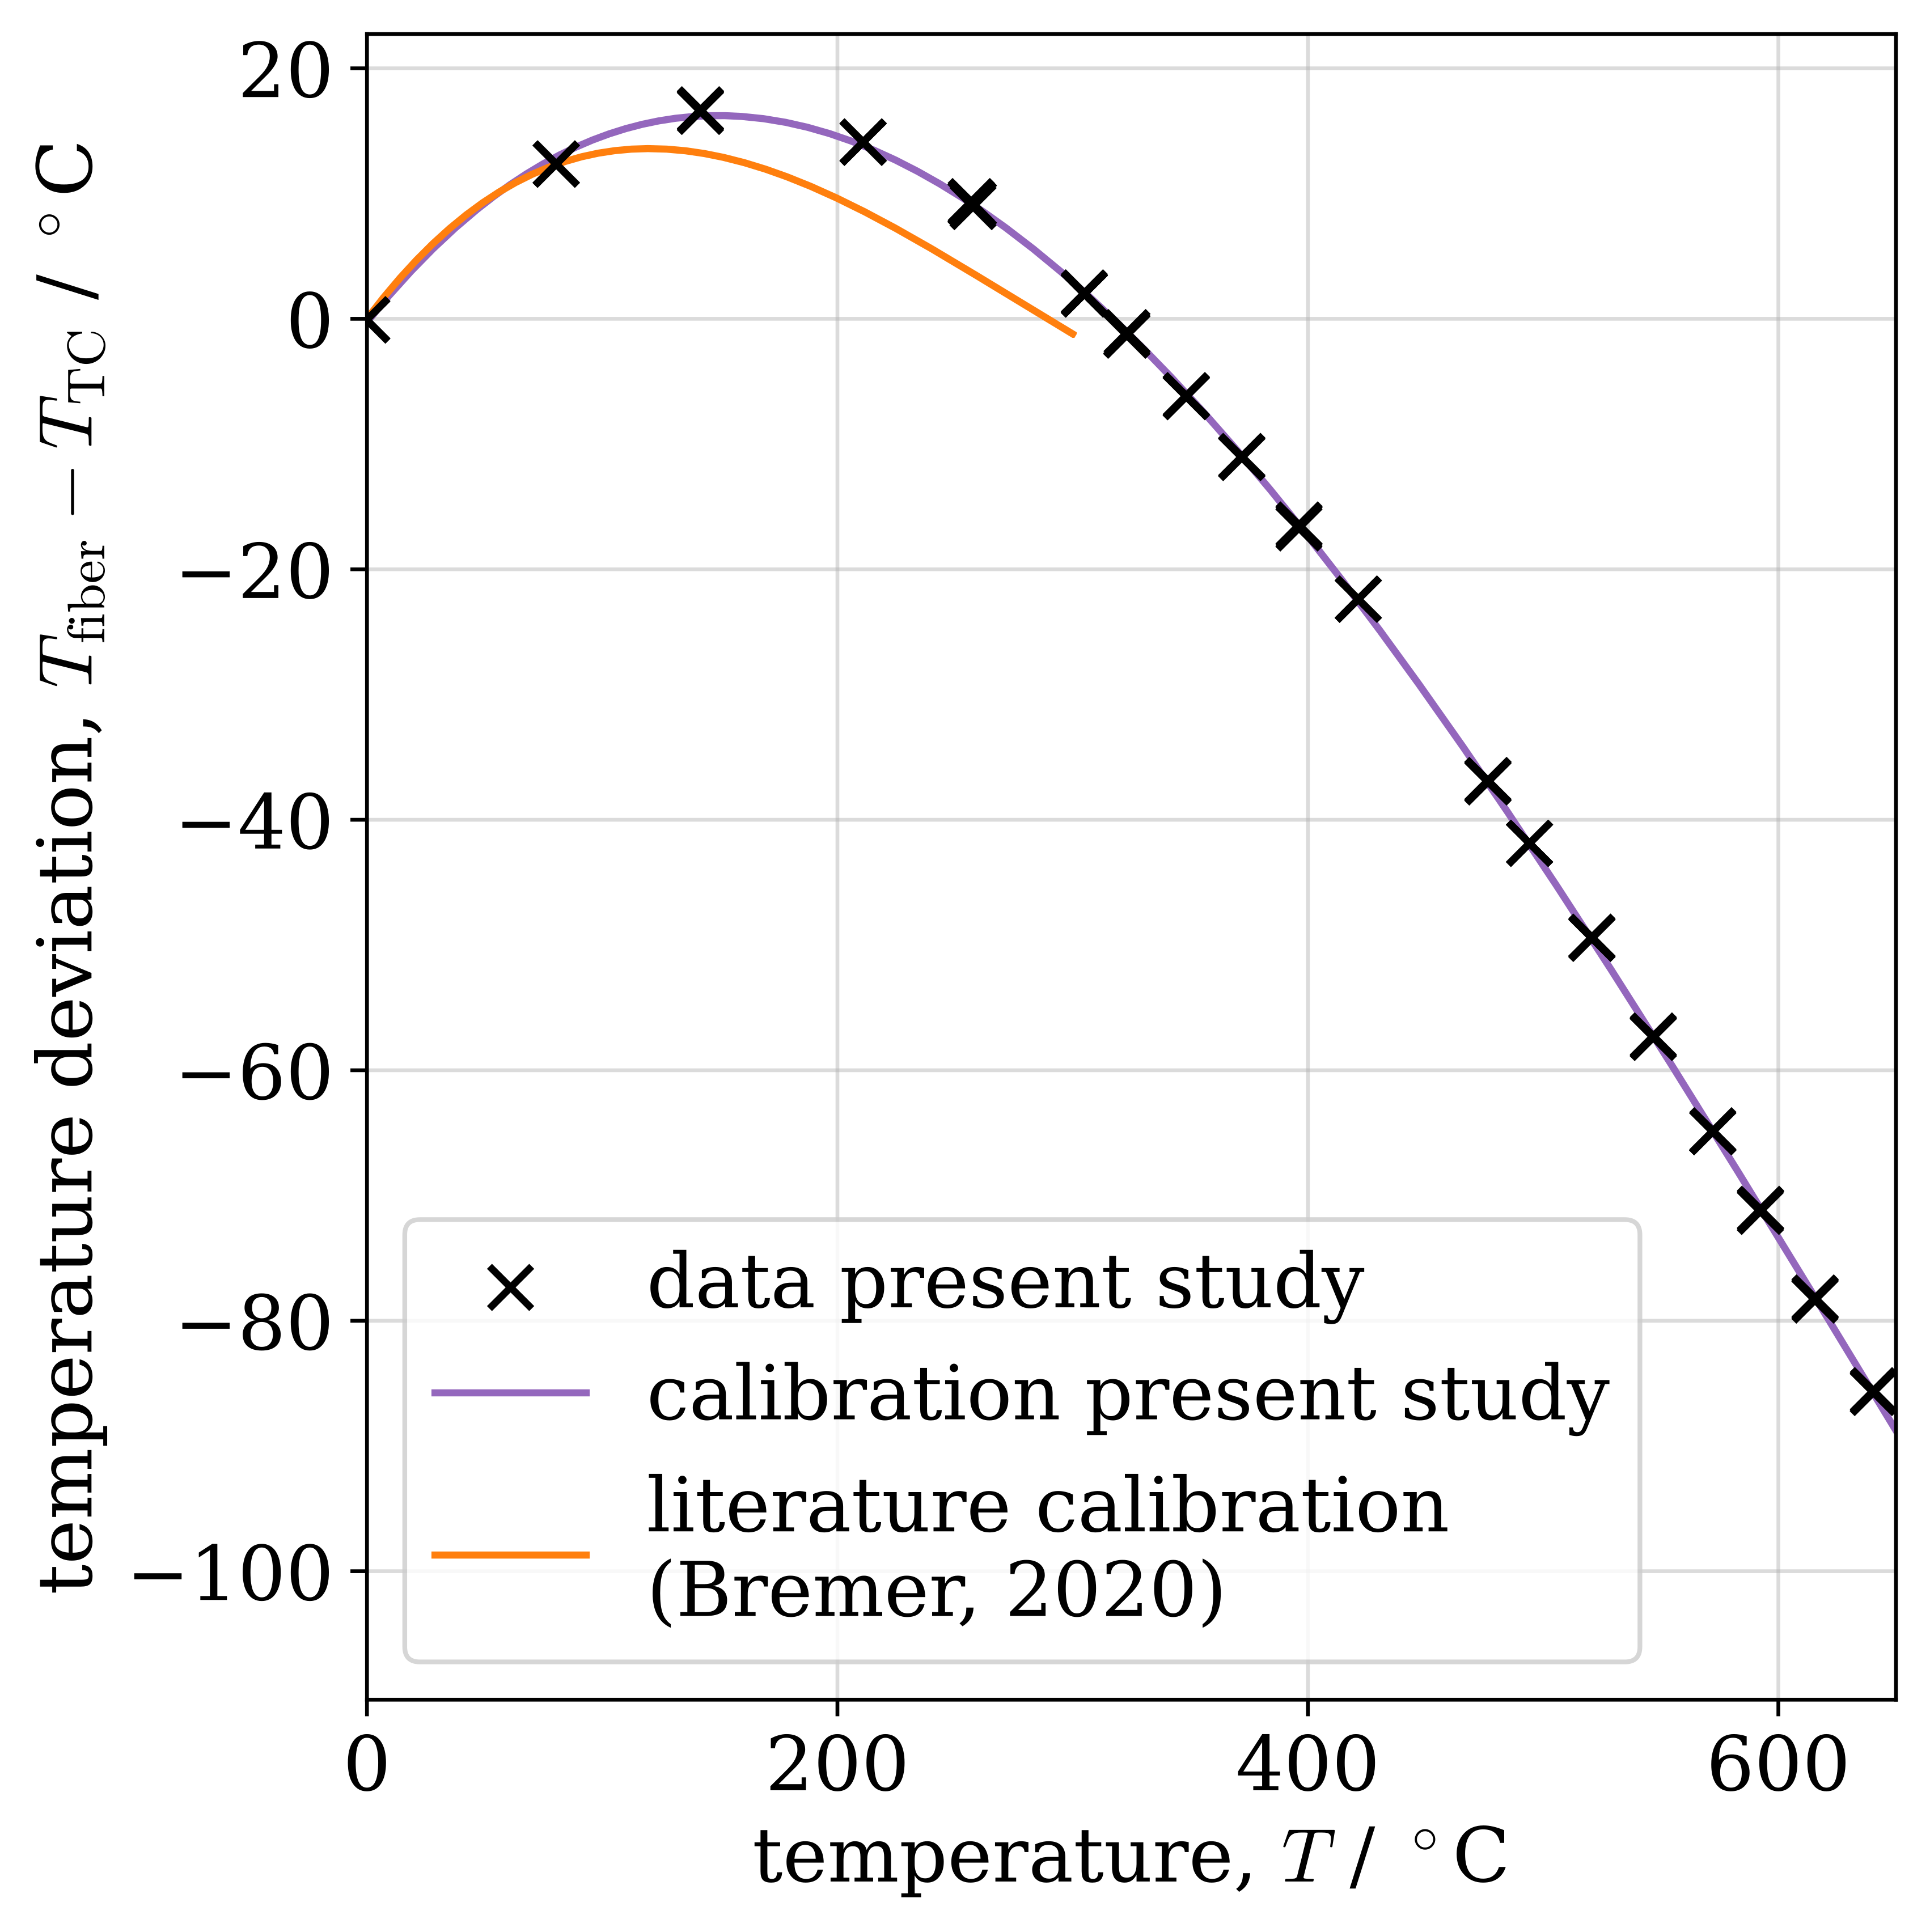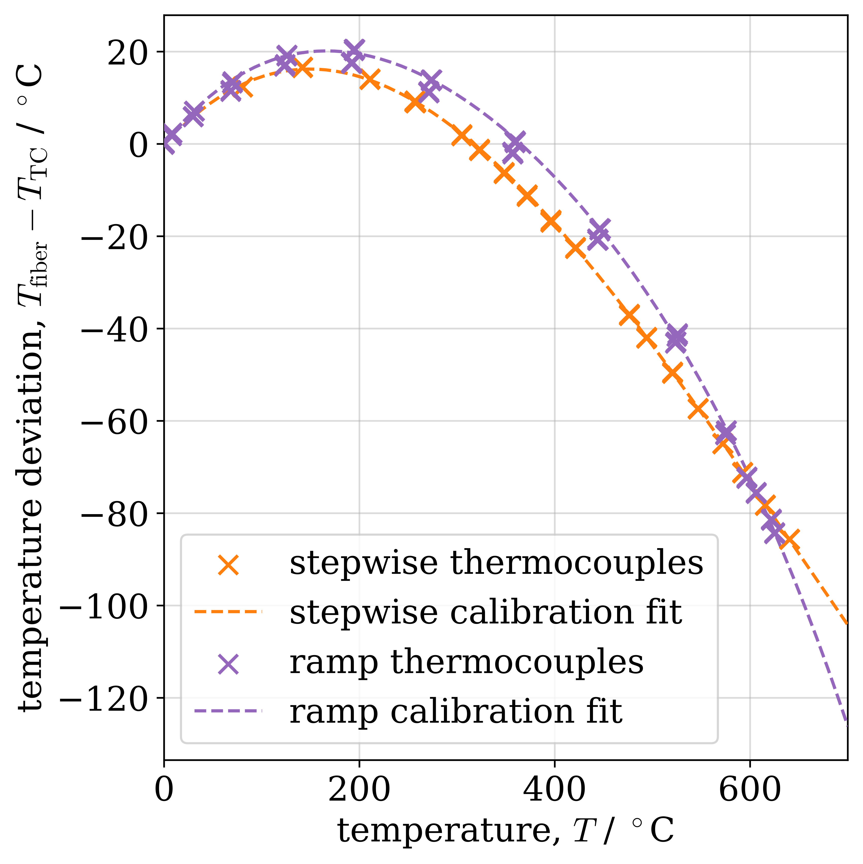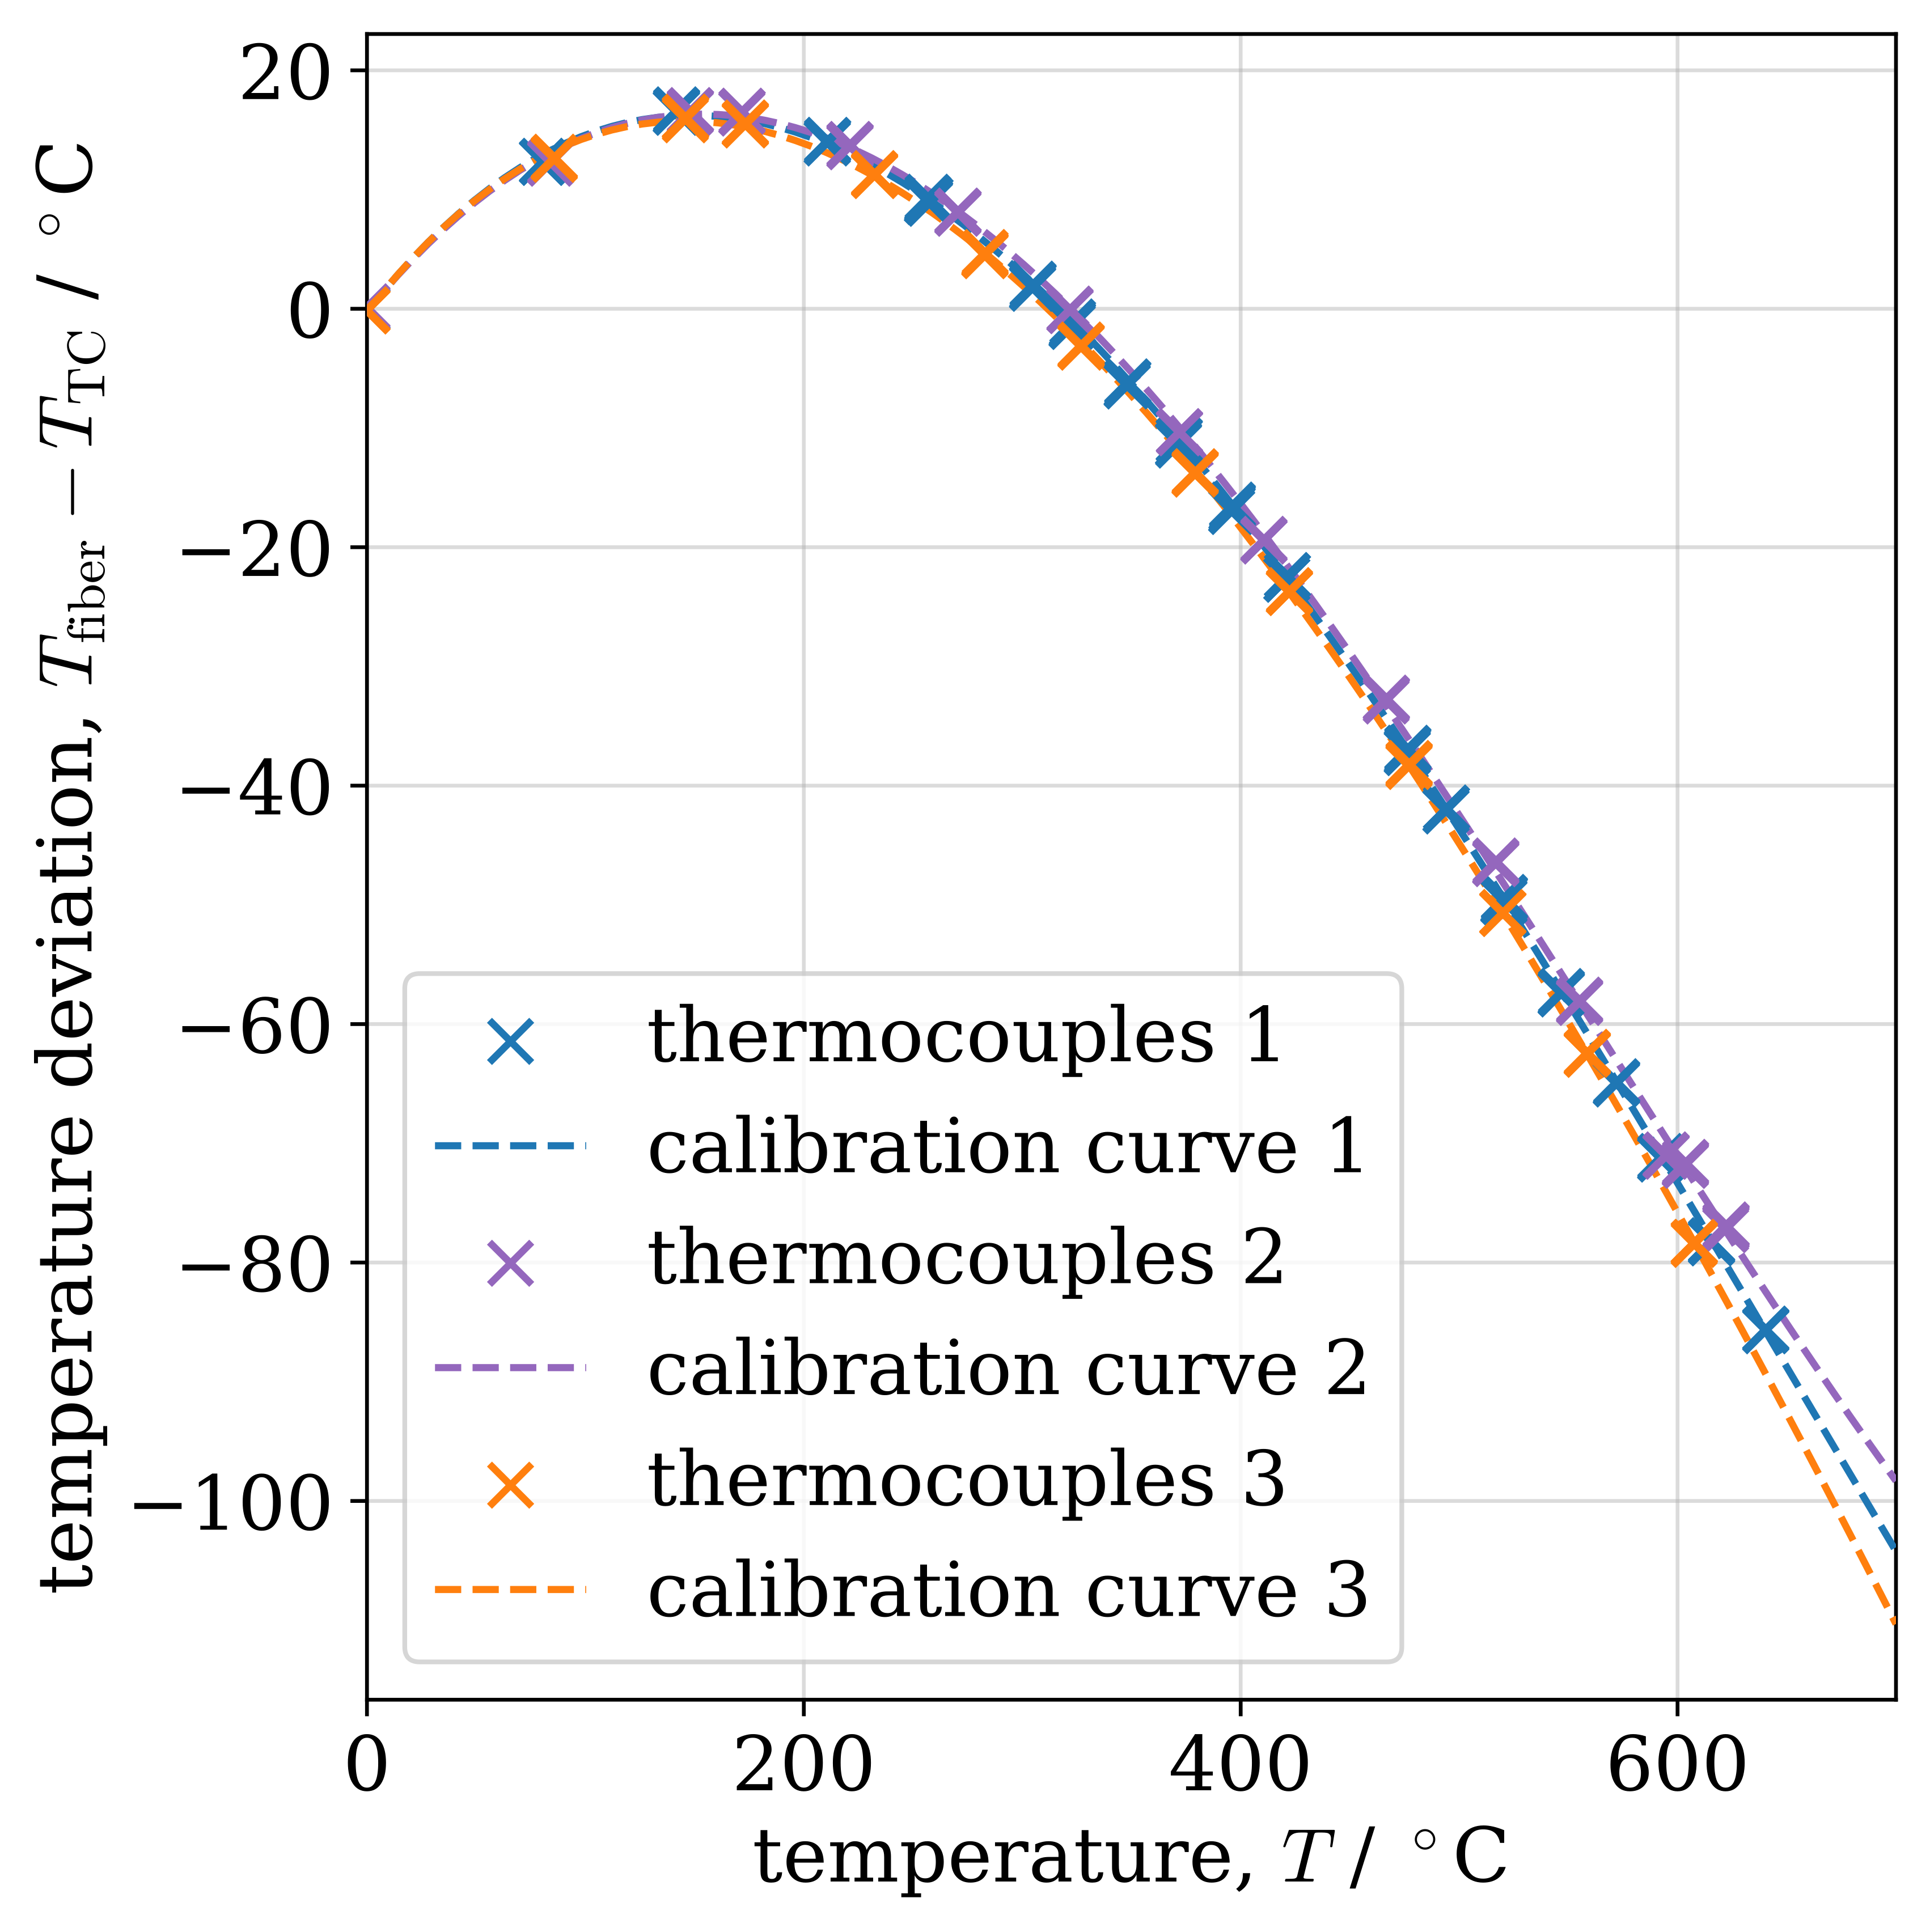
c)
b)
a)
Figure 2: Comparison of OFDR calibration behavior for different sensors, calibration procedures, and repeated high-temperature exposure. a) Comparison of the sensor-specific calibration obtained in this study with the literature calibration of Bremer (2020) over the overlapping temperature range up to approximately 300 °C. b) Comparison of continuous ramp calibration at 25 °C min⁻¹ and stepwise steady-state calibration up to 650 °C. c) Calibration curves obtained after repeated 1 h exposures to approximately 650 °C followed by cooling and rekeying.
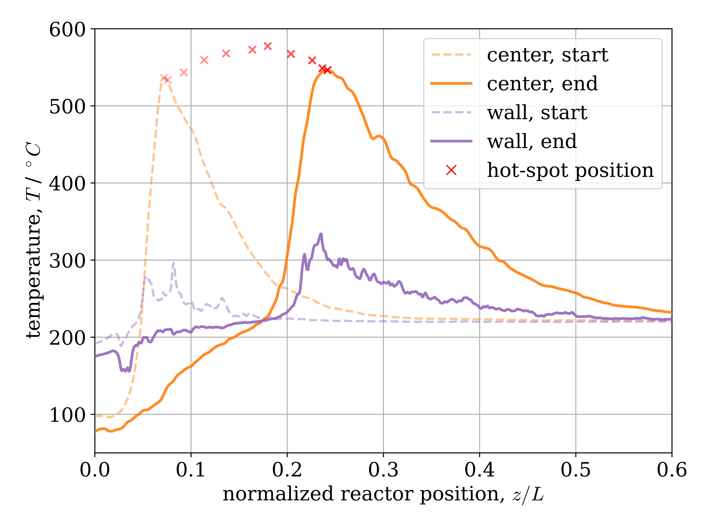
Figure 3: Dynamic feed-flow experiment during CO₂ methanation. Dashed and solid lines show the centerline and wall temperature profiles at the start and end of the hot-spot transition, respectively, while crosses indicate the progression of the centerline hot-spot position and temperature.
    - Sensor durability
The thermal durability of the fiber-optic sensors was assessed by repeated exposure to localized hot-spots under ex situ conditions. Such exposure can cause a hot-spot burn-in phenomenon in which the local Rayleigh pattern of the fiber is modified, leading to apparent drift in the temperature readings if the original reference pattern is used for further measurements. The results of recording a new calibration curve with a rekeyed sensor after the fiber-optic sensor has cooled following controlled overheating to 650 °C are shown in Figure 2c. The calibration curves increasingly diverged above approximately 500 °C. This indicates that prolonged exposure in this temperature range may alter not only the Rayleigh reference pattern but also the calibration itself, such that recalibration should be considered after extended high-temperature operation. Below approximately 500 °C, the repeated calibration curves remained comparatively consistent under the investigated conditions. In this range, a burn-in-induced offset could generally be compensated by rekeying after cooling without requiring a new calibration. The observed burn-in became more pronounced at elevated temperatures and after repeated high-temperature exposure, so rekeying is primarily required after sufficiently severe local overheating. This observation supports the hypothesis that initial hot-spot burn-in introduces a shift in the Rayleigh backscatter pattern, while functionality can be restored by rekeying the sensor and, depending on operating conditions, recalibration. Progressive degradation of the sensor was not observed over the overheating cycles. These results suggest a practical distinction between changes in the Rayleigh reference pattern, which can be compensated by rekeying, and changes in the temperature calibration itself, which require recalibration after sufficiently severe high-temperature exposure.
    - Dynamic measurements
The calibrated OFDR sensors were applied to monitor the spatial evolution of the temperature field during dynamic reactor operation, as seen in Figure 3. During the investigated load change, the centerline hot-spot shifted towards the reactor outlet during the transition. The temperature profiles broadened and the absolute wall hot-spot temperature increased slightly. The reactor temperature field continued to evolve after completion of the feed-flow ramp and approached a new steady state after an additional 8 min.
Figure 3 illustrates the diagnostic advantage of distributed temperature sensing during this load transition. A fixed thermocouple may register an increase, decrease, or almost no change depending on its position relative to the moving hot-spot. In contrast, the OFDR sensor resolves the complete axial temperature profile and therefore distinguishes hot-spot migration from a purely local temperature change at a single position. The simultaneous wall measurement additionally indicates changes in the radial temperature difference and associated heat removal during the transition. Such spatially and temporally resolved measurements provide the experimental basis required for validating dynamic reactor models and subsequently for developing model-based load-following and control strategies.
  - Conclusions
Stainless-steel-encapsulated OFDR fiber-optic sensors were evaluated as minimally invasive temperature probes for dynamically operated packed-bed reactors. Sensor-specific calibration was found to be necessary. The sensor-specific calibration differed from the previously reported calibration by up to approximately 5.5 K within their overlapping temperature range up to approximately 300 °C. For the strongly exothermic system, ex situ calibration was required because the accessible in situ calibration range did not cover hot-spot temperatures. The rapid ramp-based calibration also deviated from the stepwise procedure, indicating that thermal equilibration of the calibration assembly must be considered. Hot-spot burn-in was identified as an important durability aspect. Exposure at 650 °C altered the Rayleigh backscatter pattern after cooling. Below 500 °C, repeated calibrations remained consistent, such that burn-in-induced offsets could be compensated for by rekeying. At higher temperatures, deviations between the repeated calibrations indicate that recalibration should be considered after prolonged high-temperature operation.
During dynamic reactor operation, the OFDR system resolved the downstream hot-spot migration and broadening, without indication of significant measurement delay or axial smearing during the experiments, indicating that the measurement system is sufficiently responsive for the investigated reactor dynamics. These results support the use of stainless-steel-encapsulated OFDR sensors for dynamic reactor-model validation and load-following applications, provided that sensor-specific calibration, rekeying after burn-in, and recalibration after sufficiently severe high-temperature exposure are considered. Future work should investigate slower heat-up ramps during calibration to ensure equilibrium within the calibration assembly and use model-based analysis to quantify the specific time constants of the sensor in situ.

Acknowledgments
We gratefully acknowledge the Deutsche Forschungsgemeinschaft (DFG) for funding the equipment used in this work within the framework of project 549580941. This publication was created as part of the research program "Transforming the Energy System Lower Saxony" (TEN.efzn) at the Energy Research Center of Lower Saxony (efzn). Grant Number: 11-76251-2884/2024 (ZN4464). Funded by zukunft.niedersachsen, the joint science funding program of the Lower Saxony Ministry of Science and Culture and the Volkswagen Foundation.
References
Bremer J., 2020, Advanced Operating Strategies for Non-Isothermal Fixed-Bed Reactors Exemplified for CO₂ Methanation, PhD Thesis, Otto-von-Guericke-Universität Magdeburg, Magdeburg, Germany.
Cholewa T., Steinbach B., Heim C., Nestler F., Nanba T., Güttel R., Salem O., 2024, Reaction kinetics for ammonia synthesis using ruthenium and iron based catalysts under low temperature and pressure conditions, Sustainable Energy & Fuels, 8, 2245–2255.
Geschke A., Zimmermann R.T., Bremer J. and Sundmacher K., 2024, Core-Shell Catalyst Pellets for CO₂ Methanation in a Pilot-Scale Fixed-Bed Reactor. Chemie Ingenieur Technik, 96, 1718-1725.
Grenko B., de Jong W., van de Ketterij R., van Biert L., 2026, Analytical and numerical aspects of dynamic industrial chemical process analysis in fixed bed reactors, Chemical Engineering Science, 325, 123421.
Kreger S., Rahim N. A. A., Garg N., Klute S., Metrey D., Beaty N., Jeans J., Gamber R., 2016, Optical frequency domain reflectometry: principles and applications in fiber optic sensing, Proc. SPIE 9852, Fiber Optic Sensors and Applications XIII, 98520T.
Ma S., Xu Y., Pang Y., Zhao X., Li Y., Qin Z., Liu Z., Lu P., Bao X., 2022, Optical Fiber Sensors for High-Temperature Monitoring: A Review, Sensors 22, no. 15, 5722.
Nestler F., Müller V. P., Ouda M., Hadrich M. J., Schaadt A., Bajohr S., Kolb T., 2021, A novel approach for kinetic measurements in exothermic fixed bed reactors: advancements in non-isothermal bed conditions demonstrated for methanol synthesis, React. Chem. Eng., 6, 1092–1107.
Nguyen H., Harold M.P., Luss D., 2013, Optical frequency domain reflectometry measurements of spatio-temporal temperature inside catalytic reactors: Applied to study wrong-way behavior, Chemical Engineering Journal, 234, 312–317.
Palmieri L., Schenato L., Santagiustina M., Galtarossa A., 2022, Rayleigh-Based Distributed Optical Fiber Sensing, Sensors, 22, 6811.
Rahim N. A. A., Davis M., Routhier L., Chang B., Chevalier J., Bos J., Kreger S., Sandorn E., 2015, Accuracy and Survivability of Distributed Fiber Optic Temperature Sensors, 53rd AIAA Aerospace Sciences Meeting.
Stegehake C., Gruenewald M., 2017, Application of Fiber-Optic Measurement Technology for Minimally-Invasive Measurements of Temperature Profiles in Reactors, Chemie Ingenieur Technik, 89, 480-485.
Stegehake C., Gruenewald M., Zanthoff H.-W., Hecht C., 2018, Fiber-optic temperature profile measurements in fixed-bed reactors for model-based evaluation of effective radial thermal conductivity (in German), Chemie Ingenieur Technik, 90, 602-614.

