 CHEMICAL ENGINEERING TRANSACTIONS  VOL. xxx, 2026 | A publication of  
The Italian Association
of Chemical Engineering
Online at www.cetjournal.it

Guest Editors: Flavio Manenti, Botir Usmonov, Alessandro Di Pretoro
Copyright © 2026, AIDIC Servizi S.r.l.
ISBN 979-12-81206-xx-x; ISSN 2283-9216

Waste-to-Resource Strategy: Enhancing Concrete Properties through Sustainable Use of Soda Industry Limestone Residues
Shohrukh Rajabov^{a,}*, Kholtura Mirzakulovª, Mirjalil Yunusov^{b}, Gavhar Melikulovaª, Kamola Arifdjanovaª
ª Tashkent Institute of Chemical Technology, Department of Inorganic Substances Technology, 32 Navoi Street, Tashkent 100011, Uzbekistan
^{b} Tashkent Institute of Chemical Technology, Department of Industrial Ecology and “Green” Technologies, 32 Navoi Street, Tashkent 100011, Uzbekistan
*- rajabovs179@gmail.com

The rapid growth of soda production industries has led to the continuous accumulation of fine-fraction limestone waste, posing a significant environmental challenge due to land degradation, dust emissions, and inefficient resource utilization. In particular, the Kungrat soda plant generates approximately 35–40 tons of such waste daily, highlighting the urgent need for sustainable waste management solutions aligned with circular economy principles. This study investigates the potential reuse of fine-fraction limestone waste as a secondary raw material in high-strength concrete production, with a focus on both environmental and engineering performance.
Comprehensive physico-chemical and mechanical analyses of the waste material were conducted using modern characterization techniques, including X-ray diffraction (XRD) and infrared (IR) spectroscopy. The results confirmed that the waste is predominantly composed of calcium carbonate (CaCO₃ ≈95.5 %) with minor impurities, and does not contain harmful components that could negatively affect concrete durability or environmental safety. Its granulometric composition and mechanical properties meet the standard requirements for coarse aggregates.
Experimental investigations were carried out to evaluate the performance of concrete mixtures incorporating varying proportions of limestone waste. The findings revealed that partial substitution of conventional aggregates with 60–65 % limestone waste leads to optimal results, improving compressive strength by up to 3.5 % compared to traditional concrete. Additionally, concrete produced with up to 85 % waste content meets standard strength requirements, demonstrating the material’s technical viability.
From an ecological perspective, the proposed approach significantly reduces industrial waste accumulation, minimizes the need for natural aggregate extraction, and lowers the environmental footprint of construction materials. The reuse of limestone waste contributes to resource conservation, reduction of greenhouse gas emissions associated with raw material processing, and mitigation of pollution from waste disposal sites.
Overall, this research demonstrates that integrating soda industry limestone waste into concrete production represents an effective and sustainable strategy that simultaneously addresses environmental concerns and enhances material performance. The results support the development of eco-friendly construction technologies and provide a practical pathway toward achieving sustainable industrial waste valorization.

Keywords: industrial waste recycling, sustainable concrete, limestone waste, circular economy, eco-friendly materials, soda industry.

Introduction.
In recent decades, rapid industrial growth has led to the large-scale generation of solid waste, creating significant environmental challenges worldwide. In particular, the soda ash industry produces fine-fraction limestone waste, which accumulates in open areas and contributes to land degradation and environmental pollution (Chajec A., 2022; Damtoft et al., 2008). At the same time, the construction industry, especially concrete production, is a major consumer of natural resources. The extraction of aggregates not only depletes non-renewable resources but also increases CO₂ emissions and ecological disturbances (Scrivener et al., 2018; Andrew, 2018; Miller et al., 2016). Therefore, the use of industrial by-products as alternative raw materials is considered an effective approach to sustainable construction (Etxeberria and Castillo, 2023).
Among industrial wastes, limestone residues from soda production are of particular interest due to their high calcium carbonate content and favorable physicochemical properties (Shmlls et al., 2023; Gartner and Sui, 2018). Previous studies have shown that carbonate materials improve concrete performance by enhancing bonding and optimizing the microstructure (Bentz et al., 2016; Li et al., 2024), while their compatibility with cement hydration products contributes to improved durability (Lothenbach et al., 2011). The use of carbonate fillers has also been associated with improved strength due to better stress distribution. However, the large-scale utilization of fine-fraction limestone waste from soda industries remains limited (Su et al., 2023). From an environmental perspective, the reuse of industrial waste reduces landfill accumulation, conserves natural resources, and lowers greenhouse gas emissions (Habert et al., 2020; Siddique and Cachim, 2018). Therefore, this study aims to evaluate the potential of fine-fraction limestone waste as a coarse aggregate in high-strength concrete, focusing on its physicochemical characteristics, mechanical performance, and environmental benefits.
Although previous studies have investigated the use of limestone-based materials in cementitious systems, limited attention has been given to the utilization of fine-fraction limestone waste generated specifically by soda production plants as a coarse aggregate in high-strength concrete. In addition, the combined evaluation of physicochemical characteristics, mechanical performance, and environmental benefits of this waste material remains insufficiently explored. Therefore, the novelty of this study lies in the comprehensive investigation of soda industry limestone residues as a sustainable alternative aggregate for high-strength concrete production within a circular economy framework.

Methods
The chemical composition of the fine-fraction limestone waste was determined under laboratory conditions using standard analytical methods. The contents of CaO and MgO were analyzed by volumetric titration using a 0.05 N Trilon B solution in the presence of a chrome dark blue indicator according to GOST 8677-76 and GOST 4526-75.
X-ray diffraction (XRD) analysis of the raw material was performed using a SHIMADZU 6100 diffractometer under the following operating conditions: voltage 25 kV, current 8 mA, and scanning speed 2°/min.
Infrared (IR) spectroscopic analysis was carried out using a SHIMADZU IRAffinity-1S spectrophotometer in the wavenumber range of 4000–400 cm⁻¹.
The granulometric composition and physical-mechanical properties of the limestone waste were determined in accordance with GOST 8267-93 and GOST 8269-97 standards.
Concrete samples (100×100×100 mm) of grade M400 (class B30) were prepared using limestone waste as a coarse aggregate, quartz sand as a fine aggregate, and Portland cement (PC400-D20) as a binder. The water–cement ratio was maintained at 0.55, and the workability of the mixtures corresponded to slump class P2 according to GOST 7473-2010.
The compressive strength of the concrete samples was tested at different curing periods (3, 7, 28, 90, 180, and 360 days) in accordance with GOST 10180-2012.

Research Results
In order to study the effect of the waste products of Soda production plants on the strength of concrete, firstly, it is necessary to study its composition and physico-mechanical properties. As fillers applied for high strength concrete should be clean and have a good granular composition, and less porous, should not have as weak granules as possible. The consistency limit of a large filler should be 20 % higher than the given strength of concrete.
For this reason, the chemical composition was determined of the first raw materials. Based on the results of the conducted chemical analysis, the chemical composition of the fine-fraction limestone, coming out of the soda production plant, was determined. The results are presented in Table 1 below. listed.

Table 1. Chemical composition of fine-fraction limestones of the Soda plant
№ | CaO | MgO | SiO₂ | Na₂O | Al₂O₃ | Fe₂O₃ | SO₃ | Loss on ignition
1 | 54,22 | 0,89 | 1,21 | 0,31 | 0,67 | 0,19 | 0,49 | 42,02
2 | 54,14 | 0,64 | 0,76 | 0,38 | 0,34 | 0,21 | 0,61 | 42,92
3 | 53,62 | 0,36 | 1,51 | 0,14 | 0,43 | 0,28 | 0,22 | 44,44
4 | 53,43 | 0,97 | 2,34 | 0,28 | 0,84 | 0,10 | 0,43 | 41,61
5 | 52,21 | 0,43 | 1,54 | 0,36 | 0,70 | 0,09 | 0,44 | 44,23
Average | 53,52 | 0,65 | 1,47 | 0,29 | 0,59 | 0,17 | 0,43 | 42,88
From the results on the basis of the experimental model device, it can be seen that the soda enterprise is made up of CaCO₃, the main composition of small-fraction limestone waste. Based on the data presented in Table 1, the mass fraction of CaCO₃ in the composition of these wastes is an average of 95,5 %. In addition MgCO₃, MgSiO₃ and R₂O₃ were identified in small quantities.
The results of an X-ray analysis of the small fraction limestone waste of Soda enterprise were obtained, and the obtained XRD patterns are presented in Figure 1.
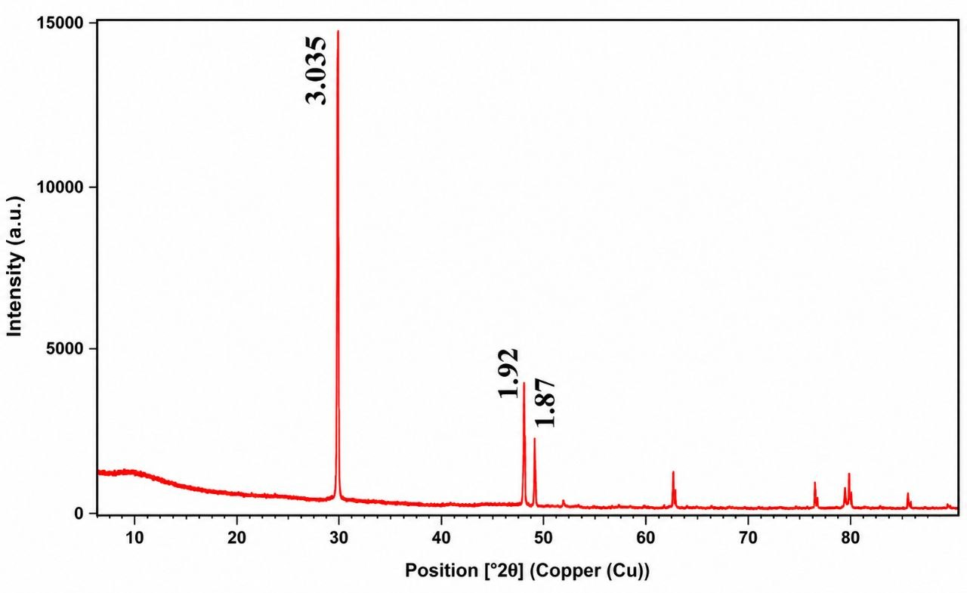
Figure 1. Results of X-ray analysis of fine-fraction limestone of soda enterprise

When we did an X-ray study of the initial samples, it was confirmed that the planelararo distances: 3,035; 1,87 nm in it was CaCO₃ (Picture 1). It also revealed the presence of 1,92 nm MgCO₃*3H₂O.
The results of the IR spectroscopic analysis of the fine-fraction limestone waste of Soda enterprise were conducted (Figure 2).
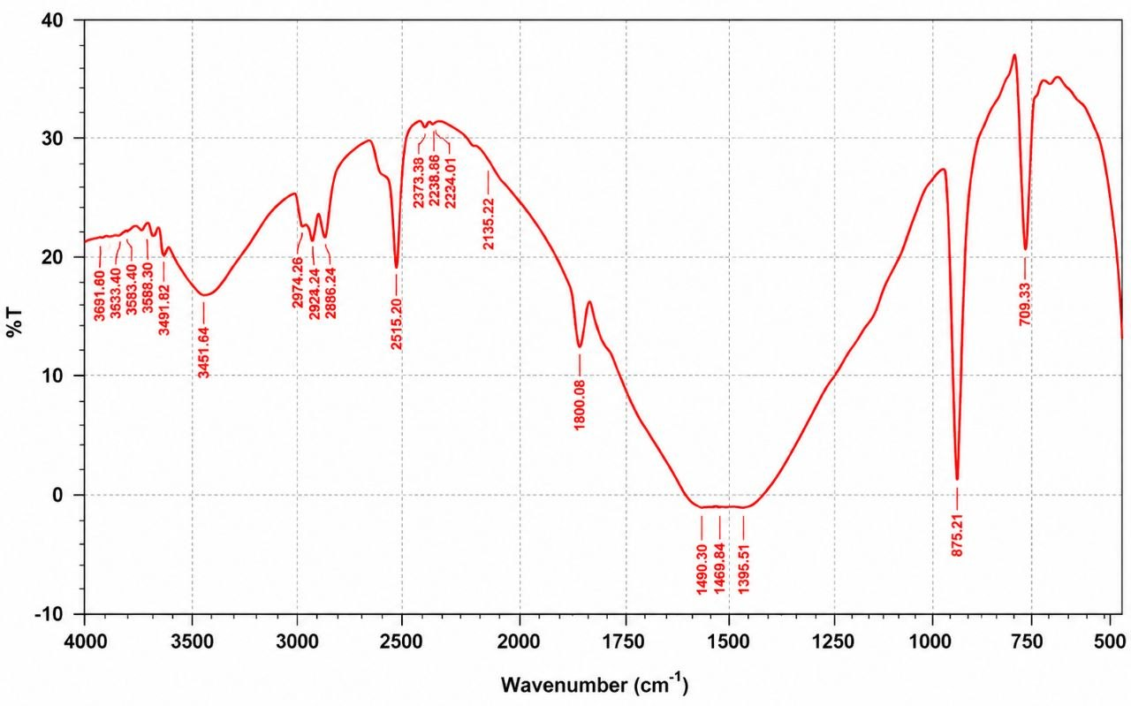

Figure 2. Infra-red (IR) spectroscopy of fine-fraction limestone waste from the soda enterprise

According to the results of infrared spectroscopy of fine-fraction limestone waste from the soda plant, slight changes in intensity values are observed. In particular, deformation vibrations of CaO atoms corresponding to the upper range of IR radiation are observed at 709.33 and 875.21 cm−1. In the region from 1395.51 to 1800.08 cm−1, vibrations with the participation of secondary bonds and CO₂ atoms are observed. In the region from 2135.22 to 2373.91 cm−1, bonds were revealed in the presence of tripled MgO*H₂O. In the range from 2515 to 4000 cm-1, vibrations involving hydrogen atoms are observed.
Sieving of 10-20 mm limestones according to GOST 8267-93 was carried out using the following formula and the following results were obtained.
$$1,25*D=1,25*2=25 mm (1)$$
$$D=20 mm (2)$$
$$\frac{D+d}{2}=\frac{20+10}{2}=15 mm (3)$$
$$d=10 mm (4)$$

Figure 3. Particle size distribution of 10–20 mm limestone waste aggregate.

As shown in Figure 3, the particle size distribution of the 10–20 mm limestone waste aggregates meets the standard granulometric requirements specified by GOST.

Figure 4. Particle size distribution of 5–10 mm limestone waste aggregate.

As illustrated in Figure 4, the bulk density and mechanical strength parameters of the limestone waste aggregates comply with the relevant GOST standards.
Equations (5)–(8) were used to evaluate the granulometric composition, crushing resistance, and shape characteristics of the limestone waste aggregates according to GOST 8267-93 and GOST 8269-97 standards.
$D_{1}=\frac{m-m_{1}}{m}∙100=\frac{338,8-284,6}{338,8}∙100=15,99 \%$ (5)
$D_{2}=\frac{m-m_{1}}{m}∙100=\frac{339,5-286,8}{339,5}∙100=15,52 \%$ (6)
$D_{ум}=\frac{D_{1}+D_{2}}{2}$ $=\frac{15,99+15,52}{2}=15,75 \%$ (7)
where m is the total sample mass and m1 is the mass of the sieved fraction. Here m-total weight, m₁–0.25 mm sieved, i.e. crushed limestone. According to the results of the test conducted to determine the strength limit, it was determined that the small-fraction limestone waste of the soda enterprise belongs to the M1000 class of large fillers according to GOST 8267-93.
The test results of plate-like and needle-like indicators according to GOST 8267-93 were as follows.
$П=\frac{m}{m}=\frac{51,9}{250}∙100=20,76\%$ (8)
According to the results of this analysis, it was determined that the small-fraction limestone waste of the soda enterprise belongs to the type of large fillers of the 2nd category according to GOST 8267-93 and can be used as a large filler of small-fraction limestone waste.
The results indicate that the incorporation of soda industry limestone waste as coarse aggregate can significantly improve the compressive strength of concrete. Experimental studies were carried out on 100×100×100 mm concrete samples of grade M400 (class B30). The mixtures included fine-fraction limestone waste from a soda plant as coarse aggregate, quartz sand as fine aggregate, and PC400-D20 “Karakalpak” Portland cement as a binder. The water–cement ratio was 0.55, and the workability corresponded to slump class P2 according to GOST 7473-2010. The experimental results (Table 2) show that the inclusion of limestone waste leads to an increase in concrete strength up to a certain optimal level, beyond which a gradual decrease is observed. The cement consumption was maintained at 475 kg/m³ for all mixtures..

Table 2. Compressive strength of concrete samples with the addition of fine-fraction limestone waste from the soda plant
Raw materials % |  | Time concrete strength MPa
Filler (crushed stone) | Soda enterprise limestone waste | 3  day | 7  day | 28  day | 90  day | 180  day | 360  day
100 | - | 13,07 | 27,92 | 40,43 | 46,55 | 52,71 | 58,22
90 | 10 | 13,12 | 28,00 | 40,51 | 46,62 | 52,80 | 58,31
85 | 15 | 13,28 | 28,04 | 40,56 | 46,65 | 52,83 | 58,36
80 | 20 | 13,72 | 28,08 | 40,64 | 46,69 | 52,85 | 58,39
75 | 25 | 13,91 | 28,10 | 40,70 | 46,73 | 52,88 | 58,42
70 | 30 | 13,96 | 28,13 | 40,77 | 46,75 | 52,91 | 58,46
65 | 35 | 14,08 | 28,15 | 40,81 | 46,78 | 52,95 | 58,48
60 | 40 | 14,11 | 28,17 | 40,88 | 46,82 | 52,98 | 58,53
55 | 45 | 14,13 | 28,18 | 40,92 | 46,85 | 53,02 | 58,58
50 | 50 | 14,21 | 28,20 | 41,00 | 46,87 | 53,05 | 58,61
45 | 55 | 14,15 | 28,21 | 41,06 | 46,90 | 53,09 | 58,64
40 | 60 | 14,03 | 28,22 | 41,13 | 46,92 | 53,11 | 58,66
35 | 65 | 13,80 | 28,20 | 41,86 | 46,91 | 53,08 | 58,69
30 | 70 | 13,46 | 28,17 | 40,92 | 46,86 | 53,01 | 58,65
25 | 75 | 13,41 | 28,13 | 40,79 | 46,81 | 52,95 | 58,59
20 | 80 | 13,30 | 28,07 | 40,66 | 46,77 | 52,87 | 58,52
15 | 85 | 13,22 | 27,98 | 40,50 | 46,70 | 52,76 | 58,40
10 | 90 | 13,02 | 27,90 | 40,35 | 46,63 | 52,67 | 58,32
The results presented in Table 2 show that the incorporation of limestone waste significantly influences the compressive strength of concrete. An increase in strength is observed at replacement levels up to 60–65 %, indicating improved particle packing and enhanced interaction between the aggregate and cement matrix. At the next ages (90, 180, and 360), the solidification period of concrete continued, and the samples of 80 % soda enterprise with small fractional limestone wastes showed strength limits of 46.91, 53.08, and 58.69 MPa. It was found that the strength limit of the soda enterprise, when 90 % and higher volume of small fractional limestone waste is introduced, is lower than the requirements of “GOST 10180-2012-Methods for determining the strength of concrete samples”.

Discussion
The experimental results obtained in this study confirm that fine-fraction limestone waste from soda production can be effectively utilized as a coarse aggregate in high-strength concrete. The observed improvement in compressive strength at optimal replacement levels (60–65 %) indicates that the material contributes positively to the structural performance of concrete. This behavior can be attributed to the high calcium carbonate content and the favorable interaction between limestone particles and cement hydration products, which enhances the interfacial transition zone and overall microstructure of the composite.
These findings are consistent with previous studies reported by Bentz et al. (2016) and Li et al. (2024), which demonstrated that limestone-based materials improve the packing density and promote better bonding within cementitious systems. Similarly, the results align with the work of Lothenbach et al. (2011), who emphasized the role of supplementary materials in optimizing the hydration process and improving the durability of concrete.
From a materials engineering perspective, the existence of an optimal replacement threshold is an important observation. While the incorporation of limestone waste up to 65 % enhances strength, further increase beyond this level leads to a gradual decline in performance. This can be explained by the reduction in the proportion of stronger natural aggregates and potential changes in the internal structure of the composite, which negatively affect load-bearing capacity. A similar trend has been reported in studies on alternative aggregates and recycled materials (Siddique and Cachim, 2018).
In addition to mechanical performance, the environmental implications of the proposed approach are significant. The reuse of soda industry waste directly contributes to reducing the volume of industrial waste accumulated in disposal sites, thereby mitigating land degradation and environmental pollution. This aligns with the principles of sustainable development and circular economy, as highlighted by Klemeš et al. (2016) and Habert et al. (2020), who emphasized the importance of resource efficiency and waste valorization in modern industrial systems.
Furthermore, replacing natural aggregates with industrial waste reduces the demand for raw material extraction, which is associated with high energy consumption and CO₂ emissions (Andrew, 2018; Miller et al., 2016). Therefore, the proposed method not only improves material efficiency but also contributes to lowering the environmental footprint of concrete production.
Overall, the results of this study demonstrate that fine-fraction limestone waste can serve as an effective and environmentally sustainable alternative material in concrete production. The integration of such waste into construction practices represents a practical step toward achieving eco-friendly and resource-efficient building technologies. However, further research is required to evaluate long-term durability, environmental impact through life-cycle assessment, and large-scale industrial applicability.

Conclusion
The results of this study confirm that fine-fraction limestone waste from soda production possesses a high-quality chemical composition (CaCO₃ ≈95.5 %) and suitable granulometric characteristics for use as a coarse aggregate in concrete. The experimental findings show that the incorporation of this waste at 60–65% improves compressive strength, while even at higher replacement levels of up to 90%, the concrete maintains strength values in accordance with GOST requirements.
The obtained results demonstrate that the investigated waste material can be effectively utilized without compromising mechanical performance. From an environmental perspective, its application contributes to reducing industrial waste accumulation and conserving natural resources.
Furthermore, the reuse of limestone waste enables the production of value-added construction materials and creates opportunities for the large-scale utilization of industrial waste, supporting the development of sustainable and resource-efficient construction technologies.

References
Andrew R.M., 2018, Global CO₂ emissions from cement production, Earth System Science Data, 10, 195–217. https://doi.org/10.5194/essd-10-195-2018
Bentz D.P., Irassar E.F., Bucher B.E., Weiss W.J., 2016, Limestone fillers in cement and concrete: A multiscale approach, NIST Technical Note, 1896, 1–45. https://doi.org/10.6028/NIST.TN.1896
Damtoft J.S., Lukasik J., Herfort D., Sorrentino D., Gartner E.M., 2008, Sustainable development and climate change initiatives, Cement and Concrete Research, 38(2), 115–127. https://doi.org/10.1016/j.cemconres.2007.09.008
Gartner E., Sui T., 2018, Alternative cement clinkers, Cement and Concrete Research, 114, 27–39. https://doi.org/10.1016/j.cemconres.2017.02.002
Habert G., Miller S.A., John V.M., Provis J.L., Favier A., Horvath A., Scrivener K.L., 2020, Environmental impacts and decarbonization strategies in the cement and concrete industries, Nature Reviews Earth & Environment, 1, 559–573. https://doi.org/10.1038/s43017-020-0093-3
Chajec A., 2022, Towards the Cleaner Production of Cementitious Materials with the Synergistic Addition of Granite Powder Waste and Fly Ash, Chemical Engineering Transactions, 94, 289–294. https://doi.org/10.3303/CET2294048
Li X., Li T., Wu M., 2024, Recent developments on the effects of micro- and nano-limestone materials on cement hydration, Materials, 17(9), 1–18. https://doi.org/10.3390/ma17092000
Lothenbach B., Scrivener K., Hooton R.D., 2011, Supplementary cementitious materials, Cement and Concrete Research, 41(12), 1244–1256. https://doi.org/10.1016/j.cemconres.2010.12.001
Etxeberria M., Castillo S., 2023, How the Carbonation Treatment of Different Types of Recycled Aggregates Affects the Properties of Concrete, Sustainability, 15(4), 3169. https://doi.org/10.3390/su15043169
Miller S.A., Horvath A., Monteiro P.J.M., 2016, Readily implementable techniques can cut annual CO₂ emissions from the production of concrete by over 20%, Environmental Research Letters, 11(7), 074029. https://doi.org/10.1088/1748-9326/11/7/074029
Shmlls M., Bozsaky D., Horváth T., 2023, The Analysis of Lifecycle and Multi-Criteria Decision-Making for Three-Generation High-Strength Recycled Aggregate Concrete, Chemical Engineering Transactions, 107, 229–234. https://doi.org/10.3303/CET23107039
Scrivener K.L., John V.M., Gartner E.M., 2018, Eco-efficient cements: Potential, economically viable solutions for a low-CO₂ cement-based materials industry, Cement and Concrete Research, 114, 2–26. https://doi.org/10.1016/j.cemconres.2018.03.015
Su Y., Yao Y., Wang Y., Zhao X., Li L., Zhang J., 2023, Modification of Recycled Concrete Aggregate and Its Use in Concrete: An Overview of Research Progress, Materials, 16(22), 7144. https://doi.org/10.3390/ma16227144
Siddique R., Cachim P., 2018, Waste and supplementary cementitious materials in concrete: Characterisation, properties and applications, Resources, Conservation and Recycling, 134, 80–100. https://doi.org/10.1016/j.resconrec.2018.03.018

