 CHEMICAL ENGINEERING TRANSACTIONS  VOL. xxx, 2026 | A publication of  
The Italian Association
of Chemical Engineering
Online at www.cetjournal.it

Guest Editors: Flavio Manenti, Botir Usmonov, Alessandro Di Pretoro
Copyright © 2026, AIDIC Servizi S.r.l.
ISBN 979-12-81206-xx-x; ISSN 2283-9216

Synthesis and Characterization of Tunable Porous Ceramics from Alkali-Activated Changi Glauconite with Silicon Carbide Foaming Agents
Shahnoza U. Ruzimova*, Zebo A. Babakhanova, Utkirbek R. Azamatov
Tashkent Institute of Chemical Technology, Tashkent, Uzbekistan
shahnozaruzimova@gmail.com
This study investigates the synthesis of sustainable porous ceramic thermal insulation fillers using alkali-activated Changi glauconite and silicon carbide (SiC) foaming agents. The aim is to evaluate combined thermo-chemical reactivity and morphological evolution to engineer lightweight materials for high-temperature insulation and filtration. Glauconite was blended with sodium hydroxide (NaOH) and SiC (0–5 wt %), then calcined between 800 °C and 950 °C. Results showed consistent thermal mass reductions of 22 % to 29 %, driven by dehydroxylation and moisture evaporation. The oxidation of SiC particles within the viscous alkali-silicate melt triggered significant matrix expansion, decreasing apparent density while increasing water permeability up to 0.86 g/cm³. Structural analysis reveals a controlled transformation from closed pores into open interlinked pore networks with increasing SiC content. These findings confirm the ability to control void structure profiles, establishing this local phyllosilicate as a highly efficient precursor for high-tech ceramics.
  - Introduction
The global shift towards sustainable industrial processes has spurred research into utilizing environmentally friendly mineral precursors. Historically, ceramic production relied on energy-intensive processes, prompting the utilization of industrial solid wastes to minimize carbon footprints (Abdel-Gawwad et al., 2020; Shang et al., 2022). These waste-derived materials often exhibit low thermal conductivity and high specific surface areas. Consequently, developing lightweight porous ceramics using abundant aluminosilicate minerals has become increasingly relevant. Among potential sources, glauconite—an iron and potassium phyllosilicate clay mineral—holds great promise. The Changi glauconite deposit in Uzbekistan is a prime example of such regional resources. Although traditionally used as a soil amendment, recent studies highlight its potential in functionally modified aluminosilicate ceramics (Ruzimova et al., 2025a) and thermal expansion applications (Ruzimova et al., 2025b).
Alkali activation facilitates the conversion of relatively inert aluminosilicates into reactive materials. The addition of alkaline fluxes, such as NaOH, destabilizes the silicate structure, promoting the partial dissolution of silicon and aluminum species (Leonovich et al., 2020; Ramli et al., 2022). Upon calcination, this alkali-activated paste forms a viscous silicate-alkali melt, which is essential for densification and subsequent pore formation (Kazantseva & Rashchenko, 2014). To generate macro- and micro-porosity, foaming agents like SiC are introduced. SiC undergoes controlled oxidation at elevated temperatures, releasing CO and CO₂ gases (Lao and Xu, 2018). The entrapment of these gases within the highly viscous melt causes structural expansion, allowing precise control over pore size and distribution by varying the SiC concentration and thermal parameters (Sarı et al., 2022; Deng et al., 2023).
While the alkali activation of fly ash and metakaolin is well-documented, the behavior of complex iron-potassium phyllosilicates remains under-investigated. This study addresses this scientific gap by examining the interactions between Changi glauconite, NaOH flux, and SiC high-temperature oxidation. The study evaluates the influence of different NaOH concentrations and SiC mass fractions on thermal mass loss, apparent density, porosity, and permeability.
  - Materials and Methods
    - Raw Materials
The primary precursor was natural glauconite from the Changi deposit in the Tashkent region, Uzbekistan. Its composition includes SiO₂ (61.33 wt %), Al₂O₃ (12.24 wt %), Fe₂O₃ (6.55 wt %), FeO (4.62 wt %), and TiO₂ (0.36 wt %) (Ruzimova and Babakhanova, 2024). Analytical-grade sodium hydroxide (NaOH) served as the alkali activator to dissolve the silicate structure, and commercial silicon carbide (SiC) powder was utilized as the primary foaming agent.
    - Sample Preparation and Thermal Processing
Raw Changi glauconite powder was blended with the NaOH activator at mass ratios ranging from 85:15 to 92.5:7.5. SiC powder was dry-mixed into these compositions at 0 %, 1 %, 3 %, and 5 % by weight. Distilled water was added (30-34 % moisture) to achieve a uniform clay-like consistency. The pastes were shaped into pre-calcination cylindrical preforms with initial volumes designated as Small (0.1 cm³), Medium (0.5 cm³), and Large (1.0 cm³). After air-drying, these initial preform samples were calcined in a muffle furnace at peak temperatures of 800 °C, 850 °C, 900 °C, and 950 °C for one hour to promote alkali-silicate melt formation. All formulations were prepared in triplicate (n=3) to ensure statistical reliability.
    - Characterization Techniques
Thermal mass reduction was determined by measuring pre- and post-firing mass. Apparent structural density and absolute porosity were calculated via the Archimedes displacement principle. Microscopic imaging was conducted using an NSZ-810 stereo zoom microscope. Water permeability (g/cm³) was assessed to evaluate pore interconnectivity. Statistical analysis was performed using one-way ANOVA (p < 0.05), and data are reported as mean values ± standard deviation to accurately reflect experimental variability.
  - Results and Discussion
    - Thermo-Chemical Transformations and Mass Reduction
Thermal processing resulted in significant mass reductions ranging from 22 % to 29 % (Table 1). This reduction occurs in two stages: initial moisture evaporation up to 200 °C, followed by extensive dehydroxylation of the glauconite lattice at peak temperatures (800–950 °C). Higher NaOH concentrations accelerated the breakdown of the silicate network, promoting greater volatile release. This aligns with findings by Leonovich et al. (2020), who observed enhanced structural disruption in highly alkaline environments.
Table 1: Thermal Mass Reduction of Activated Glauconite Samples (Optimal compositions, V=0.5 cm³)
Formulation (Glauconite:NaOH) | SiC (wt %) | Temp. (°C) | Initial Mass (g) | Post-Firing Mass (g) | Mass Reduction (%)
85:15 | 0 | 800 | 3.48 ± 0.05 | 2.55 ± 0.04 | 26.7 ± 1.2
92.5:7.5 | 1 | 850 | 3.25 ± 0.04 | 2.52 ± 0.05 | 22.4 ± 1.0
92.5:7.5 | 3 | 900 | 3.15 ± 0.03 | 2.29 ± 0.03 | 27.3 ± 1.1
92.5:7.5 | 5 | 950 | 3.05 ± 0.04 | 2.17 ± 0.02 | 28.8 ± 1.3

    - Morphological Evolution and Density Variations
During calcination, samples expanded into quasi-spherical structures due to the formation of a viscous liquid phase that entrapped internal gases. Table 2 shows that SiC addition drove substantial matrix expansion. Apparent density decreased by ~20 % in base samples and up to 83 % in heavily doped samples (5 % SiC), achieving ultra-lightweight densities around 340 kg/m³. The oxidation of SiC to CO/CO₂ acts as a powerful propellent against the softening alkali-silicate walls. This profound density reduction parallels the foaming mechanisms reported by El-Amir et al. (2022) for soda lime glass.
Table 2: Volumetric Expansion and Apparent Density Variations (V=0.5 cm³, 900 °C)
SiC (wt %) | Initial Vol. (cm³) | Fired Vol. (cm³) | Initial Density (kg/m³) | Fired Density (kg/m³) | Density Change (%)
0 | 0.50 | 0.53 ± 0.02 | 2155 ± 25 | 1720 ± 45 | -20.1 ± 2.5
1 | 0.50 | 0.85 ± 0.04 | 2110 ± 22 | 1050 ± 35 | -50.2 ± 3.1
3 | 0.50 | 1.45 ± 0.05 | 2065 ± 28 | 680 ± 25 | -67.0 ± 4.0
5 | 0.50 | 2.10 ± 0.08 | 2000 ± 20 | 340 ± 15 | -83.0 ± 4.5

Figure 1 shows the effect of SiC content and alkali ratio on density at the optimal 900 °C firing temperature and how temperature influences melt expansion with a constant 1 wt % SiC addition. Figure 2 evaluates the final fired density distribution across the initial (pre-calcination) preform volumes using a violin plot, while Figure 3 evaluates the scale effect by plotting the minimum achieved post-calcination density against the final fired volume.
Figure 1: Heatmap illustrating the effect of SiC addition mass percentage content and Glauconite content on the fired apparent density at 900 °C and across all corresponding formulations.
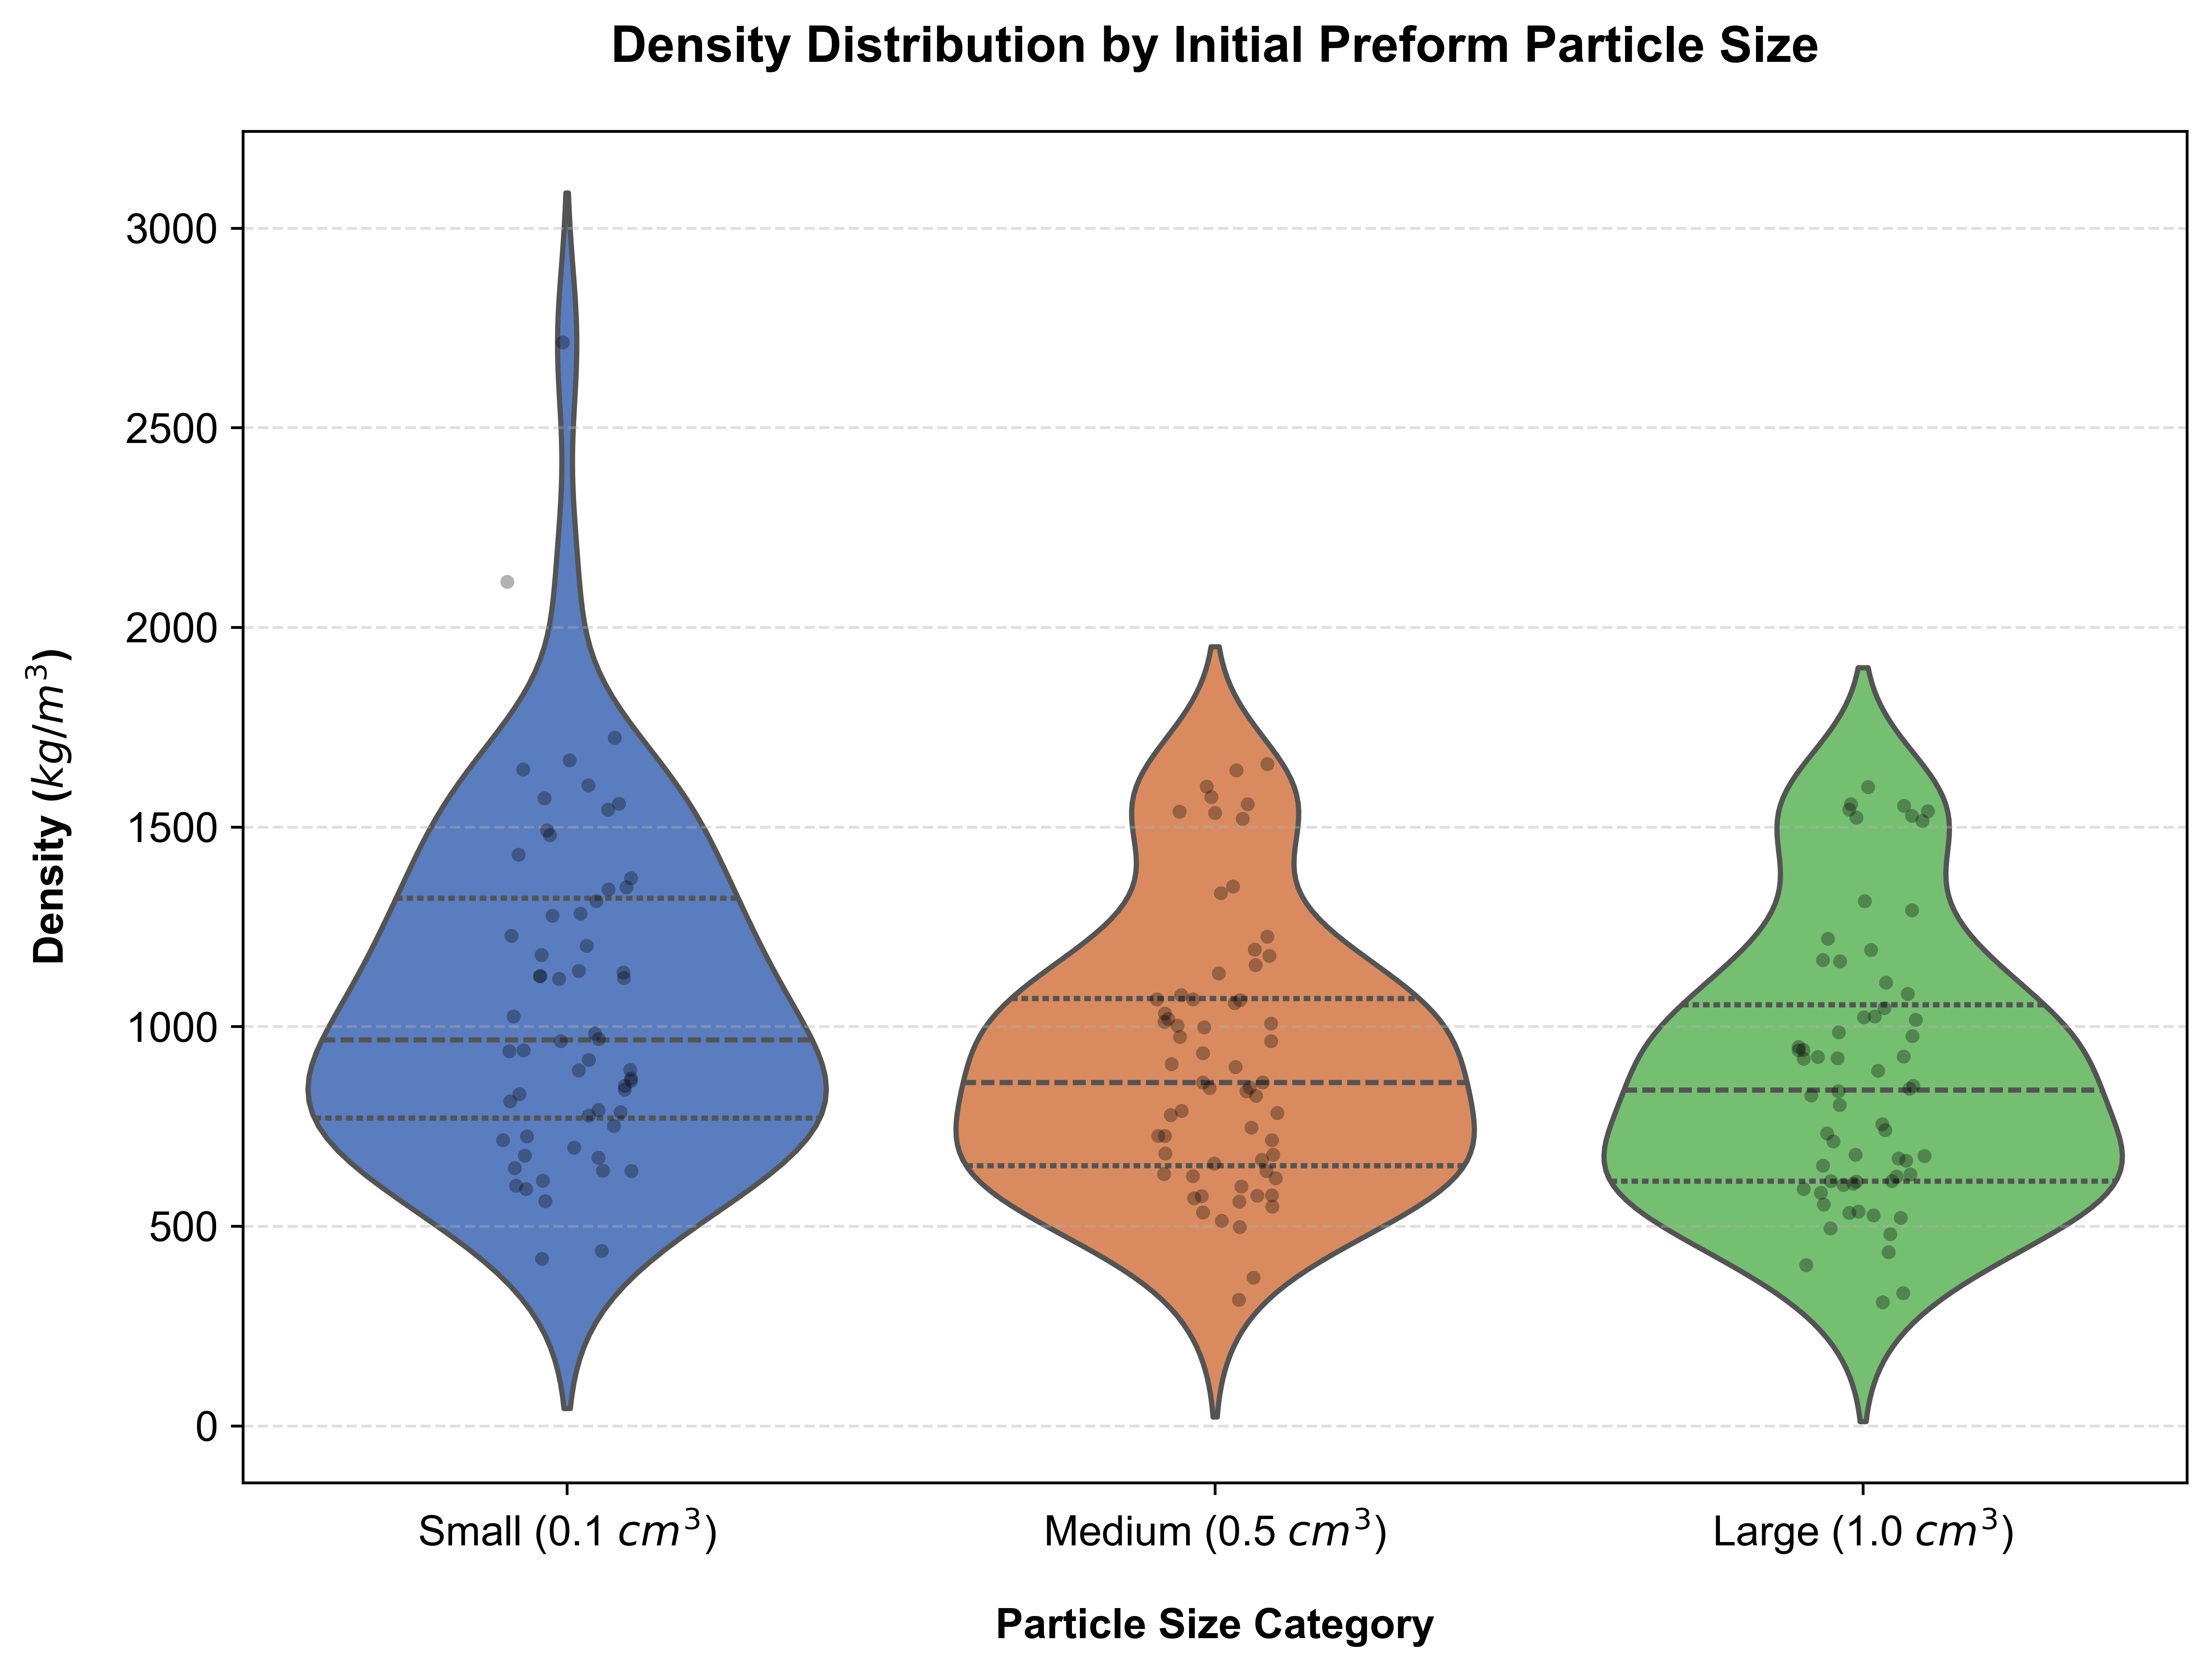
Figure 2: Violin plot showing the final fired density distribution across the initial (pre-calcination) Small, Medium, and Large preform volume categories for all 64 sample formulations.
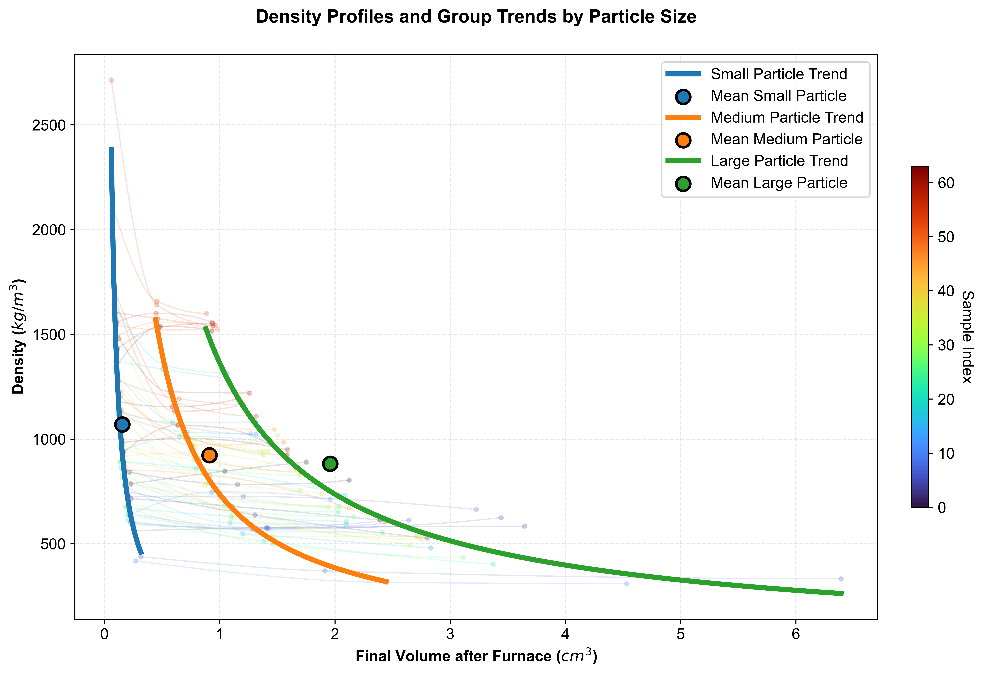
Figure 3: Density profiles and group trends by pre-calcination particle size, showing the effect of initial (unfired) sample volume on the final fired volume and minimum achieved post-calcination density.
Microscopic analysis shown in Figure 4 visually validates these density drops, showing the transition from a dense matrix to an expanded, porous structure as SiC concentration increases.
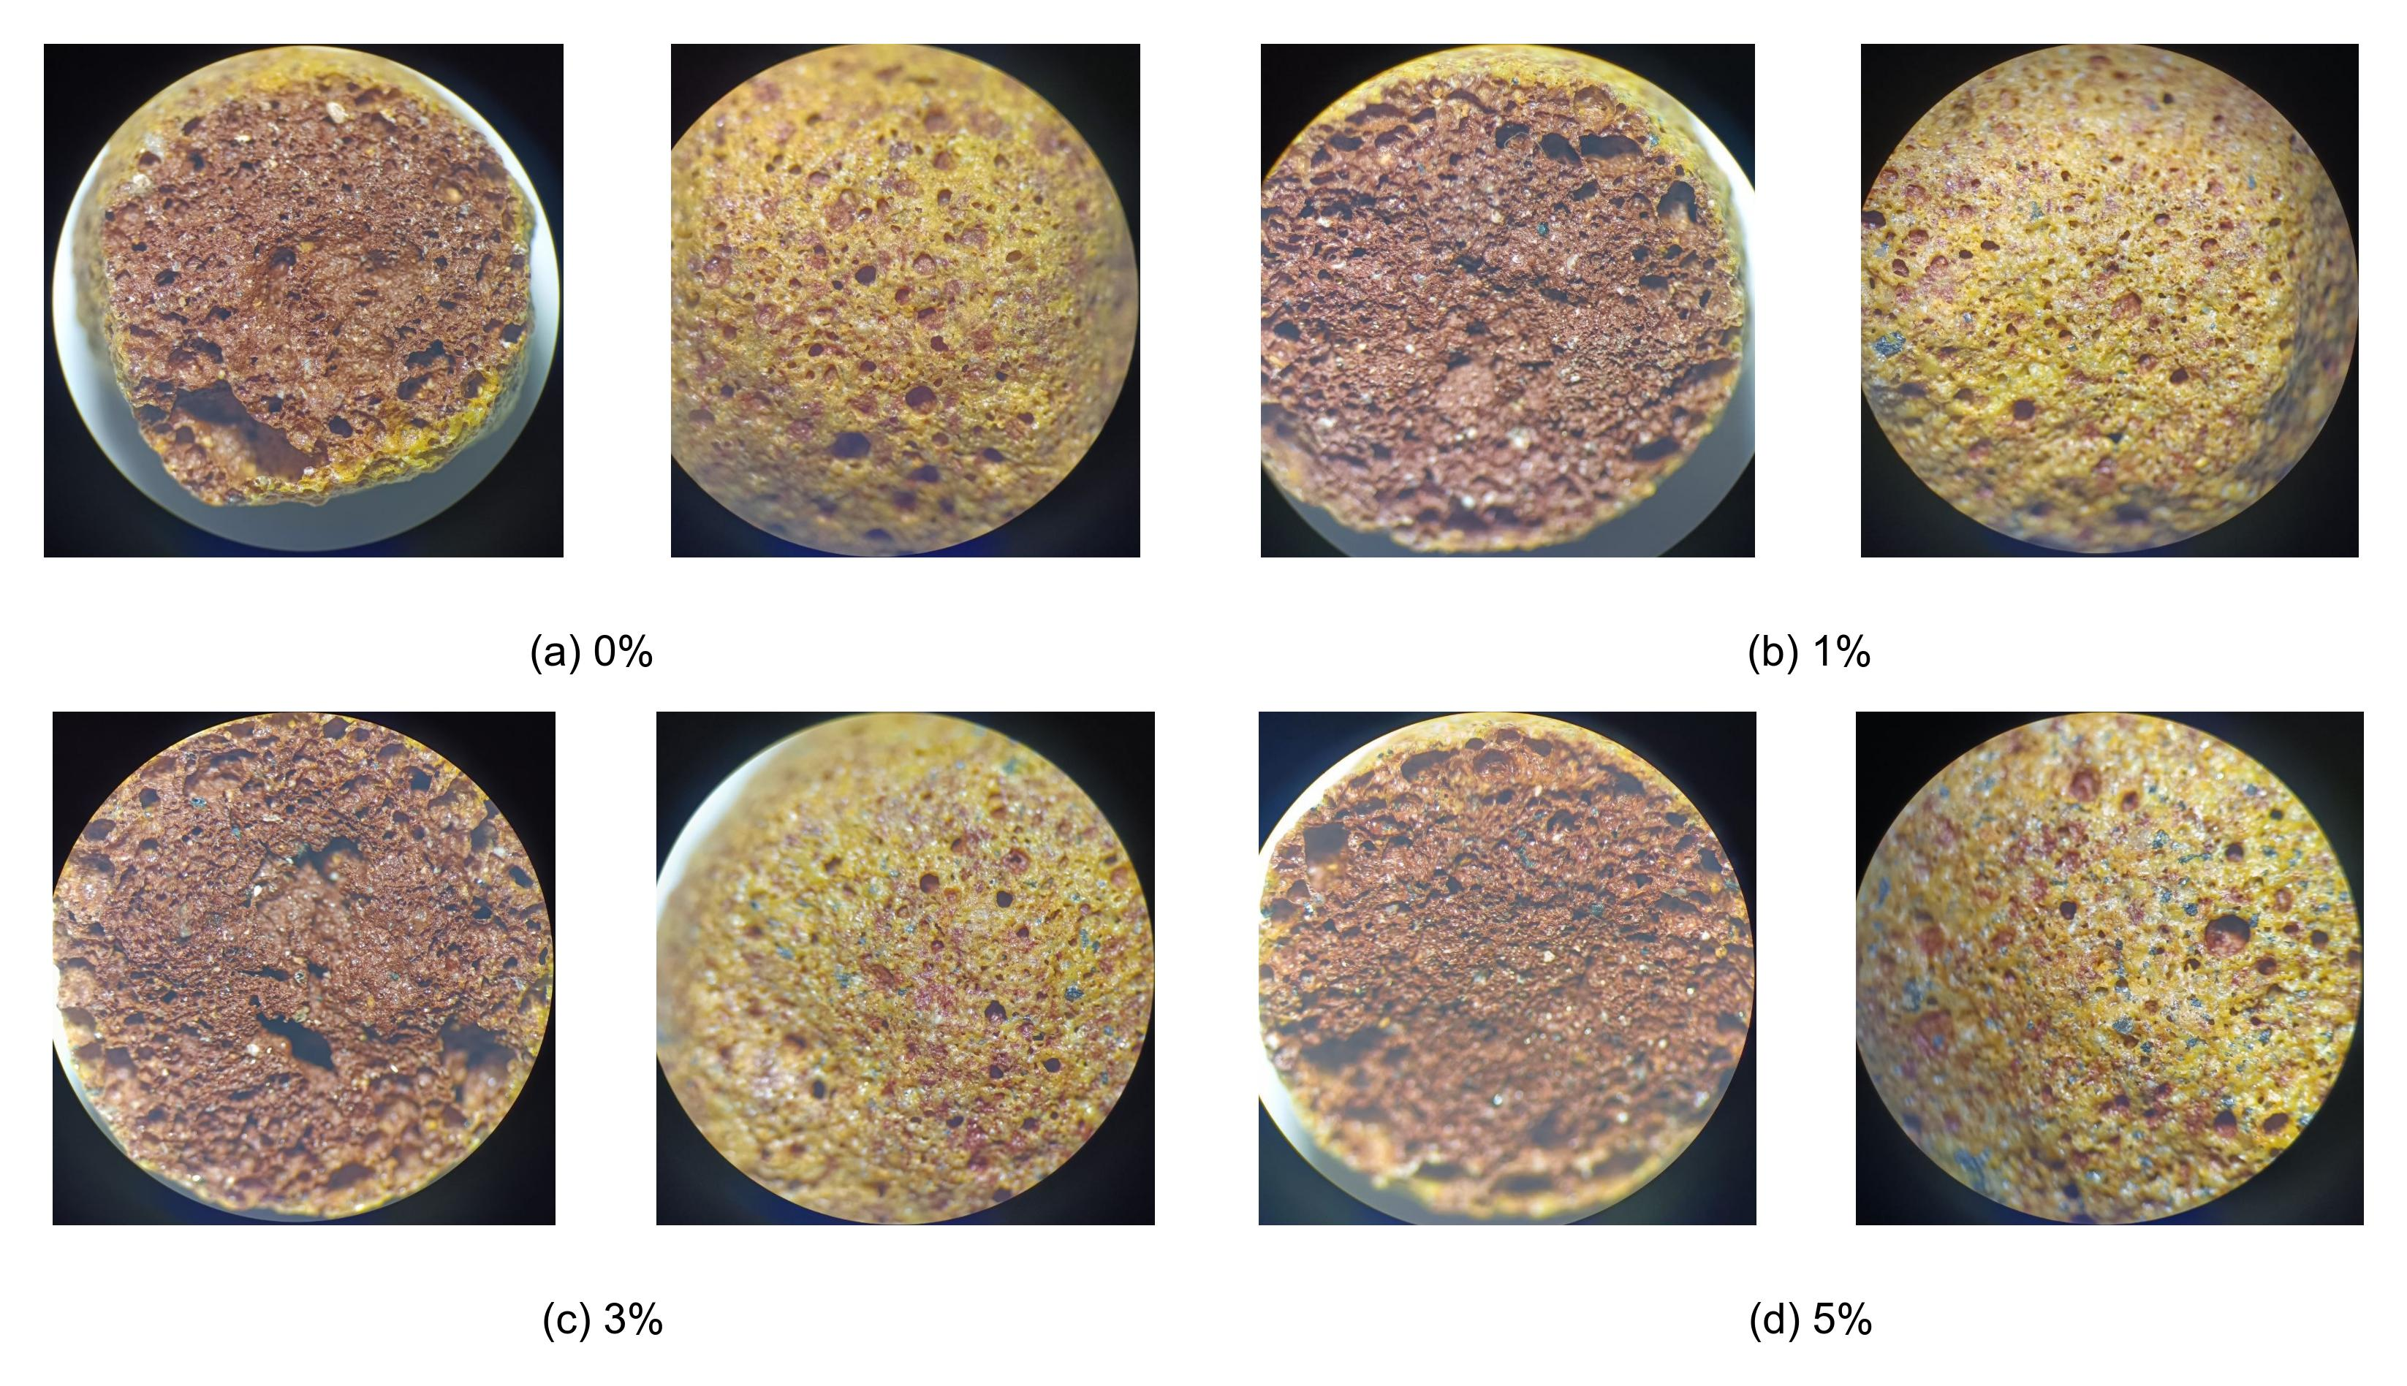
Figure 4: Microscopic evaluation of samples showing inner pore structures for formulations with (a) 0 %, (b) 1 %, (c) 3 %, and (d) 5 % SiC content.
    - Porosity, Permeability, and Pore Formation Mechanisms
The decrease in density exponentially increases absolute porosity. Water permeability metrics (Figure 5) clarify pore interconnectivity, ranging from 0.23 g/cm³ (mostly closed) to 0.86 g/cm³ (highly open). At 3 % and 5 % SiC, permeability surges, reflecting the formation of interconnected structures. At these concentrations, the internal gas volume exceeds the molten phase's surface tension, causing pore walls to rupture and interconnect.
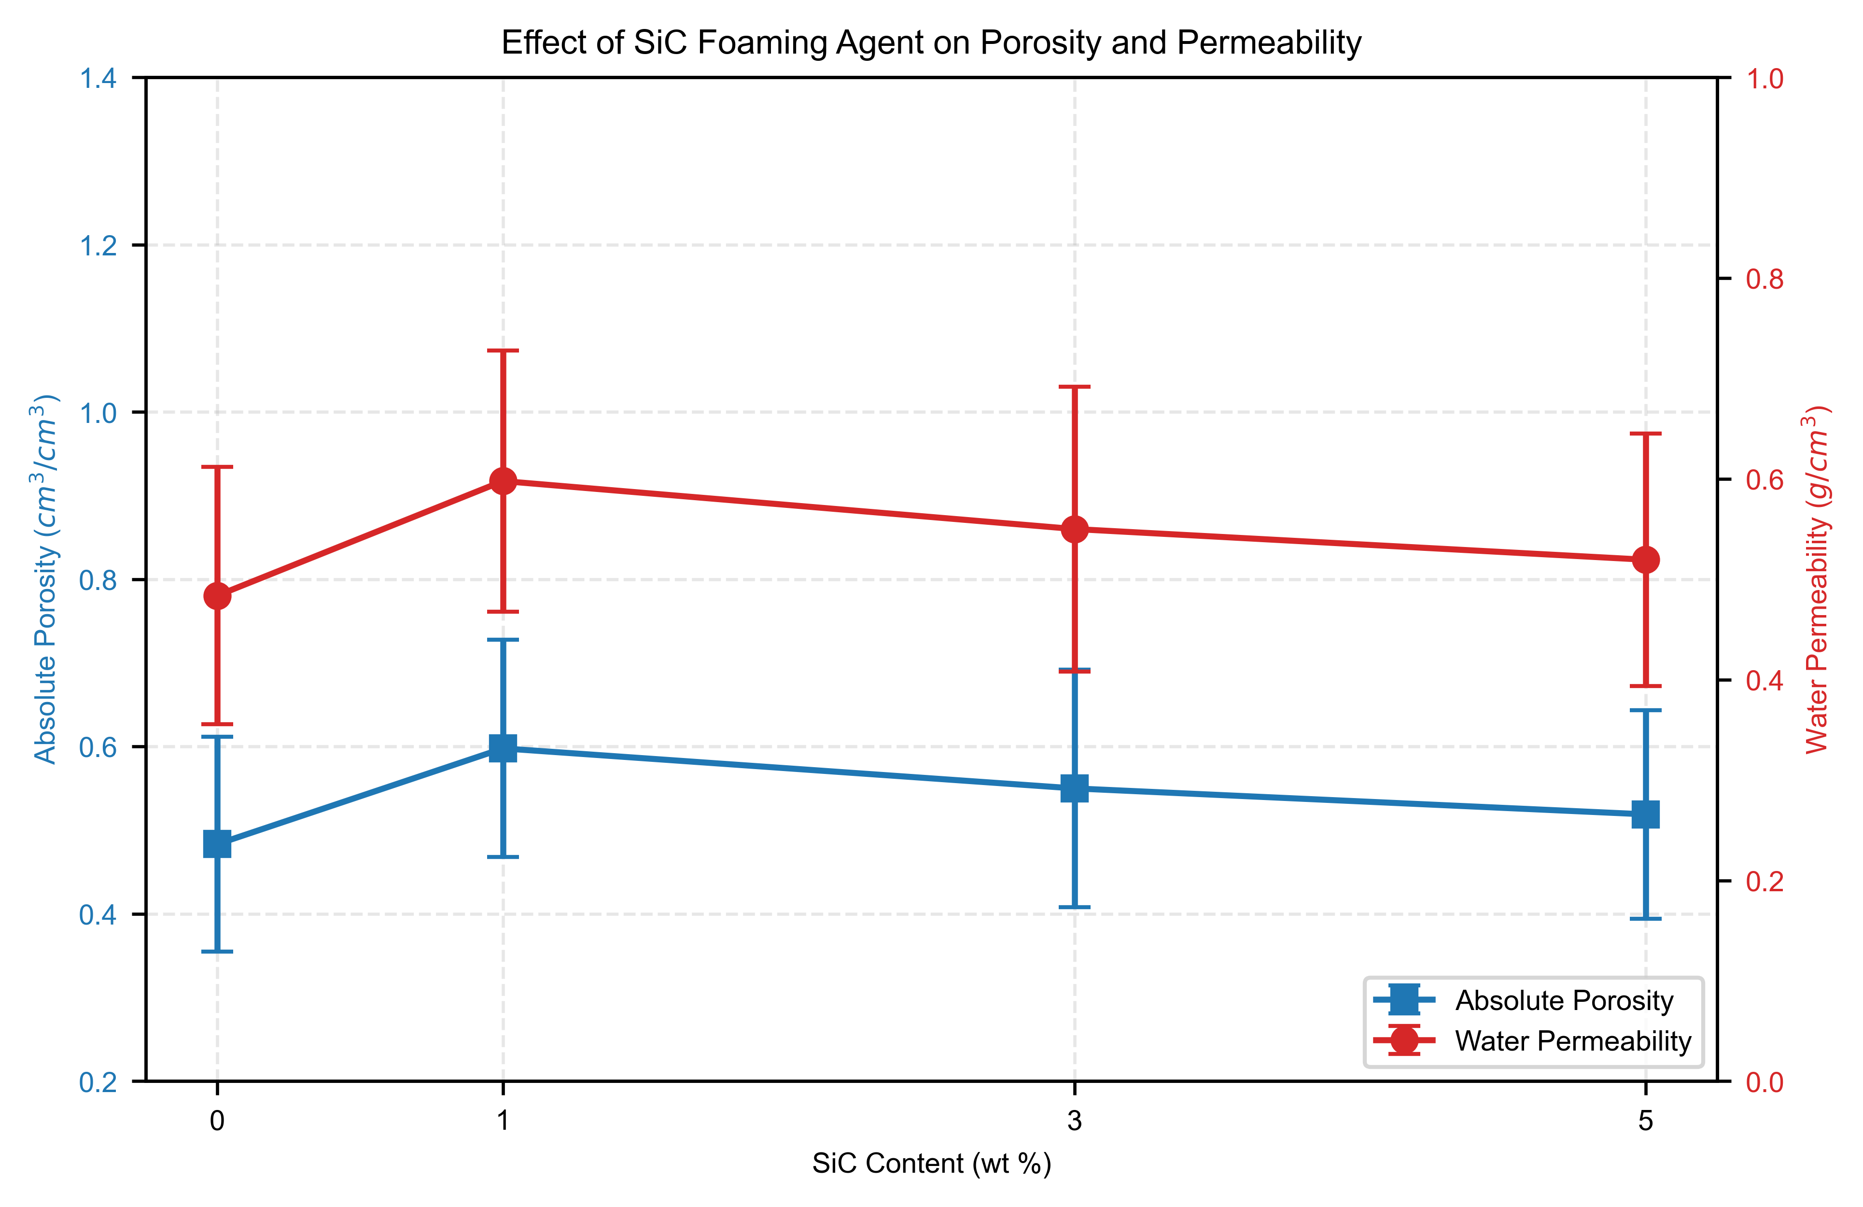
Figure 5: Effect of SiC Foaming Agent on Absolute Porosity and Water Permeability.

The pore creation mechanism relies on a delicate thermodynamic balance. The SiC grains oxidize to release carbon gases (CO and CO₂) while the NaOH-activated glauconite yields a viscous silicate melt. The melt must be sufficiently mobile to expand under pressure but viscous enough to retain the gas. Lower SiC concentrations (<3 %) produce discrete, closed pores ideal for thermal insulation. Conversely, higher SiC concentrations (≥3 %) and elevated temperatures drive extensive pore coalescence, producing interconnected foam networks suitable for high-temperature filtration. This mechanistic insight extends the models proposed by Deng et al. (2023) by demonstrating the unique rheological control offered by complex phyllosilicate precursors.
  - Conclusions
This study confirms that alkali-activated Changi glauconite is a viable and sustainable precursor for tunable porous ceramics. Utilizing NaOH as a flux and SiC as a foaming agent between 800–950 °C enables the transformation of a dense phyllosilicate into a highly porous matrix. SiC oxidation acts as the primary driving force for structural expansion, where a 5 wt % SiC addition reduces apparent density by 83 % to an ultra-lightweight 340 kg/m³. Concurrently, water permeability increases from 0.23 to 0.86 g/cm³, marking a functional transition from closed-pore thermal insulators to open-network filtration media. These results highlight the precise morphological control achievable with local mineral resources.
Acknowledgments
The authors gratefully acknowledge the institutional support and technical assistance provided by the Department of Technology of silicate materials at the Tashkent Institute of Chemical Technology, and the Scientific Laboratory of Physical and Chemical Analysis and Nanomaterials.
References
Abdel-Gawwad H.A., Mohammed M.S., Heikal M., 2020, Ultra-lightweight porous materials fabrication and hazardous lead-stabilization through alkali-activation/sintering of different industrial solid wastes, Journal of Cleaner Production, 244, 118742.
Deng F., Wang F., Shi X., Liu L., Liao Q., 2023, Synthesis and properties of foam glass-ceramics from granite tailings by using SiC and MnO₂ as the mixed foaming agent, Ceramics International, 49, 34647–34656.
El-Amir A.A.M., Attia M.A.A., Fend T., Ewais E.M.M., 2022, Production of high-quality glass foam from soda lime glass waste using SiC-AlN foaming agent, Journal of the Korean Ceramic Society, 59, 444–452.
Kazantseva L.K., Rashchenko S.V., 2014, Chemical processes during energy-saving preparation of lightweight ceramics, Journal of the American Ceramic Society, 97.
Lao X., Xu X., 2018, Effect of silica on in-situ synthesis of nano-SiC whiskers in porous Al₂O₃-SiC composite ceramics for solar thermal storage by aluminium-assisted carbothermal reduction, Ceramics International, 44, 20501–20507.
Leonovich S., Sviridov D., Belanovich A., Karpushenkava L.S., Karpushenkov S.A., Kim L.V., 2020, Use of alkali activation to obtain porous glass-ceramic material from clay raw materials, FEFU: School of Engineering Bulletin, 43, (in Russian).
Ramli M.I.I., Salleh M.A.A.M., Abdullah M.M.A.B., Aziz I.H., Ying T.C., Shahedan N.F., Kockelmann W., Fedrigo A., Sandu A.V., Vizureanu P., Chaiprapa J., Burduhos Nergis D.D., 2022, The influence of sintering temperature on the pore structure of an alkali-activated kaolin-based geopolymer ceramic, Materials, 15, 2667.
Ruzimova S.U., Babakhanova Z.A., 2024, Study of raw mineral resources of Uzbekistan for production of lightweight ceramic materials, Eurasian Journal of Academic Research, 4, 81–89.
Ruzimova S.U., Babaxanova Z.A., Azamatov U.R., 2025a, Multi-criteria optimization of glauconite-based geopolymer aggregates: Balancing thermal conductivity and mechanical strength, International Journal of Research Publication and Reviews, 6.
Ruzimova S.U., Babaxanova Z.A., Azamatov U.R., 2025b, Thermal expansion kinetics of glauconite-based aluminosilicate composites: Mass loss analysis and temperature optimization, International Journal of Research Publication and Reviews, 6.
Sarı A., Akdeniz R., Soydan A.M., Yıldız Ö., 2022, The influence of process parameters on the properties of glass foam produced from industrial waste glass using SiC as the foaming agent, Eskişehir Technical University Journal of Science and Technology, 23, 2136.
Shang S., Fan H., Li Y., Li L., Li Z., 2022, Preparation of lightweight ceramsite from solid waste using SiC as a foaming agent, Materials, 15, 325.

