 CHEMICAL ENGINEERING TRANSACTIONS  VOL. xxx, 2026 | A publication of  
The Italian Association
of Chemical Engineering
Online at www.cetjournal.it

Guest Editors: Flavio Manenti, Botir Usmonov, Alessandro Di Pretoro
Copyright © 2026, AIDIC Servizi S.r.l.
ISBN 979-12-81206-xx-x; ISSN 2283-9216

Synthesis and Physico-Chemical Evaluation of Advanced Dental Cements
Toshboyev Jahongir
Tashkent institute of chemical technology, PhD student of department Technology of silicate materials, Navoi Street, 32, Tashkent, Uzbekistan, 100011.
dsjaha36@gmail.com
Dental cements are fundamental for achieving durable, leak-proof seals and ensuring the mechanical stability of dental prostheses. This study explores the synthesis of advanced bioactive glass formulations using a high-temperature melt-quench technique at 1450°C, followed by rapid quenching and milling to a refined particle size below 20 micrometers. Structural characterization through XRD and FTIR confirmed that bioactivity was successfully integrated without compromising mechanical strength. The synthesized cements demonstrated minimized water sorption and optimized setting times, indicating a highly cross-linked internal matrix. These properties, alongside exceptionally low solubility rates, offer a significant advancement over traditional cements by enhancing the longevity of restorations in load-bearing posterior regions. Ultimately, this methodology establishes a viable scientific foundation for local manufacturing and import substitution in Central Asia, which would enhance the overall quality and accessibility of oral healthcare through the use of high-performance restorative materials.
  - Introduction
Dental cements serve as specialized materials within restorative and endodontic dentistry, functioning as luting agents, liners, or filling materials that must withstand the rigorous thermal and mechanical stresses of the oral environment. Modern advancements have shifted the focus from chemically inert options, such as zinc phosphate, toward bioactive systems like glass ionomer cements (GIC) and calcium silicate-based formulations, including white Portland cement. These contemporary materials utilize complex hydration or acid-base reactions to facilitate ion exchange at the tooth-material interface, often incorporating additives like bioactive glass or radiopacifying oxides to enhance mineralized tissue formation and clinical visibility. By promoting the precipitation of a hydroxyapatite layer, these "smart" cements not only provide a superior hermetic seal against microleakage but also actively participate in the remineralization of dental tissues, effectively bridging the gap between material science and biological regeneration (Davidson, 2006; Staněk et al., 2023).
While contemporary bioactive dental materials such as glass ionomer cements, Mineral Trioxide Aggregate (MTA), and advanced calcium silicate-based formulations like Biodentine have revolutionized endodontic therapies, they are hindered by notable clinical limitations. Traditional MTA suffers from excessively long setting times, poor handling characteristics, and tooth discoloration, whereas newer alternatives face challenges like Biodentine's higher initial solubility and the unpredictable, moisture-dependent curing times of premixed syringeable cements. To overcome these drawbacks, the proposed white Portland cement–bioactive glass (WPC–BG) system integrates a highly reactive glass phase that rapidly accelerates carbonated hydroxyapatite precipitation upon contact with physiological fluids. This synergistic combination not only ensures a faster, seamless chemical bond with dentin to minimize microleakage and early solubility risks but also provides a sustained release of calcium and phosphate ions, maintaining an antimicrobial environment and actively stimulating dental pulp stem cells for superior biological regeneration.
The incorporation of white Portland cement (WPC) into dental applications as the structural backbone of Mineral Trioxide Aggregate (MTA) has been significantly enhanced by the integration of bioactive glasses (BG) to improve regenerative outcomes. While WPC provides a robust, biocompatible matrix primarily composed of tricalcium silicate (Ca₃​SiO₅​) and dicalcium silicate (Ca₂​SiO₄​), the addition of BG particles introduces a highly reactive phase that accelerates the precipitation of a carbonated hydroxyapatite (Ca₁₀​(PO₄​)₆​(OH)₂​) layer upon contact with physiological fluids. This interfacial layer is vital for creating a seamless chemical bond between the cement and the dentin, which drastically improves sealing efficiency and minimizes the risk of microleakage. From a chemical perspective, the glass component facilitates a more rapid release of calcium (Ca²⁺) and phosphate (PO₄³⁻​) ions compared to WPC alone, maintaining a high local pH that serves as an effective antimicrobial barrier. Furthermore, this synergistic blend does more than just fill a gap; it actively stimulates dental pulp stem cells and promotes the formation of reparative dentin bridges, proving that even in the world of endodontics, a little bit of glass can go a long way in making a "bright" material even smarter.
The primary aim of this research is to develop and systematically evaluate a novel, highly reactive biocidal dental cement by integrating a bioactive glass phase with white Portland cement synthesized via a concentrated solar furnace. By leveraging rapid solar-thermal clinkerization, the study seeks to achieve an ultra-pure, high-alite matrix completely free from combustion contaminants, thereby eliminating the tooth discoloration and localized toxicity issues frequently associated with conventional endodontic materials. Conventional kilns rely on burning coal, natural gas, or alternative fuels to reach the required 1,400°C to 1,500°C for clinkerization. This inevitably introduces ash, carbon residue, and heavy metal trace contaminants into the cement matrix.
  - Materials and Methods
    - Synthesis of WPC
To obtain White Portland cement, microcalcite was used as a source of calcium oxide (CaO), and primary kaolin was used as a source of silicon dioxide (SiO₂​) and aluminum oxide (Al₂​O₃​). The raw materials were weighed on an analytical balance with an accuracy of 0.001 g. The proportions of the components were calculated based on stoichiometric ratios to obtain the target clinker phases (predominantly alite C₃​S and belite C₂​S). The raw materials were pre-dried in a drying oven at 200°C. Subsequently, the components were ground and mixed manually in an agate mortar to achieve homogenization. Drying raw materials like microcalcite and primary kaolin at 200°C effectively removes both free moisture (surface water) and loosely bound hygroscopic water. This step is critical because any residual moisture would introduce errors during the analytical weighing process, skewing the strictly calculated stoichiometric ratios of the oxides (Ismatov, 2006). The chemical composition of the clinker synthesized using concentrated solar energy was determined by X-ray fluorescence (XRF) analysis and IR spectroscopy. While typical gray Portland cement can tolerate certain thermal variations and combustion byproducts, WPC requires absolute chemical purity and exceptionally high synthesis temperatures. Shifting this process to solar thermal reactors fundamentally transforms the thermodynamics, purity controls, and environmental footprint of the operation.
The raw material, in both powder and briquette form, was placed into corundum crucibles. The synthesis was carried out at temperatures up to 1550°C and held at the peak temperature for 10 minutes. The operation of a high-temperature solar furnace is based on the principle of double reflection and concentration of solar radiation. The system functions like a giant optical lens that collects scattered solar energy from a large area and focuses it into a small spot (the focal zone), creating extremely high temperatures (Riskiev and Suleimanov, 2009).
    - Synthesis of bioactive glass
The synthesis of the experimental glass phases was performed in a high-temperature laboratory electric furnace utilizing silicon carbide (SiC) resistive heating elements, which ensured stable thermal distribution throughout the chamber. High-purity starting reagents of analytical grade (pro analysi, p.a.) were precisely proportioned by weighing on an analytical balance with a sensitivity limit of ±0.001 g to ensure strict adherence to the target stoichiometric formulations. High-temperature melting was conducted within a temperature range of 1500–1550°C, a thermal window chosen to achieve complete dissolution of the refractory oxides and lower the melt viscosity for optimal homogenization. The process temperature was continuously monitored using a calibrated platinum-platinum/rhodium thermocouple (Type S/R) positioned in close proximity to the reaction zone. To prevent structural contamination and resist chemical attack by the aggressive oxide melt, the batches were processed inside high-purity corundum (α-Al₂​O₃​) crucibles.
    - Fourier Transform Infrared Analysis
Fourier Transform Infrared (FTIR) Analysis is a powerful analytical technique used to identify organic, polymeric, and, in some cases, inorganic materials. By exposing a sample to infrared radiation, the method measures how much light is absorbed or transmitted at different wavelengths, creating a unique molecular "fingerprint" that reveals the chemical bonds and functional groups present within the structure (Smith, 2011).
    - Determining the solubility of materials
The specimens were formed into standardized molds to ensure a consistent surface area and volume. After the material has reached its final set at 37°C, the initial dry mass is recorded. The specimens are then suspended in distilled water for 24 hours. The weight loss is quantified by evaporating the immersion water and weighing the residue.
  - Results
    - Composition of synthesized cement
The chemical composition of the clinker synthesized using concentrated solar energy was determined by X-ray fluorescence (XRF) analysis and IR spectroscopy
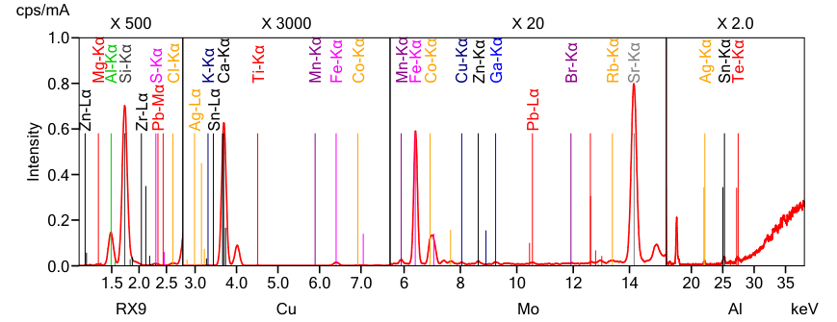
Figure 1: XRD pattern of the synthesized cement
Table 1. Composition of cement (based on XRF analysis results)
Component | Result | Unit | . Stat. Err. | LLD | LLQ
Cl | 0.0155 | mass% | 0.0002 | 0.0002 | 0.0005
Br | 0.0004 | mass% | <0.0001 | 0.0001 | 0.0003
MgO | 1.14 | mass% | 0.0208 | 0.0341 | 0.102
Al₂O₃ | 8.53 | mass% | 0.0222 | 0.0118 | 0.0353
SiO₂ | 16.8 | mass% | 0.0184 | 0.0072 | 0.0215
SO₃ | 0.0689 | mass% | 0.0008 | 0.0005 | 0.0014
K₂O | 0.0891 | mass% | 0.0028 | 0.0061 | 0.0184
CaO | 71.3 | mass% | 0.0502 | 0.0277 | 0.0832
TiO₂ | 0.133 | mass% | 0.0029 | 0.0034 | 0.0102
MnO | 0.0225 | mass% | 0.0012 | 0.0021 | 0.0064
Fe₂O₃ | 0.459 | mass% | 0.0037 | 0.0024 | 0.0071
Co₂O₃ | 0.0567 | mass% | 0.0013 | 0.0023 | 0.0068
CuO | 0.0019 | mass% | 0.0002 | 0.0005 | 0.0014
ZnO | 0.0025 | mass% | 0.0002 | 0.0004 | 0.0011
Ga₂O₃ | 0.0016 | mass% | 0.0001 | 0.0003 | 0.0009
Rb₂O | 0.0010 | mass% | <0.0001 | <0.0001 | 0.0003
SrO | 0.0317 | mass% | 0.0002 | 0.0003 | 0.0010
ZrO₂ | 0.261 | mass% | 0.0024 | 0.0008 | 0.0025
Ag₂O | 0.0020 | mass% | 0.0002 | 0.0003 | 0.0008

As shown in Figure 1. and Table 1. analysis revealed an extremely low content of coloring oxides, including Fe₂​O₃​ (0.46%) and MnO (0.02%). This indicates the absence of contamination from fuel ash, which is the primary advantage of the environmentally friendly solar sintering process.
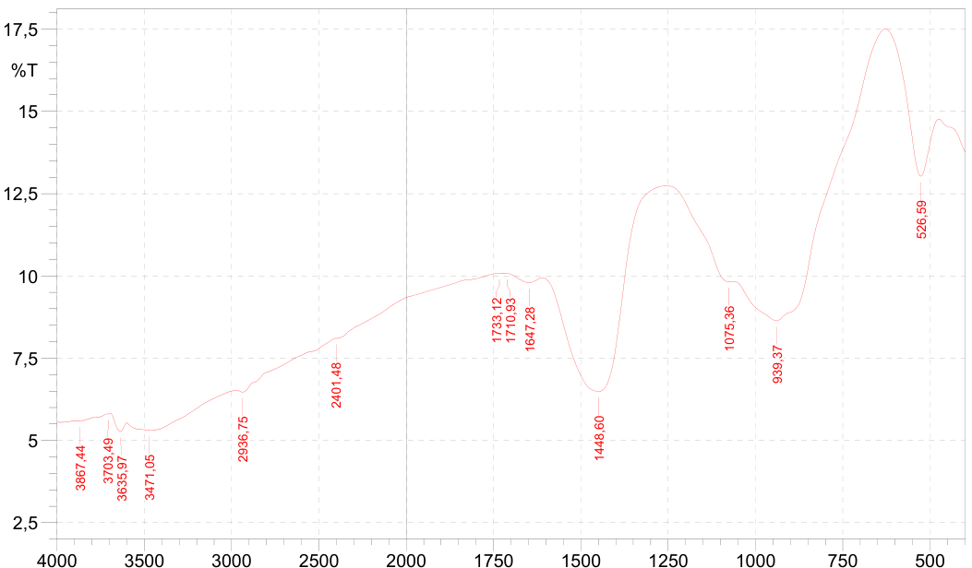
Figure 2: FTIR spectrum of the synthesized cement
Table 2. IR spectrum data
Peak | Intensity | Corr. Intensity | Base (H) | Base (L) | Area | Corr. Area
526,59 | 13,03 | 2,655 | 627,86 | 475,47 | 125,526 | 4,616
939,37 | 8,636 | 3,365 | 1061,86 | 628,82 | 408,618 | 26,959
1075,36 | 9,821 | 0,2 | 1253,78 | 1062,82 | 181,048 | 0,551
1448,6 | 6,485 | 4,726 | 1609,67 | 1254,75 | 370,729 | 34,588
1647,28 | 9,795 | 0,196 | 1707,08 | 1610,63 | 96,882 | 0,46
1710,93 | 10,068 | 0,003 | 1720,58 | 1708,04 | 12,5 | 0,001
1733,12 | 10,075 | 0,001 | 1735,04 | 1730,22 | 4,807 | 0
2401,48 | 8,099 | 0,012 | 2405,34 | 1736,01 | 696,97 | 0,128
2936,75 | 6,467 | 0,149 | 2969,54 | 2406,3 | 640,385 | 0,561
3471,05 | 5,302 | 0,433 | 3600,29 | 2970,5 | 779,757 | 10,715
3635,97 | 5,274 | 0,363 | 3694,81 | 3601,25 | 118,059 | 1,467
3703,49 | 5,804 | 0,001 | 3704,45 | 3695,77 | 10,726 | 0
3867,44 | 5,588 | 0,001 | 3868,41 | 3852,01 | 20,528 | 0,001
FTIR spectroscopy confirmed the successful formation of the main crystalline phases of Portland cement. A strong peak at 939.37 cm⁻¹ clearly indicates the presence of Alite and Belite, which are essential for ensuring strength.
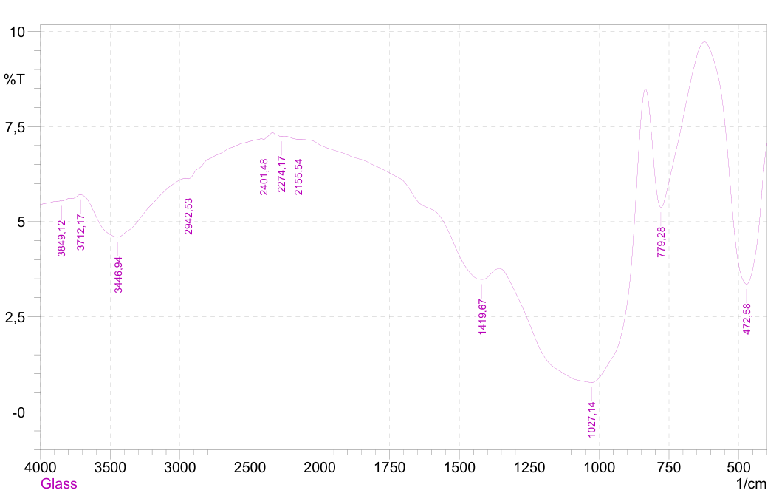
Figure 3: FTIR spectrum of the synthesized glass
This FTIR spectrum shown in Figure 3. reveals the characteristic vibrational modes of a fluoroaluminosilicate glass network, showing the classic distribution of silicate and aluminate structural units along with surface-adsorbed species. The intense, dominant absorption band centered at 1027.14 cm⁻¹ represents the asymmetric stretching vibrations of the Si-O-Si and Si-O-Al bridging bonds within the main tetrahedral network. The sharp, strong peak at the lowest end of the spectrum, 472.58 cm⁻¹, represents the fundamental rocking and bending vibrations of the Si-O-Si and Si-O-Al bonds. The position and sharpness of this band confirm a well-developed, highly interconnected amorphous network characteristic of dense dental or bioactive glass systems. The experimental spectrum reveals a continuous, smooth transition within the valley bounded by the peaks at 779.28cm⁻¹ and 472.58 cm⁻¹, devoid of any discrete, isolated reflections. This spectral profile indicates that the orthophosphate units remain entirely amorphous, structurally disordered, and homogeneously dispersed as network modifiers within the glass matrix, rather than undergoing phase separation or localized clustering. Consequently, this amorphous bending contribution is superimposed directly onto the broad baseline shift descending toward the fundamental rocking mode at 472.58 cm⁻¹. Due to the highly disordered nature of the vitreous network, these phosphate-related configurations present as broad, underlying sub-components that contribute to the inhomogeneous broadening of the primary silicate bands rather than appearing as distinct, resolved peaks.
    - Solubility
The solubility of dental cements is a fundamental measure of their clinical durability and biological safety. A cement that dissolves too readily in the oral environment leads to the loss of marginal integrity, which facilitates the ingress of bacteria and eventually causes secondary caries or the total failure of the restoration.
When a cement fails to meet solubility norms, the primary consequence is marginal leakage. As the cement at the interface of the tooth and the restoration dissolves, a micro-gap form. This gap acts as a reservoir for oral fluids and microorganisms, leading to pulpal irritation and the eventual breakdown of the bond. Furthermore, high solubility is often accompanied by high water sorption, which can cause the material to swell and exert internal stresses on the tooth structure, potentially leading to fractures in brittle restorative materials (Francisconi et al, 2009).
Table 3. Solubility of materials
White Portland cement (w%) | Bioactive fluoroaluminosilicate glass (w%) | Solubility after 24 hours (mg/cm³)
0.1 | 0.9 | 0.85
0.2 | 0.8 | 0.78
0.25 | 0.75 | 0.72
0.5 | 0.5 | 0.64
0.75 | 0.25 | 0.55
0.75 | 0.25 | 0.55
The data from Table 3. indicates that as the concentration of White Portland Cement increases, there is a consistent reduction in both the setting window and the solubility. This suggests that the white Portland cement particles are effectively acting as a hardening accelerator and a reinforcing agent within the bioactive glass matrix. The 0.75 white Portland cement ratio demonstrates the highest chemical stability, which is likely due to the denser cross-linking achieved when the hydration of silicates complements the polyacrylate formation. All these values remain within the ISO 9917-1 regulatory threshold of 1.0 mg/cm³ confirming that these specific experimental blends are viable candidates for clinical restorative applications.
    - Setting time
The setting time of dental cements is a critical clinical parameter that dictates how long a dentist has to manipulate the material before it hardens. It represents the transition of the cement from a workable, plastic paste into a rigid, load-bearing solid structure. The data shown in Table 4. suggests that the glass component is the primary driver of rapid hardening. By adjusting the white Portland cement fraction, it’s possible to "tune" the material: use smaller fraction of white Portland cement and larger fraction of bioactive glass for fast-setting requirements or larger fraction of white Portland cement and less bioactive glass if the application requires a longer period of maturation or potentially different mechanical properties derived from Portland hydration products.
Table 4. Setting times of materials
White Portland cement (w%) | Bioactive fluoroaluminosilicate glass (w%) | Working time (minutes) | Initial setting time (minutes) | Final setting time (minutes)
0.1 | 0.9 | 3 | 4.5 | 35
0.2 | 0.8 | 3 | 4.5 | 45
0.25 | 0.75 | 2.5 | 4 | 50
0.5 | 0.5 | 2.5 | 4 | 80
0.75 | 0.25 | 2 | 3.5 | 115
  - Conclusions
The synthesized advanced dental cement integrates the hydration characteristics of white Portland cement (WPC) with the ion-exchange kinetics of bioactive fluoroaluminosilicate glass. Upon contact with physiological fluids, the alite and belite phases identified at 939.37cm⁻¹ undergo hydrolysis. This hydration primarily forms an amorphous calcium silicate hydrate (C-S-H) matrix and releases calcium hydroxide. The deprotonation of silanol groups within this highly alkaline C-S-H layer creates a negatively charged surface that actively attracts calcium cations (Niu et al., 2014). Simultaneously, the amorphous glass network—confirmed by robust Si-O-Si and Si-O-Al stretching modes at 1027.14cm⁻¹—undergoes rapid dissolution. This glass network rapidly releases modifying ions, leading to the condensation of a silica-rich hydrogel that acts as a nucleation template for biologically stable hydroxyl carbonate apatite precipitation (Profeta & Prucher, 2017). This dual-action mechanism ensures the dense cross-linking observed in this study, wherein WPC acts as a reinforcing agent to minimize early solubility.
The employment of a concentrated solar furnace at 1450–1550°C introduces a strict thermodynamic advantage over conventional kilns. Because alite formation is endothermic and metastable at ambient temperatures, the rapid thermal quench provided by the solar reactor effectively "freezes" the reactive alite structure, preventing its reversion into belite. Additionally, X-ray fluorescence data confirms that this combustion-free environment eradicates trace heavy metal contamination. By restricting transition metal oxides like Fe₂O₃ (0.46%) and MnO (0.02%) to negligible levels, the solar-calcined material eliminates the tooth discoloration commonly plaguing traditional calcium silicate cements.
The experimental data reveals a direct inverse relationship between WPC content and solubility, lowering from 0.85 mg/cm³ to 0.55 mg/cm³ as WPC increases, maintaining strict compliance with ISO 9917-1 limits. This superior chemical stability in higher WPC ratios correlates with extended setting windows of up to 115 minutes, whereas increasing the bioactive glass fraction accelerates final setting times to 35 minutes. This kinetic tunability allows clinicians to safely optimize the cement for varied endodontic needs, ranging from rapid pulp capping to complex restorations requiring extended manipulation.
References
Davidson, C. L. (2006) 'Advances in glass-ionomer cements', Journal of Applied Oral Science, pp. 3–9.
Francisconi, L. F., Freitas, A. P. d., Scaffa, P. M. C., Mondelli, R. F. L. and Francisconi, P. A. S. (2009) 'Water sorption and solubility of different calcium hydroxide cements', Journal of Applied Oral Science, 17(5), pp. 427–431.
Ismatov, A. A. (2006) Technology of silicates and refractory non-metallic materials. Tashkent: Fan va texnologiya, pp. 184–190.
Niu, L., Jiao, K., Wang, T., et al. (2014) 'A review of the bioactivity of hydraulic calcium silicate cements', Journal of Dentistry, 42(5), pp. 517–533.
Profeta, A. C. and Prucher, G. M. (2017) 'Bioactive-glass in endodontic therapy and associated microsurgery', The Open Dentistry Journal, 11, pp. 164–170.
Riskiev, T. T. and Suleimanov, S. K. (2009) 'The Parkent solar furnace: A key to the future of materials science', Applied Solar Energy, 45(1), pp. 1–6.
Smith, B. C. (2011) Fundamentals of Fourier transform infrared spectroscopy. 2nd edn. Boca Raton, FL: CRC Press.
Staněk, J., Azar, B. E. and Fichtel, T. (2023) 'Cement-based materials in dentistry', in Saleh, H. M. and A., I. (eds.) Reinforced concrete structures - innovations in materials, design and analysis. London: IntechOpen.

