 CHEMICAL ENGINEERING TRANSACTIONS  VOL. xxx, 2026 | A publication of  
The Italian Association
of Chemical Engineering
Online at www.cetjournal.it

Guest Editors: Flavio Manenti, Botir Usmonov, Alessandro Di Pretoro
Copyright © 2026, AIDIC Servizi S.r.l.
ISBN 979-12-81206-xx-x; ISSN 2283-9216

Active learning strategies for sustainability-oriented education in Chemical and Process Engineering:
a case study from a Master’s degree course
Federico d’Amore^{a,}*, Paolo Mocellin^{b}
ªCAPE-Lab – Computer-Aided Process Engineering Laboratory, Department of Industrial Engineering, University of Padova, via Marzolo 9, 35131 Padova PD (Italy)
^{b}Department of Industrial Engineering and Department of Civil, Environmental and Architectural Engineering, University of Padova, via Marzolo 9, 35131, Padova PD (Italy)
federico.damore@unipd.it
Active learning methodologies are increasingly recognised as valuable approaches in Chemical and Process Engineering education, particularly in topics related to sustainability and energy transition. Teaching strategies such as project-based learning, peer assessment, collaborative problem solving, and multidisciplinary teamwork can support the development of both technical competences and transversal skills required to address complex and multifaceted engineering challenges.
This work presents the educational approach adopted in the Master’s degree course Process Technologies for Carbon Neutral Fuels (PTCNF) at the University of Padova, Italy. The course involves students from different engineering backgrounds and is centred on open-ended multidisciplinary projects related to sustainable energy systems and industrial decarbonisation. Students work in teams to develop strategic action plans integrating technological, environmental, and socio-economic considerations.
The assessment methodology combines group presentations, written reports, anonymised peer-review activities, and individual discussions. Through this structure, students engage in critical evaluation, strategic analysis, and collaborative learning while strengthening communication and professional skills. The proposed approach demonstrates how active learning and multidisciplinary teamwork can effectively support sustainability-oriented education in Chemical and Process Engineering programmes.
  - Introduction
Engineering education is increasingly evolving towards teaching methodologies capable of integrating technical knowledge with transversal competences such as teamwork, communication, critical thinking, and systems-level analysis (Prince, 2004; Wiek et al., 2011; Mulder et al., 2012; Sabri, 2025). This evolution is particularly relevant in Chemical and Process Engineering, where future engineers are expected to address complex sustainability challenges associated with the energy transition, industrial decarbonisation, resource efficiency, and circular economy (Wiek et al., 2011; Lozano et al., 2017). Traditional lecture-based teaching approaches, while effective for delivering theoretical foundations, are often insufficient to reproduce the complexity, uncertainty, and multidisciplinary nature of real engineering decision-making processes (Mulder et al., 2012).
In recent years, active learning methodologies have gained growing attention in engineering education as effective tools to improve student engagement and learning outcomes (Prince, 2004). These approaches shift the focus from passive reception of information to student-centred learning processes in which learners actively participate in problem solving, discussion, collaboration, and critical evaluation activities. Within Chemical Engineering education, several studies have highlighted the benefits of project-based learning, collaborative assignments, peer assessment, and multidisciplinary teamwork in fostering deeper understanding and improving professional preparedness (Ravi, 2023). Among active learning approaches, project-based learning is particularly suitable for sustainability-related topics because it enables students to tackle open-ended and realistic engineering problems that require the simultaneous consideration of technological, environmental, economic, and societal aspects (Wiek et al., 2011; Lozano et al., 2017). Similarly, peer-review and collaborative assessment activities can enhance students’ critical thinking abilities and encourage reflective learning processes (Topping, 1998). Cifrian et al. (2020) showed that integrating different assessment approaches in engineering courses can improve student participation, autonomy, and engagement while supporting the development of communication and teamwork skills. These aspects are especially important in educational activities focused on sustainable energy systems and industrial decarbonisation.
Evaluating low-carbon technologies and sustainability strategies often requires the integration of knowledge across multiple engineering disciplines, together with the ability to navigate uncertain contexts characterised by incomplete or evolving information (Wiek et al., 2011). Consequently, multidisciplinary teamwork and open-ended problem solving become essential educational components for preparing students to operate in real industrial and societal contexts (Lozano et al., 2017). Within this framework, this work presents the educational methodology adopted in the course Process Technologies for Carbon Neutral Fuels (PTCNF), a Master’s degree elective course at the University of Padova (Italy) offered to students in Chemical and Process Engineering, Energy Engineering, and Materials Engineering. The course addresses topics including biofuels, carbon capture utilisation and storage, hydrogen technologies, and decarbonisation pathways for hard-to-abate sectors, such as cement, steelmaking, and refining. A distinctive feature of the course is its examination methodology, which is based on multidisciplinary group projects focused on broad open-ended sustainability challenges. Students are organised into teams comprising different backgrounds and are asked to develop strategic action plans for complex sustainability scenarios. The assessment combines oral presentations, written reports, peer-review activities, and individual discussions, with the objective of evaluating not only technical knowledge but also collaboration, communication, and critical analysis skills (Topping, 1998; Ravi, 2023).
While the individual educational components adopted in PTCNF, such as project-based learning, peer-review activities, and collaborative assessment, are not new in themselves, the originality of the proposed framework lies in their integration within a sustainability-oriented Chemical and Process Engineering course. In particular, the methodology combines multidisciplinary team formation, open-ended industrial decarbonisation challenges, iterative peer-review cycles, and a balanced mixture of group and individual assessment activities. This combination aims to reproduce some of the complexity, uncertainty, and collaborative decision-making processes that characterise real sustainability-driven projects, while simultaneously promoting both technical and transversal competences. Within this framework, the objective of the present work is to describe and critically discuss the adopted educational methodology, its assessment structure, and the observed outcomes in terms of student engagement, skill development, and perceived educational effectiveness.
  - Educational methodology and course organisation
Process Technologies for Carbon Neutral Fuels (PTCNF) is an elective Master’s degree course at the University of Padova (Italy) offered to students in Chemical and Process Engineering, Energy Engineering, and Materials Engineering. The course focuses on technologies and strategies for industrial decarbonisation and sustainable systems, including biofuels, carbon capture utilisation and storage, hydrogen production, and low-carbon solutions for hard-to-abate sectors. In addition to providing technical knowledge on emerging process technologies, the course is designed to foster transversal competences associated with sustainability-oriented engineering education, such as systems thinking, multidisciplinary collaboration, communication skills, and critical evaluation of complex technological scenarios (Wiek et al., 2011; Lozano et al., 2017).
A central element of the educational methodology is the use of active-learning approaches based on multidisciplinary teamwork and project-based activities. Students are organised into groups of 8 comprising different engineering backgrounds, with the objective of exposing them to different perspectives, competences, and approaches. Group composition is defined directly by the students, while maintaining constraints aimed at preserving multidisciplinary interaction. This structure encourages collaborative learning and requires students to engage with technical topics that may initially fall outside their own disciplinary background. This intentional exposure to disciplinary ‘technical discomfort’ is designed to stimulate peer learning, autonomous knowledge acquisition, and systems-level reasoning. Unlike traditional teaching environments in which students predominantly operate within their own disciplinary domain, multidisciplinary teams require participants to explain assumptions, justify technical choices, and integrate knowledge originating from different engineering perspectives. This process more closely reflects the collaborative nature of real industrial and research projects.
The course activities are centred around open-ended sustainability challenges related to energy systems and industrial decarbonisation. In particular, students are asked to develop strategic action plans for broad engineering scenarios characterised by incomplete information, multiple technological options, and interconnected environmental and socio-economic implications. The proposed projects require students to critically analyse technical literature, identify relevant assumptions, compare alternative pathways, and justify their decisions within realistic operational constraints. In this context, the educational focus shifts from obtaining a single “correct” answer towards developing structured and scientifically grounded engineering reasoning. Unlike conventional engineering exercises characterised by predefined inputs and expected solutions, these activities require students to navigate uncertainty, evaluate competing alternatives, and justify decisions under realistic technical and operational constraints. Such an approach aims to foster critical thinking and strategic decision-making capabilities that are increasingly relevant in industrial and research contexts. Representative project assignments include scenarios involving the decarbonisation of multimodal logistics systems, sustainable fuel production pathways, and integrated energy infrastructures. For example, one project required students to develop a transition strategy for a logistics company aiming to become net carbon dioxide (CO₂) negative by 2050 while maintaining transport capacity and operational reliability. The analysis required the evaluation of alternative fuels, hydrogen technologies, carbon removal options, supply-chain implications, and interactions with other sectors. Therefore, students are encouraged to integrate technological knowledge with broader considerations related to sustainability, infrastructure, resource availability, and industrial feasibility. The intention is not only to evaluate individual technologies, but also to develop an understanding of the interactions and trade-offs that emerge when engineering decisions are embedded within larger socio-technical systems.
The educational methodology combines conventional lectures with collaborative project development, critical discussion, and seminars from experts in the field. In addition to lecture material, students are encouraged to use scientific literature, industrial reports, and external technical sources to support their analyses. Overall, the adopted methodology aims to reproduce, within an educational environment, some of the complexity and uncertainty that characterise real engineering decision-making processes in sustainability-oriented industrial contexts. By combining multidisciplinary teamwork, open-ended sustainability challenges, and progressive project development, the course seeks to complement traditional lecture-based knowledge acquisition with opportunities for critical analysis, collaborative problem solving, and systems-level reasoning.
  - Assessment and peer-review framework
The assessment methodology of PTCNF evaluates not only students’ technical understanding of decarbonisation technologies, but also their capability to analyse multifaceted scenarios, communicate effectively, work in multidisciplinary teams, and critically revise alternative proposals. As such, the examination structure combines group-based and individual assessments through a progressive workflow comprising oral presentations, written reports, anonymised peer-review activities, and a final discussion (Table 1).
The assessment process follows a progressive structure in which students receive feedback and are encouraged to refine their work throughout the semester (Figure 1). The preliminary presentation (P1) represents a formative assessment aimed at helping students define the scope and direction of their projects. During this activity, groups present the initial objectives, assumptions, and possible methodological approaches, receiving feedback from the lecturer regarding feasibility, scientific relevance, and project organisation. The subsequent intermediate presentation (P2) focuses on the progression of the work, including scheduling, risk assessment, bibliography, and preliminary technical results. This progressive structure encourages students to organise project activities over time and promotes iterative improvement rather than last-minute preparation. The written project report (R1) requires students to synthesise assumptions, methodologies, results, and references within a concise technical document. In parallel, the course integrates a fully anonymised peer-review activity (R2), in which each student is asked to critically evaluate the report prepared by another group. The objective of this activity is not only to assess the reviewed project, but also to evaluate the reviewer’s capability to identify strengths, weaknesses, inconsistencies, and possible improvements in a constructive and scientifically grounded manner. The use of peer-review methodologies in higher education has been shown to support reflective learning processes and critical-thinking skills (Topping, 1998).

Table 1: Structure of the assessment methodology adopted in PTCNF.
Code | Activity | Type | Objective | Relevance
P1 | Preliminary presentation | Oral | Definition of objectives, assumptions, and project strategy | Formative feedback
P2 | Intermediate presentation | Oral | Discussion of project development, methodology, scheduling, and risks | Group assessment
R1 | Project report | Written | Presentation of assumptions, methods, and results | Group assessment
R2 | Peer-review | Written | Critical evaluation of another group project | Individual assessment
R3 | Reply to feedback | Written | Reply to comments and revision | Group assessment
P3 | Final presentation and discussion | Oral | Final discussion of project outcomes, critical analysis, theory questions | Individual assessment

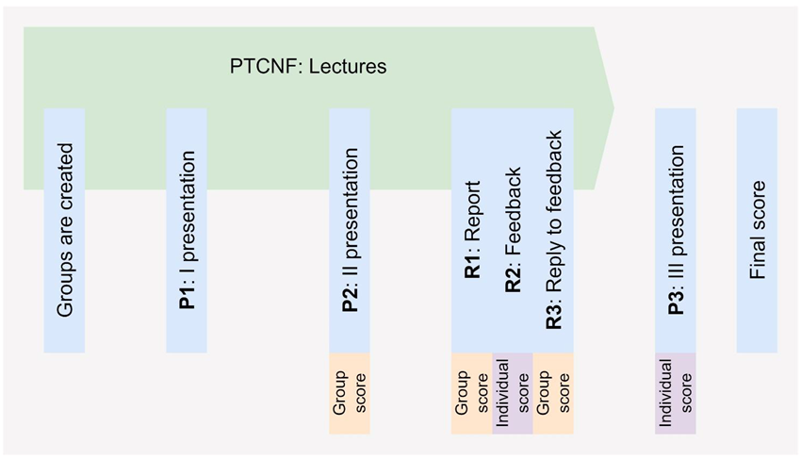
Figure 1. Course scheduling and organisation.

Following the peer-review stage, each group is required to prepare a reply-to-feedback document (R3), discussing the received comments and explaining how the project was revised accordingly. This phase reproduces, in simplified form, the iterative review-and-revision dynamics typical of scientific and engineering professional environments. The process encourages students to critically reflect on external feedback, justify their methodological choices, and improve the clarity and robustness of their analyses. The final presentation (P3) constitutes the concluding stage of the assessment process. Unlike the previous presentations, all team members are required to actively contribute to the discussion. The activity combines technical presentation and oral examination elements, with students being asked to justify assumptions, discuss methodological choices, critically analyse results, and reflect on limitations and broader implications of their proposed strategies, alongside individual targeted theory questions.
Overall, the adopted framework aims to balance collaborative learning and individual accountability. While group activities promote multidisciplinary interaction and collective problem solving, the individual assessment components and oral discussions help ensure active participation and independent critical understanding. The combination of iterative feedback, peer-review activities, and progressive project development contributes to reproducing some of the dynamics encountered in real engineering and research environments. The course has been designed around the current active-learning framework since its introduction, and therefore no direct comparison with a traditional lecture-based implementation is available. Similarly, the assessment system was conceived primarily as a tool to support learning and evaluate project outcomes rather than to quantitatively measure learning gains throughout the semester. As such, the evidence presented in this work relies on indirect indicators, e.g., student participation and examination outcomes over multi-year teaching evaluation data.
  - Student engagement and discussion
Over the last academic years, PTCNF has consistently attracted strong student participation despite being an elective course, with more than 100 examinations registered annually. The course also shows a balanced participation from students belonging to different engineering programmes, particularly Chemical and Process Engineering, Energy Engineering, and Materials Engineering (Figure 2a). This multidisciplinary participation represents an important aspect of the educational framework, as it contributes to the diversity of perspectives and competences within the project activities. The growing and stable interest in the course may be associated both with the increasing relevance of sustainability and decarbonisation topics within engineering education, and with the active-learning structure adopted throughout the semester.
The proposed educational methodology encourages students to move beyond the traditional approach based on closed and well-defined engineering exercises. Instead, students are exposed to broad sustainability scenarios characterised by uncertainty, incomplete information, and multiple possible technological pathways. Within this context, project activities require students to critically analyse scientific literature, identify key assumptions, compare competing alternatives, and justify strategic decisions considering technological, environmental, and industrial implications. Such activities promote systems-level reasoning and encourage the integration of knowledge across different engineering domains. An additional observation concerns the distribution of final examination scores obtained during the academic year. As shown in Figure 2b, the assessment methodology produces a relatively broad distribution of final marks, suggesting that the combination of group and individual activities is capable of differentiating students’ levels of engagement, critical understanding, and communication skills. In particular, the individual assessment components, namely the peer-review activity (R2) and the final oral presentation and discussion (P3), appear to play a significant role in shaping the final score distribution. While the preliminary group activities tend to produce relatively homogeneous results among team members, the individual evaluation stages introduce greater differentiation based on each student’s capability to critically analyse technical material, discuss methodological choices, and communicate project outcomes effectively. This observation supports the importance of combining collaborative learning with individual knowledge in multidisciplinary project-based courses, helping to reduce the risk of excessive score homogenisation typically associated with purely group-based assessments.

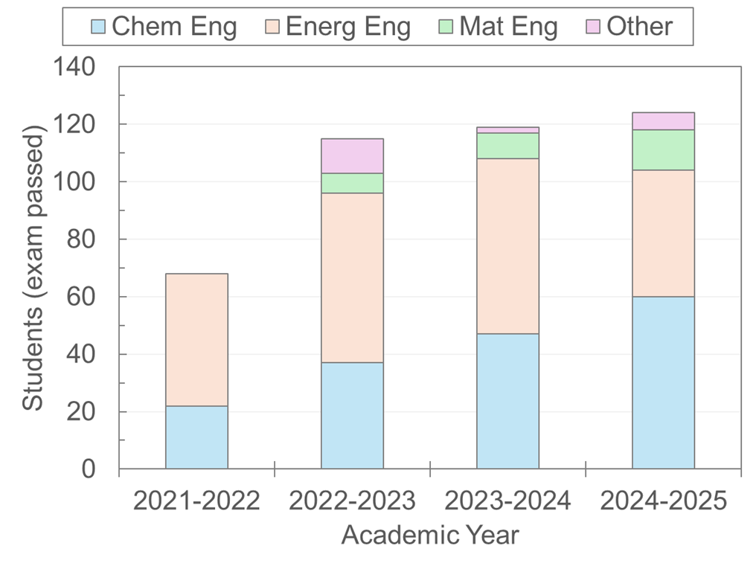 | 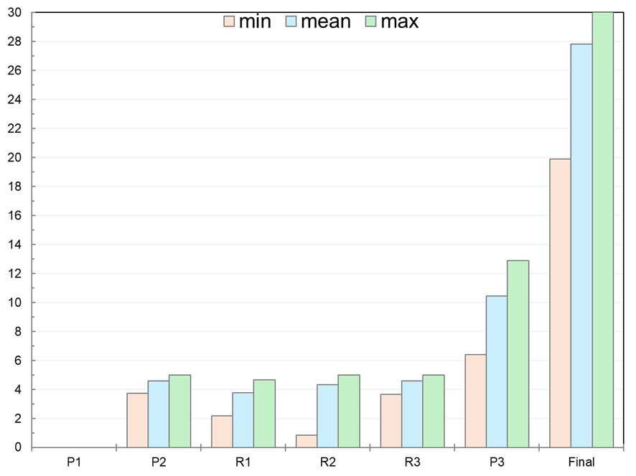
(a) | (b)
Figure 2: Course participation and results: (a) students enrolled and backgrounds (Chemical and Process, Energy, and Materials Engineering); and (b) scores distribution (/30) for exams passed in 2024 (sample size: 119 students; mean final score: 27.8/30; standard deviation: ±2.7/30).

The combination of multidisciplinary teamwork and progressive project development also contributes to strengthening several transferable competences that are increasingly relevant for sustainability-oriented engineering practice (Table 2). Notably, students are required to collaborate within groups comprising different technical backgrounds, organise project activities autonomously, communicate technical concepts effectively, and critically evaluate both their own work and the proposals developed by other groups. The peer-review and reply-to-feedback activities appear particularly effective in stimulating reflective learning processes and encouraging constructive scientific discussion among students.

Table 2: Main educational activities and corresponding targeted competences.
Educational activity | Main targeted competences
Multidisciplinary teamwork | Collaboration, peer learning, communication
Open-ended sustainability projects | Systems thinking, strategic analysis, problem solving
Literature-based project development | Critical interpretation of technical information
Peer-review activities | Critical evaluation, reflective learning
Reply-to-feedback process | Scientific discussion, argumentation, adaptability
Oral presentations and discussions | Communication and presentation skills

The positive reception of the course is also reflected in students’ evaluation results collected over multiple academic years. According to the official teaching evaluations, PTCNF consistently received high scores in terms of overall student satisfaction, perceived teaching quality, and course organisation. Between academic years 2021-2022 and 2023-2024, the course obtained average scores between 8.2-8.6/10 for overall satisfaction, between 8.6-8.8/10 for teaching quality, and between 8.6-8.9/10 for course organisation. These results suggest a positive student perception not only of the technical contents of the course, but also of the adopted educational methodology and project-based structure. In addition, the course received a teaching award from students in Energy Engineering for achieving the best teaching evaluation among the courses of the programme. While student evaluations alone cannot provide a comprehensive assessment of learning outcomes, these indicators support the observation that active-learning approaches and multidisciplinary project activities can contribute positively to student engagement and perceived educational quality.
Another relevant aspect concerns the increasing diffusion of generative Artificial Intelligence (AI) tools in education. The availability of AI-assisted systems for information retrieval, language revision, content generation, and data interpretation is rapidly changing the way students approach project-based learning activities. Within PTCNF, the use of generative AI is permitted as a support tool for learning activities, particularly for language revision and improvement of the graphical quality of reports and presentations. Conversely, the undisclosed use of AI-generated technical analyses, critical evaluations, or substantial portions of assessed coursework is not permitted. Students remain fully responsible for the accuracy, originality, and scientific validity of submitted material. From an educational perspective, the adopted assessment framework provides several safeguards against an excessive reliance on AI-generated content. The peer-review activity requires students to critically evaluate the work of others and formulate independent technical judgements, while the final oral discussion allows verification of individual understanding beyond the quality of written deliverables. Rather than attempting to exclude AI tools from the learning process, the course seeks to promote their responsible and transparent use while maintaining critical thinking and scientific reasoning as central educational objectives.
  - Conclusions
This work presented the educational methodology adopted in the Master’s degree course Process Technologies for Carbon Neutral Fuels (PTCNF) at the University of Padova (Italy), which combines project-based learning, multidisciplinary teamwork, and peer-review activities within a sustainability-oriented Chemical and Process Engineering context. The proposed framework aims to expose students to open-ended and multifaceted decarbonisation challenges. The observed outcomes, including student participation, examination results, and teaching evaluations, suggest a positive level of engagement with the proposed educational approach. Furthermore, the combination of collaborative and individual assessment components supports both multidisciplinary interaction and individual accountability, while peer-review activities contribute to the development of critical reasoning. Overall, the experience discussed in this work suggests that active-learning methodologies based on multidisciplinary teamwork, open-ended sustainability projects, and peer-review activities can effectively support the development of both technical and transversal competences in Chemical and Process Engineering education.
Some limitations should nevertheless be acknowledged. Teamwork-based methodologies may require significant organisational effort and may become more difficult to manage in large compulsory courses. In addition, differences in individual participation within groups remain a potential challenge despite the presence of individual assessment components. Another emerging consideration concerns the increasing diffusion of Artificial Intelligence-assisted tools for information search and content generation. While such tools may support students in accessing technical information and developing preliminary analyses, maintaining students’ independent reasoning and critical understanding remains an important educational objective. Also, the present contribution should be interpreted primarily as a pedagogical case study rather than as a controlled educational effectiveness study. Since the course has been based on the current active-learning framework since its introduction, no direct comparison with traditional teaching approaches is available. Future developments will therefore focus on the implementation of dedicated instruments for measuring learning gains throughout the semester, e.g., diagnostic quizzes or competency-oriented assessments. Such tools could provide a more rigorous evaluation of knowledge acquisition, systems-thinking capabilities, and critical-analysis skills, while also enabling a more systematic assessment of the educational impact of the proposed methodology.
References
Cifrian E., Andrés A., Galán B., Viguri J.R., 2020, Integration of different assessment approaches: application to a project-based learning engineering course, Education for Chemical Engineers, 31, 62–75.
Lozano R., Merrill M.Y., Sammalisto K., Ceulemans K., Lozano F.J., 2017, Connecting competences and pedagogical approaches for sustainable development in higher education: A literature review and framework proposal, Sustainability, 9, 1889.
Mulder K.F., Segalàs J., Ferrer-Balas D., 2012, How to educate engineers for/in sustainable development: Ten years of discussion, remaining challenges, International Journal of Sustainability in Higher Education, 13, 211–218.
Prince M., 2004, Does active learning work? A review of the research, Journal of Engineering Education, 93, 223–231.
Ravi M., 2023, Evolving trends in student assessment in chemical engineering education, Education for Chemical Engineers, 45, 151–160.
Sabri O.K., 2025, Rethinking sustainability in engineering education: a call for systemic change, Frontiers in Education, 10, 1587430.
Topping K., 1998, Peer assessment between students in colleges and universities, Review of Educational Research, 68, 249–276.
Wiek A., Withycombe L., Redman C.L., 2011, Key competencies in sustainability: a reference framework for academic program development, Sustainability Science, 6, 203–218.

