 CHEMICAL ENGINEERING TRANSACTIONS  VOL. xxx, 2026 | A publication of  
The Italian Association
of Chemical Engineering
Online at www.cetjournal.it

Guest Editors: Flavio Manenti, Botir Usmonov, Alessandro Di Pretoro
Copyright © 2026, AIDIC Servizi S.r.l.
ISBN 979-12-81206-xx-x; ISSN 2283-9216

Strategic Planning for Resilient Water Systems in Arid Regions Under Disruptive Events
Jaya Prasanth Rajakal¹, Logan Cochrane², Dhabia M Al-Mohannadi^{1,*}
¹College of Science and Engineering, Hamad Bin Khalifa University, Education City, Doha, Qatar
²College of Public Policy, Hamad Bin Khalifa University, Education City, Doha, Qatar

dalmohannadi@hbku.edu.qa
Desalination plants are the primary source of freshwater in most of the arid regions. However, these desalination plants are at increasing risks ranging from geopolitical to climate risks. Disruption in their operations will result in significant water shortage, threatening water security in the region. This work presents a multi-period optimization model to deploy an optimal combination of alternate water production technologies to mitigate the supply risks during disruptive events at minimal cost. The model considers several alternate technologies such as floating desalination barges, atmospheric water generation - condensation systems, atmospheric water generation – solar based absorption system, and the import of freshwater via maritime transport. The selection of these technologies is based on their unique technoeconomic profiles. An illustrative case study was solved to demonstrate the developed model. The results showed that deployment of these technologies have improved the resilience index by 8% and significantly reduced the unmet demand when compared to the standalone desalination plants.
  - Introduction
Water security is critical to the social and economic progress of a country (Jia et al., 2020). In arid regions, limited freshwater availability and low precipitation have necessitated increasing reliance on desalination to meet growing water demands. Desalination provides a reliable and independent source of freshwater and has become a critical component of water supply systems in many of the countries in arid region (Khanzada et al., 2026).
Despite its importance, reliance on desalination results in a new set of vulnerabilities. Desalination facilities are typically located along coastal areas and depend on uninterrupted access to seawater and energy supplies. Consequently, disruptive events such as algal blooms, oil spills, seawater contamination, sea level rise, extreme weather events, power outages, equipment failures, geopolitical conflicts and other natural or anthropogenic hazards can significantly reduce freshwater production. Such disruptions may compromise water security, particularly in regions where desalination constitutes a major share of the total water supply.
Enhancing the resilience of water systems requires diversification strategies that reduce dependence on a single water source (Hashimoto et al., 1982). These strategies include the deployment of alternative water production technologies - floating desalination systems, emergency water imports, atmospheric water generation technologies, decentralized treatment systems, strategic water storage, and water reuse initiatives. While these options can enhance system resilience, they differ considerably in terms of production capacity, deployment lead time, scalability, operating cost, investment, energy requirements, and environmental performance. Furthermore, some technologies require substantial installation periods and phased capacity expansion before reaching their full production potential. The unique technoeconomic characteristics of these technology results in a complex planning problem.
Several studies have investigated resilience enhancement measures for water systems through infrastructure diversification, strategic storage reserve, and alternative water supply technologies (Beh et al., 2018). However, limited attention has been given to optimal integration and temporal coordination of these measures during disruption scenarios. To address this gap, this study develops a multi-period optimization model that integrates desalination disruption, storage dynamics, technology-specific deployment lead times, phased capacity build-up, and unmet water demand. The methodological contribution lies in simultaneously determining which alternative technologies should be deployed, when they should become operational, and how their capacities should be expanded and operated throughout the disruption. The proposed model aims to determine cost-effective and operationally feasible water-supply recovery pathways under disruption scenarios. The model can serve as a decision-support tool for water utilities and policymakers seeking to strengthen the resilience of desalination dependent water systems in arid regions.
  - Methodology
    - Problem Statement
The formal problem statement can be defined as follows: - In arid region, freshwater supply is heavily dependent on desalination plants. Any disruption at these facilities can result in significant decrease in water production resulting in acute water shortage, threatening water security. Given are a set of desalination plants $d ∈D$ which cumulatively meet the demand for freshwater, $F_{t}^{DM}$ (m³/d) for a given region. A set of alternative water production technologies and water supply options, $j ∈J$ are considered for deployment, to mitigate the impact of disruptive events at desalination facilities. These alternate technologies have unique techno economic profiles such as maximum capacity ($C_{j}^{MAX}$), lead time ($L_{j}$), cost ($Z_{j,t}^{Cost}$), and capacity build-up rate ($X_{j}^{BR}$). To enhance the resilience of the water system, the model determines optimal deployment and operation of alternate technologies to reduce or nullify the unmet demand at minimal cost.
    - Mathematical Model
This section presents the mathematical formulation developed to determine optimal recovery pathway during disruptions at desalination dependent water system. The novelty of the formulation is the unified framework that accounts for storage, technology-specific lead times, progressive capacity build-up, operating limits, and unmet demand. To begin with, the water balance between production and demand can be shown as in Equation (1)
$$F_{t}^{EW}+ F_{t}^{AW}+ S_{t}^{OUT}+ X_{t}^{Shortage}=F_{t}^{DM}+ S_{t}^{IN}$$ | $$∀t$$ | (1)
where $F_{t}^{EW}$ (m3/d) is the total water produced from existing desalination plants during time t, $F_{t}^{AW}$ (m³/d) is the total water produced from alternative technologies during time t, $S_{t}^{OUT}$(m3/d) is the amount of water drawn from storage reservoir during time t, $S_{t}^{IN}$(m³/d) is the amount of water sent for storage during time t, $F_{t}^{DM}$ is the water demand during time t, and $X_{t}^{Shortage}$ (m³/d) is the unmet demand during the time t.
The water produced from desalination plants, $F_{d,t}^{D_PROD}$ (m³/d) and alternative technologies, $F_{j,t}^{A_PROD}$ (m³/d) can determined as shown in Equation (2) and (3). Water production from alternative technologies is constrained as shown in Equation (4).
$$F_{d,t}^{D_PROD}≤F_{d}^{DP}{ (1-X}_{d,t}^{DF})$$ | $$∀d∀t$$ | (2)
$$F_{j,t}^{A_PROD}≤C_{j,t}^{IN}$$ | $$∀j∀t$$ | (3)
$$C_{j}^{MAX}{ I}_{j,t}^{ON}{≥F}_{j,t}^{A_PROD}≥C_{j}^{MIN}{ I}_{j,t}^{ON}$$ | $$∀j∀t$$ | (4)
where $F_{d}^{DP}$ (m3/d) is the maximum water that can be produced at desalination plant d and ${ X}_{d,t}^{DF}$ is the disruption factor at desalination plant d during time t. Likewise, $C_{j,t}^{IN}$ (m3/d) is the capacity of alternate technology j installed during time t, $C_{j}^{MAX}$ is the maximum capacity of alternate technology j that can be installed in considered region, $C_{j}^{MIN}$ (m3/d) is the minimum operating capacity of alternate technology j, and ${ I}_{j,t}^{ON}$ is the binary variable indicating the selection of the alternate technology j during time t. The total amount of water produced from existing desalination plants and alternate technologies during time t can be determined as shown in Equation (5) and (6).
$$F_{t}^{EW}=\sum_{d=1}^{D}{F_{d,t}^{D_PROD}}$$ | $$∀t$$ | (5)
$$F_{t}^{AW}=\sum_{j=1}^{J}{F_{j,t}^{A_PROD}}$$ | $$∀t$$ | (6)
The alternative technologies require a lead time for deployment and may also necessitate a start-up time before water production can commence. This is constrained as shown in Equation (7). Besides, the alternative technologies are activated at most once as shown in Equation (8).
$${ I}_{j,t}^{ON}≤\sum_{p}^{t-L_{j}}{y_{j,p}}$$ | $$∀j∀t$$ | (7)
$$\sum_{t=1}^{T}{\sum_{J=1}^{J}{y_{j,t}≤1}}$$ | $$∀j∀t$$ | (8)
where, ${ I}_{j,t}^{ON}$ is the binary variable indicating the operational status of the alternate technology j during time t, $L_{j}$ (d) is the lead time required by alternate technology j, and $y_{j,p}$is the binary variable indicating deployment or start-up of the alternate technology j, with the index p is a time index representing prior periods. Moreover, the maximum capacity of alternate technology cannot be deployed immediately. Typically, capacity is ramped up progressively through phased installation and operational scale-up. This is constrained as shown in Equation (9).
$C_{j,t}^{IN}≤ {(C}_{j,t-1}^{IN}+X_{j}^{BR}){ I}_{j,t}^{ON}$ | $$∀j∀t$$ | (9)
where, $X_{j}^{BR}$ is the capacity ramp-up factor of alternate technology j. The cost of producing water from alternate technology j during time t, $Z_{j,t}^{Cost}$ (USD/d) can be determined as shown in Equation (10). Likewise, the cost of producing water from desalination plant d during time t, $Y_{d,t}^{Cost}$ (USD/d) can be determined as shown in Equation (11). Discharge of water from the storage incurs additional cost, $X_{d,t}^{Cost}$ (USD/d) as shown in Equation (12).
$$Z_{j,t}^{Cost}= X_{j}^{ST}{ I}_{j,t}^{ON}+ F_{j,t}^{A_PROD}X_{j}^{PR_A}$$ | $$∀j∀t$$ | (10)
$$Y_{d,t}^{Cost}= F_{d,t}^{D_PROD}X_{j}^{PR_D}$$ | $$∀d∀t$$ | (11)
$$X_{t}^{Cost}= S_{t}^{OUT} X^{S_DC}$$ | $$∀t$$ | (12)
where $X_{j}^{ST}$ (USD) is the start-up cost incurred for alternate technology j, $X_{j}^{PR_A}$ (USD/m³) is the cost of water production using alternate technology j, $X_{j}^{PR_D}$ (USD/m³) is the cost of water production using existing desalination plant d, $X^{S_DC}$ (USD/m³) is cost of water withdrawal from storage system. The total annual cost can for the time t can be determined as shown in Equation (13).
$${Cost}_{t}= \sum_{d=1}^{D}{Y_{d,t}^{Cost}}+ \sum_{j=1}^{J}{Z_{j,t}^{Cost}}+ X_{t}^{Cost}+ X_{t}^{Shortage}M$$ | $$∀t$$ | (13)
where M is a large constant used to introduce the unmet demand into the cost function. In this study, M value was set at USD 10 million/m³ of unmet demand to ensure that shortages occur only when demand cannot be satisfied because of technical or capacity constraints. Therefore, the model first prioritizes minimizing unmet demand and then identifies the least-cost combination of alternatives for achieving the same level of demand satisfaction. Thus, the large constant, M does not represent the economic cost of water shortages but serves as a prioritization parameter. The water available, $S_{t}^{AVL}$ (m³/d) in the storage is given by Equation (14) and is constrained to its maximum capacity, $S_{t}^{CPTY}$ (m3/d) as shown in Equation (15). The objective function is to minimize the total cost as shown in Equation (16).
$$S_{t}^{AVL}= S_{t-1}^{AVL}+ S_{t}^{IN}- S_{t}^{OUT}$$ | $$∀t$$ | (14)
$$S_{t}^{AVL}≤ S^{CPTY}$$ | $$∀t$$ | (15)
$$Min \sum_{t=1}^{T}{{Cost}_{t}}$$ |  | (16)
  - Case Study
This section presents an illustrative case study of a water system in arid region to demonstrate the developed model. Desalination is the primary source of freshwater in arid regions. The given water system has a total installed desalination capacity of 2.32 million m³/d. There are three major desalination facilities Plant 1, Plant 2 and Plant 3 with maximum water production capacities of 668,000 m³/d, 741,500 m³/d, and 909,000 m³/d respectively. The corresponding levelized cost of water production is taken as USD 1.20/m³ for Plant 1, USD 1.50/m³ for Plant 2 and USD 0.80/m³ for Plant 3. The average daily water demand is estimated to be 1.85 million m³/d.
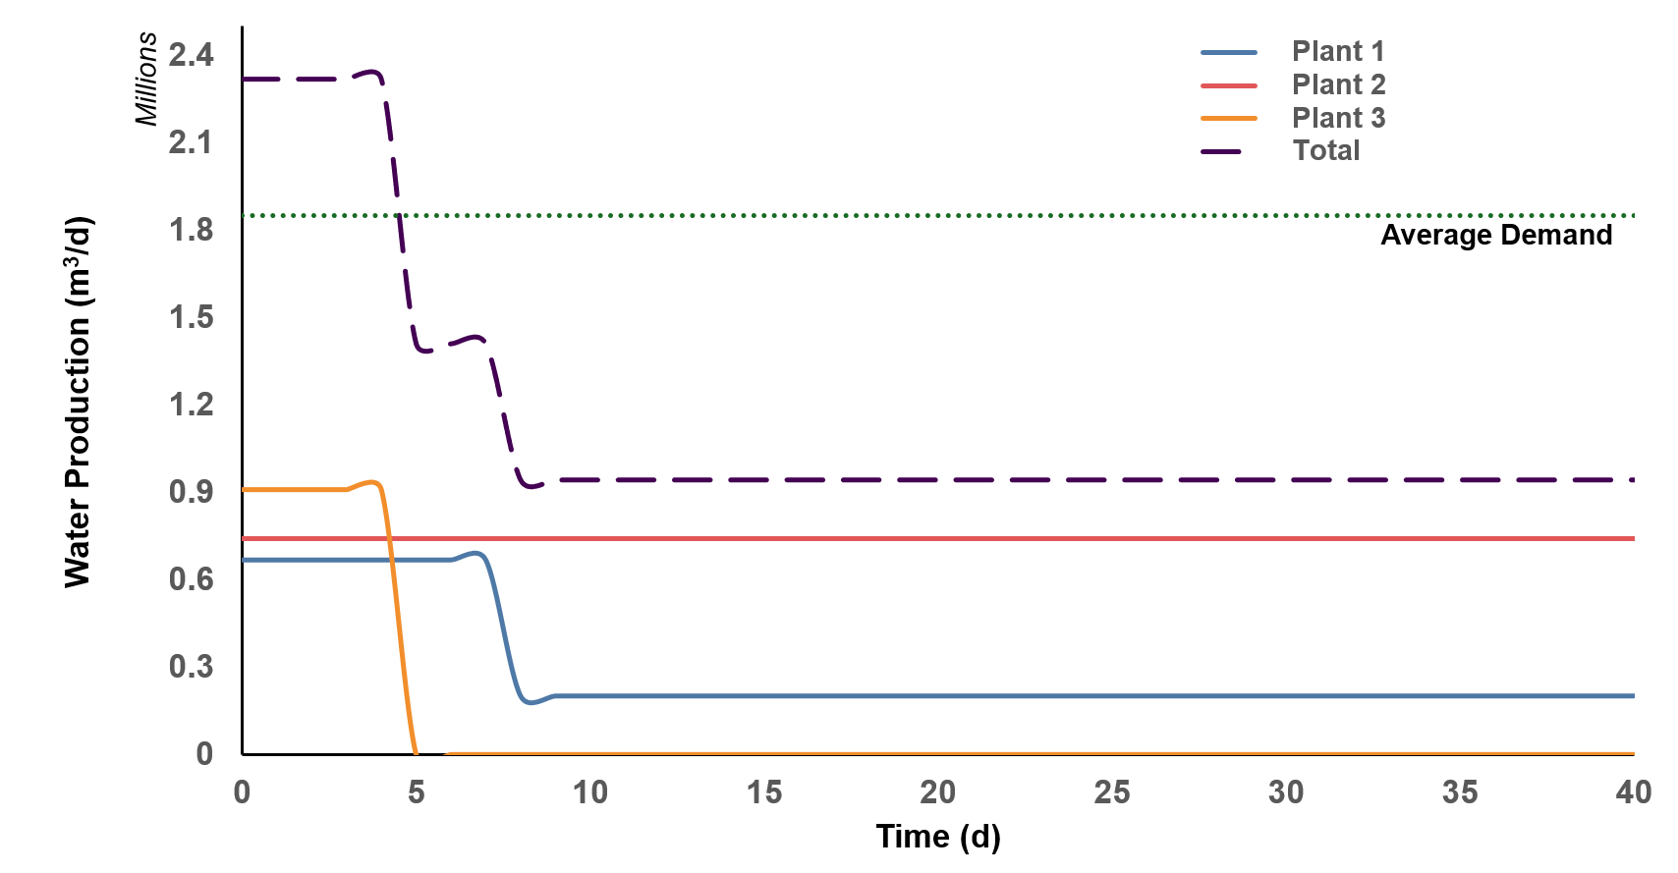
Figure 1: Case study: Disruption scenario
This study evaluates several alternative water production technologies and supply options that can be deployed to mitigate water shortages during disruptive events at desalination facilities. The technologies considered include floating desalination barges (FDB), atmospheric water generation - condensation systems (AWG-C), atmospheric water generation – solar based absorption system (AWG-A), and the import of freshwater via maritime transport (IM). These alternatives were selected based on their technical feasibility and suitability within the Qatari context. The key characteristics of each technology, including maximum production or supply capacity, deployment lead time, capacity build-up rate, and levelized cost of water production, are summarized as shown in Table 1. Since most of these technologies are still emerging and have seen limited or no large-scale commercial deployment, reliable cost and performance data are often unavailable. Therefore, where appropriate, costs were estimated using scaling approach based on available data. In cases where sufficient data were not available, reasonable engineering assumptions were made to represent the technologies within the model. In addition, the maximum water storage capacity available was assumed to be 14 million m³, reflecting Qatar's strategic water reserve infrastructure. These assumptions enable a preliminary assessment of the potential contribution of alternative water supply technologies to improving the resilience of the national water system during disruptive events.
Table 1: Alternate water production technology characteristics
Technology | Maximum  Capacity (m³/d) | Lead time  (d) | Capacity build-up  Rate (m³d) | Cost  (USD/m³)
FDB | 120,000 | 14 | 60,000 | 2.10
AWG-C | 70,000 | 21 | 3,000 | 7.00
AWG-A | 115,000 | 21 | 2,000 | 0.40
IM | 600,000 | 7 | 200,000 | 4.30
This case study considers a disruption scenario affecting Plant 1 and Plant 3. During the disruption period, Plant 1 operates at only 30% of its maximum production capacity, while Plant 3 experiences a complete shutdown. This disruption profile represents a severe, prolonged event affecting multiple desalination facilities, as shown in Figure 1. This disruption profile was selected to create a supply deficit that cannot be fully addressed by the remaining desalination capacity and therefore tests the adequacy of strategic storage and alternative options. Scenario 1 represents the baseline scenario, in which the system relies only on the remaining desalination capacity and strategic water storage. Scenario 2 considers the same disruption and demand conditions but considers the deployment of alternative technologies. The two scenarios enable to identify the improvement in system performance from the deployment of optimal technology portfolio. Planning horizon of 40 days is considered in this case study with each period representing single day. The equations presented in Section 2 along with the above-described dataset are coded in LINGO optimization solver. The model is of the class mixed integer linear programming (MILP) and is solved using an Intel® Core (TM) i5 processor built in a 64-bit Windows operating system. The computational time taken to determine the optimal solution – for both scenarios is less than two minutes.

  - Results and Discussion
    - Scenario 1
This scenario represents the baseline response of the water system to the considered disruption event, without the deployment of alternative water production or supply technologies. Prior to the disruption, the system operates at full capacity, producing 2.32 million m³/day, which exceeds the average daily demand of 1.85 million m³/day. Once the disruption occurs, total water production declines to 0.93 million m³/day, a reduction of about 60% in production capacity. As shown in Figure 1, strategic water reserves play a critical role during the initial stages of the disruption. Storage water is utilized to bridge the gap between available production and demand, enabling the system to maintain service levels temporarily despite the significant loss in desalination capacity. However, as the disruption persists, the storage reserves are progressively depleted and are unable to sustain the required demand. Consequently, the system enters a prolonged period of supply deficit, during which water production remains significantly below the demand.
The resilience index, defined as the ratio of time periods during which water demand is fully satisfied to the total analysis period, was determined to be 0.63. This indicates that the existing strategic water reserve infrastructure alone is insufficient to mitigate the impacts of a prolonged disruption. The scenario highlights the high vulnerability of desalination dependent water systems and the need for resilience initiatives to enhance water security.
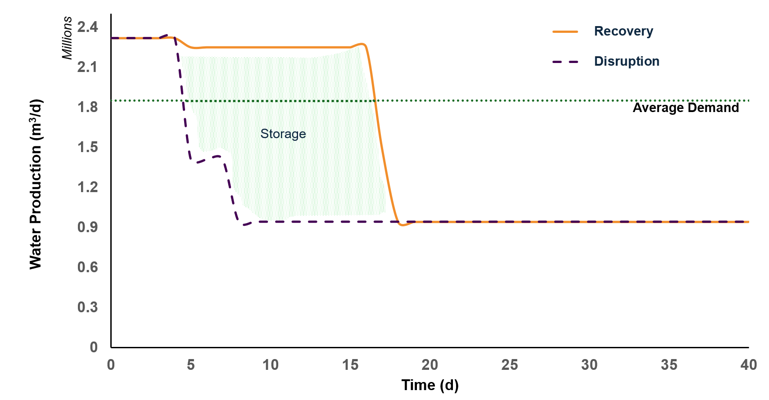
Figure 2: Scenario 1 – Recovery curve
    - Scenario 2
This section evaluates the response of the water system when alternative water production and supply technologies are considered for deployment during the disruptive event. The model prioritizes freshwater imports (IM) as the primary response measure due to their shorter deployment lead time and large supply capacity. Freshwater imports are deployed on day 7 from the disruptive event and reach their maximum capacity of 0.60 million m³/d by day 10, providing an immediate reduction in the supply deficit. Subsequently, floating desalination barges (FDB) are deployed and gradually increase production to 0.12 million m³/d by day 20. Atmospheric water generation through condensation (AWG-C) and absorption (AWG-A) technologies are introduced only during the later stages of the disruption due to their longer lead time and slower capacity build-up rate; and contribute relatively smaller volume of water.
The impact of these interventions on system performance is evident from Figure 3. The deployment of alternative technologies with the combination of strategic water reserve significantly improved the resilience of the water system by maintaining water production at a 2.25 million m³/d during most of the disruption period. Although a decline in production occurs after day 20 due to the depletion of strategic water reserves, the recovery curve remains considerably higher than the disruption curve, demonstrating the effectiveness of the alternative supply portfolio in mitigating the impacts of the disruption. Nevertheless, total water production still falls below the demand during the later stages of the disruption. Although the resilience index improved to 0.57, which is 8% higher than Scenario 1, the combined capacity of the available alternative technologies is insufficient to fully compensate for the loss from desalination production. This highlights the importance of strategic water reserve as a short-term buffer and suggests that additional supply options or larger deployment capacities may be required to achieve complete water security under severe and prolonged disruption scenarios.
A sensitivity analysis varying the alternate technology costs up to 25% was conducted. The results showed that these cost variations did not affect the selection and deployment timing of alternative technologies, demonstrating the robustness of the optimal solution.

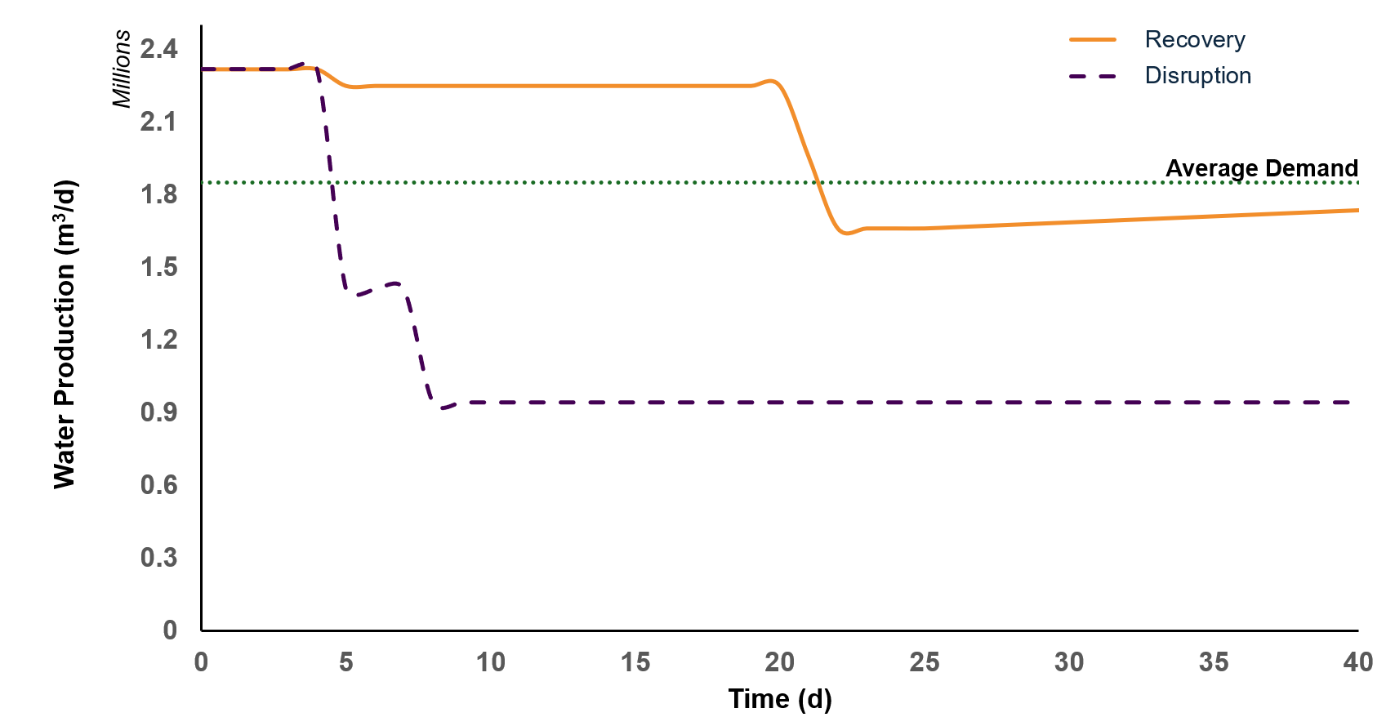
Figure 3: Scenario 2 – Recovery curve
The results were comparable with established resilience principles. The model prioritizes existing production and strategic storage during the initial disruption period, followed by rapidly deployable supply options and, subsequently, technologies with longer lead times. This deployment of alternative measures is consistent with the role of strategic storage as an immediate response and alternative supply technologies as medium-term recovery measures reported in the literature (Jägerskog et al., 2021).
  - Conclusions
The work presents a multi-period optimization model to determine an optimal combination of alternate water production technologies to mitigate supply risks during disruptive events at desalination facilities in arid regions. For the considered case study, the results demonstrate that the deployment of these technologies improves the resilience index by 16% compared to the baseline scenario. However, the available alternatives are unable to fully compensate for the loss in desalination capacity, resulting in periods of unmet water demand during prolonged disruptions. These findings highlight both the potential and limitations of current alternative water supply options in improving water system resilience. The proposed model can be extended to real-world case studies and serve as a decision-support tool for policymakers in long-term planning for resilient water systems. Furthermore, the work can be extended to examine the model’s sensitivity to other key parameters, such as technology deployment lead times and capacity build-up rates. Moreover, the optimization framework can include footprints such as emissions and land in future works.
Acknowledgments
The research reported in this paper was supported by the Qatar Research Development and Innovation Council (QRDI) [NPRP14C-0920-210017]. The content is solely the responsibility of the authors and does not necessarily represent the official views of the Qatar Research Development and Innovation Council (QRDI).
References
Hashimoto T., Stedinger J.R., Loucks, D.P., 1982, Reliability, resiliency, and vulnerability criteria for water resource system performance evaluation, Water Resources Research, 18, 14–20.
Jägerskog A., Schulz M., Kim K., Giordano M., 2021, Advancing Knowledge of the Water-Energy Nexus in the Middle East and North Africa, World Bank, Washington DC, USA.
Jia X., Zhang J., Li Z., Tan R.R., Lee J.-Y., Wang F., 2020, Inoperability Input-Output Models for Water System in Industrial Parks, Chemical Engineering Transactions, 81, 979–984.
Khanzada N.K., Al-Juboori R.A., Ibrahim Y., Khatri M., Ahmed F.E., An A.K., Hilal N., 2026, Desalination and the Middle East: research, practices, implications, and prospects, npj Clean Water, 2026.
Shin S., Park H., 2018, Achieving cost-efficient diversification of water infrastructure systems against uncertainty using modern portfolio theory, Journal of Hydroinformatics, 739 – 750.
Hashimoto T., Stedinger J.R., Loucks, D.P., 1982, Reliability, resiliency, and vulnerability criteria for water resource system performance evaluation, Water Resources Research, 18, 14–20.

