 CHEMICAL ENGINEERING TRANSACTIONS  VOL. xxx, 2026 | A publication of  
The Italian Association
of Chemical Engineering
Online at www.cetjournal.it

Guest Editors: Flavio Manenti, Botir Usmonov, Alessandro Di Pretoro
Copyright © 2026, AIDIC Servizi S.r.l.
ISBN 979-12-81206-xx-x; ISSN 2283-9216

Influence of Catalyst Precursor on the Structure and Electrochemical Behaviour of Ag-Based Gas Diffusion Electrodes
Yasheng Nijiati, Thomas Turek*
Clausthal University of Technology, Institute of Chemical and Electrochemical Process Engineering, Leibnizstrasse 17, 38678 Clausthal-Zellerfeld, Germany
*turek@icvt.tu-clausthal.de
The successful implementation of oxygen-depolarised cathode (ODC) technology in industrial-scale chlor-alkali electrolysis has demonstrated the potential of gas diffusion electrodes (GDEs) for large-scale electrochemical applications. However, electrode degradation remains a major factor limiting long-term performance. In this study, silver (Ag)-based and silver oxide (Ag₂O)-based GDEs were fabricated using a laboratory-scale manufacturing process and investigated with respect to their physical properties, electrochemical response during accelerated stress testing (AST), and behaviour under varying oxygen backpressures. Capillary flow porometry and BET surface area analysis revealed that the Ag₂O-based GDEs exhibited larger pore diameters and lower specific surface areas than the Ag-based GDEs, indicating that the catalyst precursor influences the resulting porous electrode structure. Accelerated stress testing revealed an overall deterioration in electrochemical performance for both electrode types. Electrochemical impedance spectroscopy (EIS) combined with distribution of relaxation times (DRT) analysis showed that the most pronounced changes in the dominant relaxation peaks occurred after the first AST sequence. During subsequent sequences, the peak positions remained largely unchanged, while the corresponding relaxation strengths increased gradually, suggesting a progressive intensification of the same dominant relaxation processes rather than the emergence of additional ones. Measurements under varying oxygen backpressures revealed increased potential fluctuations and lower ORR potentials at elevated backpressures, with differences in the response of the two electrode types. The results provide further insight into the relationship between catalyst precursor, electrode structure, degradation behaviour, and electrochemical performance in oxygen-depolarised gas diffusion electrodes.

Keywords: Chlor-alkali electrolysis, Gas diffusion electrode, Electrode degradation
  - Introduction
Chlor-alkali electrolysis is the primary industrial process for the production of chlorine (Cl₂) and sodium hydroxide (NaOH). During the electrolysis of sodium chloride (NaCl) brine, chlorine gas is generated at the anode. Depending on the cell technology employed, hydrogen (H₂) and hydroxide ions (OH⁻) are produced either directly at the cathode through water reduction or in a separate decomposer, as in mercury-cell processes. Among the available technologies, membrane cells represent the current state of the art. These systems enable the production of high-purity NaOH while offering the lowest specific energy demand. In addition, the membrane-cell technology eliminates the use of hazardous materials such as asbestos and mercury associated with diaphragm and mercury cells, respectively (O’Brien et al., 2005).
Despite continuous technological improvements, chlor-alkali electrolysis remains one of the most energy-intensive processes in the chemical industry (Euro Chlor, 2025). Although hydrogen is a valuable by-product, its utilisation is not always economically feasible because of limitations in local infrastructure, storage capacity, or transport logistics at some production sites. Under such conditions, ODC technology offers an energy-efficient alternative to conventional hydrogen-evolving cathodes by promoting the oxygen reduction reaction (ORR). Moussallem et al. (2008) reviewed the development and implementation of ODC technology, while Kintrup et al. (2017) highlighted its potential for energy-efficient chlor-alkali electrolysis.
ODCs belong to the class of GDEs, which provide a porous structure that enables simultaneous contact between the gaseous reactant, liquid electrolyte, and solid electrocatalyst. This three-phase boundary facilitates the direct supply of oxygen to the reaction zone through the gas phase. Such an approach is essential because the solubility of oxygen in concentrated aqueous sodium hydroxide is very low, which would otherwise severely limit the ORR rate. The electrochemical principles and operation of oxygen-depolarised cathodes have been discussed in detail by Jörissen et al. (2011).
The standard equilibrium potential of the ORR is 1.23 V more positive than that of the hydrogen evolution reaction (HER). Consequently, replacing HER with ORR at the cathode can reduce the cell voltage by up to 1 V under industrial operating conditions. Jung et al. (2014) demonstrated that this reduction corresponds to electrical energy savings of up to 25 %, making ODC technology an attractive option for improving the energy efficiency of chlor-alkali electrolysis. The recent commissioning of world-scale chlor-alkali plants employing ODC technology has demonstrated the technical feasibility of integrating GDEs into large electrochemical cells with active areas of up to 2.7 m² (Covestro AG, 2023).
Despite these advances, degradation of the gas diffusion electrode remains a major challenge affecting long-term performance. Sugiyama et al. (2003) investigated accelerated degradation testing of GDEs for chlor-alkali applications, while Chlistunoff (2004) investigated the impact of shutdowns on the lifetime of GDEs containing noble-metal catalysts supported on carbon. The identification of degradation mechanisms is complicated by the heterogeneous structure of GDEs and the dynamic interactions between electrode architecture, gas transport, electrolyte transport, and electrochemical reactions during operation. In particular, changes in the porous electrode structure may influence both degradation behaviour and electrochemical performance.
The present study investigates the relationship between catalyst precursor, electrode structure, and electrochemical behaviour in Ag-based and Ag₂O-based gas diffusion electrodes. The electrodes were characterised by capillary flow porometry and BET surface area analysis to assess differences in pore structure arising from the catalyst precursor. Furthermore, electrode degradation behaviour was evaluated using an electrochemical AST combined with EIS and DRT analysis. Additional measurements under varying oxygen backpressures were conducted to examine the response of the electrodes to changes in gas-side operating conditions. The results provide insight into the relationship between electrode structure, degradation behaviour, and electrochemical performance in oxygen-depolarised gas diffusion electrodes.
  - Methods
Ag-based and Ag₂O-based gas diffusion electrodes were fabricated by spray deposition using an established in-house Ag-GDE manufacturing protocol based on reported procedures (Moussallem et al., 2012). The spray suspension contained the respective catalyst precursor (Ag or Ag₂O), hydrophobic polytetrafluoroethylene (PTFE), and hydroxyethyl methyl cellulose (HEMC) as a dispersing agent and pore-forming additive and was spray-deposited onto a nickel-mesh support. During spraying, the electrodes were weighed intermittently until a target catalyst loading of approximately 180 mg cm⁻² was reached. The coated electrodes were subsequently hot-pressed and heat-treated at 330 °C. Three GDEs were produced in each manufacturing batch, with final electrode thicknesses typically ranging from 400 to 450 µm after heat treatment. Throughout this work, the terms Ag-based and Ag₂O-based refer to the catalyst precursor used in the spray suspension.
From each manufacturing batch, one of the three GDEs was reserved for physical characterisation in the pristine state. The pore structure and physical properties of the pristine GDEs were characterised by capillary flow porometry (Porometer 3G, Quantachrome), krypton BET surface area analysis (3Flex, Micromeritics), and helium pycnometry (Pycnomatic ATC Multivolume, Thermo Fisher Scientific). Pore size distributions were determined using a wet–dry porometry method with nitrogen as the probe gas, while skeletal densities were obtained from five replicate pycnometry measurements. For capillary flow porometry, two circular samples (18 mm in diameter) were prepared from each GDE, and each sample was measured three times unless stated otherwise. The remaining electrode material was subsequently used for helium pycnometry and krypton BET surface area analysis.
Electrochemical characterisation was conducted in a stationary half-cell (FlexCell, Gaskatel GmbH, Germany) with an active electrode area of 3.14 cm². The cell was operated with an aqueous NaOH electrolyte (approximately 32 wt%) maintained at approximately 85 °C. The prepared GDEs served as the working electrodes. A platinum-iridium wire was used as the counter electrode, and a HydroFlex reversible hydrogen electrode (Gaskatel GmbH, Germany) was used as the reference electrode. The reference electrode was positioned in the designated holder within the cell, with the integrated Luggin capillary connecting it close to the active electrode surface.
The standard electrochemical characterisation protocol consisted of a 15 min of open-circuit potential (OCP) measurement, followed by 45 min of galvanostatic chronopotentiometry at a current density of −4 kA m⁻². Subsequently, a polarisation curve was recorded over a current density range from −0.01 to −8 kA m⁻². A second galvanostatic chronopotentiometry step was then performed for 15 min at −4 kA m⁻². Finally, galvanostatic EIS was carried out at a direct current density of −4 kA m⁻² with an alternating current amplitude corresponding to approximately 6 % of the applied direct current. The frequency range extended from 100 mHz to 20 kHz. DRT analysis was performed using DearEIS (Yrjänä, 2022). The DRT spectra were calculated using the Bayesian Hilbert Transform (BHT) method with a first-order derivative regularisation and a Gaussian radial basis function kernel. In addition to these measurements, an AST was applied to assess electrode response to repeated oxidative and reductive cycling.
The AST was performed under potentiostatic control. During the test, the working electrode potential was cycled between approximately 1.2 V versus the reversible hydrogen electrode (RHE), corresponding to the OCP, and 2.0 V versus RHE. Each AST sequence consisted of five potential cycles. Following each sequence, the standard electrochemical characterisation protocol was repeated, including the acquisition of polarisation curves and EIS measurements. One complete AST sequence, including the subsequent electrochemical characterisation, required approximately 2 h. Depending on the observed electrode performance, up to five consecutive AST sequences were conducted.
  - Results and Discussion
The physical characterisation of the prepared GDEs revealed distinct differences between Ag-based and Ag₂O-based electrodes. As shown in Figure 1a, the Ag₂O-based GDEs exhibited a broader pore size distribution shifted towards larger pore diameters. Consistent with this observation, BET analysis revealed a lower specific surface area for the Ag₂O-based GDEs (0.061 m² g⁻¹) compared with the Ag-based electrodes (0.078 m² g⁻¹) (Figure 1b). Together, these results indicate that the use of Ag₂O as the catalyst precursor leads to a less finely structured pore network and a lower accessible surface area.

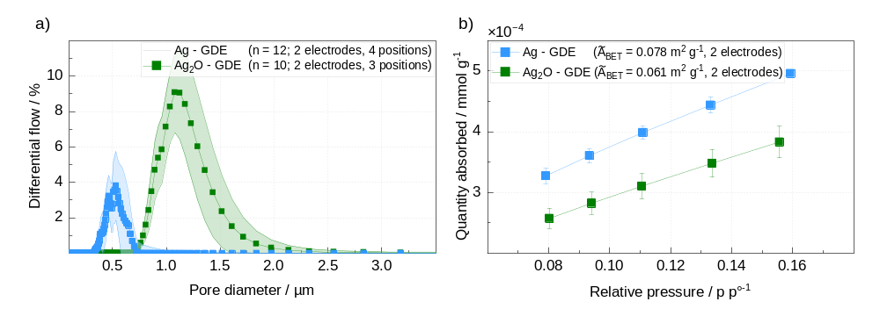
Figure 1: (a) Capillary flow porometry results for Ag- and Ag₂O-based GDEs (n = total number of measurements). (b) Krypton adsorption data in the BET evaluation range for Ag- and Ag₂O-based GDEs (A̅_{BET} = mean BET specific surface area).
Waterhouse et al. (2001) reported that Ag₂O thermally decomposes to metallic Ag at elevated temperatures. In the present fabrication procedure, the electrodes were heat-treaded at 330 °C. After heat treatment, the electrode surface of Ag₂O-based GDEs exhibited a distinct colour change from dark to bright, suggesting that conversion of the Ag₂O precursor occurred during this step. However, the colour change alone does not establish the extent of conversion. Accordingly, the structural differences may originate from precursor-dependent processes during electrode formation, but the final phase composition after heat treatment was not quantified in the present study. Particle size distributions are not discussed in detail in the present work. Nevertheless, characterisation of used precursors materials indicated larger particle sizes for the Ag₂O precursor than for the Ag powder. This observation is consistent with the larger pore diameters measured for the Ag₂O-based GDEs and suggests that precursor morphology may play an important role in determining the final electrode architecture and may contribute to the slight differences observed in the electrochemical behaviour of the investigated GDEs.
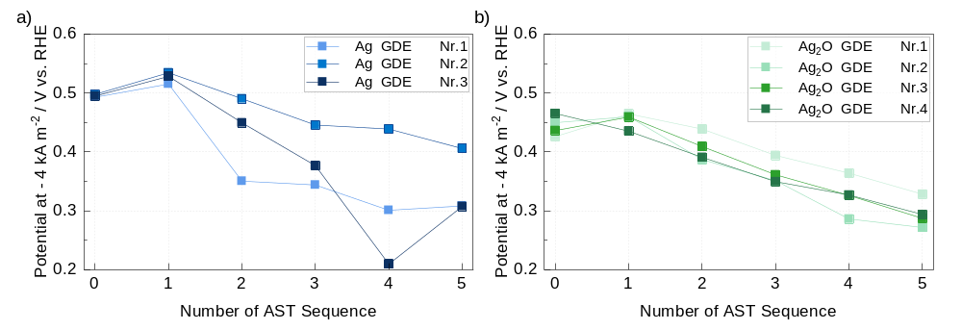
Figure 2: Electrode potential of (a) Ag-based and (b) Ag₂O-based GDEs measured at −4 kA m⁻² before and after each AST sequence. Each curve represents an individual laboratory-manufactured electrode.
Following the structural characterisation, the electrochemical response of the prepared GDEs to repeated accelerated stress testing was investigated. Figure 2 shows the electrode potentials measured at a current density of −4 kA m⁻² after each AST sequence. For several electrodes, a slight shift towards more positive potentials was observed after the first sequence, followed by a progressive decrease during subsequent sequences. The initial improvement may reflect incomplete electrode conditioning before the AST and should not be interpreted as enhanced durability. The subsequent decrease in potential indicates a progressive loss of electrochemical performance under repeated stress exposure.
Although the overall degradation trends were comparable, the Ag-based GDEs exhibited greater scatter between individual electrodes, whereas the Ag₂O-based electrodes showed a more consistent response. Minor differences between individual electrodes in catalyst loading and mean thickness may contribute to this variability. In addition, the potential measurement is particularly sensitive to the local electrode region adjacent to the Luggin capillary rather than representing a strict area average over the entire active surface. Local variations in coating thickness, catalyst distribution, pore structure, or wetting, together with small differences in electrode positioning, may therefore contribute to the measured response.
The applied AST represents an intentionally accelerated degradation protocol involving repeated oxidation and reduction cycles over a comparatively short testing period. Although these conditions do not reproduce practical operating conditions, they enable the comparison of different electrode architectures within the limited testing time of a stationary half-cell. Consequently, the observed degradation trends should not be interpreted as direct predictions of service lifetime but rather as indicators of the relative susceptibility of the investigated GDEs to electrochemical degradation under repeated oxidative and reductive cycling.
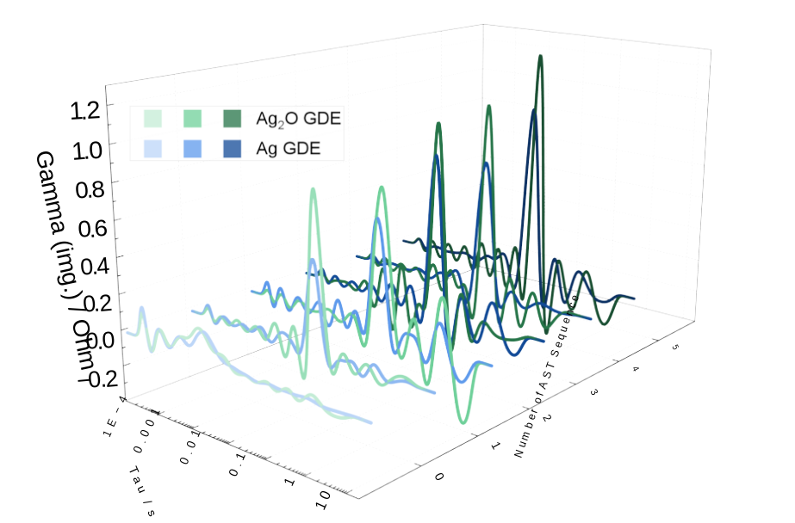
Figure 3: DRT derived from electrochemical impedance spectroscopy measurements after each AST sequence for Ag-based GDE No. 1 and Ag₂O-based GDE No. 2 shown in Figure 2. Gamma denotes the relaxation strength, and tau the relaxation time.
To gain further insight into the degradation processes occurring during the AST, the EIS data were analysed using the DRT method. In a DRT spectrum, the peak position represents the characteristic relaxation time of a process, while the peak magnitude, gamma, reflects its contribution to the overall impedance. As shown in Figure 3, the most pronounced changes occurred after the first AST sequence for the two representative GDEs. The dominant DRT peaks increased in magnitude and shifted towards higher relaxation times, indicating a growing contribution from slower electrochemical and/or transport-related processes.
During the subsequent AST sequences, the dominant peak positions remained largely unchanged, while the corresponding gamma values increased gradually. The temporal evolution of the DRT spectra therefore did not directly parallel the trend observed in the chronopotentiometric measurements. Apart from the initial conditioning-related shift observed for several electrodes, the electrode potential decreased progressively during the later AST sequences. By contrast, the most pronounced change in the DRT spectra occurred directly after the first sequence, whereas subsequent sequences produced only gradual increases in relaxation strength without substantial further shifts in peak position.
The results therefore suggest that the first exposure to the oxidative potential excursion established a modified electrochemical state, while subsequent cycling progressively increased the impedance contribution of the established relaxation processes rather than introducing additional dominant processes. The overall evolution of the DRT spectra was similar for the two representative GDEs, with the dominant relaxation peaks remaining at comparable characteristic relaxation times throughout the AST. This suggests that comparable dominant relaxation processes contributed to the impedance response of both electrodes. The main difference was the magnitude of the corresponding gamma values, which were consistently slightly higher for the Ag₂O-based GDE, indicating a larger impedance contribution from the respective relaxation processes.
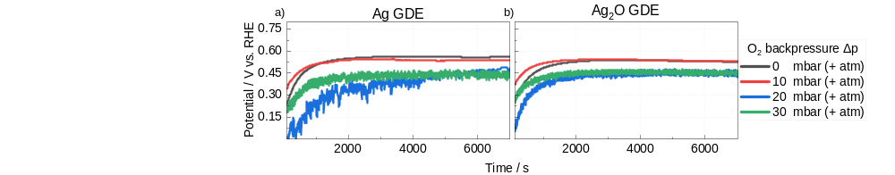
Figure 4: Chronopotentiometric measurements at −4 kA m⁻² for (a) an Ag-based GDE and (b) an Ag₂O-based GDE at different oxygen backpressures. Measurements were performed sequentially from 0 mbar to 30 mbar gauge pressure.
The influence of oxygen backpressure on electrode performance is shown in Figure 4. Both electrode types responded noticeably to changes in oxygen backpressure. Compared with measurements at 0 and 10 mbar, the two highest applied backpressures resulted in a shift towards lower ORR potentials for both electrode types. In addition, increased potential fluctuations were observed, particularly for the Ag-based GDE, whereas the Ag₂O-based GDE exhibited lower fluctuations under identical conditions.
These observations suggest that increasing oxygen backpressure alters the balance between gas and electrolyte transport within the porous electrode structure. A higher gas-side pressure may displace the gas-liquid interface within the pore network towards the electrolyte side, thereby shifting the region of the three-phase boundary. At sufficiently high backpressures, this displacement could result in local gas breakthrough into the electrolyte compartment. Although gas breakthrough could not be observed in the cell configuration, the partly periodic potential fluctuations at elevated backpressures are consistent with an intermittent redistribution of gas and electrolyte within the porous structure.
Although both electrode types exhibited the same overall trend, differences in the magnitude of the potential fluctuations were observed. Together with the differences in pore structure identified by porometry and BET analysis, this observation suggests that porous electrode architecture may influence the electrochemical response to changes in oxygen backpressure. However, the underlying mechanisms require further investigation.
  - Conclusion
In this work, Ag-based and Ag₂O-based gas diffusion electrodes were fabricated using a laboratory-scale manufacturing process and investigated with respect to their physical properties, performance changes during AST, and response to varying oxygen backpressures. The colour change observed after the heat-treatment step of the GDE manufacturing process suggests conversion of the Ag₂O precursor to metallic Ag. Nevertheless, the Ag₂O-based GDEs exhibited larger pore diameters and lower BET specific surface areas, indicating that the precursor influences the resulting porous electrode structure.
The accelerated electrochemical stress test revealed an overall deterioration in performance for both electrode types. While some variability between individual electrodes was observed, the overall degradation trends were comparable for Ag- and Ag₂O-based GDEs. The chronopotentiometric measurements showed a progressive decrease in electrode potential during the AST sequences, whereas DRT analysis revealed the most pronounced changes directly after the first sequence. During subsequent sequences, the dominant DRT peak positions remained largely unchanged, while the corresponding gamma values increased gradually. The DRT evolution therefore did not directly mirror the gradual decline in electrode potential. Instead, the results suggest that the first exposure to the oxidative potential excursion established a modified electrochemical state, while further cycling progressively increased the impedance contribution of the established relaxation processes rather than introducing additional dominant processes.
Measurements under varying oxygen backpressures showed pressure-dependent changes in the electrochemical response of both electrode types. Increasing oxygen backpressure resulted in larger potential fluctuations and, at higher backpressures, lower ORR potentials. Differences in the magnitude of these effects were observed between the Ag- and Ag₂O-based GDEs, suggesting that variations in pore structure and electrode architecture may influence the response of the electrodes to changing operating conditions.
Overall, the results demonstrate that the choice of catalyst precursor influences GDE pore structure and is associated with differences in electrochemical behaviour and operational response, while the overall degradation trends remain comparable.
Acknowledgements
Funding from the German Federal Ministry for Economic Affairs and Energy (BMWE) and collaboration with partners within the publicly funded project “LO2CAL” (03EN2133 A-C) are acknowledged.
References
Chlistunoff J., 2004, Advanced Chlor-Alkali Technology, Final Technical Report, Los Alamos National Laboratory, Los Alamos, NM, USA.
Covestro AG, 2023, Covestro successfully starts up a new world-scale chlorine plant in Tarragona, <covestro.com/press/covestro-successfully-starts-up-a-new-world-scale-chlorine-plant-in-tarragona/> accessed 10.06.2026.
Euro Chlor, 2024, Chlor-Alkali Industry Review 2024–2025, <chlorineindustryreview.com> accessed 10.06.2026.
Jörissen J., Turek T., Weber R., 2011, Oxygen-depolarised cathodes in chlor-alkali electrolysis, Chemie in unserer Zeit, 45, 172–183 (in German).
Jung J., Postels S., Bardow A., 2014, Cleaner chlorine production using oxygen-depolarised cathodes: Life cycle and economic assessment, Journal of Cleaner Production, 80, 46–56.
Kintrup J., Millaruelo M., Trieu V., Bulan A., Mojica E.S., 2017, Gas Diffusion Electrodes for Efficient Manufacturing of Chlorine and Other Chemicals, The Electrochemical Society Interface, 26, 73–75.
Moussallem I., Jörissen J., Kunz U., Pinnow S., Turek T., 2008, Chlor-alkali electrolysis with oxygen depolarised cathodes: History, present status and future prospects, Journal of Applied Electrochemistry, 38, 1177–1194.
Moussallem I., Pinnow S., Wagner N., Turek T., 2012, Development of high-performance silver-based gas-diffusion electrodes for chlor-alkali electrolysis with oxygen depolarized cathodes, Chemical Engineering and Processing, 52, 125–131.
O’Brien T.F., Bommaraju T.V., Hine F., 2005, Handbook of Chlor-Alkali Technology: Brine Treatment and Cell Operation, Vol. 2, Plenum Publishing Corporation, New York, USA, 17–18.
Sugiyama M., Saiki K., Sakata A., Aikawa H., Furuya N., 2003, Accelerated degradation testing of gas diffusion electrodes for the chlor-alkali process, Journal of Applied Electrochemistry, 33, 929–932.
Waterhouse G. I. N., Bowmaker G. A, Metson J. B., 2001, The thermal decomposition of silver (I, III) oxide: A combined XRD, FT-IR and Raman spectroscopic study, Physical Chemistry Chemical Physics, 3, 3838–3845.
Yrjänä V., 2022, DearEIS – a GUI program for analyzing impedance spectra, Journal of Open Source Software, 7, 4808.

