 CHEMICAL ENGINEERING TRANSACTIONS  VOL. xxx, 2026 | A publication of  
The Italian Association
of Chemical Engineering
Online at www.cetjournal.it

Guest Editors: Flavio Manenti, Botir Usmonov, Alessandro Di Pretoro
Copyright © 2026, AIDIC Servizi S.r.l.
ISBN 979-12-81206-xx-x; ISSN 2283-9216

Assessment of bioanode resilience in a microbial electrolysis cell following a severe inhibition event
Angela Marchetti^{a,*}, Matteo Serafiniª, Martina Trinchilloª, Marco Zeppilliª
ªDepartment of Chemistry University of Rome Sapienza, Piazzale Aldo Moro 5 00185 Rome
*angela.marchetti@uniroma1.it
Microbial electrolysis cells (MECs) are promising systems for coupling organic waste conversion with biohydrogen production, although their long-term application can be limited by the sensitivity of electroactive biofilms to inhibitory disturbances. This study investigated the resilience and recovery of a long-term operated bioanode in a three-chamber MEC following a severe inhibition event caused by the direct feeding of an untreated wastewater from the food-processing industry. After the inhibitory event, the MEC was returned to the synthetic substrate previously used for its operation, and the recovery of the same bioanode, continuously operated without replacement or reinoculation, was assessed through a rapid screening approach. Following recovery, steady-state operation resulted in average anodic and cathodic coulombic efficiencies of 83.9 ± 2.5% and 84.2 ± 3.7%, respectively, with a chemical oxygen demand (COD) removal efficiency of 24.6 ± 1.3% and an energy efficiency of 103.2 ± 5.4%. Cyclic voltammetry further confirmed the bioelectrochemical activity of the recovered bioanode. Overall, the results demonstrate the ability of an established bioanode to recover and maintain substantial electrochemical activity following a severe inhibitory perturbation, highlighting bioanode resilience as a relevant factor for the long-term operation of MEC systems.
  - Introduction
The transition towards low-carbon energy systems and circular resource management is driving the development of technologies capable of simultaneously treating waste streams and recovering valuable energy carriers. In this context, microbial electrolysis cells (MECs) have emerged as promising bioelectrochemical systems for the conversion of organic substrates into energy sources, while contributing to wastewater treatment and resource recovery (Pal et al., 2025). In the hydrogen production context, electroactive microorganisms growing as a biofilm on the anode, oxidizing organic matter and transferring the resulting electrons to the electrode, while the associated protons and electrons are subsequently converted into hydrogen at the cathode upon application of a small external voltage (Mohamed Ashiq et al., 2025). This configuration can reduce the electrical energy requirement compared with conventional water electrolysis, as part of the energy required for hydrogen evolution is provided by the oxidation of organic substrates (Ganguly et al., 2025). MECs have therefore been investigated using a wide range of substrates, including municipal and industrial wastewaters, agricultural residues, fermented waste streams and synthetic solutions (Alcaraz-Gonzalez et al., 2023; Marchetti, Sassetto, et al., 2026). However, despite their potential, the long-term operation of MECs remains challenging, particularly when complex real wastewaters are employed. Bioanode performance is governed by the electroactive components, the activity of microbial community and can be affected by changes in substrate composition, hydraulic conditions, presence of potentially inhibitory compounds and membrane fouling (Colantoni et al., 2025; Stoller et al., 2019). Consequently, the ability of an established bioanode to withstand and recover from adverse perturbations represents an important aspect of MEC robustness and long-term applicability but has received comparatively limited attention (Zainal et al., 2024). In this regard, the resilience of a bioanode can be assessed by monitoring its ability to recover electrochemical and substrate-conversion performance after a severe inhibitory event without replacing or re-inoculating the established biofilm. In this view here the resilience of a long-term operated bioanode was investigated following a severe inhibition event, occurred at the end of 2025 and lasted for a month, caused by the direct feeding of an untreated wastewater from the food-processing industry. Due to confidentiality requirements, the specific characteristics and origin of the industrial wastewater cannot be disclosed; however, the wastewater was characterized by a pH of 7.3, with a concentration of 0.5 gCOD/L and a high content of stabilizing compounds, including iron- and aluminium-based coagulants, which may have contributed to the observed deterioration of bioanode activity. Following this event, the MEC was returned to the synthetic substrate previously employed for its operation. A key aspect of the experimental approach is that the pre- and post-inhibition performance refers to the same long-term operated bioanode since 2024 and neither replaced nor re-inoculated, rather than to independently developed biofilms. This design enables the recovery response to be assessed while minimizing variability associated with differences in biofilm establishment and inoculation history. To assess the extent of bioanode resilience, the current generation and COD removal obtained during the recovery phase under different dilution rate (D_{rate}) and organic loading rates (OLRs) were compared with the reference performance previously obtained with the same synthetic substrate and reported by (Marchetti, Valentino, et al., 2026). The recovery was further assessed under stable operating conditions and through cyclic voltammetries (CVs), providing complementary information on the electrochemical response of the bioanode after the inhibitory event. This approach provides insights into the capacity of a long-term operated MEC bioanode to withstand a severe substrate-related perturbation and recover its activity without bioanode replacement or reinoculation (Marsili et al., 2008).
  - Material and methods
    - Microbial electrolysis cell configuration
A laboratory-scale three-chamber MEC was used, consisting of three identical Plexiglas chambers (0.86 L each; 17 × 17 × 3 cm). A CMI International cation exchange membrane (CEM; Membrane International, USA) separated the bioanode from the two cathodic chambers. Each cathode consisted of a 316 stainless-steel sheet (176.46 cm²), while the bioanode was filled with granular graphite (<4 mm; Faima Srl, Milan), which served both as the electrode material and as a support for biofilm development. The bioanode was inoculated with activated sludge containing a mixed microbial culture (MMC) collected from a full-scale wastewater treatment plant and previously washed with the mineral medium described by (Dell’Armi et al., 2025). The solution was stored in a Tedlar bag and continuously supplied to the anodic chamber using a peristaltic pump, while the anodic effluent was collected in a second Tedlar bag. The cathodic chambers were operated in batch mode using 0.5 M NaCl, with daily catholyte replacement to compensate for electro-osmotic water transfer through the CEM. A 0.30-L glass chamber equipped with sampling ports was connected to each MEC chamber for liquid and gas sampling. The MEC was maintained at 25 ± 1 °C throughout the experiments. The potential of the individual electrodes was monitored using Ag/AgCl reference electrodes immersed in saturated KCl (E = +0.199 V vs. SHE). The graphite bioanode was electrically connected through three graphite rods and titanium wires to a potentiostat (Amel S.r.l., Italy) and maintained at +0.2 V vs. SHE.
    - Experimental approach
Following the inhibitory event, the MEC was returned to the synthetic feeding conditions previously adopted. The synthetic feeding solution contained 1.25 g COD/L, consisting of glucose (0.68 g/L), sodium acetate (0.20 g/L), peptone (0.22 g/L) and yeast extract (0.15 g/L), supplemented with the same mineral medium used for inoculum preparation and characterized by a total conductivity of 6.0 mS/cm and physiological pH. The recovery of the same bioanode was monitored by applying the rapid screening approach described by (Marchetti, Valentino, et al., 2026), by progressively varying the hydraulic conditions and evaluating current generation and COD removal. Following, the bioanode performance under stable operating conditions was monitored by working with a D_{rate} of 1.7 d⁻¹, corresponding to an OLR of 2 gCOD/(L·d). Importantly, the same bioanode, continuously operated since 2024, was maintained throughout the study without replacement or reinoculation. The recovered bioanode was finally characterized by cyclic voltammetry to assess its electrochemical response.
    - Analytical procedures and bioelectrochemical characterization
The volumetric flow rate of the outlet gas was measured using a Ritter® milligas counter. Gas composition (O₂, H₂, CO₂, and CH₄) was analyzed by extracting a 50 μL sample with a gas-tight syringe and injecting it into a Dani Master GC gas chromatograph (Milan, Italy) equipped with a thermal conductivity detector (TCD). The total and soluble COD were assessed by digesting unfiltered and filtered (0.2 µm) samples, respectively, at 150°C for 2 hours using commercial Spectroquant test kits (Macherey-Nagel, Duren, Germany) and measuring absorbance at 605 nm with a Nanocolor Vario4 UV–Vis spectrophotometer (Macherey-Nagel, Duren, Germany) (APHA, 1995). Conductivity and pH were determined using an SI Analytics HandyLab680 meter (Fisher Scientific,Wien, Austria). Finally, the electrochemical response of the recovered anodic biofilm was characterized by cyclic voltammetry under potentiodynamic control. CVs were recorded at four scan rates (5, 20, 40 and 60 mV/min) over a potential range from +0.40 to −0.40 V vs SHE. Three consecutive cycles were performed for each scan rate, but only the third cycle is reported. All these tests were carried out under turnover conditions, i.e., in the presence of the synthetic substrate in the anodic compartment of the MEC, under the same operative conditions as those used during the steady-state period.
    - Calculation
To calculate the removed COD (mg/Ld), the following equation was employed, where COD_{in} and COD_{out} (mg/L) represent the influent and effluent COD concentrations, Qin and Qout (L/d) denote the influent and the effluent flow rates, respectively. The result was then normalized by the bioanodic chamber volume V:
${COD}_{removed}\left(\frac{mg}{L d}\right)=\frac{Qin * CODin- Qout*CODout}{V} (1)$

From this value it is possible to quantify the efficiency of COD converted as follows:
$$ηCOD\left(\%\right)=\frac{COD_{removed}*100}{CODin} (2)$$

The bioanode coulombic efficiency, in which meqi represents the cumulative charge that has passed in the circuit and meqCOD represents the cumulative charge generated by the oxidation of the removed COD, was determined according to the equation:
$CE\left(\%\right)= 100 *\frac{meqi}{meqCOD } (3)$

The cathodic coulombic efficiency, was determined as the ratio of the cumulative H₂ produced, expressed in meq, and the meqi:
$CCE\left(\%\right)= 100 *\frac{meqH_{2}}{meqi} (4)$

The overall energy efficiency was evaluated using the equation:
$ηE (\%)=\frac{|{ΔG}^{0}H_{2}| CCE}{2|ΔV|F} (5)$

In which ΔG⁰H₂ is the Gibbs free energy for the combustion of hydrogen (kJ/mol), 2 are the mole of electrons necessary to produce a mole of hydrogen (eq/ molH₂), ΔV (V) is the average potential difference between cathode (-) and anode (+), and F is Faraday’s constant (96,485 C/eq).
  - Results and discussion
    - Assessment of bioanode resilience through pre- and post-inhibition performance
Following the inhibitory event, the resilience of the bioanode was initially assessed by comparing the MEC performance obtained during the recovery operation in 2026 with the corresponding results previously achieved under the same synthetic feeding conditions in 2025 (Marchetti, Valentino, et al., 2026). Figure 1 reports the ηCOD (Figure 1.A) and produced current (Figure 1.B) obtained at increasing D_{rate}. The corresponding operating conditions and performance indicators are summarized in Table 1. The largest difference in current generation was observed at the lowest D_{rate} (Case A), with 50 mA obtained in 2025 compared with 27 mA in 2026, corresponding to a decrement of 46%. As the D_{rate} increased, this difference progressively decreased, reaching a decrement of 14.7% at the highest tested condition (Case F). A similar convergence was observed for ηCOD, although the trend was not strictly monotonic, with the largest decrement of 34.4% observed for Case B. The difference progressively decreased up to Case F, obtaining 11.7% and 9%, respectively, corresponding to a decrement of 23 %. Overall, the bioanode recovered a substantial fraction of its previous performance, although the post-inhibition values remained consistently lower than those measured in 2025.

Table 1: Operating conditions and MEC performance before and after bioanode inhibition. 2025 data adapted from (Marchetti, Valentino, et al., 2026); values are rounded to the nearest whole number.
Case | Q  (L/d) | D_{rate}  (d⁻¹) | OLR  (gCOD/Ld) | ηCOD 2025 vs 2026  (%) | Current 2025 vs 2026  (mA)
A | 0.72 | 0.8 | 1 | 64 vs 50 | 50 vs 27
B | 1.45 | 1.7 | 2 | 38 vs 25 | 77 vs 45
C | 2.9 | 3.4 | 4 | 32 vs 23 | 114 vs 75
D | 5.8 | 6.9 | 8 | 28 vs 21 | 142 vs 100
E | 11.6 | 13.7 | 16 | 13 vs 10 | 162 vs 120
F | 23.2 | 27.4 | 33 | 12 vs 9 | 170 vs 145
The progressive reduction in the difference between pre- and post-inhibition current generation with increasing D is consistent with the hydraulic behavior previously observed for this MEC. As reported by Marchetti et al. (2026), at low dilution rates, substrate transport towards the biofilm can represent a limiting factor, whereas increasing the flow rate enhances convective transport and progressively reduces mass-transfer limitations. At higher D_{rate}, the system approaches a regime in which further increases in substrate transport provide progressively smaller improvements in current generation, suggesting a greater contribution of the intrinsic biological and electrochemical characteristics of the bioanode. The closer agreement between the 2025 and 2026 current values at the highest dilution rates therefore indicates that, despite the severe inhibitory event, the recovered bioanode retained a substantially similar electrochemical response under conditions where hydraulic limitations were reduced. The ηCOD followed the expected decrease with increasing D_{rate}, reflecting the shorter substrate–biofilm contact time at higher flow rates, while the non-monotonic difference between the two campaigns suggests that COD conversion was probably affected differently from current generation during bioanode recovery. Overall, the comparison demonstrates that the bioanode was able to regain a considerable level of its previous activity after the inhibitory event, without replacement or reinoculation. The progressive convergence of current generation between the two campaigns, particularly at high dilution rates, provides evidence of the resilience of the established bioelectroactive community and supports its capacity to recover following a severe operational perturbation.

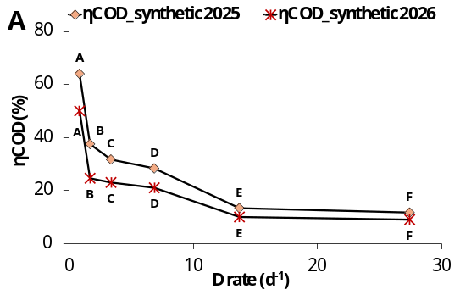 | 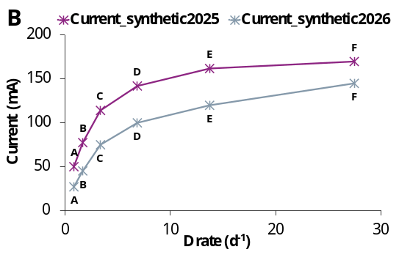
Figure 1: Trends of the ηCOD (A) and of produced current (B) obtained in MEC reactor as a function of D_{rate} for all operating conditions before (2025) and after (2026) bioanode inhibition. 2025 data are reproduced from (Marchetti, Valentino, et al., 2026).

    - Steady-state performance evaluation
Following the recovery phase, the MEC was operated under steady-state conditions to assess whether the restored bioanode activity could be maintained over time. As shown in Figure 2.A, the current remained relatively stable throughout the investigated period, fluctuating between approximately 35 and 50 mA, with no progressive decrease in performance. Hydrogen production also remained sustained, ranging from approximately 10 to 21 mmol/d, although some fluctuations were observed between individual measurements, with a maximum of 27 mmol/d. The simultaneous maintenance of current generation and hydrogen production indicates that the recovered bioanode was able to sustain stable electron transfer to the cathode and support continuous biohydrogen production under steady-state operation.The main performance parameters calculated over the steady-state period are summarized in Figure 2.B. The MEC achieved an average CE of 83.9 ± 2.5%, while the CCE reached 84.2 ± 3.7%. The average ηE of 103.2 ± 5.4% was obtained, reflecting the contribution of the chemical energy contained in the organic substrate to hydrogen production. The high ηE was also favoured by the good conductivity of the synthetic feed, which resulted in a relatively low average potential difference between the anodic and cathodic compartments (ΔV = −1.22 ± 0.10 V), thereby limiting ohmic losses. In addition, an effective conversion of the electrons generated through substrate oxidation at the bioanode into hydrogen at the cathode occurred. However, the value slightly exceeding 100% should be interpreted considering the experimental variability associated with the analytical and operational parameters used in the calculation. Overall, the stable current generation, sustained hydrogen production and relatively low variability of the calculated performance parameters confirm the establishment of stable operating conditions after the inhibitory event, indicating that the recovered bioanode could maintain its electrochemical activity under steady-state operation.
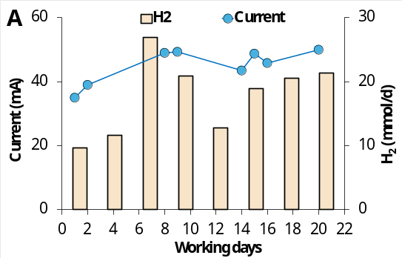 | 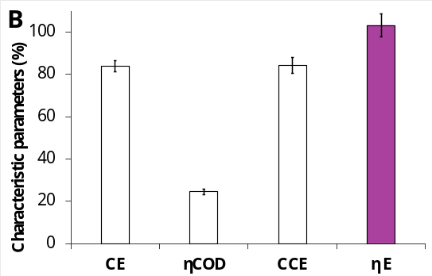
Figure 2: Trends of the produced current and of hydrogen (A) and average value (± standard error calculated from n= 8) of the main characterizing parameters of the MEC system (B) obtained during the steady state period.
    - Electrochemical characterization through CVs method
Cyclic voltammetry was finally performed to characterize the electrochemical response of the recovered bioanode at different scan rates (Figure 3). The voltammograms showed a clear dependence of the recorded current on the scan rate, with progressively higher current responses observed when increasing the scan rate from 5 to 60 mV/min. Under turnover conditions (Figure 3.A), the current response increased with increasing scan rate, from 5 to 60 mV/min, with the highest scan rate reaching approximately 230 mA at +0.2 V vs SHE. At 5 mV/min, the current response was substantially lower, reaching approximately 100 mA at +0.15 V vs SHE. This behavior is consistent with an increasing contribution of capacitive current at higher scan rates, while also reflecting the bioelectrocatalytic activity of the anodic biofilm.
For comparison, CVs were also recorded under non-turnover conditions, in the absence of organic substrate (Figure 3.B). The non-turnover profiles showed markedly lower and flatter current, with no plateau-like response, indicating that the pronounced output observed under turnover conditions was mainly associated with substrate-dependent bioelectrocatalytic activity rather than solely with capacitive and background currents. Overall, the CV results provide complementary evidence of the electrochemical activity of the recovered bioanode following the inhibitory event.

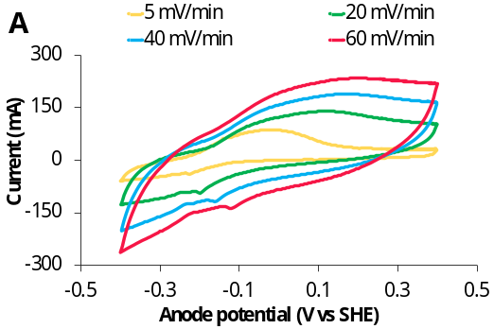 | 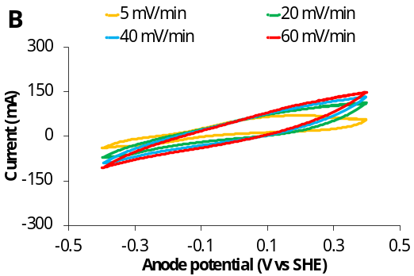
Figure 3: Cyclic voltammetries of the electroactive bioanode, under turnover (A) and non-turnover conditions (B) at different scan rates.
  - Conclusions
The present study assessed the resilience of a long-term operated bioanode in a three-chamber MEC following a severe inhibitory event caused by the direct feeding of an untreated food-processing wastewater. After returning to the previously adopted synthetic substrate, the same bioanode, continuously operated and without replacement or reinoculation, progressively recovered its electrochemical activity. Comparison with the pre-inhibition performance showed that the difference in current generation decreased with increasing dilution rate, reaching only 14.7% at the highest tested condition, while COD removal efficiency showed a lower but still substantial recovery. The subsequent steady-state operation confirmed the stability of the recovered bioanode, with average CE and CCE values of 83.9 ± 2.5% and 84.2 ± 3.7%, respectively, and sustained hydrogen production. The electrochemical characterization by cyclic voltammetry further confirmed the electrocatalytic activity of the recovered bioanode. Overall, the study provides experimental evidence that the resilience of an established bioanode can be assessed by combining pre- and post-perturbation performance under comparable operating conditions with subsequent steady-state and electrochemical characterization. This approach contributes to understanding bioanode robustness, an aspect that is particularly relevant for the long-term implementation of MECs treating variable or potentially inhibitory waste-derived substrates. Nevertheless, these findings also highlight the importance of implementing suitable pretreatment strategies to improve the quality of real waste-derived substrates, thus minimizing the introduction of potentially inhibitory compounds before their feeding to MEC systems.

Funding

This research was conducted within the framework of the Ricerca di Ateneo – Avvio alla Ricerca 2025 project “Electrolysis Integration with REal-substrates and Nanoparticles for waste-to-Energy valorization – boosting bioHydrogen production (EIRENE-H2)”, funded by Sapienza University of Rome (CUP: B83C25004300005; UGOV: 128896).

References

Alcaraz-Gonzalez V., Flores-Estrella R. A., Nolasco M., Cano V. and González-Alvarez V., 2023, Microbial Electrolysis Cells for Biohydrogen Generation and Wastewater Treatment—A Short Review and Current Trends. 73–85. https://doi.org/10.1007/978-3-031-36298-9_6
APHA. (1995). Part 5. American Journal of Public Health, 85(8_Pt_2), P.164-P.203. https://doi.org/10.2105/AJPH.85.8_Pt_2.P.164
Colantoni S., Marchetti A., Zeppilli M. and Cristiani L., 2025, Towards the industrial application of microbial electrolysis cells for hydrogen production: a critical review on cell’s components, Environmental Chemistry and Safety, 1(3), 9600019. https://doi.org/10.26599/ECS.2025.9600019
Dell’Armi E., Ciampi P., Marchetti A., Bartsch E., Alesi M., Alesi E. J., Rehner G., Matturro B., Feigl V., Molnar M., Rossetti S., Petrangeli Papini M. and Zeppilli M., 2025, Field test of a scaled-up bioelectrochemical sequential reductive/oxidative process for chlorinated aliphatic hydrocarbons (CAHs) remediation from contaminated groundwater, Chemical Engineering Journal, 524, 169825. https://doi.org/10.1016/J.CEJ.2025.169825
Ganguly A., Sun P., Liu X., Delgado H. E., Sun L. and Elgowainy A., 2025, Techno-economic and life cycle analysis of bio-hydrogen production using bio-based waste streams through the integration of dark fermentation and microbial electrolysis, Green Chemistry, 27(21), 6213–6231. https://doi.org/10.1039/D4GC05020G
Marchetti A., Sassetto G., Cabras D., Hosseini S., Milia S. and Zeppilli M., 2026, From Wastewater to Bio-Hydrogen: Advancing Microbial Electrolysis Cells Through Challenges, Innovations, and Process Integration, Hydrogen, 7(2), 85. https://doi.org/10.3390/hydrogen7020085
Marchetti A., Valentino F., Gottardo M. and Zeppilli M., 2026, Rapid screening approach to evaluate MEC performance for biohydrogen production using synthetic and real organic waste-derived substrates, Sustainable Energy Technologies and Assessments, 93, 105351. https://doi.org/10.1016/J.SETA.2026.105351
Marsili E., Rollefson J. B., Baron D. B., Hozalski R. M. and Bond D. R., 2008, Microbial biofilm voltammetry: Direct electrochemical characterization of catalytic electrode-attached biofilms, Applied and Environmental Microbiology, 74(23), 7329–7337. https://doi.org/10.1128/AEM.00177-08
Mohamed Ashiq N., Juma Al Rahma Aldarmaki A. A., Saif Alketbi M. S., Abdullah Alshehhi H. A., Obaid Alkaabi A. S., Mubarak Saeed Alshamsi N. S. and Aly Hassan A., 2025, Challenges in Operating a Microbial Electrolysis Cell (MEC): Translating Biofilm Activity to Electron Flow and Hydrogen, Sustainability, 17(24), 11216. https://doi.org/10.3390/su172411216
Pal R., Pal D. B. and Rathoure A. K., 2025, Bio-Hydrogen Production from Biomass Feedstocks: Innovations and Sustainable Pathways, Clean Energy Technologies: Status and Perspective of Next-Generation Fuels,105–129. https://doi.org/10.1007/978-981-96-7925-6_6
Stoller M., Marchetti A. and Ochando Pulido J. M., 2019, On the effect of specific boundary flux parameters on membrane process design, Chemical Engineering Transactions, 74. https://doi.org/10.3303/CET1974115
Zainal B. S., Ker P. J., Mohamed H., Ong H. C., Fattah I. M. R., Rahman S. M. A., Nghiem L. D. and Mahlia T. M. I., 2024, Recent advancement and assessment of green hydrogen production technologies. Renewable and Sustainable Energy Reviews, 189, 113941. https://doi.org/10.1016/J.RSER.2023.113941

