Study of corrosion rate and protection efficiency of locally synthesized composite inhibitors for steel 20 using the gravimetric method
Jahongir Sharopov^{a,}*, Oybek Makhammadiyevª, Qunduz Soqiyeva^{b}, Zumrad Abzalova^{c}, Zarina Arabova^{d}, Chimri Begimqulova^{d}
^{a*}Tashkent State Technical University, Tashkent, Uzbekistan
ªTashkent International University of Chemistry, Tashkent, Uzbekistan
^{b}Tashkent Institute of Chemical Technology, Tashkent, Uzbekistan
^{c}Tashkent Pharmaceutical Institute, Tashkent, Uzbekistan
^{d}Qarshi State University, Qarshi, Uzbekistan
jahongir.user@gmail.com
Steel 20 is widely used in industrial pipelines, acid cleaning and chemical processing equipment, where hydrochloric and sulfuric acid media can cause rapid metal dissolution. This study evaluates locally synthesized water-soluble composite inhibitors as alternatives to imported commercial products. The protective performance of the EFGK, EFGT-1, EFGT-2, DFGT and EFGK-1 formulations was determined by the gravimetric weight-loss method in 0.5 M HCl, 0.5 M H₂SO₄ and 0.5 M HCl + 200 mg L⁻¹ NaCl solutions at 30–70 °C and inhibitor concentrations of 50–250 mg L⁻¹. In 0.5 M HCl, EFGT-1 reached 94.75 % protection at 250 mg L⁻¹ and 70 °C, while EFGT-2 and EFGK reached 93.62 % and 90.84 %. In 0.5 M H₂SO₄, the corresponding efficiencies were 92.63 %, 92.14 % and 87.56 %. In the acid–salt solution, DFGT gave 93.26 % protection at 200 mg L⁻¹, slightly higher than EFGT (92.25 %). EFGK-1 showed the best result in 0.5 M HCl at 200 mg L⁻¹, reaching 95.89 %. The inhibition effect is attributed to the adsorption of N-, O- and S-containing functional groups on the steel surface, leading to a compact protective film that hinders acid attack. The synthesized inhibitors demonstrated efficiencies comparable with the imported Fleck and Flogard products and can be considered technologically and economically attractive formulations for acidic industrial media.
  - Introduction
Low-carbon and mild steels remain among the most widely used structural materials in industrial pipelines, heat-exchange equipment and acid cleaning systems because they combine sufficient mechanical strength with relatively low cost. However, contact with hydrochloric and sulfuric acid during pickling, descaling and chemical cleaning accelerates anodic dissolution of iron and can substantially increase maintenance and replacement costs.
Organic inhibitors are a practical route for reducing the dissolution rate of steel in acidic environments; the general principles of their selection and application were systematized by Sastri (1998). Quraishi et al. (2001) related the protection of mild steel in hydrochloric acid to the donor ability of N- and S-containing molecules, and Ahamad et al. (2010) confirmed by thermodynamic, electrochemical and quantum chemical methods that Schiff bases act through the adsorption of electron-donating centres. Bentiss et al. (2000) showed that heterocyclic 1,3,4-oxadiazoles form stable protective layers in acidic media, and Babic-Samardzija et al. (2005) related the inhibiting action of organic compounds to their molecular structure and coordination ability.
A wide range of molecular architectures has been examined for acid media. Hegazy et al. (2011) reported effective inhibition of carbon steel in hydrochloric acid by cationic surfactants, and Hegazy and Atlam (2016) extended this approach to bolaamphiphiles. Farag et al. (2015) applied polyester derivatives, and Fouda et al. (2013) evaluated several organic compounds for carbon steel in acid. Umoren and Ekanem (2010) compared natural and synthetic inhibitors, Obot et al. (2011) analysed the adsorption characteristics of organic inhibitors, and Kannan et al. (2016) reported adsorption and quantum chemical studies of a benzimidazolium compound on carbon steel.
In chloride-containing media, ionic species additionally influence the surface charge of the metal and the adsorption of inhibitor molecules. Zhou et al. (2013) showed that chloride-driven electrochemical migration governs the failure of copper conductors in salt-containing environments, and Wang et al. (2015) demonstrated by electrochemical and DFT methods that quinoline derivatives remain effective adsorption-type inhibitors in NaCl solution. The behaviour of inhibitors in combined acid–salt systems therefore requires separate evaluation.
Despite the availability of commercial products, the local synthesis of inhibitors from accessible raw materials is relevant because imported inhibitors increase the operating cost of corrosion protection, their composition is not always optimized for local water chemistry and operating temperature, and composite molecules containing amine, carbamide, thiocarbamide and hydroxyl fragments can provide multiple adsorption centres for a protective interfacial film. Such water-soluble formulations are also environmentally and economically attractive, being effective at low working concentrations of 50–250 mg L⁻¹. The synthesis of the EFGK and EFGT series from local raw materials was reported by Maxammadiyev et al. (2021), and the functional groups formed in these formulations were identified by IR spectroscopy (Maxammadiyev and Beknazarov, 2022). The purpose of this work was to evaluate locally synthesized composite inhibitors for Steel 20 in acidic and acid–salt media using a reproducible gravimetric method and to compare their performance with imported analogues.
  - Materials and methods
    - Materials and inhibitor codes
Hydrochloric acid and sulfuric acid solutions with a concentration of 0.5 M were used as aggressive media. The acid–salt medium was prepared as 0.5 M HCl containing 200 mg L⁻¹ NaCl. Steel 20 plates with the following chemical composition (wt %): C 0.20, Mn 0.50, Cr 0.25, Cu 0.20, Si 0.17, S 0.05, Ni 0.04, P 0.04, Fe balance, were used as test specimens; before exposure they were mechanically cleaned, degreased, dried and weighed. The imported inhibitors Fleck and Flogard were used as reference formulations for comparison with the synthesized products. The inhibitor codes used in this work are defined in Table 1; the synthesized series also includes the DFGK, MFGK and MFGT analogues, which were not evaluated in this study. The suffix -1 or -2 indicates a formulation variant within the same inhibitor family, obtained by changing the molar ratio of the starting components while preserving the same base chemical class.
Table 1: Nomenclature of the synthesized inhibitor series
Code | Base composition | Evaluated in this work
EFGT | Ethylenediamine–thiocarbamide (thiourea) composite | EFGT-1 and EFGT-2 variants; EFGT in acid–salt medium
EFGK | Ethylenediamine–carbamide (urea) composite | EFGK and EFGK-1 variants
DFGT | Diethanolamine–thiocarbamide (thiourea) composite | Acid–salt medium
    - Synthesis approach
The composite inhibitors were synthesized at the laboratory of the Tashkent Research Institute of Chemical Technology using locally available amine-containing raw materials. Ethylenediamine, diethanolamine or monoethanolamine were used as the amine component, while carbamide or thiocarbamide supplied additional O, N or S donor sites. Phosphoric acid and glycerol were used as modifying components in the synthesis of the ethylenediamine-based formulations. The obtained water-soluble inhibitor concentrates were diluted to the required working concentrations immediately before the corrosion tests.
These components were selected because amine, hydroxyl, carbamide and thiocarbamide fragments can be protonated in acid and can interact with the steel surface through the lone electron pairs of N, O and S atoms, which promotes adsorption and the formation of a compact protective layer.
    - Gravimetric procedure and calculations
The corrosion rate was determined by the gravimetric method according to GOST 9.506-87. Experiments were performed in the temperature range of 30–70 °C at a liquid flow velocity of 1.1 m s⁻¹. Steel 20 plates with dimensions of 20 × 30 × 3 mm were used. Each specimen was weighed on an analytical balance before and after exposure. After immersion, corrosion products were removed from the surface, and the specimens were washed, dried and weighed again. All compared tests were performed under the same exposure-time conditions. The corrosion rate W and the protection efficiency Z were calculated using Eq(1) and Eq(2):
W = (m₀ − m₁) / (S·t) | (1)
Z = ((W₀ − W_{i}) / W₀) × 100 | (2)
where m₀ and m₁ are the specimen masses before and after exposure (g), S is the exposed surface area (m²), t is the exposure time (h), W₀ is the corrosion rate without inhibitor and W_{i} is the corrosion rate in the presence of an inhibitor (g m⁻² h⁻¹). The overall experimental workflow is shown in Figure 1.
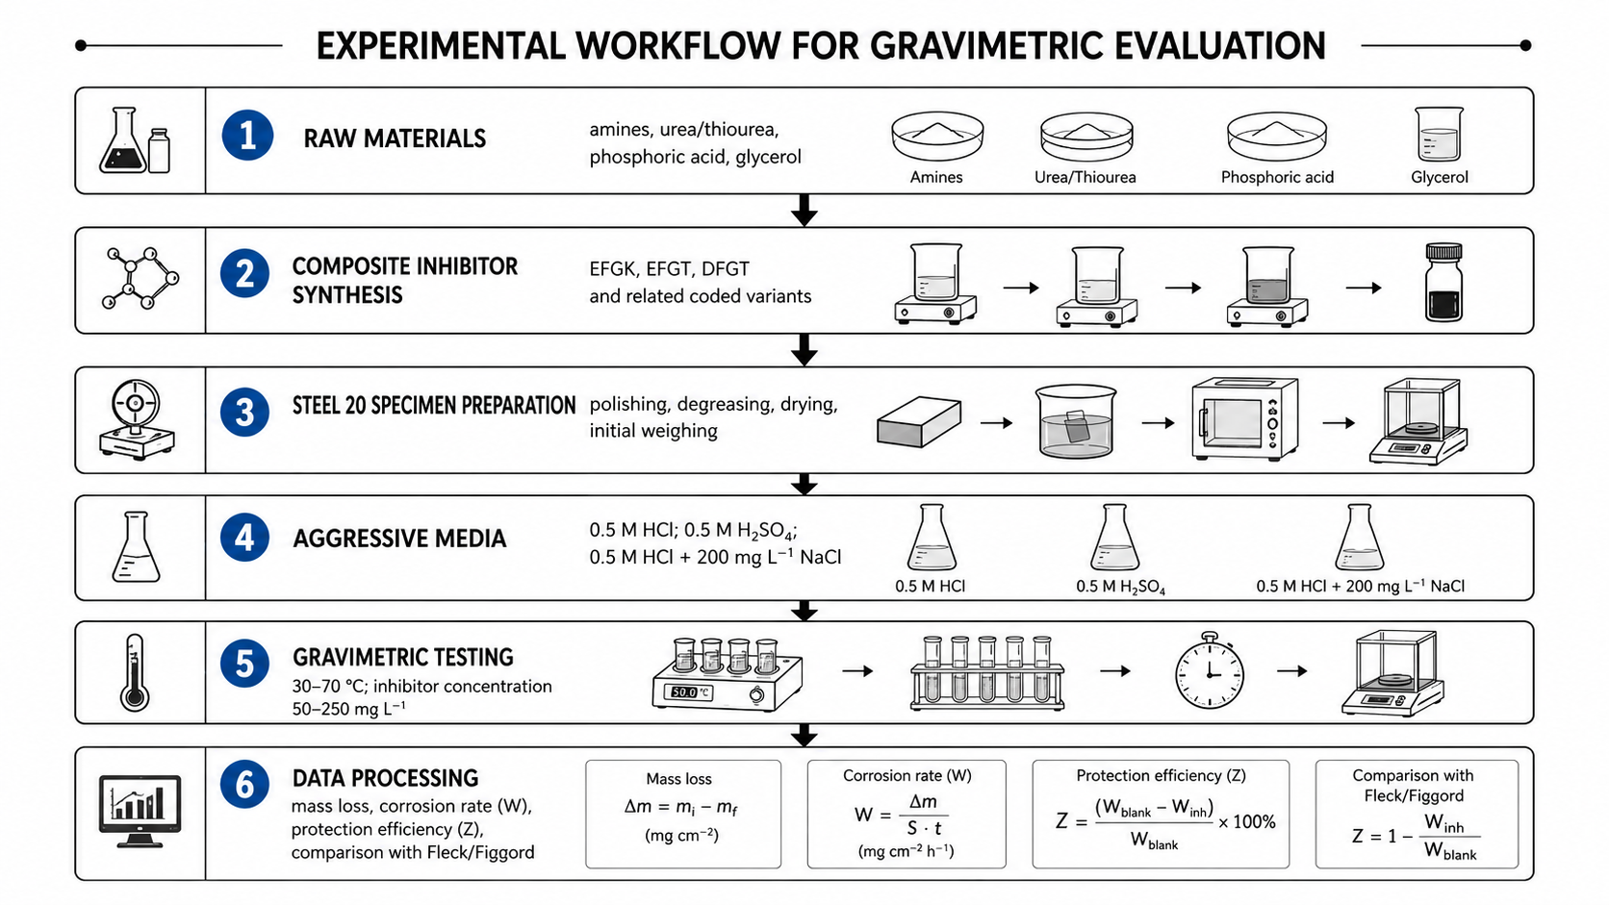
Figure 1: Experimental workflow used to evaluate Steel 20 corrosion inhibitors by the gravimetric method
  - Results and discussion
    - Corrosion behaviour in 0.5 M HCl and 0.5 M H₂SO₄
The corrosion rate and protection efficiency of Steel 20 in 0.5 M HCl and 0.5 M H₂SO₄ are summarized in Table 2. The experimental series covered 30–70 °C and 50–250 mg L⁻¹ inhibitor concentrations. The data show a significant decrease in corrosion rate in the presence of the inhibitors compared with the uninhibited acid media. In the uninhibited solutions, the corrosion rate increased from 0.0112 to 0.0522 g m⁻² h⁻¹ in HCl and from 0.0108 to 0.0513 g m⁻² h⁻¹ in H₂SO₄ as the temperature increased from 30 to 70 °C.
Table 2: Corrosion rate (W, g m⁻² h⁻¹) and protection efficiency (Z, %) of Steel 20 in 0.5 M HCl and 0.5 M H₂SO₄ with and without inhibitors
Inhibitor | C, mg L⁻¹ | T, °C | W (HCl) | Z (HCl) | W (H₂SO₄) | Z (H₂SO₄)
No inhibitor | – | 30 | 0.0112 | – | 0.0108 | –
No inhibitor | – | 40 | 0.0196 | – | 0.0203 | –
No inhibitor | – | 50 | 0.0287 | – | 0.0291 | –
No inhibitor | – | 60 | 0.0450 | – | 0.0459 | –
No inhibitor | – | 70 | 0.0522 | – | 0.0513 | –
Flogard | 50 | 30 | 0.0028 | 75.00 | 0.0021 | 79.53
Flogard | 100 | 40 | 0.0025 | 77.67 | 0.0034 | 83.00
Flogard | 150 | 50 | 0.0021 | 81.25 | 0.0029 | 89.96
Flogard | 200 | 60 | 0.0018 | 83.92 | 0.0044 | 90.39
Flogard | 250 | 70 | 0.0014 | 87.51 | 0.0062 | 91.23
EFGK | 50 | 30 | 0.0029 | 74.01 | 0.0037 | 65.18
EFGK | 100 | 40 | 0.0044 | 77.50 | 0.0056 | 72.31
EFGK | 150 | 50 | 0.0049 | 82.71 | 0.0061 | 78.96
EFGK | 200 | 60 | 0.0056 | 87.44 | 0.0066 | 85.59
EFGK | 250 | 70 | 0.0047 | 90.84 | 0.0063 | 87.56
Fleck | 50 | 30 | 0.0008 | 92.16 | 0.0016 | 84.33
Fleck | 100 | 40 | 0.0009 | 95.09 | 0.0031 | 84.45
Fleck | 150 | 50 | 0.0012 | 95.73 | 0.0023 | 91.82
Fleck | 200 | 60 | 0.0019 | 95.79 | 0.0037 | 91.89
Fleck | 250 | 70 | 0.0021 | 95.87 | 0.0041 | 92.00
EFGT-1 | 50 | 30 | 0.0011 | 90.17 | 0.0016 | 84.73
EFGT-1 | 100 | 40 | 0.0018 | 90.81 | 0.0031 | 85.48
EFGT-1 | 150 | 50 | 0.0026 | 90.93 | 0.0017 | 91.31
EFGT-1 | 200 | 60 | 0.0037 | 91.15 | 0.0039 | 91.48
EFGT-1 | 250 | 70 | 0.0027 | 94.75 | 0.0041 | 92.63
EFGT-2 | 50 | 30 | 0.0010 | 90.11 | 0.0011 | 84.17
EFGT-2 | 100 | 40 | 0.0016 | 90.74 | 0.0028 | 84.48
EFGT-2 | 150 | 50 | 0.0025 | 90.88 | 0.0016 | 91.02
EFGT-2 | 200 | 60 | 0.0035 | 91.17 | 0.0038 | 91.48
EFGT-2 | 250 | 70 | 0.0027 | 93.62 | 0.0040 | 92.14
At 250 mg L⁻¹ and 70 °C, the highest protection efficiency of the locally synthesized EFGT-1 inhibitor was 94.75 % in 0.5 M HCl and 92.63 % in 0.5 M H₂SO₄. EFGT-2 showed 93.62 % and 92.14 %, while EFGK reached 90.84 % and 87.56 % in the same media. These values are close to those of the imported Fleck inhibitor, which showed 95.87 % protection in HCl and 92.00 % in H₂SO₄, while Flogard showed 87.51 % and 91.23 %.
The higher efficiencies observed in HCl compared with H₂SO₄ for most synthesized inhibitors can be explained by the adsorption behaviour of acid-protonated inhibitor species. Chloride ions can be adsorbed on the steel surface and may facilitate the interaction of cationic inhibitor species with the metal interface. Sulfate ions are larger and more strongly hydrated; therefore, competitive adsorption and solvation effects can reduce the compactness of the protective film. The high performance of the thiocarbamide-containing EFGT variants indicates that sulfur-containing fragments strengthen adsorption and support the formation of a more stable barrier layer.
    - Protection in the acid–salt medium
The effect of EFGT and DFGT in the acid–salt medium is given in Table 3 and Figure 2. Without inhibitor, the corrosion rate was 1.0702 g m⁻² h⁻¹. Increasing the inhibitor concentration from 50 to 200 mg L⁻¹ decreased the corrosion rate and increased the protection efficiency for both formulations.
Table 3: Corrosion rate and protection efficiency of EFGT and DFGT in the 0.5 M HCl + 200 mg L⁻¹ NaCl acid–salt solution
Inhibitor | C, mg L⁻¹ |  | W, g m⁻² h⁻¹ | Z, %
No inhibitor | – |  | 1.0702 | –
EFGT | 50 |  | 0.1906 | 82.24
EFGT | 100 |  | 0.1421 | 86.72
EFGT | 150 |  | 0.1138 | 89.43
EFGT | 200 |  | 0.0754 | 92.25
DFGT | 50 |  | 0.1714 | 84.11
DFGT | 100 |  | 0.1295 | 87.89
DFGT | 150 |  | 0.1058 | 90.11
DFGT | 200 |  | 0.0721 | 93.26
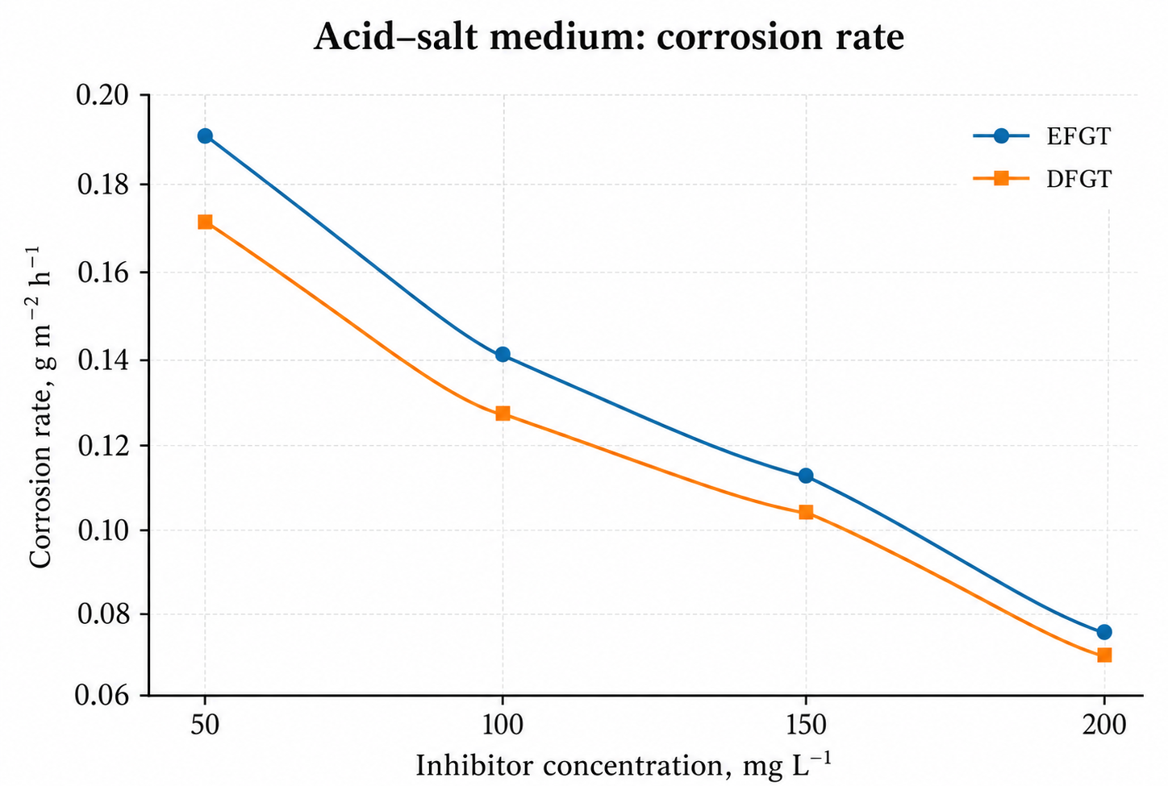 |  | 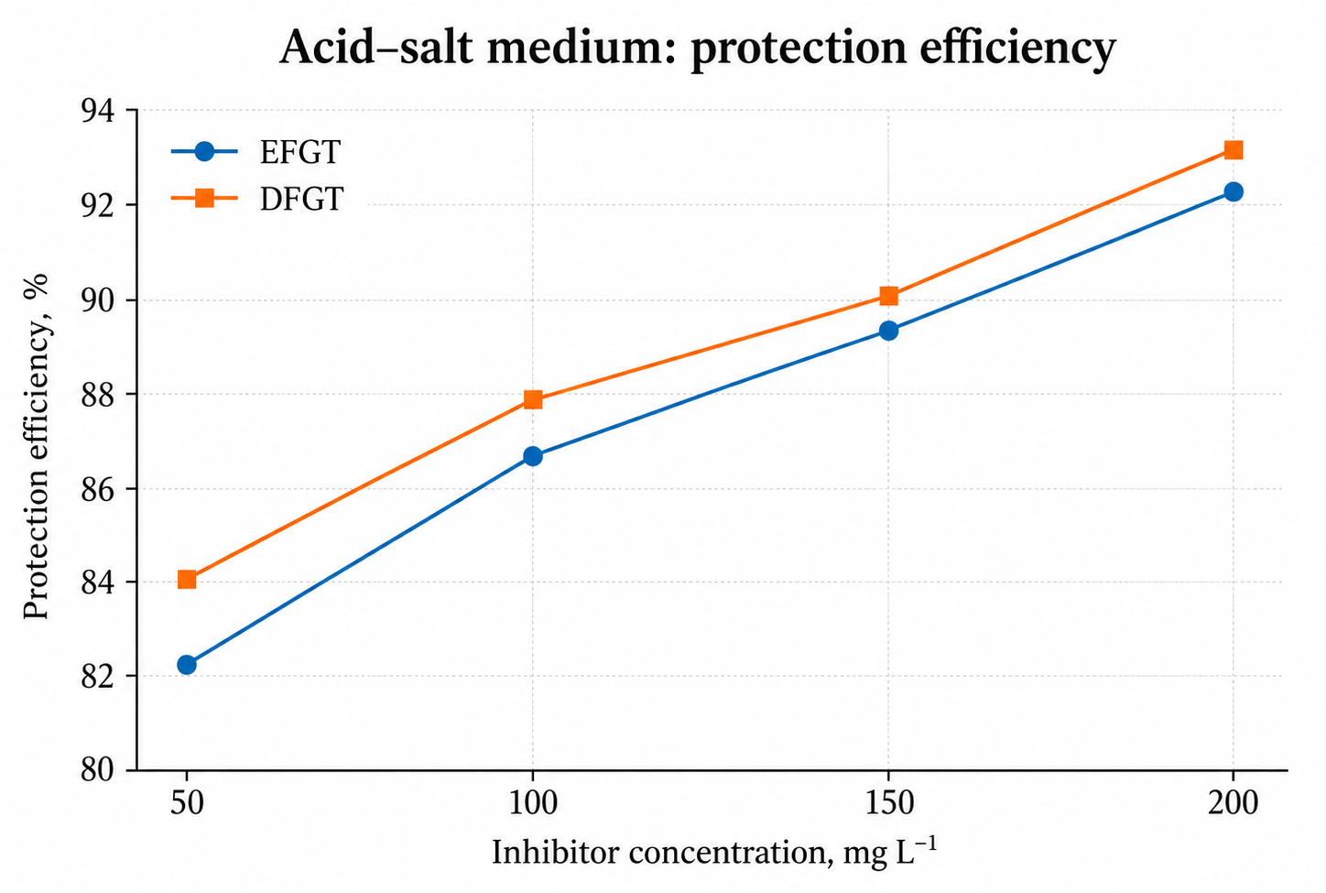
Figure 2: Effect of inhibitor concentration on (a) corrosion rate and (b) protection efficiency in the 0.5 M HCl + 200 mg L⁻¹ NaCl acid–salt medium
At 200 mg L⁻¹, EFGT decreased the corrosion rate to 0.0754 g m⁻² h⁻¹ and provided 92.25 % protection, while DFGT decreased the corrosion rate to 0.0721 g m⁻² h⁻¹ and provided 93.26 % protection. The slightly higher efficiency of DFGT can be associated with the simultaneous presence of thiocarbamide sulfur and diethanolamine hydroxyl groups, which increases the number of adsorption centres and strengthens the protective film in the chloride-containing medium.
    - Temperature dependence at 200 mg L⁻¹
The influence of temperature on EFGT-1 and EFGK-1 at a fixed concentration of 200 mg L⁻¹ is summarized in Table 4 and Figure 3. Both inhibitors significantly reduced the corrosion rate over the entire temperature interval compared with the uninhibited acid media.
Table 4: Temperature dependence of corrosion rate (g m⁻² h⁻¹) and protection efficiency at 200 mg L⁻¹ inhibitor concentration in 0.5 M HCl and 0.5 M H₂SO₄
Medium | T, °C | W₀ | W (EFGT-1) |  | Z (EFGT-1), % | W (EFGK-1) | Z (EFGK-1), %
HCl | 30 | 0.0112 | 0.00128 |  | 88.57 | 0.00087 | 92.23
HCl | 40 | 0.0196 | 0.00223 |  | 88.62 | 0.00096 | 95.09
HCl | 50 | 0.0287 | 0.00265 |  | 90.76 | 0.00121 | 95.73
HCl | 60 | 0.0450 | 0.00370 |  | 91.15 | 0.00192 | 95.78
HCl | 70 | 0.0522 | 0.00384 |  | 92.64 | 0.00216 | 95.89
H₂SO₄ | 30 | 0.0108 | 0.00169 |  | 84.35 | 0.00168 | 84.44
H₂SO₄ | 40 | 0.0203 | 0.00310 |  | 84.73 | 0.00296 | 85.41
H₂SO₄ | 50 | 0.0291 | 0.00442 |  | 84.81 | 0.00369 | 87.32
H₂SO₄ | 60 | 0.0459 | 0.00391 |  | 91.48 | 0.00481 | 89.52
H₂SO₄ | 70 | 0.0513 | 0.00414 |  | 91.92 | 0.00463 | 90.97
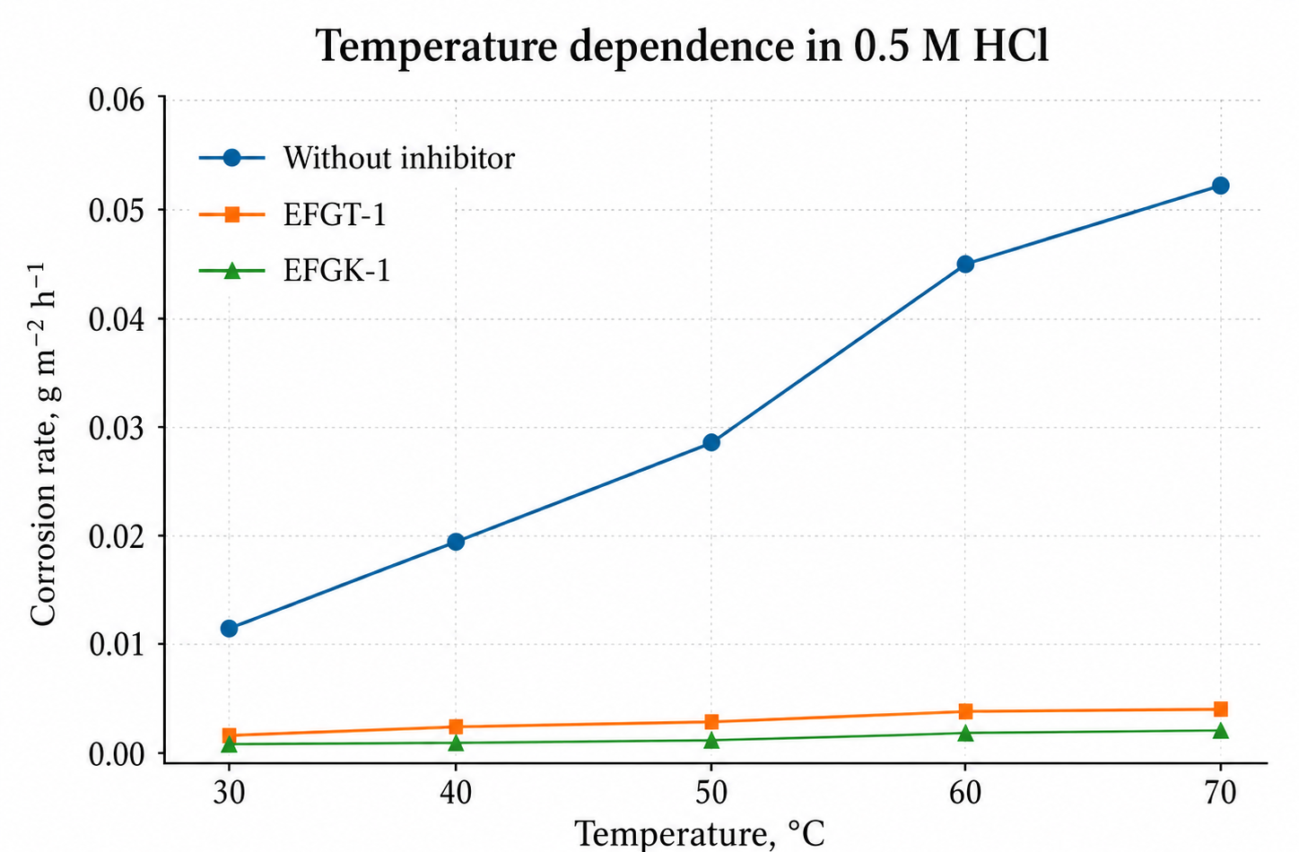 |  |  |  | 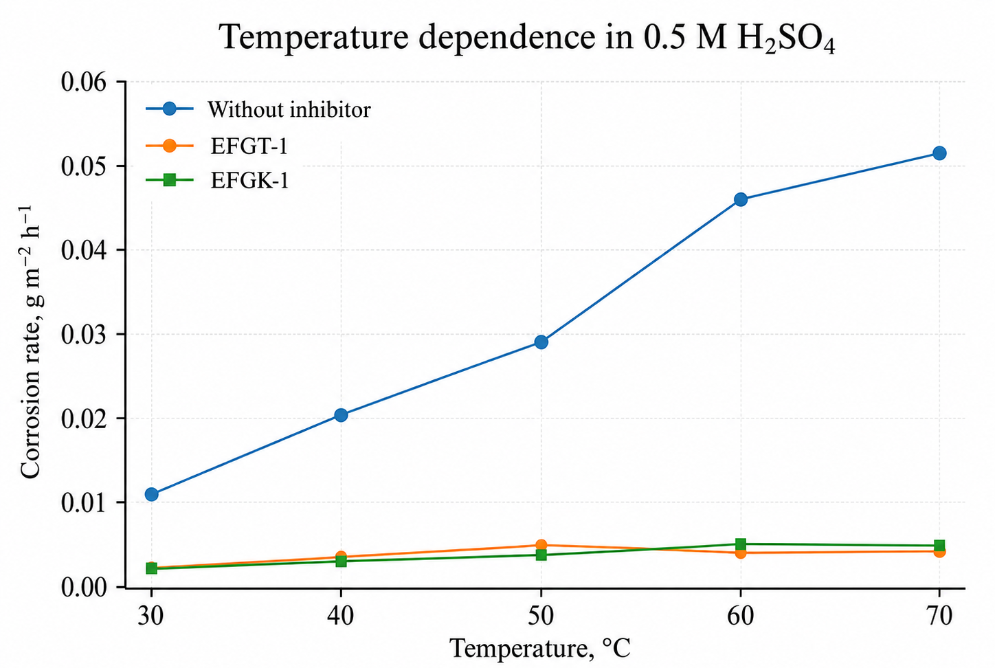
Figure 3: Temperature dependence of corrosion rate in (a) 0.5 M HCl and (b) 0.5 M H₂SO₄ with and without EFGT-1 and EFGK-1 inhibitors
In 0.5 M HCl, EFGK-1 showed the best performance, with the protection efficiency increasing from 92.23 % at 30 °C to 95.89 % at 70 °C. EFGT-1 increased from 88.57 % to 92.64 % in the same temperature interval. In 0.5 M H₂SO₄, EFGT-1 reached 91.92 % at 70 °C, while EFGK-1 reached 90.97 %. The increase in protection efficiency with temperature suggests that chemisorption contributes to the formation of the protective layer. If only weak physical adsorption dominated, a decrease in efficiency with temperature would be expected due to desorption.
    - Proposed inhibition mechanism
The observed efficiency of the synthesized inhibitors can be explained by an adsorption-controlled mechanism (Figure 4). In acidic solutions, the inhibitors can be protonated, but donor atoms and polar functional groups remain important for surface interaction. Nitrogen, oxygen and sulfur atoms, together with amine, carbamide, thiocarbamide and hydroxyl fragments, provide adsorption centres. The adsorbed molecules form a thin film that decreases the contact area between the acid and the steel surface, reduces the number of active dissolution sites and blocks the diffusion of aggressive ions.
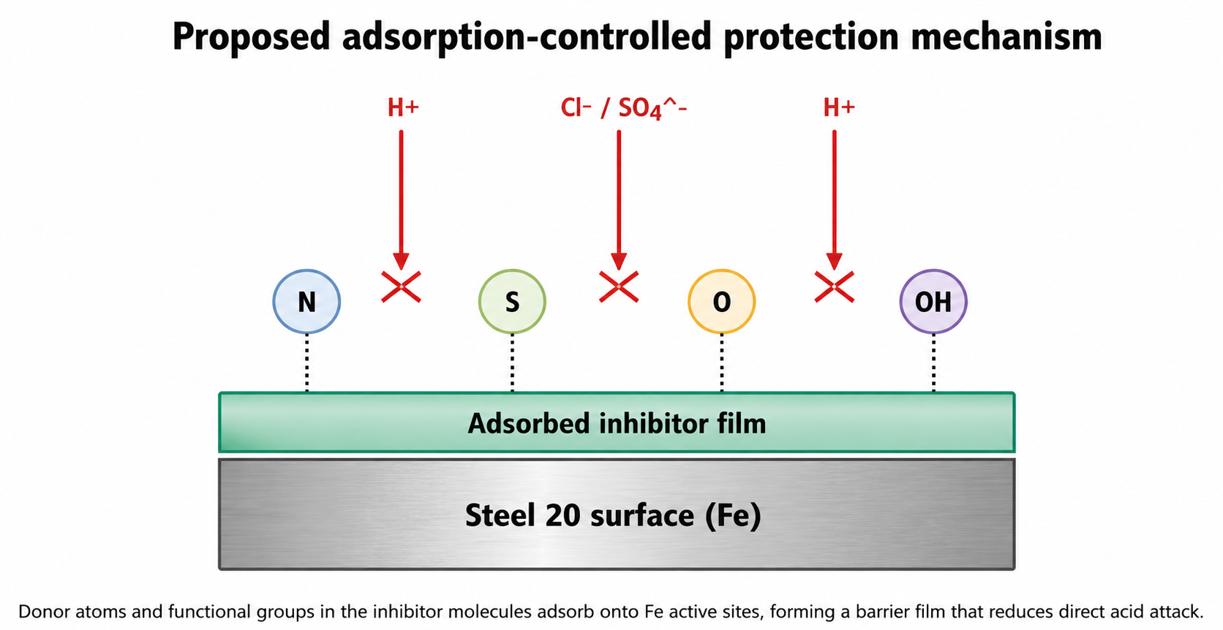
Figure 4: Proposed adsorption-controlled mechanism for the protection of Steel 20 by N-, O- and S-containing composite inhibitors
The comparison between the synthesized and imported inhibitors shows that local formulations can approach commercial performance. In HCl, EFGT-1 and EFGK-1 achieved values close to those of Fleck, while in the sulfate medium EFGT-1 and EFGT-2 showed efficiencies higher than 92 %. In the acid–salt medium, DFGT was slightly more effective than EFGT.
  - Conclusions
The gravimetric data confirm that the locally synthesized EFGK, EFGT-1, EFGT-2, DFGT and EFGK-1 composite inhibitors substantially reduce the corrosion rate of Steel 20 in acidic and acid–salt media. In 0.5 M HCl at 250 mg L⁻¹ and 70 °C, EFGT-1 reached 94.75 % protection, EFGT-2 93.62 % and EFGK 90.84 %; in 0.5 M H₂SO₄ the corresponding efficiencies were 92.63 %, 92.14 % and 87.56 %. At 200 mg L⁻¹, EFGK-1 achieved 95.89 % protection in 0.5 M HCl, which is comparable to the imported Fleck product, while EFGT-1 provided 91.92 % protection in 0.5 M H₂SO₄ at 70 °C. In the acid–salt solution, DFGT provided 93.26 % protection at 200 mg L⁻¹, slightly exceeding EFGT (92.25 %).
The protective effect is attributed to the adsorption of N-, O- and S-containing functional groups on the steel surface and the formation of a thin film that hinders the access of aggressive acid and chloride/sulfate ions. The growth of protection efficiency with temperature indicates a contribution of chemisorption to the film formation. The synthesized inhibitors can be considered promising local alternatives to imported products for industrial acid cleaning and pipeline protection. Further work should include electrochemical impedance spectroscopy, polarization measurements and surface analysis to quantify the film resistance and adsorption parameters.
References
Ahamad I., Prasad R., Quraishi M.A., 2010, Thermodynamic, electrochemical and quantum chemical investigation of some Schiff bases as corrosion inhibitors for mild steel in hydrochloric acid solutions, Materials Chemistry and Physics, 124, 1155–1165.
Babic-Samardzija K., Khaled K.F., Hackerman N., 2005, Investigation of the inhibiting action of organic compounds on the corrosion of metals, Applied Surface Science, 240, 327–340.
Bentiss F., Traisnel M., Lagrenee M., 2000, The substituted 1,3,4-oxadiazoles: a new class of corrosion inhibitors of mild steel in acidic media, Corrosion Science, 42, 127–146.
Farag A.A., Ismail A.S., Migahed M.A., 2015, Inhibition of carbon steel corrosion in acidic solution using some newly polyester derivatives, Journal of Molecular Liquids, 211, 915–923.
Fouda A.S., Elewady G.Y., Mostafa H.A., Habbouba S., 2013, Inhibition of carbon steel corrosion in acidic media by organic compounds, African Journal of Pure and Applied Chemistry, 7, 198–207.
Hegazy M.A., Ahmed H.M., El-Tabei A.S., 2011, Investigation of the corrosion inhibition effect of cationic surfactants on carbon steel in hydrochloric acid solution, Corrosion Science, 53, 671–678.
Hegazy M.A., Atlam F.M., 2016, Three novel bolaamphiphiles as corrosion inhibitors for carbon steel in hydrochloric acid: experimental and computational studies, Journal of Molecular Liquids, 218, 649–662.
Kannan P., Shukla S.K., Rao T.S., Rajendran N., 2016, Adsorption, thermodynamic and quantum chemical studies of a substituted benzimidazolium compound on carbon steel, Journal of Materials and Environmental Science, 7, 1154–1171.
Maxammadiyev O.R., Beknazarov X.S., 2022, IR spectroscopic analysis of newly formed functional groups in the obtained inhibitors, Universum, 8(101), 221–227. (in Russian)
Maxammadiyev O.R., Beknazarov X.S., Soqiyeva K.U., Djalilov A.T., 2021, Comparison of EFGK, EFGT, Flogard and Fleck corrosion inhibitors, Universum, 9(90), 401–408. (in Russian)
Obot I.B., Obi-Egbedi N.O., Umoren S.A., 2011, Adsorption characteristics and corrosion inhibitive properties of organic compounds in acidic media, Chemical Engineering Communications, 198, 711–725.
Quraishi M.A., Sardar R., Jamal D., 2001, Corrosion inhibition of mild steel in hydrochloric acid by organic compounds, Materials Chemistry and Physics, 71, 309–313.
Sastri V.S., 1998, Corrosion Inhibitors: Principles and Applications, John Wiley & Sons, New York, USA.
Umoren S.A., Ekanem U.F., 2010, Inhibition of mild steel corrosion in acidic media using natural and synthetic organic compounds, Chemical Engineering Communications, 197, 1339–1356.
Wang D., Yang D., Zhang D., Li K., Gao L., Lin T., 2015, Electrochemical and DFT studies of quinoline derivatives on corrosion inhibition of AA5052 aluminium alloy in NaCl solution, Applied Surface Science, 357, 2176–2183.
Zhou Y., Yang P., Yuan C., Huo Y., 2013, Electrochemical migration failure of the copper trace on printed circuit board driven by immersion silver finish, Chemical Engineering Transactions, 33, 559–564.

