 CHEMICAL ENGINEERING TRANSACTIONS  VOL. xxx, 2026 | A publication of  
The Italian Association
of Chemical Engineering
Online at www.cetjournal.it

Guest Editors: Flavio Manenti, Botir Usmonov, Alessandro Di Pretoro
Copyright © 2026, AIDIC Servizi S.r.l.
ISBN 979-12-81206-xx-x; ISSN 2283-9216

Overcoming the Hurdles of Miniaturizing Corrugated-Sheet Structures: A Novel 3D-Printed Lab-Scale Distillation Packing
Mohamed Adel Ashour*, Dennis Stucke, Thomas Grützner
Ulm University, Institute of Chemical Engineering, Laboratory of Thermal Process Engineering, Albert-Einstein-Allee 47, 89081 Ulm, Germany
mohamed.ashour@uni-ulm.de
Miniaturized laboratory distillation columns are attractive for process development and scale-up because they reduce energy demand, novel chemical consumption, holdup, and safety-related effort. However, diameters below the commonly recommended 40 mm to 50 mm worsen wall effects and aggravate the geometric and installation-related inhomogeneities of conventional corrugated-sheet packings. In this work, these drawbacks are analyzed and a novel additively manufactured corrugated-sheet packing for a DN20 laboratory column is presented: the Corrugated Alternating Zigzag packing (CAZ-Pak). It combines established corrugated-sheet principles with additive-manufacturing design features: homogeneous sheet termination, exact inter-elemental mating, eliminated wall wipers, and orientation rings. The packings were manufactured from polyamide 12 by selective laser sintering and characterized under total reflux with cyclohexane/n-heptane at 900 mbar. In DN20, the CAZ-Pak showed more than double the average number of theoretical stages per meter (NTSM) compared to the reference additively manufactured XW-Pak structure with a practically flat efficiency trend over the vapor load range. In DN30, it outperformed Sulzer’s DXM laboratory packing despite a slightly higher pressure drop. This contribution is a concise version of a more comprehensive full research paper (Ashour et al., 2026). The more comprehensive paper contains further comparisons addressing patented advanced 3D-printed packings, proof of reproducibility claims, diameter variation effects on the CAZ-Pak performance, deeper mechanistic interpretations, and further detailed accounting for the CAZ-Pak’s geometric definition and homogeneity.
  - Introduction
Distillation is the most widely used separation technology in the chemical industry and is reported to consume approx. 40 % of its energy demand (Kiss and Smith, 2020). Packed laboratory-scale distillation experiments are an integral part of process development and scale-up, especially for new processes or challenging separation tasks. The most industrially applied scale-up approach is based on the work of Eiden et al. (1995), implemented by the major German chemical companies (Schoenmakers and Spiegel, 2014). There, the separation efficiency of a “calibrated” laboratory column, determined at different vapor loads (F-factor) and pressures with a standard distillation test mixture, is compared to pilot-scale data to derive transferability correlations. This requires the separation efficiency of the packing to be minimally dependent on the vapor load as well as accurate and reproducible. Such a packing is considered “scalable”, and the approach works well even if the laboratory packing differs from the industrial one (Eiden et al., 1995).
Calibrated laboratory columns usually have a recommended inside diameter of 40 mm to 50 mm (Schoenmakers and Spiegel, 2014), while further miniaturization promises lower energy and equipment expenditure, reduced chemical consumption and holdup, and more lenient safety requirements. However, diameters below approx. 50 mm (DN50) significantly increase the wall-to-packing surface ratio, exacerbating heat losses and wall flow and thus the inaccuracies in the derived performance numbers. Moreover, standard packings, manufactured by bending, cutting and piercing of metal sheets or by plastic molding, are difficult to adapt to smaller diameters, and slight deformations of the fragile sheets cause significant deviations in the measured data.
In previous work, heat losses were minimized by an active insulation system. Moreover, a joint research project between Ulm University, the Technical University of Munich, and BASF SE utilized additive manufacturing (AM) to target a scalable packing for a 20 mm column inner diameter (DN20), focusing on repetitive unit cells. It yielded the XW-Pak (Neukäufer et al., 2023) and several advanced structures, one of which is presented in patent application number EP4497498A1. The present contribution follows a different design route based on the corrugated-sheet geometry, the most established structured packing family in industry, whose reliable miniaturization has received limited attention in open literature. This yields the novel “Corrugated Alternating Zigzag” packing, abbreviated as CAZ-Pak (Ashour et al., 2026). Finally, the CAZ-Pak is compared to the XW-Pak structure from the aforementioned project and benchmarked against Sulzer’s DXM corrugated-sheet packing.
  - Materials and methods
This section outlines the investigated packings, the experimental setup along with the major equations utilized to generate the separation performance curves.
    - Packings and additive manufacturing
The packings investigated in this study are illustrated in Figure 1. The CAZ-Pak (Ashour et al., 2026) is compared to the XW-Pak with its repetitive X-shaped unit cells (Neukäufer et al., 2023) at the target DN20 size. It is further benchmarked in the DN30 size against the conventionally manufactured Sulzer DXM, a metal-sheet equivalent of the wire-gauze DX structure.
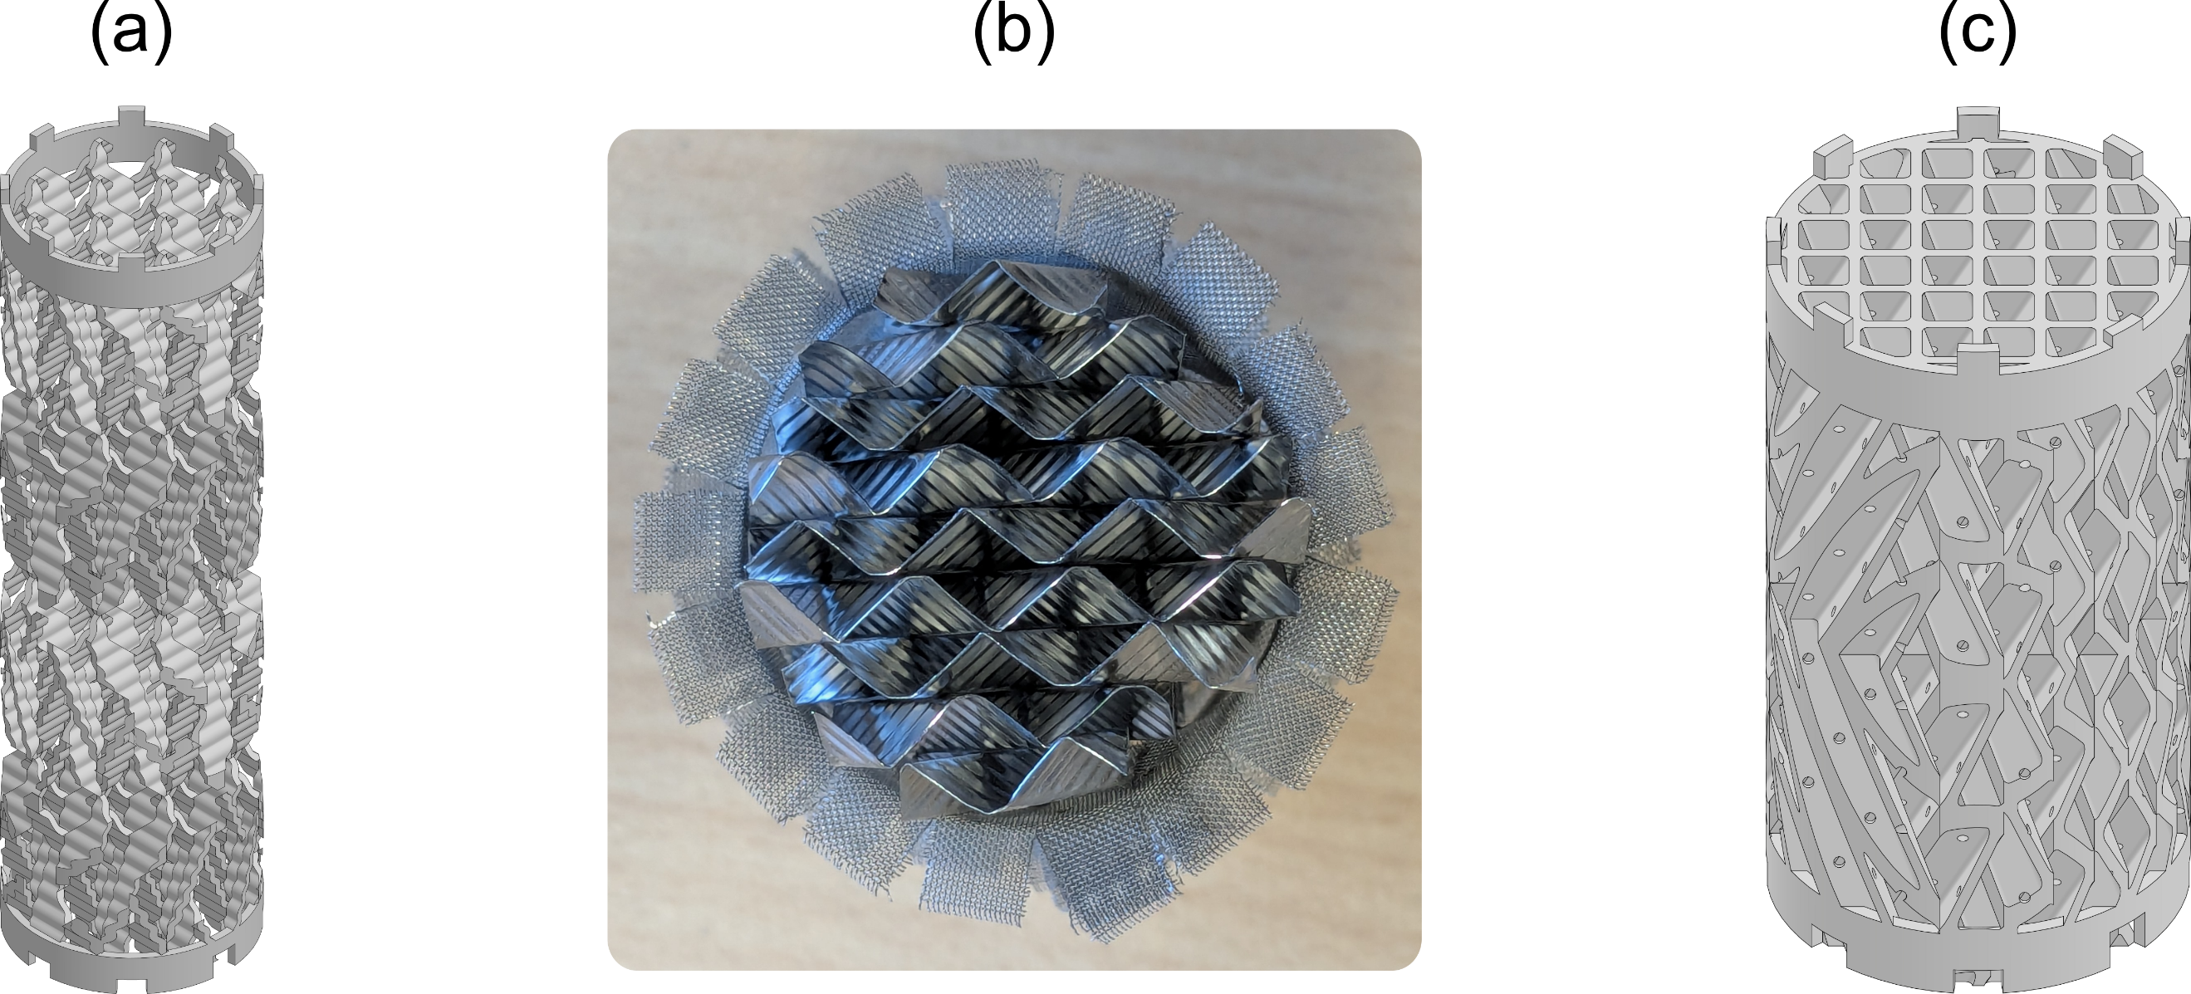
Figure 1: Investigated packings: XW-Pak (a), Sulzer DXM (b), and CAZ-Pak (c).
Polyamide 12 (PA12) is chosen as printing material for economic reasons. It resists the utilized test mixture chemically and thermally. Moreover, the comparative wettability of the post-processed 3D-printed PA12 surface is found to be comparable to SS 316L sheets as indicated by similar values of preliminary contact angle measurements of water performed at Ulm University. All parts are printed in-house by selective laser sintering (SLS) of PA12 powder using a Formlabs Fuse 1 printer. After printing, excess powder is removed and the packings are blasted with glass beads for a uniform surface.
    - Experimental setup
The measurements are carried out in a flexible laboratory-scale distillation test rig for column diameters between 20 mm and 50 mm, described by Neukäufer et al. (2021) with later modifications outlined by Ashour et al. (2026). Operation at a constant 900 mbar avoids atmospheric pressure fluctuations. The column consists of an AM cylindrical shell housing up to 1 m of packing (glass shells for the DXM). Vapor is generated in an electrically heated glass reboiler (vapor loads up to 1.2 Pa^{0.5}) and condensed in a water-cooled glass condenser. The condensate is returned under total reflux by a gear pump via a Coriolis flow meter. Heat losses are compensated by the active insulation system, and a glass heat exchanger limits the reflux subcooling to 2.5 °C below the measured head temperature. Liquid samples below the packing and from the distillate circuit are analyzed by gas chromatography. The efficiency calculations therefore refer exclusively to the packed section. Experiments used the cyclohexane/n-heptane (C6/C7) recommended distillation test mixture (Onken and Arlt, 1990), approaching operating points stepwise and ensuring steady state before sampling.
    - Evaluation equations
Separation efficiency is reported as the height equivalent to a theoretical plate (HETP) or the number of theoretical stages per meter (NTSM = 1/HETP) plotted against the average vapor load (F-factor). The HETP follows from the number of theoretical stages n_{th} and packed height h_{P} as in Eq(1). Owing to the near-ideal behavior of the C6/C7 system, n_{th} is calculated by the well-known Fenske equation in Eq(2) (Fenske, 1932).
$$HETP=\frac{h_{P}}{n_{th}}$$ | (1)
$$n_{th}=\frac{\ln\left[\frac{x_{C6,top}⋅(1-x_{C6,bot})}{x_{C6,bot}⋅(1-x_{C6,top})}\right]}{ln α_{12,avg}}$$ | (2)
The required vapor-liquid equilibrium at 900 mbar is calculated by the modified Raoult’s law with the NRTL model for the activity coefficients, and the average relative volatility α_{12,avg} is obtained via geometric mean over the discretized measured composition range. The F-factor at an axial point j is calculated as in Eq(3), where u_{V,j} is the superficial vapor velocity, ρ_{V,j} the vapor density, ṁ_{V,j} the vapor mass flow rate and d_{c} the inside column diameter.
$$F_{V}=0.5⋅\left(F_{V,top}+F_{V,bot}\right)=0.5⋅\left[\frac{4⋅{\dot{m}}_{V,top}}{π⋅{d_{c}}^{2}⋅{ρ_{V,top}}^{0.5}}+\frac{4⋅{\dot{m}}_{V,bot}}{π⋅{d_{c}}^{2}⋅{ρ_{V,bot}}^{0.5}}\right]$$ | (3)
Since vapor density and mass flow rate vary along the column height, the measured reflux flow rate at the top is corrected via heat balances for reflux subcooling, heat losses, and latent heat differences and the density is corrected for the pressure drop. The representative F-factor is the arithmetic average between top and bottom. The extensive set of equations and correlations implemented to calculate the required thermophysical and thermodynamic properties can be found in Neukäufer et al. (2021) and Ashour et al. (2026). Finally, the error bars are obtained from error propagation as described by Neukäufer et al. (2021).
  - Conventional laboratory packings drawbacks
Conventional corrugated wire-gauze packings are the most widely used packing type for laboratory applications. While they exhibit outstanding separation performance, their NTSM varies strongly with the gas load. Moreover, conventional manufacturing cannot produce such packings precisely at this scale, nor can the elements be installed repeatably, causing inaccuracies or spread in the measured data. Four groups of inhomogeneities are identified:
- Sheet cutting and stacking: if one sheet is cut slightly higher than the rest, inter-element gaps emerge upon stacking, and manual pressing to close them deforms the fragile sheets. If the cutting ignores the inherent height periodicity of the corrugation, adjacent sheets terminate randomly (“heterogeneous termination”) instead of mating exactly with the channel apexes forming closed polygons (“homogeneous termination”).
- Vertical stacking: the conventional 90° inter-elemental axial rotation is applied manually and is therefore inexact and unrepeatable between column reconstructions. A 45° rotation exacerbates the relative error and lacks the visual confirmation of orthogonal sheets. Combined with heterogeneous termination, channels at the mating plane get their open area sliced, causing cross-section reduction, higher pressure losses and potential localized flooding.
- Wall wipers: they create an annular space between packing and column inner wall. Wetted wipers represent a hydrodynamic resistance that locally increases the vapor load within the packing (Riese et al., 2022), while unwetted wipers allow vapor bypass through the annular space. In a DN20 column, the wall-wiper gap can occupy up to 32 % of the volume available for mass transfer internals assuming only a 1.75 mm gap.
- Mechanical sensitivity: the very thin sheets are only bundled by the wall-wiping belt rather than mechanically joined, so deformations easily occur during installation and reconstruction; moderate ones constitute irreversible damage. Most of these inhomogeneities also exist on the industrial scale but can be neglected there due to the different geometric scales.
  - Results and discussion
In this section, the design of the new CAZ-Pak (Ashour et al., 2026) is concisely presented and its performance is briefly discussed.
    - CAZ-Pak design
In conventional corrugated packings, the flow channels form an isosceles triangle in the plane perpendicular to the flow direction. The CAZ-Pak design instead starts from the two horizontal planes at the top and bottom of its sheet, spaced to realize the desired corrugation angle of 60° (Figure 2). At each plane, the sheet profile forms isosceles right triangular channels (channel height 2.5 mm, half the base; apex angle 90°; 0.5 mm apex fillet to limit liquid accumulation), and a loft operation between the profiles creates the corrugated sheet (0.8 mm projected thickness and perforations with diameter of 0.8 mm). The sheet height is an integer multiple (here 10) of the fundamental height unit dictated by the vertical periodicity of the corrugation, so the perforations repeat regularly and no random sheet termination occurs at an arbitrary height. A mirroring operation at half the element height (Figure 2) introduces a channel directional change within the same sheet as shown in Figure 3, promoting mixing and phase renewal. The sheets are repeated with alternating corrugation direction, mated, and cylindrically cut to the exact packing diameter without wall wipers as illustrated in Figure 3. Two orientation rings with teeth and grooves provide precise control over the inter-elemental rotational angle during vertical stacking (Neukäufer et al., 2021). Figure 3 illustrates the design progression.
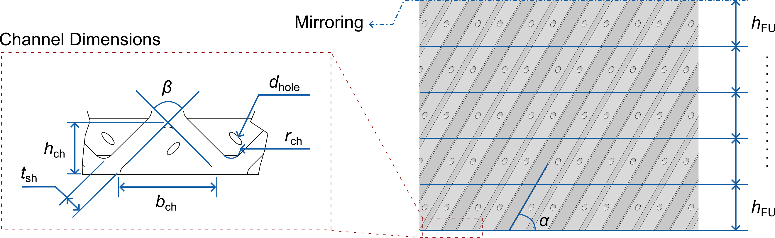
Figure 2: Characteristic geometric dimensions of the CAZ-Pak design.
Combined, these considerations make the CAZ-Pak substantially more geometrically homogeneous than conventional laboratory packings: cutting and stacking are defined digitally and replicated exactly by AM, eliminating inter-elemental gaps. The sheets terminate homogeneously with the channels of adjacent sheets forming squares, and this identical layout is preserved under 90° rotation, so the open channel areas mate without cross-section splitting. The eliminated wall wipers better utilize the limited DN20 volume and balance the liquid exchange with the wall. The orientation rings guarantee homogeneous vertical stacking and the one-piece element with sheets fused during SLS ensures high mechanical strength.
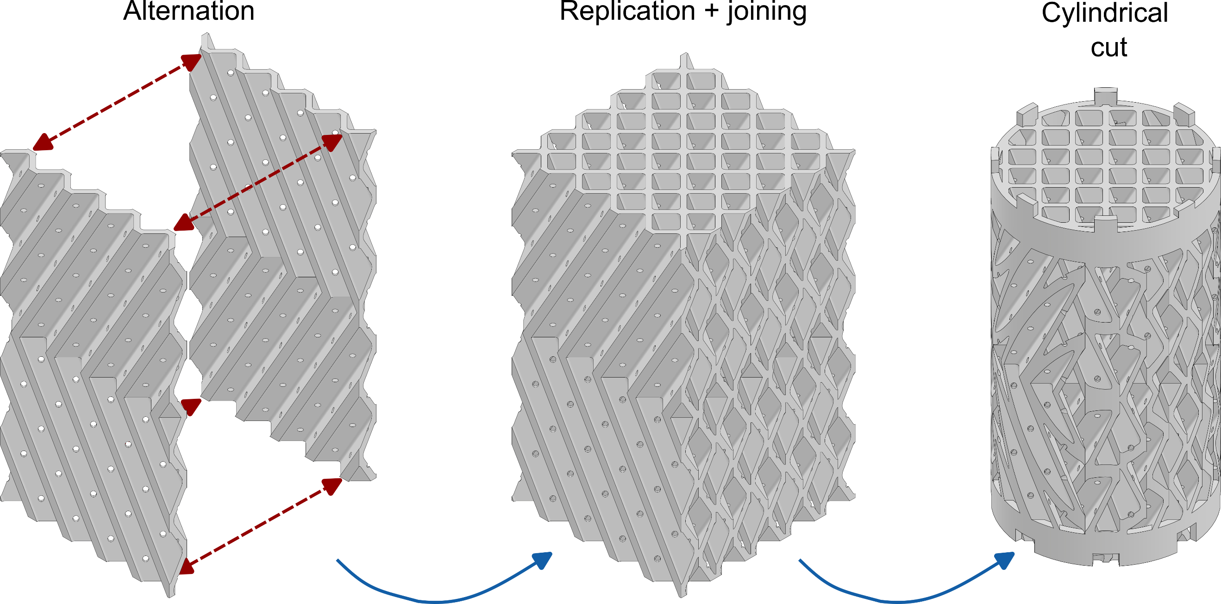
Figure 3: From a single perforated corrugated sheet to the CAZ-Pak packing element (DN30).
    - CAZ-Pak performance
The separation efficiency and irrigated pressure drop of the investigated packings at the different column diameters are plotted in Figure 4 and summarized with the geometric parameters in Table 1. Each dataset is measured twice except for the CAZ-Pak which was measured three times. Firstly, the discussion emphasizes the DN20 size data. On the one hand, the XW-Pak shows the worst performance with an average NTSM of 3.61 (± 2.22 % relative standard deviation, RSD). This can be explained by the XW-Pak’s significantly lower specific geometric surface. Its main advantages are an only slightly varying efficiency trend that comes with a significant reduction in pressure losses compared to the CAZ-Pak. On the other hand, the DN20 CAZ-Pak shows a significantly better mass transfer performance with an average NTSM of 7.55 (± 2.65 % RSD), an improvement by a factor of 2.09 over the XW-Pak. This is consistent with its higher specific geometric surface. Moreover, the CAZ-Pak also exhibits a practically flat efficiency trend with low data points scattering (Figure 4a), making it a “scalable” laboratory packing as defined and required in the industrial scale-up practice of Eiden et al. (1995).
The major disadvantage of the CAZ-Pak comes in its higher pressure drop (Figure 4b). This is not only consistent with the far lower void fraction of 66.8 %, but also with the corrugations forcing the vapor splitting into quasi-channel flows of small hydraulic diameter. This is contrary to the XW-Pak’s open structure which does not promote restricted channeling of the vapor flow. In order to challenge the CAZ-Pak design further, a fairer comparison against another corrugated-sheet packing is warranted. For such comparison, the Sulzer DXM corrugated-sheet metal packing is chosen.
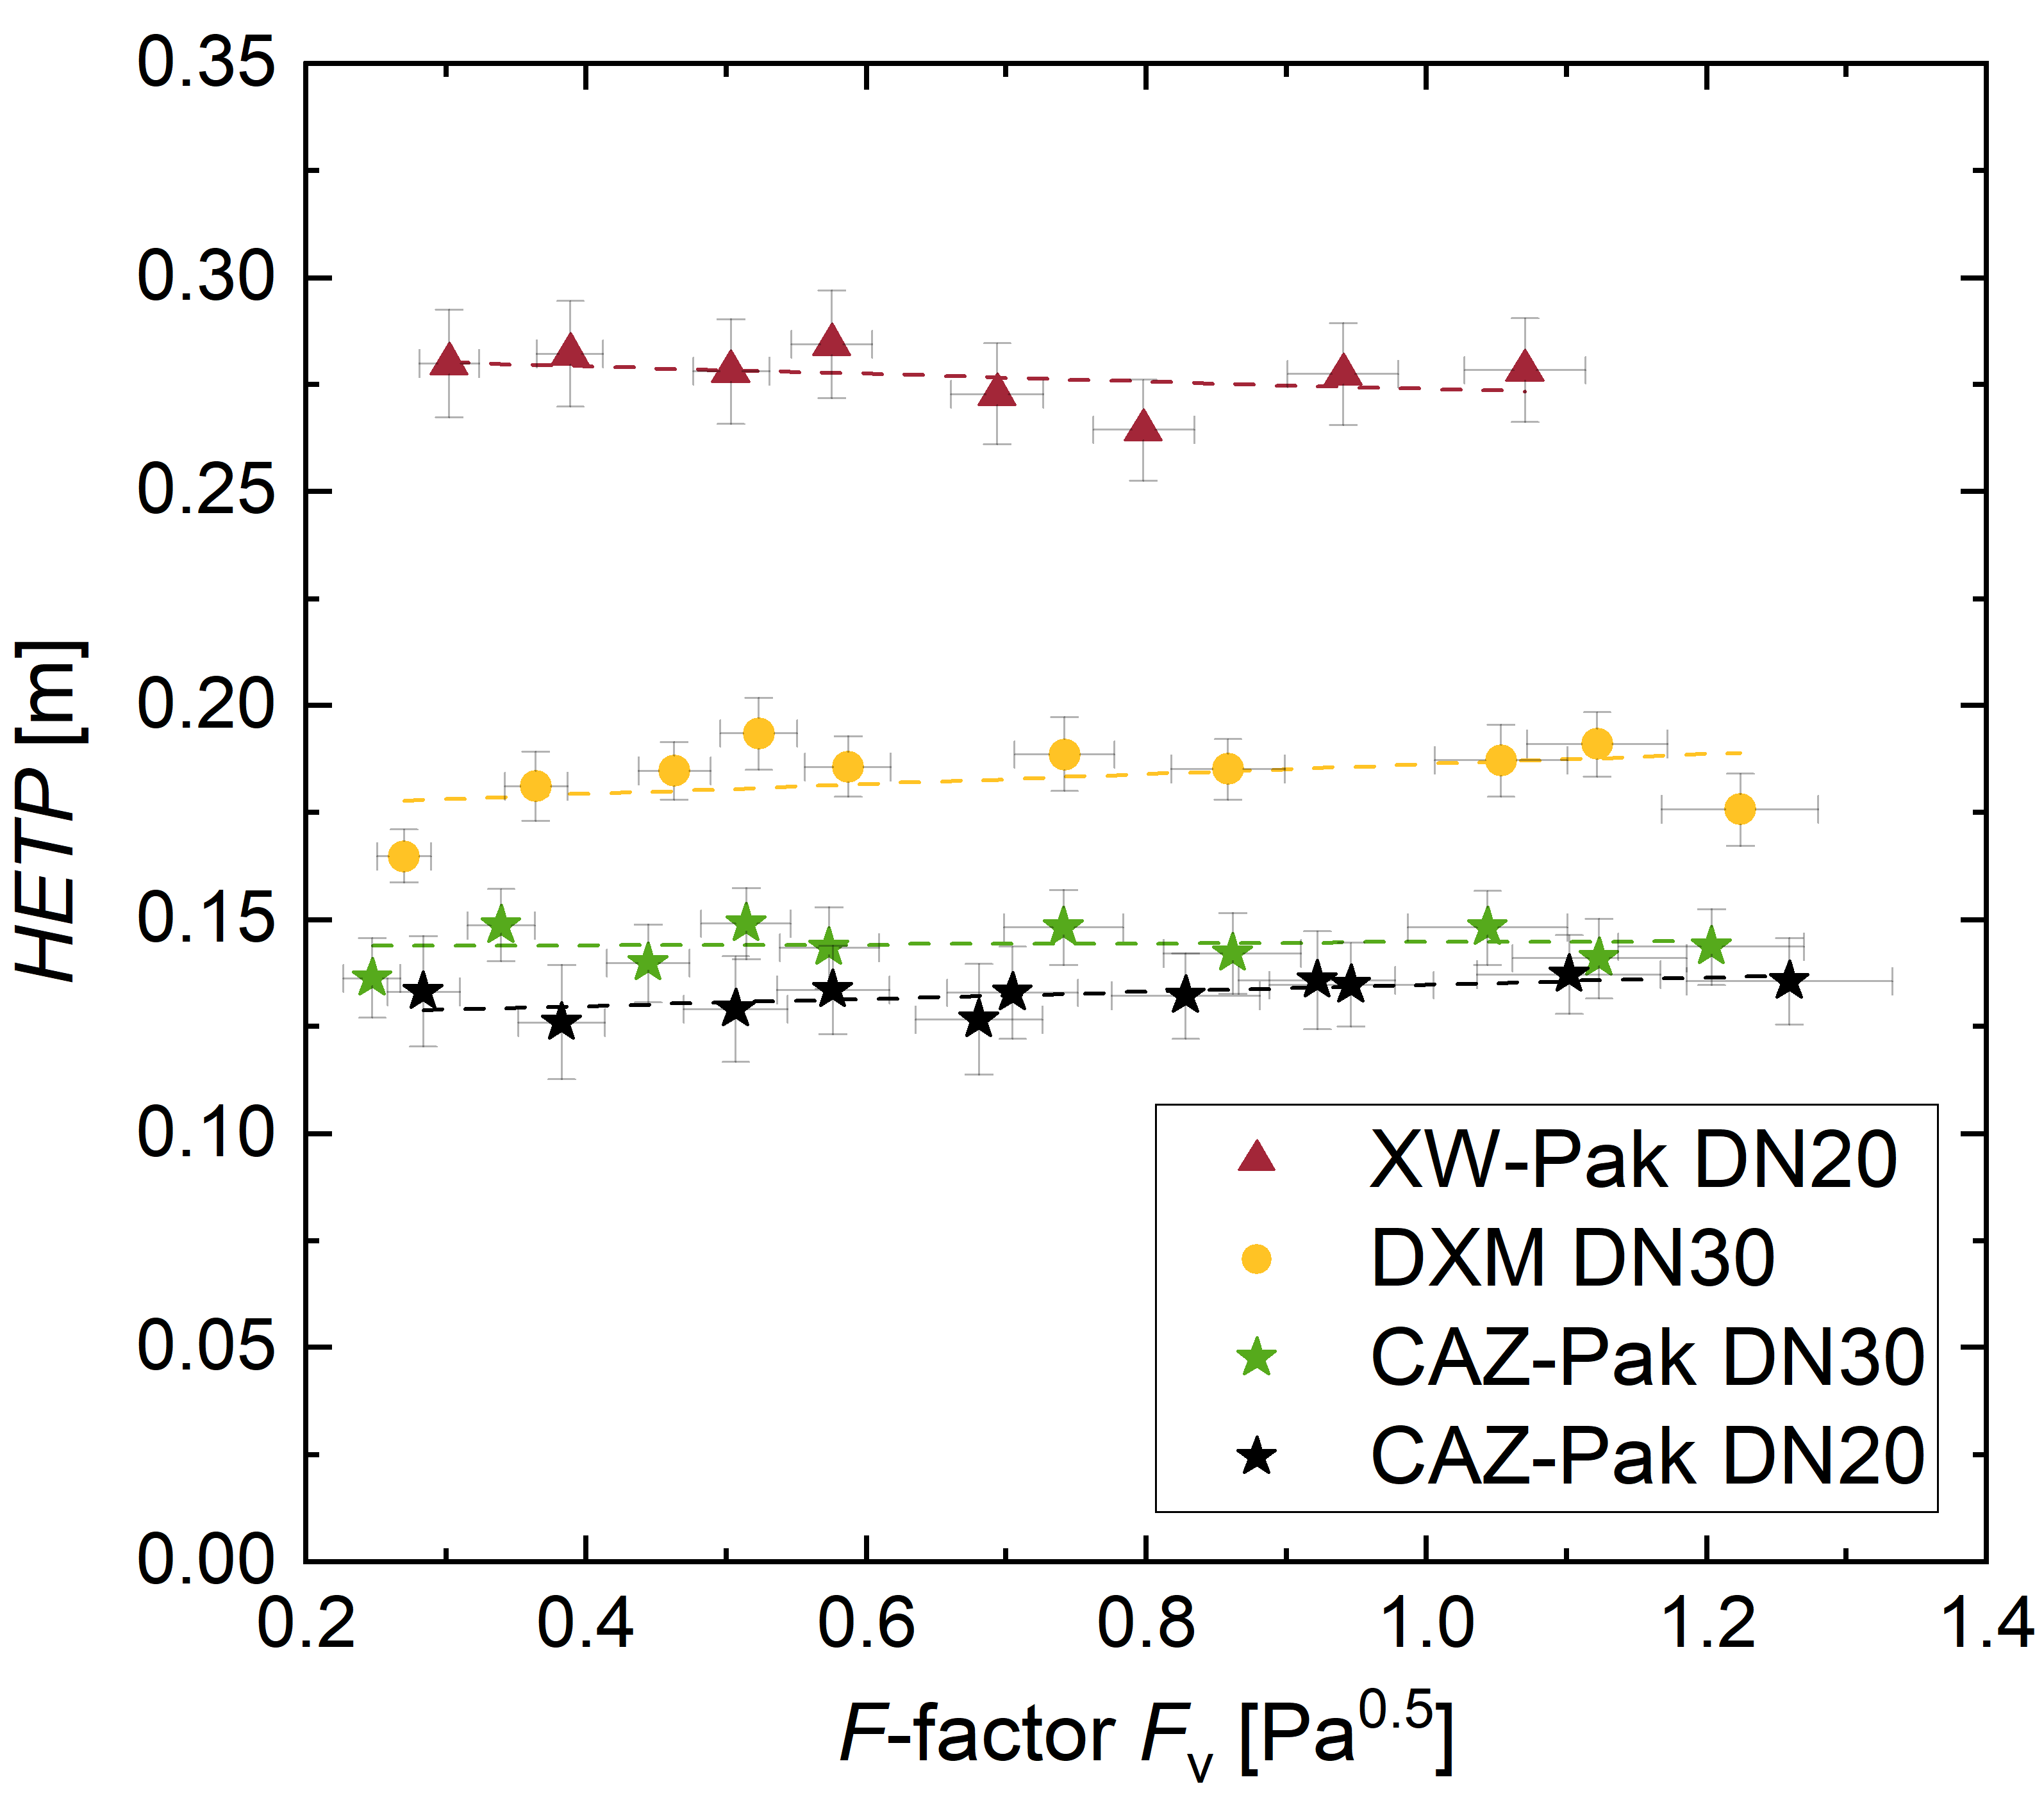 | 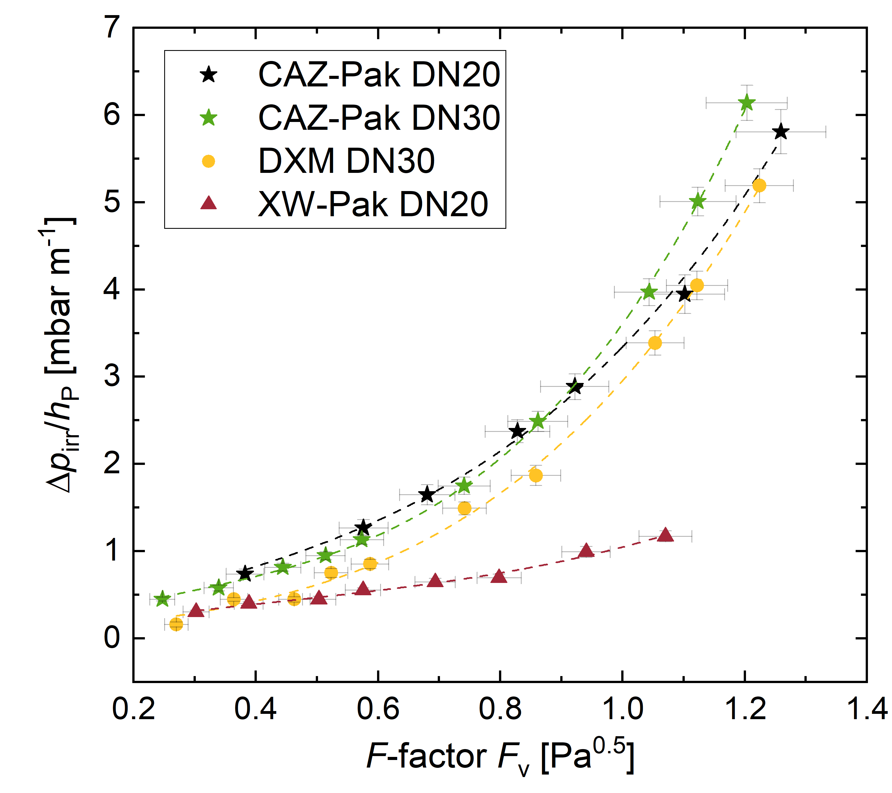
Figure 4: Performance of the AM CAZ-Pak compared to the AM XW-Pak and the conventional Sulzer DXM: (a) separation efficiency and (b) pressure drop.
Table 1: Summary of the geometric parameters and results of the measured packings.
Parameter | DN20 |  | DN30
Parameter | XW-Pak | CAZ-Pak | Sulzer DXM | CAZ-Pak
Void fraction ε_{V} [%] | 89.1 | 66.8 | ~93 | 66.5
Geometric area, packing a_{geo,P} [m²m⁻³] | 334 | 894 | ~963 | 908
Geometric area, with wall a_{geo,PW} [m²m⁻³] | 512 | 1028 | ~1093 | 995
Average NTSM [m⁻¹] | 3.61 | 7.55 | 5.45 | 6.95
NTSM relative standard deviation RSD [%] | 2.22 | 2.65 | 4.59 | 2.88
Sulzer recommends a minimum inside diameter of 30 mm for the DXM. The CAZ-Pak is therefore also manufactured in DN30 to exclude diameter effects. As observed in Figure 4a, the DN30 CAZ-Pak displays an average NTSM of 6.95 (± 2.88 % RSD) versus 5.45 (± 4.59 % RSD) for the DXM. This represents approx. 27.5 % higher NTSM despite an approx. 9 % lower specific geometric area including the column wall (995 versus ~1093 m²m⁻³) and a far lower void fraction (66.5 % versus ~93 %). The CAZ-Pak also maintains the flat and minimally scattering efficiency behavior (± 2.88 % RSD) of its DN20 counterpart, while the DXM data is more scattered (± 4.59 % RSD). These enhancements are likely attributed to the improved geometric homogeneity: more uniform interaction of both phases with the structure, better volume utilization by replacing the annular gap with packing surface, and improved radial mixing by the mid-element directional change.
Both packings show similar pressure drop trends (Figure 4b), with the CAZ-Pak slightly higher across the entire range, with the relative difference reaching approximately 15.4 % at the highest investigated F-factor. This only moderate increase, despite the far lower void fraction, is likely due to the exact square-pitched channel layout at the inter-elemental plane eliminating losses from partial channel closure, and the elimination of both the expansion-contraction contributions at the wall-wiper gap and the resistance of wetted wipers. On the laboratory scale, pressure drop is rarely detrimental unless deep vacuum operation is required. Therefore, the CAZ-Pak seems to be the best alternative among the laboratory packings tested in this study. Its moderate pressure drop also indicates potential for operation at reduced pressures, although dedicated vacuum experiments are required.
  - Conclusions
This work addressed the miniaturization of laboratory-scale corrugated-sheet packings for process development and scale-up of distillation columns. The drawbacks of conventional laboratory packings were analyzed and used as the basis for the additively manufactured CAZ-Pak, featuring homogeneous sheet termination, exact inter-elemental mating, eliminated wall wipers, orientation rings, and one-piece manufacturing. The experiments showed a favorable combination of mass transfer performance and scalability. In DN20, the CAZ-Pak outperformed the XW-Pak by doubling the average NTSM while maintaining a practically constant efficiency trend across the operation range. In the DN30 size, the CAZ-Pak surpassed the Sulzer DXM by 27.5 % in average NTSM at a moderately higher pressure drop. It also largely retained its performance upon diameter reduction from DN30 to DN20. Future work comprises exploring the geometric design space to reduce the pressure drop, manufacturing from stainless steel 316L for testing aggressive mixtures at multiple pressures, and examining the proposed hypotheses by CFD and liquid distribution studies.
Nomenclature
α_{12,avg} – average relative volatility, 1
a_{geo,P} – Geometric area packing, m² m⁻³
a_{geo,PW} – Geometric area packing with wall, m² m⁻³
b_{ch} – channel width, m
d_{c} – inner column diameter, m
d_{hole} – hole diameter, m
F_{V} – gas load or F-Factor, Pa^{0.5}
h_{ch} – channel height, m
h_{FU} – height of fundamental unit, m
hp – packing height, m
HETP – height equivalent to a theoretical plate, m
ṁ_{V,j} – vapor mass flow rate, kg s⁻¹
n_{th} – number of theoretical stages, 1
NTSM – number of theoretical stages per meter, m⁻¹
Δp_{irr} – irrigated pressure drop, Pa
r_{ch} – apex fillet radius, m
t_{sh} – sheet thickness, m
x_{C6,bot} – cyclohexane mole fraction at the bottom, 1
x_{C6,top} – cyclohexane mole fraction at the top, 1
α – corrugation angle, °
β – apex angle, °
ε_{V} – void fraction, %
$ρ_{V}$– vapor density, kg m⁻³

Acknowledgments
The authors thank Sulzer Chemtech for the DXM donation and Humay Hamidli for her assistance in the laboratory work.
References
Ashour M.A., Stucke D., Grützner T., 2026, Miniaturized Yet Scalable: A Novel 3D-Printed Corrugated-Sheet Packing for Laboratory Distillation, Chemical Engineering Journal, 548, 181552, doi.org/10.1016/j.cej.2026.181552
Eiden U., Kaiser R., Schuch G., Wolf D., 1995, Scale-up of distillation columns, Chemie Ingenieur Technik, 67, 269–279, doi.org/10.1002/cite.330670303 (in German).
Fenske M.R., 1932, Fractionation of Straight-Run Pennsylvania Gasoline, Industrial & Engineering Chemistry, 24, doi.org/10.1021/ie50269a003.
Kiss A.A., Smith R., 2020, Rethinking energy use in distillation processes for a more sustainable chemical industry, Energy, 203, 117788, doi.org/10.1016/j.energy.2020.117788.
Neukäufer J., Sarajlic N., Klein H., Rehfeldt S., Hallmann H., Knösche C., Grützner T., 2021, Flexible distillation test rig on a laboratory scale for characterization of additively manufactured packings, AIChE Journal, 67, e17381, doi.org/10.1002/aic.17381.
Neukäufer J., Ashour M.A., Sarajlic N., Klein H., Rehfeldt S., Hallmann H., Meinicke S., Paschold J., Knösche C., Grützner T., 2023, Development of enhanced three-dimensional printed packings for scale-up of distillation columns: a successful case study, AIChE Journal, 69, e17902, doi.org/10.1002/aic.17902.
Onken U., Arlt W., 1990, Recommended Test Mixtures for Distillation Columns, 2nd ed., Institution of Chemical Engineers, London, UK.
Riese J., Reitze A., Grünewald M., 2022, Experimental characterization of 3D printed structured metal packing with an enclosed column wall, Chemie Ingenieur Technik, 94, 993–1001, doi.org/10.1002/cite.202200002.
Schoenmakers H., Spiegel L., 2014, Laboratory distillation and scale-up, Chapter In: Górak A., Olujić Ž. (Eds.), Distillation: Equipment and Processes, Elsevier, Amsterdam, the Netherlands, 319–339, doi.org/10.1016/b978-0-12-386878-7.00010-3.

