 CHEMICAL ENGINEERING TRANSACTIONS  VOL. xxx, 2026 | A publication of  
The Italian Association
of Chemical Engineering
Online at www.cetjournal.it

Guest Editors: Flavio Manenti, Botir Usmonov, Alessandro Di Pretoro
Copyright © 2026, AIDIC Servizi S.r.l.
ISBN 979-12-81206-xx-x; ISSN 2283-9216

Application of Ni, Co, and Mn-based catalysts recovered from spent lithium-ion batteries for gasification of waste plastics: investigation of the effect of sulphate and nitrate precursors
Norbert Miskolcziª, Viktoria Zsinkaª, Ningbo Gao^{b}, Cui Quan^{b}
ª University of Pannonia, Faculty of Engineering, Institute of Chemical Engineering and Process Engineering, H-8200, Veszprém, Egyetem u. 10, Hungary
^{b} Xi'an Jiaotong University, School of Energy and Power Engineering, Xi’an, Xianning West Road No. 28, 710049, P.R. China

The aim of this research is to develop a circular economy approach that utilizes metals recovered from spent Li-ion battery via hydrometallurgy as catalyst precursors for waste plastics gasification, thereby facilitating the hydrogen and synthesis gas production. Dissolution of transition metal sulphates and nitrates obtained by carbonate precipitation followed by nitric acid treatment was used for catalyst preparation. The activity of the prepared catalysts was evaluated during the high-temperature catalytic gasification of waste plastics. The composition of gas products was investigated by GC-FID and GC-TCD methods. The results demonstrated that the type of metal precursor significantly influenced the reforming activity of the catalysts. Increasing metal content enhanced the efficiency of the reforming reactions, resulting in higher yields of hydrogen and synthesis gas for catalysts prepared from nitrate precursors. In contrast, the increasing concentration of metals for catalysts made from sulphate precursors, led to a decline in catalytic performance. This adverse effect is attributed to sulphur-containing compounds remaining on the catalyst surface, because they can poison the reforming reactions by blocking the active sites, thereby reducing the rate of hydrogen formation.
1. Introduction
The global consumption of lithium-ion batteries is rising significantly due to the expansion of electromobility and stationary energy storage. Consequently, a significant increase in the amount of batteries reaching the end of their service life is predicted in the near future. The recycling of spent Li-ion batteries is important not only for environmental reasons, but also because they utilize numerous components that are either in limited supply or of strategic importance (Liu et al. 2020, Yang et al. 2020). There are different types of Li-ion batteries, from which the NMC (Nickel Manganese Cobalt) type are widely used in different electric devices. Their cathode materials contain Li, Ni, Mn, and Co, with a general composition of LiNi_{x}Mn_{y}Co_{z}O₂ (Zhuang et al. 2019). Li-ion batteries can be recycled using mechanical, pyrometallurgical, hydrometallurgical, solvent-based (including ionic liquid-assisted), biohydrometallurgical, electrochemical, and direct recycling or regeneration processes (Sommerville et al., 2024). Hydrometallurgical recycling of Li-ion batteries typically involves the leaching of valuable metals such as Li, Co, Ni, and Mn using inorganic acids (e.g., H₂SO₄, HCl, and HNO₃) or organic acids, followed by selective separation and recovery through precipitation, solvent extraction, or ion-exchange processes. Ionic liquids are increasingly investigated as alternative or complementary leaching and extraction media due to their tunable properties, high selectivity toward metal ions, low volatility, and potential for regeneration and reuse (Latini et al., 2022, Kovacevic et al., 2024). Sulphuric acid is the most commonly used acid for this purpose, usually in combination with a reducing agent such as H₂O₂ (Liu et al. 2020, Zhan et al. 2018, Zhuamg et al. 2019). The primary objective of hydrometallurgy methods is to separate the metals contained in the cathode material in the form of water-soluble salts, resulting in a multi-component solution containing Li, Ni, Co, and Mn sulphates. The main advantages of leaching with sulphuric acid are the relatively low reagent costs, widespread industrial availability, and the fact that, under appropriate conditions, Li, Ni, Co, and Mn can all be brought into solution with high efficiency. The use of H₂O₂ as a reducing agent primarily facilitates the reduction of Co and Mn compounds in higher oxidation states, thereby increasing their solubility (Jung et al. 2021, Liu et al. 2020, Shin et al. 2005, Zhuang et al. 2019). The use of nitric acid is the another possibility for hydrometallurgy process. The key advantages of leaching the metals with sulphuric acid are its superior cost-effectiveness and industrial applicability. Sulphuric acid is a relatively inexpensive industrial chemical, available in large quantities, and the resulting metal sulphate solutions can be readily integrated into a technological value chain aimed at the remanufacture of Li-ion batteries. In contrast, nitric acid is a strong oxidizing acid; its use imposes stricter requirements regarding corrosion resistance and occupational safety, and the formation of nitrogen oxides must also be predicted under certain conditions. Furthermore, the dissolution process and treatment of wastewaters containing nitrates requires special attention (Jin et al. 2024, Lee at al. 2025, Meshram et al. 2015). One of the most disadvantages of the hydrometallurgy process, that the metals can be recovered in a multi-component dissolution, which further application is difficult. The separation of multi component dissolution into individual metals is difficult and the process feasibility is limited. Majority of the research activities are focussing to the re-application of hydrometallurgy sourced dissolution for production of batteries again. However, there are some other possibilities, where the multi elemental dissolution has alternative for its value added utilization (Latini et al., 2022, Sommerville et al., 2024). Waste polymers can converted into valuable products by their high temperature process (e.g. pyrolysis, gasification). The yield of valuable products can enhance by the application of different catalysts containing transition metals. For hydrogen and syngas production nickel, cobalt or manganese have advantageous properties (e.g. high selectivity, high product yield, resistance against contaminants) (Ayuso-Díaz et al., 2025).
The aim of this research is to recover metals from spent Li-ion batteries using metal salt dissolutions and to utilize them in a value-added manner for the production of catalysts. These catalysts are intended for use in the pyrolysis-gasification of plastic waste to obtained hydrogen-rich products. It is known, that metal nitrate dissolutions offer lots of advantages compared to metal sulphate dissolutions for multifunctional catalysts preparation via wet impregnation, because they convert more readily into metal oxides during the calcination. Therefore this work also investigates the use of both metal sulphate and metal nitrate dissolutions in the synthesis of multifunctional ZSM-5 catalysts. To eliminate the disadvantages of leaching process by nitric acid, the metal nitrates were obtained from the dissolution of Li₂SO₄, NiSO₄, CoSO₄, and MnSO₄ via carbonate precipitation followed by nitric acid treatment. This approach can combine the economic and technological advantages of sulphuric acid-based hydrometallurgy metal recovery with the more favourable properties of nitrates as catalyst precursors.
  - Materials & methods
    - Raw material
Polyethylene waste obtained from packaging sector was used as raw material for pyrolysis-gasification experiments. The polyolefin waste contained 1.5% ash, 97.9% volatiles and 0.6% humidity. Its carbon content was 84.9%, while the hydrogen content was 15.1%.
    - Catalyst preparation
Dissolutions containing Li₂SO₄, NiSO₄, CoSO₄, and MnSO₄ at various concentrations (0.1, 0.5, and 1.0 M) were used for catalyst preparation. A portion of these solutions was used to impregnate ZSM-5 catalyst. The preparation method for the catalysts using the sulphate-salt solutions is shown in Figure 1/a.

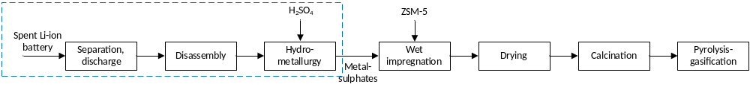
a)
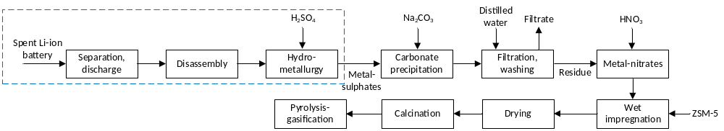
b)
Figure 1: Preparation of sulphate-based ZSM-5 (a) and nitrate-based ZSM-5 (b) catalysts
During the impregnation, 1:50 ratio of ZSM-5 zeolite catalyst and metal-sulphate dissolution was used. The impregnated catalysts were filtered and washed until neutral, dried at 110°C for 6 hours, then calcined at 600°C for 1 hour. Dissolutions containing metal-sulphate salts were also converted into metal nitrates via carbonate precipitation followed by nitric acid treatment. In this process, the sulphate-containing solution was first reacted with an Na₂CO₃, and the precipitated metal carbonates were separated by filtration and subsequently purified by washing. Then the precipitate was reacted with nitric acid. ZSM-5 catalyst was impregnated with the resulting metal-nitrate dissolutions using the method previously described. The main characteristics of the catalysts are summarized in Table 1.
Table 1: The main properties of catalysts
 | Sulphate-based catalysts |  |  |  | Nitrate-based catalysts
Concentration, M | 0.1 | 0.5 | 1.0 |  | 0.1 | 0.5 | 1.0
BET surface, m²/g | 380 | 362 | 335 |  | 351 | 324 | 316
BJH surface, m²/g | 86 | 73 | 62 |  | 75 | 61 | 52
Si/Al | 23 | 22 | 22 |  | 22 | 22 | 22
Elements, %
S | 0.8 | 1.5 | 2.9 |  | - | - | -
Li | 0.3 | 0.4 | 0.8 |  | <0.1 | 0.1 | 0.2
Ni | 0.5 | 1.4 | 1.9 |  | 0.4 | 1.1 | 1.7
Mn | 0.6 | 0.9 | 1.6 |  | 0.6 | 0.7 | 1.5
Co | 0.6 | 1.1 | 1.9 |  | 0.5 | 0.8 | 1.7

The data in the table clearly show that S, Li, Ni, Mn, and Co were detectable in the sulphate-containing solutions, whereas the Li content was significantly lower in the solutions containing metal-nitrates. For this reason, the better solubility of Li₂CO₃ can be blamed compared by that of the other metal carbonates. Consequently, following filtration after carbonate formation, the precipitate becomes enriched in Ni, Mn, and Co, while its Li content is lower, as the majority of the Li remains in the filtrate due to the higher solubility of Li₂CO₃. The sulphate-based catalysts also contained 1.5-3.9% sulphur, which was most likely attributed to the presence of surface sulphate compounds. During impregnation, Ni, Mn, and Co ions interact with the ion-exchange and adsorption sites of the zeolite, while the subsequent washing removes most of the unbound metal and sulphate compounds. However, a fraction of the sulphate species can remain strongly adsorbed or chemically bound to the metal-containing surface sites and may persist after calcination at 600 °C as thermally stable surface sulphate compounds. The BET surface area of the catalysts was in the range of 316-380m²/g, while that of BJH surface area 52-86m²/g. In both cases, the surfaces areas decreased as function of metal-salt concentration. Regarding the Si/Al ratio, no significant differences was observed, which refers that the main structure of zeolite does not changed during the treatment. The XRD results of the catalysts are presented in Figure 2. The results indicate that, after calcination, sulphur-containing species, primarily transition-metal compounds associated with sulphate groups, were present on the sulphate-based catalysts. In contrast, the transition metals in the nitrate-based catalysts were predominantly present in their oxide forms.

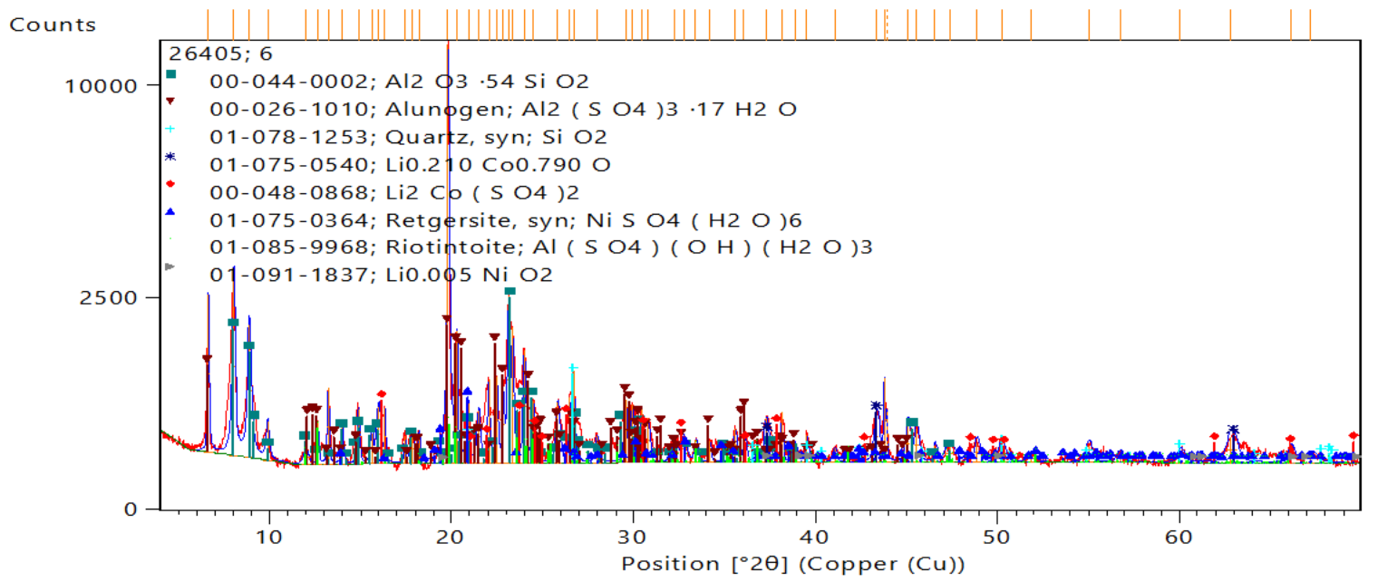 | 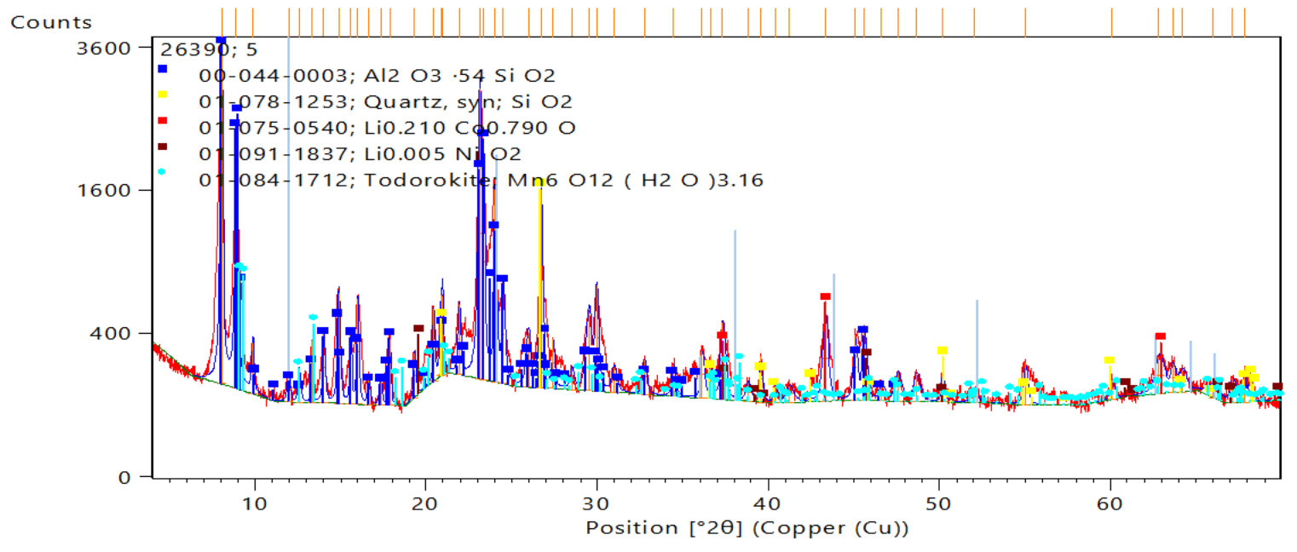
a) | b)
Figure 2: XRD result of sulphate-based ZSM-5 (a) and nitrate-based ZSM-5 (b) catalysts
    - Pyrolysis-gasification process and product analysis
Polyethylene waste have been decomposed by pyrolysis-gasification in a tubular reactor at 500°C during the pyrolysis and 800°C during the gasification. In order to increase the hydrogen content of the gas product, steam was also added to the catalyst bed at 800°C at a flow rate of 5dm³/h. The raw material catalyst ratio was 2:1. The gas products formed in the reaction were collected in a Tedlar bag for further analysis. The gas composition was investigated by DANI GC gas-chromatograph. The instrument was fitted with FID and TCD detectors, the used columns were an Rtx-1 PONA type (100 m long with an internal diameter of 0.25 mm and film thickness of 0.5 μm) and a CarboxenTM 1006 PLOT column (30 m long and 0.53 mm internal diameter). Clarity software was used to evaluate the chromatograms. The repeatability (RSD%) of the pyrolysis-gasification process, based on three parallel measurements, was 1.9-2.5% for the product yields, while the individual repeatability of the components determined by gas chromatographic analysis was 2.3-2.9%.
  - Result and discussion
    - Product yields
The product yield of pyrolysis-gasification is summarized in Figure 3. It is clearly seen that the amount of water+liquid hydrocarbon was higher, while that of gaseous products was less in case of the ZSM-5 catalyst impregnated with a metal sulphate-containing solution. This phenomenon is explained by the sulphur-containing components remain after the calcination from the sulphate ions, which could block the active centres of the catalyst. Furthermore, the larger size of the sulphate ions could significantly deteriorate the advantageous shape selectivity of the ZSM-5 catalyst during pyrolysis-gasification. This is also supported by the observation that the amount of water+liquid hydrocarbon increased with increasing the concentration of the sulphate-containing solution. The higher liquid product yields observed with metal sulphate-containing solutions, as well as their increase with increasing solution concentration, can also be attributed to the reduced conversion of water introduced into the reactor, resulting from the inhibitory effect of sulphur-containing species on gasification reactions. Sulphur-containing components are strong catalyst poisons. In particular, they degrade the favourable properties observed in the reduction of C₅₊ hydrocarbons of Ni and Co transition metals. In case of Mn and Li, their properties to reducing the coke formation were also reduced. As a result, the amount of coke on the catalyst surface also increased. On the other hand, coke deposition on catalyst surface was also observed after the pyrolysis-gasification, which was explained by the aromatisation → polymerisation → coke formation reactions.

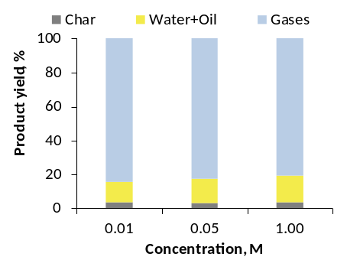 | 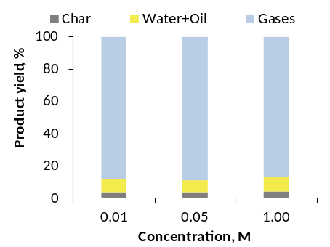
a) | b)
Figure 3: The yields of products (sulphate-based ZSM-5 (a) and nitrate-based ZSM-5 (b) catalysts)
    - Gases
The composition of gaseous product are shown in Figure 4. The results well demonstrate that the effect of catalysts prepared with sulphate-containing solutions and nitrate-containing solutions on the composition of gaseous products was significantly different. In case of sulphate-containing solutions, the hydrogen and CO content of the gaseous products decreased significantly, while the CO₂, methane and C₂-C₅ contents increased with the concentration of the solutions. However, in case of catalysts prepared with nitrate-containing solutions, the hydrogen content of the gaseous products increased significantly, while the CO₂, methane and C₂-C₅ hydrocarbons concentrations decreased with the salt concentration. The CO content of the gaseous products did not change significantly. The observed differences were caused primarily by the distinct thermal behaviour of the metal precursors, the varying catalytic activities of the Li-, Ni-, Mn-, and Co-containing components, and the catalytic inhibitory effect of residual groups derived from sulphate ions. In case of nitrate-based solutions, the metals were present in oxide form on the catalyst surface following calcination. In contrast, catalysts impregnated with sulphate-containing solutions retained residual sulphate species on their surface, while the decomposition of sulphates resulted in the formation of additional sulphur-containing species. The abundance of these surface sulphur species increased with increasing concentration of the impregnating solution. These sulphur-containing components could modify the metal-support interaction, impair the reducibility of the metal compounds, and block the active sites of the ZSM-5 catalyst. Furthermore, they could influence the Brønsted and Lewis acidity of the catalyst. This resulted in a significant loss of catalytic activity, particularly for Ni, as Ni is highly sensitive to sulphur-containing impurities; even small amounts of sulphur significantly impair the catalytic activity of Ni.

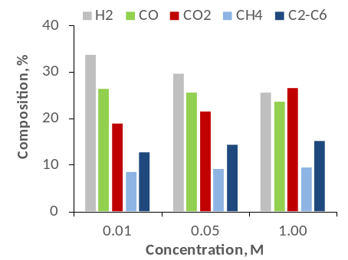 | 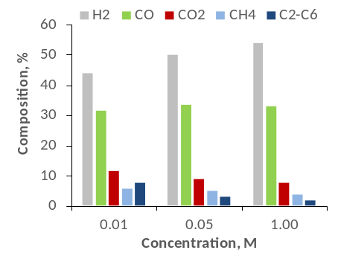
a) | b)
Figure 4: The composition of gaseous products (sulphate-based ZSM-5 (a) and nitrate-based ZSM-5 (b) catalysts)

During pyrolysis-gasification, metal oxides formed upon calcination of nitrate-impregnated catalysts were reduced in situ by the generated hydrogen, forming catalytically active metallic species. Increasing the impregnation concentration therefore increased the metal loading and promoted cracking and gasification reactions, resulting in enhanced H₂ production and reduced CH₄ and C₂-C₅ hydrocarbon yields. The nearly constant CO concentration likely reflects the competing effects of steam/dry reforming, which generate CO, and the water-gas shift reaction, which consumes it. The decrease in CO₂ levels was primarily a result of hydrocarbon dry reforming reactions. The significant increase in hydrogen production, coupled with the reduction in CO₂ and hydrocarbon concentrations, indicates that the catalyst activity in secondary reforming was substantially enhanced as the nitrate content increased. In case of catalysts prepared using sulphate-containing solutions, increasing the concentration of the impregnating solution allowed a nominally larger amount of metal to bind to the catalyst surface; however, this also resulted in a higher quantity of sulphur-containing agents. Due to the increased loading caused by sulphate and other sulphur-containing groups, the probability of steam reforming and other hydrogen-producing reactions occurring was significantly reduced. Consequently, less hydrocarbon was converted into hydrogen and CO. The increase in CO₂ concentration was primarily the result of the suppression of dry reforming reactions.
Figure 5 summarizes the synthesis gas yields of the gaseous products. Based on the data, the synthesis gas yield (on the base of the feedstock) showed a decreasing trend for catalysts prepared with sulphate-containing impregnating solutions, whereas it showed an increasing trend for those prepared with nitrate-containing solutions.

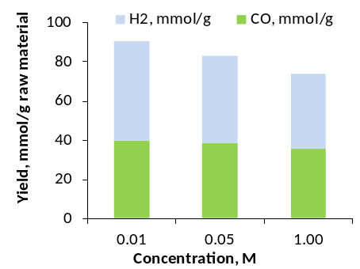 | 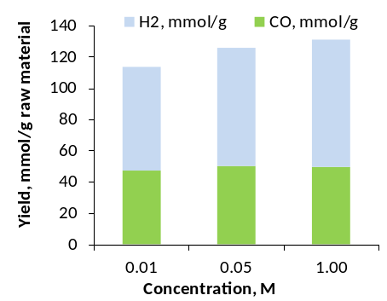
a) | b)
Figure 5: The yield of synthesis gas (sulphate-based ZSM-5 (a) and nitrate-based ZSM-5 (b) catalysts)

Both the increase and the decrease were primarily driven by significant changes in hydrogen yield. This resulted from the fact that, with the nitrate solution, increasing the metal concentration enhanced the active reforming properties of the Ni/Mn/Co/ZSM-5 catalyst, whereas with the sulphate-containing solution, the increasing concentration of sulphur-containing precursors reduced this activity. This may have been partly due to the blocking of the catalyst active sites by polyaromatics and coke particles formed during the reaction. It is also worth to mention, that the lithium present in the sulphate solution failed to significantly suppress coke formation.
  - Conclusions
Metals (Li, Ni, Mn, Co) recovered from waste NMC cathodes can enhance H₂ production during plastic pyrolysis-gasification, although catalytic performance strongly depends on the precursor anion. Increasing precursor concentration resulted in a decrease in H₂ and CO yields using catalysts impregnated with sulphate precursors. In contrast, for catalysts prepared from nitrate precursors -obtained via carbonate precipitation followed by redissolution in nitric acid - the increasing metal concentration primarily promoted the H₂ formation and the amount of CO changed only slightly. The concentrations of CO₂, CH₄, and C₂-C₅ components decreased. The results demonstrate that Li, Ni, Mn, and Co recovered from waste NMC cathode materials can be effectively utilized as catalytic components to enhance H₂ production during the pyrolysis–gasification of waste plastics, with catalytic performance being strongly influenced by the precursor anion. Sulphur-containing components can inhibit the steam reforming of hydrocarbons and the H₂ formation associated with the water-gas shift reaction. In contrast, calcination of nitrate precursors can lead to the formation of metal oxide phases that are more favourable and active in reforming reactions. Carbonate precipitation and redissolution can result in a partial loss of Li; therefore, differences in Li content may also contribute to the distinction between nitrate- and sulphate-based catalysts.
Acknowledgments
The project No. 2024-1.2.5-TÉT-2024-00025 was financed by the Ministry of Cultural and Innovation from the National Research Development and Innovation Fund, within the 2024-1.2.5-TET program.
References
Ayuso-Díaz I., Perez-Gil S., Lopez G., Santamaria L., Antoñanzas-González F.J., 2025, Progress on waste plastics gasification process: A review of operating conditions, reactors and catalysts for clean syngas production and tar abatement, International Journal of Hydrogen Energy 148, 150000.
Jin X., Zhang X., Zhang P., Rohani S., Li H., He M., Teng L., Liu Q., Liu W., 2024, Efficient extraction of valuable metals from spent LiNi_{0.5}Co_{0.2}Mn_{0.3}O₂ cathode based on an acid-free leaching process, Hydrometallurgy 224, 106243.
Jung J.C.-Y., Sui P.-C., Zhang J., 2021, A review of recycling spent lithium-ion battery cathode materials using hydrometallurgical treatments, Journal of Energy Storage 35, 102217.
Kovačević A., Tolazzi M., Sanadar M., Melchior A., 2024, Hydrometallurgical recovery of metals from spent lithium-ion batteries with ionic liquids and deep eutectic solvents, Journal of Environmental Chemical Engineering 12, 113248.
Latini D., Lagnoni M., Brunazzi E., Mauri R., Nicolella C., Della Posta P., Tognotti L., Bertei A., 2022, Recycling of Lithium-ion Batteries: Overview of Existing Processes, Analysis and Performance, Chemical Engineering Transactions 96, 25-30.
Lee C., Arby D.S., Kim C., Lim J., Kwon K., Chung E., 2025, Hydrometallurgical process of spent lithium-ion battery recycling Part 1. Chemical leaching of valuable metals from cathode active materials: Review and case study, Hydrometallurgy 235, 106494.
Liu T., Chen J., Li H., Li K., 2020, An integrated process for the separation and recovery of valuable metals from the spent LiNi_{0.5}Co_{0.2}Mn_{0.3}O₂ cathode materials, Separation and Purification Technology 245, 116869.
Meshram P., Pandey B.D., Mankhand T.R., 2015, Hydrometallurgical processing of spent lithium ion batteries (LIBs) in the presence of a reducing agent with emphasis on kinetics of leaching, Chemical Engineering Journal 281, 418-427.
Shin S.M., Kim N.H., Sohn J.S., Yang D.H., Kim Y.H., 2005, Development of a metal recovery process from Li-ion battery wastes, Hydrometallurgy 79, 172-181.
Sommerville R., Zhu P., Rajaeifar M.A., Heidrich O., Goodship V., Kendrick E., 2024, A comprehensive review of emerging technologies for recycling spent lithium-ion batteries, Science of the Total Environment 910, 168543.
Zhuang L., Sun C., Zhou T., Li H., Dai A., 2019, Recovery of valuable metals from LiNi_{0.5}Co_{0.2}Mn_{0.3}O₂ cathode materials of spent Li-ion batteries using mild mixed acid as leachant, Waste Management 85, 175-185.
Yang Y., Lei S., Song S., Sun W., Wang L., 2020, Stepwise recycling of valuable metals from Ni-rich cathode material of spent lithium-ion batteries, Waste Management 102, 131-138.
Zhan C., Wu T., Lu J., Amine K., 2018, Dissolution, migration, and deposition of transition metal ions in Li-ion batteries exemplified by Mn-based cathodes - A critical review. Energy Environmental Science 11, 243-257.

