 CHEMICAL ENGINEERING TRANSACTIONS  VOL. xxx, 2026 | A publication of  
The Italian Association
of Chemical Engineering
Online at www.cetjournal.it

Guest Editors: Flavio Manenti, Botir Usmonov, Alessandro Di Pretoro
Copyright © 2026, AIDIC Servizi S.r.l.
ISBN 979-12-81206-xx-x; ISSN 2283-9216

Comparative study of neural network-based and first-principle model-based predictive control of continuous crystallizer
László Balogh*,Ferenc Ficzere, Lajos Nagy, Attila Egedy, Ágnes Bárkányi
Faculty of Engineering, Research Centre of Biochemical, Environmental and Chemical Engineering, Department of Process Engineering, Egyetem utca 10., Veszprém, 8200, HU, Hungary
*correspondig: balogh.laszlo@mk.uni-pannon.hu
Growing demand in the pharmaceutical industry is driving a shift towards continuous technologies. The precise control of the equipment is the basis of profitability. In this study, we compare two nonlinear control solutions for controlling the expected crystal size and the crystallizer yield. The manipulated variables are the inlet volume flow rate (which indirectly controls the residence time) and the cooling medium volume flow rate. In the first case, the model predictive controller (MPC) is based on the crystallizer's first-principle (FP) momentum model, while in the second case, it is based on the crystallizer's neural network (NN) model. The main advantages of the model-based solution for multiple-input multiple-output (MIMO) control are that the detaching effect is directly derived from the model and that it enables better utilisation of the manipulated variables. The process and its models are nonlinear; the controlled object could change the sign of the gain, so model-based control could be a good solution in this field. However, the application of the MPC has a few disadvantages, for example, high computational demand and limited realizability on DCS systems. During this investigation, we aim to address the computational demand problem using surrogate models. Through this comparative analysis of the simulation-based FP-MPC and NN-MPC, we seek to provide practical insights for optimizing controller selection and implementation in industrial crystallization processes.
  - Introduction
The basis of model predictive control is a proper model of the equipment, but the modeling approaches can vary. The traditional MPC uses a linear model, but the crystallizer's behavior is nonlinear. The process dynamics depend on the operating point, resulting in varying process gain and time constants across different conditions. Accordingly, the literature mainly discusses nonlinear model-based approaches. Another key is the model's solver method, as solution time is crucial for real-time optimization.
Szilágyi et al. (2019) discussed an experimental implementation of MPC based on the FP-PBM (Population Balance Model) model. They used the MPC in a batch crystallizer, and the model solver was a high-resolution finite-volume method. The proposed solution reduces the batch time for crystallization and overcomes process nonlinearity. Yang and Nagy (2015) recommended a hierarchical control structure in which the MPC provides only a set point, with interventions handled by local control loops. Damour et al. (2010) developed an NN-based control system for an industrial continuous crystallizer. They concluded the supposed NN-based NMPC algorithm showed significant improvement over linear PID. Lima et al. (2022) worked on NN-based concentration control in crystallization. They used a comparative approach to identify the best NN architecture for the task, finding that echo state networks yielded the best results. Johnson et al. (2026) reviewed current and future applications of MPC in crystallization. The examination extends to the solver methods of the PBE and different equipment models (MSPMR, tubular crystallizer), as well as to the surrogate models. They found that the surrogate model-based MPC’s performance was comparable to the FP-based MPC. Zheng et al. (2022) focused on different machine learning models. They compared the recurrent neural network (RNN), the autoencoder−RNN (AERNN), and the FP model. They found that the computation time of the NN-based algorithms is much shorter than that of the mechanistic approach.
In this study, we want to compare the performance of NN-based simulation with FP based simulation, in a hierarchical control structure. For proper comparison, we demonstrate a the NN-FP model mismatch, the performance of the two algorithms over the time horizon, and the characterized difference in the error between the setpoint (SP) and the system output. In Section 2, we introduce the first principle, the neural network model, the controller algorithm scheme and the result characterization method. Section 3 presents the results of the two approaches.
  - Mathematical modeling
Proper models are important for model-based control. The crystallizer is typically modeled using PBEs (Population Balance Equation) to describe the crystal-size distribution. In the case examined, we examined the system model-based. The examined system is a continuous mixed-suspension, mixed-product-removal crystallizer equipped with a cooling jacket. For the hierarchical modeling, the following assumptions were implemented during the modeling process:
- The crystallizer and the jacket site are perfectly mixed, and the product removal is representative.
- The level control is ideal, so the liquid level is constant.
- The inlet is perfectly clear.
- The measured properties are directly measured on the equipment.
    - First-principle modelling
The used PBM accordingly the assumptions are the following (eq. (1)):
$$\frac{∂Ψ\left(t,r\right)}{∂t}+\frac{v_{r} ∂Ψ(t,r)}{∂r}=\frac{- qΨ(t,r)}{V}+Bϵδ\left(r-r_{0}\right) where v_{r}=k_{g}r^{α} B=k_{p}Δc^{p}+k_{s}Δc^{s}V_{S}^{ω}$$ | (1)
The equation is a hyperbolic, inhomogeneous partial differential equation. For the solution, the initial and the two boundary conditions are the following (eq. (2)):
$$\begin{matrix}Ψ\left(0,r\right)=Ψ_{0}\left(r\right) & \lim_{r→0}{Ψv_{r}=0} & \lim_{r→∞}{Ψ=0}\end{matrix}$$ | (2)
The eq. (1) can be solved with the standard method of moments (SMOM), so we used the moments transformed model of eq. (1), in case of $m>3$ ($m$ is the order of the moments) the moments give a closed ordinary differential equation (ODE) system with the following form (eq. (3)).
$$\begin{matrix}\frac{dμ_{0}(t)}{dt}=Bϵ(t) & if m =0 \\ \frac{dμ_{m}(t)}{dt}=mv_{r}μ_{m-1}(t)-\frac{q}{V} μ_{m}(t) & if m>0\end{matrix}$$ | (3)
The unit model consists of 6 equations, that describe the volume of liquid ($V_{F}$) and solid phase ($V_{S}$), the concentration of solute ($C_{F}$) and the solvent ($C_{O}$), and the temperature of the inside ($T_{R}$) and the jacket site ($T_{J}$). So, the used ODE system has the following form (eq. (4)):
$\dot{x}\left(t\right)=f\left(t,x\left(t\right)\right), where x={\left(V_{F},V_{S}, C_{F},C_{O},T_{R},T_{j},μ_{0},…,μ_{3}\right)}^{T} x\left(t\right)∈ R^{10}$ | (4)
The used model equation ($f$) is in the same form and parameter set as that used by Balogh et al. (2023).
    - Neural network modelling
The first step of NN modeling was data generation. In this case, the system has two inputs and two outputs, so the fitted model needs to describe the effect of both inputs. The training dataset is the result of 2000 step tests. For proper model fitting, 30% of the step tests changed only $u_{1}$, 30% only $u_{2}$, 30% both, and in 10% both input variables remained constant. In addition, 20% of the step tests are duplicated in the dataset (so the whole training dataset contains 2400 step tests). The dataset was normalized before the training.
For the training, only the stationary data points were used, so the NN estimates only the steady state. The neural network must estimate the steady-state output given the inputs and outputs at a given moment (as long as the input remains constant). The input and output vector of the NN is the following (the $c$ lower index means the current value, the $n$ means the new value, while the $s$ means the stationary output).
$$\begin{matrix}x_{NN}={\left[u_{1,c},{ u}_{2c},{ u}_{1n},{ u}_{2,n}, Δu_{1}, Δu_{2},{ y}_{1,c},{ y}_{2c} \right]}^{T}∈R^{8} & y_{NN}={\left[y_{1,s}, y_{2,s}\right]}^{T}∈R^{2} \end{matrix}$$ | (5)
The neural network was trained with the Adam optimizer using a mini-batch size of 64, an initial learning rate of 1e-3, and a maximum of 400 epochs. We minimize the error between the two outputs of the network using mean squared error. 70% of the created stationary samples were used for training, 15% for validation, and the remainder for testing. The network used was a multilayer perceptron (MLP). The MLP is a feedforward NN, consisting of fully connected neurons and nonlinear activation functions (Goodfellow et al, 2016).
    - Control Schemes
The examined system has two manipulated variables and two controlled variables, so it is a MIMO system. The manipulated variables (on the equipment) are the volume flow rate of the hot solution and the volume flow ($q$) rate of the cooling medium ($q_{j}$). However, the MPC gives SPs for the internal temperature of the equipment and $q$. And a PID algorithm sets the temperature thought the $q_{j}$. The controlled variables are the expected value of the crystal size ($E$) and the solid volume fraction of the inside ($V_{S}$) (in case of continuous crystallizer, this variable directly determines the crystalline product yield, but there is no direct mathematical relationship with the value of the inlet flow). The $V_{S}$ comes directly from the solution of the ODE system, and the $E$ is calculated with the following equation (eq. (5))
$$E(t) [m]=\frac{μ_{1}(t)}{μ_{0} (t)}$$ | (7)
During the investigations we used following control structure, it can be seen in Figure 1.
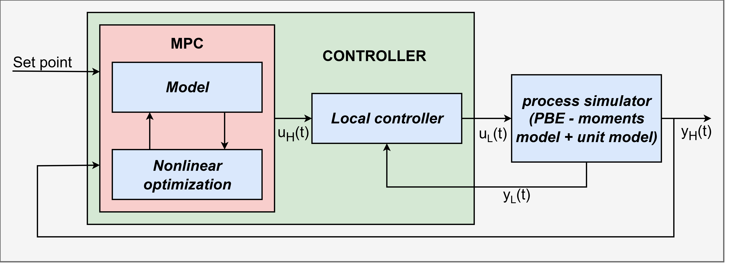
Figure 1: Structure of the hierarchical MPC
The controller is divisible into two parts: the “MPC“ part and the “Local controller” part. The MPC gets the high-level (or supervisory) SPs (and calculates the low-level SPs ($u_{L}$) for the temperature and volume flow rate controllers. The manipulated variables on the two levels can be summarized with the following:
$u_{H}=\left[\begin{matrix}T_{R} & q\end{matrix}\right] u_{L}=\left[\begin{matrix}q_{j} & q\end{matrix}\right]$ | (8)
The $T_{R}$ could be changed through the inlet volume flow rate to the jacket, so the temperature control can be achieved precisely with a master slave structure (The parameters of the PD controllers was determined by internal model control). However, the volume flow rate of the hot solution must also account for the temperature inside. This effect can be compensated for with gain scheduling in the master loop.
The process simulator is a PBE-moments-transformed model attached to a unit model of the equipment. For the first-principles model, we used the same model as the process simulator, except that the heat balance was removed. In the case of NN, the model was fitted to the process simulator model. The control model does not include the dynamics resulting from the temperature change, but the lower-level controller handles the dynamic interventions.
    - Characterization of the results
The deviation between the controlled variable and the SP is quantified by the mean squared error (MSE). The MSE was calculated on the timescale for the two outputs with the following equation. The runtime was measured with randomized inputs and the measured runtime is a mean of 1000 runs.
${MSE}_{i}=\frac{1}{\left|t\right|} \sum_{t=0}^{\left|t\right|}{{\left(y_{i}-SP_{i}\right)}^{2}} where i=1,2$ | (9)
  - Results
At first (in the section 3.1) we present the performance of the NN, and then (in the section 3.2) we compare the results of the FP based and the NN based MPC. All the simulations were carried out in MATLAB 2025b on an Intel 13th Gen Intel(R) Core(TM) i7-13700 processor with 64 Gb of DDR5 RAM.
    - Performance of the NN
During network testing, we examined the coefficient of determination for both output variables. For the test, we regenerated another 2000-step test. To compare the results of the FP model and the NN estimate, we plotted them on a common parity plot, one for the $E$ (or $y_{1}$) and one for the $V_{S}$ (or $y_{2}$); this is shown in Figure 2.
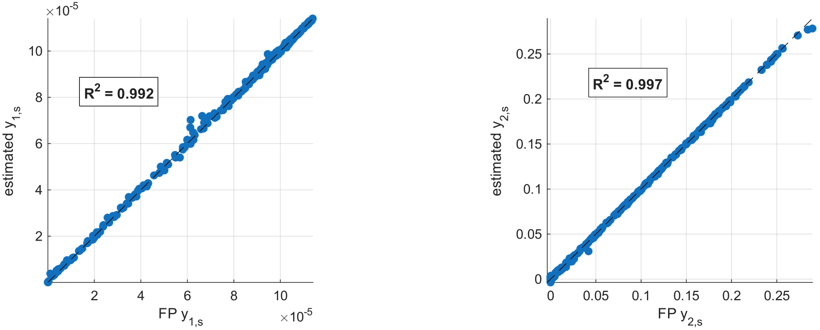
a. | b.
Figure 2. Comparison of the estimated stationary value of the output of the FP and the NN (a.: expected value of the crystal size; b.: solid volume rate of the crystals)
Figure 2 shows the NN's performance in estimating the system's stationary values. The black dashed curves show the perfect case (identity line), and the blue dots show the output of the NN and the FP depending on each other. Most of the points follow the identity line well; however, in the subplot, the range around 6e-5 and 8e-5, a slightly larger deviation and some visible deviations appear. At higher values, a slight, systematic overestimation or underestimation can also be observed, but the extent of this is small. The estimate of the second output (b. subplot) is more uniform across the entire examined range.
    - Performance of the different algorithm
The performance of the two algorithms is compared on a time scale with the same parameter set. The prediction horizon was 3000s in case of FP-MPC, the MPC sampling time was 10s. The expected value of the crystal size is depicted in Figure 4, while the volume of the solid crystal volume is depicted in Figure 5. Figure 6 shows the MPC-set temperature SP and the PID-set actual temperature. Finaly the Figure 7 shows the volume flowrate of the cooling medium and the hot solution. During the investigation the performance was examined in servo mode when both SP is changed (first part of the diagrams), and in quasi regulatory mode when the SP of E is constant and the other SP changes.
Figures 4 and 5 show the controlled variables. It can be seen that the FP-based MPC follows the set points with minor errors and minimal overshoot. The behavior is smooth, and the controller can eliminate cross-effects between the two controlled variables. In contrast, the NN-based MPC performed worse, and Figures 6 and 7 show that the intervention change is sometimes abrupt (~500 s). The neural network-based controller reacts less aggressively to SP changes, but significant tracking errors are observed in several periods. This is especially visible in the period from 500 to 2500 s and after 4500 s, where the controlled value remains permanently below the SP. The main difference and the deterioration in control performance come from the NN training error, and sometimes the used minimization algorithm cannot find a proper manipulated valid sequence.
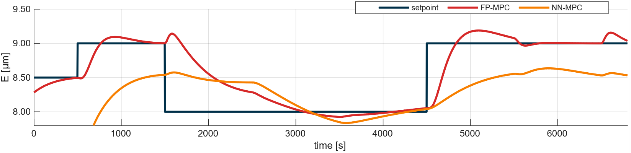Figure 4: Comparison of the performance of the two algorithms in case of control of expected crystal size
The FP-MPC controller responds quickly to jumps, but at some transitions, for example, around 500, 1700, and 4600 s, short-term undershoot or overshoot occurs. The NN-MPC response is also slower for this output. The output approaches the new SP more gradually and in some sections only reaches its surroundings with a significant delay. A larger tracking deviation is observed for the higher SP between 1500 and 2500 s and after the last SP change. The advantage of NN-MPC here is also the smoother transition, but this comes at the expense of speed and accuracy.
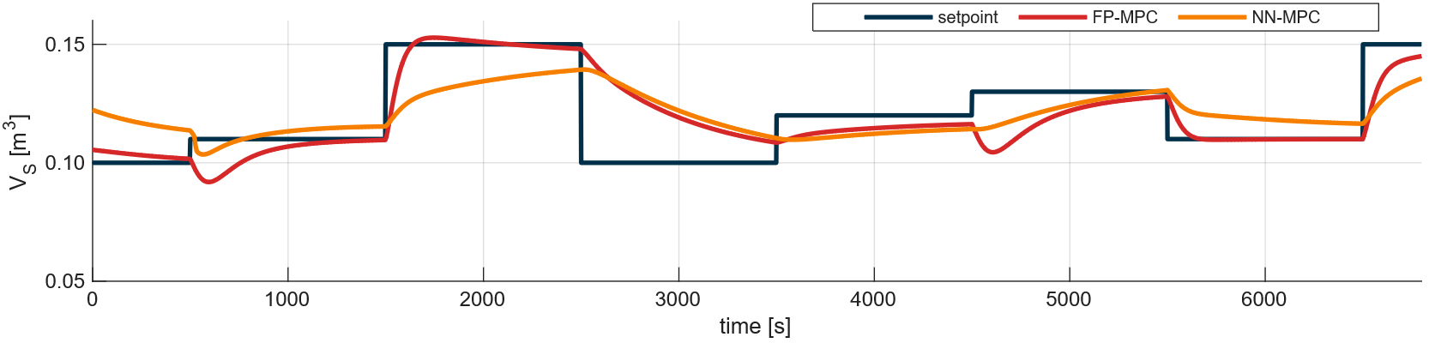
Figure 5: Comparison of the performance of the two algorithms in case of control of solid volume

Figures 6 and 7 show the manipulated variables over time. Figure 6 shows the performance of the PD controller. It can be seen that the controller follows the set point, and the temperature is set to it. In some cases, when the volume flow rate of the hot solution increases (between 4000s and 5000s), the controller compensates by increasing intervention.
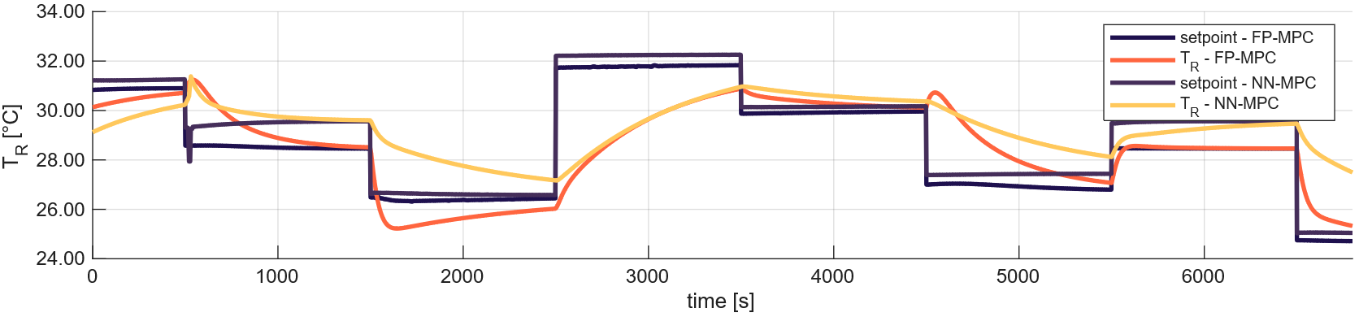Figure 6: Comparison of temperature SP and profile
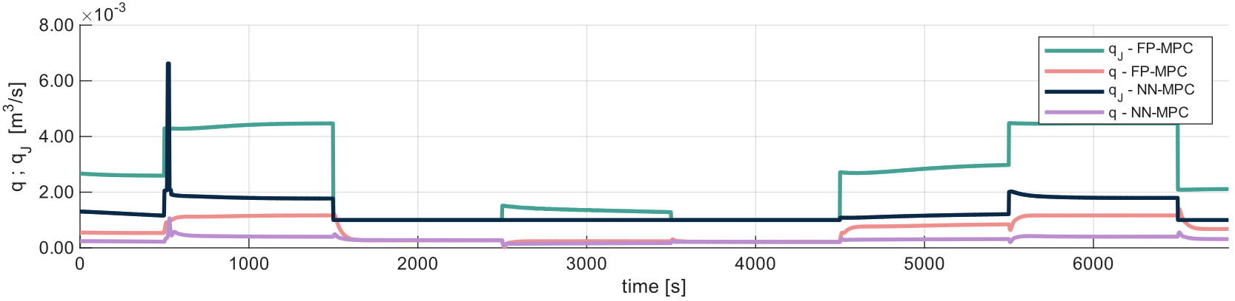
Figure 7: Volume flowrate of the hot solution and the cooling medium
For the characterization of the results the MSE values between the SP and the outputs and the runtime time of the different models can be found in Table 1. It can be said the FP model-based solution outperform in both of MSE and runtime value of the NN. For output E, the MSE of the FP model is about 72% lower than that of the NN model, while for Vs it is about 31%.
Table 1: Summary of the control accuracy and the runtime of the two model
used model | MSE – $E$ [m] | MSE – $V_{S}$ [m³] | runtime of the model [s]
FP | 0.1007 | 1.51e6 | 0.0073
NN | 0.3618 | 2.19e6 | 0.0633
  - Conclusion
In comparison, the FP outperforms the NN-based solution. However, the results are promising for applicability; this is primarily because an efficient SMOM-based model can be applied to this system. For more complex systems, where SMOM is not applicable or can only be used with significantly higher computational requirements, the runtime of FP-based optimization can increase significantly. In contrast, the evaluation time of an already trained neural network is expected to remain nearly unchanged, as it is primarily determined by the fixed structure of the network, rather than the complexity of the original process model. The computational time of the NN is much shorter than that of general PBE solvers (especially if the descriptive model contains an aggregation or fragmentation term). Therefore, although the NN-based solution performs less well on the current test system, it may represent a more computationally favorable alternative for more complex systems. Note that, next to NN, the network was trained on the FP model, so its accuracy reflects that training. In this case, the dynamic information is lost from the system; only the controller uses the output's stationary value. The performance of the NN could be improved with dynamic information, although this would come at the expense of runtime.
Nomenclature

$α$ – exponent of the crystal growing rate function
$B$ – nucleation rate
$C_{F}$ – solute concentration of liquid phase, kgkg⁻¹ solvent
$C_{O}$ – solvent concentration of liquid phase
c – current value (as index)
$E$ – expected crystal size, m
f – nonlinear ode system
$ϵ(t)$ – solid volume fraction
$k_{g}$ – crystal growing rate constant
$k_{p}, k_{s}$ – nucleation rate constants
$m$ – order of moments
n – new value (as index)
$μ_{m}$ – m-th moments
$p, s, ω-$ exponent of the nucleation rate function
$Ψ(t,r)$ – number distribution function
$Ψ_{0}$ – initial distribution
$q$ – volume flow of solution, m³s⁻¹
$q_{j}$ – volume flow of cooling medium, m³s⁻¹
$r$ – size coordinate, m
$r_{0}$ – smallest nucleus size, m
s – stationary value (as index)
$t$ – time coordinate, s
$T_{J}$ – temperature of jacket side, °C
$T_{R}$ – temperature inside the crystallizer, °C
$u_{H}$ – high level manipulated variable
$u_{L}$ – low level manipulated variables
$V$ – volume of the equipment, m³
$V_{F}$ – volume of liquid phase, m³
$V_{S}$ – volume of solid phase, m³
$v_{r}$ – crystal growing rate, ms⁻¹
x_{NN} – input vector of the NN
y_{NN} – output vector of the NN
MPC – model predictive control
FP – first principle
MIMO – multi-input multi-output
NN – neural network
ODE – ordinary differential equation
PBM – population balance model
PBE – population balance equation
MSE – mean squared error
MLP – multilayer perceptron
SP – setpoint
SMOM – standard method of moments

References
Balogh L., Egedy A., Bárkányi Á., 2023, Model Predictive Control of CMSMPR Crystalliser, Chemical Engineering Transactions, 99, 661–666.
Damour C., Benne M., Grondin-Perez B., Chabriat J.-P., 2010, Nonlinear predictive control based on artificial neural network model for industrial crystallization, Journal of Food Engineering, 99 (2), 225–231.
Goodfellow I., Bengio Y., Courville A., 2016, Deep Learning, MIT Press, Cambridge, Massachusetts, USA.
Johnson C.R., Wohlgemuth K., Lucia S., 2026, A tutorial overview of model predictive control for continuous crystallization: Current possibilities and future perspectives, Journal of Process Control, 158, 103630.
Lima F.A.R.D., de Moraes M.G.F., Secchi A.R., de Souza Jr. M.B., 2022, Development of a recurrent neural networks-based NMPC for controlling the concentration of a crystallization process, Digital Chemical Engineering, 5, 100052.
Szilágyi B., Borsos Á., Pal K., Nagy Z.K., 2019, Experimental implementation of a Quality-by-Control (QbC) framework using a mechanistic PBM-based nonlinear model predictive control involving chord length distribution measurement for the batch cooling crystallization of l-ascorbic acid, Chemical Engineering Science, 195, 335–346.
Yang Y., Nagy Z.K., 2015, Advanced control approaches for combined cooling/antisolvent crystallization in continuous mixed suspension mixed product removal cascade crystallizers, Chemical Engineering Science, 127, 362–373.
Zheng Y., Wang X., Wu Z., 2022, Machine Learning Modeling and Predictive Control of the Batch Crystallization Process, Industrial & Engineering Chemistry Research, 61 (16), 5578–5592.

