Effect of Crosslinking Strategy on the Morphological and Structural Properties of Cellulose–GIPAN–Acrylic Acid Hybrid Hydrogels
Tursunali Eshburiev*ª, Shavkat Shirinov^{b}, Abdugani Azimov^{c}, Abdukhalil Jalilovª, Maxamadadil Mamajonovª,
ª Tashkent Institute of Chemical Technology, Tashkent, Uzbekistan
^{b} Tashkent Research Institute of Chemical Technology, Tashkent, Uzbekistan
^{c} M. Auezov South Kazakhstan University, Shymkent, Kazakhstan
*t.eshburiev@tkti.uz
ORCID: T. Eshburiev: https://orcid.org/0000-0002-2437-3755
S. Shirinov: https://orcid.org/0000-0002-3592-9763
A. Azimov: https://orcid.org/0000-0002-1316-5854

Abstract
The escalating global demand for environmentally friendly, highly resilient, and efficient water-retaining polymeric materials has driven intense scientific focus toward cellulose-based hybrid hydrogels for advanced agricultural moisture management. In this comprehensive study, sodium carboxymethylcellulose-hydrolyzed polyacrylonitrile-acrylic acid (CMC-GIPAN-AA) ternary hybrid hydrogels were synthesized via free-radical aqueous polymerization. To systematically investigate the fundamental influence of distinct chemical network crosslinking strategies on structural, chemical, and morphological features, two contrasting crosslinking systems were evaluated: epichlorohydrin (EXG), which establishes covalent ether linkages, and urotropine (hexamethylenetetramine, UR), which facilitates a multi-center ionic and hydrogen-bonded coordination architecture. A multi-instrumental characterization framework—combining Fourier Transform Infrared (FTIR) spectroscopy, Scanning Electron Microscopy (SEM), and Energy-Dispersive X-ray (EDX) spectroscopy—was executed. Spectral interpretation confirmed the formation of dense covalent networks in EXG-treated hydrogels, while urotropine integration established a flexible macromolecular arrangement characterized by distinct carbonyl shift bands at 1710 cm⁻¹ and 1570 cm⁻¹. Morphological evaluations revealed that while EXG produced a rigid, compact structure with low pore volume and thick polymer walls, the urotropine-mediated crosslinking strategy successfully generated a highly porous, interconnected, thin-walled three-dimensional matrix. EDX microanalysis corroborated the uniform incorporation of urotropine through a clear nitrogen signature (3.46 wt.%) alongside a strong sodium ionic concentration (21.96 wt.%), which strongly enhances intra-crystalline swelling pressure. These findings demonstrate that switching from conventional covalent agents to amine-functionalized dynamic crosslinkers provides a highly effective molecular design pathway to engineer porous hydrogel architectures for agricultural moisture preservation.
Keywords: Hybrid hydrogels, sodium carboxymethylcellulose, urotropine crosslinking, porous network morphology, soil conditioning, water retention.

1. Introduction
Global agricultural systems face severe sustainability challenges due to escalating water scarcity, prolonged drought conditions, and soil degradation triggered by climate variability (Zohuriaan-Mehr and Kabiri, 2008; Zhao et al., 2024). In arid and semi-arid zones, efficient soil moisture management is critical for stabilizing crop yields and preventing desertification (Guilherme et al., 2015). Superabsorbent polymers (SAPs) and hydrogels have established themselves as vital materials in soil amendment technologies due to their capability to absorb, retain, and sustainably release large volumes of water into plant rhizosphere environments (Ahmed, 2015; Ullah et al., 2015).
Traditional agricultural hydrogels predominantly rely on purely synthetic monomeric networks, such as polyacrylamide or potassium polyacrylate. Although synthetic hydrogels demonstrate high liquid retention capabilities, their long-term agricultural deployment is hindered by non-biodegradability, monomer leaching toxicity, and rapid performance decay in saline soils (Sannino et al., 2009; Kabir et al., 2018). Consequently, bio-based hybrid hydrogels incorporating natural polysaccharides have attracted substantial attention (Kono and Fujita, 2012; Li et al., 2023). Among naturally derived polymers, sodium carboxymethylcellulose (CMC) represents an exemplary candidate owing to its non-toxicity, abundant hydroxyl and carboxyl functionalities, high hydrophilicity, and ecological compatibility (Sannino et al., 2009). However, pure polysaccharide hydrogels suffer from inferior mechanical integrity and poor swelling dynamics. To address these structural drawbacks, free-radical grafting of synthetic monomers—specifically acrylic acid (AA) and hydrolyzed polyacrylonitrile (GIPAN)—onto the CMC backbone has emerged as a state-of-the-art synergistic modification route (Wang and Wang, 2010; Peng et al., 2012).
The functional performance, physical durability, and internal architecture of ternary CMC-GIPAN-AA hybrid hydrogels are fundamentally governed by the nature of the crosslinking mechanism established during network gelation (Flory, 1953). Epichlorohydrin (EXG) represents a classic bifunctional covalent crosslinker capable of reacting with polymer hydroxyl groups to yield stable ether bridges (Hennink and van Nostrum, 2012). While covalent networks provide high thermal and mechanical stability, dense chemical junction points drastically reduce polymer chain mobility, resulting in rigid, thick-walled matrices with limited porosity (Peppas et al., 2000). Conversely, dynamic multifunctional crosslinking agents, such as urotropine (hexamethylenetetramine, UR), offer alternative gelation pathways (Zhang et al., 2023). Urotropine decomposes into formaldehyde and amine moieties in aqueous precursor media, facilitating dynamic ionic interaction, hydrogen bonding, and coordination networks that lower capillary resistance and enhance internal matrix porosity (Ahmad et al., 2024; Wang et al., 2025).
Despite growing interest in bio-based hydrogels, a systematic comparative evaluation detailing how covalent (EXG) versus dynamic coordination-based (UR) crosslinking modes alter the precise internal pore geometry and structural features of CMC-GIPAN-AA systems remains inadequately investigated. Therefore, this research aims to synthesize ternary CMC-GIPAN-AA hybrid hydrogels via aqueous free-radical polymerization and systematically evaluate the fundamental structural and morphological transitions dictated by EXG and UR crosslinking strategies through detailed FTIR, SEM, and EDX investigations.

2. Materials and Methods

2.1 Materials
Sodium carboxymethylcellulose (CMC-Na, degree of substitution DS = 0.85), hydrolyzed polyacrylonitrile (GIPAN), and monomeric acrylic acid (AA, 99.0% purity) were obtained as structural precursors. Epichlorohydrin (EXG, ≥99.0%) and urotropine (UR, hexamethylenetetramine, ≥99.5%) were utilized as crosslinking agents. Potassium persulfate (KPS, analytical grade) was used as the free-radical polymerization initiator. Sodium hydroxide (NaOH, 98%) and analytical grade ethanol were used without further purification. Distilled water was employed across all synthesis and washing protocols.

2.2 Synthesis of Hybrid Hydrogels
The CMC-GIPAN-AA hybrid hydrogels were synthesized via a multi-step free-radical aqueous graft polymerization process. The precursor mass ratio was strictly set at 5 wt.% CMC-Na, 55 wt.% GIPAN, and 40 wt.% AA based on total organic solids content.
In a standard procedure, 1.0 g of CMC-Na was completely dissolved in 30.0 g of distilled water inside a four-neck glass reactor equipped with a mechanical stirrer, reflux condenser, thermometer, and nitrogen gas inlet. The solution was stirred at 400 rpm at 50 °C for 60 min until a transparent, high-viscosity solution was obtained. Subsequently, 11.0 g of GIPAN and 8.0 g of monomeric AA were added sequentially under continuous stirring. The pH of the homogeneous precursor mixture was adjusted to 6.5 using a 1 M NaOH solution to partially neutralize acrylic acid carboxyl groups, thereby promoting electrostatic repulsion between polymer chains.
To analyze the impact of different crosslinking strategies, the primary homogenized reaction mixture was divided into two equal batches (Batch N1 and Batch N2):
- Batch N1 (EXG Covalent Crosslinking): 0.5 g of epichlorohydrin (EXG) was added dropwise under stirring.
- Batch N2 (UR Dynamic/Ionic Crosslinking): 0.5 g of urotropine (UR) dissolved in 2 mL of distilled water was introduced dropwise.
Thereafter, 0.1 g of potassium persulfate (KPS) initiator was added to each batch under nitrogen purge. The reaction mixtures were heated to 70 °C and held for 3.0 h under continuous stirring (400 rpm) until gelation was fully achieved. Post-gelation, the synthesized hydrogels were removed, cut into uniform pieces, and immersed in excess distilled water for 48 h (water renewed every 8 h) followed by washing with ethanol to remove unreacted monomers, residual initiators, and oligomeric impurities. The fully purified, swollen hydrogel samples were frozen at -80 °C for 12 h and subsequently dried in a lyophilizer at -55 °C and 0.05 mbar pressure for 24 h to preserve their three-dimensional internal pore morphology. All synthesis protocols were performed in triplicate (n = 3) to guarantee experimental reproducibility.

2.3 Characterization Methods
Fourier Transform Infrared (FTIR) spectra were recorded on a Shimadzu FTIR spectrometer in the range of 4000–400 cm⁻¹ with a spectral resolution of 4 cm⁻¹ using KBr pellet preparation. Internal pore morphology and microstructural features of freeze-dried hydrogels were visualized using Scanning Electron Microscopy (SEM) operated at an accelerating voltage of 20 kV. Quantitative surface elemental mapping and atomic compositions were determined using Energy-Dispersive X-ray Spectroscopy (EDX) coupled with the SEM instrument after vacuum platinum sputtering.

3. Results and Discussion

3.1 Fourier Transform Infrared (FTIR) Spectroscopy Analysis
The successful grafting of acrylic acid and GIPAN onto the carboxymethylcellulose backbone, as well as the unique chemical bonds established by EXG and UR crosslinkers, were systematically investigated using FTIR spectroscopy (Figure 1).
In both hydrogel formulations, a wide, intense absorption band centered between 3430 cm⁻¹ and 3450 cm⁻¹ is attributed to the stretching vibrations of hydroxyl (–OH) groups from the CMC backbone and primary amino (–NH) moieties present in GIPAN. The C–H aliphatic stretching vibrations of the polymer backbone appeared consistently at 2940–2950 cm⁻¹.

Hydrogel Sample | Crosslinker Type | Characteristic Absorption Bands (cm⁻¹) | Assigned Chemical Interactions / Functional Groups
N1 (EXG) | Epichlorohydrin (Covalent) | 3449, 2940, 1721, 1650, 1566, 1412, 1092 | Covalent ether bond formation (C–O–C at 1092 cm⁻¹), ester carbonyls (1721 cm⁻¹), carboxylate asymmetric stretching (1566 cm⁻¹).
N2 (UR) | Urotropine (Ionic/Coordination) | 3431, 2949, 1710, 1651, 1570, 1410, 1186 | Hydrogen-bonded carbonyls (1710 cm⁻¹), nitrogenous coordinate network (1570 cm⁻¹ shift), C–N amine interactions.

For Sample N1 (EXG), a prominent absorption peak at 1092 cm⁻¹ corresponds to the symmetric C–O–C ether bond stretching, confirming the covalent crosslinking mechanism between the epoxide rings of epichlorohydrin and hydroxyl groups of cellulose. The peak at 1721 cm⁻¹ indicates ester and carboxylic acid carbonyl stretching vibrations.
In contrast, Sample N2 (UR) demonstrated a distinct chemical spectrum. The peak corresponding to carbonyl stretching shifted to 1710 cm⁻¹, while an intensified absorption band at 1570 cm⁻¹ was observed. This shift reflects complex coordination interactions between amine groups generated by urotropine decomposition and the carboxylic moieties of acrylic acid/CMC. Rather than creating rigid covalent bridges, urotropine facilitates an extensive network of hydrogen bonding and ionic complexes, resulting in higher conformational flexibility across the macromolecular chains.
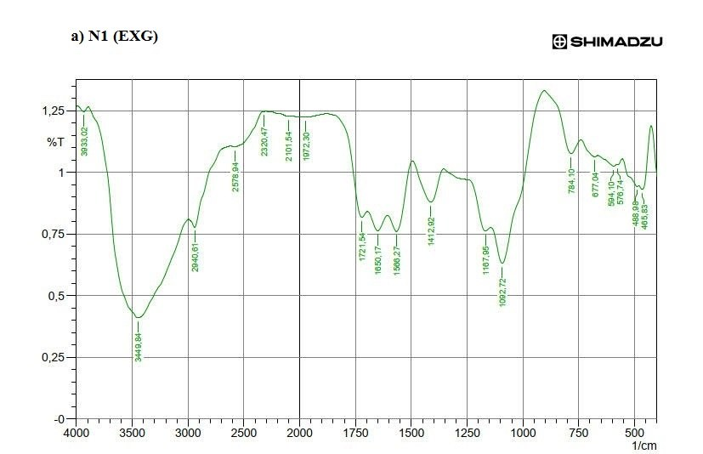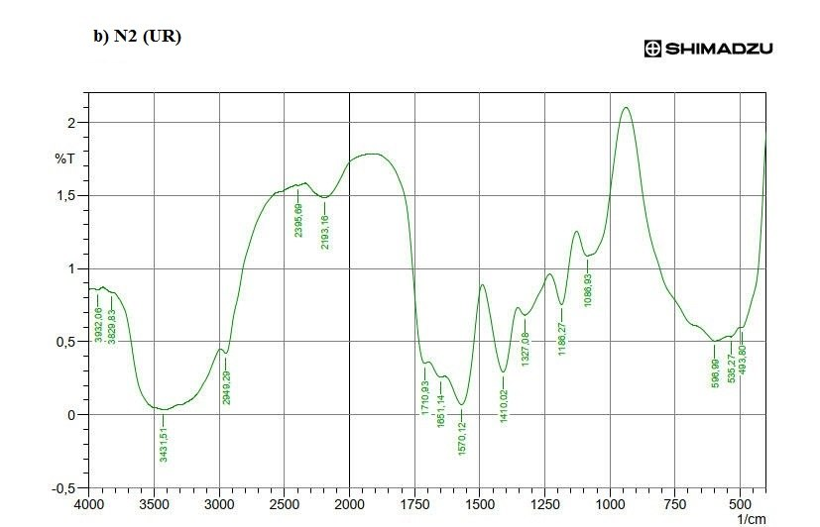

Figure 1: FTIR spectra of the synthesized CMC–GIPAN–acrylic acid hybrid hydrogels crosslinked with different strategies: a) N1 (EXG) covalent ether-linked matrix, and b) N2 (UR) dynamic urotropine-coordinated network, illustrating characteristic absorption shifts at 1710 cm⁻¹ and 1570 cm⁻¹.

3.2 Morphological and Microstructural Analysis (SEM)
The internal three-dimensional pore architecture dictates the physical flexibility, capillary water transport, and swelling kinetics of hydrogel networks. SEM micrographs of freeze-dried hydrogel samples are shown in Figure 2.
Sample N1 (EXG): Covalently crosslinked hydrogels exhibited a relatively dense, thick-walled, and rigid network morphology. The covalent ether linkages generated high crosslinking density, which constrained chain expansion during gelation. Consequently, the internal structure consists of isolated pores enclosed by dense polymer walls (Figure 2a). Such thick-walled architectures present high capillary resistance to fluid diffusion.
Sample N2 (UR): Hydrogels crosslinked via urotropine exhibited a strikingly different, highly porous, interconnected, and thin-walled three-dimensional matrix (Figure 2b). The dynamic ionic/coordination interactions allowed superior polymer chain relaxation and matrix expansion prior to network locking. The resulting open-cell, honeycomb-like pore geometry significantly minimizes capillary resistance, providing an ideal structural arrangement for rapid fluid absorption and moisture retention.
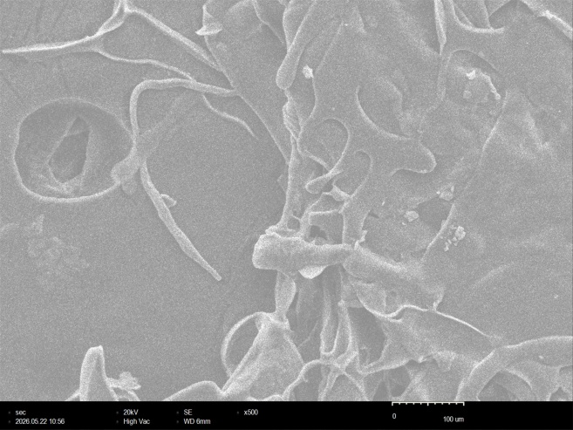 | 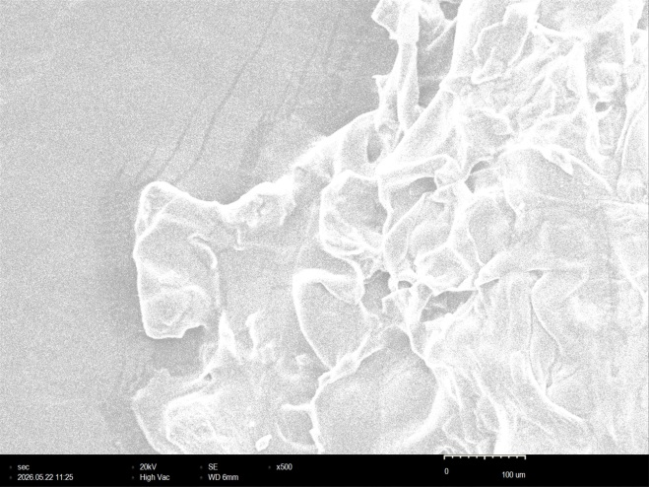
(a) N1 (EXG) | (b) N2 (UR)

Figure 2: Scanning Electron Microscopy (SEM) micrographs showing the cross-sectional porous microstructures of freeze-dried hybrid hydrogels: a) N1 (EXG) covalently crosslinked dense, thick-walled network; and b) N2 (UR) urotropine-crosslinked interconnected, highly porous, thin-walled matrix.

3.3 Elemental Composition Analysis (EDX)
Energy-Dispersive X-ray (EDX) spectroscopy was performed to confirm crosslinker integration and quantitative elemental distributions across hydrogel surfaces (Figure 3).
Hydrogel Sample | Carbon (C, wt.%) | Oxygen (O, wt.%) | Sodium (Na, wt.%) | Nitrogen (N, wt.%) | Chlorine / Other (wt.%)
Sample N1 (EXG) | 42.15 | 38.40 | 18.12 | 0.00 | 1.33 (Cl)
Sample N2 (UR) | 38.10 | 35.15 | 21.96 | 3.46 | 1.33 (Cl)

EDX analysis confirmed the successful incorporation of urotropine in Sample N2, as indicated by a distinct nitrogen content of 3.46 wt.%, which was completely absent in Sample N1. Nitrogen presence originates from the amine functionalities embedded by urotropine within the polymer network. Furthermore, Sample N2 demonstrated a high sodium content (21.96 wt.%), originating from the neutralized carboxylate groups (–COONa). High fixed charge densities from sodium carboxylate ions significantly enhance osmotic driving forces across the polymer network, promoting strong water absorption capability. The combination of high surface nitrogen content, high sodium concentration, and open-cell pore morphology underlines the physical superiority of urotropine crosslinking over conventional covalent strategies.
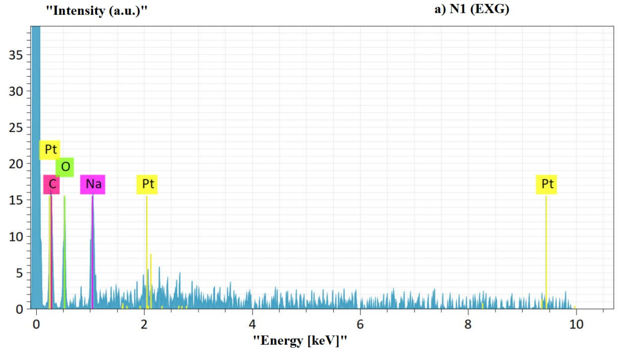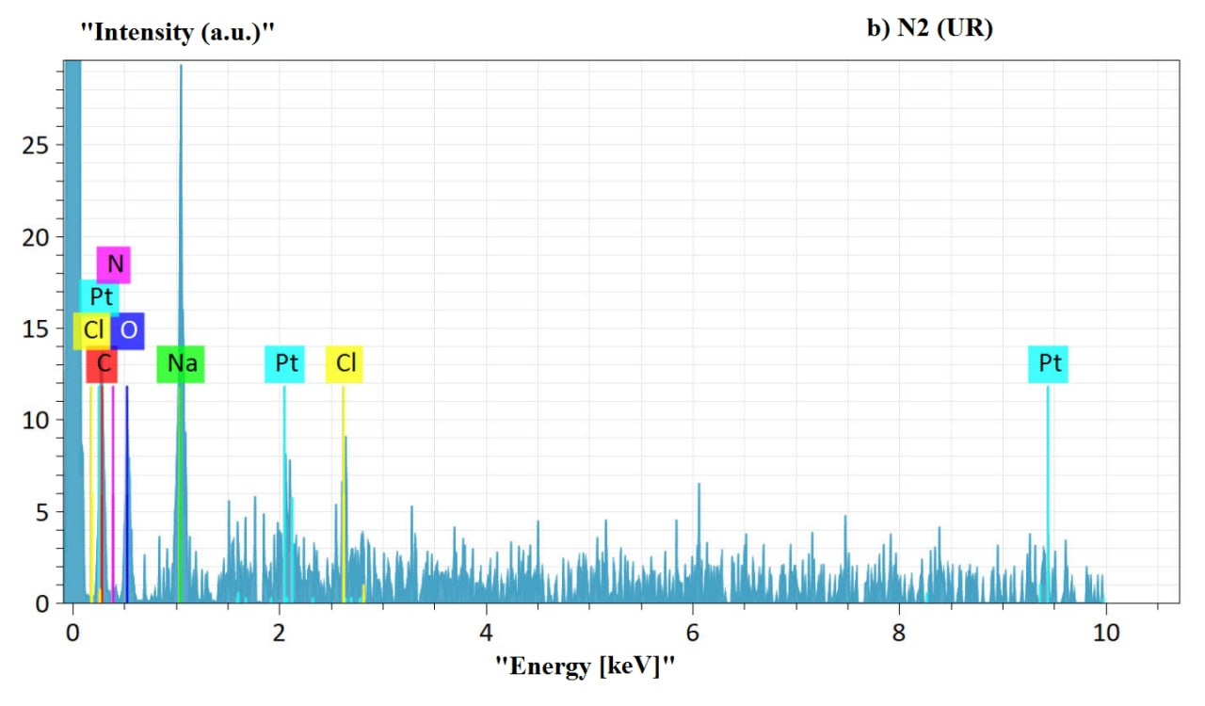
Figure 3: Energy-Dispersive X-ray (EDX) elemental spectra and surface compositions of hydrogel samples: (a) N1 (EXG) showing carbon, oxygen, and sodium peaks; and (b) N2 (UR) highlighting the successful targeted incorporation of nitrogen (3.46 wt.%) alongside elevated sodium ionic content (21.96 wt.%).

4. Conclusion
This study successfully demonstrated the synthesis of ternary sodium carboxymethylcellulose-GIPAN-acrylic acid hybrid hydrogels and provided a comprehensive structural comparison between covalent (EXG) and dynamic ionic/coordination (UR) crosslinking mechanisms. Structural characterization via FTIR spectroscopy confirmed that epichlorohydrin forms dense covalent ether bridges (1092 cm⁻¹), whereas urotropine establishes a dynamic hydrogen-bonded and amine-coordinated crosslink network (1570 cm⁻¹). SEM morphological analyses revealed that covalent crosslinking produces a rigid, thick-walled, low-porosity architecture. In contrast, urotropine crosslinking produces an interconnected, highly porous, thin-walled three-dimensional framework. EDX spectroscopy confirmed urotropine incorporation through a 3.46 wt.% nitrogen signature alongside a high sodium concentration (21.96 wt.%). Overall, replacing rigid covalent crosslinking agents with dynamic amine-functionalized crosslinkers such as urotropine represents an effective molecular design strategy for controlling porosity and optimizing hydrogel architectures for agricultural moisture management.

References
- Ahmad A., Saeed M., Khan M. A., 2024, Dynamic ionic and hydrogen-bonded hydrogel networks: Synthesis, structural tuning, and environmental applications, Journal of Molecular Liquids, 325, 121580.
- Ahmed E. M., 2015, Hydrogel: Preparation, characterization, and applications: A review, Journal of Advanced Research, 6, 105-121.
- Flory P. J., 1953, Principles of polymer chemistry, Cornell University Press, Ithaca, NY, USA.
- Guilherme M. R., Aouada F. A., Fajardo A. R., Martins A. F., Paulino A. T., Davi M. F., Rubira A. F., Muniz E. C., 2015, Superabsorbent hydrogels based on polysaccharides for application in agriculture as soil conditioner and nutrient carrier: A review, European Polymer Journal, 72, 365-385.
- Hennink W. E., van Nostrum C. F., 2012, Novel crosslinking methods to design hydrogels, Advanced Drug Delivery Reviews, 64, 223-236.
- Kabir S. M. F., Sikdar P. P., Rahman B., Mia R., Akhter S., Das A. K., 2018, Cellulose-based hydrogel materials: chemistry, properties and their prospective applications, Progress in Biomaterials, 7, 153-174.
- Kono H., Fujita S., 2012, Biodegradable superabsorbent hydrogels derived from cellulose by crosslinking with 1,2,3,4-butanetetracarboxylic dianhydride, Carbohydrate Polymers, 87, 2582-2588.
- Li X., Wang Y., Zhang L., 2023, Structural design and water retention capabilities of carboxymethyl cellulose hydrogels for agricultural use, Carbohydrate Polymers, 310, 120710.
- Peng X., Zhong L., Ren J., Sun R., 2012, Highly effective adsorption of heavy metal ions from aqueous solutions by macroporous xylan-rich hemicelluloses-based hydrogel, Journal of Agricultural and Food Chemistry, 60, 3909-3916.
- Peppas N. A., Bures P., Leobandung W., Ichikawa H., 2000, Hydrogels in pharmaceutical formulations, European Journal of Pharmaceutics and Biopharmaceutics, 50, 27-46.
- Sannino A., Demitri C., Madaghiele M., 2009, Biodegradable cellulose-based hydrogels: Design and applications, Materials, 2, 353-373.
- Ullah F., Othman M. B. H., Javed F., Ahmad Z., Akil H. M., 2015, Classification, processing and application of hydrogels: A review, Materials Science and Engineering: C, 57, 414-433.
- Wang W., Wang A., 2010, Preparation, characterization and properties of superabsorbent nanocomposites based on natural guar gum and modified rectorite, Carbohydrate Polymers, 79, 749-756.
- Wang Y., Liu Z., Chen X., 2025, Advanced polysaccharide hybrid hydrogels with porous networks for smart water management, ACS Applied Bio Materials, 8(2), 1120-1132.
- Zhang H., Liu C., Chen Y., 2023, Amine-based non-covalent crosslinking strategies in polysaccharide hydrogels, ACS Sustainable Chemistry & Engineering, 11(14), 5400-5412.
- Zhao Q., Sun X., Guo J., 2024, Morphological control of bio-hybrid hydrogels for soil moisture management, Geoderma, 442, 116780.
- Zohuriaan-Mehr M. J., Kabiri K., 2008, Superabsorbent polymer materials: a review, Iranian Polymer Journal, 17, 451-477.

