 CHEMICAL ENGINEERING TRANSACTIONS  VOL. xxx, 2026 | A publication of  
The Italian Association
of Chemical Engineering
Online at www.cetjournal.it

Guest Editors: Flavio Manenti, Botir Usmonov, Alessandro Di Pretoro
Copyright © 2026, AIDIC Servizi S.r.l.
ISBN 979-12-81206-xx-x; ISSN 2283-9216

ANALYSIS OF THE PROTEIN COMPOSITION OF MACLURA POMIFERA FRUITS
Juraev N. Ruyiddinª, Nazarov A. Golibª, Normatov M. Anvarª, Nazarova B. Sarvinozª, Karimova Robiaª
ª Tashkent Institute of Chemical Technology, Tashkent 100000, Uzbekistan
*jorayevruyiddin1996@gmail.com
Medicinal plants have been an important means of preserving human health for centuries. Despite modern pharmaceutical advances, their richness in natural biologically active substances continues to maintain their scientific and practical significance. Maclura pomifera – to date, 11 varieties have been identified. Maclura is typically a fruit tree growing to a height of 8–15 meters. This plant is named in honor of the American geologist William Maclure (1763–1840). Maclura pomifera, a perennial tree belonging to the Moraceae (fig) family, is distinguished by the richness of its fruit in flavonoids, phenolic compounds, lipids, polysaccharides, vitamins, proteins, and amino acids. In-depth study of the plant's composition and the isolation of its biologically active components is of great relevance to modern biotechnology and pharmaceuticals. The fruit of Maclura pomifera was selected as the research object. Aqueous, alcoholic, and oily extracts were obtained from it, and compositional analyses were carried out using modern physicochemical methods. Specifically, gel electrophoresis, high-performance liquid chromatography (HPLC), gas–liquid chromatography (GLC), nano-LC-MS/MS, and UV-Vis spectroscopy were employed. During the protein fraction separation process, fatty components were removed from the samples, and then extraction was performed at an optimal pH and temperature. Protein quantification was carried out using the Kjeldahl and Lowry methods, and purification was performed by dialysis. The amino acid composition was analyzed by HPLC using the formation of FTC derivatives. According to the research findings, the fruit of Maclura pomifera was confirmed to contain antioxidant compounds such as pomiferin, osain, quercetin, flavonoids, gallic acid, and ellagic acid. From the protein fraction, a glycoprotein with a molecular weight of 65 kDa-macluralisin-was isolated as the main component, and its primary protein portion was found to be 50 kDa. The protein recovery yield was 18%. Using the Kjeldahl method, the fruit was found to contain 1.72% nitrogen, indicating an average protein content of 11% on a dry matter basis. The electrophoresis results confirmed the fractional composition of the proteins. The HPLC analyses revealed the presence of all 20 essential amino acids for living organisms in the plant fruit. The results obtained showed that the fruit of Maclura pomifera is rich in biologically active compounds and that the compounds isolated from it have high biopotential.
  - Introduction
Currently, the use of natural plant-based resources in traditional therapeutic approaches has become a priority area worldwide. According to the World Health Organization (WHO), approximately 80% of the population in developing countries prefer herbal preparations for health promotion and disease prevention. In particular, the development of next-generation biologically active supplements with high antioxidant potential and minimal adverse effects is considered a pressing task in the management of prevalent joint disorders, including arthritis, osteoarthritis, and inflammatory arthropathies.
At present, the diversity of medicinal plants has increased significantly, enriching traditional medicine with a wide range of therapeutic botanical resources. Among these, Maclura pomifera, which is widely cultivated as an ornamental tree along streets and in parks throughout our country, has attracted considerable attention due to its potential medicinal properties
The fruit of Maclura pomifera is non-toxic to both humans and livestock; however, it is generally not consumed due to its large size, firm texture, and relatively dry composition. Nevertheless, the edible seeds contained within the fruit serve as a food source for certain animal species. The fruit is characterized by a distinctive wrinkled surface and resembles an orange in both shape and color. When cut, it exudes a sticky, milky-white latex. Morphologically, the fruit exhibits a unique internal structure consisting of three distinct sections, with the seeds located near the central region of the fruit
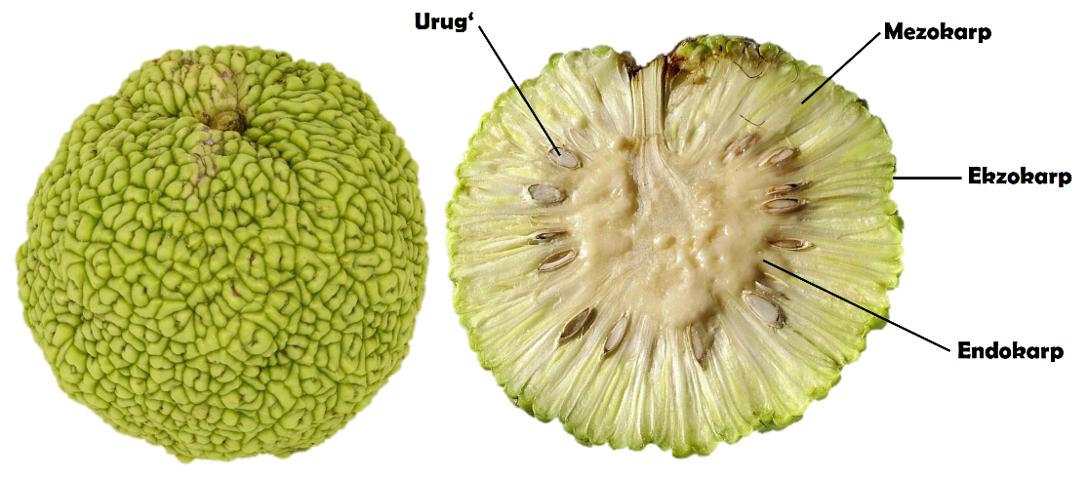
Figure 1. External appearance and internal structure of Maclura pomifera fruit.
The milky latex of Maclura pomifera contains numerous cyclic triterpene alcohols, primarily present in the form of fatty acid esters. This class of biologically active compounds, which is widely distributed throughout the plant kingdom, includes sterols, bile acids, and saponins. During the ripening stage, the total triterpenoid content of Maclura pomifera fruits may reach up to 4%.
The seeds are located within the fruit and possess a small almond-like shape, containing approximately 30% fatty acids. However, the most valuable constituents of Maclura pomifera are considered to be flavonoid compounds, a class of bioactive substances structurally related to vitamin P. Among the flavonols, kaempferol has been identified as the predominant compound, occurring at concentrations of up to 1.2%. This compound is primarily responsible for the characteristic yellow to orange coloration of the fruits.
Within the Commonwealth of Independent States (CIS), V.A. Korotkov investigated the therapeutic properties of Maclura extracts against prostatitis and hemorrhoids. In Uzbekistan, preliminary biochemical analyses of Maclura pomifera were conducted by G.A. Nazarov and U.J. Ishimov, providing foundational data on the plant’s chemical composition and biological potential.
Despite these advances, insufficient scientific attention has been devoted to the comprehensive investigation of Maclura pomifera fruits cultivated under the environmental conditions of Uzbekistan. In particular, studies focusing on the quantitative analysis of biologically active compounds, the development of efficient extraction technologies, and the production of high-quality biologically active supplements based on the isolated metabolites remain limited. Furthermore, issues related to the extraction of ellagic acid from locally available raw materials and the evaluation of its economic feasibility for applications in the food industry have not yet been adequately addressed.
Therefore, the primary objective of the present study is to develop an effective technology for the isolation of biologically active compounds from Maclura pomifera fruits widely distributed throughout the regions of the Republic of Uzbekistan and to provide a scientific basis for their utilization in the formulation of biologically active supplements and as functional ingredients in the food industry.
2. Methods
2.1 Materials and sample preparation
2.1. Protein Extraction Techniques from Maclura pomifera Fruit
The protein isolation process was carried out following the defatting and drying of the raw material and consisted of three main stages. The dried and finely ground fruit sample was mixed with distilled water at a ratio of 1:5 (w/v). The resulting mixture was subjected to extraction using a magnetic stirrer at 300 rpm for 2 h. To maximize protein recovery, the extraction procedure was repeated twice, ensuring the complete transfer of proteins into the aqueous phase.
The obtained protein extract was heated in a thermostatically controlled water bath to 37–38°C. Under continuous stirring at 150 rpm, the pH of the solution was adjusted to 3.0 using a 0.1% HCl solution. The resulting suspension was initially maintained at room temperature for 10 min and subsequently stored under refrigerated conditions for 3–4 h to ensure complete protein precipitation.
After sedimentation, the supernatant was carefully removed by decantation. The protein concentrate remaining at the bottom of the vessel was rapidly frozen onto the walls of the flask using liquid nitrogen. Subsequently, the samples were freeze-dried in a lyophilization unit at −60°C under a vacuum of 0.9 Pa for 8 h.
2.2. Determination of Water-Soluble Protein Content in Maclura pomifera Fruit Using the Lowry Method
Among the various methods available for the quantitative determination of proteins, the Lowry method is one of the most widely used due to its high sensitivity and reliability. The Lowry assay is based on two simultaneous reactions: the Biuret reaction, which involves the formation of a complex between peptide bonds and copper ions under alkaline conditions, and the colorimetric reaction of the Folin–Ciocalteu reagent with the aromatic amino acids tyrosine and cysteine present in protein molecules.
After preparing five series of standard solutions from the aqueous extract of the Maclura pomifera fruit sample, 1 mL aliquots of each solution were transferred into separate test tubes, followed by the addition of 4 mL of a mixture of Reagents A and B. The solutions were thoroughly homogenized using a vortex shaker (Vortex DLAB MX-S) and subsequently incubated at room temperature for 10 min.
Thereafter, 0.4 mL of Folin–Ciocalteu reagent was added to each mixture using an automatic pipette, and the samples were allowed to stand for 20–30 min to ensure complete color development. The optical density (absorbance) of the resulting solutions was then measured at a wavelength of 670 nm using a UV–Vis spectrophotometer.

2.3. Dialysis Method for the Purification of Maclura pomifera Proteins
Dialysis was employed for the molecular-size-based purification of Maclura pomifera proteins. This technique enables the removal not only of low-molecular-weight proteins and proteinaceous compounds but also of other unwanted constituents present in the extract. For this purpose, a dialysis membrane (VISKING Dialysis Tubing 36/32, 27 mm × 5 m) with a molecular weight cut-off (MWCO) of 50 kDa was used.
The dialysis process was carried out against distilled water for 8 h. To enhance mass transfer and improve the efficiency of dialysis, the external medium was continuously stirred using a magnetic stirrer at a speed of 500 rpm throughout the purification process.

2.4. Electrophoretic Analysis of Maclura pomifera Proteins
Electrophoretic separation of proteins isolated from Maclura pomifera fruit was performed according to the method described by Laemmli. The electrophoretic analysis was carried out using a Bio-Rad vertical gel electrophoresis system (Hiiu Kalur, Estonia) with gel dimensions of 12 × 13 cm. Protein samples were separated on a 10–15% polyacrylamide gradient gel (PAAG) prepared in the presence of 2% SDS (T = 10–15%; C = 0.3%), with a gel thickness of 1 mm.
Electrophoresis was initially conducted at 100 V, 0.03 A, and 3 W, followed by a running regime of 150 V, 0.03 A, and 6 W. After electrophoretic separation, the gels were stained with 0.1% Coomassie Brilliant Blue G-250 prepared in a solution containing 10% acetic acid and 25% ethanol. Excess dye was subsequently removed by destaining in an aqueous solution of 10% acetic acid and 25% ethanol.
The stained gels were scanned using an HP Scanjet 2400 scanner, and the resulting images were converted from JPG format to TIF format for analysis. The number and distribution of protein bands were evaluated using Quantity One software (version 4.6.3).
The electrophoretic analyses were performed using a Bio-Rad vertical gel electrophoresis system (Hiiu Kalur, Estonia) equipped with gels measuring 12 × 13 cm and a gel thickness of 1 mm. The apparatus was operated using a power supply with an input voltage of 100–120/220–240 V.
The molecular weights of proteins isolated from plant fruit samples were determined by gel electrophoresis using polyacrylamide gels prepared from the following formulations. The resolving gel solution (Gel 1) consisted of 5.66 mL acrylamide–bisacrylamide solution (A-A), 7.10 mL distilled water, Tris-HCl buffer (pH 8.8), 20 μL TEMED, and 60 μL ammonium persulfate (APS). The stacking gel solution (Gel 2) was prepared from 1.7 mL acrylamide–bisacrylamide solution (A-A), 5.3 mL distilled water, Tris-HCl buffer (pH 6.8), 10 μL TEMED, and 90 μL APS. Protein samples were analyzed in the prepared gel matrix under standard electrophoretic conditions.

2.5. HPLC-Based Determination of the Amino Acid Composition of Maclura pomifera Proteins
The dialyzed protein sample was subjected to qualitative and quantitative analysis of its amino acid composition using high-performance liquid chromatography (HPLC). Analysis of amino acids was performed following the synthesis of phenylthiocarbamyl (PTC) derivatives of free amino acids according to the method of Steven A. Cohen and Daniel.
Identification of PTC-amino acids was carried out using an Agilent Technologies 1200 HPLC system equipped with a Discovery HS C18 column (75 × 4.6 mm). The mobile phase consisted of solvent A (0.14 M sodium acetate, CH₃COONa, containing 0.05% triethylamine (TEA), adjusted to pH 6.4) and solvent B (acetonitrile, CH₃CN). Chromatographic separation was performed at a flow rate of 1.2 mL min⁻¹, and detection was conducted at a wavelength of 269 nm.
The gradient elution program was as follows: 1–6% B from 0 to 2.5 min; 6–30% B from 2.51 to 40 min; 30–60% B from 40.1 to 45 min; 60% B from 45.1 to 50 min; and 60–0% B from 50.1 to 55 min. Qualitative identification and quantitative determination of amino acids were performed based on the corresponding chromatographic parameters.
3. Results and discussion
3.1 Protein Isolation from Maclura pomifera Fruit: Results and Characterization
Maclura pomifera fruit contains a proteinaceous compound known as macluralisin, which, owing to its biological activity, is also classified as an enzyme. A serine proteinase has been isolated from the fruit of this plant and has been widely employed for many years in protein hydrolysis processes. Macluralisin is a glycoprotein with a total molecular mass of approximately 65 kDa, of which the principal protein component corresponds to a molecular mass of approximately 50 kDa.
For the isolation of proteins from Maclura pomifera fruit, it is essential that the lipid fraction of the sample be completely removed prior to protein extraction. Following defatting, the fruit material is dried, and protein isolation is subsequently carried out under controlled temperature and pH conditions. In the present study, a 0.1% hydrochloric acid (HCl) solution was used to adjust the extraction conditions.
Protein recovery from Maclura pomifera can be achieved through either alkaline or acid precipitation. In the subsequent purification stage, the resulting protein precipitate may be further purified by dialysis or ultrafiltration to remove low-molecular-weight impurities and other non-protein constituents.
For freeze-drying, the recovered protein solution was accurately dispensed into 1 L flat-bottom flasks in 50 mL aliquots. The samples were then uniformly frozen onto the inner walls of the flasks using liquid nitrogen. Subsequently, the frozen protein samples were subjected to lyophilization at −60°C under a vacuum pressure of 0.9 Pa for 8 h.
Following freeze-drying, the protein preparations were stored under moisture-free conditions to preserve their stability and suitability for subsequent analyses.
The isolated protein was designated as macluralisin and was identified as a glycoprotein with a total molecular mass of approximately 65 kDa. The recovery yield of the protein from the biological source was 18%.
Characterization of the isolated protein revealed physicochemical and biochemical properties consistent with those reported for macluralisin. According to the literature, the amino acid composition of macluralisin is similar to that of cucumisin and other serine proteinases of the Cucurbitaceae family; however, it is distinguished by a relatively high content of cysteine and cystine residues. The elevated cysteine content detected in the isolated protein in the present study further supports its identification as macluralisin.
3.2. Determination of Total Protein Content in Maclura pomifera Fruit by the Kjeldahl Method: Results
At the initial stage of the study, the total protein content of Maclura pomifera fruit was determined using the Kjeldahl method. The obtained results revealed that the fruit samples contained 1.72% nitrogen. Based on this value, the protein content was calculated using the standard conversion formula, demonstrating that the fruit contained an average of 11.0% protein on a dry weight basis.
In addition, the lipid content of Maclura pomifera fruit was evaluated during the preliminary phase of the investigation. Fat extraction was performed using a Soxhlet apparatus with hexane as the extraction solvent. Quantitative analysis of the obtained extracts showed that the fruit contained 29.42% lipids. These findings were consistent with previously reported literature data indicating a lipid content of up to 30%, thereby confirming the reliability of the results.
Table 1: Total and Soluble Protein Contents of Defatted Maclura pomifera Fruit Flour
(M±n, n=3)
Samples | Nitrogen Content, % | Total Protein Content Determined by the Kjeldahl Method (%) | Water-Soluble Protein Content Determined by the Lowry Method (μg/mg)
Maclura pomifera (Tashkent) | 1.72 | 11.7±0.2 | 191±0.2
Maclura pomifera (Jizzakh) | 1.68 | 11.2±0.21 | 165,8±0.2
Maclura pomifera (literature) | 1 – 1.23 | 10.25 – 10.68 | 152 – 156
Based on the results presented in Table 1, it can be concluded that the total protein content of Maclura pomifera fruits, as determined by the Kjeldahl method, ranged from 11.2% to 11.7% relative to the initial sample weight. A slight variation in protein content was observed between samples collected from different geographical locations. Specifically, fruits harvested in the Tashkent region exhibited a higher protein content (11.7%) compared with those collected from the Jizzakh region (11.2%).
When compared with previously reported values obtained by researchers from Turkey, Russia, and Kazakhstan (10.25–10.68%), the protein content of M. pomifera fruits grown under local environmental conditions was found to be noticeably higher.
In the subsequent stage of the study, defatted fruit samples were used to investigate the content of water-soluble proteins.
3.3. Determination of Water-Soluble Protein Content in Maclura pomifera Fruit by the Lowry Method
Water-soluble proteins were quantified according to the Lowry assay. A standard calibration curve was generated using albumin solutions with concentrations ranging from 0.025 to 0.300 mg. The amount of water-soluble protein present in the fruit samples was calculated from the calibration equation obtained from the standard curve.
After performing the Lowry reaction with five series of standard protein solutions, a calibration curve was constructed. Optical density was plotted on the ordinate (y-axis), while protein concentration was plotted on the abscissa (x-axis). The corresponding points were determined according to the photoelectric colorimeter (PEC) readings. Four-times recrystallized egg albumin was used as the reference standard.
The protein content of Maclura pomifera fruit samples collected from Tashkent City and Jizzakh Region was analyzed. The mean spectral absorbance values and their corresponding measurement errors were determined for each sample. Subsequently, the protein concentration was calculated using the calibration equation, and the total protein content of the samples was determined.
The calculated content of water-soluble proteins in the first sample was found to be 191 µg/mg.
The water-soluble protein content of Maclura pomifera fruits collected from the Jizzakh Region (Sample 2) was determined using the same procedure and calculated as follows.
Based on protein quantification performed using the Lowry assay and UV spectroscopic analysis, the water-soluble protein contents of both samples were found to be comparable. Specifically, the water-soluble protein content in Sample 1 was determined to be 191 µg/mg, whereas Sample 2 contained 165.8 µg/mg of water-soluble protein.
In the subsequent stage of this study, gel electrophoresis analysis was performed to determine the molecular weight distribution of the purified proteins isolated from Maclura pomifera. This approach enabled the characterization and verification of the molecular weight profile of the extracted protein fractions.
3.4. Molecular Weight Characterization of Maclura pomifera Proteins by Gel Electrophoresis
The molecular weight distribution of Maclura pomifera proteins was investigated using gel electrophoresis according to the method described in the literature. During electrophoresis, protein migration was continuously monitored as the protein molecules moved through the gel matrix from the cathode toward the anode. The electrophoretic run was terminated when the tracking dye front reached a distance of approximately 8–10 mm from the bottom edge of the gel.
Under the experimental conditions employed, the average electrophoresis run time was approximately 2 h. However, this duration may vary depending on the composition and preparation of the electrode buffer system.
Analysis of the prepared gel revealed distinct staining patterns for Maclura pomifera protein samples dissolved in three different solvent systems. These differences in banding profiles indicate variations in protein solubility and migration behavior, reflecting the influence of the solvent environment on the electrophoretic characteristics of the protein fractions.
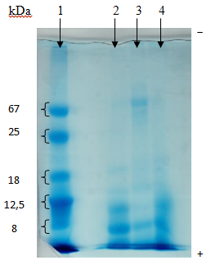
Figure 2. SDS–PAGE Analysis of Maclura pomifera Protein Fractions Dissolved in Three Different Solvent Systems Using 10% Polyacrylamide Gel
Lane 1: molecular weight marker (BSA, xylanase/trypsin, and cytochrome c); Lane 2: Sample 1; Lane 3: Sample 2; Lane 4: Sample 3.
The protein bands observed in the gel were analyzed by comparison with the molecular weight marker lane. The electrophoretic profiles revealed the presence of proteins with molecular masses ranging from approximately 8 to 67 kDa in all analyzed samples.
In Sample 1, prominent protein bands corresponding to molecular masses of approximately 8, 12.5, and 18 kDa were observed. Sample 2 exhibited a broader distribution of protein bands, including proteins with molecular masses ranging from 8 to 67 kDa as well as proteins exceeding 67 kDa. In Sample 3, distinct bands corresponding primarily to proteins of 8, 12.5, 18, and 67 kDa were detected. Similarly, Sample 4 displayed prominent protein bands at approximately 8, 12.5, and 18 kDa.
Based on the electrophoretic analysis of protein fractions isolated from Maclura pomifera fruit using different extraction solvents, it can be concluded that the fruit predominantly contains proteins with molecular masses in the range of 8–67 kDa. Furthermore, the presence of a major protein band at approximately 67 kDa is consistent with previously reported data and suggests that the principal water-soluble protein present in Maclura pomifera fruit is macluralisin. The stained bands detected in the lower molecular weight region are likely attributable to peptides with molecular masses ranging from approximately 0.3 to 13 kDa, in agreement with earlier reports.
3.5. Characterization of the Amino Acid Profile of Maclura pomifera Proteins by High-Performance Liquid Chromatography (HPLC)
In the next stage of the study, the qualitative and quantitative composition of amino acids present in Maclura pomifera fruit was determined using high-performance liquid chromatography (HPLC). The obtained chromatographic data were subsequently compared with those of standard amino acid reference compounds to identify and quantify the amino acids present in the samples.
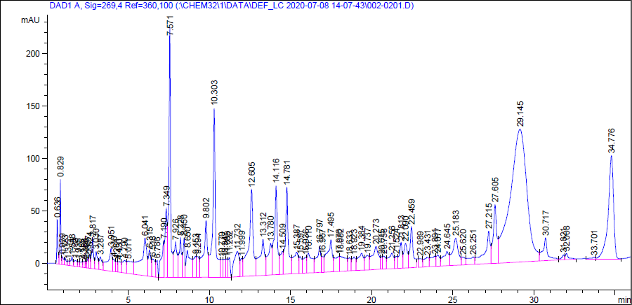
Figure 3. Comparative HPLC Chromatograms of Amino Acid Standards and the Analyzed Maclura pomifera Sample
Quantitative analysis of the peak intensities observed in the HPLC chromatogram revealed the presence and concentrations of 20 amino acids in Maclura pomifera fruit. The quantitative composition of the identified amino acids is summarized in Table 2.
Table 2. Quantitative Amino Acid Profile of Maclura pomifera Fruit
№ | Amino acids | Quantitiesmg/g | № | Amino acids | Quantitiesmg/g
1 | Aspartic acid | 0,894438 | 11 | Proline | 0,008473
2 | Glutamic acid | 0,902388 | 12 | Tyrosine | 0,519465
3 | Serine | 1,078687 | 13 | Valine | 0,514286
4 | Glycine | 0,658116 | 14 | Methionine | 0,216077
5 | Asparagine | 0,663402 | 15 | Isoleucine | 0,889492
6 | Glutamine | 1,347714 | 16 | Leucine | 0,926678
7 | Cysteine | 0,594109 | 17 | Histidine | 0,427061
8 | Treonine | 0,539624 | 18 | Tryptophan | 0,539297
9 | Argenine | 0,56209 | 19 | Phenylalanine | 0,062733
10 | Alanine | 0,80958 | 20 | Lysine HCl | 0,013374
The results of the study demonstrated that Maclura pomifera fruit contains all 20 amino acids commonly found in living organisms. Among the identified amino acids, serine, glutamine, and leucine were present at the highest concentrations, whereas aspartic acid, glutamic acid, isoleucine, and glycine were detected at moderately elevated levels compared with the remaining amino acids. The concentrations of all other amino acids were comparatively lower.
4. Conclusions
Based on the results of the conducted investigations, the following conclusions were drawn regarding the phytochemical composition and biological activity of Maclura pomifera fruit:
Extraction and Yield. The oil content of Maclura pomifera fruit was determined to range from 28.56% to 29.42%. Using an acid precipitation method, a glycoprotein, identified as macluralisin, was isolated with a yield of 18%. The isolated protein exhibited a molecular mass of approximately 65 kDa.
Analysis of Individual Compounds. Ellagic acid was synthesized using 0.5% sulfuric acid with a yield of 5% (2 g obtained from 40 g of raw material) and a purity of 88.18%. In addition, pomiferin and osajin were separated from the fruit extract into eight fractions by column chromatography employing a chloroform–ethyl acetate solvent system (8:2, v/v). The structures of the isolated compounds were confirmed using modern physicochemical techniques, including high-performance liquid chromatography (HPLC), ultraviolet (UV) spectroscopy, and gel electrophoresis.
Technological Development. A technology for obtaining Maclura pomifera fruit extract based on the maceration method was developed. Furthermore, a formulation of biologically active dietary supplements possessing antioxidant properties was created on the basis of this extract and was found to comply with the requirements of the State Pharmacopoeia.
References
Christian Bailly. Pharmacological properties of extracts and prenylated isoflavonoids from the fruits of Osage orange (Maclura pomifera (Raf.) C.K.Schneid.) Sep:177:106112.doi: 10.1016/j.fitote.2024.106112. Epub 2024 Jul 5
Adjonu, R., Doran, G., Torley, P., & Agboola, S. Screening of whey protein isolate hydrolysates for their dual functionality: Influence of heat pre-treatment and enzyme specificity. Food Chemistry, 136(3-4), 1435–1443. doi:10.1016/j.foodchem.2012.09.053
Alizadeh-Pasdar, N., & Li-Chan, E. C. Y. (2000). Comparison of protein surface hydrophobicity measured at various pH values using three different fluorescent probes. Journal of Agricultural & Food Chemistry, 48(2), 328–334.
Cheison, S. C., Schmitt, M., Leeb, E., Letzel, T., & Kulozik, U. (2010). Influence of temperature and degree of hydrolysis on the peptide composition of trypsin hydrolysates of b-lactoglobulin: Analysis by LC-ESI-TOF/MS. Food Chemistry, 121(2), 457–467.
López, L. M. I., Natalucci, C. L., Caffini, N. O., & Curotto, E. (1993). Isolation and partial characterization of serine proteinases present in the latex of Maclura pomifera («Osage orange») fruits. Acta Alimentaria (Budapest), 22(2), 131–142.

