 CHEMICAL ENGINEERING TRANSACTIONS  VOL. xxx, 2026 | A publication of  
The Italian Association
of Chemical Engineering
Online at www.cetjournal.it

Guest Editors: Flavio Manenti, Botir Usmonov, Alessandro Di Pretoro
Copyright © 2026, AIDIC Servizi S.r.l.
ISBN 979-12-81206-xx-x; ISSN 2283-9216

Acid Gas to Methanol: a New Process for Low-carbon Fuel Synthesis
Flavio Manenti*, Simone Colombo, Giulia L. Bozzano
Politecnico di Milano, CMIC Dept. „Giulio Natta“, Piazza Leonardo da Vinci 32, 20133 Milano, Italy
* flavio.manenti@polimi.it
The neutralization of acid gases represents one of the main challenges both in fossil and bio-processes such as refining, natural gas processing, and gasification industries. AG2S™ (Acid Gas to Syngas™), developed at Politecnico di Milano proposes a paradigm shift by transforming H₂S and CO₂ from by-products requiring treatment into valuable feedstocks for syngas production.
The core of the process is a regenerative thermal reactor in which the new overall reaction 2 H₂S + CO₂ → H₂ + CO + S₂ + H₂O takes place. A limited oxygen supply provides the heat required by the endothermic nature of reaction, while the separation and recycling of unconverted reactants increase the overall conversion efficiency. Integration with existing Claus units makes AG2S™ process suitable for plant revamping, reducing the environmental impact while simultaneously valorizing carbon and sulfur. The resulting syngas can be used for the downstream production of hydrogen, methanol, Sustainable Aviation Fuel (SAF) or other fuels and chemicals, promoting the integration of emission treatment and energy-carrier production.
This contribution presents the chemical engineering fundamentals of the technology, its main process design features, and the preliminary results of techno-economic feasibility studies, highlighting its potential application in the production of low-carbon fuels by processing sulfur-containing feedstocks. The case of methanol synthesis and purification at IMPCA standard grade is briefly described and adopted as ideal case-study to demonstrate the feasibility of acid gas emissions to syngas and, thus, to methanol ad low-carbon fuel.
  - Introduction
Hydrogen sulfide is a natural compound in gas fields and anaerobic basins as well as an unavoidable synthetic by-product of hydrodesulfurization (of both fossil and bio resources) and acid-gas treatment (Gupta et al., 2016). Conventional sulfur recovery converts H₂S into elemental sulfur adopting a partial combustion (reaction 1) in the order of one third of the total, within an in-line refractory chamber and the Claus synthesis (reaction 2) in a series of catalytic converters according to the sulfur removal target (Towler and Lynn, 1993; Manenti et al., 2014):

(Hydrogen sulfide combustion)
H₂S + 1.5 O₂ = SO₂ + H₂O (1)

(Claus reaction, S₂ allotrope only has been considered for the sake of simplicity)
2 H₂S + SO₂ = 1.5 S₂ + 2 H₂O (2)

Unfortunately, by doing so, the hydrogen fraction of the molecule is not valorized and it is fully converted to water. This limitation becomes increasingly relevant as sour feedstocks are processed and as hydrogen efficiency acquires greater economic and environmental importance as per energy and environmental transition times. The AG2S™ process addresses this issue by using H₂S as both a hydrogen source and a (free) reducing agent for CO₂, which is very often co-present in acid gas streams, producing synthesis gas (namely, syngas) together with recoverable sulfur and water.
AG2S™ process differs from the conventional Sulfur Recovery Units (SRUs), mainly implemented as Claus processes, because the target is not only sulfur recovery. A controlled fraction of H₂S is still oxidized as per Claus process (reaction 1), but using pure oxygen rather than combustion air and using a smaller amount of oxygen with respect to the stoichiometric one third adopted in traditional processes. Typical amount of oxygen, in fact, varies between 5-25%v and the optimal injection varies according to different compositions of the feedstock (e.g., presence of ammonia) and, therefore, the optimal temperature to be achieved in the thermal chamber to destroy all the impurities and simultaneously providing the appropriate heat required by endothermic H₂S splitting and CO₂ reduction of the overall AG2S™ reaction:

(Overall AG2S™ reaction replacing Claus thermal step)
2 H₂S + CO₂ = H₂ + CO + S₂ + H₂O (3)

Reaction (3) condenses the neutralization of H₂S and the reduction of CO₂ without any exploitation of resources and consuming a minor injection of oxygen for energy self-sustainability according to the exothermic nature of reaction 1. The resulting syngas (H₂ and CO mixture) can subsequently be used as intermediate for fuels or chemical syntheses apart from conditioning and cleaning by shift reaction and carbon capture technologies. Previous studies on AG2S™ process confirmed feasibility and appeal of its integration with sulfur chemistry, pilot tests and industrial campaigns, demonstrating technology robustness and readiness for industrial deployment.
The objective of this contribution is consequently twofold: to provide a compact description of the AG2S™ process operating window and approach the production of methanol starting from acid gases. Particular attention is paid to preliminary quantitative operating and economic targets.
  - Process Configuration
AG2S™ process is focused on a Regenerative Thermal Reactor (RTR) comprising feed preheating, a high-temperature combustion zone and rapid heat recovery (Figure 1). Acid gas containing H₂S and CO₂ is preheated to approximately 700 °C by exchanging heat with the reactor effluent. Oxygen is then introduced to raise the furnace temperature to the 1150–1350 °C range. Partial H₂S oxidation (reaction 1) supplies the thermal duty, while H₂S pyrolysis and the global oxy-reduction chemistry generate hydrogen and carbon monoxide as per reaction (3). Detailed sulfur kinetics are required because COS, CS₂ and sulfur allotropes influence both conversion and downstream purification (Manenti et al., 2013).
The reactor effluent must be quenched rapidly to approximately 900 °C to suppress relevant recombination of H₂ with sulfur to give back H₂S and to limit COS formation. Heat is recovered in a waste heat boiler and in the gas/gas exchanger acting as energy recuperator. It is worth noting that the waste heat boiler is recovering much less duty with respect to traditional processes. The produced syngas, must undergo a deep cleaning after cooling. A catalytic section is required for three different targets: the removal of small amount of SO₂ generated by oxygen injection; which is possible adopting reaction 2 over alumina filling; the hydrolysis of sulfur and organo-sulfur compounds, which is possible by means commercial catalysts and dedicated converter; and the removal of persisting sulfur vapors by means of hydrogenation step, which is also well-know step. Condensation separates water and sulfur from syngas, whereas residual H₂S and CO₂ still affecting the syngas are finally removed and recycled back to RTR by means of conventional sweetening processes (e.g., amine washing), with a purge preventing accumulation of non-reactive species.

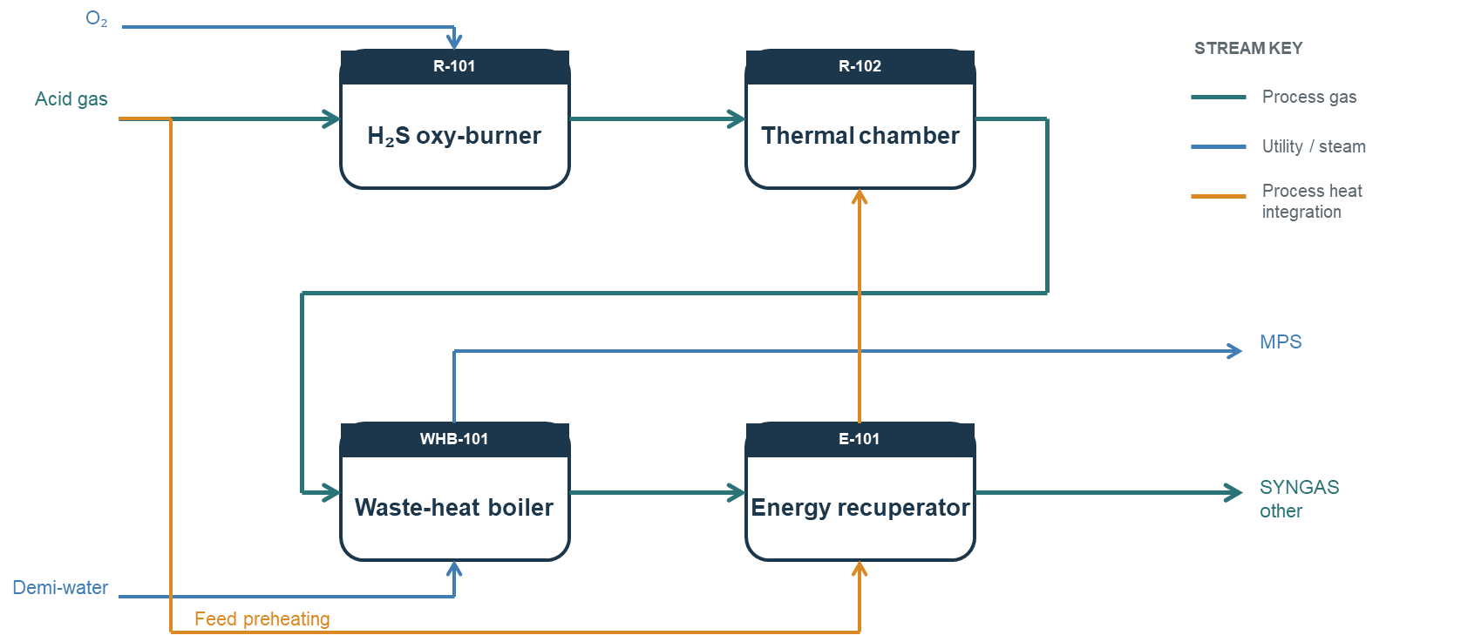
Figure 1: Representation of the AG2S™ thermal section named Regenerative Thermal Reactor (RTR). The diagram emphasizes energy integration and reaction quenching.
    - Multi-scale process modelling
Kinetic scale
A detailed kinetic package developed at Politecnico di Milano was adopted as modelling basis (Manenti et al., 2013); a reduced model has been also proposed in the literature for reasonably simplified multi-scale process simulations (Andoglu et al., 2019). The broader mechanism contains more than 500 species and about 20000 reactions and had previously been validated for industrial acid gas combustion processes. The kinetic model is embedded in non-ideal reactor models and linked to process simulator in an integrated multi-scale modeling approach. This is essential because equilibrium calculations alone cannot describe the short residence times and recombination phenomena that govern H₂, CO and sulfur-species yields.
The RTR combines a regenerative heat-exchange section with a high-temperature reaction zone and its feedstock is split in two streams:

- the main stream to preheat the rest of acid gas to approximately 700 °C by the hot reactor effluent;
- the secondary stream to supply the oxy-burner at low temperature (near 250 °C).

A limited amount of oxygen combined with the secondary stream supplies the heat required to raise the temperature of RTR and sustain the conversion (reaction 3). The reference design pressure is in the range of 1.2-1.5 bara, residence time is roughly 0.4 s and reaction temperatures are up to 1500 °C. The hot product gas must then be cooled rapidly down to 900 °C in the waste heat boiler to limit recombination reactions and preserve the generated syngas.

Process scale
The reactor calculations demonstrate the strong effect of temperature on reactant conversion and syngas formation (Table 1). For an ideal basis of 10 kmol CO₂ and 30 kmol H₂S, the high-temperature case uses 9.19 kmol O₂ and reaches 1500 °C. The calculated outlet contains 4.47 kmol CO₂, 4.32 kmol H₂S, 11.25 kmol S₂, 6.32 kmol H₂ and 5.40 kmol CO. At 1000 °C, with 3.47 kmol O₂, the residual reactants increase to 7.44 kmol CO₂ and 19.79 kmol H₂S, while H₂ and CO decrease to 3.99 and 2.23 kmol, respectively. These results confirm that high temperature is a key driver for H₂S activation and CO₂ reduction, although oxygen dosage must be controlled because excessive oxidation would consume the generated hydrogen. In any case, a process optimization selecting the best operating condition balancing the optimal temperature (then, the optimal amount of oxygen) and the size of recycle stream of unreacted acid gas is possible and scheduled for future developments.
Table 1. Boundary operating conditions and effluents for RTR with related quantity and quality of syngas for feeds of 30 kmol H₂S and 10 kmol CO₂.
Case | RTR T (°C) | H₂ (kmol) | CO (kmol) | O₂ (kmol) | CO₂ (kmol) | H₂S (kmol)
High temperature | 1500 | 6.32 | 5.40 | 9.19 | 4.47 | 4.32
Low temperature | 1000 | 3.99 | 2.23 | 3.47 | 7.44 | 19.79

The complete process comprises reaction, cooling and separation. Acid gas, CO₂ and a small oxygen stream enter the RTR. The effluent is first quenched in a waste-heat boiler, where Medium Pressure Steam (MPS) is generated, and then cooled through the regenerative section. Rapid cooling is important to suppress recombination effects. Elemental sulfur is condensed and removed, followed by water separation. Remaining SO₂ may be handled through dedicated separation or, more advantageously especially in case of refurbishing, through the catalytic train of a Claus unit. Finally, residual H₂S and CO₂ are removed from the syngas by an acid-gas separation step such as amine absorption and regeneration and are recycled to the RTR.
    - Surrogate modeling
Design variables and performance indicators
Two dimensionless feed ratios have been investigated as operating window for AG2S™ process (Caspani et al., 2026): H₂S/CO₂ ratio, which controls the relative availability of reducing species and carbon oxide, and H₂S/O₂, which controls oxygen availability and therefore the furnace thermal level. The principal responses are overall single-pass H₂S conversion, syngas selectivity, syngas molar flow rate and the H₂/CO molar ratio. The latter is particularly important because organic synthesis typically require substantially more hydrogen-rich feeds than the raw AG2S™ product. Furnace temperature and waste-heat-boiler outlet temperature are treated as hard process constraints rather than optimization targets.

Reaction and heat-management implications
At high temperature, H₂S splitting forms H₂ and sulfur, while the reaction (3) with CO₂ produces CO. Both the splitting route and reaction (3) are endothermic and benefit from high temperature. Oxygen addition is therefore necessary, but it creates an intrinsic selectivity penalty because complete H₂S oxidation produces SO₂ and H₂O instead of syngas. The waste heat boiler has a second function in addition to steam generation: its cooling rate determines how effectively the high-temperature radicalic pool is extinct. Slow cooling favours reassociation of H₂ with sulfur and the formation of COS, reducing recoverable hydrogen and increasing the burden on the catalytic section.
This thermal-chemical coupling explains the choice of the two feed ratios as design variables. H₂S/O₂ is a direct proxy for combustion intensity, whereas H₂S/CO₂ changes both reaction stoichiometry and the relative availability of carbon for CO formation. Their interaction cannot be interpreted from stoichiometry alone and motivates the use of the detailed simulation as the data-generating model.
  - Syngas conversion into methanol
AG2S™ process acts in substitution of syngas generation units such as reformers or gasifiers. Then, whatever syngas-based synthesis is simplified in terms of process layout in case of green or brown fields or the synthesis is boosted in case of refurbished fields. Methanol synthesis is selected as case-study and it is integrated to AG2S™ process as in the Block Flow Diagram (BFD) reported in Figure 2. The syngas is purified by:

- SO₂ generated in reaction (1) by means of a single catalytic converter for Claus reaction (2);
- Organo-sulfur species such as COS and CS₂ (tens/hundreds of ppm) by means of catalytic hydrolyser;
- Sulfur vapors (mainly S₈ allotrope, tens of ppm) by means of catalytic hydrogenation;
- Non reacted H₂S and CO₂ by means of amine washing.

Syngas conditioning is performed by water-gas shift unit including sequestration of CO₂ surplus. Methanol synthesis is performed by means of MeOHmax™ process and DZMR™ reactor (Leonzio et al., 2025; Manenti and Manenti, 2026). Specifically, a series of two DZMR™ with intermediate product recovery is adopted. At last, purification of methanol/water mixture is performed by means of pre-flash tower to remove dissolved incondensable gases and primary distillation column for methanol/water splitting. No impurities have been considered.
A Process Flow Diagram (PFD) implemented using AspenHysys is reported in Figure 3. Syngas coming from AG2S™ unit is compressed to 63 bara using multi-stage intercooled compressor. Gas is further heated up to 250°C before entering DZMR™ reactor. Vanden Bussche and Froment (Vanden Bussche and Froment, 1996) kinetics has been adopted and implemented in AspenHysys according to literature standards (Bisotti et al., 2022). Non reacted syngas is recycled back to the synthesis by means of a booster, whereas the liquid condensate containing methanol and water is collected and sent to the downstream section. Downstream section consists of a first low-pressure vessel operating at 3 bara to remove the majority of incondensable gases to be supplied to the flaring line, the pre-flash operating at 1.5 bara and 8 stages to stabilize the liquid product, and the primary distillation column operating at 3 bara and 40 stages. Without considering any impurity, IMPCA standard grade is achieved with 27 stages; a rough overdesign of 50% have been adopted to account for impurities (e.g., ethanol, di-methyl-ether). At last, a methanol storage is modelled at 2.5 bara of operating pressure. Energy integration between AG2S™ unit and methanol synthesis is also feasible, but not considered for the current contribution.
  - Process analysis
According to Table 1 and to detailed modelling and simulation of Paragraphs 2 and 3, methanol production would ideally range between 1.94 – 3.67 kmol per unit of time having fixed the following operating specs:

- 5% of purge of syngas recycle in the methanol synthesis;
- 1% of methanol fraction lost at the bottom of the primary distillation unit.

Taking into consideration compact and modular processes for methanol synthesis such as MeOHmax™, reasonable CapEx breakeven based on author experience is in the order of 3 kt/y of IMPCA grade methanol production starting from biogas/biomethane/methane. In the case of AG2S™ process combined with methanol synthesis, the breakeven would be therefore consistently achieved with 120 kmol/h of H₂S and 40 kmol/h of CO₂, corresponding to almost 6 t/h of acid gases in molar ratio 3/1, respectively, which is largely less than typical capacities of acid gas treatment units making the solution applicable everywhere. Moreover, CapEx of the reforming unit and/or gasification unit has not to be accounted in the case of AG2S™ technology since the sulfur recovery unit, which already exists to neutralize acid gases, is also generating the syngas for synthesis of fuels. It unavoidably means that the overall CapEx of the proposed process is further reduced with respect to biogas/biomethane/methane field applications and the breakeven capacity of 3 kt/y is even halved.
To what above, for the sake of consistency, it should be considered that no costs for resources as input has to be accounted for, since two emissions only, namely H₂S and CO₂, are considered as feedstock for methanol synthesis. On the contrary, whatever other process currently industrially deployed that utilizes CO₂ requires costly molecules (e.g., methane, hydrogen, ammonia). To be precise, since the process is utilizing CO₂ as feedstock, local incentives should be accounted in techno-economic analyses. The real operational cost in terms of resources is pure oxygen injection, but reduced size of the plant and reduced injection both make less relevant the cost item.

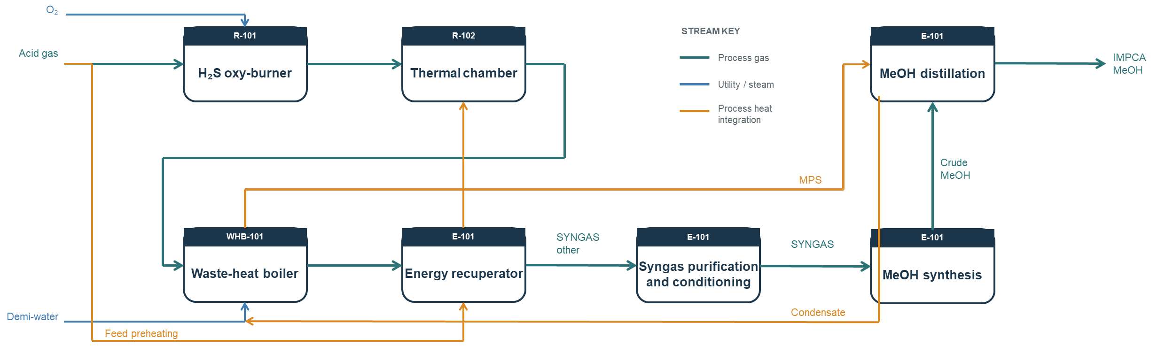
Figure 2: Integrated AG2S™ and methanol synthesis using MeOHmax™ process and DZMR™ reactor, Block Flow Diagram (BFD).

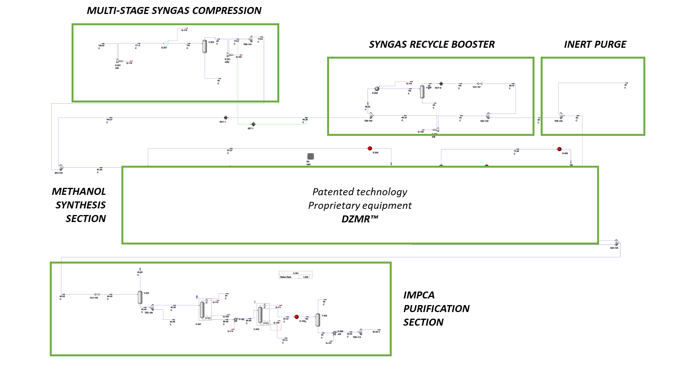
Figure 3: Process Flow Diagram of MeOHmax™ process and DZMR™ reactor for methanol synthesis developed in AspenHysys.
The only remaining relevant operational cost is syngas compression between low-pressure AG2S™ and high-pressure MeOHmax™ units, but it is an order of magnitude less than the income of produced methanol at conservative market price. Giving such promising preliminary process data, a detailed sus-techno-economic analysis will be accomplished for future contributions.
  - Conclusions
Acid Gas to Syngas™ (AG2S™) process for the production of low-carbon fuels starting from acid gases has been demonstrated as viable route for energy and environmental transition targets. Co-presence of H₂S and CO₂ or an appropriate mixing of these emissions has been adopted as feedstock for syngas production and methanol synthesis by means of detailed process modelling and process simulation. The coupling of AG2S™ technology with existing and well-established compact processes for IMPCA grade methanol production preliminarily demonstrated the economic appeal of such solutions, providing some indications on plant size limiting threshold for CapEx breakeven and major operating cost items to be accounted for more detailed and deterministic process techno-economic analyses and energy-process optimizations. As the main achievement of the paper and looking forward to future developments to improve the acid gas to methanol synthesis process, 25%w conversion efficiency has been achieved with conservative computations. Removing from performance computing the elemental sulfur production so as to relate the yield to C, H and O chemical elements only, full process performance is higher than 50%w without any exploitation of (neither fossil nor bio-) resources. Conversion of acid gases by means of AG2S™ process is viable route also for the synthesis of Sustainable Aviation Fuel (SAF), di-methyl-ether, and synthetic methane to quote a few.
Acknowledgments
Support from Ing. L. Molinari and Ing. G. Manenti is gratefully acknowledged for process debottlenecking and thermal design, respectively. Prof. E. Ranzi is also gratefully acknowledged for supporting the implementation of complex kinetics for in-line refractory chamber and reactive waste heat boiler of Acid Gas to Syngas™ process technology.
References
Andoglu, E. M., Dell’Angelo, A., Ranzi, E. M., Kaytakoǧlu, S., Manenti, F., Chemical Engineering Transactions, 2019, 74, pp. 649–654.
Bisotti, F., Fedeli, M., Prifti, K., Galeazzi, A., Dell’Angelo, A., Manenti, F.; Impact of Kinetic Models on Methanol Synthesis Reactor Predictions: In Silico Assessment and Comparison with Industrial Data, Industrial Engineering Chemistry Research, 2022, 61 (5), pp. 2206–2226.
Caspani, S., Sánchez, L. F., Vallerio, M., Manenti, F., Optimal Design of Acid Gas-to-Syngas (AG2S) Technology: Process Optimization and Surrogate Modeling, Industrial and Engineering Chemistry Research, 2026, 65(15), pp. 8006–8016.
Gupta, A.K., Ibrahim, S., Al Shoaibi, A., Advances in sulfur chemistry for treatment of acid gases, Progress in Energy and Combustion Science, 2016, 54, pp. 65-92.
Leonzio, G., Manenti, G., Bozzini, M. M., Baratti, R., & Manenti, F. (2025). “Analysis of a Methanol Synthesis Reactor Operating in Non-Isothermal Cooling Conditions.” Fuel Processing Technology, 276, 108288. DOI: 10.1016/j.fuproc.2025.108288.
Manenti, F., Manenti, G., Sustainability Deployment by Modular and Practical Solutions: Biogas to Biomethanol Conversion using MeOHmax™ process and DZMR™ reactor, Chemical Engineering Transactions, 2026, vol. 128.
Manenti, F., Papasidero, D., Bozzano, G. L., Ranzi, E. M., Model-based optimization of sulfur recovery units, Computers and Chemical Engineering, 2014, 66, pp. 244–251.
Manenti, F., Papasidero, D., Ranzi, E. M., Revised kinetic scheme for thermal furnace of sulfur recovery units, Chemical Engineering Transactions, 2013, 32, pp. 1285–1290.
Towler, G.P. and Lynn, S., Development of a zero-emissions sulfur-recovery process. 1. Thermochemistry and reaction kinetics of mixtures of hydrogen sulfide and carbon dioxide at high temperature, Industrial & Engineering Chemistry Research, 1993, 32(11), pp. 2800–2811.
Vanden Bussche K.M., Froment G.F., A steady-state kinetic model for methanol synthesis and the water gas shift reaction on a commercial Cu/ZnO/Al2O3 catalyst, Journal of Catalysis, 1996, 161(1), 0156.

