Valorization of Mineralized Wastewater from the Shortan Gas Chemical Complex for Production of Powdered Technical Detergent: Physicochemical Characterization and Environmental Assessment
Saidova D.Sh*.
Doctoral researcher (PhD) at the
Tashkent Institute of Chemical Technology,
Navoi 32, Tashkent, 100011, Uzbekistan
durdona9009@mail.ru
Erkaeva N.A.
Senior Lecturer at the
Tashkent Institute of Chemical Technology,
Navoi 32, Tashkent, 100011, Uzbekistan
serena0288@mail.ru
Tursunova D.A.
Associate Professor at the
Tashkent Institute of Chemical Technology,
Navoi 32, Tashkent, 100011, Uzbekistan
tdadildora@mail.ru
Koshanova B.T.
Senior Lecturer at the
Tashkent Institute of Chemical Technology,
Navoi 32, Tashkent, 100011, Uzbekistan
koshanova_nmkt@mail.ru
Erkaev A.U.
Professor at the
Tashkent Institute of Chemical Technology,
Navoi 32, Tashkent, 100011, Uzbekistan
Aerkaev_1960@mail.ru

Abstract
Industrial wastewater generated in gas-chemical complexes is characterized by a high degree of mineralization and the presence of dissolved inorganic salts, which pose significant environmental challenges if discharged without treatment. The Shortan Gas Chemical Complex, as one of the major gas processing facilities, produces large volumes of mineral-rich wastewater during gas purification, cooling, chemical washing, and auxiliary technological operations. These effluents contain predominantly sodium- and sulfate-based compounds that contribute to increased total dissolved solids and environmental salinization risks.
In the present study, mineral salts were recovered from wastewater streams of the Shortan Gas Chemical Complex through a combination of filtration and thermal drying processes, followed by mechanical grinding to obtain a powdered product. The physicochemical properties of the recovered material were investigated using X-ray diffraction (XRD), scanning electron microscopy coupled with energy dispersive X-ray spectroscopy (SEM–EDX), and differential thermal/thermogravimetric analysis (DTA/TGA).
XRD analysis confirmed that the recovered material is predominantly composed of thenardite (Na₂SO₄) with a crystallinity degree of 51.19%, along with minor phases of sodium sulfate derivatives and sodium thiosulfate. SEM observations revealed irregular crystalline morphology with particle sizes ranging between 5–10 μm, while EDX analysis confirmed a homogeneous distribution of Na, O, and S elements. Thermal analysis indicated high stability of the material, with characteristic dehydration and phase transition behavior observed at 261.23°C and melting at approximately 884.04°C.
The obtained sulfate-rich material demonstrates significant potential as a functional builder in powdered technical detergents, contributing to improved dispersion, anti-caking behavior, and surfactant efficiency. The proposed approach supports circular economy principles, reduces industrial wastewater burden, and enables the conversion of waste streams into value-added chemical products.
Keywords: wastewater valorization, gas-chemical complex, sodium sulfate, technical detergent, XRD, SEM–EDX, circular economy, green chemistry

1. Introduction
The rapid expansion of gas-processing and petrochemical industries has significantly increased the generation of industrial wastewater containing high concentrations of dissolved inorganic salts. These effluents, if not properly managed, represent a major source of environmental pollution, leading to soil salinization, groundwater contamination, and disruption of ecological balance. In recent years, the concept of wastewater valorization has gained increasing attention as part of sustainable development and circular economy strategies, where industrial waste streams are treated as secondary raw material sources (Ahmed and Geed, 2025; Tatiya et al., 2024).
The Shortan Gas Chemical Complex (Uzbekistan) is a large-scale gas processing facility where natural gas purification, fractionation, cooling, absorption–desorption, and chemical washing processes are continuously performed. During these operations, significant quantities of mineralized wastewater are generated. The main sources include gas scrubbing units, chemical absorption systems, cooling circuits, and regeneration processes. These wastewater streams are characterized by elevated concentrations of sodium ions and sulfate-based species, as well as trace inorganic compounds formed during gas treatment reactions.
Under conventional industrial practice, such wastewater is typically subjected to neutralization or partial treatment before discharge. However, the increasing emphasis on environmental sustainability has shifted focus toward resource recovery from waste streams. In this context, sodium sulfate-rich residues present in industrial wastewater can be considered a valuable raw material for chemical applications.
Recent studies have increasingly emphasized the recovery of valuable inorganic components from industrial wastewater as an alternative to conventional treatment and disposal. In particular, mineralized waste streams containing sodium, sulfate, carbonate, and chloride ions can be considered secondary sources of chemical raw materials when appropriate separation and purification methods are applied. Such approaches contribute to reducing the environmental load associated with wastewater discharge while simultaneously decreasing the consumption of primary mineral resources (Luo et al., 2025)..
Sodium sulfate is an important inorganic material with applications in detergent manufacturing, pulp and paper production, glass manufacturing, and several chemical processes. In detergent formulations, sodium sulfate can serve as a builder or filler component, contributing to powder flowability, reduction of caking, and regulation of ionic strength. Therefore, the recovery of sodium sulfate-rich fractions from industrial effluents may provide both environmental and technological benefits.
From the perspective of circular economy, the transformation of mineralized wastewater into a usable chemical product is particularly attractive because it combines waste minimization with resource recovery. However, the applicability of recovered salts depends strongly on their phase composition, elemental composition, morphology, thermal stability, and the presence of potentially undesirable impurities. Consequently, physicochemical characterization is an essential step before considering recovered mineral fractions for industrial applications (Reyes et al., 2025).
Sodium sulfate is widely used in detergent formulations as a builder component, playing a crucial role in controlling ionic strength, improving powder flowability, preventing caking, and enhancing the efficiency of surfactants. Therefore, the recovery of sodium sulfate from industrial wastewater offers a dual advantage: environmental protection and economic benefit through substitution of commercially produced raw materials (Karlilar Pata and Pata, 2025; Ahmed and Geed, 2025).
The objective of this study is to investigate the recovery of mineral salts from Shortan Gas Chemical Complex wastewater using filtration and drying methods, to characterize their physicochemical properties, and to evaluate their suitability for use in powdered technical detergent formulations.

2. Materials and Methods
Wastewater Source and Salt Recovery Process. Industrial wastewater samples were collected from technological units of the Shortan Gas Chemical Complex, including gas purification, cooling systems, and chemical washing sections. The collected wastewater was subjected to a multistage treatment process involving mechanical filtration to remove suspended solids, followed by vacuum filtration to concentrate dissolved salts. The resulting slurry was then dried at 105–120°C to obtain crystalline solid residues. The dried material was subsequently milled to produce a homogeneous powdered product suitable for further characterization (Tursunova et al., 2022; Tursunova et al., 2025; Vakhobova et al., 2025).

X-Ray Diffraction (XRD) Analysis. Phase composition of the recovered material was analyzed using a Rigaku NEX CG diffractometer equipped with Cu-Kα radiation. The diffraction patterns were recorded and compared with standard database references to identify crystalline phases.
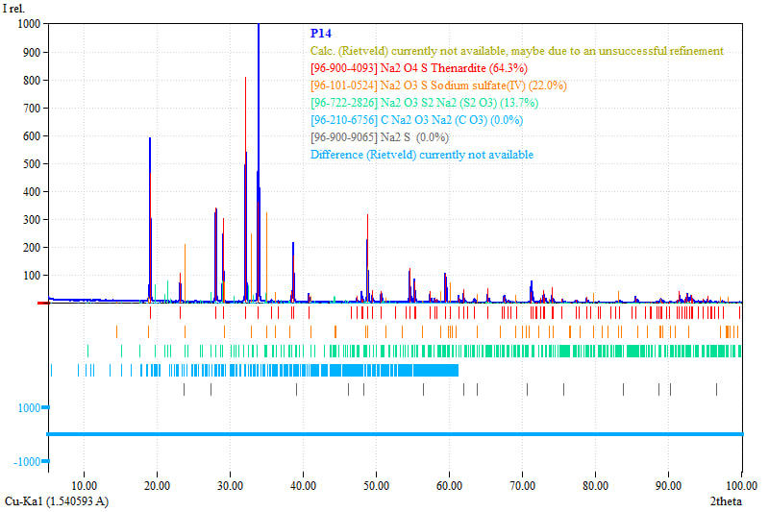
Figure 1. XRD diffraction pattern of recovered salt from wastewater.
The XRD results indicated that the material is mainly composed of thenardite (Na₂SO₄), accounting for 64.3% of the total crystalline phases. Secondary phases include sodium sulfate derivatives (Na₂O₃S, 22.0%) and sodium thiosulfate (Na₂S₂O₃, 13.7%). The overall crystallinity degree was determined to be 51.19%, indicating a semi-crystalline structure suitable for industrial processing applications.
Scanning Electron Microscopy (SEM–EDX)
The SEM–EDX analysis of sample P14 revealed an irregular crystalline morphology with particles and aggregates in the micrometre range. The elemental mapping demonstrated a relatively uniform distribution of sodium, oxygen, and sulfur throughout the analyzed area, indicating that these elements constitute the principal components of the recovered mineral phase. The EDX analysis showed approximately 41.88 wt.% Na, 39.84 wt.% O, and 18.28 wt.% S (fig 3).
The measured elemental composition should be interpreted with consideration of the inherent limitations of EDX analysis, including matrix effects, surface sensitivity, and the possible presence of minor non-detectable or overlapping phases. Therefore, the EDX results were used primarily to characterize the elemental composition and spatial distribution of the recovered material rather than to establish its absolute chemical purity. The predominance of sodium and sulfur-containing phases was further supported by the XRD results, which identified thenardite (Na₂SO₄) as the major crystalline phase.
The presence of carbon observed in the elemental mapping may be associated with the carbon-based conductive tape used during SEM sample preparation. Overall, the combined SEM–EDX and XRD results indicate that the recovered material is a sodium- and sulfate-rich mineral product dominated by sodium sulfate.
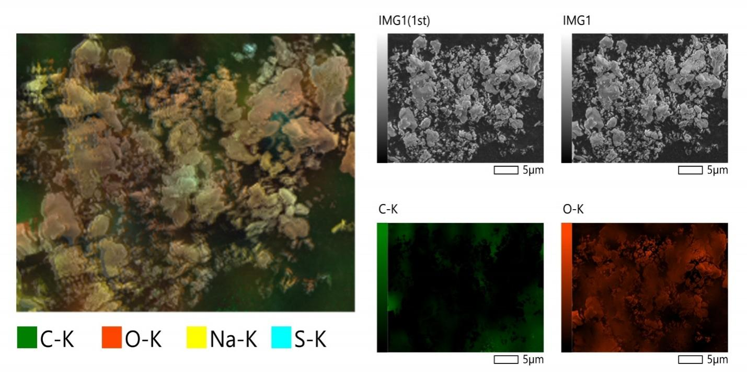
Figure 2. SEM microstructure of recovered salt particles.
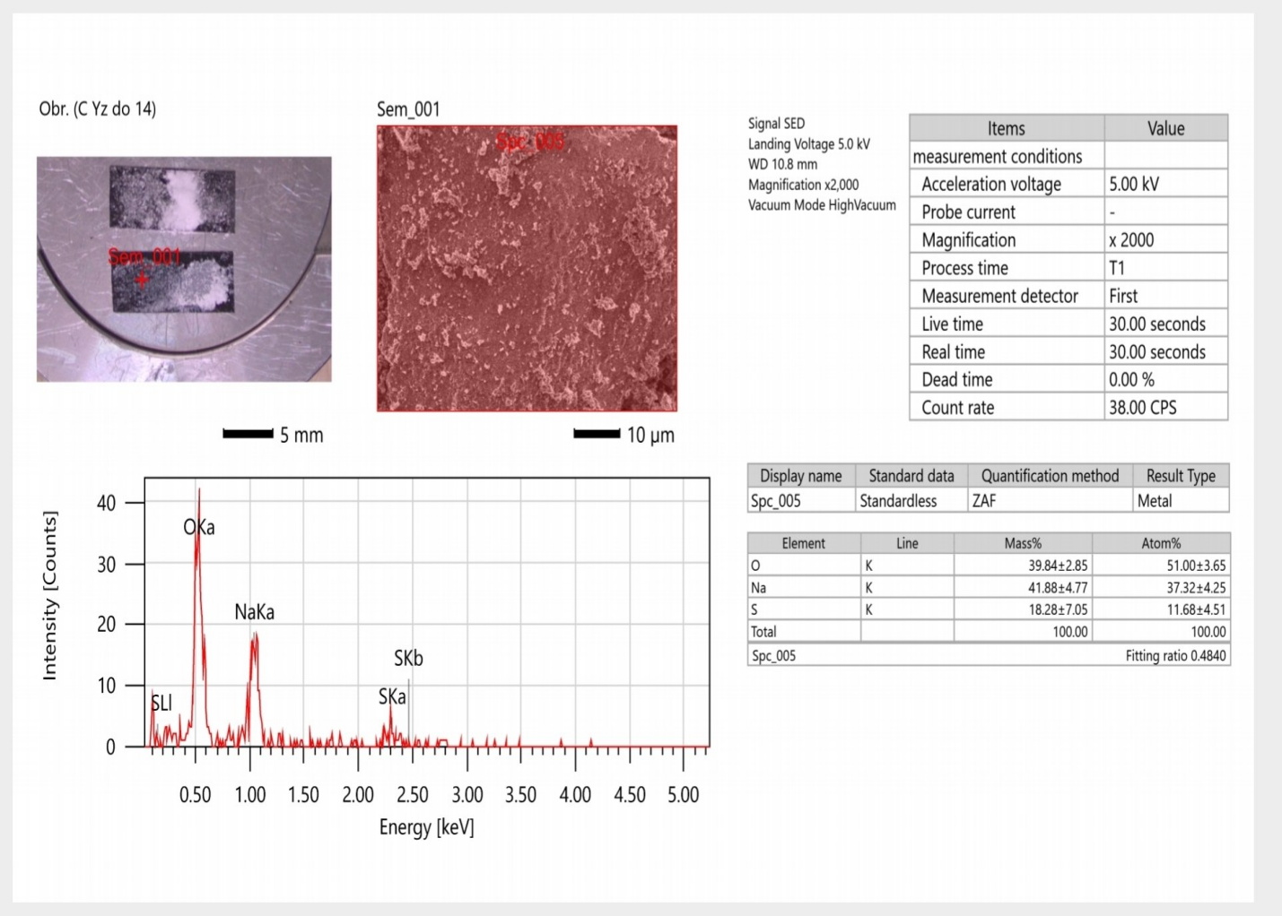
Figure 3. EDX elemental mapping of Na, O, and S distribution.

Thermal Analysis (DTA/TGA)
Thermal stability of the recovered material was evaluated using differential thermal analysis and thermogravimetric analysis up to 1000°C. The TGA curve indicated an initial mass loss of approximately 7.8% at 261.23°C, corresponding to the removal of physically adsorbed and crystalline water. A pronounced endothermic peak observed at 884.04°C corresponds to the melting point of sodium sulfate, confirming the presence of thermally stable anhydrous phases (fig 4).
The results demonstrate that the material maintains structural integrity under elevated temperatures, making it suitable for industrial detergent formulations requiring thermal stability.
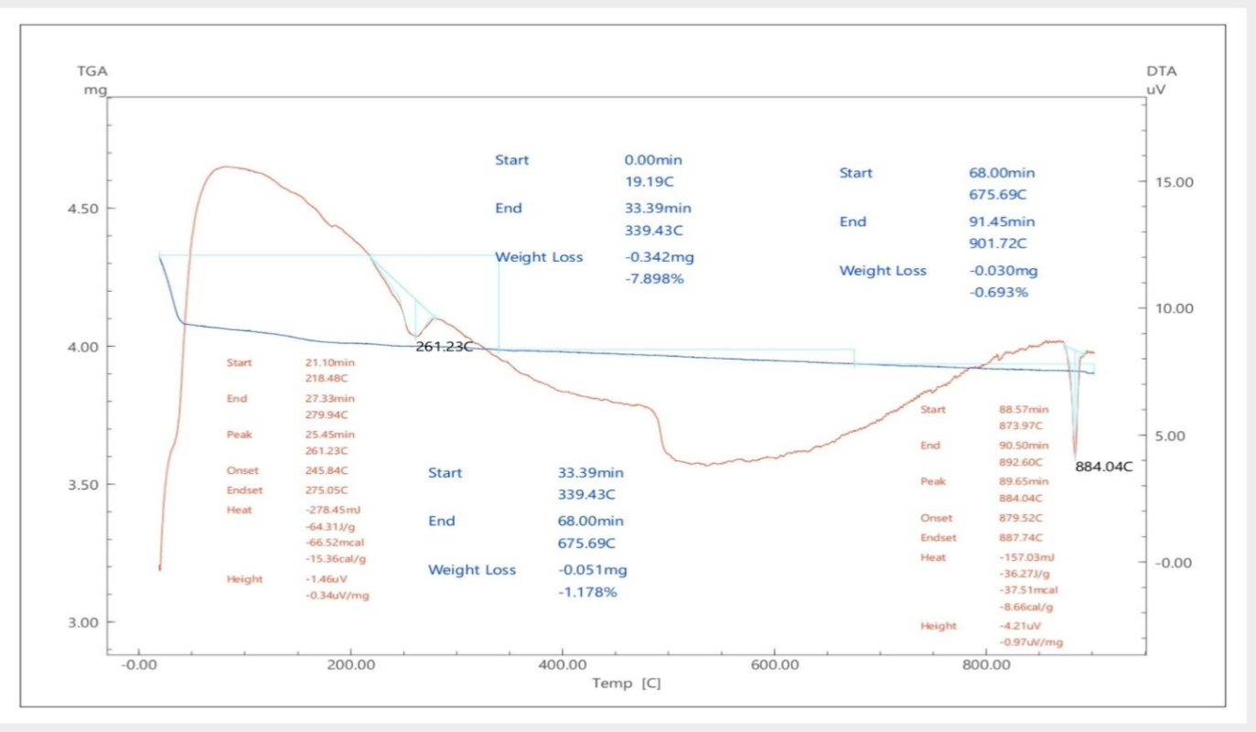
Figure 4. DTA/TGA curves of recovered mineral salt.

3. Results and Discussion
The integration of XRD, SEM–EDX, and thermal analysis confirms that the recovered material is primarily composed of sodium sulfate in a semi-crystalline form with minor sulfate-related impurities. The presence of thenardite as the dominant phase is particularly significant, as it is widely recognized as a key functional component in detergent systems.
From a morphological perspective, the particle size distribution (5–10 μm) ensures favorable flowability and mixing behavior in powdered formulations. Such characteristics are essential for achieving uniform distribution of active surfactants in technical detergents.
Thermal stability analysis indicates that the material remains stable under typical industrial washing conditions, where elevated temperatures are frequently applied. This enhances its applicability in heavy-duty cleaning operations sources (Erkayeva et al., 2023).
The recovered salt functions primarily as a builder component in detergent systems. It improves powder dispersion, reduces caking tendency, and enhances the efficiency of surfactants by controlling ionic strength in aqueous solutions.
The results obtained by the complementary analytical techniques demonstrate a consistent physicochemical profile of the recovered mineral fraction. XRD analysis identified thenardite as the dominant crystalline phase, while SEM revealed an irregular crystalline morphology of the recovered particles. EDX mapping confirmed that Na, O, and S were the predominant elements distributed throughout the analyzed region. Thermal analysis further demonstrated the high thermal stability of the sodium sulfate-rich fraction, with the major endothermic effect corresponding to melting of the sulfate phase.
The combination of structural, morphological, elemental, and thermal characterization provides a more reliable assessment of the recovered material than any individual analytical method. In particular, the predominance of sodium sulfate indicated by XRD, together with the corresponding Na-O-S elemental distribution observed by EDX, supports the proposed valorization of the recovered mineral fraction as a potential component of technical detergent formulations.

4. Application: Revised application of the recovered salt
The recovered sodium sulfate was considered as a functional builder in a powdered technical detergent formulation. The proposed formulation contained recovered Na₂SO₄ as the main builder component, together with anionic/nonionic surfactants, sodium carbonate, sodium silicate, and functional additives. The role of the recovered sodium sulfate is associated primarily with improving powder flowability, reducing the tendency of the formulation to cake, and regulating the ionic strength of the washing medium.
The proposed formulation is intended for technical cleaning applications, including the removal of oil-containing contaminants from metal surfaces, equipment, pipelines, and technological vessels in gas-chemical and petrochemical facilities. The relatively high sodium sulfate content of the recovered material makes it potentially suitable as a low-cost inorganic filler and builder component.
However, the present study primarily focused on the physicochemical characterization and valorization of the recovered mineral fraction. A detailed quantitative evaluation of oil-removal efficiency, washing kinetics, and comparison with commercial technical detergents requires additional controlled experiments. Such studies will be considered in subsequent work to determine the optimal formulation and establish the practical cleaning performance of the developed detergent (Koshanova et al., 2024)..

5. Environmental and Economic Assessment
The proposed approach contributes significantly to environmental sustainability by reducing the discharge of mineralized wastewater into natural ecosystems. The recovery and reuse of sodium sulfate from industrial effluents reduce the demand for virgin raw materials, thereby lowering energy consumption and associated carbon emissions. From an economic perspective, the utilization of wastewater-derived salts provides a cost-effective alternative to commercially produced sodium sulfate, with potential cost reductions of 25–35% in detergent production. Furthermore, this approach supports import substitution strategies and strengthens local chemical manufacturing capacity.

6. Conclusion
The present study demonstrates that mineral salts recovered from Shortan Gas Chemical Complex wastewater via filtration and drying processes can be effectively utilized as a functional component in powdered technical detergents. Physicochemical characterization confirmed that the material is predominantly composed of thermally stable sodium sulfate with suitable morphological and structural properties for industrial applications.
The proposed wastewater valorization strategy aligns with circular economy principles, offering an environmentally friendly and economically viable solution for industrial waste management. Future research should focus on large-scale process optimization and integration into existing industrial detergent production systems.

References
1. Ahmed, A. and Geed, S.R. (2025). Sustainable refinery waste management through biotechnological interventions: Health impacts, historical successes, and emerging solutions. Environmental Research. https://doi.org/10.1016/j.envres.2025.120967.
2. Erkayeva, N., Kaipbergenov, A., Erkayev, A. and Kucharov, B. (2023). Study on the process of producing sodium percarbonate. IOP Conference Series: Earth and Environmental Science, 1142(1), 012106.
4. Karlilar Pata, S. and Pata, U.K. (2025). Assessing the sustainable development in the European Union: Influence of municipal waste, industrial waste, and waste related patents. Integrated Environmental Assessment and Management, 21(1), pp. 141–151. https://doi.org/10.1093/inteam/vjae009.
5. Koshanova, B.T., Erkaev, A.U., Erkaeva, N.A. and Tursunova, D.A. (2024). Development of technology for obtaining sodium peroxide sulfate. International Journal of Materials and Chemistry, pp. 24–29. https://doi.org/10.5923/j.ijmc.20241402.03.
6. Luo, C., Zheng, B., Li, Y. and Yang, Q. (2025). Preparation of alkali-activated oil shale residue-slag geopolymer-based binder using calcium carbide slag and sodium carbonate as alkali activator. PLOS ONE, 20(1), e0317341. https://doi.org/10.1371/journal.pone.0317341.
7. Reyes, L., Bourgeois, C., Renard, G.G., Jame, P., Saupin, X., Nikitine, C. and Vilcocq, L. (2025). Analysis of aliphatic and phenolic compounds present in industrial black liquors using HPLC-DAD and IC-MS/MS methods. Journal of Chromatography B: Analytical Technologies in the Biomedical and Life Sciences, 1253, 124442. https://doi.org/10.1016/j.jchromb.2024.124442.
8. Tatiya, S., Maurya, S., Pandey, M. and Bhattacharya, S. (2024). Advanced neutralization technique for the treatment of highly acidic wastewater from steel rolling mills of western Rajasthan. Water Environment Research, 96(12), e11158. https://doi.org/10.1002/wer.11158.
9. Tursunova, D., Koshanova, B., Erkayeva, N., Shamuratova, A. and Akilova, F. (2022). Функциональные показатели синтетических моющих средств. 8th International Conference on Research in Humanities, Applied Science and Education. Berlin.
10. Tursunova, D.A., Erkaeva, N.A., Saidova, D.Sh. and Erkaev, A.U. (2025). Исследования влияния расход полифосфатов пенообразования синтезированных СМС в жестких водах. Central Asian Food Engineering and Technology, 10. ISSN: 2181-385X.
11. Vakhobova, D.N., Tursunova, D.A., Erkaeva, N.A. and Erkaev, A.U. (n.d.). Разработка метода получения полифасфатов аммония и щелочных металлов из экстракционной фосфорной кислоты Центральных Кызылкумов. Namangan davlat universiteti ilmiy axborotnomasi.
12. Vakhobova, D.N., Tursunova, D.A., Erkaeva, N.A. and Erkaev, A.U. (2025). The role of phosphates and nonionic surfactants in enhancing the detergent performance of synthetic detergents. Modern American Journal of Engineering, Technology, and Innovation, 1(9), pp. 13–20.

