 CHEMICAL ENGINEERING TRANSACTIONS  VOL. xxx, 2026 | A publication of  
The Italian Association
of Chemical Engineering
Online at www.cetjournal.it

Guest Editors: Flavio Manenti, Botir Usmonov, Alessandro Di Pretoro
Copyright © 2026, AIDIC Servizi S.r.l.
ISBN 979-12-81206-xx-x; ISSN 2283-9216

PHYSICOCHEMICAL ANALYSIS OF THE PROCESS OF OBTAINING Na₂SO₃ FROM WASTE SULFURIC ACID
Toshtemirov A*, Erkayev A*, Koshanova B*
ªTashkent Institute of Chemical Technology –Navoi Avenue 32, Tashkent- info@tkti.uz
*Toshtemirov A - azizbek.1999.11.24@gmail.com
*Erkayev A - Aerkaev61@mail.ru
*Koshanova B – koshanova_nmkt@mail.ru

Abstract
Waste sulfuric acid from Navoiyazot JSC was investigated as a secondary sulfur source for sodium sulfite production. The laboratory sequence comprised thermal treatment, condensation, two-stage absorption in sodium hydroxide solution, evaporation, filtration and drying. The reported acid concentration was 84.75 wt.%. Absorbent concentrations of 5–20 % were examined. In the 20 % experiment, the two absorbers yielded 11.85 and 5.92 g of dried solid, respectively, giving a combined recovered mass of 17.77 g. X-ray diffraction was consistent with the presence of crystalline Na₂SO₃, but did not establish quantitative purity. Thermal analysis showed measurable mass changes and a thermal event near 741 °C. Density and viscosity measurements describe the behaviour of the recovered-product solutions. The results support further evaluation of waste-acid conversion, while gas speciation, sulfur recovery and product assay remain necessary to establish selectivity and process performance.
Key words: air pollution, WHO (WORLD HEALTH ORGANIZATION), DTA (differential thermal analyses), sodium sulfite, X-ray analyses, rheological analyses.

1 Introduction
The conversion of waste sulfuric acid into usable sulfur compounds can reduce the demand for primary raw materials, provided that contaminants and secondary streams are controlled. The present work concerns waste acid generated in the caustic soda and polyvinyl chloride production area of Navoiyazot JSC. Its practical objective is to investigate a laboratory route to a sodium sulfite-containing solid rather than to assume that acid neutralisation alone produces sulfite.
Published recovery routes include purification of organic-contaminated acid by steam treatment, filtration and adsorption (Luo et al., 2014), and regenerative processing through iron sulfate intermediates (Klotz, 1998). These routes target acid recovery. In contrast, Yang (2020) describes sulfite production through sulfur dioxide absorption in sodium carbonate solution, adjustment of the reaction liquor and solid recovery. These patents establish process context, but do not validate performance for the waste acid examined here [1-4].
Hikita et al. (1977) measured SO₂ absorption into aqueous hydroxide and sulfite solutions and demonstrated the importance of interfacial transport. Weib et al. (2021) studied a magnesium-based absorption system and showed that temperature, reagent ratio and solution speciation affect precipitation. Their findings motivate explicit treatment of absorption chemistry and solid formation, although numerical conditions for magnesium systems cannot be transferred directly to sodium solutions [5-10].

2 Materials and methods
The experimental dataset comprises heating tests on waste acid, absorption experiments with four NaOH concentrations, gravimetric solid recovery, thermal analysis, X-ray diffraction and measurements of solution density and viscosity [11, 12]. The available records do not report replicate counts or measurement uncertainties; the results are therefore presented descriptively.
2.1 Waste acid and thermal treatment
The waste acid was reported to contain 84.75 wt.% H₂SO₄ and unspecified impurities. Separate heating tests used initial samples of 50 g. Residual masses and temperatures were recorded at 5, 10, 15, 20 and 40 min under five heating histories. The records do not provide a fixed heating rate or an operating pressure. Accordingly, these observations are not treated as isothermal kinetic measurements. Formation of a black solid residue was observed, but its chemical composition was not determined.
2.2 Absorption and solid recovery
The gas stream from thermal treatment passed through a condenser and two absorbers connected in series (Figure 1). Each absorber initially contained 85 g of NaOH solution, giving 170 g of absorbent per experiment. The reported NaOH concentrations were 5, 10, 15 and 20 %; the concentration basis was not explicitly stated in the original record. Condensate mass, density and pH, and selected first-absorber liquor properties were recorded. Condensation separated a liquid stream but was not demonstrated to remove all contaminants or to yield pure SO₂.
For the 20 % experiment, the absorber liquors were concentrated at a reported temperature of 100–120 °C and filtered separately. The filtered solids were heated at 150 °C for 90 min before final weighing. The source does not distinguish heater temperature from bulk-liquid temperature during evaporation. It also does not specify filtration temperature, cooling history, washing or drying atmosphere. The mass decrease on drying is reported as loss on drying, rather than as a selective water measurement [13, 14].
The first-absorber mass in this experiment is reported as 108.5 g in the original table and 106.5 g in the narrative. Both values are retained as an unresolved record discrepancy. No corrected value has been inferred. The second-absorber mass was 89.5 g in both descriptions.
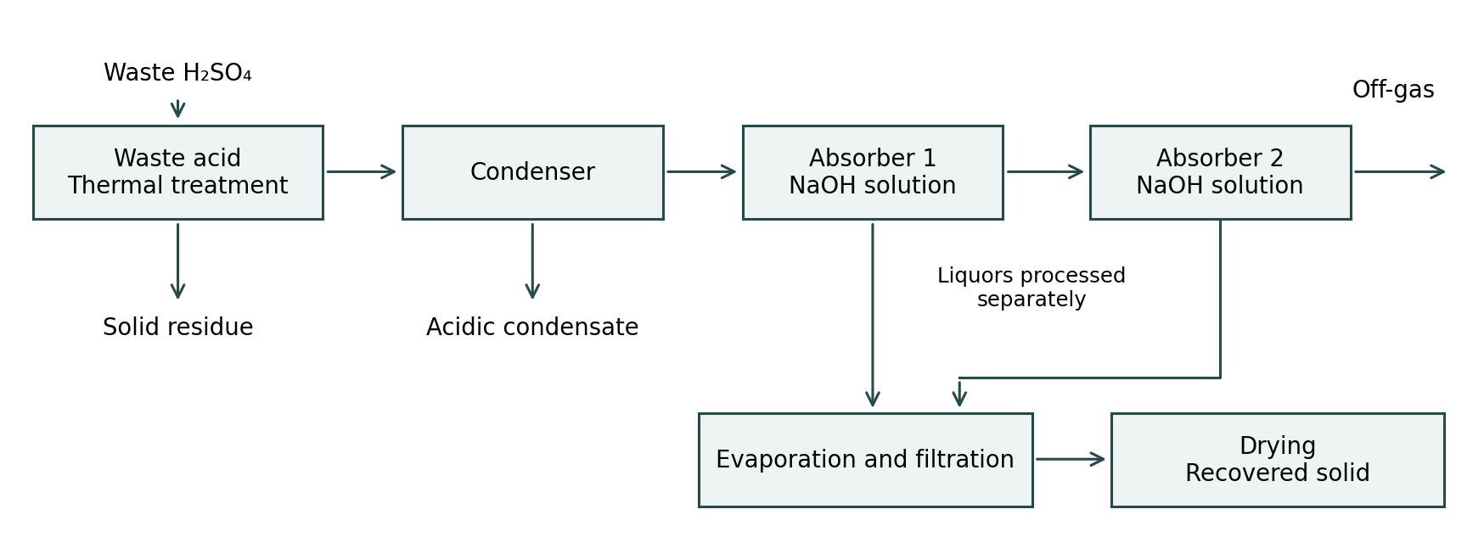
Figure 1: Process sequence reconstructed from the reported laboratory procedure. Condensate, solid residue, mother liquor and off-gas require separate assessment; the diagram does not imply a closed material balance.
2.3 Product characterisation
The supplied thermal plot contains thermogravimetric and differential thermal signals. The XRD export identifies Cu Kα₁ radiation with a wavelength of 1.540593 Å and the reference entry 96-101-0524 for Na₂SO₃. Density and viscosity were measured for nominal product-solution concentrations of 1–30 % at 20–100 °C. Instrument models, calibration procedures, thermal-analysis atmosphere and the solution-concentration basis were not provided. These omissions limit quantitative comparisons and reproducibility; no missing settings or uncertainties have been reconstructed.

3 Results and discussion
The observations are separated into waste-acid heating, gas absorption, solid recovery and product characterisation. Apparent mass changes are distinguished from chemical conversion because the available dataset does not close the sulfur balance.
3.1 Heating behaviour of the waste acid
Table 1: Residual mass and recorded temperature during heating of 50 g waste-acid samples
Run | 5 min  g / °C | 10 min  g / °C | 15 min  g / °C | 20 min  g / °C | 40 min  g / °C
1 | 37 / 102 | 24.5 / 144 | 20.5 / 150 | 16.5 / 280 | 7 / 160*
2 | 34 / 121 | 24.5 / 165 | 13 / 180 | 9.5 / 218 | 4 / 294
3 | 29 / 160 | 18.5 / 180 | 9 / 201 | 5 / 252 | 2 / 304
4 | 25 / 180 | 14.4 / 218 | 7.5 / 220 | 3.8 / 290 | 1.5 / 320
5 | 23 / 218 | 12.5 / 294 | 4.5 / 290 | 1 / 335 | 0.45 / 387
* The reported 160 °C value follows 280 °C in run 1; it is retained without correction and requires confirmation. Different runs represent different recorded temperature histories.
After 40 min, residual masses ranged from 7 to 0.45 g, corresponding to apparent mass losses of 86.0–99.1 % of the initial sample. This is not a sulfuric-acid conversion range: water evaporation, acid transfer, gas evolution and impurity transformation may all contribute. The different heating histories prevent isolation of a temperature effect from the time dependence. The data therefore support a qualitative description of thermal processing, not a rate constant or an optimum decomposition temperature.
3.2 Chemical pathway and selectivity
Na₂SO₃ formation requires sulfur in oxidation state +IV. Direct neutralisation of H₂SO₄, where sulfur is +VI, produces sulfate according to Eq(1). SO₂ absorption under sufficient alkalinity can produce sulfite according to Eq(2); additional SO₂ can shift the solution towards bisulfite according to Eq(3).
H₂SO₄ + 2 NaOH → Na₂SO₄ + 2 H₂O (1)
SO₂ + 2 NaOH → Na₂SO₃ + H₂O (2)
Na₂SO₃ + SO₂ + H₂O → 2 NaHSO₃ (3)
SO₃ + 2 NaOH → Na₂SO₄ + H₂O (4)
2 Na₂SO₃ + O₂ → 2 Na₂SO₄ (5)
Consequently, the generic description “sulfur oxides” is insufficient to establish sulfite selectivity. SO₃ or entrained sulfuric acid can introduce sulfate, while oxygen can oxidise sulfite. Thermal processing of the contaminated acid may involve reduction by organic constituents, but the present data do not identify the reducing species or establish the gas-phase mechanism. A decrease in reactor mass does not distinguish SO₂ formation from acid or water evaporation. Gas analysis and sulfur-species measurements are needed before assigning a conversion mechanism.
The distinction also affects process design. The condenser provides a separate acidic stream, while the second absorber provides additional gas–liquid contact. Neither feature demonstrates complete sulfur capture without outlet-gas measurements. Chianese et al. (2024) discuss the energy and wastewater implications of adding wet scrubbing to flue-gas treatment. Their work supports including secondary liquid streams and thermal duty when evaluating the environmental benefit of the present route.

3.3 Absorption and recovered solid mass
Table 2: Reported absorption experiments using 170 g of total NaOH solution
NaOH  % | Waste  acid g | Condensate  g | Condensate  g/mL | Condensate  pH | Absorber 1  g | Absorber 1  g/mL | Absorber 1  pH
5 | 14.00 | 2.5 | 1.051 | 1.09 | 92.0 | 1.108 | 5.16
10 | 24.57 | 6.1 | 1.052 | 1.00 | 93.5 | 1.154 | 6.30
15 | 36.85 | 7.8 | 1.053 | 0.88 | 95.5 | 1.206 | 7.50
20 | 49.14 | 12.0 | 1.073 | 0.75 | 108.5* | 1.254 | 4.95
* The narrative gives 106.5 g. The original “sediment (2 % solution)” pH values were 2.43, 2.48, 2.52 and 2.61, respectively; the material represented by this label is not defined sufficiently for interpretation. Second-absorber final masses were 86, 86, 87 and 89.5 g, respectively. Density measurement temperatures were not specified.
The condensates were acidic, with reported pH values of 0.75–1.09. Their sulfur content was not measured, so sulfur carried into this stream cannot be included in a recovery calculation. The first-absorber pH values were non-monotonic with initial NaOH concentration because acid charge also changed between experiments. The pH of 4.95 in the 20 % test is inconsistent with assuming an exclusively sulfite-rich alkaline liquor; bisulfite and other acidic species must be considered. A higher initial NaOH concentration alone is therefore not evidence of improved sulfite selectivity.
Table 3: Solid recovery in the experiment using nominal 20 % NaOH solution
Quantity | Absorber 1 | Absorber 2 | Combined
Initial absorbent mass, g | 85.00 | 85.00 | 170.00
Mass after absorption, g | 106.5 / 108.5* | 89.50 | 196.0 / 198.0*
Mass after evaporation, g | 55.00 | 42.00 | 97.00
Wet filtered solid, g | 17.94 | 9.65 | 27.59
Solid after 150 °C for 90 min, g | 11.85 | 5.92 | 17.77
Loss on drying, % of wet solid | 33.95 | 38.65 | 35.59
* Two inconsistent source values. Combined masses are sums, not independent measurements. Loss on drying = 100 × (wet solid − dried solid)/wet solid.
The first and second absorbers contributed 66.7 and 33.3 % of the total recovered dried mass. The second stage therefore made a substantial contribution to solid recovery in this experiment. This proportion is not the second-stage SO₂ capture efficiency because the gas composition, residual dissolved sulfur and product assay were not measured.
If the stated 20 % concentration denotes a mass fraction, 170 g of absorbent contains 34.0 g NaOH (0.850 mol). Eq(2) gives a maximum of approximately 53.6 g Na₂SO₃. Independently, 49.14 g of waste acid at 84.75 wt.% contains approximately 41.65 g H₂SO₄ (0.425 mol), also corresponding to about 53.5 g Na₂SO₃ under complete sulfur conversion and recovery. The dried mass of 17.77 g is about 33.2 % of this conditional stoichiometric amount. It is an apparent recovered-solid ratio, not an assay-corrected product yield or measured acid conversion.
A sulfur balance would need to include the solid residue, condensate, both mother liquors, isolated solids and off-gas. Missing these streams precludes claims of complete conversion, complete absorption or waste-free operation. Likewise, economic savings cannot be quantified from the present laboratory masses alone.

3.4 Thermal behaviour and phase identification
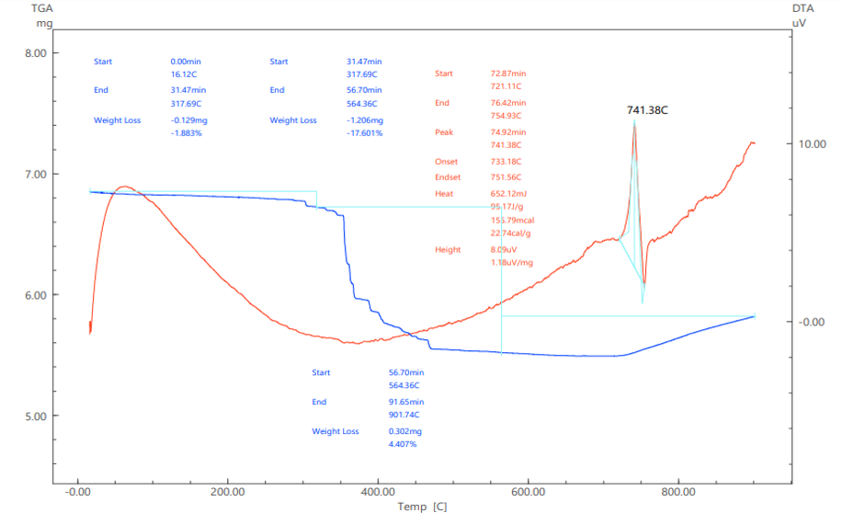
Figure 2: Original TG–DTA export for the recovered solid. The plotted mass changes and thermal event are observations; individual reaction assignments remain unverified.
Figure 2 reports a mass decrease of 1.883 % between approximately 16 and 318 °C and a further decrease of 17.601 % between approximately 318 and 564 °C. At higher temperatures the plotted TG trace rises, although the software annotation still uses “weight loss”. The DTA peak is labelled 741.38 °C. Without the atmosphere, heating programme or evolved-gas analysis, these features cannot be assigned uniquely to dehydration, oxidation or decomposition. They do not substantiate the original claim of excellent high-temperature stability.
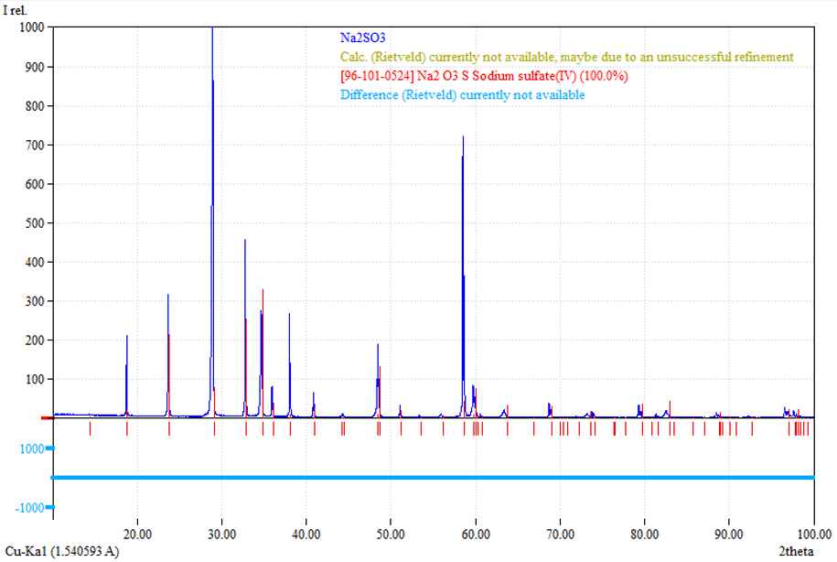
Figure 3: Original XRD export with Na₂SO₃ reference entry 96-101-0524. The export explicitly states that Rietveld calculation and difference curves are unavailable.
The supplied phase-search output is consistent with crystalline sodium sulfite. However, the displayed “100.0 %” is not accepted as a quantitative purity result because the export states that the Rietveld calculation is unavailable, possibly because refinement was unsuccessful. No calibrated phase quantification, internal-standard analysis or independent sulfite assay was supplied. Minor crystalline phases and amorphous impurities therefore remain unquantified. Phase identification is retained, while the assertion of almost 100 % chemical purity is withdrawn.
3.5 Density and viscosity of recovered-product solutions
Table 4: Reported density ρ in g/mL and dynamic viscosity μ in mPa·s at nominal solution concentrations
Property | T, °C | 1 % | 2.5 % | 5 % | 10 % | 15 % | 20 % | 25 % | 30 %
ρ | 20 | 1.009 | 1.035 | 1.047 | 1.095 | 1.141 | 1.122* | 1.245 | 1.281
ρ | 40 | 1.003 | 1.021 | 1.043 | 1.095 | 1.131 | 1.192 | 1.221 | 1.265
ρ | 60 | 1.001 | 1.007 | 1.041 | 1.085 | 1.131 | 1.753* | 1.214 | 1.252
ρ | 80 | 0.985 | 1.005 | 1.015 | 1.072 | 1.124 | 1.162 | 1.193 | 1.235
ρ | 100 | 0.965 | 0.975 | 1.012 | 1.043 | 1.109 | 1.134 | 1.192 | 1.212
μ | 20 | 1.010 | 1.045 | 1.070 | 1.150 | 1.200 | 1.400 | 1.700 | 3.000
μ | 40 | 0.670 | 0.680 | 0.700 | 0.750 | 0.800 | 1.100 | 1.300 | 1.700
μ | 60 | 0.470 | 0.500 | 0.500 | 0.550 | 0.600 | 0.620 | 0.650 | 1.000
μ | 80 | 0.350 | 0.350 | 0.370 | 0.380 | 0.400 | 0.420 | 0.600 | 0.800
μ | 100 | 0.290 | 0.300 | 0.310 | 0.350 | 0.380 | 0.390 | 0.400 | 0.400
* Values retained from the source and requiring verification. The percentage basis and uncertainty were not specified. No interpolation or correction has been applied.
Viscosity increased with nominal concentration and decreased with temperature. At 30 %, it fell from 3.00 mPa·s at 20 °C to 0.40 mPa·s at 100 °C. Most density values showed the same temperature trend, but the two marked 20 % values do not follow the neighbouring data consistently. These measurements describe bulk solution properties; they cannot independently prove salt identity or purity. Comparison with reference-property data requires a verified concentration basis and measurement protocol.
4 Conclusions
Laboratory processing of waste acid reported as 84.75 wt.% H₂SO₄ produced 17.77 g of dried solid in a two-absorber experiment using nominal 20 % NaOH solutions. The second absorber contributed 5.92 g, demonstrating its contribution to recovered solid mass. The XRD export supports the presence of crystalline Na₂SO₃, but quantitative purity is not established. Thermal analysis reveals mass changes and a thermal event near 741 °C, so unrestricted thermal stability cannot be claimed.
The results identify a route for further investigation rather than a validated high-yield industrial process. The principal unresolved requirements are identification of the sulfur-containing gas, measurement of sulfite and sulfate, reconciliation of the source-data discrepancies and closure of the sulfur balance. These checks are necessary before assigning an optimum operating condition or claiming environmental and economic performance.
References
- Buzek J., Jaschik M., 1995, Gas-liquid equilibria in the system SO₂-aqueous solutions of NaHSO₃/Na₂SO₃/Na₂SO₄, Chemical Engineering Science, 50(19), 3067–3075, DOI: 10.1016/0009-2509(95)00144-T.
- Chang C.S., Rochelle G.T., 1985, Sulfur dioxide absorption into sodium hydroxide and sodium sulfite aqueous solutions, Industrial & Engineering Chemistry Fundamentals, 24(1), 7–11, DOI: 10.1021/i100017a002.
- Chianese C., Dal Pozzo A., Cozzani V., 2024, Assessing wet scrubbing as final additional stage for dry waste-to-energy flue gas treatment lines, Chemical Engineering Transactions, 111, 571–576, DOI: 10.3303/CET24111096.
- Goldberg R.N., Parker V.B., 1985, Thermodynamics of solution of SO₂(g) in water and of aqueous sulfur dioxide solutions, Journal of Research of the National Bureau of Standards, 90(5), 341–358, DOI: 10.6028/jres.090.024.
- Hikita H., Asai S., Tsuji T., 1977, Absorption of sulfur dioxide into aqueous sodium hydroxide and sodium sulfite solutions, AIChE Journal, 23(4), 538–544, DOI: 10.1002/aic.690230419.
- Klotz W.L., 1998, Sulfuric acid waste recycling by regenerative process, US Patent US5730950A, United States Patent and Trademark Office, Washington, DC, USA.
- Luo G., Ning Z., Tu Y., Lin Z., Liu M., Wu Y., Wei X., 2014, Purification recovery process of waste sulfuric acid rich in organic impurity, Chinese Patent Application CN103482587A, State Intellectual Property Office, Beijing, China (in Chinese).
- Ogawa S., Shimizu Y., Tone S., Otake T., 1982, Kinetics of the oxidation of aqueous sodium sulfite solutions with air, Journal of Chemical Engineering of Japan, 15(5), 400–402, DOI: 10.1252/jcej.15.400.
- Schwartz D., Gadiou R., Brilhac J.F., Prado G., Martinez G., 2000, A kinetic study of the decomposition of spent sulfuric acids at high temperature, Industrial & Engineering Chemistry Research, 39(7), 2183–2189, DOI: 10.1021/ie990801e.
- Weib B.D., Fuchs W., Harasek M., 2021, Finding optimized process conditions to minimize precipitations in an SO₂ absorption process using thermodynamic process simulation, Chemical Engineering Transactions, 88, 535–540, DOI: 10.3303/CET2188089.
- Wilkinson P.M., Doldersum B., Cramers P.H.M.R., van Dierendonck L.L., 1993, The kinetics of uncatalyzed sodium sulfite oxidation, Chemical Engineering Science, 48(5), 933–941, DOI: 10.1016/0009-2509(93)80331-J.
- Xu P., Huang Y., Kong X., Gong D., Fu K., Chen X., Qiu M., Fan Y., 2020, Hydrophilic membrane contactor for improving selective removal of SO₂ by NaOH solution, Separation and Purification Technology, 250, 117134, DOI: 10.1016/j.seppur.2020.117134.
- Yang Y., 2020, A kind of production technology of sodium sulfite, Chinese Patent CN108557777B, China National Intellectual Property Administration, Beijing, China (in Chinese).
- Zhang J., Jin X., Zhao H., Yang C., 2022, Synergistic advanced oxidation process for enhanced degradation of organic pollutants in spent sulfuric acid over recoverable apricot shell-derived biochar catalyst, RSC Advances, 12(4), 1904–1913, DOI: 10.1039/D1RA07814C.

