CHEMICAL CHARACTERIZATION OF BASIL (OCIMUM BASILICUM L.) SEED OIL OBTAINED BY COLD PRESSING AND SOLVENT EXTRACTION USING FTIR AND GC

Mukaddamkhon Gulomova^{a*}, Abbos Khasanovª, Dilafruz Sagdullaeva^{b}, Abbosxan Turayev^{b}, Abdusamat Nabiev^{b}, Sarvar Khodjaev^{c}

ªDepartment of functional product technology, Tashkent Institute of Chemical Technology, Navoi 32, Tashkent 100011, Uzbekistan
^{b}Institute of Bioorganic Chemistry named after O.Sodikov of the Academy of Sciences of the Republic of Uzbekistan, M.Ulugbek 83, Tashkent 100125, Uzbekistan.
^{c}Department of Food and Perfumery-Cosmetic Products, Tashkent Institute of Chemical Technology, Navoi 32, Tashkent 100011, Uzbekistan
* gulyamova.masha96@gmail.com
Abstract
This study investigates the chemical characterization of basil seed oil (Ocimum basilicum L.) obtained by two different extraction methods, namely cold pressing and solvent extraction. The influence of extraction technique on oil yield, physicochemical properties, and fatty acid composition was systematically evaluated. Cold pressing resulted in an oil yield of 10.2%, whereas solvent extraction provided a higher yield of 14.0%. However, differences were observed in oil quality parameters, including acid value and color characteristics.
FTIR spectroscopy analysis revealed the presence of characteristic absorption bands corresponding to triglyceride structures, including ester carbonyl (C=O), C–O, and unsaturated (=C–H) functional groups, confirming the typical lipid nature of the extracted oils. The spectra of both samples showed similar overall profiles, indicating that the main chemical structures were not significantly altered by the extraction method.
Fatty acid composition was determined by gas chromatography after preparation of fatty acid methyl esters. The results demonstrated that basil seed oil is rich in polyunsaturated fatty acids, with α-linolenic acid (C_{18:3} ω-3) as the predominant component. Cold-pressed oil contained a higher level of α-linolenic acid (57.41%) compared to solvent-extracted oil (48.75%), while the latter showed relatively higher levels of saturated fatty acids, particularly palmitic acid.
Overall, the findings indicate that solvent extraction enhances oil yield, whereas cold pressing better preserves nutritionally valuable polyunsaturated fatty acids. Basil seed oil can therefore be considered a promising plant-based source of essential fatty acids with potential applications in food, nutraceutical, and pharmaceutical industries.
Key words:
Basil seed oil; cold pressing; solvent extraction; fatty acid composition; gas chromatography; FTIR spectroscopy.
1. Introduction
Basil (Ocimum basilicum L.), a member of the Lamiaceae family, is widely recognized as an economically important aromatic and medicinal plant cultivated across diverse climatic regions. While extensive research has focused on basil essential oil, recent studies have increasingly highlighted the significance of basil seeds as a valuable source of edible oil with promising nutritional and functional properties [1,2].
Basil seed oil is characterized by a high proportion of polyunsaturated fatty acids, particularly α-linolenic acid (C_{18:3}, ω-3), along with linoleic and oleic acids. These fatty acids are known to contribute to various health benefits, including cardiovascular protection, anti-inflammatory activity, and antioxidant effects, making basil seed oil a potential candidate for functional food and nutraceutical applications [3-5]. The growing interest in plant-based omega-3 sources has further increased the scientific and industrial relevance of basil seed oil.
The quality and composition of vegetable oils are strongly influenced by the extraction method employed. Mechanical extraction techniques such as cold pressing are preferred for preserving thermolabile bioactive compounds and minimizing chemical alterations, whereas solvent extraction methods typically yield higher oil recovery but may affect the integrity of sensitive components [6-8]. Therefore, a comparative assessment of extraction techniques is essential for understanding their impact on oil yield, fatty acid composition, and overall quality.
Accurate characterization of plant oils requires the application of advanced analytical techniques. Gas chromatography (GC) is widely used for the determination of fatty acid composition in the form of fatty acid methyl esters (FAMEs), providing reliable quantitative analysis of lipid profiles, while Fourier Transform Infrared Spectroscopy (FTIR) offers rapid information about functional groups and overall molecular structure of oils [9-11].
In addition to fatty acids, basil-derived products are known to contain volatile bioactive compounds such as linalool and estragole, which contribute to their biological activity and aromatic properties. These compounds are predominantly identified in basil essential oils; however, the presence of oxygenated functional groups observed in FTIR spectra of basil-derived products may be associated with such constituents [12-14]. Nevertheless, FTIR spectroscopy alone cannot confirm the presence of individual compounds, and chromatographic techniques such as GC remain essential for their identification [15].
Despite increasing interest in basil seed oil, limited studies have systematically compared the influence of different extraction methods on its chemical composition using combined GC and FTIR approaches. Therefore, the present study aims to investigate the chemical composition of basil seed oil obtained by cold pressing and solvent extraction, and to evaluate the effect of extraction techniques on oil yield and fatty acid profile using complementary analytical methods.

2. Materials and Methods
2.1. Materials
Basil seeds (Ocimum basilicum L.) were used as the raw material in this study. The seeds were obtained from locally cultivated basil plants grown in the Republic of Uzbekistan during the 2025-2026 growing season. Before oil extraction, the seeds were manually cleaned to remove dust, damaged seeds, husks, and other foreign materials. The cleaned seeds were then stored in airtight containers at room temperature until further use.
2.2. Oil extraction methods
Cold-pressed basil seed oil was obtained using a screw-type mechanical oil press. Prior to pressing, the cleaned basil seeds were visually inspected and homogenized to ensure uniform processing. The seeds were pressed at a controlled temperature of 40-45°C, which was selected to minimize thermal degradation of heat-sensitive lipid components. The crude oil obtained after pressing was allowed to stand for sedimentation and was then filtered to remove suspended solid particles. The filtered oil was collected in dark glass bottles and stored under refrigerated conditions until analysis. The oil yield was calculated based on the mass of oil obtained relative to the initial mass of basil seeds.
Solvent extraction was carried out using basil seed cake remaining after cold pressing. The cake was extracted with hexane/petroleum ether in a Soxhlet apparatus for 6 h. After extraction, the obtained solvent-oil mixture was filtered, and the solvent was removed using a rotary evaporator at 55-60°C.
2.3. Oil yield
The oil yield was calculated using the following equation:
$Oil yield=\frac{m_{1}}{m_{0}}∙100, \%$ (1)
where m₁ is the mass of extracted oil and m₀ is the initial mass of basil seeds.

2.4. Physical and chemical properties
The acid value was determined by titration with potassium hydroxide solution according to a standard oil analysis procedure. Briefly, a measured amount of oil was dissolved in a neutralized alcohol–ether mixture and titrated with potassium hydroxide solution using phenolphthalein as an indicator. The acid value was expressed as mg KOH required to neutralize free fatty acids in 1 g of oil.
The acid value was calculated using the following equation:
$Acid value=\frac{V∙C∙56.1}{m}$ (2)
where V is the volume of KOH solution used for titration, C is the concentration of KOH solution, 56.1 is the molecular weight of KOH, and m is the mass of the oil sample.

The color of the oil samples was evaluated using color units for red, yellow, and blue components (Model F, Lovibond). The measurements were performed under the same conditions for both oil samples to allow comparison between extraction methods.

2.5. FTIR spectroscopy analysis
Fourier-transform infrared spectroscopy was used to identify the main functional groups present in the basil seed oil samples. FTIR spectra were recorded using a PerkinElmer System 2000 FTIR spectrometer equipped with KBr pellet system. The spectra were collected in the range of 4000-400 cm⁻¹. For KBr pellet preparation, approximately 10 mg of oil sample was mixed with dried potassium bromide and ground thoroughly to obtain a homogeneous mixture. The mixture was then pressed into a transparent pellet and analyzed immediately.

2.6. Gas chromatographic analysis of fatty acids
Before chromatographic analysis, the fatty acids present in the oil samples were converted into their corresponding fatty acid methyl esters. FAMEs were prepared using sodium methoxide in methanol according to ISO 12966-2:2017 [16].
The fatty acid composition of basil seed oils was determined using gas chromatography. The analysis was performed on a Shimadzu GC-2030 gas chromatograph equipped with an autosampler, injector, SP-2560 capillary column and a flame ionization detector. The column dimensions were 100 m × 0.25 mm × 0.20 µm. Helium was used as the carrier gas at a flow rate of 2 mL/min. The injection volume was 1 µL, and the split ratio was 1:20. The injector temperature was maintained at 220°C. The oven temperature program was as follows: the initial temperature was set at 100°C and held for 4 min; then increased to 200°C at a rate of 25°C/min and held for 8 min; finally, the temperature was raised to 250°C at 5°C/min and held for 6 min. Fatty acids were identified by comparing the retention times of the sample peaks with those of the Supelco 37 Component FAME Mix standard. The relative amount of each fatty acid was expressed as a percentage of the total identified fatty acids.

2.7. Chemicals
All solvents and reagents were of analytical or chromatographic grade. n-hexane, methanol, potassium hydroxide, phenolphthalein, and potassium bromide were purchased from Merck KGaA, Darmstadt, Germany. Sodium methoxide solution in methanol and Supelco 37 Component FAME Mix were obtained from Sigma-Aldrich, St. Louis, MO, USA. Distilled water was used throughout the experimental procedures.

3. Results and Discussions
The extraction method had a noticeable influence on the oil recovery from basil seeds. Cold mechanical pressing produced an oil yield of 10.2%, whereas solvent extraction resulted in a higher yield of 14.0%. The higher yield obtained by solvent extraction can be explained by the greater ability of organic solvents to penetrate the cellular structure of the seed material and dissolve lipids that remain inaccessible during mechanical pressing.
Although solvent extraction improved oil recovery, cold pressing remains a valuable method because it does not require organic solvents and is generally preferred for oils intended for food and nutraceutical applications. In addition, the relatively low processing temperature used during cold pressing may help preserve heat-sensitive lipid components, particularly polyunsaturated fatty acids.
The acid value of the cold-pressed oil was 1.5 mg KOH/g, while the solvent-extracted oil showed a slightly higher acid value of 2.0 mg KOH/g. These values indicate a low level of free fatty acids in both samples, suggesting that the oils were not strongly hydrolyzed and that the raw material was of acceptable quality.
Visual differences were also observed between the two oil samples. The cold-pressed oil showed color values of 1.8 red units, 64.0 yellow units, and 0.0 blue units, indicating a predominantly yellow appearance. In contrast, the solvent-extracted oil showed 10.1 red units, 0.4 yellow units, and 0.5 blue units, suggesting a darker tone with a higher red component. These differences may reflect the co-extraction of pigments, minor lipid-soluble compounds, and oxidation-related substances during solvent extraction.
Overall, the results show that solvent extraction is more efficient in terms of oil yield, whereas cold pressing may be more favorable when minimal processing and preservation of nutritional quality are prioritized.

3.2. FTIR Characterization of basil seed oil
FTIR analysis was performed to investigate the functional group composition of basil seed oils obtained by cold pressing and solvent extraction. The FTIR spectra of the two oil samples are presented in Figure 1 and Figure 2, corresponding to cold-pressed and solvent-extracted basil seed oils, respectively.
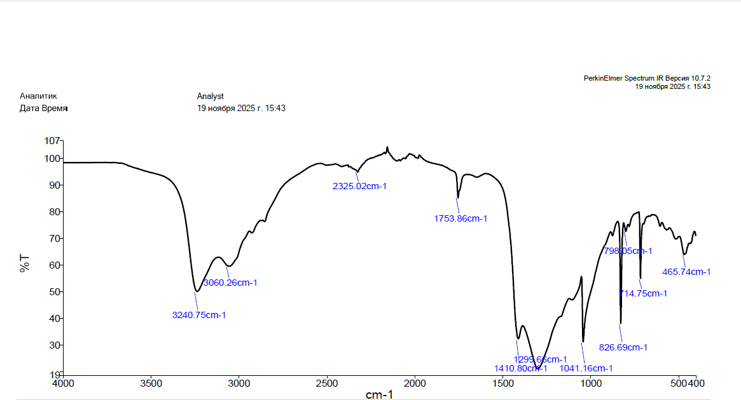
Figure 1. FTIR spectrum of cold-pressed basil seed oil

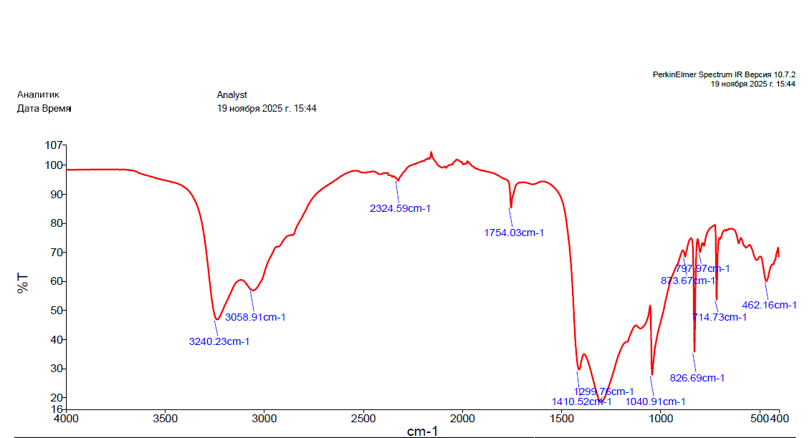
Figure 2. FTIR spectrum of solvent-extracted basil seed oil

As shown in both figures, the spectra exhibit similar absorption patterns, indicating that the major chemical structures of the oils are comparable regardless of the extraction method. The presence of characteristic absorption bands confirms that both samples are typical vegetable oils composed mainly of triglycerides.
The main absorption bands observed in the FTIR spectra of basil seed oils can be assigned to characteristic functional groups of lipid structures. A broad band around ~3240 cm⁻¹ was observed in both samples and is attributed to O–H stretching vibrations. This band may be associated with trace amounts of moisture, hydroperoxides, or minor oxygen-containing compounds naturally present in the oil. The absorption region at ~3056-3060 cm⁻¹ corresponds to =C–H stretching vibrations of unsaturated fatty acids. The presence of this band confirms that the oils contain a significant proportion of unsaturated lipid components, which is consistent with the fatty acid composition dominated by polyunsaturated fatty acids. A strong and well-defined peak at ~1753-1754 cm⁻¹ is assigned to the ester carbonyl C=O stretching vibration of triglycerides. This is a characteristic feature of vegetable oils and clearly indicates that the extracted products are primarily composed of triacylglycerol structures. The band observed at ~1410 cm⁻¹ is related to bending vibrations of aliphatic CH₂ and CH₃ groups. This absorption is typical for long hydrocarbon chains present in fatty acids. Absorption bands in the region of ~1241-1299 cm⁻¹ are associated with C–O stretching and bending vibrations of ester functional groups. These bands further confirm the presence of ester linkages within triglyceride molecules. The peak at ~1040-1041 cm⁻¹ corresponds to C–O stretching vibrations in ester groups of glycerides. This band is commonly observed in plant oils and supports the presence of esterified fatty acids. The band near ~826 cm⁻¹ is attributed to out-of-plane bending vibrations of =C–H bonds, which are characteristic of unsaturated fatty acid structures. This further supports the presence of double bonds in the lipid chains.
The absorption bands observed in the regions around 3240 cm⁻¹ and 1040-1100 cm⁻¹ may also be associated with O–H and C–O functional groups of minor oxygenated compounds. In basil-derived products, such functional groups are commonly linked to volatile constituents such as linalool and estragole reported in the literature [1]. However, it should be emphasized that FTIR spectroscopy alone is not sufficient for the identification of individual compounds, and confirmation of such components requires GC-MS analysis.

3.3. Fatty acid profile of basil seed oil
The fatty acid profile of basil seed oil was strongly dominated by unsaturated fatty acids, particularly polyunsaturated fatty acids. The main fatty acid detected in both oil samples was α-linolenic acid (C_{18:3} ω-3), followed by linoleic acid (C_{18:2} ω-6), oleic acid (C_{18:1} ω-9), and palmitic acid (C_{16:0}).
Cold-pressed basil seed oil contained 57.41% α-linolenic acid, 22.13% linoleic acid, 10.00% oleic acid, and 6.76% palmitic acid. In comparison, the solvent-extracted oil contained 48.75% α-linolenic acid, 21.17% linoleic acid, 10.89% oleic acid, and 9.16% palmitic acid (table 1).
Table 1
Fatty acid composition of cold-pressed and solvent-extracted basil seed oils
Fatty acid | Abbrevation | Cold-pressed oil (%) | Solvent-extracted oil (%)
Palmitic acid | C_{16:0} | 6.76 | 9.16
Stearic acid | C_{18:0} | 2.84 | 2.92
Oleic acid | C_{18:1} ω-9 | 10.00 | 10.89
Linoleic acid | C_{18:2} ω-6 | 22.13 | 21.17
γ-Linolenic acid | C_{18:3} ω-6 | 0.30 | 0.25
α-Linolenic acid | C_{18:3} ω-3 | 57.41 | 48.75
Arachidic acid | C_{20:0} | 0.19 | 0.18

These results indicate that cold pressing better preserved α-linolenic acid, while solvent extraction resulted in a relatively higher proportion of saturated fatty acids, especially palmitic acid. The difference may be associated with the extraction conditions and the ability of the solvent to extract a broader range of lipid fractions from the seed matrix. Since α-linolenic acid is sensitive to oxidation and thermal degradation, the lower processing intensity of cold pressing may contribute to its higher relative content.
The high level of α-linolenic acid is nutritionally important because this fatty acid is an essential omega-3 fatty acid and a precursor for longer-chain polyunsaturated fatty acids. The presence of considerable amounts of linoleic acid, an omega-6 fatty acid, also increases the nutritional value of basil seed oil. Therefore, basil seed oil can be considered a promising plant-based source of essential fatty acids.

4. Concluion
The present study demonstrated that the extraction method significantly affects the yield and chemical composition of basil seed oil. Solvent extraction provided a higher oil yield, whereas cold pressing better preserved α-linolenic acid, an essential omega-3 fatty acid. FTIR analysis confirmed the presence of characteristic functional groups of triglycerides in both samples. The results indicate that basil seed oil is a valuable source of polyunsaturated fatty acids and has strong potential for application in food, pharmaceutical, and nutraceutical industries. Cold-pressed oil, in particular, appears more suitable for functional applications due to its higher nutritional quality.

References
1. Simon, J.E., Quinn, J., Murray, R.G. (1999). Basil: A source of essential oils. In: Perspectives on New Crops and New Uses. ASHS Press.
2. Javanmardi, J., Khalighi, A., Kashi, A., Bais, H.P., Vivanco, J.M. (2003). Chemical characterization of basil (Ocimum basilicum L.) found in local accessions and used in traditional medicines in Iran. Journal of Agricultural and Food Chemistry, 51, 4243-4249. https://doi.org/10.1021/jf034090u
3. Ramadan, M.F., Mörsel, J.T. (2002). Oil composition of basil (Ocimum basilicum L.) seeds. European Journal of Lipid Science and Technology, 104, 35-40. https://doi.org/10.1002/1438-9312(200201)104:1<35::AID-EJLT35>3.0.CO;2-T
4. Özcan, M.M., Chalchat, J.C. (2002). Chemical composition and fatty acid profile of basil seed oil. Journal of Food Lipids, 9, 233-239.
5. Saha, S., et al. (2018). Nutritional composition and fatty acid profile of basil seed oil. Journal of Food Composition and Analysis, 67, 110-116. https://doi.org/10.1016/j.jfca.2017.12.015
6. Azmir, J., et al. (2013). Techniques for extraction of bioactive compounds from plant materials. Journal of Food Engineering, 117, 426-436. https://doi.org/10.1016/j.jfoodeng.2013.01.014
7. Chemat, F., Vian, M.A., Cravotto, G. (2012). Green extraction of natural products. International Journal of Molecular Sciences, 13, 8615-8627. https://doi.org/10.3390/ijms13078615
8. Uquiche, E., Jeréz, M., Ortiz, J. (2008). Effect of pretreatment and extraction methods on oil yield and quality. Journal of Food Engineering, 84, 495-500.
9. Guillén, M.D., Cabo, N. (1997). Characterization of edible oils by FTIR spectroscopy. Journal of the Science of Food and Agriculture, 75, 1-11.
10. Rohman, A., Che Man, Y.B. (2012). FTIR spectroscopy for analysis of edible oils. Food Chemistry, 134, 1419–1425. https://doi.org/10.1016/j.foodchem.2011.07.024
11. Yang, H., Irudayaraj, J., Paradkar, M.M. (2005). Discrimination of edible oils by FTIR spectroscopy. Food Chemistry, 93, 25-32.
12. Telci, I., Bayram, E., Yılmaz, G., Avcı, B. (2006). Variability in essential oil composition of Turkish basils. Journal of Essential Oil Research, 18, 173-177.
13. Hussain, A.I., Anwar, F., Sherazi, S.T.H., Przybylski, R. (2008). Chemical composition and antioxidant activity of basil essential oil. Food Chemistry, 108, 986-995. https://doi.org/10.1016/j.foodchem.2007.12.061
14. Vieira, R.F., Simon, J.E. (2006). Chemical characterization of basil varieties. Journal of Agricultural and Food Chemistry, 54, 7733-7737. https://doi.org/10.1021/jf060335c
15. Rohman, A. (2017). Infrared spectroscopy for analysis of edible oils: A review. Vibrational Spectroscopy, 88, 1-12. https://doi.org/10.1016/j.vibspec.2017.02.012
16. ISO 12966-2:2017. Animal and vegetable fats and oils – Gas chromatography of fatty acid methyl esters – Part 2: Preparation of methyl esters of fatty acids. International Organization for Standardization, Geneva, Switzerland.

