 CHEMICAL ENGINEERING TRANSACTIONS  VOL. xxx, 2026 | A publication of  
The Italian Association
of Chemical Engineering
Online at www.cetjournal.it

Guest Editors: Flavio Manenti, Botir Usmonov, Alessandro Di Pretoro
Copyright © 2026, AIDIC Servizi S.r.l.
ISBN 979-12-81206-xx-x; ISSN 2283-9216

Industrial fed-batch Streptomyces sp. fermentation for Active Pharmaceutical Ingredient (API) production: a modeling approach
Adriano Porcelli, Giacomo Nardi, Elena Barbera*, Eleonora Sforza
Department of Industrial Engineering, University of Padova, Via Marzolo 9, 35131 Padova, Italy
elena.barbera@unipid.it
Industrial fermentation is a highly complex and variable process. This is particularly true for fed-batch operations, where substrate feed and consumption must be precisely balanced to minimize waste. Such precision is increasingly critical for the production of molecules designed to combat antimicrobial resistance. One such molecule is produced by Streptomyces sp. via aerobic fermentation, typically in fed-batch mode. Tuning and controlling operating variables is essential to maximize productivity, and mathematical modeling serves as a powerful tool in this regard. By employing a defined dataset, a model can be developed to describe the general dynamics of the process, including biomass growth, product synthesis, and substrate consumption. This study aims to develop a mathematical model that characterizes the complete kinetics of this fermentation process. The model was built using industrial fed-batch datasets and is based on Monod kinetics for biomass growth and Michaelis–Menten kinetics for substrate-driven product formation. In this framework, two substrates are needed for biomass growth; the biomass then acts as a catalyst for the conversion of these substrates into the final product. The resulting dynamic model accounts for biomass growth, production of the molecule of interest, and substrate consumption, with reference to a fed-batch system. Key process phenomena are incorporated, including thermal degradation of the product molecule, product inhibition, and the non-growth-associated nature of product formation. This work provides a robust mathematical framework for the fed-batch cultivation of Streptomyces sp. for Active Pharmaceutical Ingredient (API) production, offering new perspectives for process optimization.
  - Introduction
The global rise of antibiotic resistance has made it imperative to develop new therapeutic strategies and to optimize existing ones. The use of a molecule produced by bacteria of the genus Streptomyces represents one such approach (Bush & Bradford, 2019). At the industrial level, the production of these molecules is predominantly carried out through batch or fed-batch fermentation. These processes, however, are strongly influenced by a range of operating variables, including pH, temperature, and nutrient concentration (Ser et al., 2016), each of which affects bacterial growth and molecule production in distinct ways.
Temperature is a particularly critical parameter. The product is a chemically unstable molecule whose degradation rate increases with temperature (Marques et al., 2009), yet bacterial growth requires temperatures in the range of 26–30°C, creating an inherent trade-off between product stability and cell viability. The carbon source is another key variable influencing product titers: glycerol and vegetable oils are the most commonly used substrates (Gómez-Ríos et al., 2024) and are typically supplied as feed during fed-batch cultivation. Fed-batch processes are generally preferred over batch modes due to their higher productivity and extended stationary phase (Gómez-Rios et al., 2022). The latter is of particular relevance for the production of this molecule, given its nature as a secondary metabolite. Secondary metabolites can be synthesized throughout the bacterial life cycle, but their production predominantly occurs during the late-exponential and stationary growth phases (Seyedsayamdost, 2019).
A powerful tool for rationalizing and controlling the complex interplay of variables that govern fed-batch fermentation is mathematical modeling. In this work, a model describing the kinetics of a fed-batch fermentation process for the production of a molecule helpful to contrast antibiotic resistance is developed. The model is based on Monod kinetics for biomass growth and Michaelis-Menten kinetics for product formation and was developed and calibrated using data from a real industrial process.
  - Methodology
    - Mathematical model
The model provides a structured mathematical framework describing the relationships between substrate consumption, microbial growth, and molecule production. The set of differential equations presented incorporates key biological kinetics and the process is modelled considering the fermentation process as composed by two distinct phases. First, the microbial growth phase, where the two main substrates – i.e. glycerol (S₁) and oil (S₂), which are the preferred carbon sources of this species and the ones used in the industrial fed-batch process from which the calibration datasets originate – are used to produce more biomass (X) (Eq. 1); second, the stationary phase, when the microbial metabolism shifts toward the production of secondary metabolites (P) using the same two substrates and the previously produced biomass as catalyst (eq. 2 and 3, where $β_{i}$ [g_{P}/g_{Si}] indicates the stoichiometric coefficients describing the amount of product generated per unit of converted substrate). Each of these stages is characterized by specific kinetic parameters and substrate consumption rates.
$$S_{1}+S_{2}→X$$ | (1)
$$S_{1}\underset{→}{X}β_{1}*P$$ | (2)
$$S_{2}\underset{→}{X}β_{2}*P$$ | (3)
The mass evolution over time of each system component - i.e. biomass, glycerol, soybean oil, and product - is described through a system of four ordinary differential equations (ODEs), developed specifically for this process. A fifth equation, describing the time evolution of the total mass, is present as well (Eq. 4 to 8).
$$\frac{dm_{x}}{dt}=μ_{max}C_{x}V_{r}\left(\frac{C_{s1}}{K_{S1}+C_{s1}}\right)\left(\frac{C_{s2}}{K_{S2}+C_{S2}}\right)\left(1-\frac{C_{p}-P_{ix}}{P_{xmax}-P_{ix}}\right)-K_{d}C_{x}V_{r}$$ | (4)
$$\frac{dm_{s1}}{dt}={\dot{m}}_{s1}-γ_{1}μ_{max}C_{x}V_{r}\left(\frac{C_{s1}}{K_{S1}+C_{s1}}\right)\left(\frac{C_{s2}}{K_{S2}+C_{S2}}\right)\left(1-\frac{C_{p}-P_{ix}}{P_{xmax}-P_{ix}}\right)*F_{n}-\frac{δ_{1}C_{x}C_{s1}}{K_{M1}+C_{s1}}V_{r}*(1- F_{n})$$ | (5)
$$\frac{dm_{s2}}{dt}={\dot{m}}_{s2}-γ_{2}μ_{max}C_{x}V_{r}\left(\frac{C_{s1}}{K_{S1}+C_{s1}}\right)\left(\frac{C_{s2}}{K_{S2}+C_{S2}}\right)\left(1-\frac{C_{p}-P_{ix}}{P_{xmax}-P_{ix}}\right)*F_{n}-\frac{δ_{2}C_{x}C_{s2}}{K_{M2}+C_{s2}}V_{r}*(1- F_{n})$$ | (6)
$$\frac{dm_{p}}{dt}=\left(β_{1}\frac{δ_{1}C_{x}C_{s1}}{K_{M1}+C_{s1}}+β_{2}\frac{δ_{2}C_{x}C_{s2}}{K_{M2}+C_{s2}}\right)V_{r}-kC_{p}V_{r}$$ | (7)
$$\frac{dm_{tot}}{dt }={\dot{m}}_{e}$$ | (8)
In these equations $V_{r}$ [L] is the volume of the culture in the reactor, and being the model referred to a fed-batch process its time evolution is described as follows (Eq. 9 to 11).
$$V_{r}\left(t\right)=V_{r,0}+{\dot{V}}_{in}*t$$ | (9)
With:
$${\dot{V}}_{in}={\dot{m}}_{e}*ρ$$ | (10)
$${\dot{m}}_{e}={\dot{m}}_{s1}+{\dot{m}}_{s2}+{\dot{m}}_{inert}$$ | (11)
Being $V_{r,0}$ [L] the culture volume in the reactor at the beginning of the process, ${\dot{m}}_{e}$ [g/h] the total inlet mass flowrate, $ρ$ [g/mL] the density that has been approximated as constant and equal to 1 and ${\dot{m}}_{inert}$ [g/h] the sum of the hourly mass flowrates of a stream of demineralized water and another one of a sodium phosphate solution, which is assumed not to play any role on the physics of the process except for their action on the volume of the fermentative broth.
Eq. 4 describes biomass growth using Monod-type kinetics. Here, $μ_{max}$[h⁻¹] is the maximum specific growth rate, and $K_{s1}, K_{s2}$ [g/L] are the half-saturation constants for the two substrates, representing the substrate concentrations at which the maximum specific growth rate is half of its maximum value. This equation takes also into account the phenomenon of product inhibition. As suggested by experimental and industrial fermentation data, indeed, the biomass decline after a certain time is probably caused by growth inhibition induced by the product itself. This phenomenon is described using the equations proposed by Nandasana & Kumar (2008), which introduce parameters $P_{ix}$ [g/L] and $P_{xmax}$ [g/L] that represent the minimum product concentration necessary to cause product inhibition and the product concentration that completely suppresses biomass growth, respectively. Finally, $K_{d}$[h⁻¹] is the endogenous decay coefficient describing the decline of the microbial population at the end of the stationary phase.
Eq. 5 and 6 define the substrates kinetics with the inlet terms described by ${\dot{m}}_{si}$ [g/h] and the consumption kinetics described by $γ_{i}$ [g_{Si}/g_{X}] accounting for the substrates consumption during the growth phase, and $δ_{i}$ [g_{Si}/g_{X}/h] representing the rate of substrate consumption per unit of microbial concentration during the stationary phase.
In order to model the transition between the exponential growth phase and the stationary phase, a specific switching mechanism based on product concentration was implemented. The microorganism's metabolism undergoes a radical shift: initially, substrate consumption is almost exclusively directed toward biomass production, whereas once a certain threshold is exceeded, the metabolic flux shifts toward cellular maintenance and product synthesis. The switch function implemented has the following structure (Eq. 12 and 13).
$$F_{n} = \frac{1}{2}\left(\frac{N}{\sqrt{N^{2}+{γ_{switch}}^{2}}}+1\right)$$ | (12)
$$N = C_{p LIM} - C_{p}(t)$$ | (13)
Where $N$ represents the distance from the limiting product concentration ($C_{p LIM})$ and $γ_{switch}$ is a smoothing parameter that defines the steepness of the transition (in this case $γ_{switch}$ = 0.01).
Eq. 7 describes the product formation, according to a Michaelis-Menten type kinetic, considering that substrates are converted according to their own kinetics and stoichiometry. In the equation, $K_{Mi}$ [g/L] is the Michaelis-Menten constant, reflecting the affinity of the substrate to the microorganism. The lower is the value of $K_{M}$and the higher is its affinity, resulting in high conversion rates even at low substrate concentrations. Finally, as previously discussed, this molecule is sensitive to temperature, so it is mandatory to take thermal degradation and its kinetics into account. Specifically, it was assumed to be a first order kinetic process (Bersanetti et al., 2005) following Eq. 14.
$$\frac{dC_{p}}{dt}=-kC_{p}$$ | (14)
With $k$ being an Arrhenius-type parameter, depending exponentially on temperature (Eq. 15):
$$k=A*\exp\left(-\frac{E_{a}}{RT}\right)$$ | (15)
Here, $A$ [h⁻¹] is a pre-exponential factor, $E_{a}$[J] is the activation energy of the reaction, $R$ [J/(mol*K)] represents the ideal gas constant and $T$ [K] is the temperature of the reactive environment.
    - Parameters estimation
The model was calibrated on 14 independent fed-batch industrial fermentations carried out in production-scale bioreactors under the same nominal operating protocol. For each batch, biomass, glycerol, soybean oil and product concentrations were measured over time with a sampling frequency of approximately 10 h, together with the recorded hourly feed rates of each substrate. Owing to a confidentiality agreement with the industrial partner further details of the process from which the datasets originate cannot be disclosed. It should be pointed out that this process, and therefore the datasets representing it, is characterized by a strong intrinsic variability. The model parameters, indeed, were fitted on every dataset and iteratively refined to reduce the discrepancy between the simulated results and the experimental observations, achieving an optimal fit.
Overall, the model presents 15 parameters. To minimize the number of fitted ones and increase the robustness of the model, some of them were fixed using different strategies. First, a sensitivity analysis was performed, revealing that $P_{ix}$ and $P_{xmax}$, do not significantly influence the variation of the model error. Taking into account these results and the physical meaning of the parameters, $P_{ix}$ and $P_{xmax}$ were fixed at their average value. The value of the thermal degradation constant $k$ was also fixed at the average between values reported in literature (Bersanetti et al., 2005).
In order to further decrease the number of unconstrained parameters, $β_{1}{ , β}_{2}$, $δ_{1}{ and δ}_{2}$ were directly estimated and fixed through data analysis. These assumptions further reduced model complexity and unconstrained parameters number, while maintaining its biological plausibility.
The 7 fixed parameters and their values are presented in Table 1.
Table 1: Fixed model parameters.
$$P_{ix}[g/L]$$ | $$P_{xmax}[g/L]$$ | $$k \left[h^{-1}\right]$$ | $$β_{1} [g_{P}/g_{S1}]$$ | $$δ_{1 } [g_{S1}/g_{X}/h ]$$ | $$β_{2} [g_{P}/g_{S2}]$$ | $$δ_{2 }\left[g_{S2}/g_{X}/h \right]$$
0.08 | 10 | 0.01335 | 0.044 | 0.060 | 0.418 | 0.0131

  - Results and discussion
The resulting values of the 8 fitted parameters are reported in Table 2.
Table 2: Unconstrained model parameters with standard deviation.
$$μ_{max}\left[h^{-1}\right]$$ | $$K_{d}\left[h^{-1}\right]$$ | $$γ_{1}[g_{S1}/g_{X}]$$ | $$γ_{2}[g_{S2}/g_{X}]$$ | $$K_{S_{1}}[g/L]$$ | $${K_{S}}_{2}[g/L]$$ | $$K_{M_{1}}[g/L]$$ | $$K_{M_{2}}[g/L]$$
0.341 ± 0.04 | 0.058 ± 0.01 | 0.876 ± 0.16 | 0.348 ± 0.07 | 4.812 ± 0.77 | 0.367 ± 0.11 | 1.574 ± 0.51 | 1.323 ± 0.32

Analyzing the parameters values, $P_{ix}$ and $P_{xmax}$ - 0.08 and 10 respectively - are particularly interesting because of the implication that they might have on the fermentation performances. These values show that even with relatively low concentrations of produced molecule the product inhibition phenomenon has an effect on the growth of the microorganism. This information could be used to optimize the fermentation process by reducing the product concentration in the bioreactor, for example through a semicontinuous fermentation. Moreover, the ratio between $β_{2}$ and $β_{1}$, equal to 9.5, shows that the amount of product obtained per unit of oil is much higher compared to that of glycerol. The ratio between $δ_{2}$ and $δ_{1}$ was instead fixed at 0.218, meaning that the rate of oil consumption is much lower compared to the rate of glycerol consumption. This could be physically correct because oil requires an additional hydrolysis step to free glycerol, the preferred carbon source of Streptomyces sp.
An example of experimental data and model data fitting, based on one of the 14 datasets, is showed in Figure 1.
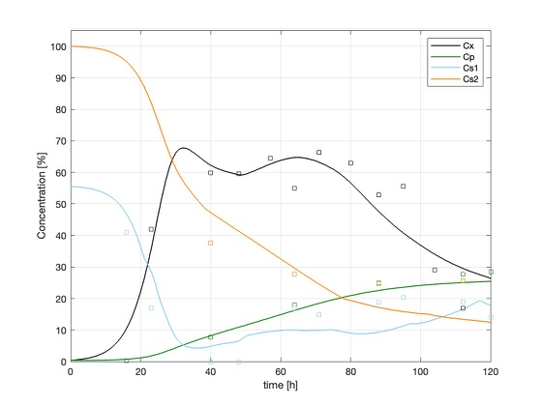
Figure 1: Simulated (continuous line) and experimental (dispersed points) data of Streptomyces sp. fermentation process. Concentrations values are expressed as percentage of the highest value (initial C_{S2} concentration).
As shown, the model can describe with good approximation (NRMSE of 10.3 %) the different evolution profiles of biomass and product formation, and substrate consumption. Looking at the biomass profile, it is interesting to note that the stationary growth phase starts around 48 h after the start of the process. This is also the time when the product concentration starts to increase, confirming the secondary metabolite nature of the product. It is also interesting that after 80 h the biomass concentration starts to decrease, even though there are still nutrients (oil and glycerol) available in the bioreactor. This is probably due to the presence of product inhibition. At the end of the stationary phase, indeed, the product reaches high concentrations that cause significant stress to the cells. This is also in agreement with the values of $P_{xmax}$.Moreover, the glycerol concentration starts to increase after ~40 h as a consequence of the switch from the exponential growth phase to the stationary phase. Once the switch occurs, glycerol is consumed at a slower rate for the production of the desired molecule, while the feed continues at a nearly constant rate: since the feed rate now exceeds the residual uptake rate, glycerol progressively accumulates in the broth. The same metabolic switch also affects oil consumption, but in this case no accumulation is observed, since most of the oil is supplied as an initial charge and its feed rate remains lower than the residual uptake rate, so that its concentration keeps decreasing throughout the stationary phase.
The model was also employed to estimate the substrate consumption evolution during the fed-batch process. Results are shown in Figure 2.

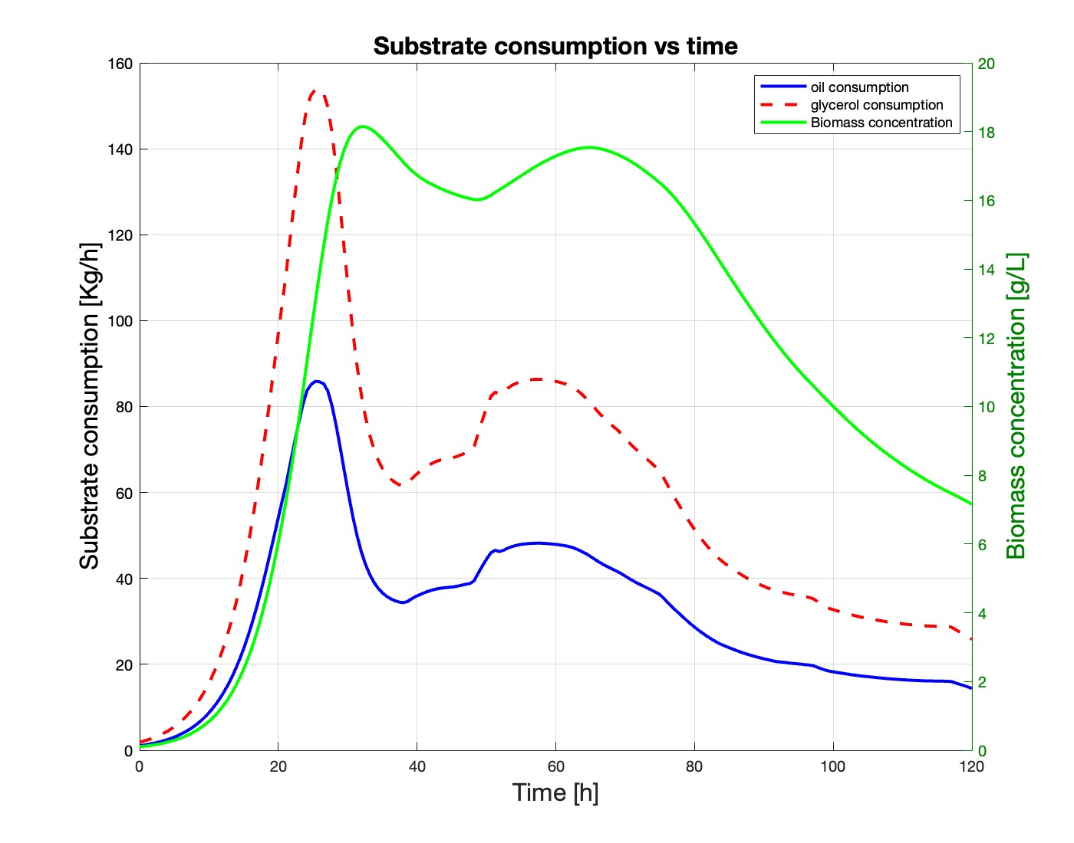
Figure 2: Substrate consumption prediction and biomass evolution during fermentation process.

As can be observed, substrate consumption increases proportionally to biomass concentration during the exponential growth phase of the microorganism. The peak of substrate consumption occurs just before the onset of the stationary growth phase (around 20–40 hours) and then decreases drastically before stabilizing at an almost constant value during the late idiophase, where the highest production of the target metabolite takes place. It can be observed that glycerol consumption during the exponential growth phase is significantly higher compared to oil consumption, a phenomenon that is also reflected in the values of $γ_{1}$ and $γ_{2}$ which describe the substrate consumption during the exponential growth phase. The glycerol parameter ($γ_{1})$ indeed, is higher than the one describing oil consumption ($γ_{2})$.
Finally, a sensitivity analysis on the 8 unconstrained model parameters was performed. Results are shown in Figure 3.
Figure 3: Sensitivity analysis of the unconstrained parameters.

The sensitivity analysis was conducted by increasing each parameter individually by 10% from its optimal value. The resulting percentage change in the final model error was then collected and illustrated in Figure 3, showing the relative influence of each parameter on the model’s accuracy.
As shown, the parameter exerting the greatest influence on model predictions is $μ_{max}$. This parameter governs the biomass concentration predicted by the model at any point during the process, which in turn affects all other process variables, as biomass is involved in every equation of the model. It is therefore expected that model predictions are highly sensitive to the biomass concentration profile throughout the fermentation. Unfortunately, Streptomyces growth is characterized by significant intrinsic variability, making it particularly challenging to identify single values of and that are capable of generalizing process behavior without introducing a non-negligible degree of error.
  - Conclusions
This study develops a kinetic model for the production of an important molecule to contrast the phenomenon of antibiotic resistance by Streptomyces in fed-batch fermentation, incorporating product inhibition. The model identifies 8 unconstrained parameters, revealing that the maximum specific growth rate is the most influential. A key finding is that even low product concentrations significantly suppress cell growth, causing biomass decline after 110 hours. The model accurately describes the secondary metabolite nature of the product (increased during stationary phase) and substrate-specific metabolic preferences. Despite inherent variability in Streptomyces limiting parameter generalization, the model serves as a valuable tool for process optimization and designing fed-batch strategies to reduce product inhibition.
References
Bersanetti, P. A., Almeida, R. M. R. G., Barboza, M., Araújo, M. L. G. C., & Hokka, C. O. (2005). Kinetic studies on clavulanic acid degradation. Chemico-Biological Interactions, 23(1), 31–36. https://doi.org/10.1016/J.BEJ.2004.10.007
Bush, K., & Bradford, P. A. (2019). Interplay between β-lactamases and new β-lactamase inhibitors. Nature Reviews Microbiology 2019 17:5, 17(5), 295–306. https://doi.org/10.1038/s41579-019-0159-8
Gómez-Ríos, D., María Gómez-Gaona, L., & Ramírez-Malule, H. (2024). Clavulanic Acid Overproduction: A Review of Environmental Conditions, Metabolic Fluxes, and Strain Engineering in Streptomyces clavuligerus. https://doi.org/10.3390/fermentation10100526
Gómez-Rios, D., Ramírez-Malule, H., Ochoa, S., & Ríos-Estepa, R. (2022). Rational selection of culture medium for clavulanic acid production by Streptomyces clavuligerus based on a metabolic modeling approach. Agriculture and Natural Resources, 56(2), 267–276. https://doi.org/10.34044/j.anres.2022.56.2.05
Marques, D. A. V., Oliveira, R. P. S., Perego, P., Porto, A. L. F., Pessoa, A., & Converti, A. (2009). Kinetic and thermodynamic investigation on clavulanic acid formation and degradation during glycerol fermentation by Streptomyces DAUFPE 3060. Enzyme and Microbial Technology, 45(2), 169–173. https://doi.org/10.1016/J.ENZMICTEC.2009.03.005
Nandasana, A. D., & Kumar, S. (2008). Kinetic modeling of lactic acid production from molasses using Enterococcus faecalis RKY1. Biochemical Engineering Journal, 38(3), 277–284. https://doi.org/10.1016/J.BEJ.2007.07.014
Ser, H. L., Law, J. W. F., Chaiyakunapruk, N., Jacob, S. A., Palanisamy, U. D., Chan, K. G., Goh, B. H., & Lee, L. H. (2016). Fermentation conditions that affect clavulanic acid production in Streptomyces clavuligerus: A systematic review. Frontiers in Microbiology, 7(APR). https://doi.org/10.3389/FMICB.2016.00522/PDF
Seyedsayamdost, M. R. (2019). Toward a global picture of bacterial secondary metabolism. Journal of Industrial Microbiology and Biotechnology, 46(3–4), 301–311. https://doi.org/10.1007/S10295-019-02136-Y

