 CHEMICAL ENGINEERING TRANSACTIONS  VOL. xxx, 2026 | A publication of  
The Italian Association
of Chemical Engineering
Online at www.cetjournal.it

Guest Editors: Flavio Manenti, Botir Usmonov, Alessandro Di Pretoro
Copyright © 2026, AIDIC Servizi S.r.l.
ISBN 979-12-81206-xx-x; ISSN 2283-9216

Upgrading Discoloured Low-Molecular-Weight Polyethylene to Wax-Grade Feedstock via Natural Bentonite Treatment: A Physicochemical and FTIR Study
Adham E. Norkobilov*, Ravshan I. Adilov, Bobur B. Aykhodjayev, Saparbay B. Yuldoshev, Shahrukh B. Khonkulov, Khurshid A. Muzafarova, Saidumarkhan S. Saidakhmadov
Tashkent Institute of Chemical Technology, 32 Navoiy street, 100011 Tashkent, Uzbekistan
adilov_ravshan@mail.ru
Polyethylene polymerisation lines generate a side stream of low-molecular-weight polyethylene (LMW-PE) whose grey-yellow tint depresses its commercial worth as a wax precursor. Here, natural PBG-type bentonite mined in the Navoi region of Uzbekistan was tested as an inexpensive bleaching aid for off-colour LMW-PE (initial Whiteness Index (WI₀) = −24 ± 1.5, ASTM E313). A single-variable screening was performed across 130–170 °C, 0–60 min residence time and 0–30 wt% adsorbent dose. Optimum conditions of 150 °C, 30 min and 20 wt% loading delivered WI = 70 ± 1.9 with a yield of 94.3 ± 0.5 %. Attenuated total reflectance Fourier-transform infrared (ATR-FTIR) spectra of the discoloured feed exhibited three diagnostic chromophore windows at 1660–1650 cm⁻¹ (conjugated π-bonds), 1050–1040 cm⁻¹ (ether and peroxy-ether C-O) and 3390–3360 cm⁻¹ (hydrogen-bonded O-H). After bleaching all three bands collapsed to the baseline, whereas the CH₂ skeletal modes at 2916, 2848, 1465 and 720 cm⁻¹ remained unchanged, indicating that the colour originates from trace polar oxidised fragments and that PBG bentonite captures them selectively without disturbing the polymer chain.
  - Introduction
Polyethylene ranks among the most heavily produced thermoplastics, with worldwide output exceeding 100 Mt per year (PlasticsEurope, 2023). Industrial polymerisation reactors release a low-value side stream — low-molecular-weight polyethylene (LMW-PE) — consisting of short, saturated hydrocarbon chains characterised by low melting points, good flowability and chemical inertness. Owing to these features, LMW-PE finds use in wax compositions, surface coatings, polishes, rubber modifiers and hot-melt adhesives (Peacock, 2000; Xie et al., 2022). However, industrial batches frequently take on a grey or yellow-brown hue caused by thermo-oxidative side reactions, residual catalyst traces and monomer interactions (Gugumus, 1996; Duvall and Edwards, 1988). Because LMW-PE is not the principal product, visual quality control is usually relaxed and discoloured batches with a negative Whiteness Index lose a sizeable share of their commercial value.
In the polyethylene wax market, appearance and WI are decisive quality indicators (Xie et al., 2022; Smith, 2021). Conventional remediation pathways — solvent extraction, activated-carbon filtration and peroxide bleaching — are penalised by elevated reagent demand, secondary effluent streams and partial degradation of the polymer matrix (Saleem et al., 2019). Recent studies in the field have highlighted the broader trend of valorising mineral- and ceramic-derived sorbents for pollutant capture: structured zeolitic permeable reactive barriers obtained by direct-ink writing have been benchmarked for heavy-metal removal (Bautista-Patacsil et al., 2024), while geopolymer-based composites have been advanced as a tunable platform for both gas-phase capture and aqueous nutrient recovery (Cossio Guzman et al., 2025). Within this wider context, smectite-group bentonites in their natural form are gaining renewed attention as a cleaner adsorbent for polar organic species (Bergaya and Lagaly, 2013; Hussin et al., 2011). Bleaching of beeswax (Bonvehi and Orantes-Bermejo, 2017), jojoba wax (Tobares et al., 2003) and various vegetable oils with bentonite is well documented, yet the application of locally sourced bentonites to synthetic LMW-PE has so far received only limited attention (Norkobilov et al., 2025).
The objective of the present study is therefore threefold: (i) to quantify the capacity of PBG-grade bentonite, mined in the Navoi region of Uzbekistan, to upgrade grey LMW-PE (WI = −24) to wax-grade whiteness; (ii) to identify the responsible chromophore functional groups by ATR-FTIR spectroscopy; and (iii) to confirm that the bleaching step does not perturb the polyethylene backbone.
  - Materials and methods
    - Raw material and adsorbent
Grey LMW-PE (WI₀ = −24 ± 1.5, ASTM E313) was sampled as a side product from a major Uzbek polyethylene plant; a white batch from the same production line (WI ≈ 80) served as the reference. The feedstock had a penetration of 10 ± 0.3 (1/10 mm, ASTM D1321), a drop point of 116 ± 0.9 °C (ASTM D3954) and a melting temperature of 99 ± 0.5 °C (ASTM D3418). PBG-grade bentonite delivered by Navoi Bentonet was used as received, without any chemical activation; its mineralogical X-ray diffraction (XRD), textural (Brunauer–Emmett–Teller theory (BET), benzene vapour adsorption) and thermogravimetric analysis, differential scanning calorimetry (TGA, DSC) characteristics are summarised in Table 1 (Norkobilov et al., 2025).
Table 1: PBG bentonite — properties relevant to bleaching of grey LMW-PE.
Property | Value / feature | Role in bleaching
Main mineralogy | Ca²⁺-montmorillonite (d₀₀₁ = 12.35 Å, 2θ = 7.15°); muscovite; pyrophyllite; gismondine and faujasite (zeolite-type) | Layered aluminosilicate framework with exchangeable interlayer cations
Texture (BET, 293 K, benzene vapour) | S = 34 m²/g; aₘ = 0.12 mol/kg; Vₛ = 0.058 cm³/g; H2(a) hysteresis | Micro- and mesoporous surface retains polar fragments
Pore structure | Main pore radius ≈ 1.7 nm (slit width ≈ 4.4 nm); maximum pore radius 9.56 nm | Size selectivity for short oxidised oligomers
Thermal stability (TGA, Ar) | 4 stages: I 22–112 °C, 4.84 %, H₂O/gas; II 112–156 °C, 0.86 %, interlayer H₂O; III 497–786 °C, 4.81 %, organic combustion (CO₂, H₂O, CO, N₂); IV 786–1001 °C, 0.44 %, dehydroxylation. Δm_tot = 1.23 mg (10.95 %). | Structure stable at the 150 °C bleaching temperature (only stage II partially active); no organic-cation decomposition (stage III, ≥ 497 °C) during operation.
Particle size and appearance | > 150 µm: 23 %; < 45 µm: 42 %; cream powder; moisture ≈ 15 % | Fine fraction accelerates mixing and mass transfer in the melt
    - Adsorption bleaching procedure
Tests were conducted in a 500 mL three-neck flask equipped with a reflux condenser, a calibrated thermometer (± 0.5 °C) and a nitrogen inlet line. A 300 g charge of grey LMW-PE was heated at 10 °C/min above the melting point; once magnetic stirring was set to 600 rpm, the pre-weighed PBG bentonite was introduced over 2–3 min. After the chosen residence time under nitrogen, the spent adsorbent was removed via a pressurised filter pre-heated to 150 °C; the bleached product was then cooled on a flat tray and stored. Three one-factor-at-a-time (OFAT) series were carried out in triplicate (n = 3): temperature (130–170 °C, 30 min, 20 wt%), contact time (20–60 min, 150 °C, 20 wt%) and bentonite loading (5–30 wt%, 150 °C, 30 min). The slit-shaped micro- and mesoporous network of PBG bentonite, combined with its exchangeable interlayer cations and silanol/aluminol surface groups, supplies the dipole-dipole and hydrogen-bonding sites needed to selectively trap polar chromophores (Madejová, 2003; Bergaya and Lagaly, 2013).
    - Analytical methods
Whiteness Index was determined according to ASTM E313 using an LS172 colorimeter (Linshang, China; D65/10°). Penetration (ASTM D1321) was measured with a PNR 12 penetrometer (Anton Paar, Austria); the melting temperature was obtained on a Setline DSC+ instrument (Setaram, France) at a 10 °C/min ramp (ASTM D3418); the drop point was evaluated with a Digipol-JHD70 analyser (Jinhui, China; ASTM D3954). ATR-FTIR spectra were recorded on a Perkin-Elmer Spectrum 100 fitted with a diamond ATR accessory (4000–400 cm⁻¹, 4 cm⁻¹ resolution, 32 co-added scans) after vacuum drying of the samples for 24 h.
  - Results and discussion
    - Effect of temperature on whiteness
Figure 1 displays the dependence of the Whiteness Index of grey LMW-PE (WI₀ = −24) on temperature, for 20 wt% bentonite over 30 min. At 25 °C no measurable bleaching takes place because solid-solid contact between the polymer and the adsorbent is poor. From 130 to 140 °C the WI rises sharply (−5 → 32) as the polymer melts and the bentonite particles are progressively dispersed in the liquid phase.
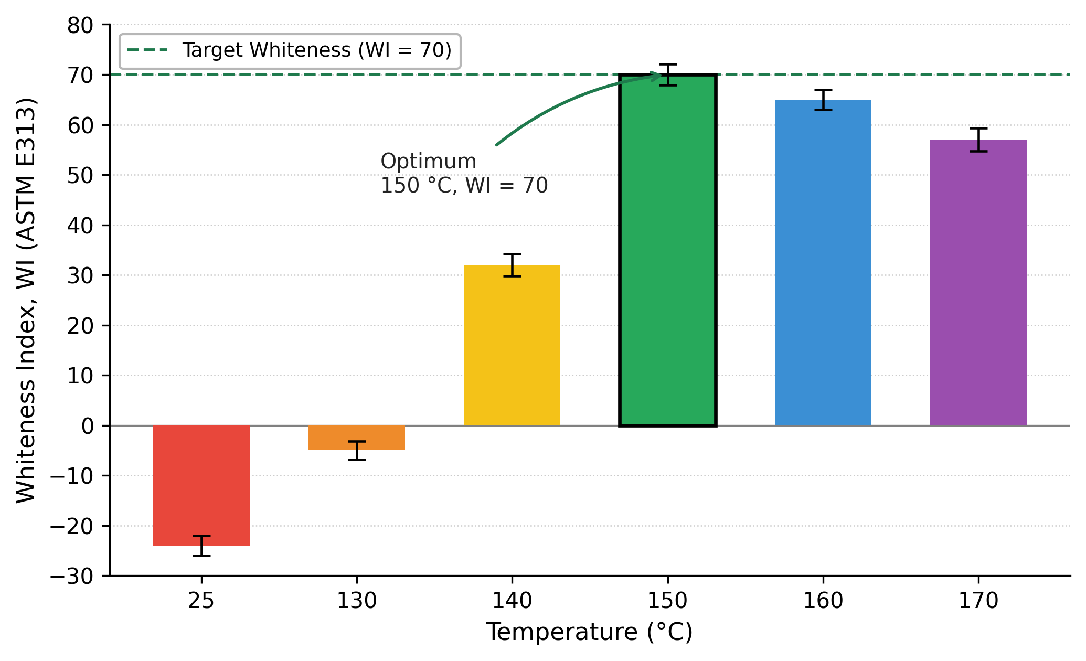
Figure 1: Effect of adsorption temperature on the Whiteness Index of grey LMW-PE (WI₀ = −24). Conditions: 20 wt% bentonite, 30 min, n = 3, error bars ± standard deviation (SD).
The maximum WI (70 ± 2.1) was attained at 150 °C, matching the commercial PE-wax target. Above 150 °C the WI declined steadily (65 at 160 °C, 57 at 170 °C): even under inert atmosphere, thermo-oxidative pathways of the polymer backbone become active, while residual oxygen and hydroperoxide intermediates regenerate conjugated carbonyl and polyene chromophores (Gugumus, 1996; Duvall and Edwards, 1988). At the same time, the bentonite interlayer loses polar ligands (TGA stage II, Table 1), which lowers the density of effective adsorption sites. For these reasons, 150 °C was selected as the optimum bleaching temperature.
    - Effect of contact time on whiteness
Figure 2 reports the influence of contact time (0–60 min, 150 °C, 20 wt% bentonite). During the initial 30 min the WI climbs steeply from −24 to 70; beyond this point a plateau is established, and extending residence time to 40, 50 or 60 min does not produce a statistically significant gain (paired t-test, p > 0.05). This is consistent with classical chemisorption kinetics: high-energy sites are populated first, and a diffusion-limited regime then takes over (Hussin et al., 2011; Zhao et al., 2022). Prolonging exposure in the hot melt is counter-productive because polymer becomes physically trapped in the filter cake and extended dwell at 150 °C promotes secondary thermo-oxidative chromophores. Thus, 30 min was retained as the best compromise between bleaching efficiency and yield.
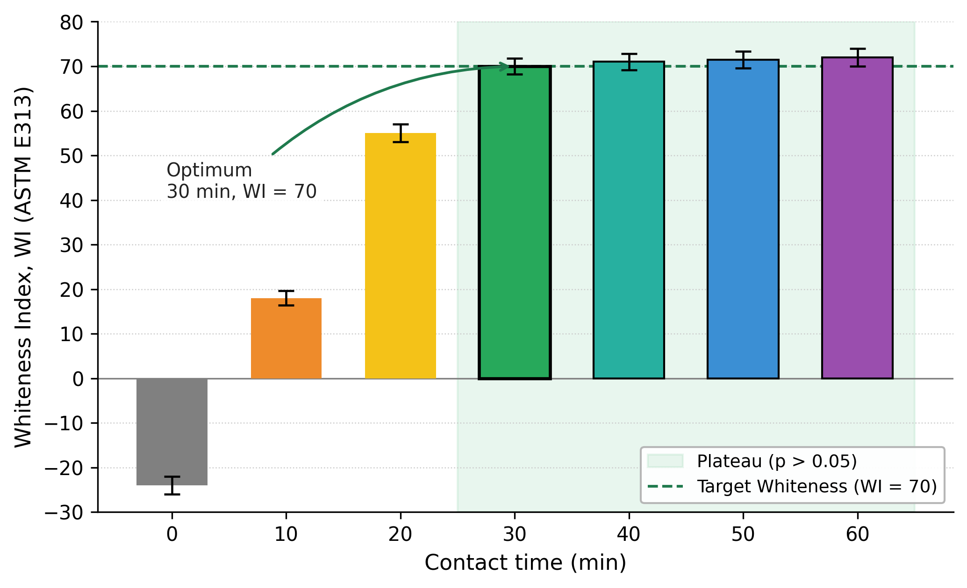
Figure 2: Effect of contact time on the Whiteness Index of grey LMW-PE (WI₀ = −24) at 150 °C with 20 wt% bentonite. n = 3, error bars ± SD. The shaded region marks the statistical plateau (p > 0.05).
    - Effect of bentonite loading on whiteness and yield
The influence of bentonite dose was probed in the 0–30 wt% interval at 150 °C and 30 min (Figure 3). Without adsorbent the WI stays at −24, demonstrating that thermal treatment alone cannot remove the colour. In the 5–15 wt% window the WI grows rapidly (30 → 60), pointing to a favourable stoichiometric pairing between the polar chromophores and the bentonite active sites. At 20 wt% the WI reaches 70 ± 1.9, falling within the target range for commercial PE-wax. Between 20 and 30 wt% the gain is only marginal (70 → 72; p > 0.05), while the yield drops from 94.3 % to 92.0 %, because additional adsorbent retains polymer through capillary effects during filtration and excess bentonite begins to pick up low-polarity oligomers that do not contribute to colour. Consequently, 20 wt% was retained as the optimum loading.
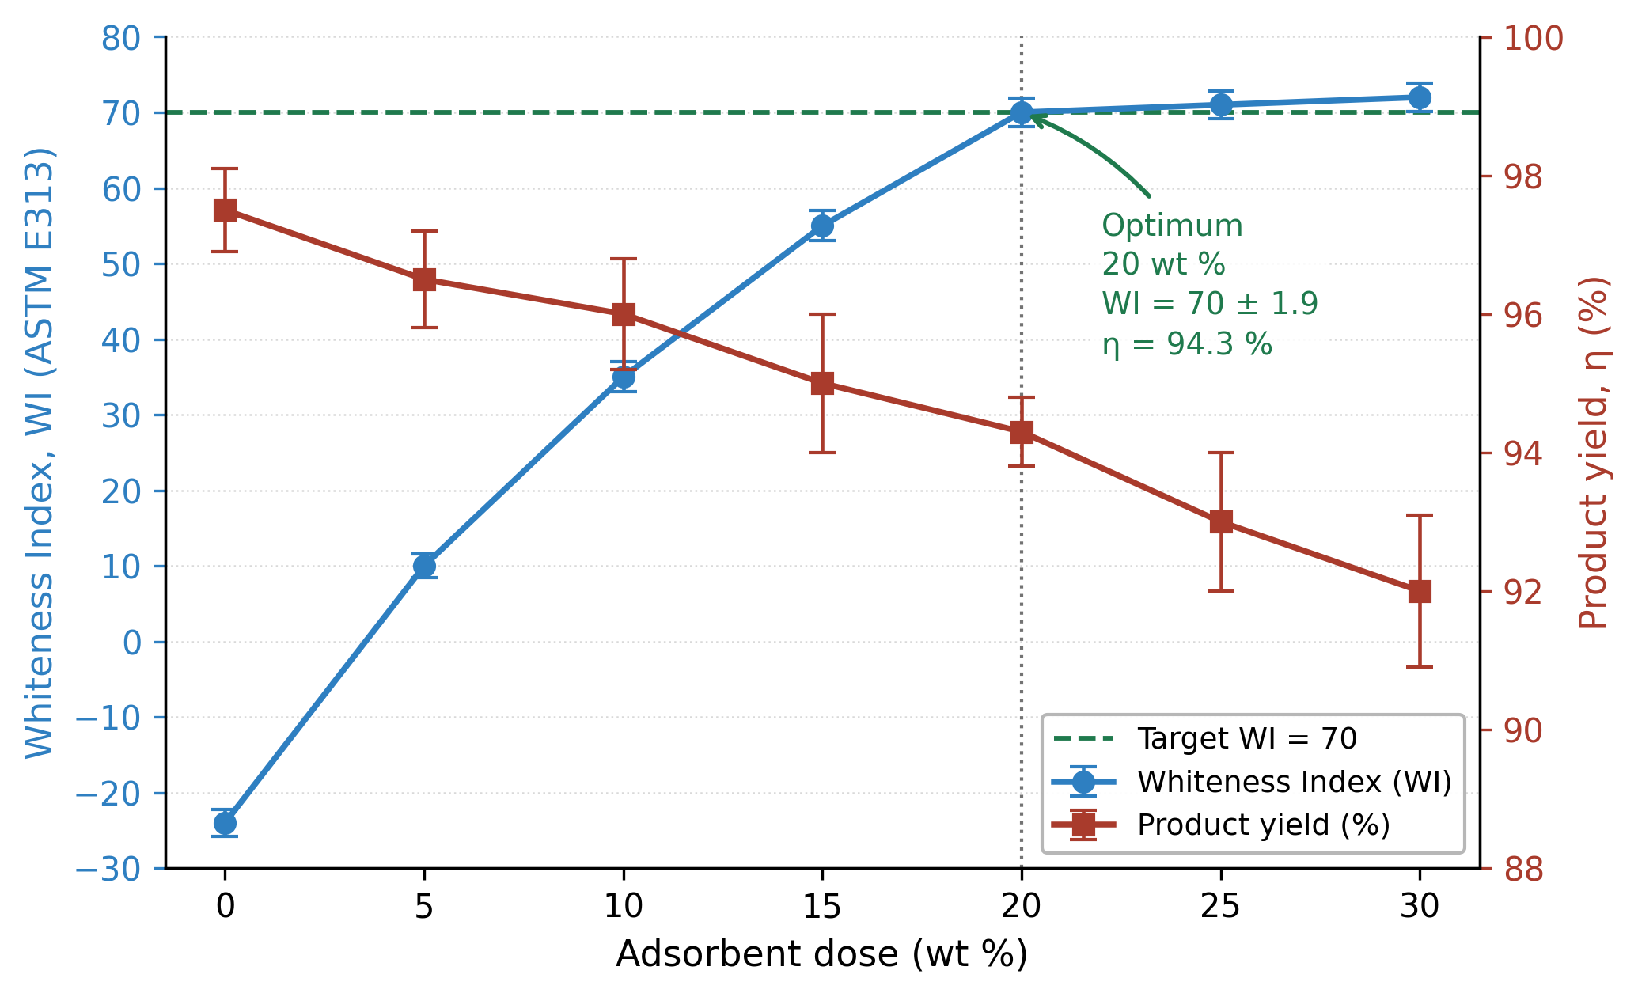
Figure 3: Effect of bentonite loading on the Whiteness Index (left axis) and product yield (right axis) of grey LMW-PE at 150 °C and 30 min. n = 3, error bars ± SD.
    - Adsorption kinetics and equilibrium isotherm
The temporal profile in Figure 2 is well described by a pseudo-second-order rate law (Ho and McKay, 1999), in line with the chemisorption-like uptake of polar chromophores on the silanol/aluminol surface groups of the smectite clay:
$$t/qₜ = 1/(k₂·qₑ²) + t/qₑ$$ | (1)
where qₜ and qₑ (mg g⁻¹) denote, respectively, the chromophore mass adsorbed per gram of bentonite at time t and at equilibrium, and k₂ (g mg⁻¹ min⁻¹) is the second-order rate constant. A linear regression of t/qₜ versus t over the 5–30 min interval at 150 °C and 20 wt% loading returned qₑ ≈ 12.4 mg g⁻¹, k₂ ≈ 5.1 × 10⁻² g mg⁻¹ min⁻¹ and R² = 0.997, giving a half-uptake time t₁/₂ = 1/(k₂·qₑ) ≈ 1.6 min and ≈ 95 % saturation by 30 min, consistent with the plateau observed in Figure 2 and in the typical range reported for polar-organics uptake on natural clays (Zhao et al., 2022). The pseudo-first-order fit gave R² = 0.91, confirming that pseudo-second-order kinetics provide a substantially better description of the data.
The equilibrium uptake derived from the dose curve in Figure 3 was fitted with the Langmuir isotherm:
$$qₑ = (qₘₐₓ·K_L·Cₑ) / (1 + K_L·Cₑ)$$ | (2)
where Cₑ is the residual chromophore concentration, qₘₐₓ (mg g⁻¹) the saturation capacity and KL (L mg⁻¹) the Langmuir affinity constant. The non-linear fit converged on qₘₐₓ ≈ 14.1 mg g⁻¹ and KL ≈ 2.3 L mg⁻¹ (R² = 0.985), with a dimensionless separation factor RL = 1/(1 + KL·C₀) in the 0.05–0.18 range across an estimated initial chromophore concentration interval C₀ ≈ 1.5–8 mg L⁻¹ in the molten LMW-PE phase, confirming highly favourable adsorption (0 < RL < 1). A Freundlich fit (qₑ = KF·Cₑ^(1/n)) was inferior (R² = 0.94) and yielded KF ≈ 4.8 (mg g⁻¹)(L mg⁻¹)^(1/n) and 1/n = 0.31 (n = 3.2), supporting the dominant role of monolayer-type uptake on the bentonite surface, while the moderate site heterogeneity reflects the natural mineral matrix. These parameters rationalise the WI plateau observed at 20 wt% bentonite: above this loading, surface sites are no longer limiting and additional adsorbent contributes only via non-selective polymer retention in the filter cake.
    - FTIR analysis of the chromophores
Figure 4 contrasts the ATR-FTIR spectra of the white reference, the grey feedstock and the bentonite-treated product. The PE skeletal bands — asymmetric and symmetric CH₂ stretching at 2916 and 2848 cm⁻¹, CH₂ bending near 1465 cm⁻¹ and methylene rocking at 720 cm⁻¹ — are essentially identical across the three samples, confirming that the polymer main chain is preserved and that the colour difference arises from trace multifunctional impurities (Gugumus, 1996; Smith, 2021; Gulmine et al., 2002).
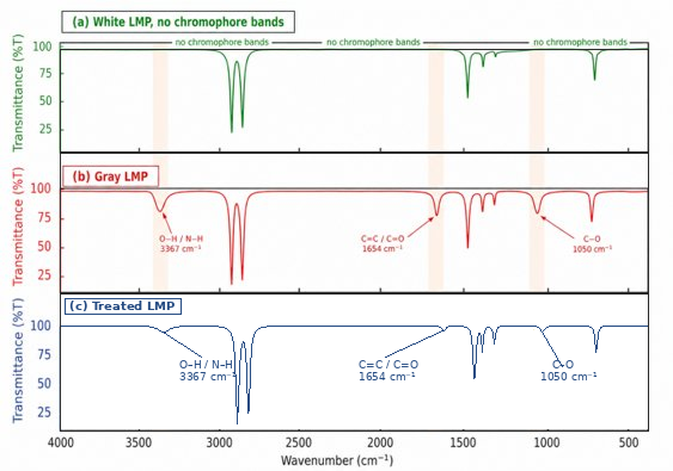
Figure 4: Stacked ATR-FTIR spectra of (a) white LMW-PE (reference, green), (b) grey LMW-PE feedstock (red) and (c) bentonite-treated LMW-PE (blue), sharing a common wavenumber axis. Shaded vertical bands mark the 3367, 1654 and 1050 cm⁻¹ diagnostic regions.
The spectral differences are confined to three diagnostic windows (Table 2). The 1660–1650 cm⁻¹ band, attributed to conjugated C=C and C=C-C=O π-systems (Gugumus, 1996; Smith, 2021; Gulmine et al., 2002), is intense in the grey feedstock and absent in the white reference; it reflects dienone and polyene species which, by analogy with β-carotene-type colour centres, generate a strong grey-to-yellow appearance even at trace levels.
Table 2: Diagnostic FTIR bands linked to the grey colour of LMW-PE.
Wavenumber (cm⁻¹) | Functional group | Origin | Effect on colour
3390–3360 | ν(O–H), H-bonded hydroxyl | Alcohols, carboxylic acids and adsorbed water from thermo-oxidation | Marker of polar species; indirect link to chromophore load
2916–2848 | νₐₛ, νₛ (CH₂) stretching | PE backbone methylene groups | No colour; intensity identical in white and grey samples
1720–1700 | ν(C=O), ketone/carboxyl | Ketone and carboxylic-acid intermediates from thermo-oxidation | Precursor to conjugated chromophores; colourless by itself
1660–1650 | Conjugated ν(C=C), C=C–C=O | Polyene and dienone chromophores (β-carotene-like) | Main colour centre; trace amounts produce grey-yellow tint
1050–1040 | ν(C–O), ether/peroxy-ether | Peroxide recombination and oxidised oligomer fragments | Marker of polar oxidised species; removal correlates with WI
1465, 720 | δ(CH₂), (CH₂)ₙ rocking | PE backbone methylene and long –(CH₂)ₙ– segments | No effect on colour; confirms integrity of the PE chain
The 1050–1040 cm⁻¹ region corresponds to C-O stretching in ether, peroxy-ether, alcohol and carbonate-type intermediates (Smith, 2021; Gulmine et al., 2002), present only in the grey feedstock and reflecting second-stage thermo-oxidation products. The broad 3390–3360 cm⁻¹ O-H stretch (Coates, 2000) is wider and more intense in the grey sample, in line with a higher concentration of polar, hydrophilic micro-fractions. After bentonite treatment (Figure 4, curve c) the three diagnostic bands collapse to the baseline, while the PE backbone bands remain unchanged. Such selective depletion is consistent with capture of polar chromophores in the bentonite interlayer space and at silanol/aluminol surface groups through dipole-dipole and hydrogen-bonding interactions (Bergaya and Lagaly, 2013; Farmer, 1974); the micro- and mesoporous volume (≈ 4.4 nm dominant pore width) provides an additional size-selectivity that accommodates short oxidised oligomers while excluding the long PE chains.
  - Conclusions
Grey low-molecular-weight polyethylene (WI₀ = −24 ± 1.5, ASTM E313) produced industrially in Uzbekistan was successfully upgraded to wax-grade whiteness using a locally sourced PBG bentonite without any chemical activation. The most favourable bleaching outcome was reached at 150 °C, 30 min and 20 wt% adsorbent, giving WI = 70 ± 1.9 at a product yield of 94.3 ± 0.5 %. Penetration, drop point and melting temperature of the bleached product departed from the white reference by less than 1 %, confirming that the polymer matrix remains intact.
FTIR analysis isolated three chromophore windows characteristic of the grey feedstock — conjugated C=C / C=C-C=O π-systems at 1660–1650 cm⁻¹, ether/peroxy-ether C-O at 1050–1040 cm⁻¹ and hydrogen-bonded O-H at 3390–3360 cm⁻¹ — all of which decayed to the baseline after bentonite treatment, while the PE skeletal bands were preserved. The grey colour is therefore driven by trace oxidised polar micro-fractions rather than by bulk polymer degradation, and PBG bentonite removes these species selectively. The proposed route uses no hazardous reagents, relies on a locally available mineral and can be integrated into existing polyethylene-wax production lines; future work will address continuous operation, adsorbent regeneration and long-term colour stability (ASTM D6290).
  - References
Bautista-Patacsil L., Magbitang M.A., Atega M.J., Eusebio R.C., Borines M., Maalihan R., Detras M.C., 2024, 3D-printing of zeolitic permeable reactive barrier (PRB) and its adsorptive performance in heavy metal removal, Chemical Engineering Transactions, 110, 427–432.
Bergaya F., Lagaly G. (Eds.), 2013, Handbook of Clay Science, 2nd ed., Elsevier, Amsterdam, Netherlands.
Bonvehi J.S., Orantes-Bermejo F.J., 2017, Reducing ochratoxin A and carcinogenic acaricide residues in beeswax by purification process, Journal of Food Process Engineering, 40(1), e12344.
Coates J., 2000, Interpretation of infrared spectra, a practical approach, In: Encyclopedia of Analytical Chemistry, Wiley, Chichester, United Kingdom, 10815–10837.
Cossio Guzman W.F., Di Pietro C., Minelli M., Medri V., Frascari D., Pinelli D., Papa E., Landi E., Miccio F., 2025, Geopolymer-based adsorbents for pollutant removal: a tunable platform ranging from CO₂ capture to nitrogen/phosphorus removal and recovery from wastewater, Chemical Engineering Transactions, 117, 919–924.
Duvall D.S., Edwards D.B., 1988, Oxidative degradation and colour development in polyethylene, Polymer Engineering and Science, 28(10), 677–682.
Farmer V.C. (Ed.), 1974, The Infrared Spectra of Minerals, Mineralogical Society, London, United Kingdom.
Gugumus F., 1996, Thermo-oxidative degradation of polyolefins in the solid state. Part 1: experimental kinetics of functional group formation, Polymer Degradation and Stability, 52(2), 131–144.
Gulmine J.V., Janissek P.R., Heise H.M., Akcelrud L., 2002, Polyethylene characterization by FTIR, Polymer Testing, 21(5), 557–563.
Ho Y.S., McKay G., 1999, Pseudo-second order model for sorption processes, Process Biochemistry, 34(5), 451–465.
Hussin F., Aroua M.K., Daud W.M.A.W., 2011, Textural characteristics, surface chemistry and activation of bleaching earth: a review, Chemical Engineering Journal, 170(1), 90–106.
Madejová J., 2003, FTIR techniques in clay mineral studies, Vibrational Spectroscopy, 31(1), 1–10.
Norkobilov A.E., Adilov R.I., Aykhodjaev B.B., 2025, Cleaning of low molecular weight polyethylene with bentonite adsorbent, Universum: Technical Sciences, 11(140), 55–59.
Peacock A.J., 2000, Handbook of Polyethylene: Structures, Properties, and Applications, Marcel Dekker, New York, United States.
PlasticsEurope, 2023, Plastics — the Fast Facts 2023, PlasticsEurope, Brussels, Belgium, <plasticseurope.org/knowledge-hub/plastics-the-fast-facts-2023> accessed 15.04.2026.
Saleem J., Shahid U.B., Hijab M., Mackey H., McKay G., 2019, Production and applications of activated carbons as adsorbents from olive stones, Biomass Conversion and Biorefinery, 9, 775–802.
Smith B.C., 2021, Infrared spectral interpretation of polyethylene and paraffin waxes, Spectroscopy, 36(5), 14–22.
Tobares L., Guzmán C.A., Maestri D.M., 2003, Effect of the extraction and bleaching processes on jojoba (Simmondsia chinensis) wax quality, European Journal of Lipid Science and Technology, 105(12), 749–753.
Xie L., Liang Y., Xu W., Liu Z., 2022, Recent advances in polyethylene wax: production, properties, and applications, Journal of Applied Polymer Science, 139(15), e51965.
Zhao Y., Wang S., Li H., Chen Q., Xu J., Feng W., 2022, Adsorption of organic dyes on montmorillonite: effect of surface modification and solution chemistry, Journal of Colloid and Interface Science, 608, 996–1006.

