Development of Environmentally Safer Multistage Stabilization of Hydrocarbon Fractions of Gas Condensate: A Laboratory Comparative Study
Hodiyev I.*, Abdubannobov M., Dadamirzayev H., Mengliev S., Igamkulova N., Mirzaakhmedova M.
Department of Chemical Technology of Oil and Gas Processing, Tashkent Institute of Chemical Technology, Tashkent, 100011, Uzbekistan
*Corresponding author: ilyoshodiyev29@gmail.com
This laboratory study compares single-, two-, and three-stage flash stabilization of high-methane gas condensate from the Shurtan and Kokdumalak processing plants. The tested three-stage sequence used 4.0 → 1.6 → 0.13 MPa and 10 → 0 → 40 °C at 2.0 ± 0.1 kg h⁻¹ and 15 min residence time per stage. Each configuration was run in triplicate and is reported descriptively as mean ± standard deviation. The liquid methane mole fraction decreased from 51.3 mol% in the feed to 16.2, 9.4, and 3.9 mol% after single-, two-, and three-stage treatment, respectively; the C5+ liquid mole fraction increased to 66.7, 77.9, and 87.9 mol%. The corresponding Reid vapor pressures were 89.3, 80.4, and 66.5 kPa. The final value satisfied the study acceptance target of 66.7 kPa; ASTM D323 was used only as the measurement method. The estimated total energy requirement of the three-stage configuration was 361.5 kJ kg⁻¹, 16.6% below the two-stage estimate. A screening greenhouse-gas calculation, using an IPCC AR6 GWP100 of 29.8 for fossil methane, gave 79.4 versus 184.6 kg CO₂-eq t⁻¹ feed. The contribution is a controlled laboratory comparison for the investigated feed and operating window, rather than a claim that multistage stabilization itself is novel. Pilot-scale testing, rigorous C5+ characterization, and independent model validation are required before industrial design or economic conclusions can be made.
Keywords: gas condensate; flash stabilization; Peng–Robinson equation of state; Reid vapor pressure; methane emissions; intermediate cooling

1. Introduction
Gas condensate stabilization removes volatile light hydrocarbons to control product vapor pressure, reduce evaporative losses, and prepare the liquid for storage or downstream processing. Industrial implementations include stabilization columns and multistage flash systems, whose performance depends strongly on feed composition, pressure sequence, temperature, heat integration, and vapor recovery (Rahmanian et al., 2016; Uwitonze et al., 2017). ASTM D323 specifies a method for measuring Reid vapor pressure at 37.8 °C; it does not prescribe a universal product limit. In this work, 66.7 kPa is therefore identified as the project acceptance target rather than an ASTM specification.
Recent studies have investigated plant-data-validated simulation and optimization (Rahmanian et al., 2016), energy and exergy performance (Hajizadeh et al., 2022), advanced control (Shafiei et al., 2023), stripping and heat integration (Uwitonze et al., 2017), and flare reduction through operating-condition optimization (Farahbod, 2024). These publications establish that multistage stabilization and intermediate thermal conditioning are known engineering approaches. The specific question addressed here is narrower: for the investigated Uzbekistan condensate and laboratory apparatus, how do three defined pressure–temperature sequences compare on liquid composition, RVP, estimated energy demand, and a screening emissions basis?
The study contribution is consequently the side-by-side experimental dataset for a high-methane feed and a specified 4.0 → 1.6 → 0.13 MPa sequence with an intermediate 0 °C stage. It is not evidence of industrial readiness. The analysis has been revised to avoid extrapolating the 2 kg h⁻¹ results to commercial throughput or presenting unverified capital cost and payback estimates.

2. Materials and methods

2.1 Feedstock and analytical methods
Unstable gas-condensate samples were obtained from the Shurtan and Kokdumalak gas-processing plants (Uzbekistan) during January–March 2024 and stored in pressurized containers at 4.0 MPa and 10 °C. Composition was measured by gas chromatography (Agilent 7890B, FID, HP-PONA column, 50 m × 0.20 mm × 0.50 μm). Reid vapor pressure was measured with a Grabner MiniVap VP Vision (stated instrument accuracy ±0.5 kPa) according to ASTM D323-20. The reported variability represents three runs performed on different days; the available dataset does not support a separate decomposition of sampling, instrument, and day-to-day uncertainty.
Table 1. Composition of the unstable gas-condensate feed
Component | Content (mol%) | SD
N₂ | 0.11 | 0.04
CH₄ | 51.3 | 0.3
C₂H₆ | 9.85 | 0.95
C₃H₈ | 5.20 | 4.20
i-C₄H₁₀ | 2.30 | 0.20
n-C₄H₁₀ | 1.80 | 1.00
C₅+ | 29.2 | 6.5
CO₂ | 0.45 | 0.25

2.2 Process configurations and experimental design
The feed rate was 2.0 ± 0.1 kg h⁻¹ and the nominal residence time was 15 min per stage. Configuration 1 consisted of one separator at 0.13 MPa and 40 °C. Configuration 2 used 4.0 MPa and 10 °C followed by 0.13 MPa and 40 °C. Configuration 3 used 4.0 MPa and 10 °C, 1.6 MPa and 0 °C, and 0.13 MPa and 40 °C (Figure 1). Each complete configuration was tested three times on different days. Because n = 3 per configuration is too small to assess normality and homoscedasticity reliably, the revised analysis reports means and standard deviations without confirmatory ANOVA or Tukey inference. The comparisons should be interpreted as descriptive evidence for this apparatus and feed.
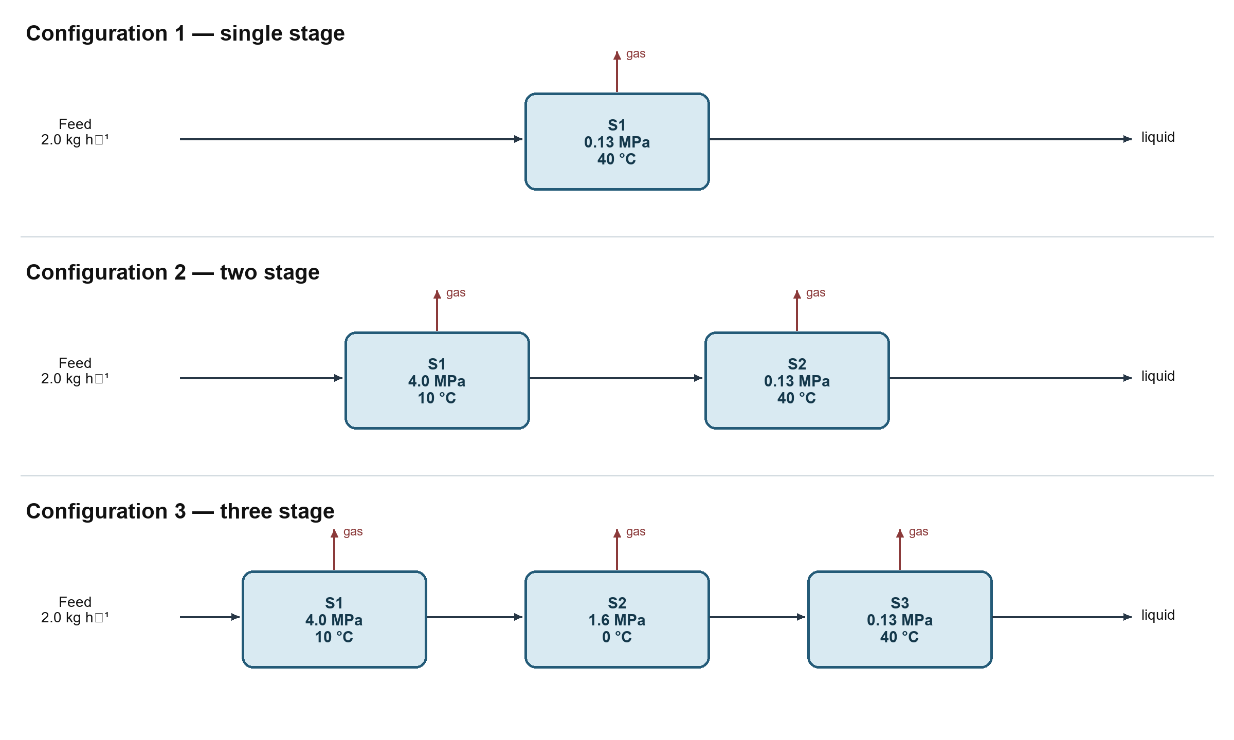
Figure 1. Laboratory process-flow schemes and investigated operating conditions. Gas streams leave the top of each separator; the liquid proceeds to the next stage.

2.3 Thermodynamic and energy calculations
Sequential isothermal–isobaric flash calculations were formulated with the Peng–Robinson equation of state (Peng and Robinson, 1976):
P = RT/(V − b) − a(T)/[V(V + b) + b(V − b)] (1)
Conventional van der Waals mixing rules and binary-interaction parameters from the cited DIPPR compilation were used. At each stage, the liquid outlet from the preceding flash was passed to the next pressure–temperature condition. Heating duty, cooling duty divided by an assumed coefficient of performance of 3.0, and isentropic compression work at an assumed efficiency of 0.75 were summed as an engineering energy estimate. The analytical C5+ fraction was treated as a single lump because a boiling-point distribution, molecular-weight distribution, density, and pseudo-component assay were not available. This limits heavy-end phase-equilibrium accuracy. The manuscript therefore no longer claims quantitative model validation or an average absolute deviation below 5%; stagewise model outputs and matched experimental points must be supplied before such validation can be reported.

2.4 Screening greenhouse-gas calculation
The boundary includes reported direct methane emissions and the energy-related CO₂ estimate associated with the laboratory energy calculation; it is not a life-cycle assessment. Fossil methane was converted with GWP100 = 29.8 kg CO₂-eq kg⁻¹ CH₄ from IPCC AR6. Total GHG was calculated as CH₄ × 29.8 + energy-related CO₂. The available records do not provide primary meter data or the energy-emission factor used for the energy-related CO₂ term, so those values are retained as screening estimates and their uncertainty cannot be independently reconstructed.

3. Results and discussion

3.1 Liquid composition and vapor pressure
The liquid methane mole fraction decreased monotonically with additional stages, while the C5+ mole fraction increased (Table 2 and Figure 2). The latter is compositional enrichment, not mass recovery or retention: a C5+ component balance would require liquid and vapor flow rates and compositions for every stage. Accordingly, the earlier claim of 87.9% C5+ retention has been removed. The three-stage liquid contained 3.9 ± 0.5 mol% CH₄ and 87.9 ± 1.3 mol% C5+. Relative to the feed methane mole fraction, the descriptive decrease was 92.4%.
Table 2. Stabilized-liquid composition (mol%, mean ± SD; n = 3)
Component | Single stage | Two stage | Three stage
CH₄ | 16.2 ± 1.1 | 9.4 ± 0.8 | 3.9 ± 0.5
C₂H₆ | 8.3 ± 0.6 | 5.7 ± 0.4 | 3.2 ± 0.3
C₃H₈ | 4.8 ± 0.5 | 3.6 ± 0.3 | 2.1 ± 0.2
C₄ total | 3.9 ± 0.3 | 3.4 ± 0.2 | 2.9 ± 0.1
C₅+ | 66.7 ± 1.8 | 77.9 ± 1.2 | 87.9 ± 1.3

RVP decreased from 89.3 ± 2.5 kPa after single-stage treatment to 80.4 ± 2.9 kPa after two stages and 66.5 ± 3.2 kPa after three stages (Table 3). The three-stage mean was below the 66.7 kPa study target, but the standard deviation overlaps the target; therefore, individual-run compliance and a one-sided acceptance analysis should be checked before a specification guarantee is made. With only three configurations, fitting a logarithmic trend and reporting R² = 0.96 would not provide reliable mechanistic evidence, so that claim has been removed.
Table 3. Vapor-pressure and estimated-energy comparison (mean ± SD; n = 3)
Parameter | Single stage | Two stage | Three stage
RVP (kPa) | 89.3 ± 2.5 | 80.4 ± 2.9 | 66.5 ± 3.2
RVP decrease from feed (%) | 14.3 ± 1.9 | 22.8 ± 2.2 | 36.2 ± 2.4
Estimated total energy (kJ kg⁻¹) | 277.7 ± 12 | 433.4 ± 19 | 361.5 ± 16

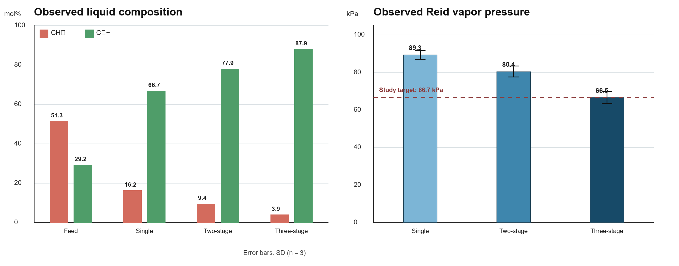
Figure 2. Observed stabilized-liquid composition and Reid vapor pressure. Error bars are SD (n = 3). C5+ values are liquid mole fractions, not component recovery. The 66.7 kPa line is the study target, not an ASTM-prescribed limit.

3.2 Stagewise behavior of the three-stage configuration
Table 4. Stagewise observations for the three-stage configuration
Parameter | Stage I  4.0 MPa, 10 °C | Stage II  1.6 MPa, 0 °C | Stage III  0.13 MPa, 40 °C
CH₄ in liquid (mol%) | 28.4 ± 1.2 | 12.7 ± 0.9 | 3.9 ± 0.5
Decrease in liquid CH₄ vs feed (%) | 44.6 | 75.2 | 92.4
C₅+ in liquid (mol%) | 53.8 ± 2.1 | 72.6 ± 1.8 | 87.9 ± 1.3
Gas/liquid ratio (reported) | 0.42 ± 0.03 | 0.28 ± 0.02 | 0.15 ± 0.01
Calculated CH₄ K-value | 3.2 | 8.3 | 15.7
Vapor pressure (kPa) | 96.8 ± 2.7 | 82.3 ± 3.1 | 66.5 ± 3.2

Table 4 uses one consistent feed-relative basis for the methane decrease: 100 × (51.3 − xstage)/51.3. This corrects the earlier mixed cumulative/stage-specific percentages. The increasing C5+ liquid mole fraction is consistent with preferential removal of lighter components, but it cannot establish C5+ recovery without stagewise mass balances. The calculated K-values provide a qualitative explanation for methane volatilization across the pressure sequence; because the C5+ assay was lumped, they should not be used to claim quantified selectivity or negligible heavy-hydrocarbon loss.

3.3 Energy and environmental screening
Table 5. Components of the engineering energy estimate (kJ kg⁻¹ stabilized condensate)
Energy component | Single stage | Two stage | Three stage | Three vs two
Heating | 145.3 ± 8.2 | 198.7 ± 11 | 167.4 ± 9.8 | −15.8%
Cooling/COP | 89.6 ± 5.4 | 156.3 ± 9.7 | 124.8 ± 7.6 | −20.1%
Compression | 42.8 ± 3.1 | 78.4 ± 5.2 | 69.3 ± 4.8 | −11.6%
Total | 277.7 ± 12 | 433.4 ± 19 | 361.5 ± 16 | −16.6%

The three-stage estimate was 16.6% below the two-stage estimate but 30.2% above the single-stage value. Its advantage is therefore conditional: it combines lower RVP and a lower calculated duty than the tested two-stage sequence, not the minimum absolute energy among all configurations. The calculation depends on COP and compressor-efficiency assumptions and has not been reconciled against measured utility consumption. Earlier exergy-efficiency and energy-per-kilogram-methane claims are omitted because their calculation basis and dimensional reconciliation were not available.
Table 6. Screening direct-emission results per tonne of feed
Metric | Single stage | Two stage | Three stage | Three vs two
Reported CH₄ (kg t⁻¹) | 9.6 ± 0.8 | 5.4 ± 0.5 | 2.0 ± 0.3 | −63.0%
CH₄ climate term (kg CO₂-eq t⁻¹) | 286.1 | 160.9 | 59.6 | −63.0%
Energy-related CO₂ estimate (kg t⁻¹) | 14.8 | 23.7 | 19.8 ± 0.9 | −16.5%
Screening total (kg CO₂-eq t⁻¹) | 300.9 | 184.6 | 79.4 | −57.0%

Using the corrected AR6 fossil-methane factor, the screening total for the three-stage configuration is 79.4 kg CO₂-eq t⁻¹, 57.0% below the two-stage estimate. The methane difference alone corresponds to 101.3 kg CO₂-eq t⁻¹ feed. These figures should not be scaled to annual plant emissions until vapor-routing measurements, recovery efficiency, utility emission factors, operating hours, and plant throughput are documented.

3.4 Critical comparison and limitations
Table 7. Evidence-based comparison with selected published work
Study | Scale/evidence | Focus | Relevance and limitation
This study | 2 kg h⁻¹; n = 3 | Three flash sequences | Direct laboratory comparison; no pilot or plant validation
Rahmanian et al. (2016) | Industrial simulation validated with plant data | Simulation and optimization | Stronger scale validation; different plant and feed
Hajizadeh et al. (2022) | Process simulation and energy/exergy analysis | Thermodynamic performance | Useful framework; not a matched experimental benchmark
Shafiei et al. (2023) | Industrial-unit 4E/APC study | Advanced control | Reported 19% exergy-efficiency improvement and 13% energy-cost reduction; different intervention
Farahbod (2024) | Plant operating-condition study | Flare reduction | Industrial relevance; operating window and feed differ
Uwitonze et al. (2017) | Process modeling | Stripping and heat integration | Shows integration options; no direct comparison with the present apparatus

The comparison avoids transferring energy and vapor-pressure values across unlike feedstocks, boundaries, and throughput bases. The present data support a laboratory ranking within the tested operating window only. Key limitations are the small number of runs; absence of raw replicate and individual RVP results; no stagewise component mass balance; a lumped C5+ characterization; no independently checkable model-versus-experiment dataset; calculated rather than metered utilities; and no pilot-scale hydrodynamic, control, operability, safety, or economic assessment. The dissertation supplied with the revision concerns a different vacuum-rectification/reforming system and therefore was not used as validation of this flash-stabilization process.

4. Conclusions
For the investigated feed and 2 kg h⁻¹ laboratory unit, the 4.0 → 1.6 → 0.13 MPa sequence with 10 → 0 → 40 °C conditioning produced the lowest liquid methane mole fraction and RVP among the three tested configurations. The final liquid contained 3.9 ± 0.5 mol% CH₄ and 87.9 ± 1.3 mol% C5+, and its mean RVP was 66.5 ± 3.2 kPa. C5+ enrichment must not be interpreted as recovery without a component balance, and the RVP variability precludes an unconditional specification guarantee. The estimated energy demand was 361.5 ± 16 kJ kg⁻¹, 16.6% below the tested two-stage sequence, while the corrected screening GHG total was 79.4 kg CO₂-eq t⁻¹ feed. These results justify pilot-scale investigation, not immediate industrial implementation. Further work should provide raw replicate data, characterized C5+ pseudo-components, matched model predictions and residuals, stagewise mass balances, metered utility data, and a transparent techno-economic assessment.

Acknowledgments
The authors acknowledge the Tashkent Institute of Chemical Technology for providing laboratory facilities and analytical equipment.

References
ASTM International, 2020, ASTM D323-20: Standard Test Method for Vapor Pressure of Petroleum Products (Reid Method), West Conshohocken, PA.
Farahbod F., 2024, Improvement of operating conditions and composition of streams in gas condensate stabilization unit with the aim of reducing flare gas in Sarkhon and Qeshm gas plant, Journal of Petroleum Exploration and Production Technology, 14, 555–566. https://doi.org/10.1007/s13202-023-01718-y.
Hajizadeh A., Mohamadi-Baghmolaei M., Azin R., Zendehboudi S., 2022, Performance analysis and simulation of the gas condensate stabilization process: energy and exergy aspects, Industrial & Engineering Chemistry Research, 61(25), 9149–9164. https://doi.org/10.1021/acs.iecr.2c01167.
IPCC, 2021, Climate Change 2021: The Physical Science Basis, Working Group I contribution to the Sixth Assessment Report, Cambridge University Press.
Peng D.Y., Robinson D.B., 1976, A new two-constant equation of state, Industrial & Engineering Chemistry Fundamentals, 15(1), 59–64.
Rahmanian N., Sakinah Bt Jusoh L., Homayoonfard M., Nasrifar K., Moshfeghian M., 2016, Simulation and optimization of a condensate stabilisation process, Journal of Natural Gas Science and Engineering, 32, 453–464. https://doi.org/10.1016/j.jngse.2016.04.028.
Rowley R.L., Wilding W.V., Oscarson J.L., Yang Y., Zundel N.A., Daubert T.E., Danner R.P., 2023, DIPPR Data Compilation of Pure Chemical Properties, AIChE, New York.
Shafiei H., Azin R., Osfouri S., Mohamadi-Baghmolaei M., 2023, Advanced process control strategy for a condensate stabilization unit: energy, exergy, economic, and environmental (4E) study, Industrial & Engineering Chemistry Research, 62(9), 3985–4001. https://doi.org/10.1021/acs.iecr.2c02964.
Uwitonze H., Hwang K.S., Lee I., 2017, Modelling and improving natural gas condensate process with stripping and heat integration, Chemical Engineering and Processing: Process Intensification, 118, 71–77. https://doi.org/10.1016/j.cep.2017.04.022.

