 CHEMICAL ENGINEERING TRANSACTIONS  VOL. xxx, 2026 | A publication of  
The Italian Association
of Chemical Engineering
Online at www.cetjournal.it

Guest Editors: Flavio Manenti, Botir Usmonov, Alessandro Di Pretoro
Copyright © 2026, AIDIC Servizi S.r.l.
ISBN 979-12-81206-xx-x; ISSN 2283-9216

Adaptive Forecasting in Industry 4.0 with Gaussian Processes: Robust Global-Optimal Kernel Discovery
Francesco Negri^{a,b}, Andrea Galeazzi^{c,d}, Francesco Galloª, Flavio Manenti^{b,*}
ªItelyum Regeneration S.p.A., Via Tavernelle, 19, Pieve Fissiraga, 26854, Italy
^{b}Dipartimento di Chimica, Materiali e Ingegneria Chimica “Giulio Natta”, Politecnico di Milano, Piazza Leonardo da Vinci 32, Milano, 20133, Italy
^{c}Department of Chemical Engineering, Imperial College London, South Kensington Campus, London SW7 2AZ, UK
^{d}The Sargent Centre for Process Systems Engineering, Imperial College London, South Kensington Campus, London SW7 2AZ, UK
flavio.manenti@polimi.it
Industry 4.0 is reshaping the chemical processing sector by transforming plants into data-rich environments where adaptive forecasting can support advanced strategies such as predictive maintenance. In this context, Gaussian Process Regression (GPR) is particularly promising because it enables flexible function learning while providing uncertainty quantification. Its adaptability can be enhanced through automated kernel search, in which the covariance structure is updated as new data become available. The baseline for automated GPR is greedy search, where only the best-ranked model is expanded at each step. This work proposes a broader search strategy based on beam search with limited-discrepancy backtracking. The proposed BULB approach retains the top-ranked kernels within a beam width B and explores suboptimal branches within a discrepancy budget D, reducing the risk of premature convergence to suboptimal structures. The study evaluates several combinations of search parameters on five heterogeneous datasets for generality. The results identify a robust search configuration (B, D) = (145, 1) that recovers the global-optimal kernel for all datasets while exploring, on average, only 63.5% of the full search space. This configuration can support adaptive GPR for industrial forecasting, including predictive maintenance applications where greedy search has already shown promising results. Future developments may include extending the analysis to a larger number of datasets and incorporating uncertainty over the kernel structure by combining the best-ranked models into a meta-kernel.
  - Introduction
Industry 4.0 represents a broad reorganization of production around connected, data-rich, and increasingly autonomous systems (Lu, 2017). In industrial practice, maintenance is one of the areas most affected by this transition, where traditional reactive and preventive strategies are increasingly complemented by predictive and prescriptive maintenance approaches based on real-time data and adaptive forecasting models (Florian et al., 2021; Schweidtmann et al., 2024; Venkatasubramanian et al., 2003). Recent predictive maintenance studies have increasingly used machine learning methods to extract hidden trends directly from plant data (Hosseini et al., 2022; Negri et al., 2025a, 2025b, 2024; Sansana et al., 2024). Among these methods, Gaussian Process Regression (GPR) is particularly attractive for industrial forecasting because it combines flexible function learning with probabilistic predictions and uncertainty quantification, the latter being especially important in predictive maintenance. (Rasmussen and Williams, 2006; Rossi et al., 2019). When coupled with automated kernel search, GPR can identify covariance structures that reflect trends, long-range correlations, and changes in operating conditions, supporting adaptation to heterogeneous industrial datasets. Automated kernel search is therefore important because the covariance model determines how latent dynamics are extracted from process data and how the model behaves in time-series forecasting. The baseline approach is greedy search, in which candidate kernels are generated using predefined composition rules and base kernels, but only the best-ranked candidate is expanded at each level. Broader strategies have also been proposed, including genetic programming, where a population of candidate kernel expressions evolves through selection, crossover, and mutation. In this framework, each individual represents a valid kernel expression, its quality is assessed through a fitness function after hyperparameter optimization, and new candidates are generated by recombining or modifying parts of existing structures. Successful applications of genetic programming to automated kernel search have been reported in the literature (Roman et al., 2021). The present work proposes an innovative strategy based on beam search under limited-discrepancy backtracking (Zhou and Hansen, 2005). In this approach, the search retains the top-ranked candidates at each level instead of only the best one, and it explores suboptimal branches by spending a discrepancy budget, with later expansions possibly leading to better kernels.
  - Methods
    - Automated Gaussian Process Regression
Gaussian Processes (GPs) are stochastic processes indexed over a domain, such as time in time-series problems, where any finite set of function values follows a joint Gaussian distribution. It is defined by a mean function and a covariance function, or kernel, which encodes assumptions about the latent function, as shown in Eq. (1). Here, f(t) represents the latent function, m(t) is the GP mean, and k(t, t’) is the kernel of the model.
$$f\left(t\right) \sim GP\left(m\left(t\right),k\left(t,t^{'}\right)\right)$$ | (1)
Gaussian Process Regression uses this prior formulation through mean and kernel to infer a posterior distribution over functions from observed data, commonly assuming that observations are noisy realizations of an underlying latent function with additive Gaussian noise (Rasmussen and Williams, 2006). In this framework, the kernel is a central modeling choice because it determines the covariance structure of the latent function (Duvenaud et al., 2013; Lloyd et al., 2014). Automated kernel discovery addresses this important aspect of the procedure by searching over candidate covariance structures, with the main aim of improving predictive performance. Grammar-based compositional search, introduced by Duvenaud et al. (2013), represents the canonical approach: simple base kernels are combined through operations such as addition, multiplication, and replacement to generate increasingly complex structures, which are then scored and selected according to their performance. According to this approach, candidate kernels may be ranked using different criteria, including the Log Marginal Likelihood (Duvenaud et al., 2013), the Bayesian Information Criterion (Lloyd et al., 2014), the Mean Absolute Error (Galeazzi et al., 2024; Negri et al., 2025a) and the Weighted Interval Score (Negri et al., 2026). Grammar-based kernel discovery commonly relies on greedy search. According to this approach, at each search level, candidate kernels are evaluated using a selected validation metric and ranked; only the best-performing kernel is retained and expanded to generate the next set of candidates. Although greedy search is computationally efficient and often effective, it explores only a limited region of the search space and may discard promising kernel structures, leading to premature convergence to suboptimal solutions. To reduce this limitation, this work adopts a broader search strategy that combines beam search with limited-discrepancy backtracking, increasing the chance of identifying the global-optimal kernel in the search space of interest.
    - Kernel beam search under limited-discrepancy backtracking
Greedy search has been widely used in grammar-based kernel discovery with good results. Its main weakness is early commitment: once the best-ranked candidate at a given level is selected, alternative branches of the grammar are discarded, even if they could potentially lead to competitive structures. Beam search reduces this limitation by retaining the top-ranked candidates at each depth rather than only the single best one. Candidate kernels are scored using the selected criterion, such as Log Marginal Likelihood (LML), Bayesian Information Criterion (BIC), Mean Absolute Error (MAE), or Weighted Interval Score (WIS), and only the top-B candidates are expanded further. By preserving multiple structural hypotheses, beam search lowers the risk of premature convergence and is especially useful when similar kernels at shallow levels may later generate substantially different descendants. A further extension is limited-discrepancy search, which assumes that the heuristic ranking is usually informative but may occasionally make mistakes (Harvey and Ginsberg, 1995). In grammar-based kernel discovery, this corresponds to reconsidering candidate kernels that were not ranked in the top-B models at a given expansion step. This strategy is attractive when the global-optimal kernel differs from the greedy solution because of only a small number of early mis-rankings, although the search requires careful caching to avoid redundant and expensive model evaluations. The application of beam search under limited-discrepancy backtracking (BULB) was developed to make beam search more robust (Zhou and Hansen, 2005). In this approach, the search initially proceeds as in standard beam search, but it later revisits pruned alternatives within a limited-discrepancy budget. For grammar-based kernel discovery, BULB is therefore a promising compromise between narrow greedy search and exhaustive enumeration of all the possible combinations: it broadens exploration beyond both greedy and standard beam search, and it reduces the risk of discarding useful structures. The novelty of this work lies in applying BULB to automated GP kernel discovery. Greedy search commits to the single best kernel at each level (Duvenaud et al., 2013), while standard beam search retains multiple candidates but still permanently prunes those outside the beam (Yang et al., 2023). BULB extends beam search by adding limited-discrepancy backtracking, so selected suboptimal branches can be revisited within a controlled budget. Unlike stochastic genetic programming (Roman et al., 2021), the resulting search remains deterministic. To the best of our knowledge, this is the first use of BULB for GP kernel search. Figure 1 schematically illustrates BULB search in the kernel search space. Each dot represents a kernel: grey denotes generic models, orange denotes the top-B candidates retained at each level, light blue denotes a suboptimal branch explored by spending part of the discrepancy budget D, and red denotes the global-optimal kernel recovered by the search. Straight lines indicate parent-child relationships between kernels.

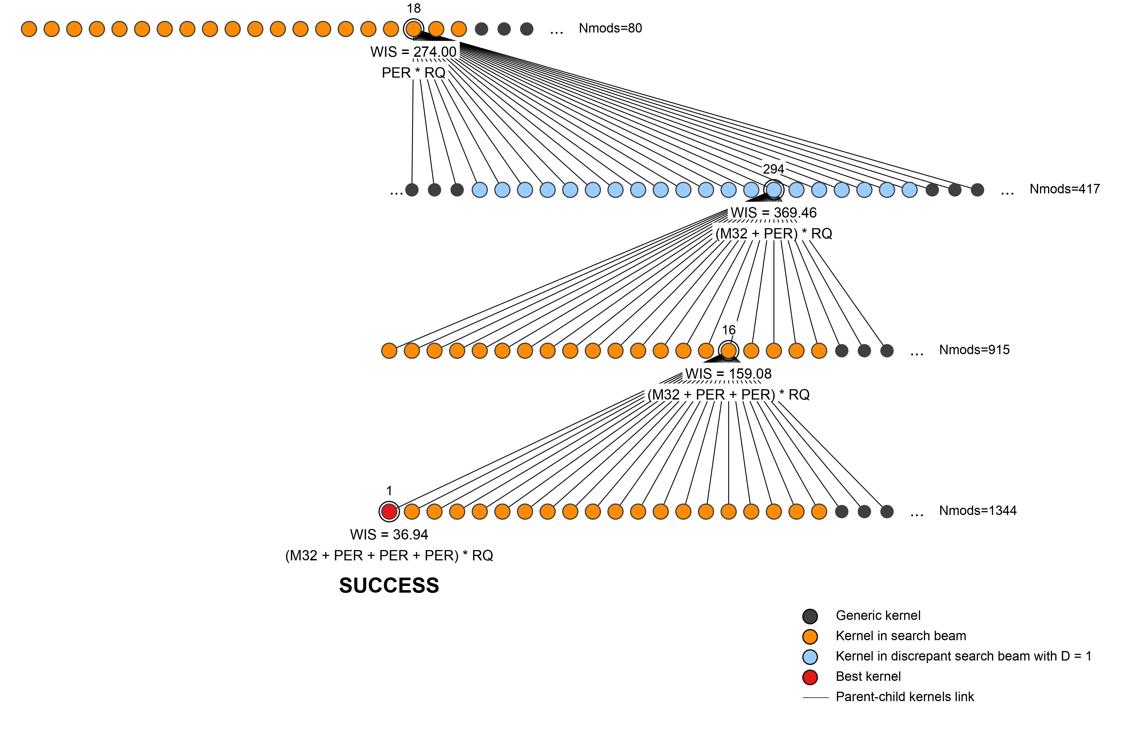
Figure 1: Schematic representation of BULB search recovering the global-optimal kernel using WIS as the scoring criterion. The search parameters are (B, D) = (20, 1), and discrepancy budget is spent at level two.
The proposed BULB procedure builds candidate kernels across successive search levels by applying addition, multiplication, and replacement operations to the sub-expressions of each expandable kernel. The base kernels included in the automated search are listed in Table 1, together with their names and a brief description of the latent functions they are most suited to model. The White-Noise kernel (WN) is not included as an active search component, but it is added to each candidate kernel to represent additive Gaussian observation noise under the standard homoscedastic GPR assumption. The search strategy is evaluated on five heterogeneous datasets to assess its generality: monthly international airline passenger totals from 1949 to 1960 (Box and Jenkins, 1976), the Mauna Loa atmospheric CO₂ record from 1959 to 2024 (Keeling et al., 1976), yearly averaged Total Solar Irradiance data from 1610 to 2024 (Lean et al., 1995), the pressure drop across the T-401 vacuum distillation column (Negri et al., 2025a), and the methane flow rate to the associated PH-401B feed-fired heater in the same used-oil refinery (Galeazzi et al., 2024). The kernel search space considered in this work is limited to combinations with a maximum length of five ($K_{≤5}$ space), excluding the final addition of the White-Noise kernel.
Table 1: Gaussian Process kernel library adopted in the automated BULB search.
ID | Kernel | Description
C | Constant | Constant offset, global bias level
LIN | Linear | Linear trends, non-stationary behaviour
RBF | Radial Basis Function | Very smooth functions, infinitely differentiable
RQ | Rational Quadratic | Scale mixture of RBF, multi-scale smoothness
M52 | Matérn 52 | Moderately smooth paths, twice differentiable
M32 | Matérn 32 | Rougher than M52, once differentiable
EXP | Exponential (Matérn 12) | Non-differentiable paths, sharp changes
PER | Periodic | Periodic patterns, repeating structure
  - Results and Discussion
This section evaluates the capability of BULB search to recover the global-optimal kernel within the predefined $K_{≤5}$ search space for the five datasets considered in this work. The reference kernel is identified beforehand by exhaustive enumeration of all kernel combinations with maximum length of five, excluding the final White-Noise term, providing a benchmark for retrieval performance. Figure 2 shows the effect of beam width B and discrepancy budget D for the Mauna Loa dataset as a representative case. Validation WIS is reported as a function of $\text{B} \text{∈ }\text{[1,} \text{100]}$, for $\text{D }\text{∈}\text{ \{0,} \text{1,} \text{2,} \text{3\}}$, as a measure of the quality of the retrieved kernel, with lower WIS values corresponding to more competitive models. The behaviour shown here is common to all investigated datasets, with WIS decreasing stepwise as B and D increase, indicating that broader exploration can gradually identify kernels with lower validation error, until the global-optimal kernel is eventually reached for a large enough combination of (B, D) search parameters. Since BULB is deterministic, B and D determine the extent of the explored search space; for sufficiently large values, the procedure becomes equivalent to exhaustive search. The objective is therefore to identify a robust combination of B and D that recovers the exhaustive-search kernel across all datasets while minimizing the number of Unique Model Evaluations (UME), which is used as a proxy for computational cost. Although this type of search may generate formally equivalent kernel expressions, the grammar-based implementation stores each unique expression together with its corresponding WIS value. Retrieving a previously evaluated expression from the cache is therefore much cheaper than repeating full GPR training. For this reason, the number of UME remains the controlling measure of computational cost. For the Mauna Loa dataset, the global-optimal kernel is recovered at (B, D) $\text{∈}$ {(3587, 0), (84, 1), (19, 2), (1, 3)}, with the beam width required for D = 0 exceeding the range shown in Figure 2a. Furthermore, Figure 2b reports the corresponding number of Unique Model Evaluations, as an indication of the computational cost of the procedure. The number of evaluations increases with both B and D, with D having the stronger effect because it enables the exploration of much larger fractions of the search space due to the systematic expansion of suboptimal branches. For D = 3, the search already reaches the cost of exhaustive exploration at (B, D) = (1, 3); therefore, the remaining analysis focuses on the more computationally relevant settings D $\text{∈}$ {0, 1, 2}.

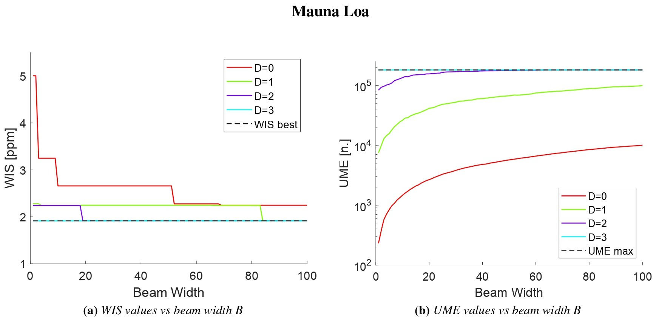
Figure 2: Results for BULB strategy on the Mauna Loa dataset over beam width B $\text{∈}$ [1,100] and D $\text{∈}$ {0,1,2,3}. Values for (a) WIS and (b) UME are reported together with the corresponding limit from exhaustive search.
Moving on a deeper investigation of the proposed approach, the search metadata provide a level-by-level interpretation of the representative Mauna Loa case. For the lowest-cost configuration that recovers the exhaustive-search kernel with the minimum UME requirement, (B, D) = (84, 1), Table 2 reports the fastest path to the solution and gives, for each selected kernel, its rank within both the full level and the retained beam. For this dataset, the second level is the controlling level, because the search must retain the eighty-fourth-ranked kernel in the B = 84 beam to remain on a path leading to the exhaustive-search solution. Furthermore, Table 2 also reports discrepancy expenditure across levels. In the fastest path, the discrepancy budget is used at level three by selecting a slice containing a kernel ranked 1719 out of 3388. The following composition step yields the global-optimal kernel and reduces validation WIS by approximately 77% between levels three and four.
Table 2: Search metadata for the Mauna Loa dataset under the lowest-cost configuration (B, D) = (84, 1).
Search level | Level rank | Beam rank | D budget | Kernel | WIS
1 | 20/80 | 20/80 | 0 | M52 + RQ | 8.197
2 | 84/816 | 84/84 | 0 | M52 * RQ + RQ | 7.646
3 | 1719/3388 | 39/84 | 1 | M52 * RQ + RQ * RQ | 8.165
4 | 1/5472 | 1/84 | 0 | M52 * (PER + RQ) + RQ* RQ | 1.914

After evaluating the (B, D) combinations across all datasets, robust search settings can be defined to recover the global-optimal kernel while avoiding full exhaustive enumeration over the search space. For each discrepancy budget D $\text{∈}$ {0, 1, 2}, a robust beam width ${\text{B}}_{\text{D}}^{\text{R}}$ is defined as the largest minimum beam width required across datasets to recover the exhaustive-search kernel, increased by a 5% safety margin, as shown in Eq. (2):
$$\left\{\begin{aligned}{\text{B}}_{\text{0}}^{\text{R}} \text{=} \text{1.05 · max(}{\text{B}}_{\text{min}}\text{)}{\text{|}}_{\text{D=0}} \text{=} \text{3766 →} \text{(}{\text{B}}_{\text{0}}^{\text{R}}\text{, 0)} \text{=} \text{(3766, 0)} \\ {\text{B}}_{\text{1}}^{\text{R}} \text{=} \text{1.05 · max(}{\text{B}}_{\text{min}}\text{)}{\text{|}}_{\text{D=1}} \text{=} \text{145 →} \text{(}{\text{B}}_{\text{1}}^{\text{R}}\text{, 1)} \text{=} \text{(145, 1)} \\ {\text{B}}_{\text{2}}^{\text{R}} \text{=} \text{1.05 · max(}{\text{B}}_{\text{min}}\text{)}{\text{|}}_{\text{D=2}} \text{=} \text{20 →} \text{(}{\text{B}}_{\text{2}}^{\text{R}}\text{, 2)} \text{=} \text{(20, 2)} \end{aligned}\right.$$ | (2)
The final robust configuration is then selected as the (B, D) pair that minimizes the average number of UME across datasets while recovering the global-optimal kernel in all cases. As reported in Table 3, the best robust configuration is (B, D) = (145, 1). This setting recovers the global-optimal kernel for all datasets with an average of 114,638 UME, corresponding to approximately 63.5% of the full $K_{≤5}$ kernel space. This robust search strategy supports an enhanced automated GPR procedure designed to identify highly competitive covariance models for complex time series forecasting tasks. Its main relevance lies in applications where robust forecasting is required due to heterogeneous, noisy, and non-stationary data, including predictive maintenance in chemical plants within the broader Industry 4.0 context. This application is further supported by previous results showing that simpler versions of the same automated Gaussian Process Regression framework can already provide satisfactory performance when based on a simple greedy search baseline (Negri et al., 2025a, 2025b, 2024).
Table 3: Robust $\text{(}{\text{B}}_{\text{D}}^{\text{R}}\text{, D)}$ pairs for global-optimal kernel discovery across datasets, with associated UME values.
Dataset | UME$|_{\text{(}{\text{B}}_{\text{0}}^{\text{R}}\text{, 0)}}$ | UME$|_{\text{(}{\text{B}}_{1}^{\text{R}}\text{, }\text{1}\text{)}}$ | UME$|_{\text{(}{\text{B}}_{2}^{\text{R}}\text{, }\text{2}\text{)}}$
Airline Passengers | 128,059 | 122,079 | 142,249
Mauna Loa | 122,008 | 117,112 | 155,289
Solar Irradiance | 127,954 | 128,511 | 152,289
PH-401B furnace | 121,577 | 109,024 | 157,449
T-401 column | 118,908 | 96,464 | 155,758
Average [n.] | 123,701 | 114,638 | 152,660
Average [%] | 68.5% | 63.5% | 84.6%
  - Conclusions
This work proposed an advanced search strategy for automated GPR aimed at the robust recovery of global-optimal kernels. This approach extends the standard greedy search baseline, in which candidate GP kernels are obtained only from expanding the best-performing model. The proposed strategy uses beam search with limited-discrepancy backtracking: it retains multiple best-ranked candidates at each level instead of only the best one, and it uses a discrepancy budget to explore suboptimal branches that would otherwise be discarded, so that later compositions may lead to better kernels. The method was evaluated on five heterogeneous datasets to test its generality. The results show that the robust configuration (B, D) = (145, 1) recovers the global-optimal kernel for all investigated datasets while requiring the lowest average number of Unique Model Evaluations among the tested configurations. On average, this specification evaluates 63.5% of the full search space, providing a substantial reduction in computational cost compared with exhaustive enumeration. The proposed BULB configuration can therefore support robust automated GPR workflows for adaptive industrial time-series forecasting. This unit-agnostic and model-agnostic approach is particularly relevant for predictive maintenance, where previous applications of automated GPR based on greedy search have shown promising results and may benefit from the broader proposed strategy. Future developments may include extending the analysis to a larger number of datasets to obtain more statistically grounded search parameters, and the inclusion of structural uncertainty over the kernel structure by combining the best-ranked models into a composite meta-kernel.
References
Box, G.E.P., Jenkins, G.M., 1976. Time Series Analysis: Forecasting and Control. Holden-Day, Inc., 500 Sansome St. San Francisco, CA, United States.
Duvenaud, D., Lloyd, J.R., Grosse, R., Tenenbaum, J.B., Ghahramani, Z., 2013. Structure Discovery in Nonparametric Regression through Compositional Kernel Search. https://doi.org/10.48550/arXiv.1302.4922
Florian, E., Sgarbossa, F., Zennaro, I., 2021. Machine learning-based predictive maintenance: A cost-oriented model for implementation. International Journal of Production Economics 236, 108114. https://doi.org/10.1016/j.ijpe.2021.108114
Galeazzi, A., de Fusco, F., Prifti, K., Gallo, F., Biegler, L., Manenti, F., 2024. Predicting the performance of an industrial furnace using Gaussian process and linear regression: A comparison. Computers & Chemical Engineering 181, 108513. https://doi.org/10.1016/j.compchemeng.2023.108513
Harvey, W.D., Ginsberg, M.L., 1995. Limited discrepancy search, in: Proceedings of the 14th International Joint Conference on Artificial Intelligence - Volume 1, IJCAI’95. Morgan Kaufmann Publishers Inc., San Francisco, CA, USA, pp. 607–613.
Hosseini, S., Khandakar, A., Chowdhury, M.E.H., Ayari, M.A., Rahman, T., Chowdhury, M.H., Vaferi, B., 2022. Novel and robust machine learning approach for estimating the fouling factor in heat exchangers. Energy Reports 8, 8767–8776. https://doi.org/10.1016/j.egyr.2022.06.123
Keeling, C.D., Bacastow, R.B., Bainbridge, A.E., Ekdahl Jr., C.A., Guenther, P.R., Waterman, L.S., Chin, J.F.S., 1976. Atmospheric carbon dioxide variations at Mauna Loa Observatory, Hawaii. Tellus 28, 538–551. https://doi.org/10.1111/j.2153-3490.1976.tb00701.x
Lean, J., Beer, J., Bradley, R., 1995. Reconstruction of solar irradiance since 1610: Implications for climate change. Geophysical Research Letters 22, 3195–3198. https://doi.org/10.1029/95GL03093
Lloyd, J.R., Duvenaud, D., Grosse, R., Tenenbaum, J.B., Ghahramani, Z., 2014. Automatic Construction and Natural-Language Description of Nonparametric Regression Models. https://doi.org/10.48550/arXiv.1402.4304
Lu, Y., 2017. Industry 4.0: A survey on technologies, applications and open research issues. Journal of Industrial Information Integration 6, 1–10. https://doi.org/10.1016/j.jii.2017.04.005
Negri, F., Galeazzi, A., Gallo, F., Manenti, F., 2026. Improving Fouling Forecasting in Industrial Distillation via Physics-Informed Hybrid Warped Gaussian Processes. Computers & Chemical Engineering 209, 109597. https://doi.org/10.1016/j.compchemeng.2026.109597
Negri, F., Galeazzi, A., Gallo, F., Manenti, F., 2025a. Reshaping Industrial Maintenance with Machine Learning: Fouling Control Using Optimized Gaussian Process Regression. Ind. Eng. Chem. Res. 64, 6633–6654. https://doi.org/10.1021/acs.iecr.4c04550
Negri, F., Galeazzi, A., Gallo, F., Manenti, F., 2025b. Enhancing Predictive Maintenance in Used Oil Re-Refining: a Hybrid Machine Learning Approach. Systems and Control Transactions 4, 1806–1811. https://doi.org/https://doi.org/10.69997/sct.125404
Negri, F., Galeazzi, A., Gallo, F., Manenti, F., 2024. Application of a Predictive Maintenance Strategy Based on Machine Learning in a Used Oil Refinery, in: Manenti, F., Reklaitis, G.V. (Eds.), Computer Aided Chemical Engineering, 34 European Symposium on Computer Aided Process Engineering / 15 International Symposium on Process Systems Engineering. Elsevier, pp. 3175–3180. https://doi.org/10.1016/B978-0-443-28824-1.50530-5
Rasmussen, C.E., Williams, C.K.I., 2006. Gaussian Processes for Machine Learning. The MIT Press, Cambridge, Mass. https://doi.org/10.7551/mitpress/3206.001.0001
Roman, I., Santana, R., Mendiburu, A., Lozano, J.A., 2021. Evolving Gaussian process kernels from elementary mathematical expressions for time series extrapolation. Neurocomputing 462, 426–439. https://doi.org/10.1016/j.neucom.2021.08.020
Rossi, F., Mockus, L., Manenti, F., Reklaitis, G., 2019. Present and Future of Model Uncertainty Quantification in Process Systems Engineering. Chemical Engineering Transactions 74, 625–630. https://doi.org/10.3303/CET1974105
Sansana, J., Rendall, R., Castillo, I., de Bruijne, L., Huggins, J., Phillips, A., Reis, M.S., 2024. Hybrid Approach for Advanced Monitoring and Forecasting of Fouling with Application to an Ethylene Oxide Plant. Ind. Eng. Chem. Res. 63, 10666–10676. https://doi.org/10.1021/acs.iecr.4c00298
Schweidtmann, A.M., Zhang, D., von Stosch, M., 2024. A review and perspective on hybrid modeling methodologies. Digital Chemical Engineering 10, 100136. https://doi.org/10.1016/j.dche.2023.100136
Venkatasubramanian, V., Rengaswamy, R., Kavuri, S.N., Yin, K., 2003. A review of process fault detection and diagnosis: Part III: Process history based methods. Computers & Chemical Engineering 27, 327–346. https://doi.org/10.1016/S0098-1354(02)00162-X
Yang, Y., Zhao, W., Xue, Y., Yang, H., Wu, C., 2023. Improved automatic kernel construction for Gaussian process regression in small sample learning for predicting lift body aerodynamic performance. Physics of Fluids 35. https://doi.org/10.1063/5.0153970
Zhou, R., Hansen, E.A., 2005. Beam-stack search: integrating backtracking with beam search, in: Proceedings of the Fifteenth International Conference on International Conference on Automated Planning and Scheduling, ICAPS’05. AAAI Press, Monterey, California, USA, pp. 90–98.

