Study of the Technology for Producing Functional Beverages Based on Extracts of Jujube (Ziziphus jujuba) and Black Mulberry (Morus nigra) Fruits Grown in Uzbekistan
Nargiza Gulomkhujaeva Khamdamovna, Mashkhura Zokirova Sodikjonova
Tashkent Institute of Chemical Technology, Uzbekistan 32 A. Navoi Street, Tashkent, 100011, Uzbekistan
E-mail: info@tkti.uz
Noncommunicable diseases are the leading cause of mortality in Uzbekistan, accounting for approximately 75-84 % of all deaths. Functional foods play an important role in preventing such diseases, as the development of food products with therapeutic and preventive properties can contribute to large-scale public health improvements within a relatively short timeframe. The development of functional products from medicinal plants and fruits rich in antioxidants is one of the most relevant approaches to preventing cardiovascular diseases, liver disorders, and cancer. Among such raw materials are jujube (Ziziphus jujuba Mill.) and black mulberry (Morus nigra L.). This study focuses on the extraction and concentration of fruit extracts, determination of polyphenols and water-soluble vitamins, formulation of functional beverages, and evaluation of their organoleptic, microbiological, antioxidant, and chemical properties. The optimal beverage (Formulation 2) demonstrated high nutritional value, containing 50.736 mg/100 g of total polyphenols and 47.906 mg/100 g of water-soluble vitamins, including 31.414 mg/100 g of vitamin C. The DPPH antioxidant activity (IC₅₀ = 42.3 μg/mL ) confirmed strong radical scavenging potential. The final product met all safety standards with no microbial growth detected (<1 CFU/mL) and heavy metal concentrations below maximum permissible limits.
- Introduction
Oxidative stress is defined as an imbalance between reactive oxygen species (oxidants) and antioxidants, leading to cellular damage and dysfunction (Khajavi Rad et al., 2021).
Free radicals-including superoxide anion radicals (O₂⁻), hydroxyl radicals (OH), nitric oxide (NO), peroxynitrite (ONOO⁻), and non-radical species such as hydrogen peroxide (H₂O₂)-are highly reactive and unstable compounds (Gaete Olivares et al., 2016; Huda-Faujan et al., 2009).
These species are known to contribute to the development of chronic and degenerative diseases such as atherosclerosis, Parkinson’s disease, cancer, diabetes, cardiovascular disease, and autoimmune disorders.
Antioxidant compounds play an important role in scavenging and neutralizing free radicals, as well as in strengthening the immune system (Adjdir et al., 2019). In recent years, antioxidants have increasingly attracted the attention of researchers. One way to meet the body’s demand for antioxidant substances is through their inclusion in the diet. Synthetic antioxidants, such as butylated hydroxyanisole and butylated hydroxytoluene, are widely used in the food industry; however, these compounds are associated with cancer and liver damage. This has led to a growing interest in natural antioxidants derived from plants. Many medicinal plants are regarded as safe and beneficial, and their active components can function as both enzymatic and non-enzymatic antioxidants (Zhu et al., 2024).
Fruits such as Ziziphus jujuba Mill. (ZJM) and Morus nigra L. (MNL) are considered rich sources of antioxidant plant raw materials. Ziziphus jujuba belongs to the Rhamnaceae family and is of great economic and medicinal importance, widely distributed across Asia, Europe, and America (Hua et al., 2022). All parts of the plant possess medicinal and nutritional properties. Its seeds, known in traditional Chinese medicine as Suanzaoren, are used to nourish the liver, calm the heart, reduce sweating, and promote fluid production, mainly treating conditions such as insomnia, palpitations, night sweating, and thirst caused by fluid deficiency (Song et al., 2025). The fruit pulp is rich in vitamins, trace elements, and biologically active compounds, and is consumed fresh or used as a food supplement (Yan et al., 2022).
Among fruits and vegetables, black mulberry (Morus nigra) is considered one of the richest sources of antioxidants (Gulomkhujayeva et al., 2025). It contains high levels of phenolic compounds, including anthocyanins, flavonoids, and other polyphenols, which contribute to its strong antioxidant activity (Kutlu et al., 2011; Liu and Zhang, 2024). Black mulberry contains significant amounts of anthocyanins such as cyanidin-3-glucoside and cyanidin-3-rutinoside, which inhibit cancer cell activity (Chen et al., 2006; Katsube et al., 2006). Cyanidin is believed to form complexes with DNA, protecting both cyanidin and DNA from oxidative damage, particularly from hydroxyl radicals (Sarma and Sharma, 1999).
This study investigates the technology for producing functional beverages based on extracts of jujube and black mulberry fruits cultivated in Uzbekistan.
- Materials and Methods
  - HPLC Analysis of Flavonoids:
The analysis was carried out using high-performance liquid chromatography (HPLC) with isocratic elution and a diode-array detector (DAD). Acetonitrile and a buffer solution were used as the mobile phase. Spectral data were recorded in the wavelength range of 200–400 nm. Chromatographic conditions: HPLC system - Agilent Technologies 1260; mobile phase - acetonitrile : buffer solution (30:70), pH = 2.92; analysis time - 20 min; injection volume - 5 µl; flow rate - 0.75 mL/min; column - Eclipse XDB-C18 (5.0 µm, 4.6 × 250 mm); detector - DAD, detection wavelengths at 254, 320, and 381 nm (Vernikovskaya, 2011).
  - Analysis of Water-Soluble Vitamins:
The analysis was performed using HPLC with gradient elution and a DAD. Acetonitrile and a buffer solution were used as the mobile phase. Spectral data were recorded at 200–400 nm (Ministry of Health of the Russian Federation, 2015). Chromatographic conditions: HPLC system - Agilent Technologies 1260; mobile phase (gradient mode) - acetonitrile : buffer solution (pH = 2.92): 4% : 96% (0-6 min), 10% : 90% (6-9 min), 20% : 80% (9-15 min), 4% : 96% (15-20 min); injection volume - 10 µl; flow rate - 0.75 ml/min; column - Eclipse XDB-C18 (5.0 µm, 4.6 × 250 mm); detector - DAD, detection wavelengths at 272, 292, 254, 297, and 360 nm.
  - Extraction and Sample Preparation:
All extractions were performed in triplicate (n = 3) using independently prepared samples (Espinoza-Vasquez Alexander P. et al., 2023). For each extraction, fresh fruits (500 g) were taken and processed as described above. The extract yield was determined gravimetrically as the ratio of dry extract mass to dry fruit mass and expressed as a percentage (w/w). The yield for Morus nigra juice concentrate was 18.6 ±0.4%; for Morus nigra alcoholic extract concentrate - 22.3 ±0.5\%; for Ziziphus jujuba aqueous extract - 14.2 ±0.3%; and for Ziziphus jujuba alcoholic extract - 19.8 ±0.4%.
  - HPLC Analysis and Validation:
Each extract was analyzed in triplicate (three injections). Calibration curves were constructed using standard references (rutin, hyperoside, robinin, gallic acid, apigenin, isoquercetin, vitamins B1, B2, B6, B9, C, PP) at six concentrations (0.5-100 μg/mL). Correlation coefficients (R²) for all calibrations were > 0.999. Limits of detection (LOD) and quantification (LOQ) were calculated as signal-to-noise ratios of 3:1 and 10:1, respectively. LOD ranged from 0.02 to 0.15 μg/mL, and LOQ from 0.07 to 0.50 μg/mL depending on the analyte. Results are presented as mean ± standard deviation (SD) of three independent extractions, each measured in triplicate.
  - Sensory Evaluation:
Evaluation was conducted in accordance with ISO 8589:2007 (Sensory analysis — General guidance for the design of test rooms, 2007). Thirty untrained volunteers (18 females, 12 males; age 22–55 years) from the staff and students of the Tashkent Institute of Chemical Technology participated in the tasting who provided informed consent. Beverage samples (20 mL) were served at 10-12℃ in randomized, coded transparent cups under white light. Panelists evaluated appearance (color and clarity), aroma, taste, texture (mouthfeel), and overall acceptability using a 9-point hedonic scale (1 = extremely dislike, 9 = extremely like). Additionally, a 5-point "Just-About-Right" (JAR) scale was used for sweetness and acidity. Sensory data were processed using one-way ANOVA followed by Tukey's post hoc test (p < 0.05). Formulation 2 received the highest overall acceptability score (7.8 ±0.9), significantly higher than Formulation 1 (6.5 ±1.1) (p < 0.05).
  - Antioxidant Activity Determination (DPPH Assay):
Antioxidant activity was evaluated by measuring the scavenging capacity of 2,2-diphenyl-1-picrylhydrazyl (DPPH) radicals according to a modified Brand-Williams method. 0.1 mL of the sample was added to 3.9 mL of methanolic DPPH solution (0.1 mM). The mixture was incubated in the dark at room temperature for 30 min, and absorbance was measured at 517 nm using a spectrophotometer. Ascorbic acid was used as a positive control. Activity was calculated as: Scavenging activity (%) = [(A₀ − A₁) / A₀] × 100. The IC₅₀ value was determined from the inhibition–concentration curve. All measurements were performed in triplicate.

- Results and Discussion
For the study, fruits of Ziziphus jujuba Mill. and Morus nigra L. grown in the Parkent district were used. Black mulberry fruits were processed in a juice extractor to obtain juice; the remaining pomace was mixed with 70% ethyl alcohol in a 1:20 ratio. Extraction was carried out under a reflux condenser for 40 minutes at 70-80 ℃. The extracts were filtered, concentrated using an IKA RV V-8 rotary evaporator until one-fifth of the original volume remained (at 40 ℃ for extract and 55 ℃ for juice).

3.1 Phenolic Compounds and Vitamins in Concentrates
All values are presented as mean ± standard deviation (SD) of three independent extraction experiments (n = 3), with each extract analyzed in triplicate. Statistical comparisons between aqueous and alcoholic extracts, as well as between Formulation 1 and Formulation 2, were performed using Student's t-test (p < 0.05). Total polyphenols in Morus nigra alcoholic extract concentrate (99.494 mg/100 g) were significantly higher than in Morus nigra juice concentrate (79.817 mg/100 g) (p < 0.05). Similarly, vitamin C content in Ziziphus jujuba alcoholic extract (36.231 mg/100 mL) was approximately twice as high as in the aqueous extract (17.874 mg/100 mL) (p < 0.01).
Table 1: Phenolic compounds in the composition of the concentrates
Samples | Content of phenolic compounds, mg/100 g
Samples | Rutin | Hyperoside | Robinin | Gallic acid
MNL juice concentrate | 42.908±0.08 | 0.928±0.09 | 18.552±0.07 | 17.429±0.04
MNL alcoholic extract concentrate | 51.251±0.05 | 3.992±0.06 | 24.886±0.03 | 19.365±0.02
Total amount of polyphenols | 94.159 | 4.92 | 43.438 | 36.789
Table 2: Content of vitamins in the studied berries
Samples | Vitamin content, mg/100 g
Samples | B6 | B9 | C | B2
MNL juice concentrate | 25.773 ±0.02 | - | 88.669 ±0.81 | 1.352 ±0.0003
MNL alcoholic extract concentrate | 43.528 ±0.04 | 6.113 ±0.05 | 177.339 ±0.76 | 2.598 ±0.0002
Total amount of vitamins | 69.301 | 6.113 | 266.008 | 3.95
Table 2 shows a high vitamin C content in the fruit concentrates. Vitamin B9 was not detected in aqueous extracts and was found at 6.113 ±0.05 mg in the concentrate obtained from ethanol pomace extract.
Jujube fruit pulp was separated from seeds, crushed, and extracted with water (1:20) or 80% ethyl alcohol (1:20) in a water bath for 30 minutes, followed by 10 minutes on a laboratory shaker.
Table 3: Vitamin content in aqueous and alcoholic extracts of Ziziphus jujuba Mill. fruits
№ | Sample name | Quantitative content, mg/100 ml
№ | Sample name | B | B6 | PP | C | B2
1 | ZJM aqueous extract | 1.124 ±0.0005 | - | - | 17.874 ±0.84 | 0.252 ±0.004
2 | ZJM alcoholic extracts | 1.301 ±0.0002 | 6.874 ±0.081 | 0.131 ±0.028 | 36.231 ±0.67 | 1.432 ±0.0003
3 | ZJM alcoholic extract concentrate | 2.025 ±0.0004 | 5.412 ±0.069 | 0.043 ±0.034 | 42.687 ±0.91 | 1.133 ±0.0001
Table 4: Polyphenol content in aqueous and alcoholic extracts of Ziziphus jujuba Mill. fruits
№ | Samples | Polyphenol content, mg/100 ml
№ | Samples | Rutin | Isoquercetin | Gallic acid | Apigenin
1 | ZJM aqueous extract | - | - | 4.682 ±0.05 | 0.00331 ±0.07
2 | ZJM alcoholic extracts | 5.369 ±0.03 | 0.154 ±0.07 | 35.562 ±0.08 | 7.365 ±0.02
3 | ZJM alcoholic extract concentrate | 11.813 ±0.07 | 0.114 ±0.03 | 21.786 ±0.08 | 2.469 ±0.04

3.2 Beverage Formulation Screening:
Seven formulations (F1–F7) were developed with varying ratios of Morus nigra concentrate (MNL) and Ziziphus jujuba concentrate (ZJM): F1 (100:0), F2 (75:25), F3 (50:50), F4 (25:75), F5 (0:100), F6 (80:20), and F7 (60:40). Soluble solids were adjusted to 15 ± 1 °Bx, and pH to 3.2–3.5 using citric acid. Screening was based on total polyphenols, total vitamins, and organoleptic acceptability (9-point hedonic scale, 30 panelists). Formulations F3, F4, and F5 were excluded due to low sensory scores (< 5.0). F6 and F7 showed moderate sensory scores but were inferior to F1 and F2 in bioactive content. Thus, F1 (MNL only) and F2 (MNL:ZJM = 75:25) were selected as they exhibited the highest content of bioactive compounds and satisfactory organoleptic properties.

3.3 Formulations of Selected Beverages:
Finished product parameters: Soluble solids ≥ 15 ± 1 °Bx; juice volume fraction ≥ 60 %; relative density 1.059 g/mL; titratable acidity 0.32–0.35 %. Formulation 2 exhibited slight turbidity, whereas Formulation 1 was clarified.
Table 5. Formulation of a beverage prepared under laboratory conditions (Formulation 1)
Ingredients (composition) | Dry matter content of the input ingredients, % °Bx | Amount of dry substances | Amount of ingredients added, g
MNL concentrate | 72 | 72 | 136.15
Sugar | 99.85 | 63.54 | 63.63
Drinking water, purified and softened | 0 | 0 | 859.22
Up to 1000 ml
Table 6. Formulation of a beverage from ZJM and MNL concentrates (Formulation 2)
Ingredients (composition) | Dry matter content of the input ingredients, % °Bx | Amount of dry substances | Amount of ingredients added, g
MNL concentrate | 72 | 72 | 137.14
ZJM concentrate | 70 | 32 | 45.71
Sucrose (sugar) | 99.85 | 30.85 | 30.9
Purified, softened potable water | – | – | 845.25
Up to 1000 Ml

3.4 Phenolic Compounds and Vitamins in Beverages
Formulations for beverages prepared under laboratory conditions (Formulation 1 and Formulation 2)
Finished product parameters: Soluble solids ≥15±1°Bx; juice volume fraction ≥ 60%; relative density 1.059 g/mL; titratable acidity 0.32-0.35%. Formulation 2 exhibited slight turbidity, whereas Formulation 1 was clarified.
Table 7: Phenolic compounds of beverages prepared based on Formulations 1 and 2
Samples | Flavonoid content, mg/100 g
Samples | Robinin | Rutin | Apigenin | Hyperoside | Gallic acid
Beverage prepared according to Formulation 1 | 10.407 | 30.989 | - | 2.557 | 4.152
Beverage prepared according to Formulation 2 | - | 33.918 | 4.569 | 2.325 | 9.924
The total polyphenol content in Formulation 1 was 48.105 mg/100 g, while in Formulation 2 it amounted to 50.736 mg/100 g.
Table 8: Vitamin composition of beverages
Samples | Vitamin content, mg/100 g
Samples | C | B | B2 | B6 | B9 | PP
Formulation 1 | 26.816 | - | - | 0.252 | 13.745 | 1.512
Formulation 2 | 31.414 | 0.687 | 0.866 | 13.745 | 1.173 | 0.0216
Total water-soluble vitamins were 42.325 mg/100 g (Formulation 1) and 47.906 mg/100 g. (Formulation 2). The decrease in vitamin C compared to concentrates is attributed to thermal treatment and dilution.

3.5 Toxic Elements and Microbiological Indicators:
Toxic elements (tin, arsenic, mercury) were not detected, and heavy metals (lead: 0.0264 mg/L, zinc: 0.6499 mg/L) did not exceed MPC limits. Microbiological safety was evaluated according to ISO 4833-1:2013 and ISO 21527-1:2008 (Microbiology of food and animal feeding stuffs..., 2008; Microbiology of the food chain..., 2013). No microbial colonies were detected on any of the culture media throughout the 10-day observation period (detection limit: < 1 CFU/mL for TMWCC; <10 CFU/mL for yeasts and molds), complying with the requirements of O‘z DSt 3020:2015 (Fruit juices and nectar. Specifications) and SanPiN RuZ No. 0031-24 (Ministry of Health of the Republic of Uzbekistan, 2024).
Table 9. Toxic elements in the beverage composition
№ | Element content. mg/L
№ | Sn | As | Pb | Zn | Hg
№1 | 0 | 0 | 0.0103 | 2.1325 | 0
№2 | 0 | 0 | 0.0264 | 0.6499 | 0
MPC |  | 0.02 | 0.5 | 10 | 0.02
*MPC (Maximum Permissible Concentration)
Among the toxic elements in the beverage composition, tin, arsenic, and mercury were not detected. Heavy metals such as lead and zinc did not exceed the maximum permissible concentrations.

3.6 Antioxidant Activity Results:
The DPPH activity of Formulation 2 (IC₅₀ = 42.3 ± 2.1 mg/ml) was significantly higher than that of Formulation 1 (IC₅₀ = 58.7 ± 3.4 5 μg/mL) (p < 0.05), consistent with higher polyphenol and vitamin levels, and comparable to ascorbic acid (IC₅₀ = 38.5 μg/mL).

3.7 Microbiological indicators of the beverages.
Initially, Sabouraud and peptone nutrient media were prepared in Petri dishes, and beverage samples were inoculated under sterile conditions. For this process, the first control medium was inoculated with sterilized water only, while the second control medium was inoculated with the beverage. The Petri dishes were placed in a thermostat chamber at a temperature of 36°C, and the inoculated dishes were monitored daily.
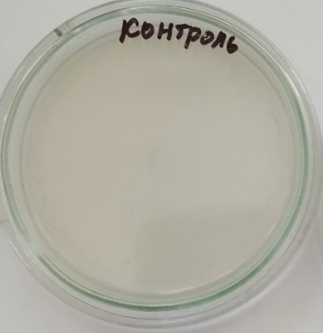 | 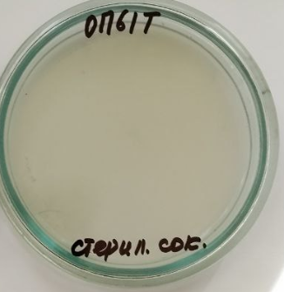
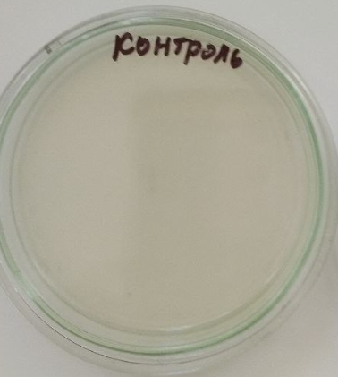 | 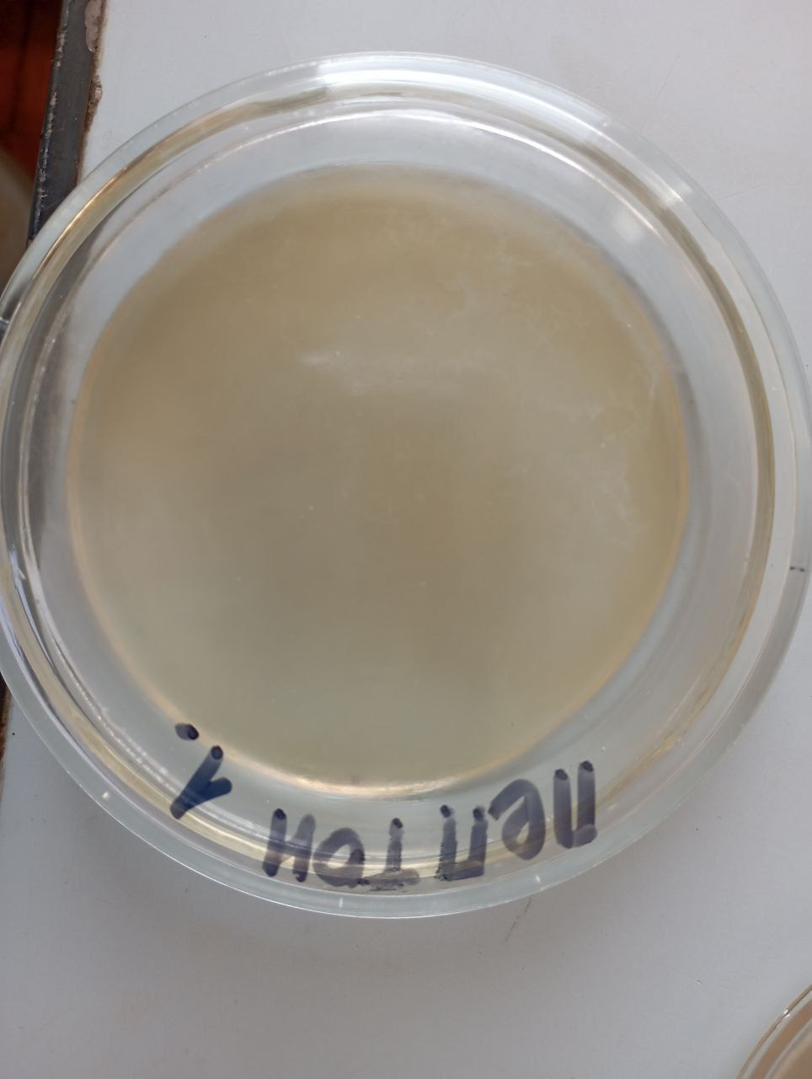
Petri dish inoculated with sterile water | Petri dish inoculated with the beverage
Figure 1. Microbiological control of functional beverages: (a) control (sterile water), (b) beverage sample.
No microorganism cells were detected in the nutrient media during the 10-day observation period

Discussion:
Comparison with Similar Functional Beverages. Total polyphenols (50.736 mg/100 g) and vitamin C (31.414 mg/100 g) in Formulation 2 are comparable to or exceeding the values for other plant-based functional beverages (Adjdir et al., 2019). Higher values stem from synergistic effects and optimized extraction (70% ethanol, 70-80 ℃, 40 min).
Aqueous vs. Alcoholic Extraction. Higher recovery of polyphenols and vitamins in alcoholic extracts is due to greater solubility in hydro-ethanolic mixtures, which disrupt hydrogen bonds between polyphenols and cell-wall polysaccharides (Song et al., 2025; Yan et al., 2022).
Comparison with Commercial Products. Commercial beverages typically contain 20-50 mg/100 g polyphenols and 10–30 mg/100 g vitamin C. Formulation 2 is competitive while adding value to local agricultural resources.
Significance for Antioxidant Activity. High concentrations of rutin (33.918 mg/100 g) and gallic acid (9.924 mg/100 g) indicate strong free radical scavenging potential.
Study Limitations. Only freshly prepared beverages were evaluated; storage stability (shelf-life, vitamin degradation, oxidation) requires further investigation.
- Conclusion
This study successfully developed and characterized functional beverage formulations based on fruit extracts of jujube (Ziziphus jujuba) and black mulberry (Morus nigra) cultivated in Uzbekistan. Main scientific findings:
- Alcoholic extraction (70% ethanol) significantly increases the yield of polyphenols and water-soluble vitamins by 1.5–2-fold compared to aqueous extraction.
- Formulation 2 (MNL:ZJM = 75:25) demonstrated superior nutritional quality: total polyphenols of 50.736 mg/100 g, water-soluble vitamins of 47.906 mg/100 g, including vitamin C at 31.414 mg/100 g.
- Both formulations meet safety standards: heavy metal concentrations are within MPC limits, and microbiological purity is confirmed with no growth observed over 10 days (<1CFU/mL).
- DPPH antioxidant activity (text IC₅₀ = 42.3 μg/mL for Formulation 2) confirms high antiradical potential.
Jujube and black mulberry fruits, currently underutilized in Uzbekistan, represent valuable raw materials for high-quality functional beverages. The optimized extraction and formulation procedures established in this study provide a scientific basis for industrial-scale production.

Acknowledgments
The authors are grateful to the Tashkent Institute of Chemical Technology for providing laboratory facilities and technical support.

References
Adjdir, S., Benariba, N., Laoufi, H., Djaziri, R., 2019. Phenolic content and antioxidant activity of Ziziphus jujuba Mill. fruit extracts. Phytothérapie 17, 74–82. https://doi.org/10.3166/phyto-2018-0033
Chen, P.-N., Chu, S.-C., Chiou, H.-H., Kuo, W.-H., Chiang, C.-L., Hsieh, Y.-S., 2006. Mulberry anthocyanins, cyanidin 3-rutinoside and cyanidin 3-glucoside, exhibited an inhibitory effect on the migration and invasion of a human lung cancer cell line. Cancer Letters 235, 248–259. https://doi.org/10.1016/j.canlet.2005.04.033
Espinoza-Vasquez Alexander P., Angulo Wilfredo, De Cecchis Dany, Gonzalez Yris, Galatro Daniela, Manzano Patricia, Choez-Guaranda Ivan, 2023. Mathematical Modeling of the Kinetics of Released Antioxidant Compounds During Solid-liquid Extraction for a Nutraceutical Beverage from Ilex Guayusa, Vernonanthura Patens, and Cocoa Husk Plants. Chemical Engineering Transactions 102, 289–294. https://doi.org/10.3303/CET23102049
Gaete Olivares, H., Moyano Lagos, N., Jara Gutierrez, C., others, 2016. Assessment oxidative stress biomarkers and metal bioaccumulation in macroalgae from coastal areas with mining activities in Chile. Environmental Monitoring and Assessment 188, 25. https://doi.org/10.1007/s10661-015-5021-5
Gulomkhujayeva, N.K.K., Zokirova, M.S., Saribaeva, D.A., 2025. INVESTIGATION OF THE CHEMICAL COMPOSITION OF LOCAL MULBERRY VARIETIES. UniTech 141. https://doi.org/10.32743/UniTech.2025.141.12.21517
Hua, Y., Xu, X., Guo, S., Xie, H., Yan, H., Ma, X., Niu, Y., Duan, J., 2022. Wild jujube (Ziziphus jujuba var. spinosa): A review of its phytonutrients, health benefits, metabolism, and applications. Journal of Agricultural and Food Chemistry 70, 7871–7886. https://doi.org/10.1021/acs.jafc.2c01905
Huda-Faujan, N., Noriham, A., Norrakiah, A.S., others, 2009. Antioxidant activity of plants methanolic extracts containing phenolic compounds. African Journal of Biotechnology 8, 484–489.
Katsube, T., Imawaka, N., Kawano, Y., Yamazaki, Y., Shiwaku, K., Yamane, Y., 2006. Antioxidant flavonol glycosides in mulberry (Morus alba L.) leaves isolated based on LDL antioxidant activity. Food Chemistry 97, 25–31. https://doi.org/10.1016/j.foodchem.2005.03.019
Khajavi Rad, A., Entezari Heravi, N., Kamkar‐Del, Y., Abbasnezhad, A., Jalili‐Nik, M., Shafei, M.N., Mohebbati, R., 2021. A standardized extract of Ziziphus jujuba Mill protects against adriamycin‐induced liver, heart, and brain toxicity: An oxidative stress and biochemical approach. J. Food Biochem. 45. https://doi.org/10.1111/jfbc.13698
Kutlu, T., Durmaz, G., Ateş, B., Yılmaz, \.Ismet, Çetin, M.Ş., 2011. Antioxidant properties of different extracts of black mulberry (Morus nigra L.). Turkish Journal of Biology 35, 103–110. https://doi.org/10.3906/biy-0904-22
Liu, S., Zhang, Y., 2024. Antioxidant properties and electrochemical activity of anthocyanins and anthocyanidins in mulberries. Journal of Food Measurement and Characterization 18, 3569–3576. https://doi.org/10.1007/s11694-024-02426-9
Microbiology of food and animal feeding stuffs... (No. ISO 21527-1:2008), 2008. . ISO.
Microbiology of the food chain... (No. ISO 4833-1:2013), 2013. . ISO.
Ministry of Health of the Republic of Uzbekistan, 2024. SanPiN No. 0031-24: Hygienic requirements for food safety. Health Ministry, Tashkent.
Ministry of Health of the Russian Federation, 2015. State Pharmacopoeia of the Russian Federation, XIV edition. Volume I. FEMB, Moscow.
Sarma, A.D., Sharma, R., 1999. Anthocyanin-DNA copigmentation complex: mutual protection against oxidative damage. Phytochemistry 52, 1313–1318.
Sensory analysis — General guidance for the design of test rooms (No. ISO 8589:2007), 2007. . International Organization for Standardization, Geneva, Switzerland.
Song, X., Zhang, Y., Zhang, L., 2025. Comprehensive Chemical Composition Evaluation of Ziziphus jujuba var. spinosa Germplasm Resources and Selection of Elite Cultivars for Seed, Pulp, and Leaf Utilization. Molecules 30, 4470. https://doi.org/10.3390/molecules30224470
Vernikovskaya, N.A., 2011. Chromatographic determination of phenolic compounds of flavonoids in medicinal plants (Candidate’s thesis). Kuban State University, Krasnodar.
Yan, M., Wang, Y., Watharkar, R.B., Pu, Y., Wu, C., Lin, M., Lu, D., Liu, M., Bao, J., Xia, Y., 2022. Physicochemical and antioxidant activity of fruit harvested from eight jujube (Ziziphus jujuba Mill.) cultivars at different development stages. Sci Rep 12, 2272. https://doi.org/10.1038/s41598-022-06313-5
Zhu, D., Zhu, Y., Tan, H., Ding, R., Dai, Q., Du, X., Liu, Y., Yue, R., 2024. Effects of jujube ( Ziziphus jujuba mill.) fruit extracts on oxidative stress: A systematic review and meta‐analysis of rodent studies. Food Science &amp; Nutrition 12, 5312–5328. https://doi.org/10.1002/fsn3.4234

