Integrated Physicochemical Characterization and Valorization of Sulfur-Alkaline Waste ("Yellow Oil") from Pyrolysis Gas Purification
Shodiyakhon A. Azimova ^{a,}* Dilmurod M. Azimov^{b}, Alisher A. Yuldashevª
ªTashkent institute of chemical technology, Uzbekistan
^{b}Tashkent State Technical University named after Islam Karimov, Uzbekistan
*prof_azimova@mail.ru
Sulfur-alkaline waste, commonly referred to as “yellow oil,” is a hazardous by-product formed during alkaline scrubbing of pyrolysis gas in ethylene production. Its complex composition, including sulfides, polysulfides, mercaptans, and heavy hydrocarbons, leads to high toxicity, persistent odor, and resistance to conventional treatment methods. At the same time, the high concentration of organosulfur compounds indicates significant potential for resource recovery, positioning yellow oil as an underutilized secondary feedstock.
This study presents a comprehensive and scalable approach to the valorization of yellow oil based on detailed physicochemical characterization and targeted conversion pathways. Industrial yellow oil samples collected from the Shurtan Gas Chemical Complex were subjected to thermal phase separation at 135–145 °C followed by physicochemical characterization using FTIR spectroscopy, Raman spectroscopy, and standardized petroleum testing methods. The obtained compositional data were used to identify feasible valorization pathways for sulfur-containing fractions.
The main contribution of this study is the demonstration that comprehensive physicochemical characterization combined with phase fractionation provides a scientific basis for the integrated valorization of sulfur-alkaline waste and its transformation from a hazardous by-product into a valuable secondary feedstock for petrochemical applications. The proposed approach can be integrated into existing alkaline scrubbing units with minimal process modification, thereby supporting industrial implementation of circular economy principles.

1. Introduction
Globally and at the national level, consistent efforts are being undertaken to develop the fuel and energy sector and diversify energy sources. This development is essential to meet the continuously increasing demand for energy resources in both industrial sectors and the population. The regeneration and reuse of industrial waste materials represent a key strategy for improving economic efficiency while simultaneously reducing environmental impact (Mansouri et al., 2026).
One of the significant industrial by-products is sulfur-alkaline waste, commonly referred to as “yellow oil,” which is formed during the alkaline purification of pyrolysis gas from acidic components such as H₂S and CO₂ (Aminuddin et al., 2024; Alguacil, 2023). Acid gases are removed between the third and fourth stages of compression using a two-stage scrubbing column designed to ensure complete removal (Aminuddin et al., 2024).
Each stage operates with an alkaline circulation loop, where the alkaline solution flows counter-currently. The upper section of the column includes a water washing stage to prevent contamination of downstream compression systems by entrained alkali. A 40 % alkaline solution is diluted to 20 %, and subsequently to 10 %, to maintain the required concentration across the column. Spent alkaline solution is directed to oxidation and neutralization units for further treatment (Azimova and Azimov, 2023).
During the process, acidic gases react with sodium hydroxide to form sulfides and carbonates. Under conditions of excess alkali (pH > 13), irreversible reactions occur:
H₂S + 2NaOH → Na₂S + 2H₂O (1)
CO₂ + 2NaOH → Na₂CO₃ + H₂O (2)
COS + 4NaOH → Na₂S + 2H₂O + Na₂CO₃ (3)
At lower alkali concentrations (pH < 12), reversible reactions dominate (Azimova and Azimov, 2023):
H₂S + NaOH ⇄ NaHS + H₂O (4)
H₂S + Na₂S ⇄ 2NaHS (5)
H₂S + Na₂CO₃ ⇄ NaHS + NaHCO₃ (6)
CO₂ + Na₂CO₃ + H₂O ⇄ 2NaHCO₃ (7)
As a result of these reactions and accompanying side processes, yellow oil accumulates in the lower section of the column. At the Shurtan Gas Chemical Complex, with an ethylene production capacity of 140,000 t/y, approximately 100–120 t/y of this waste is generated (Tilloev et al., 2022). The uncontrolled disposal of yellow oil leads to significant environmental issues (Azimova and Azimov, 2023). Sulfur-containing alkaline wastes exhibit high toxicity and corrosivity, negatively affecting wastewater systems and biological treatment units. Additionally, such wastes contain components that may cause equipment corrosion and secondary pollution (Aminuddin et al., 2024; Shokri and Nasernejad, 2023).
A number of recent studies have addressed the formation, characteristics, and treatment of sulfur-alkaline waste generated during petrochemical gas purification. Aminuddin et al. (2024) comprehensively reviewed the mechanisms of hydrogen sulfide removal by alkaline absorption and discussed the generation of sulfur-containing spent caustic requiring further treatment. Alguacil (2023) summarized recent advances in H₂S removal technologies and highlighted the environmental risks associated with sulfur-bearing alkaline wastes. Furthermore, recent reviews on spent caustic treatment have confirmed that these waste streams contain complex mixtures of sulfides, mercaptans, hydrocarbons, and oxygen-containing organic compounds, making their disposal difficult and necessitating integrated recovery or utilization technologies (Shokri and Nasernejad, 2023; Dewil et al., 2025).
In industrial practice, similar sulfur-alkaline waste problems have been reported at ethylene production facilities in Russia (Nizhnekamskneftekhim, Kazanorgsintez), China (Sinopec ethylene complexes), and several Middle Eastern petrochemical plants, where alkaline scrubbing of pyrolysis gas is widely used. In all cases, the formation of viscous sulfur-containing organic phases leads to operational challenges such as pipeline clogging, increased alkali consumption, and wastewater contamination.
To address these challenges, various treatment and valorization strategies have been proposed. Thermal oxidation and incineration remain widely used in petrochemical industries, including sulfur recovery and spent caustic disposal systems. However, these processes require high operating temperatures and substantial energy input, while also generating secondary sulfur oxide (SOₓ) emissions that necessitate additional flue gas treatment. Biological treatment technologies, including activated sludge and sulfide-oxidizing microorganisms, have also been investigated. Nevertheless, their application is often limited by the high alkalinity, elevated sulfide concentration, and toxicity of sulfur-containing organic compounds present in spent caustic wastewaters (Aminuddin et al., 2024; Shokri and Nasernejad, 2023; Dewil et al., 2025).
Despite considerable progress in sulfur-alkaline waste treatment technologies, several important challenges remain unresolved. Most published studies have focused on waste neutralization, thermal destruction, or biological treatment, whereas comprehensive physicochemical characterization of industrial yellow oil aimed at identifying its resource recovery potential has received considerably less attention. Furthermore, limited information is available regarding the relationship between the chemical composition of yellow oil and feasible valorization pathways, which restricts the development of integrated resource-efficient technologies for petrochemical applications.
The main contribution of this study is the establishment of a comprehensive physicochemical basis for the valorization of sulfur-alkaline waste ("yellow oil") generated during pyrolysis gas purification. Unlike previous studies that mainly focused on waste disposal or individual treatment methods, the present work combines detailed compositional characterization with phase fractionation to identify feasible pathways for recovering valuable sulfur-containing fractions. This integrated perspective supports the transition from conventional waste management toward resource-efficient and circular petrochemical production.

2. Materials and methods
Yellow oil samples were collected from the alkaline scrubbing unit of the Shurtan Gas Chemical Complex during routine industrial operation. Composite samples were obtained from three independent sampling events conducted over a six-month operating period to minimize the influence of process fluctuations. Sampling, storage, and transportation were carried out in accordance with ISO 3170 recommendations for petroleum liquids. The reported analytical data represent the average values obtained from the collected samples. Preliminary sample preparation was carried out using thermal settling, a widely accepted separation approach for complex petroleum-derived multiphase systems (ASTM D270-19, 2019). A 250 mL sample was heated at 135–145 °C for 30–40 min, followed by cooling to ambient temperature and settling for 3.5 h. The temperature range of 135–145 °C was selected based on preliminary laboratory observations and published data on the thermal behavior of sulfur-containing hydrocarbon mixtures (Azimova and Azimov, 2023). Within this range, efficient phase separation was achieved while minimizing excessive thermal decomposition of organosulfur compounds, thereby preserving the representative chemical composition of the recovered fractions for subsequent characterization.
This procedure resulted in separation into three distinct phases: alkaline aqueous, solid, and oil phases, due to differences in physicochemical properties such as density, polarity, and interfacial stability (GOST 3900-85; ASTM D1298-12b, 2017). Phase separation was performed using filtration and a separating funnel under gravity conditions without the use of additional chemical reagents to avoid compositional alteration, as recommended for multiphase petroleum waste treatment systems (IP 367/12, 2012). The solid phase was dried under ambient conditions, while the oil phase was additionally dehydrated in a desiccator over anhydrous calcium chloride to eliminate residual moisture.
Physicochemical properties of the oil phase were determined according to standardized petroleum and gas condensate testing procedures. Density was measured according to GOST 3900-85 and ASTM D1298-12b. Cloud point and pour point were determined using ASTM D7683 and ASTM D6749, respectively, which are commonly used for wax-containing petroleum fractions (ASTM D97-17, 2017). Flash point was measured in both open (GOST 4333) and closed (ASTM D93-20, 2020) cups. All measurements were carried out in triplicate under controlled laboratory conditions (20 ± 2 °C), ensuring statistical reliability in accordance with ASTM E29-22 (2022), and the relative standard deviation did not exceed 3%.
The chemical composition of the oil phase was investigated using Fourier-transform infrared (FTIR) spectroscopy (Figure 1) and Raman spectroscopy (Figure 2). FTIR analysis was performed in accordance with ASTM E1252-98, which provides standardized procedures for qualitative infrared spectral analysis of petroleum products. Raman spectra were obtained under standard laser excitation conditions following ISO 18455:2015, allowing detailed identification of aliphatic, aromatic, and sulfur-containing functional groups in complex hydrocarbon systems.
To ensure accuracy and reproducibility of the results, all instruments were preliminarily calibrated in accordance with ASTM E1252-98 and manufacturer recommendations. Data processing and spectral analysis were performed using standard chemometric software with baseline correction and normalization applied where necessary.
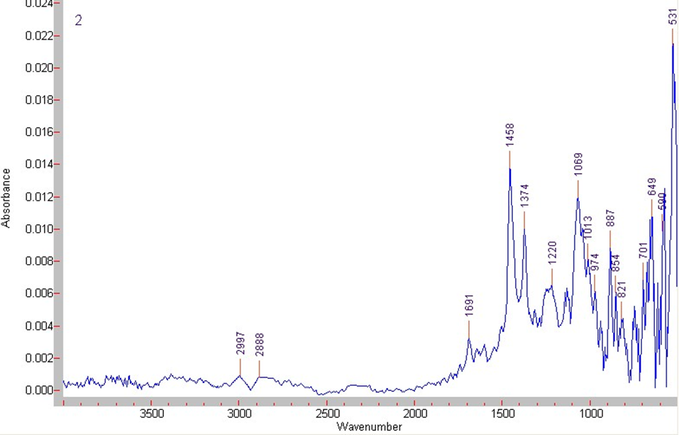
Figure 1: IR spectra of the oily fraction of waste yellow oil.
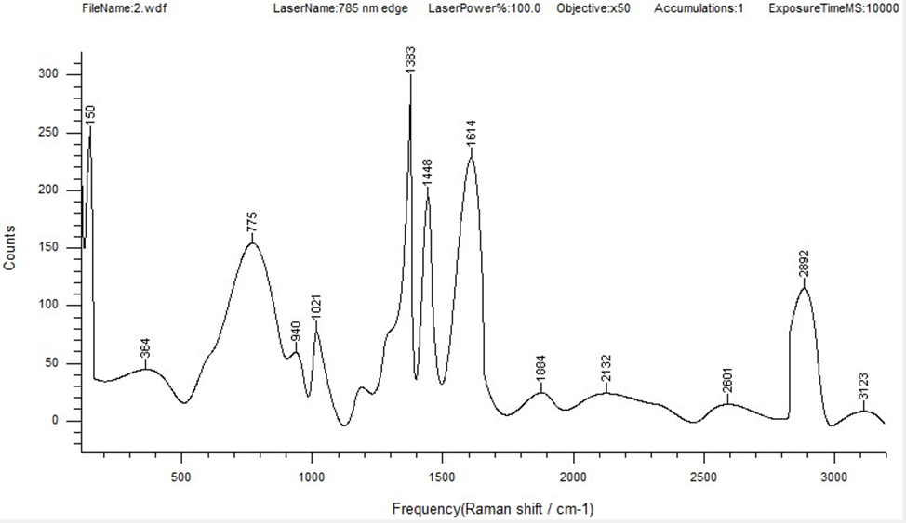
Figure 2: Raman spectra of the oily fraction of waste yellow oil.

3. Results and discussion
Thermal settling resulted in clear separation of yellow oil into three phases. The alkaline aqueous phase exhibited a high pH of 13–14 and contained predominantly sodium salts and dissolved hydrocarbons. The solid phase appeared as a brittle brown material. The oil phase consisted of a complex mixture of hydrocarbons with a density of 973 kg/m³ at 20 °C.
The oil phase demonstrated complex physicochemical behaviour. The cloud point of 8.8 °C indicates the presence of high-molecular-weight components prone to crystallisation. The pour point of −22 °C reflects low-temperature flow properties. The flash point was 115.2 °C (open cup) and 42.3 °C (closed cup), indicating the presence of volatile components.
FTIR analysis revealed multiple absorption bands corresponding to different functional groups. The major peaks are summarised in Table 1.
Table 1: Functional group identification of the oil phase
Wavenumber (cm⁻¹) | Vibration type | Interpretation
2977, 2888 | ν(C–H) | Aliphatic hydrocarbons
1691 | ν(C=O) | Carbonyl compounds
1601 | ν(C=C) | Aromatic/unsaturated hydrocarbons
1458, 1374 | δ(CH₂, CH₃) | Aliphatic structures
1220–1013 | ν(C–O) | Ethers and alcohols
971–827 | δ(=C–H) | Olefins/aromatics
764–701 | ν(C–S) | Sulfur compounds
649–531 | ν(S–S) | Polysulfides
The identified functional groups provide important insights into the chemical nature and potential utilization of yellow oil. The presence of aliphatic C–H stretching vibrations confirms that hydrocarbons constitute the dominant organic matrix of the oil fraction. Carbonyl (C=O) and C–O absorption bands indicate partial oxidation of hydrocarbons and the presence of oxygen-containing compounds formed during prolonged industrial operation. Most importantly, the characteristic C–S and S–S vibrations confirm that sulfur is predominantly incorporated into organosulfur structures rather than existing exclusively as inorganic sulfides. This finding suggests that sulfur-containing organic fractions may be selectively recovered and further utilized as raw materials for sulfur-based additives, corrosion inhibitors, or bitumen modification instead of being disposed of as hazardous waste.
Raman spectroscopy of the oil phase (Figure 2) complements the IR analysis data and enables a more detailed characterization of the structure of hydrocarbon components. The spectrum exhibits characteristic bands over a wide range of wavenumbers, confirming the complex and multicomponent nature of the studied sample.
The main peaks of the Raman spectrum can be interpreted as follows:
- ~775 cm⁻¹ — C–C vibrations and deformation modes of alkyl chains, characteristic of saturated hydrocarbons;
- ~940–1020 cm⁻¹ — C–C stretching vibrations and possible contributions from C–O groups;
- ~1383–1448 cm⁻¹ — deformation vibrations of CH₂ and CH₃ groups, typical of aliphatic structures;
- ~1614 cm⁻¹ — C=C stretching vibrations, indicating the presence of aromatic or olefinic compounds;
- ~1684 cm⁻¹ — possible vibrations of carbonyl groups or conjugated double bonds;
- ~2132 cm⁻¹ — weak bands that may be associated with cumulative or triple bonds (C≡C), or combination bands;
- ~2600–2900 cm⁻¹ (maximum at ~2892 cm⁻¹) — C–H stretching vibrations in aliphatic hydrocarbons, characteristic of saturated chains;
- ~3123 cm⁻¹ — =C–H vibrations, indicating the presence of unsaturated or aromatic structures.
The Raman spectral features also provide insight into the possible formation mechanisms of yellow oil during alkaline pyrolysis gas purification. The intense bands assigned to aliphatic C–H vibrations indicate that the oil fraction is predominantly composed of saturated hydrocarbon chains formed through condensation and polymerization of pyrolysis intermediates. The appearance of aromatic C=C vibrations near 1614 cm⁻¹ suggests that partial cyclization and aromatization reactions occur during prolonged thermal processing. In addition, the coexistence of carbonyl- and sulfur-related bands observed by FTIR and Raman spectroscopy indicates simultaneous oxidation and sulfur incorporation reactions, leading to the formation of complex organosulfur structures. These observations support the hypothesis that yellow oil is produced through a combination of radical polymerization, oxidative transformation, and sulfurization reactions occurring under industrial alkaline scrubbing conditions.
The Raman and FTIR analyses provide complementary information on the molecular structure of yellow oil. FTIR spectroscopy is particularly sensitive to polar functional groups such as C=O, C–O, and S–O bonds, allowing reliable identification of oxygen-containing compounds and sulfur-related functionalities. In contrast, Raman spectroscopy is more sensitive to nonpolar molecular vibrations, especially C=C, C–C, and aromatic skeletal vibrations, which are often weak or masked in FTIR spectra. The combined interpretation of both techniques therefore provides a more comprehensive characterization of the oil fraction, confirming the coexistence of aliphatic hydrocarbons, aromatic structures, oxygen-containing compounds, and organosulfur species.
Two primary formation mechanisms are proposed: radical polymerization of pyrolysis intermediates and aldol condensation of oxygen-containing compounds
The proposed reaction pathways are supported by the combined spectroscopic evidence obtained in this study. Radical polymerization of unsaturated pyrolysis intermediates explains the predominance of aliphatic hydrocarbon chains detected by both FTIR and Raman spectroscopy. Simultaneously, sulfur-containing gases (primarily H₂S and COS) react with alkaline media to form sulfides and polysulfides, which subsequently participate in secondary reactions with unsaturated hydrocarbons, leading to the formation of organosulfur compounds. Partial oxidation during industrial operation results in the formation of oxygen-containing functional groups, including carbonyl and ether species. Finally, condensation and aromatization reactions contribute to the formation of higher-molecular-weight aromatic structures responsible for the high density and viscosity of the oil fraction. Together, these processes explain the complex multicomponent composition of yellow oil observed experimentally.
From a technological perspective, the proposed valorization approach can be integrated into existing gas treatment units with minimal modification. This makes the approach particularly attractive for large-scale petrochemical complexes such as the Shurtan Gas Chemical Complex. The identified composition suggests that the oil phase may serve as a potential feedstock for further development of lubricant formulations, fuel additives, and sulfur-containing chemical products, subject to additional physicochemical evaluation, performance testing, and techno-economic assessment.

4. Conclusions
The novelty of the present work lies in the integrated physicochemical characterization of industrial sulfur-alkaline waste using complementary FTIR and Raman spectroscopy together with fractionation and physicochemical analyses. Unlike previous studies that primarily focused on waste treatment or disposal, the present work establishes a direct relationship between the chemical structure of yellow oil and its potential routes for resource recovery and industrial utilization.
This study demonstrated that sulfur-alkaline waste ("yellow oil") generated during pyrolysis gas purification is a complex multicomponent system that can be effectively separated into aqueous, solid, and oil fractions. The oil fraction exhibited a density of 973 kg m⁻³ at 20 °C, a cloud point of 8.8 °C, a pour point of −22 °C, and flash points of 115.2 °C (open cup) and 42.3 °C (closed cup), indicating its suitability for further physicochemical processing. FTIR and Raman spectroscopy confirmed the presence of aliphatic hydrocarbons, aromatic compounds, oxygen-containing species, and organosulfur structures, providing complementary evidence for radical polymerization, sulfur incorporation, oxidation, and condensation reactions occurring during industrial alkaline scrubbing.
The obtained results demonstrate that yellow oil should be regarded not merely as hazardous waste but as a valuable secondary hydrocarbon resource with potential applications in lubricant formulations, corrosion inhibitors, bitumen modification, and sulfur-containing chemical products. The proposed valorization strategy is compatible with existing petrochemical infrastructure and supports circular economy principles through waste minimization and resource recovery.

References
Alguacil F.J., 2023, Recent advances in H₂S removal from gas streams, Applied Sciences, 13(5), 3217.
Aminuddin M.S., Bustam M.A., Johari K., 2024, Latest technological advances and insights into capture and removal of hydrogen sulfide: A critical review, RSC Sustainability, 2, 757–803.
Azimova S.A., Azimov D.M., 2023, Mechanism of formation and structure of waste yellow oil of the Shurtan Gas Chemical Complex, O‘zbekiston neft va gaz, 3, 24–28.
Ahmadi M., Silerio-Vázquez F., Yaghmaeian K., Kakavandi B., Dewil R., 2025, Advanced oxidation processes for spent caustic wastewater treatment: A systematic review of efficiency, challenges, and future perspectives, Environmental Technology & Innovation, 40, 104436.
Mansouri A., Bennis I., Siadat A., Akef F., 2026, Transitioning manufacturing toward circular economy: A systematic review of practices, digital enablers, and implementation barriers, Circular Economy and Sustainability, 6, 265.
Shokri A., Nasernejad B., 2023, Treatment of spent caustic wastewater by electro-Fenton process: Kinetics and cost analysis, Process Safety and Environmental Protection, 172, 836–845.
Tilloev L., Dustov K., Murodov M., 2022, Research of composition of oily part obtained from the "Yellow oil" wastes of pyrogas cleaning process by chromatography–mass spectrometry analysis, Journal of Physics: Conference Series, 2373(4), 042001.

Standards
ASTM D270-19, Standard Test Method for Carbon Residue of Petroleum Products.
ASTM D1298-12b, Standard Test Method for Density of Crude Oil and Liquid Petroleum Products by Hydrometer Method.
ASTM D97-17, Standard Test Method for Pour Point of Petroleum Products.
ASTM D93-20, Standard Test Methods for Flash Point by Pensky-Martens Closed Cup Tester.
ASTM D445-21, Standard Test Method for Kinematic Viscosity of Transparent and Opaque Liquids.
ASTM E29-22, Standard Practice for Using Significant Digits in Test Data.
IP 367/12, Determination of water and sediment in crude oil, Energy Institute, London.
ISO 18455:2015, Surface chemical analysis — Raman spectroscopy.

