 CHEMICAL ENGINEERING TRANSACTIONS  VOL. xxx, 2026 | A publication of  
The Italian Association
of Chemical Engineering
Online at www.cetjournal.it

Guest Editors: Flavio Manenti, Botir Usmonov, Alessandro Di Pretoro
Copyright © 2026, AIDIC Servizi S.r.l.
ISBN 979-12-81206-xx-x; ISSN 2283-9216

Calculation of Flows with Detailed Surface Chemistry with a 2D Lattice-Boltzmann Method
Matthias Hettel^{a,}*, Eric A. Daymo^{b}, Nilesh Sawant^{c}, Olaf Deutschmannª
ªInstitute for Chemical Technology and Polymer Chemistry (ITCP),
Karlsruhe Institute of Technology (KIT), Engesserstraße 20, 76131 Karlsruhe, Germany
^{b}Tonkomo, LLC, Gilbert, Arizona, 85297 United States
^{c}ETH Zürich, Department of Mechanical and Process Engineering, Zürich 8092, Switzerland
*matthias.hettel@kit.edu
The Lattice-Boltzmann Method (LBM) is a numerical discretization scheme for the Navier-Stokes equations. The objective of this work was to investigate the capability of the LBM method for modelling of flows with detailed catalytic surface chemistry using the D2Q9 LBM code MATRICS. Modelling was done for a system where the conversion of formaldehyde occurs on a catalytic plate (length 18 mm) that also serves as the bottom wall of a rectangular channel (height 2 mm). The catalytic active area was a porous layer with thickness of 80 μm where small particles of Pt were distributed. Experimental data were collected using Planar Laser-Induced Fluorescence. A comparison was made between experimental data and calculations with Finite-Volume-Method (FVM) and LBM. For both LBM and FVM, reactions inside washcoat can be modeled using a common strategy based on the mean-field approximation and a factor for the catalytic-to-geometric surface area ratio. For LBM, the washcoat is additionally considered by a virtual porous geometry which is discretized with a high resolution numerical grid. The results achieved with both approches differ only slightly.
  - Introduction
Lattice Boltzmann methods can be interpreted as discrete solution procedures for the Boltzmann equation or its approximations. It can be shown that the standard LBM is a second-order accurate solution to the Navier-Stokes equations (Krüger et al., 2017). Although the application of LBM is advancing rapidly, the simulation of flows coupled with detailed heterogeneous surface chemistry at fluid-solid interfaces is not fully explored.
Khang (Kang et al., 2014) developed a multi-component thermal model for catalytic systems. However, for every specie, interpolation to a joint grid is needed. Nonetheless, their D2Q9 calculations of a channel with reactive walls for a one-step global reaction showed good agreement with results from a Finite-Volume-Method (FVM) solver. 3D LBM simulations were carried out by Khatoonabadi (Khatoonabadi et al., 2024) to investigate the mass transport and reaction inside and around catalytic porous particles used in fluidized beds for the one-step synthesis of methane from biogas, based on a one-step reaction. The 3D internal porous structure of a real ∼200 μm particle was available. Pore-resolved calculations revealed the influence of different diffusion coefficients for each specie on the overall conversion. The 3D modeling of flow and catalytic reaction in resolved washcoats can be found in the paper by Belot (Belot et al., 2021). Sections of catalyzed filter walls, with varying amounts of washcoat and different levels of uniformity, were digitally reconstructed from tomography data. Based on density flow field, the catalytic conversion (one-step chemistry) and mass transport of a hypothetical dilute species was solved. In work by Arcidiacono (Arcidiacono et al., 2008), a multicomponent LBM simulation of a straight channel based on D2Q9 lattice was discussed. A four-component mixture and a global catalytic CH₄ oxidation are in excellent agreement with a FVM solver in terms of both the flow field and species concentrations. Li (Li et al., 2013) used fractal theory to generate two-dimensional, square-shaped structures (i.e., without curvilinear or inclined surfaces) to study catalytic reactions in resolved porous media. A D2Q9 lattice BGK model was employed to solve the flow, temperature, and concentration fields. The chemistry was represented by a one-step dehydrogenation of isopropanol, and temperature effects on velocity were neglected. The influence of the chemical reaction on the velocity field was incorporated by adding a velocity component normal to the reactive surfaces, combined with changes in mixture density. Meanwhile, heterogeneous catalysis under pulsed-flow conditions was investigated by Falcucci (Falcucci, 2020). Here, a single platinum particle was embedded within an inert quartz porous medium of approximately 8 × 5 mm, and the analysis focused on flow in the regime $Kn ≈0.65$. Two-dimensional LB simulations based on a one-dimensional global reaction mechanism showed reasonable agreement with experimental data.

In sum, most prior studies employ global reaction schemes within LBM frameworks assuming constant-density flow.
  - Methods
    - Mean-Field Approach
Catalysts exhibit distinct structural features. One example is a washcoat, a thin, porous support layer in which dispersed particles of catalytically active material (e.g., precious metals) are embedded (Figure 1a). In classical CFD approaches, such as the Finite-Volume-Method (FVM), washcoats are commonly modeled using a mean-field approximation. (Kee et al., 2003, Deutschmann, 2011). The approach implies that the geometrical surface of the catalyst is morphologically homogeneous. The local state of the surface is described by the coverage with adsorbed species, averaged on a microscopic scale. The simplest way to account for the active catalytic surface is by calculating the flux ${\dot{R}}_{a}$ (in kmol/s) of a specie a at the fluid/solid interface:
${\dot{R}}_{a}={A_{catalytic}∙ {\dot{s}}_{a}=A}_{geometric}∙F_{cat/geo}∙ ∙ {\dot{s}}_{a}$ . | (1)
Here, ${\dot{s}}_{a}$ is the molar net production rate of gas phase species a, given in kmol/m²/s. The total molar production rate ${\dot{s}}_{a}$ of a gaseous species or an adsorbed surface species a (in kmol/m²/s) is the sum of rates for each elemental reaction where this species takes part. The single elemental rates are described with a modified Arrhenius law as a function of the local conditions temperature, species concentration in the gas-phase and local state of the surfaces.
To incorporate chemical source terms into the species transport equations of a CFD model, they must be scaled by a characteristic surface area. However, commonly a numerical grid resolves only the flow region bounded by the geometrical surface of the catalyst (green outline in Figure 1a). The catalytically active surface area $A_{catalytic}$ is the surface area of the catalytic active particles exposed to the ambient gas (fluid) phase (red outline in Figure 1a). This area can be determined experimentally. The parameter $F_{catgeo}$ represents the amount of catalytically active surface area in relation to the geometric surface area (green outline in Figure 1a) of the fluid-solid interphase. Depending on porosity of the support and the dispersion (e.g. of particles of precious metals) this factor can range from one up to the order of hundred. The catalytically active surface area should not be confused with the area representing the total inner surface area of a porous structure (curved blue outlines in Figure 1 a) (see also (Hettel et al., 2018b)).
The effectiveness factor $η$ ($0≤η≤1$) represents the ratio of the conversion rate to the rate which would occur without internal diffusion limitations inside porous solids (washcoats, particles). This factor includes parameters as washcoat thickness and effective diffusion coefficient in a porous substrate (Deutschmann, 2011). In this work it was estimated that was 1 (as explained later).

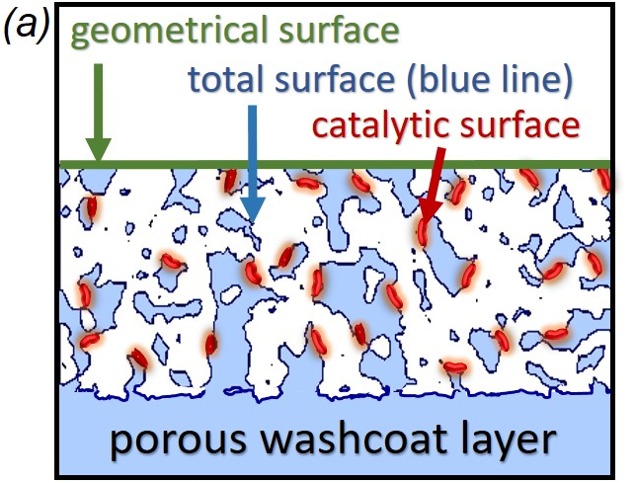 | 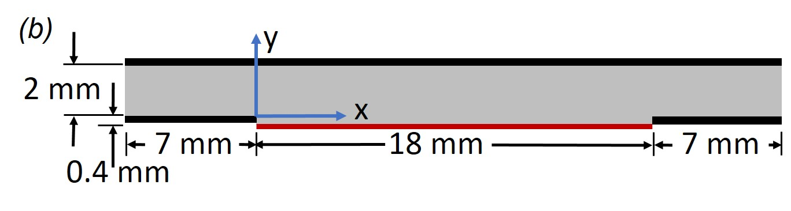
Figure 1: (a) Definition of surface areas for a porous catalyst. (b) 2D slice of reactor and calculation domain
    - Lattice-Boltzmann Method
The fundamental variable in kinetic theory is the particle distribution function $f\left(x,ξ,t\right)$. It represents the density of particles with velocity $ξ=\left(ξ_{x}, ξ_{y}, ξ_{z}\right)$ at position x and time t. The Boltzmann equation (2) is a partial differential equation which describes the evolution of the distribution function in time:
$\frac{∂f}{∂t}+ξ_{β}∙\frac{∂f}{∂x_{β}}=Ω\left(f\right) α,β∈\left\{x,y\right\} .$ | (2)
The first two terms represent the distribution function being advected with the velocity ξ of its particles. The source term on the right-hand side is the collision operator $Ω\left(f\right)$, which represents the local redistribution of f due to collisions.
In a quasi-Cartesian lattice, molecules originating from a lattice node are assumed to move only along a fixed set of Cartesian and diagonal directions to neighboring nodes. The spatial and temporal probability of movement of a certain number of fluid molecules into a direction i is described by the discrete distribution function $f_{i}\left(ξ\right)$ which is often called the particle population. Along these directions, the distribution functions, $f_{i} ,$ are streamed (i.e., propagated to adjacent nodes). The chosen lattice type determines the number of discrete directions. In the MATRICS code, a D2Q9 lattice is used, where D denotes the spatial dimension and Q the nine discrete velocity directions $i$. By discretizing the Boltzmann equation in velocity, space, and time, the following form of the lattice Boltzmann equation is obtained:
$f_{i}\left(x+c_{i}δt,t+δt\right)- f_{i}\left(x,t\right)=Ω\left(f\right)=\frac{1}{τ}∙\left(f_{i}^{eq}\left(x,t\right)-f_{i}\left(x,t\right)\right)$. | (3)
The left-hand side of this equation represents the convection (streaming) of the particle distributions, and the right-hand side the collision term. After sufficient time the distribution function $f_{i}\left(x,ξ,t\right)$will reach an equilibrium distribution $f_{i}^{eq}\left(x,ξ,t\right)$, which can be derived from the Maxwell-Boltzmann equilibrium distribution. As in most LBM codes in MATRICS the BGK (Bhatnagar Gross Krook) collision operator, τ, is used (Bhatnagar et al., 1954). Equation (3) is solved on a grid which consists of equally sized cells (aka lattices). First the equilibrium and non-equilibrium distributions are calculated (the collision step), then these distributions are shifted (the streaming step) to the neighbor cells. Because the LBM algorithm is comprised of just collision and streaming steps, the approach can be computationally very fast.
    - FVM Code DUO
For the validation of the results from the LBM code, the tool DUO was used, which is an acronym for the coupling of the two computer codes DETCHEM and (in German Und) OpenFOAM. OpenFOAM (2017) is an open source FVM CFD tool, which enables the calculation of multiple combined 1D/2D/3D fluid and solid regions. DETCHEMTM (Deutschmann et al., 2014) is a commercially available package of tools specifically designed for the modeling and simulation of reacting flows based on elementary step mechanisms, particularly for catalytic systems. DUO extends OpenFOAM to solve detailed surface reactions (Hettel et al., 2018a). For the actual calculations the 2D version was applied.
    - LBM code MATRICS
The LBM code MATRICS employs a D2Q9 lattice and enables simulations in arbitrarily shaped two-dimensional domains, including detailed surface chemistry (Hettel et al., 2026). As in the DUO code described above, chemical source terms are computed by coupling DETCHEMTM (Deutschmann et al., 2014) to MATRICS. The code supports an arbitrary number of species equations and allows the import and automatic meshing of geometric features from images. In addition, it can handle flows with variable density, which is not straightforward within standard LBM frameworks.
  - Oxidation of Formaldehyde
The experimental work is motivated by the formation of CH₂O (formaldehyde) as an intermediate of methane oxidation, leading to its presence in the exhaust of lean-burn gas engines. High air–fuel ratios, in particular, promote formaldehyde formation (Karavalakis et al., 2016). Due to increasingly stringent regulations on CH₂O emissions, there is a need to investigate its conversion through both experiments and simulations.
    - Experimental Methodology
Figure 1b shows the two-dimensional computational domain representing the central section of the reactor. The parallel-wall channel has a height of 2 mm and a depth of 18 mm. A rectangular recess is introduced at the center of the bottom wall to accommodate the catalyst plate (18 mm × 18 mm). The upper surface of the catalyst is positioned 400 µm below the ceramic bottom wall. The catalytic surface (red line) begins at $x=0$ mm and is located at $y=-0.4$ mm. The catalytic plate was coated with a catalyst-water slurry where the active component was platinum (Pt). The ratio of the catalytic surface area to geometric area $F_{cat/geo}$ was estimated to be 4.
In the experiments (Wan et al., 2020), two-dimensional CH₂O distributions were measured using planar laser-induced fluorescence (PLIF). PLIF is a non-intrusive, laser-based technique that enables high-spatial-resolution visualization of gas-phase species without disturbing the flow field. The reactor is equipped with glass windows on the top and side walls to provide optical access. Measurements were obtained in an $x$–$y$ plane located at the reactor center along the $z$-axis ($z=9$ mm). Measurement uncertainty in the concentration of CH₂O caused by the intensity deviation from single shots and the concentration fluctuation of the reference gas is within ±20%.
    - Microkinetic Model for Oxidation of Formaldehyde
The global reaction for the catalytic oxidation of CH₂O (formaldehyde) over Pt is:
$CH_{2}O+O_{2}\underset{→}{Pt(s)}H_{2}O+CO_{2}$. | (4)
In this work, a thermodynamically consistent multi-step surface reaction mechanism was used (Torkashvand et al., 2019). The mechanism contains of 6 gas-phase species (N₂, O₂, H₂, H₂O, CO, CO₂, CH₂O), 10 surface species (Pt(s), H(s), O(s), H₂O(s), CO₂(s), CO(s), CH₂O(s), OH(s), C(s), HCO(s)) and 30 elementary steps. Gas-phase reactions can be neglected under the conditions of this study.
    - Numerical Setup
Figure 1b shows a vertical slice through the center (z = 9 mm) of the reactor interior which served as the computational domain. The catalytic plate is highlighted in red. All walls (black) were modeled as no-slip boundaries, and a pressure outlet to the atmosphere is applied at the outlet (magenta). Consistent with the experiments, a preheated gas mixture of 100 ppm CH₂O, 1.5 vol. % H₂O, 5 vol. % O₂, balanced with N_{2,} was fed to the reactor. The inlet gas and wall temperatures are set to 673 K. As the heat of reaction is negligible, the system was assumed to be isothermal. The inlet volumetric flow rate, $\dot{V}$, was set to 0.5 and 1 ml/min (i.e., ${10}^{-6} m^{3}/60 s$), corresponding to Reynolds numbers of 16.35 and 32.7 and average velocities of 0.52 and 1.04 m/s, respectively.
Section 4 compares two approaches for representing the washcoat. In the first case (non-resolved washcoat), the fluid-solid interface corresponds to a flat surface (green line in Figure 1a). The same rectangular grid was used for both FVM and LBM simulations. The 2 mm channel height was discretized with 40 cells, which resulted in an equidistant grid of approximately 56,000 cells with a cell size of 50 µm. Grid independence was verified in preliminary simulations.
In FVM, a variety of cell shapes can be employed, allowing body-fitted discretization of complex geometries. As a result, deviations between the real and discretized surfaces are typically small and decrease with increasing grid resolution. In contrast, LBM uses uniform, square cells that are assigned exclusively to either fluid or solid domains. Consequently, fluid–solid interfaces are restricted to horizontal and vertical orientations, and curved or inclined boundaries are approximated by staircase-like geometries. A key limitation is that the deviation between the staircase representation and the true geometry does not vanish with increasing resolution (Hettel et al., 2026). An exact surface conservation (ESC) approach has been developed to address this issue by preserving geometric interfaces (Hettel et al., 2026). While this method could retain the exact surfaces of the spherical particles used to construct the virtual washcoat, the present study adopted the staircase representation, as particle overlap and surface roughness already introduce geometric irregularities.
For the resolved washcoat, a simplified virtual structure was constructed. Experiments indicated a geometric surface enhancement factor of $F_{cat,geo}=4$ and a washcoat thickness of approximately 80 µm. The effectiveness factor was assumed to be unity, implying negligible internal diffusion limitations due to the thin and highly porous washcoat. Accordingly, the total reactive surface in the resolved model was designed to be four times larger than that of the flat plate, ensuring consistency with the non-resolved case.
As mentioned, MATRICS can also handle a resolved washcoat. Here, the washcoat was represented as a rectangular region (18 mm × 80 µm) with its top surface located at $y=-0.4$ mm. Using the MATRICS meshing tool, circular obstacles with a diameter of 20 µm are stochastically distributed within this region (see Figure 2b). The total internal surface was monitored during generation, and approximately 3,000 particles were required to achieve a fourfold increase in surface area. Strictly speaking, in two dimensions the reactive quantity is a line length rather than a surface area; thus, the total perimeter of all particles is approximately four times the plate length (18 mm). The resulting porosity was 72%.
For the resolved washcoat simulations, the channel height was discretized with 400 cells (ten times finer than in the non-resolved case), yielding approximately $2.8×{10}^{6}$ lattice cells with a resolution of 5 µm. A portion of the resolved washcoat structure is shown in Figure 2b.
  - Comparison of Experiment and Calculation
Figure 2a shows the CH₂O mole fraction in the midplane of the channel for both the measurement (top) and LBM simulation (bottom). Due to limitations in the experimental setup, the entire cross section could not be captured by the ICCD camera. As CH₂O is converted on the catalytic plate, its mole fraction decreases from 100 ppm at the inlet (left) to approximately 50 ppm at the outlet (right).

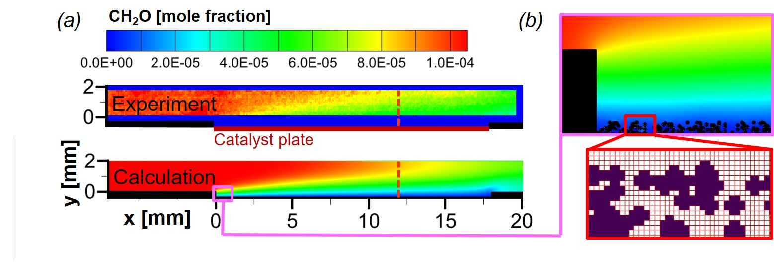
Figure 2: CH₂O mole fraction in the midplane of the channel at a flow rate of 0.5 ml/min. Flow is from left to right. (a) Comparison of experimental measurements and LBM simulation. The red dashed line indicates the position of the slices shown in Figure 3. (b) Enlarged view of a small region showing the virtual washcoat structure and grid resolution.
A distinct vertical gradient is observed, indicating that the system is controlled by mass transfer rather than chemical kinetics. The simulation result in the lower panel shows good qualitative agreement with experimental data.
(a) | 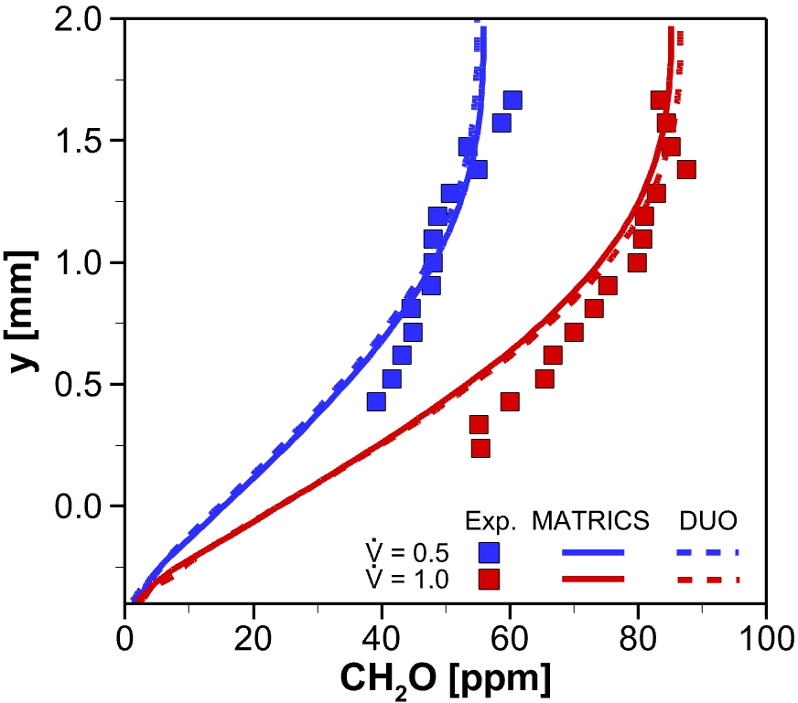 | (b) | 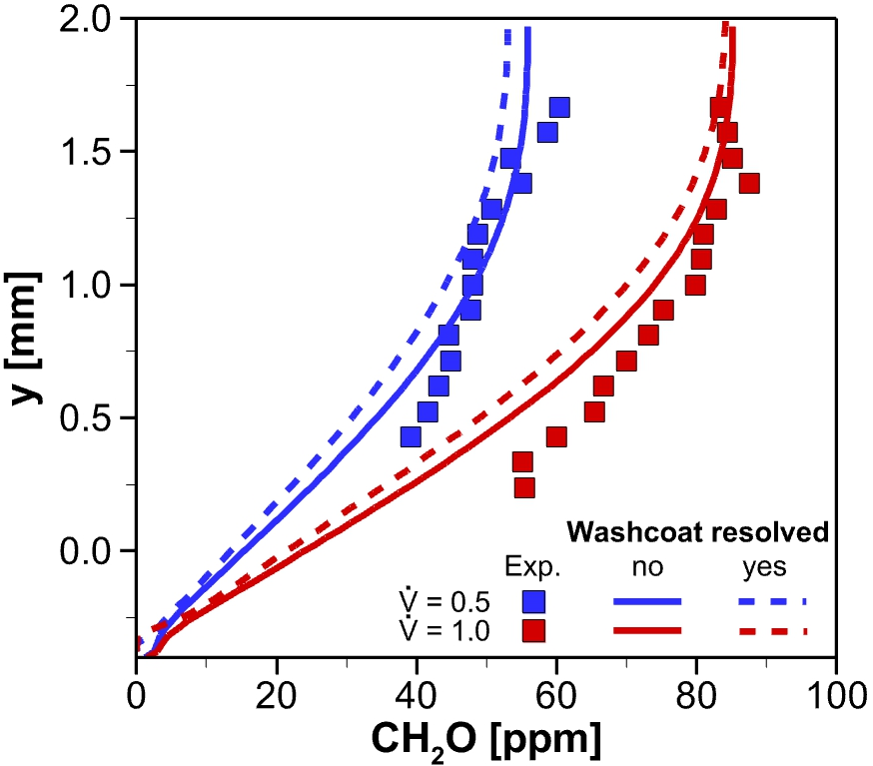
Figure 3: CH₂O mole fraction profiles at $x=12$ mm. (a) Comparison of FVM (dashed lines) and LBM (solid lines) simulations with non-resolved washcoat. (b) Comparison of LBM simulations with resolved (dashed lines) and non-resolved (solid lines) washcoat.
Figure 3 compares measured CH₂O mole fractions at two volumetric flow rates (0.5 and 1 ml/min) with simulations at an axial position of $x=12$ mm (indicated by the red dashed lines in Figure 2a). The experiments show that conversion increases with decreasing flow rate, as lower velocities result in longer residence times. The MATRICS (LBM) and DUO (FVM) simulations, both using a non-resolved washcoat, agree very well (Figure 3a). Considering the reported experimental uncertainty of ±20%, the agreement between numerical and experimental results is good. The simulations indicate that the system is diffusion-controlled for both flow rates, as the CH₂O mole fraction reaches zero at the catalytic surface. The reaction is sufficiently fast that all CH₂O transported to the surface by diffusion is immediately converted. However, extrapolating the measured data to the surface suggests that the reaction mechanism may overpredict conversion rates. The primary focus of this paper is not mechanism validation. Such validation would require measurements very close to the catalytic surface, which were not accessible due to optical constraints in the experiments. The key finding is that the LBM code produces nearly identical results to the FVM approach.
In Figure 3b, LBM simulations with a non-resolved washcoat (solid lines, same as in Figure 3a) yield only slightly larger concentrations than those with a resolved washcoat (dashed lines). It seems that the value of $F_{cat,geo}=4$ used for the calculation with flat surface was estimated well. More precise experimental data would be needed to determine which approach is more accurate.
  - Conclusions
This study investigates the capability of the lattice Boltzmann method (LBM) to simulate fluid flows with detailed catalytic surface chemistry. A two-dimensional LBM code (MATRICS) was developed and applied to model the catalytic oxidation of formaldehyde in a channel reactor. Results were compared with experimental measurements and simulations from the finite volume method (FVM) solver DUO. Two approaches for representing the catalytic washcoat were evaluated: a non-resolved approximation with a flat catalytic surface and a resolved porous geometry. Both approaches yielded similar and accurate results. The simulations showed good agreement with experimental data, particularly in capturing CH₂O concentration gradients. The analysis confirms that the system is diffusion-controlled, with rapid surface reactions consuming formaldehyde at the catalyst. Furthermore, LBM results closely matched those from the FVM approach, demonstrating comparable accuracy and reliability. Overall, this work demonstrates that LBM is a suitable and efficient method for simulating reactive flows with detailed surface chemistry, offering flexibility in handling complex catalytic structures. Next step is to use the geometry of real washcoats in the calculations.
References
Arcidiacono S., J. Mantzaras J., Karlin I. V., 2008, Lattice Boltzmann simulation of catalytic reactions, Physical Review E, 78(4), 046711
Belot I., D. Vidal, Greiner R., Votsmeier M., Hayes R. E., Bertrand F., 2021, Impact of washcoat distribution on the catalytic performance of gasoline particulate filters as predicted by lattice Boltzmann simulations, Chemical Engineering Journal, 406, 127040
Bhatnagar P. L., Gross E. P., Krook M., 1954, A Model for Collision Processes in Gases, I. Small Amplitude Processes in Charged and Neutral One-Component Systems, Physical Review, 94(3), 511-525
Deutschmann O., 2011, Modeling and Simulation of Heterogeneous Catalytic Reactions: From the molecular process to the technical system, Weinheim, Wiley-VCH
Deutschmann O., Tischer S., Correa C., Chatterjee D., Kleditzsch S., Janardhanan V. M., Mladenov N., Minh H. D., Karadeniz H., Hettel M., 2014, DETCHEM Software package, Karlsruhe, Germany, www.detchem.com.
Falcucci G., 2020, Advances in Chemical Engineering. Chapter Two - LBM for 2D and 3D chemical reactors, Van den Akker H. E. A., Academic Press, 55: 81-141
Hettel M., Daymo E., Deutschmann O., 2018, 3D modeling of a CPOX-reformer including detailed chemistry and radiation effects with DUO, Computers & Chemical Engineering, 109, 166-178
Hettel M., Daymo E. A., Sawant N., Deutschmann O., 2026, 2D lattice-boltzmann method with detailed surface chemistry: conservation of geometrical surface, Chemical Engineering Science, 321, 122797
Hettel M., Wörner M., Deutschmann O., 2018, Computational Fluid Dynamics of Catalytic Reactors, Handbook of Materials Modeling. Applications: Current and Emerging Materials, Andreoni W., Cham S. Yip., Springer International Publishing, 1-34
Kang J., Prasianakis N. I., Mantzaras J., 2014, Thermal multicomponent lattice Boltzmann model for catalytic reactive flows, Physical Review E, 89(6), 063310
Karavalakis G., Hajbabaei M., Jiang Y., Yang J., Johnson K. C., Cocker D. R., Durbin T. D., 2016, Regulated, greenhouse gas, and particulate emissions from lean-burn and stoichiometric natural gas heavy-duty vehicles on different fuel compositions, Fuel, 175, 146-156
Kee R. J., Coltrin M. E., Glarborg P., 2003, Chemically Reacting Flow, Wiley-Interscience
Khatoonabadi M., Prasianakis N. I., Mantzaras J., 2024, A pore-level 3D lattice Boltzmann simulation of mass transport and reaction in catalytic particles used for methane synthesis, International Journal of Heat and Mass Transfer, 221, 125025
Krüger T. K., Kusumaatmaja H., Kuzmin A., Shardt , O., Silva G., Viggen E. M., 2017, The Lattice Boltzmann Method. Principles and Practice, Springer Nature
Li X., Cai J., Xin F., Huai X., Guo J., 2013, Lattice Boltzmann simulation of endothermal catalytic reaction in catalyst porous media, Applied Thermal Engineering, 50(1), 1194-1200
OpenFOAM, The Open Source CFD Toolbox, 2017, www.openfoam.org
Torkashvand B., Maier L., Lott P., Schedlbauer T., Grunwaldt J.-D., Deutschmann O., 2019, Formaldehyde Oxidation Over Platinum: On the Kinetics Relevant to Exhaust Conditions of Lean-Burn Natural Gas Engines, Topics in Catalysis, 62(1), 206-213
Wan S., Torkashvand B., Häber T., Suntz R., Deutschmann O., 2020, Investigation of HCHO Catalytic Oxidation over Platinum using Planar Laser-Induced Fluorescence, Applied Catalysis B, Environmental, 264, 118473

